**CS673S16 Software Engineering**

**Team Alpha - Blueprints**

**Tests Report Team Alpha**

|  |  |  |  |
| --- | --- | --- | --- |
| Team Member | Role(s) | Signature | Date |
| Chris Willis | Environment and Integration Leader | *Chris Willis* | 03/02/16 |
| Allen Tshudy | Team leader  Security leader | *Allen Tshudy* | 4/25/2016 |
| Vikrant Sanghvi | Design Lead | *Vikrant Sanghvi* | 4/25/2016 |
| Yue Lei | Requirement Leader | *Yue Lei* | 4/25/2016 |
| Randy Charland | Configuration Leader | *Randy Charland* | 4/26/2016 |
|  |  |  |  |
|  |  |  |  |
|  |  |  |  |

**Revision history**

|  |  |  |  |
| --- | --- | --- | --- |
| **Version** | **Author** | **Date** | **Change** |
| **1.0** | **Yue Lei** | **4/25/2016** | **Add written tests** |
| **2.0** | **Vikrant Sanghvi** | **4/25/2016** | **Add tests** |
| **3.0** | **Allen Tshudy** | **4/26/2016** | **Added tests descriptions** |
| **4.0** | **Randy Charland** | **4/26/2016** | **Added test descriptions** |

# Introduction

Unit Testing and Selenium tests are 2 basic test methods applied in the project.

Unit test scripts will be run on each build to update Reporting by each team member. And then , we will test if all the requirement proposed initially are met which will be tested by real unbiased audience in real env.

Selenium test are also used for testing certain cases in requirements.

In this section, give a summary of this tests report document.

# Test Summary

Test: Upload an attachment file larger than the size limit of 10 MB

Result: Failed because IO error is thrown from a view instead of a model

Test: Created a new issue in IssueTracker

Result: Pass

Test: Verify a file is attached after attaching it

Result: Failed because exception should be thrown from the view level

Test: Submit an attachment without a file specified

Result: Failed because a missing file exception should be thrown

Test: Create an iteration and enter in a start date earlier than the current date

Result: Failed because a start date could be entered earlier than current date

Test: Create an iteration and enter in an end date earlier than the start date

Result: Failed because an end date could be entered earlier than current date

Test: Logging into IssueTracker directly

Result: Pass

Test: Verify only project manager can make projects and iterations

Result: Pass

# Tests Reports

In this section, you will give a detailed description of each test case performed and the result. You shall list what are existing tests developed in the previous semester and what are new tests developed currently.

**Old Tests**

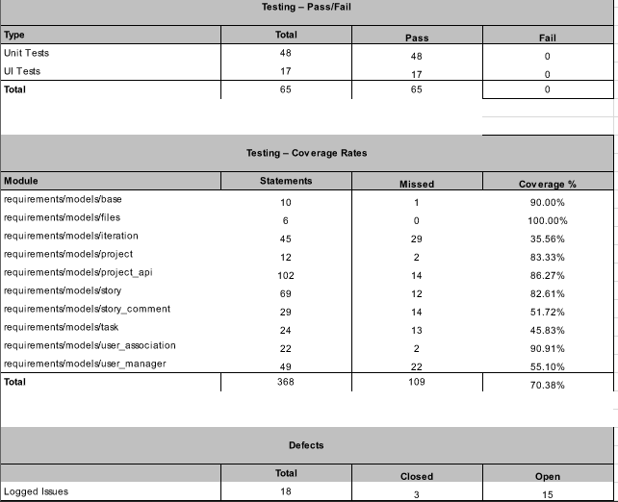

**New Tests**

* + **Unit Tests**

|  |  |  |  |  |  |
| --- | --- | --- | --- | --- | --- |
| **ID** | **Test Case** | **Target Class** | **Method Under Test** | **Result** | **Writer** |
| 1 | test_valid_date_for_iteration_end | requirements/models/iteration | create_iteration | pass | Yue Lei |
| 2 | test_create_new_task | requirements/models/task | create_task | pass | Yue Lei |
| 3 | test_get_task_from_story | requirements/models/task | get_tasks_for_story | pass | Yue Lei |
| 4 | test_get_task_from_null_story | requirements/models/task | get_tasks_for_story | pass | Yue Lei |
| 5 | test_create_null_task_from_story | requirements/models/task | create_task | pass | Yue Lei |
| 6 | test_create_task_from_null_story | requirements/models/task | create_task | pass | Yue Lei |
| 7 | test_get_task_from_id | requirements/models/task | get_task | pass | Yue Lei |
| 8 | test_get_task_from_invalid_id | requirements/models/task | get_task | pass | Yue Lei |
| 9 | test_get_all_tasks | requirements/models/task | get_all_tasks | pass | Yue Lei |
| 10 | test_create_new_comment | requirements/models/story_comment | create_comment | pass | Allen Tshudy |
| 11 | test_get_comment_from_story | requirements/models/story_comment | get_comments_for_story | pass | Allen Tshudy |
| 12 | test_get_comment_from_null_story | requirements/models/story_comment | get_comments_for_story | pass | Allen Tshudy |
| 13 | test_create_null_comment_from_story | requirements/models/story_comment | create_comment | pass | Allen Tshudy |
| 14 | test_create_comment_from_null_story | requirements/models/story_comment | create_comment | pass | Allen Tshudy |
| 15 | test_get_comment_from_id | requirements/models/story_comment | get_comment | pass | Allen Tshudy |
| 16 | test_get_comment_from_invalid_id | requirements/models/story_comment | get_comment | pass | Allen Tshudy |
| 17 | test_get_all_comments | requirements/models/story_comment | get_all_comments | pass | Allen Tshudy |
| 18 | test_attachments_file_attachment | requirements/models/story_attachment | create | pass | Allen Tshudy |
| 19 | test_attachments_file_no_attachment | requirements/models/story_attachment | create | pass | Allen Tshudy |
| 20 | test_attachments_file_no_story | requirements/models/story_attachment | create | pass | Allen Tshudy |
| 21 | test_attachments_get_attachments_for_non_story | requirements/models/story_attachment | get_attachments_for_story | pass | Allen Tshudy |
| 22 | test_attachments_get_all_attachments | requirements/models/story_attachment | get_all_attachments | pass | Allen Tshudy |
| 23 | test_attachments_file_attachment | requirements/models/story_attachment | Get_all_attachments, Create, delete | pass | Allen Tshudy |
| 24 | test_attachments_no_file_attached | requirements/models/files | does_attachment_exist | pass | Allen Tshudy |
| 25 | test_attachments_file_attached | requirements/models/files | does_attachment_exist | pass | Allen Tshudy |
| 26 | test_attachments_view_upload_attachment | requirements/view/project | upload_attachment | pass | Allen Tshudy |
| 27 | test_iteration | requirements/models/iteration | add_iteration_to_project | pass | Randy Charland |

* + **System Tests(Selenium UI test)**

A)

**Test case name:** Create Issue in Issue tracker

**New/old:** New

**Test items:** Issue Tracker of existing System

**Test priority(1-3)**: 3

**Dependencies:** Requirement Tracker Project entity.

**Preconditions:** 1. User should be logged into the system.

2. User should have access to the project for which issue is being tracked.

Input data: Project id, user id

**Test Steps:** 1. After Logging into the system , user click on create issue.

2. Create issue form pops in .

3. Fill in the details like issue short and long description , priority , type, assigned to .

4.Click on create button.

**PostConditions:** 1. Issue is created with all the details provided and can be viewed.

**Expected output:**  Issue is created successfully for the project and assigned to user.

Actual Output: Issue is created successfully for the project and assigned to user.

**Pass or Fail**: Pass

B)

**Test case name:** Issue Tracker Login Test

**New/old:** Old

**Test items:** Issue Tracker Login Functionality

**Test priority(1-3)**: 3

**Dependencies:** Registered Issue tracker and username and password

**Preconditions:** 1. User is has already registered with the system and has proper permissions to log in

2. User is currently logged out

**Test Steps:** 1. Go to the issue tracker web page

2. Select username field

3. Enter in username

4. Select password field

5. Enter in password

**PostConditions:** None

**Expected output:**  User is logged in and presented with issue tracker web page

**Actual Output**: User logged in and presented with issue tracker web page

**Pass or Fail**: Pass

**Additional notes:**

# Testing Metrics

In this section, you shall report the any metrics used for the evaluation, e.g. coverage, defects rate, etc.

Evaluation:

Bug fixed:

5 bugs were logged in Slack

7 bugs were logged in pivotal Tracker  
 11 bugs were logged in Slack  
 Total of 23 bugs where fixed

Code coverage:

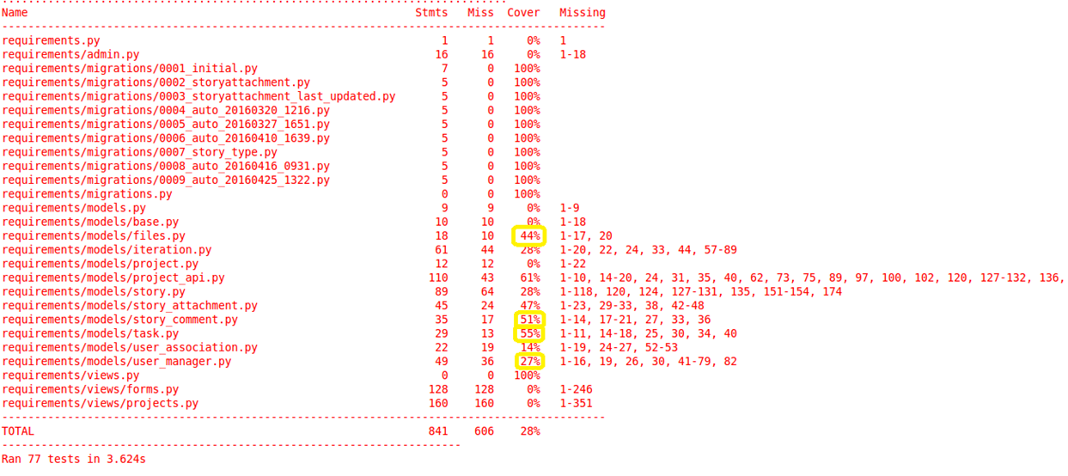  
Defect:

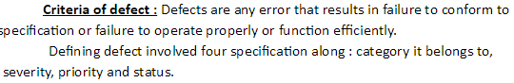

Basically we do not have defects.

# References

<https://blog.pivotal.io/labs/labs/what-powers-pivotal-tracker>

<http://www.github.com>

# Glossary