
Kauno technologijos universitetas

Informatikos fakultetas

Objektinis programavimas 2 (P175B123)
Laboratorinių darbų ataskaita

Adomas Danilevičius IFA-3/1

Studentas

Doc. Giedrius Ziberkas

Dėstytojas

Kaunas 2025

TURINYS

- Rekursija (L1) 4
  - Darbo užduotis 4
  - Grafinės naudotojo sąsajos schema 4
  - Sąsajoje panaudotų komponentų keičiamos savybės 4
  - Klasių diagrama 5
  - Programos naudotojo vadovas 6
  - Programos tekstas 6
  - Pradiniai duomenys ir rezultatai 11
  - Dėstytojo pastabos 12
- Dinaminis atminties valdymas (L2) 13
  - Darbo užduotis 13
  - Grafinės naudotojo sąsajos schema 13
  - Sąsajoje panaudotų komponentų keičiamos savybės 13
  - Klasių diagrama 14
  - Programos naudotojo vadovas 14
  - Programos tekstas 14
  - Pradiniai duomenys ir rezultatai 38
  - Dėstytojo pastabos 41
- Bendrinės klasės ir testavimas (L3) 42
  - Darbo užduotis 42
  - Grafinės naudotojo sąsajos schema 42
  - Sąsajoje panaudotų komponentų keičiamos savybės 42
  - Klasių diagrama 42
  - Programos naudotojo vadovas 42
  - Programos tekstas 42
  - Pradiniai duomenys ir rezultatai 42
  - Dėstytojo pastabos 43
- Polimorfizmas ir išimčių valdymas (L4) 44
  - Darbo užduotis 44
  - Grafinės naudotojo sąsajos schema 44
  - Sąsajoje panaudotų komponentų keičiamos savybės 44
  - Klasių diagrama 44
  - Programos naudotojo vadovas 44
  - Programos tekstas 44
  - Pradiniai duomenys ir rezultatai 44
  - Dėstytojo pastabos 45
- Deklaratyvusis programavimas (L5) 46
  - Darbo užduotis 46
  - Grafinės naudotojo sąsajos schema 46
  - Sąsajoje panaudotų komponentų keičiamos savybės 46
  - Klasių diagrama 46
  - Programos naudotojo vadovas 46
  - Programos tekstas 46
  - Pradiniai duomenys ir rezultatai 46
  - Dėstytojo pastabos 47

Rekursija (L1)

Darbo užduotis

Turime kvadrato formos languoto popieriaus lapą. Į lapo centre esantį langelių linijų susikirtimą statoma skriestuvo kojelė. Brėžiamas apskritimas, siekiantis lapo kraštus. Sunumeruokite, pradedant nuo 1, languoto popieriaus lapo langelius, pilnai patenkančius į apskritimo vidų, o kitiems langeliams priskirkite po 0. Numeravimo tvarka nėra svarbi. Atvaizduokite languoto popieriaus lapą matrica. Spindulio r (r ϵ N) dydis nurodomas langelių kiekiu.
Duomenys. r įvedamas klaviatūra (1  r  16).
Rezultatai. Spausdinkite gautą matricą.

Grafinės naudotojo sąsajos schema

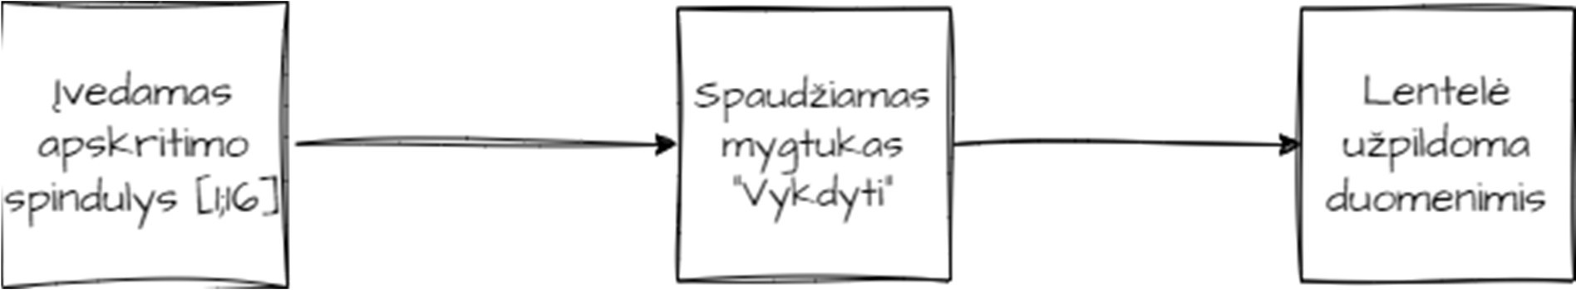

Pav. 1 Grafinės naudotojo sąsajos schema

Sąsajoje panaudotų komponentų keičiamos savybės

Komponentas | Savybė | Reikšmė
Table1 | BorderColor | Black
Table1 | BorderStyle | Solid
Table1 | BorderWidth | 1px
Table1 | GridLines | Both
ValidationSummary1 | DisplayMode | SingleParagapth
ValidationSummary1 | ForeColor | Red
Button1 | Text | „Vykdyti“
RangeValidator1 | ErrorMessage | „Apskritimo spindulys privalo būti intervale [1;16]“
RangeValidator1 | ForeColor | Red
RangeValidator1 | ControlToValidate | TextBox1
RangeValidator1 | MaximumValue | 16
RangeValidator1 | MinimumValue | 1
RangeValidator1 | Type | Integer
TextBox1 | Width | 24px

TextBox1 | Text | 8

Klasių diagrama

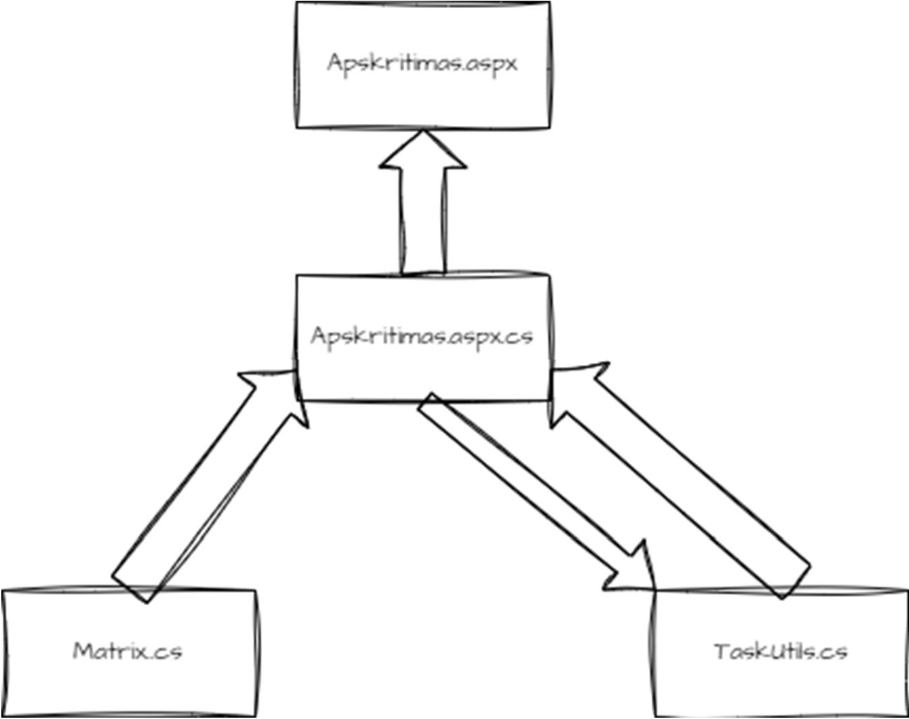

Pav. 2 Klasės diagrama

Matrix
-Matrix [,] : integer
+ (In Value : integer) : Matrix
+Add(In Value : integer, integer, integer)
+Get(In Value : integer, integer) : integer {query}
+GetLength(In Value : integer, integer) : integer {query}
-AutoFill()

TaskUtils
+CalculateCenter(In Value : integer) : integer {query}
+FillOut(In Value : Matrix, integer, integer, [,]boolean, integer, integer, integer, integer) : Matrix

Programos naudotojo vadovas

Paleidus programą lange įrašyta numatyta reikšmė 8, tačiau ją galima keisti nuo 1 iki 16. Įrašius tinkamą reikšmę, lentelėje bus matomas apskritimas iš skaičių. Visi langeliai, kurie nėra užpildyti 0, patenka į apskritimo plotą.

Programos tekstas

TaskUtils.cs
//Adomas Dnailevičius IFA-3/1 using System;
using System.Web;
using System.Web.UI.WebControls;

namespace Lab1
{
/// <summary>
/// Backend class for Apskritimas.aspx form.
/// </summary>

public partial class Apskritimas : System.Web.UI.Page
{

/// <summary>
/// Page load method
/// </summary>
/// <param name="sender"></param>
/// <param name="e"></param>

protected void Page_Load(object sender, EventArgs e)
{
if (!IsPostBack)
{
HttpContext.Current.Session["Matrix"] = new Classes.Matrix(8); GetMatrix();
}
}

/// <summary>
/// Method for actions after Button1 click.
/// </summary>
/// <param name="sender"></param>
/// <param name="e"></param>

protected void Button1_Click(object sender, EventArgs e)
{
HttpContext.Current.Session["Matrix"] = new Classes.Matrix(int.Parse(TextBox1.Text));
FillTable();
}
/// <summary>
/// Method for filling Table1 in Apskritimas.aspx from matrix.
/// </summary>

private void FillTable()
{
Classes.Matrix matrix = GetMatrix(); Table1.Rows.Clear();
int tableSize = int.Parse(TextBox1.Text) * 50; Table1.Height = new Unit(tableSize, UnitType.Pixel); Table1.Width = new Unit(tableSize, UnitType.Pixel); Table1.Style["table-layout"] = "fixed"; Table1.Style["border-collapse"] = "collapse";
Unit CenterX = Classes.TaskUtils.CalculateCenter(Table1.Width); Unit CenterY = Classes.TaskUtils.CalculateCenter(Table1.Height); int rows = matrix.GetLength(0);
int cols = matrix.GetLength(1); int[,] visited = new int[rows, cols]; int counter = 0;
HttpContext.Current.Session["Matrix"] = Classes.TaskUtils.FillOut(matrix, CenterX, CenterY, visited, 0, 0, CenterX, ref counter);

for (int i = 0; i < rows; i++)
{
TableRow row = new TableRow(); for (int j = 0; j < cols; j++)
{
TableCell cell = new TableCell(); cell.HorizontalAlign = HorizontalAlign.Center; cell.Text = matrix.Get(i, j).ToString(); cell.Attributes["style"] = "width:25px; height:25px;
padding:0; margin:0; border:1px solid black; box-sizing:border-box; overflow:hidden; text-align:center;";
row.Cells.Add(cell);
}
Table1.Rows.Add(row);
}
}

/// <summary>
/// Gets Matrix saved in session.
/// </summary>
/// <returns>Matrix that is saved in session.</returns>

private Classes.Matrix GetMatrix()
{
return (Classes.Matrix)HttpContext.Current.Session["Matrix"];
}

}
}

Matrix.cs

//Adomas Danilevičius IFA-3/1 namespace Lab1.Classes
{
/// <summary>
/// Class that contains two dimentional array.
/// </summary>

public class Matrix
{

private int[,] matrix; //Private two dimentional array.
/// <summary>
/// Constructor for two dimentional array.
/// </summary>
/// <param name="s">Size to set of square two dimentional array.</param>
public Matrix(int s)
{
matrix = new int[s * 2, s * 2]; AutoFill();
}

/// <summary>
/// Adds or changes the number in specified place.
/// </summary>
/// <param name="x">X coordinate.</param>
/// <param name="y">Y coordinate</param>
/// <param name="number"></param>

public void Add(int x, int y, int number)
{
matrix[x, y] = number;
}

/// <summary>
/// Gets specific element from array.
/// </summary>
/// <param name="x">X coordinate.</param>
/// <param name="y">Y coordinate</param>
/// <returns></returns>
public int Get(int x, int y)
{
return matrix[x, y];
}
/// <summary>
/// Gets the size of an array.
/// </summary>
/// <param name="dim">Dimention specification (0 is length and 1 is width).</param>
/// <returns>Dimention or array.</returns>

public int GetLength(int dim)
{
return matrix.GetLength(dim);
}

/// <summary>
/// Fills up two dimentional array with 0s for easier checking.
/// </summary>

private void AutoFill()
{
for (int i = 0; i < matrix.GetLength(0); i++)
{
for (int j = 0; j < matrix.GetLength(1); j++)
{
matrix[i, j] = 0;
}
}

}
}

}

Apskritimas.aspx

<%@ Page Language="C#" AutoEventWireup="true" CodeBehind="Apskritimas.aspx.cs" Inherits="Lab1.Apskritimas" %>
<!DOCTYPE html>

<html xmlns="http://www.w3.org/1999/xhtml">
<head runat="server">
<title></title>
</head>
<body>
<form id="form1" runat="server">
<div>
<strong>Apskritimas<br />
</strong>
&nbsp;<asp:ValidationSummary ID="ValidationSummary1" runat="server" DisplayMode="SingleParagraph" ForeColor="Red" />
<br />
<asp:Table ID="Table1" runat="server" BorderColor="Black" BorderStyle="Solid" BorderWidth="1px" GridLines="Both">
</asp:Table>
<br />
<br />
Nustatykite apskritimo spindulį:
<asp:TextBox ID="TextBox1" runat="server" Width="24px">8</asp:TextBox>
<asp:RangeValidator ID="RangeValidator1" runat="server" ControlToValidate="TextBox1" ErrorMessage="Apskritimo spindulys privalo būti intervale [1;16]" ForeColor="Red" MaximumValue="16" MinimumValue="1" Type="Integer">*</asp:RangeValidator>
<br />
<br />
<br /> &nbsp;&nbsp;&nbsp;&nbsp;
<asp:Button ID="Button1" runat="server" OnClick="Button1_Click" Text="Vykdyti" />
&nbsp;
<br />

</div>
</form>
</body>
</html>

Apskritimas.aspx.cs

//Adomas Danilevičius IFA-3/1 using System;
using System.Web;
using System.Web.UI.WebControls;

namespace Lab1
{
/// <summary>
/// Backend class for Apskritimas.aspx form.
/// </summary>
public partial class Apskritimas : System.Web.UI.Page
{

/// <summary>
/// Page load method
/// </summary>
/// <param name="sender"></param>
/// <param name="e"></param>
protected void Page_Load(object sender, EventArgs e)
{
if (!IsPostBack)
{
HttpContext.Current.Session["Matrix"] = new Classes.Matrix(8); GetMatrix();
}
}

/// <summary>
/// Method for actions after Button1 click.
/// </summary>
/// <param name="sender"></param>
/// <param name="e"></param>
protected void Button1_Click(object sender, EventArgs e)
{
HttpContext.Current.Session["Matrix"] = new Classes.Matrix(int.Parse(TextBox1.Text));
FillTable();
}

/// <summary>
/// Method for filling Table1 in Apskritimas.aspx from matrix.
/// </summary>

private void FillTable()
{
Classes.Matrix matrix = GetMatrix(); Table1.Rows.Clear();
int tableSize = int.Parse(TextBox1.Text) * 50; Table1.Height = new Unit(tableSize, UnitType.Pixel); Table1.Width = new Unit(tableSize, UnitType.Pixel); Table1.Style["table-layout"] = "fixed"; Table1.Style["border-collapse"] = "collapse";
Unit CenterX = Classes.TaskUtils.CalculateCenter(Table1.Width); Unit CenterY = Classes.TaskUtils.CalculateCenter(Table1.Height); int rows = matrix.GetLength(0);
int cols = matrix.GetLength(1); int[,] visited = new int[rows, cols]; int counter = 0;
HttpContext.Current.Session["Matrix"] = Classes.TaskUtils.FillOut(matrix, CenterX, CenterY, visited, 0, 0, CenterX, ref counter);

for (int i = 0; i < rows; i++)
{
TableRow row = new TableRow(); for (int j = 0; j < cols; j++)
{
TableCell cell = new TableCell(); cell.HorizontalAlign = HorizontalAlign.Center; cell.Text = matrix.Get(i, j).ToString(); cell.Attributes["style"] = "width:25px; height:25px;
padding:0; margin:0; border:1px solid black; box-sizing:border-box; overflow:hidden; text-align:center;";

row.Cells.Add(cell);
}
Table1.Rows.Add(row);
}
}

/// <summary>
/// Gets Matrix saved in session.
/// </summary>
/// <returns>Matrix that is saved in session.</returns>

private Classes.Matrix GetMatrix()
{
return (Classes.Matrix)HttpContext.Current.Session["Matrix"];
}

}
}

Pradiniai duomenys ir rezultatai
Duomenys nr. 1

Duomenys ir rezultatai kai r=5.

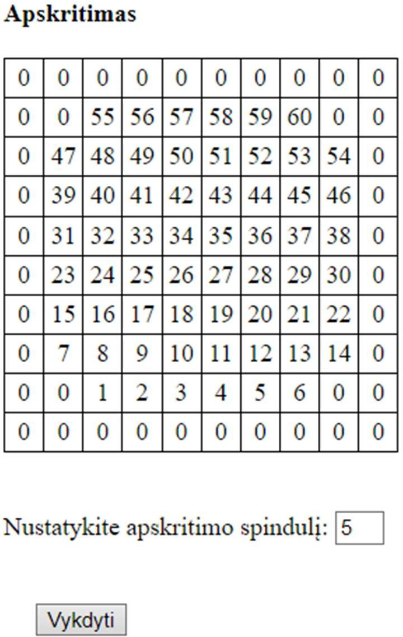

Pav. 3 Rezultatai

Duomenys nr. 2

Duomenys ir rezultatai kai r=16.
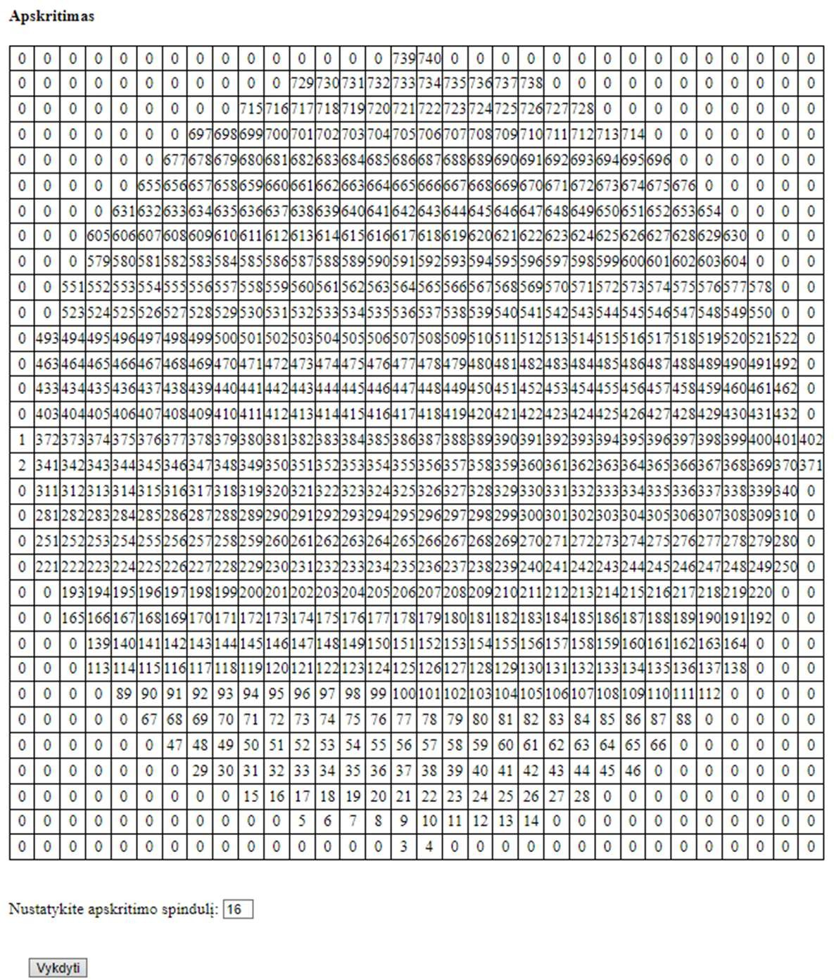

Pav. 4 Rezultatai

Dėstytojo pastabos

Nėra partial klasės Apskritimas.aspx.cs klasei;

Dinaminis atminties valdymas (L2)

Darbo užduotis
LD_6. Premijos.

Moksliniai darbuotojai atliko darbus 4 skirtingose temose. Visos temos gavo premijas. Remiantis darbuotojų indėliais, suskaičiuokite kiekvienam darbuotojui priklausančios premijos dydį pagal kiekvieną temą atskirai ir bendrą premijų sumą. Darbuotojo indėlis rodo, kokia premijos dalis jam priklauso. Indėlis gali būti išreikštas bet kokiu skaičiumi. Bet tas pats matas naudojamas visiems darbuotojams. Neišdalinkite pinigų daugiau, negu turite, ir turite išdalinti visus pinigus. Sudarykite sąrašą darbuotojų (pavardė, vardas, darbuotojo indėliai, darbuotojo premijų dydžiai pagal temas, bendra premijų sumą), kurie uždirbo mažiau už vidurkį. Duomenys:

Tekstiniame faile U6a.txt duota informacija apie darbuotojus: darbuotojų asmens kodai, pavardės, vardai, banko pavadinimas, sąskaitos numeris.

Tekstiniame faile U6b.txt duota informacija apie indėlius į darbą: pirmoje eilutėje - premijų dydžiai, tolesnėse eilutėse - darbuotojų asmens kodai, darbuotojų indėliai, kurie išreikšti naudingumo koeficientu, į eilinę temą.

Informacija apie darbuotoją užima vieną eilutę. Spausdinamas sąrašas turi būti surikiuotas pagal darbuotojų pavardes, vardus abėcėlės tvarka ir bendrą premijų sumą didėjimo tvarka. Sudarykite nurodytos temos (įvedama klaviatūra) darbuotojų uždarbių sąrašą (pavardė, vardas, darbuotojo indėliai, darbuotojo premijų dydžiai pagal temas, bendra premijų sumą).

Grafinės naudotojo sąsajos schema

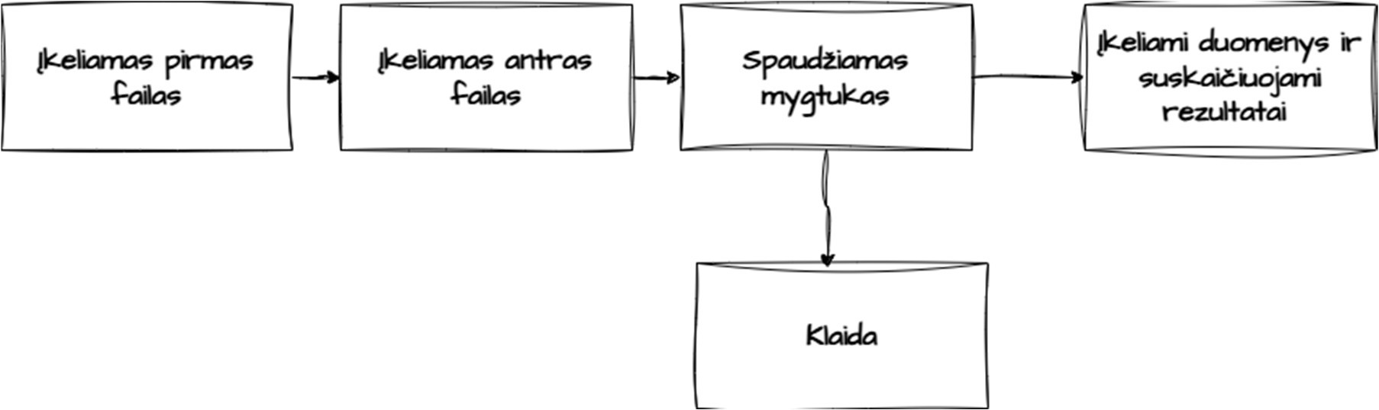

Pav. 5 GUI diagrama

Sąsajoje panaudotų komponentų keičiamos savybės

Visos savybės keičiamos styles.css faile.

Klasių diagrama
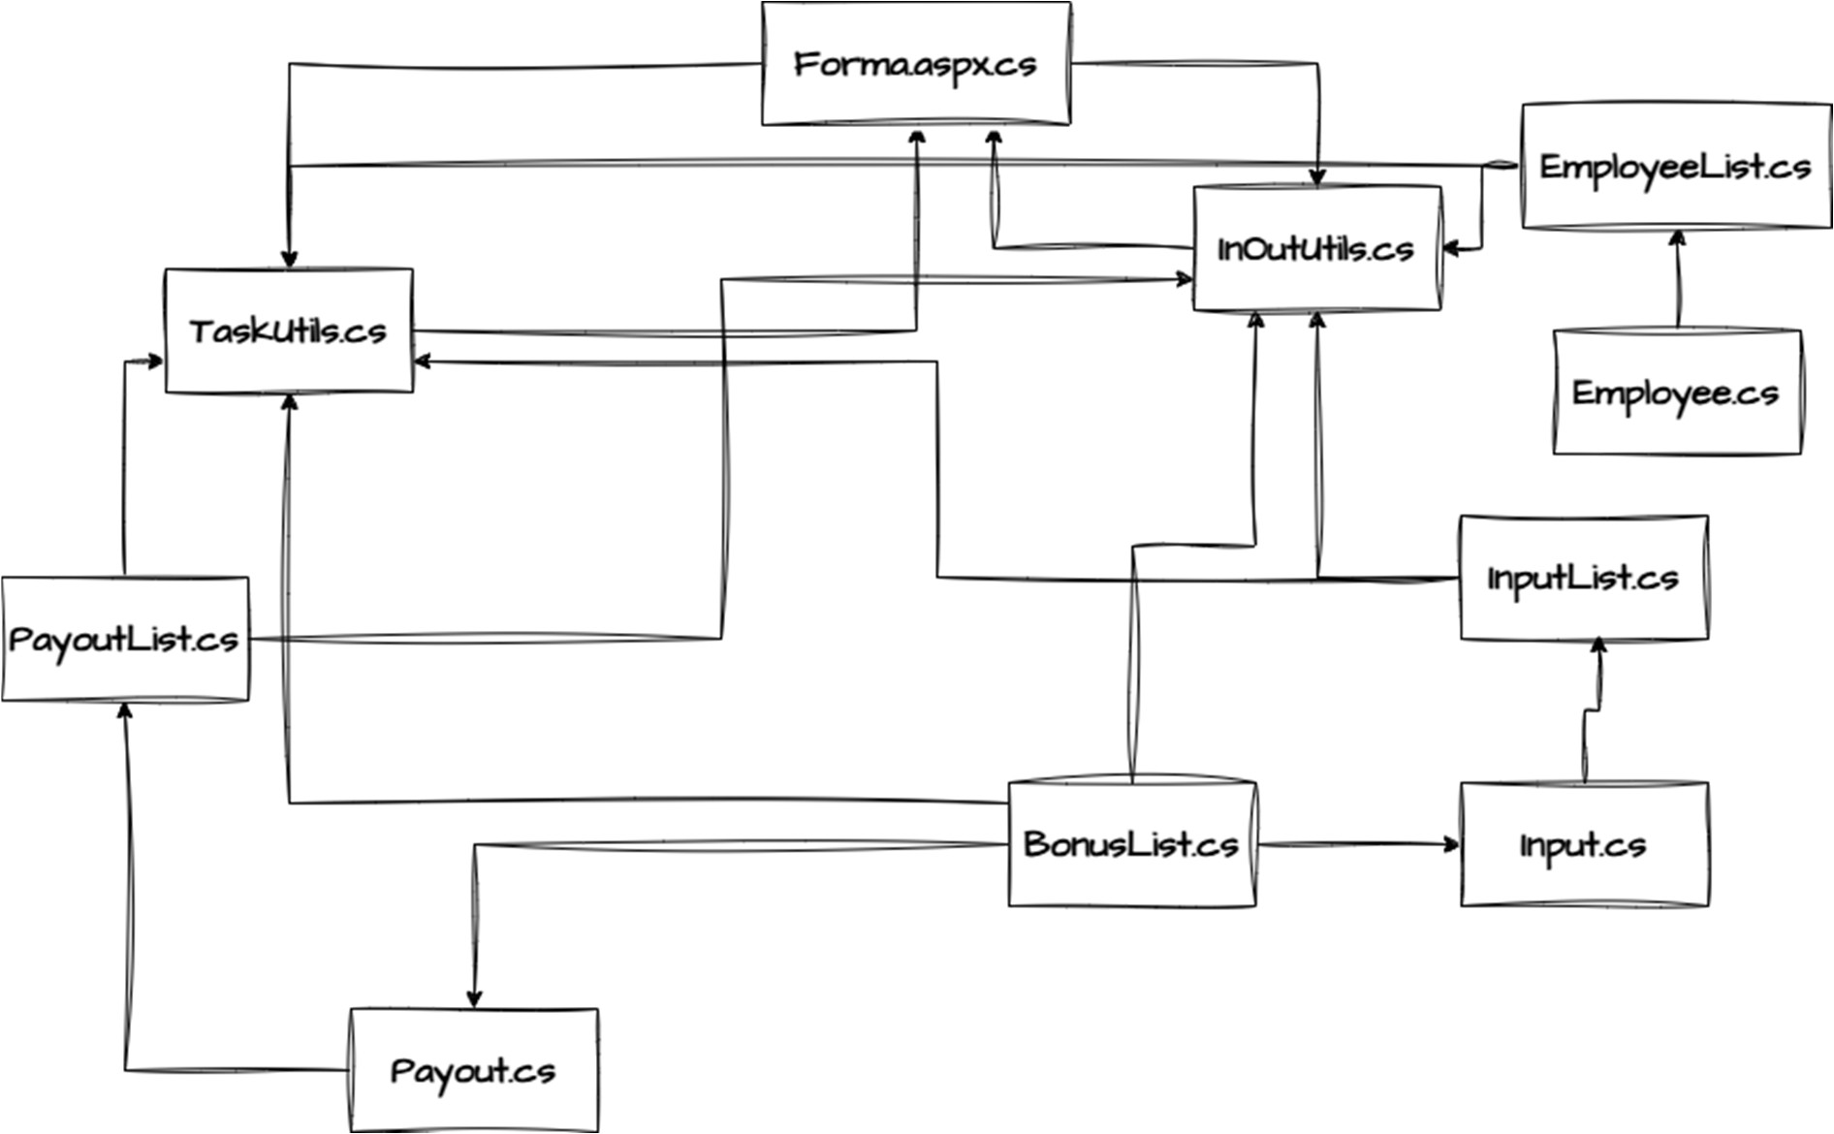

Pav. 6 Klasių diagrama

Programos naudotojo vadovas

Naudotojo sąsajoje reikia įkelti 2 failus. Viename faile turi būti duomenys apie darbuotojus :

„Asmens kodas;Pavardė;Vardas;Banko pavadinimas;Sąskaitos numeris“. Kitame faile turi būti įkelti duomenys apie premijas. Pirmoje eilutėje: „Premija už tema1; Premija už tema2; Premija už tema3; Premija už tema4“. Likusiose duomenys apie indėlį: „Asmens kodas; Indėlis1; Indėlis2; Indėlis3; Indėlis4“. Įkėlus tokia formato failus ir paspaudus mygtuką programa suskaičiuoja išmokas.

Programos tekstas
Input.cs

using Lab2_v2.Bonuses; using System;
using System.Collections.Generic; using System.Linq;
using System.Web;

namespace Lab2_v2.Einput

{
/// <summary>
/// Input object class.
/// </summary> public class Input
{
public int Id { get; set; } public BonusList Bonuses { get; set; }
/// <summary>
/// Constructor for object.
/// </summary>
/// <param name="id">ID of a person.</param>
/// <param name="bonuses">Bonus linked list for storing bonus amounts.</param> public Input(int id, BonusList bonuses)
{
this.Id = id; this.Bonuses = bonuses;
}

}
}
Employee.cs

using System;
using System.Collections.Generic; using System.Linq;
using System.Web;
namespace Lab2_v2.Employees
{
/// <summary>
/// Employee object class.
/// </summary> public class Employee
{
public int Id { get; set; } public string LastName { get; set; } public string Name { get; set; } public string BankName { get; set; }
public string AccountNumber { get; set; }
/// <summary>
/// Constructor for object.
/// </summary>
/// <param name="id">Id of a person.</param>
/// <param name="lastname">Last name of a person.</param>
/// <param name="name">Name of a person.</param>
/// <param name="bankname">Bank name of a person.</param>
/// <param name="accountnumber">Account number of person.</param>
public Employee(int id, string lastname, string name, string bankname, string accountnumber)
{
this.Id = id; this.LastName = lastname; this.Name = name; this.BankName = bankname;
this.AccountNumber = accountnumber;
}

/// <summary>

/// ToString override for formatting.
/// </summary>
/// <returns>Formatted string.</returns> public override string ToString()
{
return string.Format($"| {Id,20} | {LastName,-15} | {Name,-15} | {BankName,- 15} | {AccountNumber,-20} | ");
}

}
}
Payout.cs

using Lab2_v2.Bonuses; using System;
using System.Collections.Generic; using System.Linq;
using System.Web;

namespace Lab2_v2.Payouts
{
/// <summary>
/// Class for Payout object.
/// </summary> public class Payout
{
public string LastName { get; set; } public string Name { get; set; }
public BonusList BonusCoef { get; set; } public BonusList BonusAmounts { get; set; } public double Sum { get; set; }

bonusAmounts)
/// <summary>
/// Constructor for object.
/// </summary>
/// <param name="lastname">Last name of a person.</param>
/// <param name="name">Name of a person.</param>
/// <param name="bonusCoef">Linked list for all coeficients.</param>
/// <param name="bonusAmounts">Linked list for bonus amounts.</param> public Payout(string lastname, string name, BonusList bonusCoef, BonusList
{
this.LastName = lastname; this.Name = name; this.BonusCoef = bonusCoef;
this.BonusAmounts = bonusAmounts; this.Sum = 0;
}

/// <summary>
/// Compares node data.
/// </summary>
/// <param name="other">Other node data.</param>
/// <returns>True if they are the same false otherwise.</returns> public bool Compare(Payout other)
{

if (other.Name == Name && other.LastName == LastName)
{
return true;
}
return false;

}
/// <summary>
/// Calculates the sum of bonuses.
/// </summary> public void SumCalc()
{
double sum = 0;
for (BonusAmounts.Start(); BonusAmounts.Exists(); BonusAmounts.Next())
{
sum += BonusAmounts.Get();
}
this.Sum = sum;
}
/// <summary>
/// Compares two node data.
/// </summary>
/// <param name="other">Other node data.</param>
/// <returns></returns> public int CompareTo(Payout other)
{
int lastNameComp = string.Compare(this.LastName, other.LastName, StringComparison.OrdinalIgnoreCase);
if (lastNameComp != 0)
{
return lastNameComp;
}
int nameComp = string.Compare(this.Name, other.Name, StringComparison.OrdinalIgnoreCase);
if (nameComp != 0)
{
return nameComp;
}
return this.Sum.CompareTo(other.Sum);
}
}
}
BonusList.cs

using System;
using System.Collections.Generic; using System.Linq;
using System.Threading; using System.Web; using System.Xml.Linq;

namespace Lab2_v2.Bonuses
{
/// <summary>
/// Linked list for bonuses.
/// </summary>
public sealed class BonusList
{
/// <summary>
/// Node class for linked list elements.
/// </summary>
public class BonusNode
{
public double Data { get; set; } public BonusNode Link { get; set; }

public BonusNode(double bonus, BonusNode next)
{
this.Data = bonus; this.Link = next;
}
}
BonusNode Head; BonusNode Tail; BonusNode Current; int Count = 0;

/// <summary>
/// Linked list constructor.
/// </summary> public BonusList()
{
this.Tail = null; this.Head = null; Current = null;
}
/// <summary>
/// Adds nodes to the end of a linked list.
/// </summary>
/// <param name="value">Value to add.</param> public void Add(double value)
{
BonusNode newNode = new BonusNode(value, null);
if (Head == null)
{
Head = newNode; return;
}
BonusNode current = Head; while (current.Link != null)
{
current = current.Link;
}
current.Link = newNode; Count++;
}
/// <summary>
/// Sets pointer to head.
/// </summary>

public void Start()
{
Current = Head;
}

/// <summary>
/// Moves pointer by 1 node.
/// </summary>
public void Next()
{
Current = Current.Link;

}
/// <summary>
/// Checks if the node exists.
/// </summary>
/// <returns>True if data exits false if not.</returns>
public bool Exists()
{
return Current != null;
}

/// <summary>
/// Gets data from current node.
/// </summary>
/// <returns></returns>

public double Get()
{

return Current.Data;
}
}

}

InputList.cs

using System;
using System.Collections.Generic; using System.Linq;
using System.Web;

namespace Lab2_v2.Einput
{
/// <summary>
/// Linked list for all worker contributions.
/// </summary>
public sealed class InputList
{
/// <summary>
/// Node class for linked list elements.
/// </summary>
public class InputNode
{
public Input Data { get; set; } public InputNode Link { get; set; }
public InputNode(Input input, InputNode next)
{
this.Data = input; this.Link = next;
}
}

InputNode Head; InputNode Tail; InputNode Current;
/// <summary>
/// Linked list constructor.
/// </summary>

public InputList()

{
Head = null; Tail = null; Current = null;
}

/// <summary>
/// Adds nodes to the end of a linked list.
/// </summary>
/// <param name="value">Value to add.</param> public void Add(Input value)
{
InputNode newNode = new InputNode(value, null);

if (Head == null)
{
Head = newNode; return;
}

InputNode current = Head; while (current.Link != null)
{
current = current.Link;
}
current.Link = newNode;
}
/// <summary>
/// Sets pointer to head.
/// </summary>

public void Start()
{
Current = Head;
}
/// <summary>
/// Moves pointer by 1 node.
/// </summary>
public void Next()
{
Current = Current.Link;
}
/// <summary>
/// Checks if the node exists.
/// </summary>
/// <returns>True if data exits false if not.</returns>
public bool Exists()
{
return Current != null;
}
/// <summary>
/// Gets data from current node.
/// </summary>
/// <returns></returns>
public Input Get()

{
return Current.Data;
}

}
}
EmployeeList.cs

using Lab2_v2.Einput; using System;
using System.Collections.Generic; using System.Linq;
using System.Web;

namespace Lab2_v2.Employees
{
/// <summary>
/// Linked list for all employees.
/// </summary>
public sealed class EmployeeList
{
/// <summary>
/// Node class for linked list elements.
/// </summary>
public class EmployeeNode
{
public Employee Data { get; set; } public EmployeeNode Link { get; set; }
public EmployeeNode(Employee employee, EmployeeNode next)
{
this.Data = employee; this.Link = next;
}
}

EmployeeNode Head; EmployeeNode Tail; EmployeeNode Current;

/// <summary>
/// Linked list constructor.
/// </summary>
public EmployeeList()
{
Head = null; Tail = null; Current = null;
}

/// <summary>
/// Adds nodes to the end of a linked list.
/// </summary>
/// <param name="value">Value to add.</param>
public void Add(Employee value)
{
EmployeeNode newNode = new EmployeeNode(value, null);

if (Head == null)
{
Head = newNode; return;
}

EmployeeNode current = Head; while (current.Link != null)
{
current = current.Link;
}
current.Link = newNode;
}
/// <summary>
/// Sets pointer to head.
/// </summary> public void Start()
{
Current = Head;
}
/// <summary>
/// Moves pointer by 1 node.
/// </summary> public void Next()
{
Current = Current.Link;
}
/// <summary>
/// Checks if the node exists.
/// </summary>
/// <returns>True if data exits false if not.</returns> public bool Exists()
{
return Current != null;
}
/// <summary>
/// Gets data from current node.
/// </summary>
/// <returns></returns> public Employee Get()
{
return Current.Data;
}
}
}
PayoutList.cs

using Lab2_v2.Employees; using System;
using System.Collections.Generic; using System.Linq;
using System.Web;
using static Lab2_v2.Employees.EmployeeList;

namespace Lab2_v2.Payouts
{/// <summary>
/// Linked list for all payouts.
/// </summary>
public sealed class PayoutList
{

/// <summary>
/// Node class for linked list elements.
/// </summary>
public class PayoutNode
{
public Payout Data { get; set; } public PayoutNode Link { get; set; }

public PayoutNode(Payout data, PayoutNode next)
{
this.Data = data; this.Link = next;
}
}
PayoutNode Head; PayoutNode Tail; PayoutNode Current;

/// <summary>
/// Linked list constructor.
/// </summary> public PayoutList()
{
Head = null; Tail = null; Current = null;
}
/// <summary>
/// Adds nodes to the end of a linked list.
/// </summary>
/// <param name="value">Value to add.</param> public void Add(Payout value)
{
PayoutNode newNode = new PayoutNode(value, null);
if (Head == null)
{
Head = newNode; return;
}

PayoutNode current = Head; while (current.Link != null)
{
current = current.Link;
}
current.Link = newNode;
}
/// <summary>
/// Sets pointer to head.
/// </summary> public void Start()
{
Current = Head;
}
/// <summary>
/// Moves pointer by 1 node.
/// </summary> public void Next()
{
Current = Current.Link;
}

/// <summary>
/// Checks if the node exists.
/// </summary>
/// <returns>True if data exits false if not.</returns> public bool Exists()
{
return Current != null;
}
/// <summary>
/// Gets data from current node.
/// </summary>
/// <returns></returns> public Payout Get()
{
return Current.Data;
}
/// <summary>
/// Checks if list contains specific data.
/// </summary>
/// <param name="payout">Data to be compared to.</param>
/// <returns>True if found else false.</returns> public bool Contains(Payout payout)
{
for (Start(); Exists(); Next())
{
if (Get().Compare(payout))
{
return true;
}
}
return false;
}
/// <summary>
/// Selection sort for data of nodes.
/// </summary> public void Sort()
{
for (Start(); Exists(); Next())
{
PayoutNode outer = Current; PayoutNode min = Current; PayoutNode inner = outer.Link; while (inner != null)
{
if (inner.Data.CompareTo(min.Data) < 0)
{
min = inner;
}
inner = inner.Link;
}
if (min != outer)
{
Payout temp = outer.Data; outer.Data = min.Data; min.Data = temp;
}
}
}

}
}

TaskUtils.cs

using Lab2_v2.Bonuses; using Lab2_v2.Einput; using Lab2_v2.Payouts; using Lab2_v2.Employees; using System;
using System.Collections.Generic; using System.Linq;
using System.Web;
using System.Web.SessionState;
namespace Lab2_v2.Utils
{
public static class TaskUtils
{
/// <summary>
/// Creates a list of new payout objects.
/// </summary>
/// <param name="inputs">Input coeficients.</param>
/// <param name="employees">Employees linked list.</param>
/// <returns>Linked list of payout objects.</returns>
private static PayoutList AddToList(InputList inputs, EmployeeList employees)
{
PayoutList payoutList = new PayoutList();
for (employees.Start(); employees.Exists(); employees.Next())
{
Employee employee = employees.Get();
for (inputs.Start(); inputs.Exists(); inputs.Next())
{
Input input = inputs.Get(); if (input.Id == employee.Id)
{
Payout p = new Payout(employee.LastName, employee.Name, input.Bonuses, new BonusList());
if (!payoutList.Contains(p))
{
payoutList.Add(p);
}
}
}

}
return payoutList;
}

/// <summary>
/// Calculates bonus for each worker and each theme.
/// </summary>
/// <param name="inputs">Input coeficients.</param>
/// <param name="employees">Employees linked list.</param>
/// <param name="bonuses">Bonus linked list.</param>
/// <returns>Linked list with payout objects.</returns>
public static PayoutList CalculateBonus(InputList inputs, EmployeeList employees, BonusList bonuses)
{
PayoutList payouts = AddToList(inputs, employees); payouts.Start();
while (payouts.Exists())

{
Payout payout = payouts.Get();

bonuses.Start(); payout.BonusCoef.Start(); int themeNumber = 0;
while (payout.BonusCoef.Exists())
{
double totalCoef = AllCoef(inputs, themeNumber); double bonusAmount = 0;
if (totalCoef > 0)
{

bonuses.Get();
bonusAmount = (payout.BonusCoef.Get() / totalCoef) *

}

payout.BonusAmounts.Add(bonusAmount);
bonuses.Next(); payout.BonusCoef.Next(); themeNumber++;
}
payout.SumCalc(); payouts.Next();
}
return payouts;
}
/// <summary>
/// Calculates sum of coeficiens for each theme.
/// </summary>
/// <param name="inputs">Input coeficients.</param>
/// <param name="themeNumber">Theme number.</param>
/// <returns></returns>
private static double AllCoef(InputList inputs, int themeNumber)
{
double coefs = 0;
for (inputs.Start(); inputs.Exists(); inputs.Next())
{
var bonusList = inputs.Get().Bonuses; bonusList.Start();
for (int i = 0; i < themeNumber; i++)
{
if (!bonusList.Exists()) break; bonusList.Next();
}

if (bonusList.Exists())
{
coefs += bonusList.Get();
}
}

return coefs;
}
/// <summary>
/// Picks out objects that have sum smaller than average sum.
/// </summary>

/// <param name="payouts">Payout linked list.</param>
/// <returns>Payout linked list with objects that have smaller sums than average.</returns>
public static PayoutList LessThanAvarage(PayoutList payouts)
{
double avg = CalculateAveragePayout(payouts); PayoutList lessthanaverage = new PayoutList();
for (payouts.Start(); payouts.Exists(); payouts.Next())
{
Payout p = payouts.Get(); if (p.Sum<avg)
{
lessthanaverage.Add(p);
}
}
return lessthanaverage;
}
/// <summary>
/// Calculates average of a bonus.
/// </summary>
/// <param name="payouts">Whole payout linked list.</param>
/// <returns>Avergae of bonus sums.</returns>
private static double CalculateAveragePayout(PayoutList payouts)
{
double sum = 0; int count = 0;
for (payouts.Start(); payouts.Exists(); payouts.Next())
{
Payout p = payouts.Get();
for (p.BonusAmounts.Start(); p.BonusAmounts.Exists(); p.BonusAmounts.Next())
{
sum += p.BonusAmounts.Get();
}
count++;
}
return sum/count;
}
}
}

InOutUtils.cs
using System;
using System.Collections.Generic; using System.Linq;
using System.Web; using System.IO;
using System.Runtime.Remoting.Messaging; using Lab2_v2;
using Lab2_v2.Einput; using Lab2_v2.Bonuses; using Lab2_v2.Employees;
using System.Web.UI.WebControls; using Lab2_v2.Payouts;
namespace Lab2.Classes.Utils
{
/// <summary>
/// Class that handles all inputs and outputs.
/// </summary>

static class InOutUtils
{
/// <summary>
/// Writes all calcualted data to file.
/// </summary>
/// <param name="fileName">Name of a file.</param>
/// <param name="payouts">Linked list.</param>
/// <param name="header">Header to write.</param>
public static void WriteToFileCalculations(string fileName, PayoutList payouts, string header)
{
using (StreamWriter writer = File.AppendText(fileName))
{
writer.WriteLine(header); writer.WriteLine(new string('-', 279));
writer.WriteLine($"| {"Pavardė",20} | {"Vardas",15} | {"Tema1",-15} |
{"Tema2",-15} |" +
$" {"Tema3",-15} | {"Tema4",-15} | {"Premija už tema1", -30} |
{"Premija už tema2",-30} |" +
$" {"Premija už tema3",-30} | {"Premija už tema4",-30} | {"Suma",-

30}");
writer.WriteLine(new string('-', 279));
for (payouts.Start(); payouts.Exists(); payouts.Next())
{

15} |");
string line = ($"| {payouts.Get().LastName,20} | {payouts.Get().Name,
for (payouts.Get().BonusCoef.Start();

payouts.Get().BonusCoef.Exists(); payouts.Get().BonusCoef.Next())
{
line += ($" {payouts.Get().BonusCoef.Get().ToString(),-15} |");
}
for (payouts.Get().BonusAmounts.Start(); payouts.Get().BonusAmounts.Exists(); payouts.Get().BonusAmounts.Next())
{
line += ($" {payouts.Get().BonusAmounts.Get().ToString(),-30} |");
}
line += ($" {payouts.Get().Sum,-30} |"); writer.WriteLine(line);
}
writer.WriteLine(new string('-', 279));
}
}

header)
/// <summary>
/// Writes all input data to file.
/// </summary>
/// <param name="fileName">Name of a file.</param>
/// <param name="inputList">Linked list.</param>
/// <param name="header">Header to write.</param>
public static void WriteToFileInput(string fileName, InputList inputList, string
{
using (StreamWriter writer = File.AppendText(fileName))
{

writer.WriteLine(header); writer.WriteLine(new string('-', 96));
writer.WriteLine($"| {"Asmens kodas",20} | {"Tema1",-15} | {"Tema2",-15} |
{"Tema3",-15} | {"Tema4",-15} | ");
writer.WriteLine(new string('-', 96));
for (inputList.Start(); inputList.Exists(); inputList.Next())
{
string line = ($"| {inputList.Get().Id,20} |"); for (inputList.Get().Bonuses.Start();
inputList.Get().Bonuses.Exists(); inputList.Get().Bonuses.Next())

{
line += ($" {inputList.Get().Bonuses.Get(), -15} |");
}
writer.WriteLine(line);
}
writer.WriteLine(new string('-', 96));
}
}
/// <summary>
/// Writes all worker data to file.
/// </summary>
/// <param name="fileName">Name of a file.</param>
/// <param name="employeeList">Linked list.</param>
/// <param name="header">Header to write.</param>
public static void WriteToFileWorkers(string fileName, EmployeeList employeeList, string header)
{
using (StreamWriter writer = File.AppendText(fileName))
{
writer.WriteLine(header); writer.WriteLine(new string('-', 100));
writer.WriteLine($"| {"Asmens kodas", 20} | {"Pavardė", -15} | {"Vardas",
-15} | {"Bankas", -15} | {"Banko sąskaita", -20} | "); writer.WriteLine(new string('-', 100));
for (employeeList.Start(); employeeList.Exists(); employeeList.Next())
{
writer.WriteLine(employeeList.Get().ToString());
}
writer.WriteLine(new string('-', 100));
}
}

header)
/// <summary>
/// Writes all bonus data to file.
/// </summary>
/// <param name="fileName">Name of a file.</param>
/// <param name="bonuses">Linked list.</param>
/// <param name="header">Header to write.</param>
public static void WriteToFileBonus(string fileName, BonusList bonuses, string

{
using (StreamWriter writer = File.AppendText(fileName))
{

int count = 1; writer.WriteLine(header); writer.WriteLine(new string('-', 37));

for (bonuses.Start(); bonuses.Exists(); bonuses.Next())
{

|");
double current = bonuses.Get();
writer.WriteLine($"| {"Tema" + count, -15} | {current.ToString(), -15}

count++;
}

writer.WriteLine(new string('-', 37)); writer.WriteLine();
}
}

/// <summary>
/// Reads all workers.
/// </summary>

/// <param name="fileContetnt">File content.</param>
/// <returns>Worker linked list.</returns>
public static EmployeeList ReadWorkers(Stream fileContetnt)
{
EmployeeList list = new EmployeeList();
using (StreamReader reader = new StreamReader(fileContetnt))
{
string line;
while ((line = reader.ReadLine()) != null)
{

BankAccountNum);
}
}
string[] Values = line.Split(';'); int ID = int.Parse(Values[0]); string LastName = Values[1]; string Name = Values[2];
string BankName = Values[3]; string BankAccountNum = Values[4];
Employee w = new Employee(ID, LastName, Name, BankName, list.Add(w);

return list;
}

/// <summary>
/// Reads all contributions.
/// </summary>
/// <param name="FileContent">Content of a file.</param>
/// <returns>ContList linked list.</returns>
public static InputList ReadContributions(Stream FileContent)
{
InputList list = new InputList();
using (StreamReader reader = new StreamReader(FileContent))
{
reader.ReadLine(); string line;
while ((line = reader.ReadLine()) != null)
{
string[] Values = line.Split(';'); int ID = int.Parse(Values[0]);
BonusList contributionValuesList = new BonusList(); foreach (var amount in Values.Skip(1))
{
double value = Double.Parse(amount); contributionValuesList.Add(value);
}
Input c = new Input(ID, contributionValuesList); list.Add(c);
}
}
return list;
}
/// <summary>
/// Reads all bonuses from first line of a file.
/// </summary>
/// <param name="FileContent">File content.</param>
/// <returns>Linked list of all bonuses.</returns>
public static BonusList ReadBonusAmounts(Stream FileContent)
{
BonusList list = new BonusList();

using (StreamReader reader = new StreamReader(FileContent))
{
string bonuses = reader.ReadLine(); string[] Values = bonuses.Split(';'); foreach (var value in Values)
{
double bonus = Double.Parse(value); list.Add(bonus);
}
}

return list;
}
}

}
Forma.aspx

<%@ Page Language="C#" AutoEventWireup="true" CodeBehind="Forma.aspx.cs" Inherits="Lab2.Forma" %>

<!DOCTYPE html>

<html xmlns="http://www.w3.org/1999/xhtml">
<head runat="server">
<title></title>
<link rel="stylesheet" type="text/css" href="styles.css" />
</head>
<body>
<form id="form1" runat="server">
<h1>Premijos</h1>
<div>
<br />
Įkelti darbuotojų sąrašą:<br />
<asp:FileUpload ID="FileUpload1" runat="server" />
<br />
<br />
Įkelti premijų sąrašą:<br />
<asp:FileUpload ID="FileUpload2" runat="server" />
<br />
<br />
<asp:Button ID="Upload1" runat="server" Text="Įkelti failus ir susikaičiuoti" OnClick="Upload1_Click" />
<br />
<br />
<asp:Table ID="PayoutsPerTheme" runat="server"></asp:Table>
<br />
<asp:Table ID="DataFile1" runat="server"></asp:Table>
<br />
<asp:Table ID="DataFile2" runat="server"></asp:Table>
<br />
Premijų skaičiavimo rezultatai:<br />
<asp:Table ID="Results" runat="server">
</asp:Table>
<br />
Darbuotojai uždirbę mažiau nei premijų vidurkis:<br />
<asp:Table ID="LessAvg" runat="server">
</asp:Table>
Išrinkimas pagal temą:<br />
<br />
Pasirinkite temą: <br />
<asp:TextBox ID="ThemeSelection" runat="server"></asp:TextBox>
<br />
<asp:Table ID="PickOut" runat="server">

/>

</form>
</asp:Table>
<br />
<br />
<asp:Button ID="Pick" runat="server" OnClick="Pick_Click" Text="Išrinkti"
</div>

</body>
</html>

using Lab2.Classes.Utils; using System;
using System.Collections.Generic; using System.IO;
using System.Web; using System.Web.UI;
using System.Web.UI.WebControls; using Lab2_v2.Employees;
using Lab2_v2.Bonuses; using Lab2_v2;
using Lab2_v2.Einput; using Lab2_v2.Utils; using Lab2_v2.Payouts;

namespace Lab2
{

Forma.aspx.cs

public partial class Forma : System.Web.UI.Page
{
protected void Page_Load(object sender, EventArgs e)
{
SetTableHeaders(); LoadSessionData();
}

private void SetTableHeaders()
{
string[] headers;
headers = new string[] { "Tema 1", "Tema 2", "Tema 3", "Tema 4" }; AddHeader(headers, PayoutsPerTheme);

sąskaita" };
headers = new string[] { "Asm. k.", "Pavardė", "Vardas", "Bankas", "Banko AddHeader(headers, DataFile1);

headers = new string[] { "Asm. k.", "Indėlis j tema1", "Indėlis j tema2", "Indėlis j tema3", "Indėlis j tema4" };
AddHeader(headers, DataFile2);
headers = new string[] { "Pavardė", "Vardas", "Indėlis j tema1",
"Indėlis j tema2", "Indėlis j tema3", "Indėlis j tema4", "Bonusas už tema 1", "Bonusas už tema 2",
"Bonusas už tema 3", "Bonusas už tema 4", "Bonusų suma" }; AddHeader(headers, Results);
AddHeader(headers, LessAvg);
}
private void LoadSessionData()
{
if (Session["Bonuses"] is BonusList bonuses)
{
AddDataToThemeTable(bonuses);

}
if (Session["Workers"] is EmployeeList workers)
{
AddDataFromFile1(workers);
}
if (Session["Contributions"] is InputList contributions)
{
AddDataFromFile2(contributions);
}
if (Session["Payouts"] is PayoutList payouts)
{
AddDataToResultsTable(payouts, Results);
}
if (Session["Less"] is PayoutList LessThanAverage)
{
AddDataToResultsTable(LessThanAverage, LessAvg);
}
}
protected void Upload1_Click(object sender, EventArgs e)
{
BonusList bonuses = new BonusList(); EmployeeList workers = new EmployeeList(); InputList contributions = new InputList();
if (FileUpload1.HasFile)
{
workers = InOutUtils.ReadWorkers(FileUpload1.FileContent); Session["Workers"] = workers;
}

if (FileUpload2.HasFile)
{
using (MemoryStream memStream = new MemoryStream())
{
FileUpload2.FileContent.CopyTo(memStream); memStream.Position = 0;
using (MemoryStream firstReadStream = new MemoryStream(memStream.ToArray()))
{
contributions = InOutUtils.ReadContributions(firstReadStream); Session["Contributions"] = contributions;
}

memStream.Position = 0;
using (MemoryStream secondReadStream = new MemoryStream(memStream.ToArray()))
{
bonuses = InOutUtils.ReadBonusAmounts(secondReadStream); Session["Bonuses"] = bonuses;
}
}
}

AddDataToThemeTable(bonuses); AddDataFromFile1(workers); AddDataFromFile2(contributions);

bonuses);
PayoutList payouts = TaskUtils.CalculateBonus(contributions, workers,
payouts.Sort(); Session["Payouts"] = payouts;
AddDataToResultsTable(payouts, Results);
PayoutList LessThanAverage = TaskUtils.LessThanAvarage(payouts); LessThanAverage.Sort();
Session["Less"] = LessThanAverage;

AddDataToResultsTable(LessThanAverage, LessAvg);
string basepath = AppDomain.CurrentDomain.BaseDirectory; string filePath = Path.Combine(basepath, "ExternalData.txt"); if(File.Exists(filePath)) { File.Delete(filePath); }
InOutUtils.WriteToFileBonus(filePath, bonuses, "Premijų sumos: "); InOutUtils.WriteToFileWorkers(filePath, workers, "Darbuotojai: "); InOutUtils.WriteToFileInput(filePath, contributions, "Indėliai: "); InOutUtils.WriteToFileCalculations(filePath, payouts, "Išmokėjimai: ");
InOutUtils.WriteToFileCalculations(filePath, LessThanAverage, "Darbuotojai uždirbę mažiau nei premijų vidurkis: ");
}
protected void Pick_Click(object sender, EventArgs e)
{

}
}
}
FormaMethods.aspx.cs

using Lab2.Classes; using System;
using System.Collections.Generic; using System.Linq;
using System.Web; using System.Web.UI;
using System.Web.UI.WebControls; using Lab2_v2.Einput;
using Lab2_v2.Bonuses; using Lab2_v2.Employees; using Lab2.Classes.Utils; using Lab2_v2;
using Lab2_v2.Payouts;

namespace Lab2
{
public partial class Forma : System.Web.UI.Page
{
/// <summary>
/// Sets all headers for tables.
/// </summary>
/// <param name="headers">Headers in array</param>
/// <param name="table">Table to set to.</param>
public void AddHeader(string[] headers, Table table)
{
TableRow headerRow = new TableRow(); foreach (string header in headers)
{

TableCell cell = new TableCell(); cell.Text = header; headerRow.Cells.Add(cell);
}
table.Rows.Add(headerRow);
}

/// <summary>
/// Adds all data to table.
/// </summary>
/// <param name="bonuses">Linked list from which data is added from.</param>

public void AddDataToThemeTable(BonusList bonuses)
{
TableRow row = new TableRow();
for (bonuses.Start(); bonuses.Exists(); bonuses.Next())
{
double curr = bonuses.Get(); TableCell cell = new TableCell(); cell.Text = curr.ToString(); row.Cells.Add(cell);
}
PayoutsPerTheme.Rows.Add(row);
}
/// <summary>
/// Adds all data to table.
/// </summary>
/// <param name="workers">Linked list from which data is added from.</param>
public void AddDataFromFile1(EmployeeList workers)
{
for (workers.Start(); workers.Exists(); workers.Next())
{
TableRow row = new TableRow(); Employee curr = workers.Get();
TableCell idCell = new TableCell(); idCell.Text = curr.Id.ToString(); row.Cells.Add(idCell);
TableCell lastNameCell = new TableCell(); lastNameCell.Text = curr.LastName; row.Cells.Add(lastNameCell);

TableCell firstNameCell = new TableCell(); firstNameCell.Text = curr.Name; row.Cells.Add(firstNameCell);
TableCell bankNameCell = new TableCell(); bankNameCell.Text = curr.BankName; row.Cells.Add(bankNameCell);
TableCell bankAccountCell = new TableCell(); bankAccountCell.Text = curr.AccountNumber; row.Cells.Add(bankAccountCell); DataFile1.Rows.Add(row);
}
}
/// <summary>
/// Adds all data to table.

/// </summary>
/// <param name="conts">Linked list from which data is added from.</param>
public void AddDataFromFile2(InputList conts)
{
for (conts.Start(); conts.Exists(); conts.Next())
{
TableRow row = new TableRow(); Input curr = conts.Get();
TableCell idCell = new TableCell(); idCell.Text = curr.Id.ToString(); row.Cells.Add(idCell);
for (curr.Bonuses.Start(); curr.Bonuses.Exists(); curr.Bonuses.Next())
{
TableCell cell = new TableCell(); cell.Text = curr.Bonuses.Get().ToString(); row.Cells.Add(cell);
}
DataFile2.Rows.Add(row);
}
}

/// <summary>
/// Adds data to Results table.
/// </summary>
/// <param name="payoutlist">Linked list from which data is added from.</param>
public void AddDataToResultsTable(PayoutList payoutlist, Table table)
{
for (payoutlist.Start(); payoutlist.Exists(); payoutlist.Next())
{
TableRow row = new TableRow(); Payout curr = payoutlist.Get();
TableCell lastNameCell = new TableCell(); lastNameCell.Text = curr.LastName; row.Cells.Add(lastNameCell);

TableCell firstNameCell = new TableCell(); firstNameCell.Text = curr.Name; row.Cells.Add(firstNameCell);
for (curr.BonusCoef.Start(); curr.BonusCoef.Exists(); curr.BonusCoef.Next())
{
TableCell tableCell = new TableCell(); tableCell.Text = curr.BonusCoef.Get().ToString(); row.Cells.Add(tableCell);
}
for (curr.BonusAmounts.Start(); curr.BonusAmounts.Exists(); curr.BonusAmounts.Next())
{
TableCell tableCell = new TableCell(); tableCell.Text = curr.BonusAmounts.Get().ToString(); row.Cells.Add(tableCell);
}
TableCell SumCell = new TableCell(); SumCell.Text = curr.Sum.ToString(); row.Cells.Add(SumCell); table.Rows.Add(row);

}
}

Styles.css

body {
font-family: Arial, sans-serif; background-color: f8f9fa; margin: 20px;
padding: 0;
text-align: center; background-color: aqua;
}

table {
width: 80%; margin: 20px auto;
border-collapse: collapse; background-color: ffffff;
box-shadow: 0 4px 8px rgba(0, 0, 0, 0.1); border-radius: 8px;
overflow: hidden;
}

th, td {
border: 2px solid black; padding: 10px;
text-align: center;
}

th {

}

background-color: 007bff; color: white;
font-weight: bold;

DataFile1, DataFile2, PayoutsPerTheme, Results, PickOut, ĮessAvg { margin: 20px auto;
padding: 10px;
border: 2px solid black; border-radius: 8px; background-color: ffffff; width: 90%;
}

button {
background-color: 007bff; color: white;
border: none; padding: 10px 20px; margin: 10px;
font-size: 16px; border-radius: 5px; cursor: pointer;
}

button:hover {
background-color: 0056b3;
}

Pradiniai duomenys ir rezultatai
Duomenys nr. 1 U6a.txt

23232323;Ralius;Balius;Ukio_Bankas;LT123 56566565;Domas;Romas;SUB;LT456

89998988;Bukis;Rukis;Swud;LT789 58585858;Dukis;Akis;Bek;LT420 U6b.txt

4000;6000;8000;2000

23232323;0.37;0.37;0.5;0.37

56566565;0.2;0.2;0.2;0.2

89998988;0.43;0.43;0.3;0.43

58585858;0.20;0.43;0.23;0.43

Duomenys tikrinantys esminį programos veikimą.

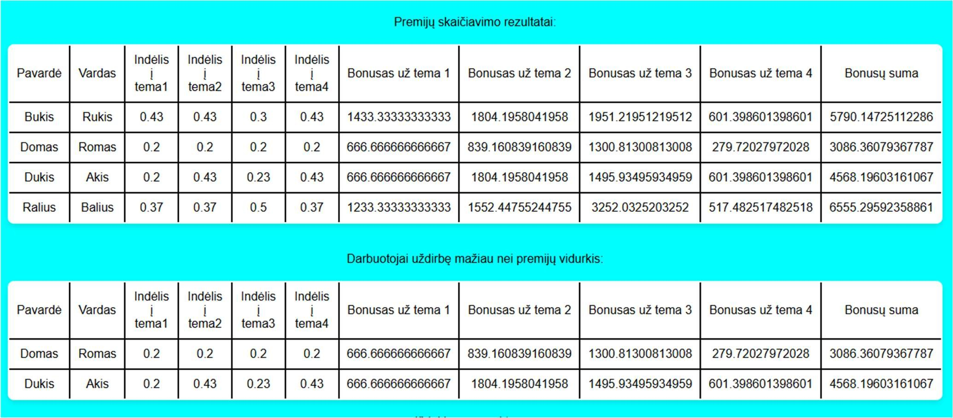

Pav. 7 Rezultatai

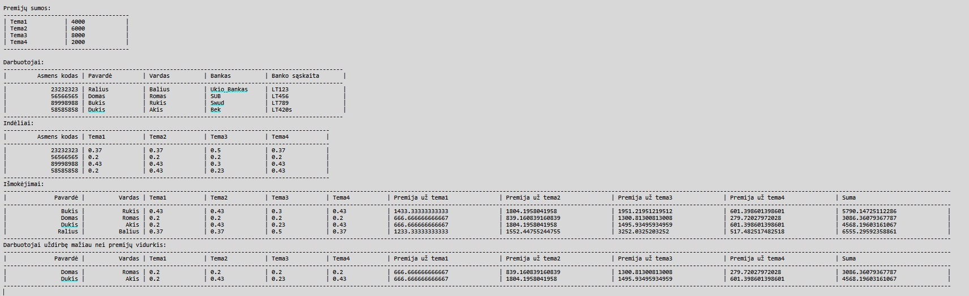

Pav. 8 Rezultatai faile
Duomenys nr. 2 U6a.txt

23232323;Ralius;Balius;Ukio_Bankas;LT123 56566565;Domas;Romas;SUB;LT456

89998988;Bukis;Rukis;Swud;LT789 58585858;Dukis;Akis;Bek;LT420 U6b.txt

4000;6000;8000;2000

23232323;1;2;3;4

56566565;6;6;7;8

89998988;9;10;11;12

58585858;3;4;5;8

Duomenys su skirtingais koeficientais.

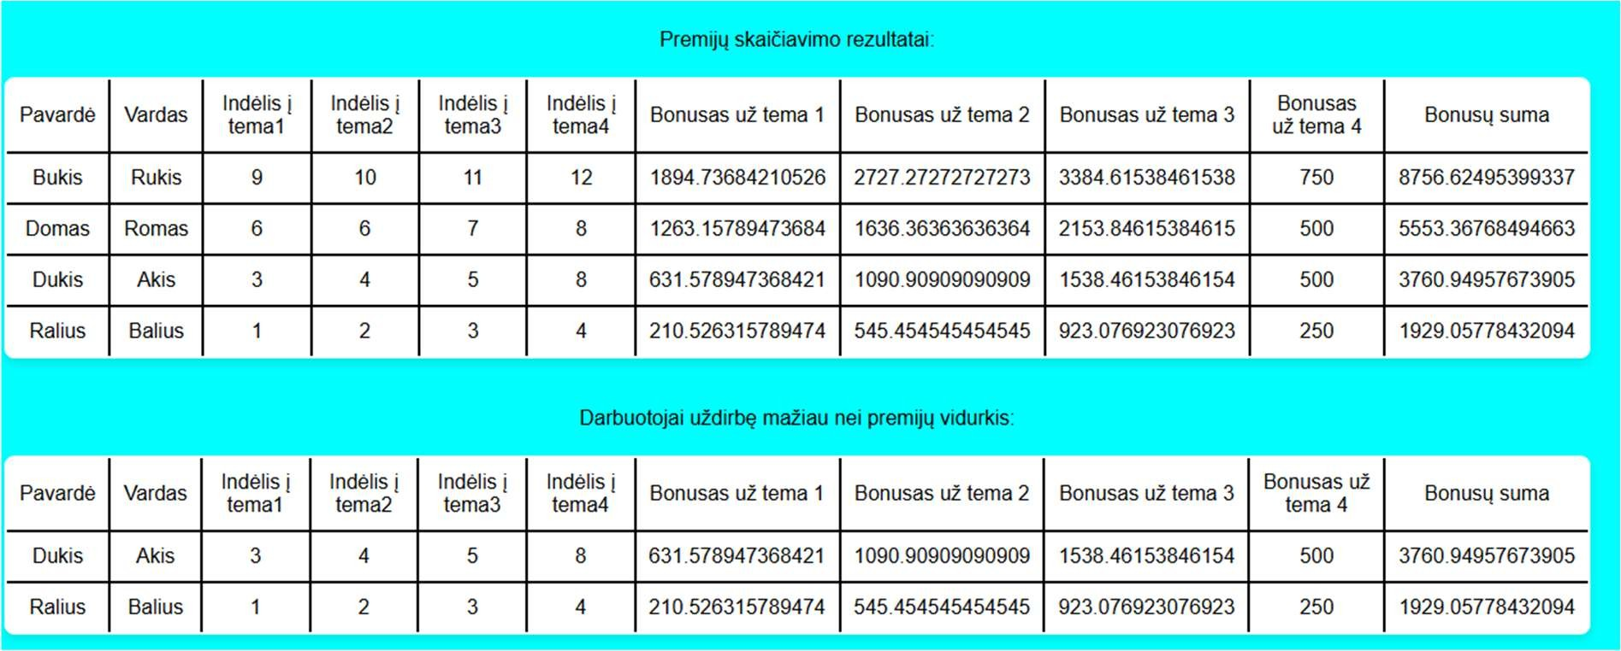

Pav. 9 Rezultatai

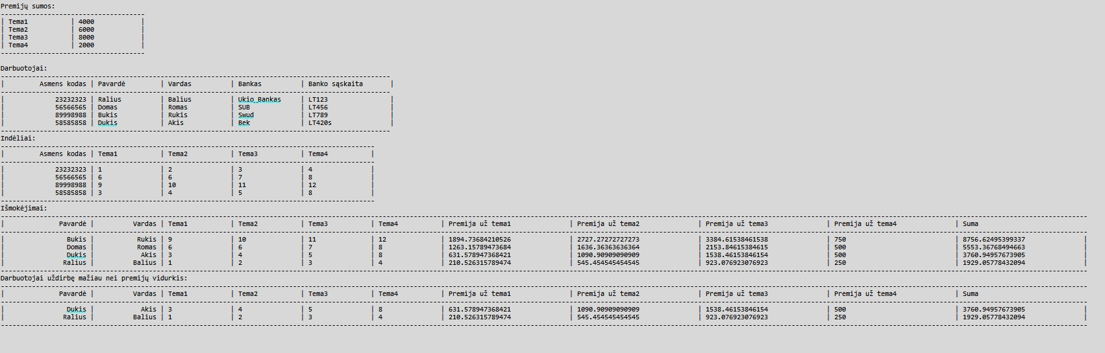

Pav. 10 Rezultatai faile
Duomenys nr. 3 U6a.txt

23232323;A;C;Ukio_Bankas;LT123

56566565;A;A;SUB;LT456

89998988;B;A;Swud;LT789

58585858;A;B;Bek;LT420
U6b.txt

4000;6000;8000;2000

23232323;1;2;3;4

56566565;6;6;7;8

89998988;9;10;11;12

58585858;3;4;5;8

Duomenys tikrina rikiavimą.

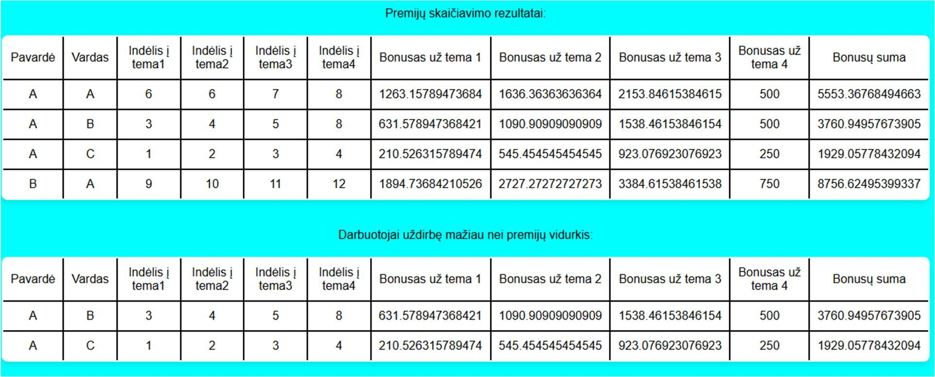

Pav. 11 Rezultatai

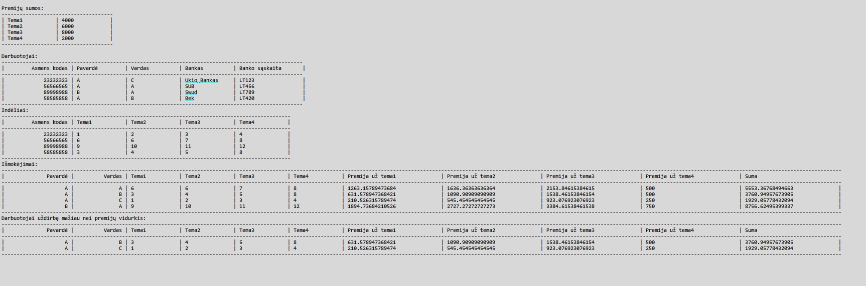

Pav. 12 Rezultatai faile

Dėstytojo pastabos

Vidiniai linked list klasės metodai negali nadoti sąsajos metodų;

Duomenų klasėje esantys vienkrypčiai sąrašai turi būti private;

Sum turi būti skaičiuojamas automatiškai;

SumCalc() metodas neturi grąžinti reikšmės;

Bendrinės klasės ir testavimas (L3)

Darbo užduotis

LD_6. Premijos. Moksliniai darbuotojai atliko darbus 4 skirtingose temose. Visos temos gavo premijas. Remiantis darbuotojų indėliais, suskaičiuokite kiekvienam darbuotojui priklausančios premijos dydį pagal kiekvieną temą atskirai ir bendrą premijų sumą. Darbuotojo indėlis rodo, kokia premijos dalis jam priklauso. Indėlis gali būti išreikštas bet kokiu skaičiumi. Bet tas pats matas naudojamas visiems darbuotojams. Neišdalinkite pinigų daugiau, negu turite, ir turite išdalinti visus pinigus. Sudarykite sąrašą darbuotojų (pavardė, vardas, darbuotojo indėliai, darbuotojo premijų dydžiai pagal temas, bendra premijų sumą), kurie uždirbo mažiau už vidurkį.
Duomenys:
• Tekstiniame faile U6a.txt duota informacija apie darbuotojus: darbuotojų asmens kodai, pavardės, vardai, banko pavadinimas, sąskaitos numeris.
• Tekstiniame faile U6b.txt duota informacija apie indėlius į darbą: pirmoje eilutėje - premijų dydžiai, tolesnėse eilutėse - darbuotojų asmens kodai, darbuotojų indėliai, kurie išreikšti naudingumo koeficientu, į eilinę temą. Informacija apie darbuotoją užima vieną eilutę.
Spausdinamas sąrašas turi būti surikiuotas pagal darbuotojų pavardes, vardus abėcėlės tvarka ir bendrą premijų sumą didėjimo tvarka. Sudarykite nurodytos temos (įvedama klaviatūra) darbuotojų uždarbių sąrašą (pavardė, vardas, darbuotojo indėliai, darbuotojo premijų dydžiai pagal temas, bendra premijų sumą).

Grafinės naudotojo sąsajos schema

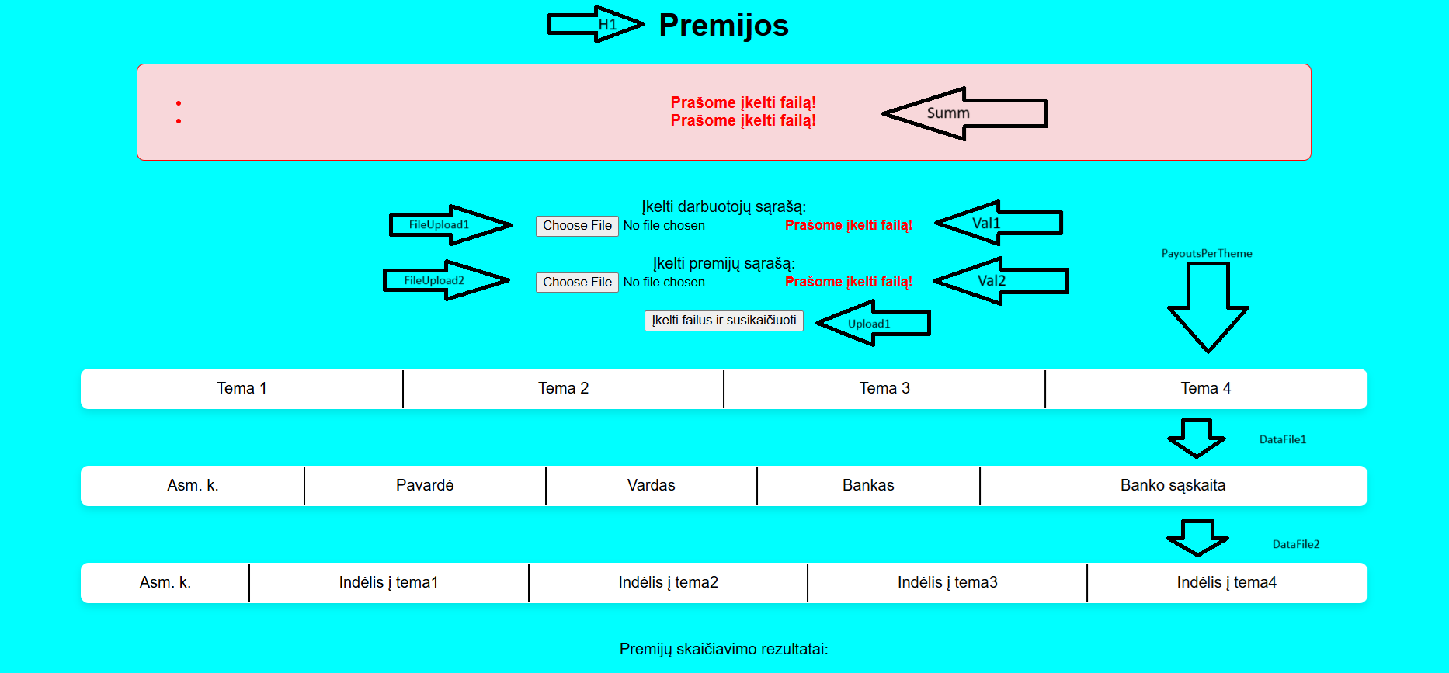

Pav. 13 GUI schema
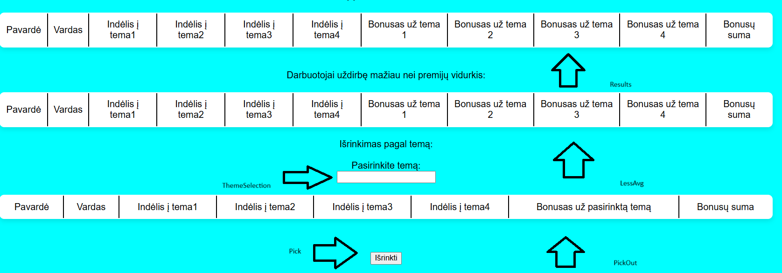

Pav.14 GUI schema

Sąsajoje panaudotų komponentų keičiamos savybės

Komponentas | Savybė | Reikšmė
H1 | Text | Premijos
Summ | CssClass | Summ
Val1 | ControlToValidate | FileUpload1
 | ErrorMessage | Prašome įkelti failą!
 | CssClass | Val1
Val2 | ControlToValidate | FileUpload2
 | ErrorMessage | Prašome įkelti failą!
 | CssClass | Val2
Upload1 | Text | Įkelti ir suskaičiuoti

Klasių diagrama

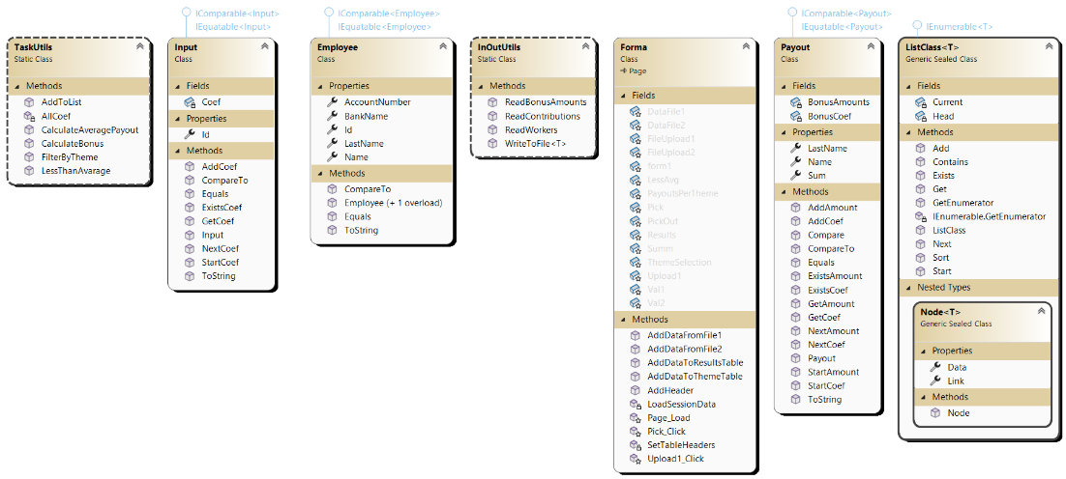

Pav.15 Klasių diagrama

Programos naudotojo vadovas

Atisdarius programą reikia įkelti failus, kurie turi informaciją apie darbuotojus ir failą, kuris turi informaciją apie darbuotojų indėlius bei premijų dydžius. Įkėlus failus spaudžiamas mygtukas „Įkelti ir suskaičiuoti“. Programa automatiškai paskirsto premijas, pagal darbuotojų indėlius. Dar kartą įkėlus failus ir įvedus norimą temą, yra galimybė išfiltruoti pagal pasirinktą temą.

Programos tekstas

Employee.cs

using System;
using System.Collections.Generic;
using System.Linq;
using System.Web;

namespace Lab3
{
/// <summary>
/// Employee object class.
/// </summary>
public class Employee : IComparable<Employee>, IEquatable<Employee>
{
public int Id { get; set; }
public string LastName { get; set; }
public string Name { get; set; }
public string BankName { get; set; }
public string AccountNumber { get; set; }

/// <summary>
/// Default constructor for object.
/// </summary>
public Employee() { }
/// <summary>
/// Constructor for object.
/// </summary>
/// <param name="id">Id of a person.</param>
/// <param name="lastname">Last name of a person.</param>
/// <param name="name">Name of a person.</param>
/// <param name="bankname">Bank name of a person.</param>
/// <param name="accountnumber">Account number of person.</param>

public Employee(int id, string lastname, string name, string bankname, string accountnumber)
{
this.Id = id;
this.LastName = lastname;
this.Name = name;
this.BankName = bankname;
this.AccountNumber = accountnumber;
}

/// <summary>
/// ToString override for formatting.
/// </summary>
/// <returns>Formatted string.</returns>
public override string ToString()
{
return string.Format($" {Id,20} | {LastName,-15} | {Name,-15} | {BankName,-15} | {AccountNumber,-20} ");
}

/// <summary>
/// Compares two Employee objects by Id.
/// </summary>
/// <param name="other">other Employee object.</param>
/// <returns>-1 ,0 or 1 depending on comparison the values</returns>
public int CompareTo(Employee other)
{
return this.Id.CompareTo(other.Id);
}

/// <summary>
/// Compares two Employee objects by Id.
/// </summary>
/// <param name="other">other Employee object</param>
/// <returns>true or false depending on the values</returns>

public bool Equals(Employee other)
{
return this.Id.Equals(other.Id);
}
}
}

Input.cs

using System;
using System.Collections.Generic;
using System.Linq;
using System.Web;

namespace Lab3
{
/// <summary>
/// Input object class.
/// </summary>
public class Input : IComparable<Input>, IEquatable<Input>
{
public int Id { get; set; }
private ListClass<double> Coef;

/// <summary>
/// Constructor for object.
/// </summary>
/// <param name="id">ID of a person.</param>
/// <param name="bonuses">Bonus linked list for storing bonus amounts.</param>
public Input(int id, ListClass<double> bonuses)
{
this.Id = id;
this.Coef = bonuses;
}

/// <summary>
/// Starts the linked list for coeficients.
/// </summary>

public void StartCoef()
{
Coef.Start();
}

/// <summary>
/// Checks if the linked list for coeficients exists.
/// </summary>
/// <returns>True or false depening on existance of a value.</returns>

public bool ExistsCoef()
{
return Coef.Exists();
}

/// <summary>
/// Moves to the next coeficient in the linked list.
/// </summary>

public void NextCoef()
{
Coef.Next();
}

/// <summary>
/// Gets the current coeficient from the linked list.
/// </summary>
/// <returns>Gets node data.</returns>

public double GetCoef()
{
return Coef.Get();
}

/// <summary>
/// Adds a coeficient to the linked list.
/// </summary>
/// <param name="value">Value to add.</param>

public void AddCoef(double value)
{
Coef.Add(value);
}

/// <summary>
/// Compares two Input objects by Id.
/// </summary>
/// <param name="other">Other Input object.</param>
/// <returns></returns>

public int CompareTo(Input other)
{
return this.Id.CompareTo(other.Id);
}

/// <summary>
/// Compares two Input objects by Id.
/// </summary>
/// <param name="other">Other Input object.</param>
/// <returns>True or false depending on values.</returns>
public bool Equals(Input other)
{
return this.Id.Equals(other.Id);
}

/// <summary>
/// ToString override for formatting.
/// </summary>
/// <returns>Foramted string</returns>

public override string ToString()
{
Coef.Start();
string firstCoef = Coef.Get().ToString();
Coef.Next();
string secondCoef = Coef.Get().ToString();
Coef.Next();
string thirdCoef = Coef.Get().ToString();
Coef.Next();
string fourthCoef = Coef.Get().ToString();

return string.Format($"{this.Id,20} | {firstCoef,-15} | {secondCoef,-15} | {thirdCoef,-15} | {fourthCoef,-15} ");
}
}
}

Payout.cs

using System;
using System.Collections.Generic;
using System.Linq;
using System.Web;

namespace Lab3
{
public class Payout : IComparable<Payout>, IEquatable<Payout>
{
/// <summary>
/// Class for Payout object.
/// </summary>

public string LastName { get; set; }
public string Name { get; set; }
private ListClass<double> BonusCoef;
private ListClass<double> BonusAmounts;
public double Sum { get; set; }

/// <summary>
/// Constructor for object.
/// </summary>
/// <param name="lastname">Last name of a person.</param>
/// <param name="name">Name of a person.</param>
/// <param name="bonusCoef">Linked list for all coeficients.</param>
/// <param name="bonusAmounts">Linked list for bonus amounts.</param>

public Payout(string lastname, string name)
{
this.LastName = lastname;
this.Name = name;
this.BonusCoef = new ListClass<double>();
this.BonusAmounts = new ListClass<double>();
this.Sum = 0;
}
/// <summary>
/// Adds a coeficient to the linked list.
/// </summary>
public void StartCoef()
{
BonusCoef.Start();
}
/// <summary>
/// Checks if the linked list for coeficients exists.
/// </summary>
/// <returns></returns>
public bool ExistsCoef()
{
return BonusCoef.Exists();
}
/// <summary>
/// Moves to the next coeficient in the linked list.
/// </summary>
public void NextCoef()
{
BonusCoef.Next();
}
/// <summary>
/// Gets the current coeficient from the linked list.
/// </summary>
/// <returns></returns>
public double GetCoef()
{
return BonusCoef.Get();
}
/// <summary>
/// Adds a coeficient to the linked list.
/// </summary>
/// <param name="value"></param>
public void AddCoef(double value)
{
BonusCoef.Add(value);
}
/// <summary>
/// Adds a bonus amount to the linked list.
/// </summary>
public void StartAmount()
{
BonusAmounts.Start();
}
/// <summary>
/// Checks if the linked list for bonus amounts exists.
/// </summary>
/// <returns></returns>
public bool ExistsAmount()
{
return BonusAmounts.Exists();
}
/// <summary>
/// Moves to the next bonus amount in the linked list.
/// </summary>
public void NextAmount()
{
BonusAmounts.Next();
}
/// <summary>
/// Gets the current bonus amount from the linked list.
/// </summary>
/// <returns></returns>
public double GetAmount()
{
return BonusAmounts.Get();
}
/// <summary>
/// Adds a bonus amount to the linked list.
/// </summary>
/// <param name="value"></param>
public void AddAmount(double value)
{
Sum += value;
BonusAmounts.Add(value);
}

/// <summary>
/// Compares node data.
/// </summary>
/// <param name="other">Other node data.</param>
/// <returns>True if they are the same false otherwise.</returns>
public bool Compare(Payout other)
{
if (other.Name == Name && other.LastName == LastName)
{
return true;
}
return false;
}

/// <summary>
/// Compares two node data.
/// </summary>
/// <param name="other">Other node data.</param>
/// <returns></returns>
public int CompareTo(Payout other)
{
int lastNameComp = string.Compare(this.LastName, other.LastName, StringComparison.OrdinalIgnoreCase);
if (lastNameComp != 0)
{
return lastNameComp;
}

int nameComp = string.Compare(this.Name, other.Name, StringComparison.OrdinalIgnoreCase);
if (nameComp != 0)
{
return nameComp;
}

return this.Sum.CompareTo(other.Sum);
}
/// <summary>
/// Checks if two node data are equal.
/// </summary>
/// <param name="other">Other Payout node.</param>
/// <returns></returns>
public bool Equals(Payout other)
{
return this.Name.Equals(other.Name) && this.LastName.Equals(other.LastName);
}
/// <summary>
/// ToString override for formatting.
/// </summary>
/// <returns>Formated string.</returns>
public override string ToString()
{
BonusCoef.Start();
string firstCoef = BonusCoef.Get().ToString();
BonusCoef.Next();
string secondCoef = BonusCoef.Get().ToString();
BonusCoef.Next();
string thirdCoef = BonusCoef.Get().ToString();
BonusCoef.Next();
string fourthCoef = BonusCoef.Get().ToString();

BonusAmounts.Start();
string firstam = BonusAmounts.Get().ToString();
BonusAmounts.Next();
string secondam = BonusAmounts.Get().ToString();
BonusAmounts.Next();
string thirdam = BonusAmounts.Get().ToString();
BonusAmounts.Next();
string fourtham = BonusAmounts.Get().ToString();

return string.Format($"{LastName,20} | {Name,15} | {firstCoef,-15} | {secondCoef,-15} |" +
$" {thirdCoef,-15} | {fourthCoef,-15} | {firstam,-30} | {secondam,-30} |" +
$" {thirdam,-30} | {fourtham,-30} | {Sum,-30}");
}
}
}

Payout.cs

using System;
using System.Collections;
using System.Collections.Generic;

namespace Lab3
{
/// <summary>
/// Class for linked list.
/// </summary>
/// <typeparam name="T">Generic object type.</typeparam>
public sealed class ListClass<T> : IEnumerable<T> where T : IComparable<T>, IEquatable<T>
{
/// <summary>
/// Node class for linked list.
/// </summary>
private sealed class Node<T>
{
public T Data { get; set; }
public Node<T> Link { get; set; }

/// <summary>
/// Constructor for node.
/// </summary>
/// <param name="data">Data to add.</param>
/// <param name="next">Pointer to next node.</param>

public Node(T data, Node<T> next)
{
this.Data = data;
this.Link = next;
}
}

Node<T> Head;
Node<T> Current;

/// <summary>
/// Constructor for linked list.
/// </summary>
public ListClass()
{
Head = null;
Current = null;
}
/// <summary>
/// Adds a new node to the end of the linked list.
/// </summary>
/// <param name="value"></param>
public void Add(T value)
{
Node<T> newNode = new Node<T>(value, null);

if (Head == null)
{
Head = newNode;
return;
}

Node<T> current = Head;
while (current.Link != null)
{
current = current.Link;
}

current.Link = newNode;
}
/// <summary>
/// Starts the linked list.
/// </summary>
public void Start()
{
Current = Head;
}
/// <summary>
/// Moves to the next node in the linked list.
/// </summary>
public void Next()
{
Current = Current.Link;
}
/// <summary>
/// Checks if the current node exists.
/// </summary>
/// <returns>True if exists, else false.</returns>
public bool Exists()
{
return Current != null;
}
/// <summary>
/// Gets the current node data.
/// </summary>
/// <returns>Data of a node.</returns>
public T Get()
{
return Current.Data;
}
/// <summary>
/// Adds a new node to the start of the linked list.
/// </summary>
/// <param name="node">Node to check.</param>
/// <returns>True if contains, else false.</returns>
public bool Contains(T node)
{
Node<T> current = Head;
while (current != null)
{
if (current.Data.Equals(node))
{
return true;
}
current = current.Link;
}
return false;
}
/// <summary>
/// Sorts the linked list using selection sort.
/// </summary>
public void Sort()
{
for (Node<T> outer = Head; outer != null; outer = outer.Link)
{
Node<T> min = outer;
for (Node<T> inner = outer.Link; inner != null; inner = inner.Link)
{
if (inner.Data.CompareTo(min.Data) < 0)
{
min = inner;
}
}

if (min != outer)
{
T temp = outer.Data;
outer.Data = min.Data;
min.Data = temp;
}
}
}
/// <summary>
/// Gets the count of nodes in the linked list.
/// </summary>
/// <returns></returns>
public IEnumerator<T> GetEnumerator()
{
Node<T> current = Head;
while (current != null)
{
yield return current.Data;
current = current.Link;
}
}
/// <summary>
/// Gets the count of nodes in the linked list.
/// </summary>
/// <returns></returns>
IEnumerator IEnumerable.GetEnumerator()
{
return GetEnumerator();
}
}
}
InOutUtils.cs
using System;
using System.Collections.Generic;
using System.IO;
using System.Linq;
using System.Runtime.Remoting.Messaging;
using System.Web;

namespace Lab3
{
/// <summary>
/// Class that handles all inputs and outputs.
/// </summary>
static class InOutUtils
{
/// <summary>
/// Generic method that writes to a file.
/// </summary>
/// <typeparam name="T">Generic object type from the project.</typeparam>
/// <param name="fileName">File to write to.</param>
/// <param name="List">Generic list to write from.</param>
/// <param name="Header">Header line for the table.</param>
/// <param name="TableHeader">Table header.</param>
/// <param name="ws">Spaces for '-' symbol.</param>
public static void WriteToFile<T>(string fileName, IEnumerable<T> List, string Header, string TableHeader, int ws) where T : IEquatable<T>, IComparable<T>
{
using (StreamWriter writer = File.AppendText(fileName))
{
writer.WriteLine(Header);
writer.WriteLine(new string('-', ws));
writer.WriteLine(TableHeader);
writer.WriteLine(new string('-', ws));
foreach (T obj in List)
{
writer.WriteLine($"| {obj.ToString(),-10} |");
}
writer.WriteLine(new string('-', ws));
writer.WriteLine();
}

}

/// <summary>
/// Reads all workers.
/// </summary>
/// <param name="fileContetnt">File content.</param>
/// <returns>Worker linked list.</returns>

public static ListClass<Employee> ReadWorkers(Stream fileContetnt)
{
ListClass<Employee> list = new ListClass<Employee>();
using (StreamReader reader = new StreamReader(fileContetnt))
{
string line;
while ((line = reader.ReadLine()) != null)
{
string[] Values = line.Split(';');
int ID = int.Parse(Values[0]);
string LastName = Values[1];
string Name = Values[2];
string BankName = Values[3];
string BankAccountNum = Values[4];
Employee w = new Employee(ID, LastName, Name, BankName, BankAccountNum);
list.Add(w);
}
}
return list;
}

/// <summary>
/// Reads all contributions.
/// </summary>
/// <param name="FileContent">Content of a file.</param>
/// <returns>ContList linked list.</returns>
public static ListClass<Input> ReadContributions(Stream FileContent)
{
ListClass<Input> list = new ListClass<Input>();
using (StreamReader reader = new StreamReader(FileContent))
{

reader.ReadLine();
string line;
while ((line = reader.ReadLine()) != null)
{
string[] Values = line.Split(';');
int ID = int.Parse(Values[0]);
ListClass<double> contributionValuesList = new ListClass<double>();
foreach (var amount in Values.Skip(1))
{
double value = Double.Parse(amount);
contributionValuesList.Add(value);
}
Input c = new Input(ID, contributionValuesList);
list.Add(c);
}
}
return list;
}
/// <summary>
/// Reads all bonuses from first line of a file.
/// </summary>
/// <param name="FileContent">File content.</param>
/// <returns>Linked list of all bonuses.</returns>

public static ListClass<double> ReadBonusAmounts(Stream FileContent)
{
ListClass<double> list = new ListClass<double>();
using (StreamReader reader = new StreamReader(FileContent))
{
string bonuses = reader.ReadLine();
string[] Values = bonuses.Split(';');
foreach (var value in Values)
{
double bonus = double.Parse(value);
list.Add(bonus);
}
}
return list;
}
}
}
TaskUtils.cs

using System;
using System.Collections.Generic;
using System.Linq;
using System.Text.RegularExpressions;
using System.Web;

namespace Lab3
{
public static class TaskUtils
{
/// <summary>
/// Creates a list of new payout objects.
/// </summary>
/// <param name="inputs">Input coeficients.</param>
/// <param name="employees">Employees linked list.</param>
/// <returns>Linked list of payout objects.</returns>
public static ListClass<Payout> AddToList(ListClass<Input> inputs, ListClass<Employee> employees)
{
ListClass<Payout> payoutList = new ListClass<Payout>();
for (employees.Start(); employees.Exists(); employees.Next())
{
Employee employee = employees.Get();
for (inputs.Start(); inputs.Exists(); inputs.Next())
{
Input input = inputs.Get();
if (input.Id == employee.Id)
{
Payout p = new Payout(employee.LastName, employee.Name);
for (input.StartCoef(); input.ExistsCoef(); input.NextCoef())
{
p.AddCoef(input.GetCoef());
}
if (!payoutList.Contains(p))
{
payoutList.Add(p);
}
}
}

}
return payoutList;
}

/// <summary>
/// Calculates bonus for each worker and each theme.
/// </summary>
/// <param name="inputs">Input coeficients.</param>
/// <param name="employees">Employees linked list.</param>
/// <param name="bonuses">Bonus linked list.</param>
/// <returns>Linked list with payout objects.</returns>
public static ListClass<Payout> CalculateBonus(ListClass<Payout> payouts, ListClass<double> bonuses, ListClass<Input> inputs)
{
payouts.Start();
while (payouts.Exists())
{
Payout payout = payouts.Get();
bonuses.Start();
payout.StartCoef();
int themeNumber = 0;

while (bonuses.Exists())
{
double totalCoef = AllCoef(inputs, themeNumber);
double bonusAmount = 0;

if (totalCoef > 0)
{
bonusAmount = (payout.GetCoef() / totalCoef) * bonuses.Get();
}

payout.AddAmount(bonusAmount);
bonuses.Next();
payout.NextCoef();
themeNumber++;
}

payouts.Next();
}

return payouts;
}

/// <summary>
/// Calculates sum of coeficients for each theme.
/// </summary>
/// <param name="inputs">Input coeficients.</param>
/// <param name="themeNumber">Theme number.</param>
/// <returns></returns>
private static double AllCoef(ListClass<Input> inputs, int themeNumber)
{
double coefs = 0;

for (inputs.Start(); inputs.Exists(); inputs.Next())
{
var bonusList = inputs.Get();
bonusList.StartCoef();
for (int i = 0; i < themeNumber; i++)
{
if (!bonusList.ExistsCoef()) break;
bonusList.NextCoef();
}

if (bonusList.ExistsCoef())
{
coefs += bonusList.GetCoef();
}
}

return coefs;
}
/// <summary>
/// Picks out objects that have sum smaller than average sum.
/// </summary>
/// <param name="payouts">Payout linked list.</param>
/// <returns>Payout linked list with objects that have smaller sums than average.</returns>
public static ListClass<Payout> LessThanAvarage(ListClass<Payout> payouts, double avg)
{
ListClass<Payout> lessthanaverage = new ListClass<Payout>();
for (payouts.Start(); payouts.Exists(); payouts.Next())
{
Payout p = payouts.Get();
if (p.Sum < avg)
{
lessthanaverage.Add(p);
}
}
return lessthanaverage;
}

/// <summary>
/// Calculates average of a bonus.
/// </summary>
/// <param name="payouts">Whole payout linked list.</param>
/// <returns>Avergae of bonus sums.</returns>
public static double CalculateAveragePayout(ListClass<Payout> payouts)
{
double sum = 0;
int count = 0;
for (payouts.Start(); payouts.Exists(); payouts.Next())
{
Payout p = payouts.Get();
sum += p.Sum;
count++;
}
return sum / count;
}
/// <summary>
/// Filters payout objects by theme.
/// </summary>
/// <param name="Theme">Theme selected.</param>
/// <param name="payouts">Linked list with all objects.</param>
/// <returns>Payout linkedlist with only amount of selected theme.</returns>
public static ListClass<Payout> FilterByTheme(string Theme, ListClass<Payout> payouts)
{
ListClass<Payout> filtered = new ListClass<Payout>();

string[] values = Theme.Split(' ');
int value = int.Parse(values[1]) - 1;

for (payouts.Start(); payouts.Exists(); payouts.Next())
{
Payout p = new Payout(payouts.Get().LastName, payouts.Get().Name);
payouts.Get().StartAmount();
for (int i = 0; i < value; i++)
{
payouts.Get().NextAmount();
}
p.AddAmount(payouts.Get().GetAmount());
p.Sum = payouts.Get().Sum;
for (payouts.Get().StartCoef(); payouts.Get().ExistsCoef(); payouts.Get().NextCoef())
{
p.AddCoef(payouts.Get().GetCoef());
}
filtered.Add(p);
}
return filtered;
}

}
}

Forma.aspx
<%@ Page Language="C#" AutoEventWireup="true" CodeBehind="Form.aspx.cs" Inherits="Lab3.Forma" %>

<!DOCTYPE html>

<html xmlns="http://www.w3.org/1999/xhtml">
<head runat="server">
<title></title>
<link rel="stylesheet" type="text/css" href="styles.css" />
</head>
<body>
<form id="form1" runat="server">

<h1>Premijos</h1>
<div>
<asp:ValidationSummary ID="Summ" runat="server" CssClass="Summ" />
<br />
Įkelti darbuotojų sąrašą:<br />
<asp:FileUpload ID="FileUpload1" runat="server" />
<asp:RequiredFieldValidator ID="Val1" runat="server" ControlToValidate="FileUpload1" ErrorMessage="Prašome įkelti failą!" CssClass="val1"></asp:RequiredFieldValidator>
<br />
<br />
Įkelti premijų sąrašą:<br />
<asp:FileUpload ID="FileUpload2" runat="server" />
<asp:RequiredFieldValidator ID="Val2" runat="server" ControlToValidate="FileUpload2" ErrorMessage="Prašome įkelti failą!" CssClass="val2"></asp:RequiredFieldValidator>
<br />
<br />
<asp:Button ID="Upload1" runat="server" Text="Įkelti failus ir susikaičiuoti" OnClick="Upload1_Click" />
<br />
<br />
<asp:Table ID="PayoutsPerTheme" runat="server"></asp:Table>
<br />
<asp:Table ID="DataFile1" runat="server"></asp:Table>
<br />
<asp:Table ID="DataFile2" runat="server"></asp:Table>
<br />
Premijų skaičiavimo rezultatai:<br />
<asp:Table ID="Results" runat="server">
</asp:Table>
<br />
Darbuotojai uždirbę mažiau nei premijų vidurkis:<br />
<asp:Table ID="LessAvg" runat="server">
</asp:Table>
Išrinkimas pagal temą:<br />
<br />
Pasirinkite temą: <br />
<asp:TextBox ID="ThemeSelection" runat="server"></asp:TextBox>
<br />
<asp:Table ID="PickOut" runat="server">
</asp:Table>
<br />
<br />
<asp:Button ID="Pick" runat="server" OnClick="Pick_Click" Text="Išrinkti" />
</div>
</form>
</body>
</html>
Form.aspx.cs
using System;
using System.Collections.Generic;
using System.IO;
using System.Linq;
using System.Web;
using System.Web.Hosting;
using System.Web.UI;
using System.Web.UI.WebControls;

namespace Lab3
{
public partial class Forma : System.Web.UI.Page
{
protected void Page_Load(object sender, EventArgs e)
{
SetTableHeaders();
LoadSessionData();
}

private void SetTableHeaders()
{
string[] headers;

headers = new string[] { "Tema 1", "Tema 2", "Tema 3", "Tema 4" };
AddHeader(headers, PayoutsPerTheme);

headers = new string[] { "Asm. k.", "Pavardė", "Vardas", "Bankas", "Banko sąskaita" };
AddHeader(headers, DataFile1);

headers = new string[] { "Asm. k.", "Indėlis į tema1", "Indėlis į tema2", "Indėlis į tema3", "Indėlis į tema4" };
AddHeader(headers, DataFile2);

headers = new string[] { "Pavardė", "Vardas", "Indėlis į tema1",
"Indėlis į tema2", "Indėlis į tema3", "Indėlis į tema4", "Bonusas už tema 1", "Bonusas už tema 2",
"Bonusas už tema 3", "Bonusas už tema 4", "Bonusų suma" };
AddHeader(headers, Results);
AddHeader(headers, LessAvg);

headers = new string[] { "Pavardė", "Vardas", "Indėlis į tema1",
"Indėlis į tema2", "Indėlis į tema3", "Indėlis į tema4", "Bonusas už pasirinktą temą", "Bonusų suma" };
AddHeader(headers, PickOut);

}

private void LoadSessionData()
{
if (Session["Bonuses"] is ListClass<double> bonuses)
{
AddDataToThemeTable(bonuses);
}

if (Session["Workers"] is ListClass<Employee> workers)
{
AddDataFromFile1(workers);
}

if (Session["Contributions"] is ListClass<Input> contributions)
{
AddDataFromFile2(contributions);
}

if (Session["Payouts"] is ListClass<Payout> payouts)
{
AddDataToResultsTable(payouts, Results);
}

if (Session["Less"] is ListClass<Payout> LessThanAverage)
{
AddDataToResultsTable(LessThanAverage, LessAvg);
}
}

protected void Upload1_Click(object sender, EventArgs e)
{
ListClass<double> bonuses = new ListClass<double>();
ListClass<Employee> workers = new ListClass<Employee>();
ListClass<Input> contributions = new ListClass<Input>();

if (FileUpload1.HasFile)
{
workers = InOutUtils.ReadWorkers(FileUpload1.FileContent);
Session["Workers"] = workers;
}

if (FileUpload2.HasFile)
{
using (MemoryStream memStream = new MemoryStream())
{
FileUpload2.FileContent.CopyTo(memStream);
memStream.Position = 0;

using (MemoryStream firstReadStream = new MemoryStream(memStream.ToArray()))
{
contributions = InOutUtils.ReadContributions(firstReadStream);
Session["Contributions"] = contributions;
}

memStream.Position = 0;

using (MemoryStream secondReadStream = new MemoryStream(memStream.ToArray()))
{
bonuses = InOutUtils.ReadBonusAmounts(secondReadStream);
Session["Bonuses"] = bonuses;
}
}
}

AddDataToThemeTable(bonuses);
AddDataFromFile1(workers);
AddDataFromFile2(contributions);
ListClass<Payout> payoutsList = TaskUtils.AddToList(contributions, workers);
ListClass<Payout> payouts = TaskUtils.CalculateBonus(payoutsList, bonuses, contributions);
payouts.Sort();
Session["Payouts"] = payouts;
AddDataToResultsTable(payouts, Results);
double avg = TaskUtils.CalculateAveragePayout(payouts);
ListClass<Payout> LessThanAverage = TaskUtils.LessThanAvarage(payouts, avg);
LessThanAverage.Sort();
Session["Less"] = LessThanAverage;
AddDataToResultsTable(LessThanAverage, LessAvg);

string basepath = AppDomain.CurrentDomain.BaseDirectory;
string filePath = Path.Combine(basepath, "ExternalData.txt");
if (File.Exists(filePath)) { File.Delete(filePath); }
InOutUtils.WriteToFile(filePath, bonuses, "Premijų sumos: ", $"| {"Sumos" ,-10} |", 15);
InOutUtils.WriteToFile(filePath, workers, "Darbuotojai: ", $"| {"Asmens kodas",20} |" +
$" {"Pavardė",-15} | {"Vardas",-15} | {"Bankas",-15} | {"Banko sąskaita",-20} | ", 100);
InOutUtils.WriteToFile(filePath, contributions, "Indėliai: ", $"| {"Asmens kodas",20} | {"Tema1",-15} |" +
$" {"Tema2",-15} | {"Tema3",-15} | {"Tema4",-15} | ", 96);
InOutUtils.WriteToFile(filePath, payouts, "Išmokėjimai: ", $"| {"Pavardė",20} | {"Vardas",15} | {"Tema1",-15} | {"Tema2",-15} |" +
$" {"Tema3",-15} | {"Tema4",-15} | {"Premija už tema1",-30} | {"Premija už tema2",-30} |" +
$" {"Premija už tema3",-30} | {"Premija už tema4",-30} | {"Suma",-30} |" , 279);

InOutUtils.WriteToFile(filePath, LessThanAverage, "Darbuotojai uždirbę mažiau nei premijų vidurkis: ", $"| {"Pavardė",20} | {"Vardas",15} | {"Tema1",-15} | {"Tema2",-15} |" +
$" {"Tema3",-15} | {"Tema4",-15} | {"Premija už tema1",-30} | {"Premija už tema2",-30} |" +
$" {"Premija už tema3",-30} | {"Premija už tema4",-30} | {"Suma",-30} |", 279);

}

protected void Pick_Click(object sender, EventArgs e)
{
string ParsedTheme = ThemeSelection.Text;

if (ParsedTheme == "Tema 1" || ParsedTheme == "Tema 2" || ParsedTheme == "Tema 3" || ParsedTheme == "Tema 4")
{
ListClass<Payout> filteredByTheme = TaskUtils.FilterByTheme(ParsedTheme, (ListClass<Payout>)Session["Payouts"]);
AddDataToResultsTable(filteredByTheme, PickOut);
}

}
}
}

FormaMethods.aspx.cs

using System;
using System.Collections.Generic;
using System.Linq;
using System.Web;
using System.Web.UI.WebControls;

namespace Lab3
{
public partial class Forma : System.Web.UI.Page
{
/// <summary>
/// Sets all headers for tables.
/// </summary>
/// <param name="headers">Headers in array</param>
/// <param name="table">Table to set to.</param>

public void AddHeader(string[] headers, Table table)
{
TableRow headerRow = new TableRow();
foreach (string header in headers)
{
TableCell cell = new TableCell();
cell.Text = header;
headerRow.Cells.Add(cell);
}
table.Rows.Add(headerRow);
}

/// <summary>
/// Adds bonus data to the table.
/// </summary>
/// <param name="bonuses">Linked list from which data is added from.</param>

public void AddDataToThemeTable(ListClass<double> bonuses)
{
TableRow row = new TableRow();
for (bonuses.Start(); bonuses.Exists(); bonuses.Next())
{
double curr = bonuses.Get();
TableCell cell = new TableCell();
cell.Text = curr.ToString();
row.Cells.Add(cell);
}
PayoutsPerTheme.Rows.Add(row);
}

/// <summary>
/// Adds employee data to the table.
/// </summary>
/// <param name="workers">Linked list from which data is added from.</param>

public void AddDataFromFile1(ListClass<Employee> workers)
{
for (workers.Start(); workers.Exists(); workers.Next())
{
TableRow row = new TableRow();
Employee curr = workers.Get();

TableCell idCell = new TableCell();
idCell.Text = curr.Id.ToString();
row.Cells.Add(idCell);

TableCell lastNameCell = new TableCell();
lastNameCell.Text = curr.LastName;
row.Cells.Add(lastNameCell);

TableCell firstNameCell = new TableCell();
firstNameCell.Text = curr.Name;
row.Cells.Add(firstNameCell);

TableCell bankNameCell = new TableCell();
bankNameCell.Text = curr.BankName;
row.Cells.Add(bankNameCell);

TableCell bankAccountCell = new TableCell();
bankAccountCell.Text = curr.AccountNumber;
row.Cells.Add(bankAccountCell);
DataFile1.Rows.Add(row);
}
}

/// <summary>
/// Adds input data to the table.
/// </summary>
/// <param name="conts">Linked list from which data is added from.</param>

public void AddDataFromFile2(ListClass<Input> conts)
{
for (conts.Start(); conts.Exists(); conts.Next())
{
TableRow row = new TableRow();

Input curr = conts.Get();

TableCell idCell = new TableCell();
idCell.Text = curr.Id.ToString();
row.Cells.Add(idCell);

for (curr.StartCoef(); curr.ExistsCoef(); curr.NextCoef())
{
TableCell cell = new TableCell();
cell.Text = curr.GetCoef().ToString();
row.Cells.Add(cell);
}
DataFile2.Rows.Add(row);
}
}

/// <summary>
/// Adds data to Results table.
/// </summary>
/// <param name="payoutlist">Linked list from which data is added from.</param>

public void AddDataToResultsTable(ListClass<Payout> payoutlist, Table table)
{

for (payoutlist.Start(); payoutlist.Exists(); payoutlist.Next())
{
TableRow row = new TableRow();
Payout curr = payoutlist.Get();

TableCell lastNameCell = new TableCell();
lastNameCell.Text = curr.LastName;
row.Cells.Add(lastNameCell);

TableCell firstNameCell = new TableCell();
firstNameCell.Text = curr.Name;
row.Cells.Add(firstNameCell);

for (curr.StartCoef(); curr.ExistsCoef(); curr.NextCoef())
{
TableCell tableCell = new TableCell();
tableCell.Text = curr.GetCoef().ToString();
row.Cells.Add(tableCell);
}
for (curr.StartAmount(); curr.ExistsAmount(); curr.NextAmount())
{
TableCell tableCell = new TableCell();
tableCell.Text = curr.GetAmount().ToString();
row.Cells.Add(tableCell);
}
TableCell SumCell = new TableCell();
SumCell.Text = curr.Sum.ToString();
row.Cells.Add(SumCell);
table.Rows.Add(row);
}

}
}
}

UnitTest1.cs

using Microsoft.VisualStudio.TestTools.UnitTesting;
using Lab3;
using System.Linq;

namespace Lab3Tests
{
[TestClass]
public class ListClassTestsEmployee
{
private Employee CreateEmployee(int id, string name)
{
return new Employee(id, name, "TestLastName", "TestBank", "LT123456789");
}

[TestMethod]
public void Add_SingleEmployee_ShouldContainEmployee()
{
var list = new ListClass<Employee>();
var employee = CreateEmployee(1, "Jonas");
list.Add(employee);

list.Start();
Assert.IsTrue(list.Exists());
Assert.AreEqual(employee, list.Get());
}

[TestMethod]
public void Add_MultipleEmployees_ShouldContainEmployeesInOrder()
{
var list = new ListClass<Employee>();
var employee1 = CreateEmployee(1, "Jonas");
var employee2 = CreateEmployee(2, "Pranas");
var employee3 = CreateEmployee(3, "Bomba");

list.Add(employee1);
list.Add(employee2);
list.Add(employee3);

list.Start();
Assert.AreEqual(employee1, list.Get());
list.Next();
Assert.AreEqual(employee2, list.Get());
list.Next();
Assert.AreEqual(employee3, list.Get());
}

[TestMethod]
public void Start_ShouldPointToFirstEmployee()
{
var list = new ListClass<Employee>();
var employee = CreateEmployee(1, "Romas");
list.Add(employee);

list.Start();
Assert.AreEqual(employee, list.Get());
}

[TestMethod]
public void Next_ShouldMoveToNextEmployee()
{
var list = new ListClass<Employee>();
var employee1 = CreateEmployee(1, "Tomas");
var employee2 = CreateEmployee(2, "Andrius");

list.Add(employee1);
list.Add(employee2);

list.Start();
list.Next();
Assert.AreEqual(employee2, list.Get());
}

[TestMethod]
public void Exists_ShouldReturnTrue_WhenEmployeeExists()
{
var list = new ListClass<Employee>();
var employee = CreateEmployee(1, "Jonas");
list.Add(employee);

list.Start();
Assert.IsTrue(list.Exists());
}

[TestMethod]
public void Exists_ShouldReturnFalse_WhenListIsEmpty()
{
var list = new ListClass<Employee>();

list.Start();
Assert.IsFalse(list.Exists());
}

[TestMethod]
public void Get_ShouldReturnCurrentEmployee()
{
var list = new ListClass<Employee>();
var employee = CreateEmployee(1, "Jonas");
list.Add(employee);

list.Start();
var value = list.Get();
Assert.AreEqual(employee, value);
}

[TestMethod]
public void Contains_ShouldReturnTrue_WhenEmployeeExists()
{
var list = new ListClass<Employee>();
var employee1 = CreateEmployee(1, "Jonas");
var employee2 = CreateEmployee(2, "Pranas");

list.Add(employee1);
list.Add(employee2);

Assert.IsTrue(list.Contains(employee2));
}

[TestMethod]
public void Contains_ShouldReturnFalse_WhenEmployeeDoesNotExist()
{
var list = new ListClass<Employee>();
var employee1 = CreateEmployee(1, "Jonas");
var employee2 = CreateEmployee(2, "Pranas");

list.Add(employee1);

Assert.IsFalse(list.Contains(employee2));
}

[TestMethod]
public void Sort_ShouldSortEmployeesByIdAscending()
{
var list = new ListClass<Employee>();
var employee1 = CreateEmployee(3, "Bananas");
var employee2 = CreateEmployee(1, "Jonas");
var employee3 = CreateEmployee(2, "Pranas");

list.Add(employee1);
list.Add(employee2);
list.Add(employee3);

list.Sort();
list.Start();

Assert.AreEqual(employee2, list.Get());
list.Next();
Assert.AreEqual(employee3, list.Get());
list.Next();
Assert.AreEqual(employee1, list.Get());
}

[TestMethod]
public void Enumerator_ShouldReturnAllEmployees()
{
var list = new ListClass<Employee>();
var employee1 = CreateEmployee(1, "Jonas");
var employee2 = CreateEmployee(2, "Pranas");
var employee3 = CreateEmployee(3, "Bananas");

list.Add(employee1);
list.Add(employee2);
list.Add(employee3);

var elements = list.ToList();
CollectionAssert.AreEqual(new[] { employee1, employee2, employee3 }, elements);
}
}
}

UnitTest2.cs

using Microsoft.VisualStudio.TestTools.UnitTesting;
using Lab3;
using System.Linq;

namespace Lab3Tests
{
[TestClass]
public class ListClassTestsInt
{
[TestMethod]
public void Add_SingleInt_ShouldContainInt()
{
var list = new ListClass<int>();
list.Add(1);

list.Start();
Assert.IsTrue(list.Exists());
Assert.AreEqual(1, list.Get());
}

[TestMethod]
public void Add_MultipleInts_ShouldContainIntsInOrder()
{
var list = new ListClass<int>();
list.Add(1);
list.Add(2);
list.Add(3);

list.Start();
Assert.AreEqual(1, list.Get());
list.Next();
Assert.AreEqual(2, list.Get());
list.Next();
Assert.AreEqual(3, list.Get());
}

[TestMethod]
public void Start_ShouldPointToFirstInt()
{
var list = new ListClass<int>();
list.Add(5);

list.Start();
Assert.AreEqual(5, list.Get());
}

[TestMethod]
public void Next_ShouldMoveToNextInt()
{
var list = new ListClass<int>();
list.Add(5);
list.Add(10);

list.Start();
list.Next();
Assert.AreEqual(10, list.Get());
}

[TestMethod]
public void Exists_ShouldReturnTrue_WhenIntExists()
{
var list = new ListClass<int>();
list.Add(1);

list.Start();
Assert.IsTrue(list.Exists());
}

[TestMethod]
public void Exists_ShouldReturnFalse_WhenListIsEmpty()
{
var list = new ListClass<int>();

list.Start();
Assert.IsFalse(list.Exists());
}

[TestMethod]
public void Get_ShouldReturnCurrentInt()
{
var list = new ListClass<int>();
list.Add(99);

list.Start();
var value = list.Get();
Assert.AreEqual(99, value);
}

[TestMethod]
public void Contains_ShouldReturnTrue_WhenIntExists()
{
var list = new ListClass<int>();
list.Add(1);
list.Add(2);

Assert.IsTrue(list.Contains(2));
}

[TestMethod]
public void Contains_ShouldReturnFalse_WhenIntDoesNotExist()
{
var list = new ListClass<int>();
list.Add(1);

Assert.IsFalse(list.Contains(2));
}

[TestMethod]
public void Sort_ShouldSortIntsByAscending()
{
var list = new ListClass<int>();
list.Add(30);
list.Add(10);
list.Add(20);

list.Sort();
list.Start();

Assert.AreEqual(10, list.Get());
list.Next();
Assert.AreEqual(20, list.Get());
list.Next();
Assert.AreEqual(30, list.Get());
}

[TestMethod]
public void Enumerator_ShouldReturnAllInts()
{
var list = new ListClass<int>();
list.Add(1);
list.Add(2);
list.Add(3);

var elements = list.ToList();
CollectionAssert.AreEqual(new[] { 1, 2, 3 }, elements);
}
}
}

Styles.css

body {
font-family: Arial, sans-serif;
background-color: #f8f9fa;
margin: 20px;
padding: 0;
text-align: center;
background-color: aqua;
}

table {
width: 80%;
margin: 20px auto;
border-collapse: collapse;
background-color: #ffffff;
box-shadow: 0 4px 8px rgba(0, 0, 0, 0.1);
border-radius: 8px;
overflow: hidden;
}

th, td {
border: 2px solid black;
padding: 10px;
text-align: center;
}

th {
background-color: #007bff;
color: white;
font-weight: bold;
}

#DataFile1, #DataFile2, #PayoutsPerTheme, #Results, #PickOut, #LessAvg {
margin: 20px auto;
padding: 10px;
border: 2px solid black;
border-radius: 8px;
background-color: #ffffff;
width: 90%;
}

button {
background-color: #007bff;
color: white;
border: none;
padding: 10px 20px;
margin: 10px;
font-size: 16px;
border-radius: 5px;
cursor: pointer;
}

button:hover {
background-color: #0056b3;
}

.Summ {
color: red;
font-weight: bold;
text-align: center;
background-color: #f8d7da;
padding: 15px;
border-radius: 8px;
margin: 20px auto;
width: 80%;
border: 1px solid red;
}

.val1, .val2 {
color: red;
font-weight: bold;
font-size: 14px;
}

Pradiniai duomenys ir rezultatai

Duomenys Nr. 1

U6a.txt

1;Petrauskas;Jonas;Swedbank;LT257044012345678901

10;Kazlauskienė;Asta;SEB;LT137044000123456789

3;Jankauskas;Darius;Luminor;LT427044012345678902

8;Bružaitė;Eglė;Šiaulių bankas;LT737044012345678903

5;Urbonas;Paulius;Citadele;LT217044012345678904

6;Žemaitienė;Gabija;Swedbank;LT837044012345678905

11;Kavaliauskas;Mantas;SEB;LT147044012345678906

7;Šimkutė;Laura;Luminor;LT357044012345678907

9;Rimkus;Tomas;Šiaulių bankas;LT567044012345678908

14;Grigaitė;Viktorija;Citadele;LT677044012345678909

U6b.txt

50000;1000000;600000;5000

1;81;85;32;90

10;75;68;15;73

3;16;89;23;32

14;23;65;51;66

5;97;90;82;34

6;32;67;31;84

11;68;66;87;24

7;64;12;60;64

9;89;53;11;45

8;10;13;37;36

Rezultatai

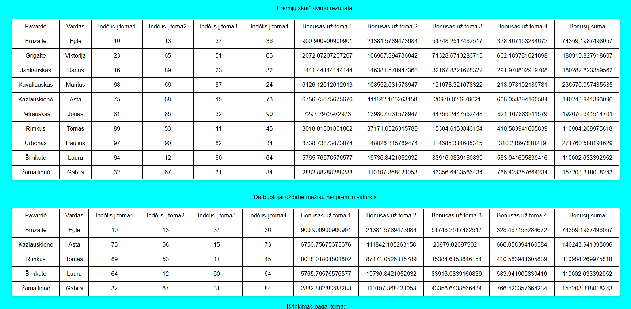

Pav.16 Rezultatai programoje

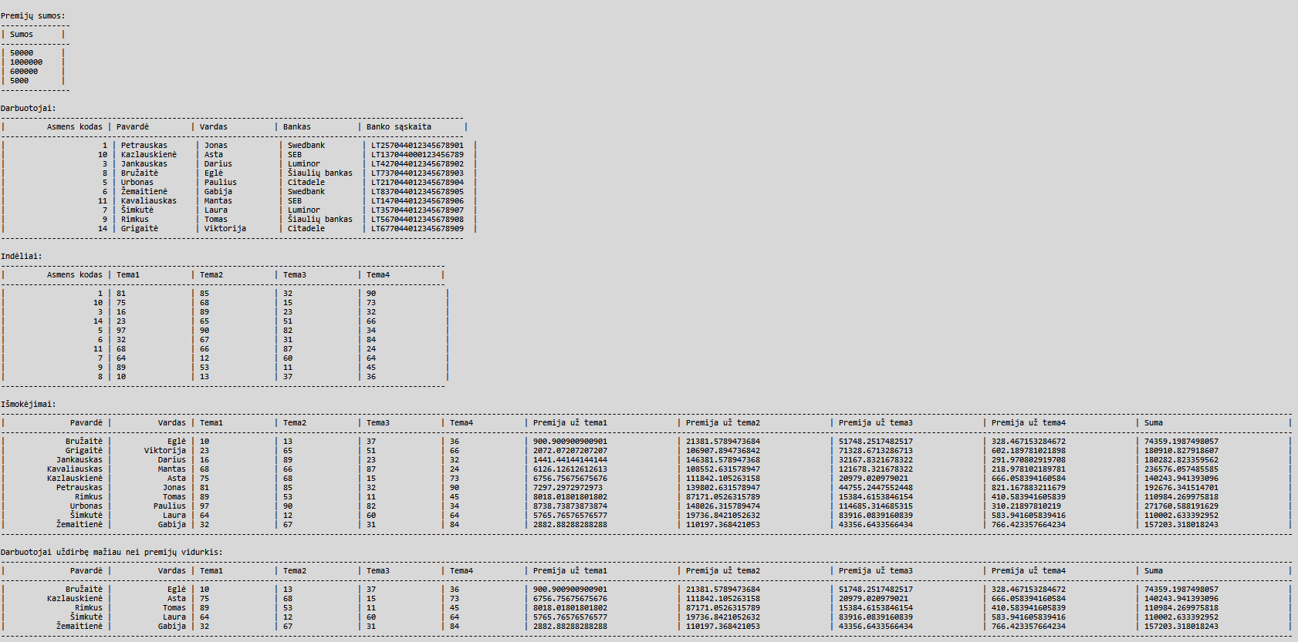

Pav.17 Rezultatai faile

Duomenys Nr. 2

U6a.txt

12;A;B;Swedbank;LT257044012345678901

34;A;C;SEB;LT137044000123456789

56;C;D;Luminor;LT427044012345678902

78;A;A;Šiaulių bankas;LT737044012345678903

U6b.txt

50000;1000000;600000;5000

12;1;1;1;1

34;2;2;2;2

56;3;3;3;3

78;4;4;4;4

Rezultatai

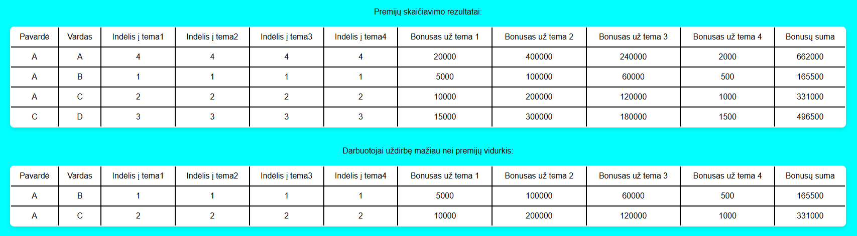

Pav.18 Rezultatai programoje

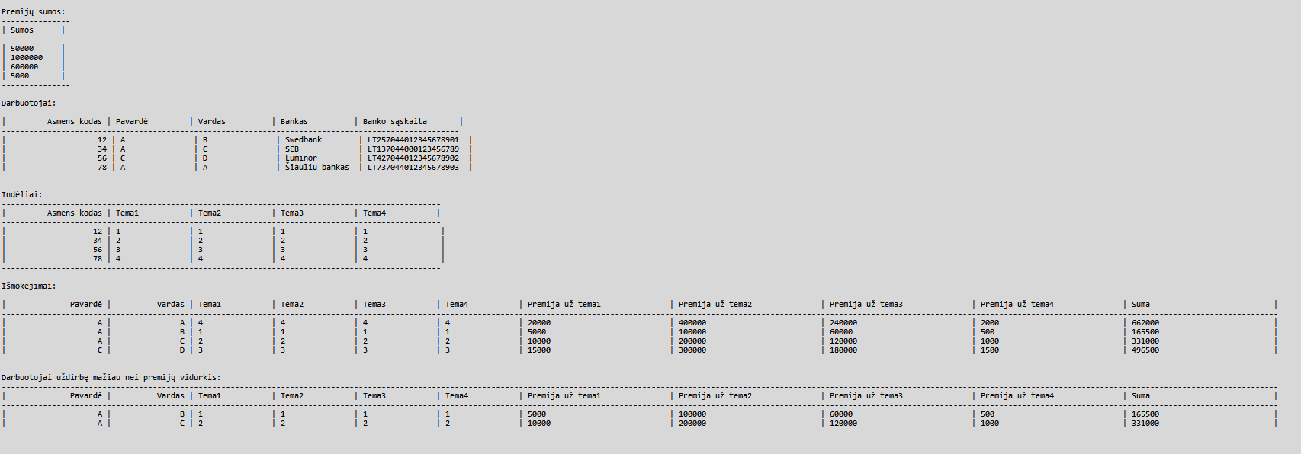

Pav.19 Rezultatai faile

Dėstytojo pastabos

Nėra išvedimo pagal temas į failą.

SumCalc () metodas yra netinkamai paskelbtas

Polimorfizmas ir išimčių valdymas (L4)

Darbo užduotis

U4_6. Nekilnojamojo turto agentūra.
Turite ir kitų nekilnojamojo turto agentūrų (>=3) duomenis. Pirmoje eilutėje yra pavadinimas, antroje – adresas, trečioje – telefonas. Nekilnojamojo turto agentūra parduoda butus ir nuosavus namus. Sukurkite abstrakčiąją klasę „RealEstate“ (savybės – miestas, mikrorajonas, gatvė, namo numeris, tipas, pastatymo metai, plotas, kambarių skaičius), kurią paveldės klasės “Flat” (savybė - aukštas) ir “House” (savybė – šildymo būdas).
• Raskite, kurioje gatvėje daugiausiai parduodamų nekilnojamo turto objektų (namų ir butų), ekrane atspausdinkite gatvės pavadinimą ir parduodamų objektų kiekį.
• Raskite seniausią nekilnojamojo turto objektą, ekrane atspausdinkite visą jo informaciją.
• Raskite, kurių namų ar butų skelbimai yra paskelbti daugiau nei vienoje agentūroje (savininkas tikriausiai labai skuba parduoti, ir bus linkęs nuleisti kainą). Išrikiuokite juos pagal gatvės pavadinimą ir namo numerį. Į failą „Kartojasi.cvs“ įrašykite informaciją apie šiuos objektus.
• Sudarykite ir surikiuokite didelių NT objektų sąrašą. Namas yra didelis, jei jo plotas didesnis nei 200 kv.m. Namus rikiuokite pagal plotą ir šildymo būdą. Butas yra didelis, jei jo plotas didesnis nei 90 kv.m. Butus rikiuokite pagal plotą ir aukštą. Rezultatus įrašykite į failą „Dideli.csv“.

Grafinės naudotojo sąsajos schema



Pav.20 GUI schema

Sąsajoje panaudotų komponentų keičiamos savybės

Komponentas | Savybė | Reikšmė
Button1 | Text | „Skaičiuoti“
 | Width | 80px

Klasių diagrama

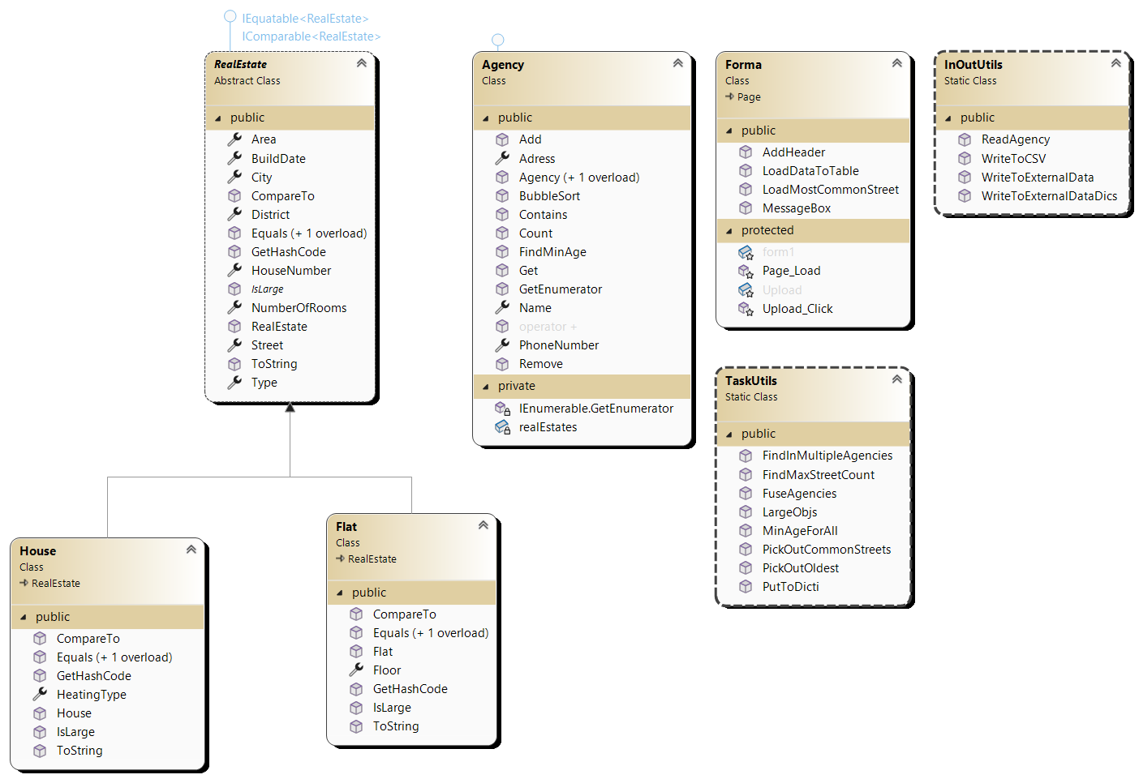

Pav.21 Klasių diagrama

Programos naudotojo vadovas

Į programos AgencyData katalogą įdedami failai, kuriuose pirma eilutė yra agentūros pavadinimas, antra adresas, trečia telefono numeris. Paleidus programą duomenys automatiškai nuskaitomi iš katalogo paspaudus mygtuką „Skaičiuoti“. Kataloge AgencyData galima rasti ir sugeneruotus .csv failus. Projekto kataloge galima rasti visą apdorotą informaciją faile ExternalData.txt.

Programos tekstas

RealEstate.cs

using System;
using System.Collections.Generic;
using System.Diagnostics.PerformanceData;
using System.Drawing;
using System.Linq;
using System.Runtime.InteropServices;
using System.Web;

namespace L4
{
/// <summary>
/// Represents a real estate with basic details.
/// </summary>
public abstract class RealEstate : IEquatable<RealEstate>, IComparable<RealEstate>
{
/// <summary>
/// The city of the real estate.
/// </summary>
public string City { get; set; }

/// <summary>
/// The district of the real estate.
/// </summary>
public string District { get; set; }

/// <summary>
/// The street of the real estate.
/// </summary>
public string Street { get; set; }

/// <summary>
/// The house number of the real estate.
/// </summary>
public int HouseNumber { get; set; }

/// <summary>
/// The type of the real estate (e.g., apartment, house).
/// </summary>
public string Type { get; set; }

/// <summary>
/// The year the real estate was built.
/// </summary>
public int BuildDate { get; set; }

/// <summary>
/// The size of the real estate in square meters.
/// </summary>
public double Area { get; set; }

/// <summary>
/// The number of rooms in the real estate.
/// </summary>
public int NumberOfRooms { get; set; }

/// <summary>
/// Creates a new real estate with the given details.
/// </summary>
public RealEstate(string city, string district, string street, int houseNumber, string type, int buildDate, double area, int numberOfRooms)
{
City = city;
District = district;
Street = street;
HouseNumber = houseNumber;
Type = type;
BuildDate = buildDate;
Area = area;
NumberOfRooms = numberOfRooms;
}

/// <summary>
/// Checks if this real estate is the same as another based on location and size.
/// </summary>
public bool Equals(RealEstate other)
{
if (other == null) return false;
if (GetType() != other.GetType()) return false;

return Street == other.Street && HouseNumber == other.HouseNumber
&& City == other.City && District == other.District && Area == other.Area;
}

/// <summary>
/// Checks if this object is the same as another object.
/// </summary>
public override bool Equals(object obj)
{
return Equals(obj as RealEstate);
}

/// <summary>
/// Returns a unique code for the real estate based on its street and house number.
/// </summary>
public override int GetHashCode()
{
return Street.GetHashCode() ^ HouseNumber.GetHashCode();
}

/// <summary>
/// Compares this real estate to another based on street and house number.
/// </summary>
public int CompareTo(RealEstate other)
{
if (Street.CompareTo(other.Street) == 0)
{
return HouseNumber.CompareTo(other.HouseNumber);
}
return Street.CompareTo(other.Street);
}

/// <summary>
/// Returns a string with all the details of the real estate.
/// </summary>
public override string ToString()
{
return $"{City},{District},{Street},{HouseNumber},{Type},{BuildDate},{Area},{NumberOfRooms}";
}

/// <summary>
/// Checks if the real estate is large based on specific rules.
/// </summary>
public abstract bool IsLarge();
}

}

House.cs

using System;
using System.Collections.Generic;
using System.Linq;
using System.Web;

namespace L4
{
/// <summary>
/// Represents a house, which is a type of property.
/// </summary>
public class House : RealEstate
{
/// <summary>
/// The heating system used in the house.
/// </summary>
public string HeatingType { get; set; }

/// <summary>
/// Creates a new house with the given details.
/// </summary>
/// <param name="city">The city where the house is located.</param>
/// <param name="district">The district where the house is located.</param>
/// <param name="street">The street where the house is located.</param>
/// <param name="houseNumber">The house number.</param>
/// <param name="type">The type of the house.</param>
/// <param name="buildDate">The year the house was built.</param>
/// <param name="area">The size of the house in square meters.</param>
/// <param name="numberOfRooms">The number of rooms in the house.</param>
/// <param name="HeatingType">The heating system used in the house.</param>
public House(string city, string district, string street, int houseNumber, string type, int buildDate, double area, int numberOfRooms, string HeatingType) :
base(city, district, street, houseNumber, type, buildDate, area, numberOfRooms)
{
this.HeatingType = HeatingType;
}

/// <summary>
/// Checks if another object is the same as this house.
/// </summary>
/// <param name="other">The object to compare with.</param>
/// <returns>True if they are the same, false otherwise.</returns>
public override bool Equals(object other)
{
return this.Equals(other as House);
}

/// <summary>
/// Checks if another house is the same as this one.
/// </summary>
/// <param name="house">The house to compare with.</param>
/// <returns>True if they are the same, false otherwise.</returns>
public bool Equals(House house)
{
if (house == null)
{
return false;
}
return base.Equals(house);
}

/// <summary>
/// Compares this house to another house by size and heating system.
/// </summary>
/// <param name="house">The house to compare with.</param>
/// <returns>A negative number if this house is smaller, positive if larger, or 0 if they are the same size.</returns>
public int CompareTo(House house)
{
if (this.Area.CompareTo(house.Area) == 0)
{
return this.HeatingType.CompareTo(house.HeatingType);
}
return this.Area.CompareTo(house.Area);
}

/// <summary>
/// Gets a unique code for this house.
/// </summary>
/// <returns>A hash code for the house.</returns>
public override int GetHashCode()
{
return base.GetHashCode();
}

/// <summary>
/// Checks if the house is big (over 200 square meters).
/// </summary>
/// <returns>True if the house is big, false otherwise.</returns>
public override bool IsLarge()
{
return this.Area > 200;
}

/// <summary>
/// Gets a text description of the house.
/// </summary>
/// <returns>A string with details about the house.</returns>
public override string ToString()
{
return base.ToString() + $",{this.HeatingType},{"-"}";
}
}

}

Flat.cs
using System;
using System.Collections.Generic;
using System.Drawing;
using System.Linq;
using System.Web;
using System.Web.Routing;

namespace L4
{
/// <summary>
/// A Flat is a type of RealEstate.
/// </summary>
public class Flat : RealEstate
{
/// <summary>
/// The floor number of the flat.
/// </summary>
public int Floor { get; set; }

/// <summary>
/// Creates a new Flat with the given details.
/// </summary>
/// <param name="city">The city of the flat.</param>
/// <param name="district">The district of the flat.</param>
/// <param name="street">The street of the flat.</param>
/// <param name="houseNumber">The house number of the flat.</param>
/// <param name="type">The type of the flat.</param>
/// <param name="buildDate">The year the flat was built.</param>
/// <param name="area">The size of the flat in square meters.</param>
/// <param name="numberOfRooms">The number of rooms in the flat.</param>
/// <param name="Floor">The floor number of the flat.</param>
public Flat(string city, string district, string street, int houseNumber, string type, int buildDate, double area, int numberOfRooms, int Floor) :
base(city, district, street, houseNumber, type, buildDate, area, numberOfRooms)
{
this.Floor = Floor;
}

/// <summary>
/// Checks if another object is the same as this Flat.
/// </summary>
/// <param name="other">The object to compare with.</param>
/// <returns>True if they are the same, otherwise false.</returns>
public override bool Equals(object other)
{
return this.Equals(other as Flat);
}

/// <summary>
/// Checks if another Flat is the same as this Flat.
/// </summary>
/// <param name="flat">The Flat to compare with.</param>
/// <returns>True if they are the same, otherwise false.</returns>
public bool Equals(Flat flat)
{
if (flat == null)
{
return false;
}
return base.Equals(flat);
}

/// <summary>
/// Compares this Flat with another Flat
/// </summary>
/// <param name="flat">The Flat to compare with.</param>
/// <returns>
/// A negative number if this Flat is smaller, 0 if they are the same, or a positive number if this Flat is larger.
/// </returns>
public int CompareTo(Flat flat)
{
if (this.Area.CompareTo(flat.Area) == 0)
{
return this.Floor.CompareTo(flat.Floor);
}
return this.Area.CompareTo(flat.Area);
}

/// <summary>
/// Gets a unique number for this Flat.
/// </summary>
/// <returns>A unique number for this Flat.</returns>
public override int GetHashCode()
{
return base.GetHashCode();
}

/// <summary>
/// Checks if the flat is large.
/// </summary>
/// <returns>True if the flat is large otherwise false</returns>
public override bool IsLarge()
{
return this.Area > 90;
}

/// <summary>
/// Gets a text description of the Flat
/// </summary>
/// <returns>A text description of the Flat.</returns>
public override string ToString()
{
return base.ToString() + $",{"-"},{this.Floor}";
}
}

}

Agency.cs
using System;
using System.CodeDom;
using System.Collections;
using System.Collections.Generic;
using System.Linq;
using System.Runtime.CompilerServices;
using System.Web;
using System.Xml;

namespace L4
{
/// <summary>
/// A real estate agency.
/// </summary>
public class Agency : IEnumerable<RealEstate>
{
public string Name { get; private set; }
public string Adress { get; private set; }
public int PhoneNumber { get; private set; }

private List<RealEstate> realEstates;

/// <summary>
/// Creates an agency with name, address, and phone number.
/// </summary>
/// <param name="name">Agency name.</param>
/// <param name="adress">Agency address.</param>
/// <param name="phoneNumber">Agency phone number.</param>
public Agency(string name, string adress, int phoneNumber)
{
this.Name = name;
this.Adress = adress;
this.PhoneNumber = phoneNumber;
this.realEstates = new List<RealEstate>();
}
/// <summary>
/// Creates an empty agency.
/// </summary>
public Agency()
{
this.realEstates = new List<RealEstate>();
}
/// <summary>
/// Adds a real estate to the agency.
/// </summary>
/// <param name="re">Real estate to add.</param>
public void Add(RealEstate re)
{
realEstates.Add(re);
}
/// <summary>
/// Removes a real estate from the agency.
/// </summary>
/// <param name="re">Real estate to remove.</param>
public void Remove(RealEstate re)
{
realEstates.Remove(re);
}
/// <summary>
/// Gets a real estate by its position in the list.
/// </summary>
/// <param name="index">Position in the list.</param>
/// <returns>The real estate at the position.</returns>
public RealEstate Get(int index)
{
return realEstates[index];
}
/// <summary>
/// Counts the real estates in the agency.
/// </summary>
/// <returns>Number of real estates.</returns>
public int Count()
{
return realEstates.Count;
}

/// <summary>
/// Checks if the agency has a specific real estate.
/// </summary>
/// <param name="estate">Real estate to check.</param>
/// <returns>True if found, otherwise false.</returns>
public bool Contains(RealEstate estate)
{
foreach (RealEstate curr in realEstates)
{
if (curr.Equals(estate))
{
return true;
}
}
return false;
}

/// <summary>
/// Finds the oldest real estate in the agency.
/// </summary>
/// <returns>Year of the oldest real estate.</returns>
public int FindMinAge()
{
int minAge = 9999;
foreach (RealEstate estate in realEstates)
{
if (estate.BuildDate < minAge)
{
minAge = estate.BuildDate;
}
}
return minAge;
}
/// <summary>
/// Combines two agencies into one.
/// </summary>
/// <param name="a1">First agency.</param>
/// <param name="a2">Second agency.</param>
/// <returns>New agency with all real estates.</returns>
public static Agency operator +(Agency a1, Agency a2)
{
Agency newAgency = new Agency();
foreach (RealEstate estate in a1.realEstates)
{
newAgency.Add(estate);
}
foreach (RealEstate estate in a2.realEstates)
{
newAgency.Add(estate);
}
return newAgency;
}
/// <summary>
/// Sorts the real estates in the agency.
/// </summary>
public void BubbleSort()
{
int n = realEstates.Count();
bool swapped;

for (int i = 0; i < n - 1; i++)
{
swapped = false;

for (int j = 0; j < n - i - 1; j++)
{
if (realEstates[i].CompareTo(realEstates[j]) > 0)
{
RealEstate temp = realEstates[j];
realEstates[j] = realEstates[j + 1];
realEstates[j + 1] = temp;

swapped = true;
}
}
if (!swapped)
break;
}
}

/// <summary>
/// Allows looping through the real estates.
/// </summary>
/// <returns>Enumerator for real estates.</returns>
public IEnumerator<RealEstate> GetEnumerator()
{
foreach (var realEstate in realEstates)
{
yield return realEstate;
}
}
/// <summary>
/// Allows looping through the real estates.
/// </summary>
/// <returns>Enumerator for real estates.</returns>
IEnumerator IEnumerable.GetEnumerator()
{
return GetEnumerator();
}

}
}

TaskUtils.cs
using System.Collections.Generic;

namespace L4
{
public static class TaskUtils
{
/// <summary>
/// Finds all large real estates from the given agencies.
/// </summary>
/// <param name="agencies">Array of agencies to search in.</param>
/// <returns>Agency containing only large real estates.</returns>
public static Agency LargeObjs(Agency[] agencies)
{
Agency bigOnes = new Agency();
foreach (Agency agency in agencies)
{
foreach (RealEstate estate in agency)
{
if (estate.IsLarge())
{
bigOnes.Add(estate);
}
}
}
return bigOnes;
}

/// <summary>
/// Combines all agencies into one.
/// </summary>
/// <param name="agencies">Array of agencies to combine.</param>
/// <returns>A single agency containing all real estates.</returns>
public static Agency FuseAgencies(Agency[] agencies)
{
Agency Fused = new Agency();
foreach (Agency agency in agencies)
{
Fused += agency;
}
return Fused;
}

/// <summary>
/// Finds real estates that appear in multiple agencies.
/// </summary>
/// <param name="fused">An agency containing all real estates.</param>
/// <returns>Agency with real estates found in multiple agencies.</returns>
public static Agency FindInMultipleAgencies(Agency fused)
{
Agency result = new Agency();

for (int i = 0; i < fused.Count(); i++)
{
RealEstate current = fused.Get(i);
int count = 0;

for (int j = 0; j < fused.Count(); j++)
{
if (current.Equals(fused.Get(j)))
{
count++;
if (count > 1) break;
}
}

if (count > 1 && !result.Contains(current))
{
result.Add(current);
}
}

return result;
}

/// <summary>
/// Picks out real estates built in a specific year.
/// </summary>
/// <param name="agencies">Array of agencies to search in.</param>
/// <param name="oldestValue">Year to filter by.</param>
/// <returns>Agency with real estates built in the given year.</returns>
public static Agency PickOutOldest(Agency[] agencies, int oldestValue)
{
Agency oldestRealEstates = new Agency();
foreach (Agency a in agencies)
{
foreach (RealEstate estate in a)
{
if (estate.BuildDate == oldestValue)
{
oldestRealEstates.Add(estate);
}
}
}
return oldestRealEstates;
}

/// <summary>
/// Finds the minimum age of real estates across all agencies.
/// </summary>
/// <param name="agencies">Array of agencies to search in.</param>
/// <returns>The minimum age of real estates.</returns>
public static int MinAgeForAll(Agency[] agencies)
{
int minAge = 9999;
foreach (Agency agency in agencies)
{
if (minAge > agency.FindMinAge())
{
minAge = agency.FindMinAge();
}
}
return minAge;
}

/// <summary>
/// Finds the maximum count of real estates on a single street.
/// </summary>
/// <param name="streetCounts">Dictionary with street names and their counts.</param>
/// <returns>The maximum count of real estates on a street.</returns>
public static int FindMaxStreetCount(Dictionary<string, int> streetCounts)
{
int max = 0;
foreach (var pair in streetCounts)
{
if (pair.Value > max)
{
max = pair.Value;
}
}
return max;
}

/// <summary>
/// Creates a dictionary of street names and their real estate counts.
/// </summary>
/// <param name="agencies">Array of agencies to process.</param>
/// <returns>Dictionary with street names and counts.</returns>
public static Dictionary<string, int> PutToDicti(Agency[] agencies)
{
Dictionary<string, int> result = new Dictionary<string, int>();
foreach (Agency agency in agencies)
{
foreach (RealEstate estate in agency)
{
if (result.ContainsKey(estate.Street))
{
result[estate.Street]++;
}
else
{
result.Add(estate.Street, 1);
}
}
}
return result;
}

/// <summary>
/// Finds streets with the maximum number of real estates.
/// </summary>
/// <param name="values">Dictionary of street names and counts.</param>
/// <param name="MaxValue">The maximum count to filter by.</param>
/// <returns>Dictionary with streets having the maximum count.</returns>
public static Dictionary<string, int> PickOutCommonStreets(Dictionary<string, int> values, int MaxValue)
{
Dictionary<string, int> result = new Dictionary<string, int>();
foreach (var pair in values)
{
if (pair.Value == MaxValue)
{
result.Add(pair.Key, pair.Value);
}
}
return result;
}
}

}

InOutUtils.cs

using Microsoft.SqlServer.Server;
using System;
using System.Collections.Generic;
using System.IO;
using System.Linq;
using System.Runtime.CompilerServices;
using System.Text;
using System.Web;
using System.Xml;
using System.Xml.Linq;

namespace L4
{
public static class InOutUtils
{
/// <summary>
/// Reads data about an agency from a file and creates an Agency object.
/// </summary>
/// <param name="fileName">The file to read data from.</param>
/// <returns>An Agency object with the data from the file.</returns>
public static Agency ReadAgency(string fileName)
{
Agency agency;

using (StreamReader reader = new StreamReader(fileName))
{
string name = reader.ReadLine();
string address = reader.ReadLine();
int phoneNumber;

phoneNumber = int.Parse(reader.ReadLine());

agency = new Agency(name, address, phoneNumber);

string line;
int lineNumber = 4;

while ((line = reader.ReadLine()) != null)
{
lineNumber++;
string[] values = line.Split(';');
try
{
string city = values[0];
string district = values[1];
string street = values[2];
int houseNumber = int.Parse(values[3]);
string type = values[4];
int buildYear = int.Parse(values[5]);
double area = double.Parse(values[6]);
int numberOfRooms = int.Parse(values[7]);
string diff = values[8];

RealEstate re;

if (int.TryParse(diff, out int floor))
{
re = new Flat(city, district, street, houseNumber, type, buildYear, area, numberOfRooms, floor);
}
else
{
re = new House(city, district, street, houseNumber, type, buildYear, area, numberOfRooms, diff);
}

agency.Add(re);
}
catch (Exception)
{
HttpContext.Current.Response.Write(
$"<script>alert('[{fileName}, line {lineNumber}: {line.Replace("'", "\\'")}');</script>");
continue;
}
}
}

return agency;
}

/// <summary>
/// Saves agency data to a CSV file.
/// </summary>
/// <param name="a">The agency to save.</param>
/// <param name="fileName">The file to save data to.</param>
/// <param name="header">The header text for the CSV file.</param>
public static void WriteToCSV(Agency a, string fileName, string header)
{
using (StreamWriter writer = new StreamWriter(fileName, false, Encoding.UTF8))
{
writer.WriteLine(header);
writer.WriteLine($"{"City"},{"District"},{"Street"}," +
$"{"House Number"},{"Type"},{"Build Year"},{"Area"}" +
$",{"Number of Rooms"},{"Heating Type"},{"Floor"}");
foreach (RealEstate estate in a)
{
writer.WriteLine(estate.ToString());
}
}
}

/// <summary>
/// Saves a dictionary of the most common streets to a file.
/// </summary>
/// <param name="fileName">The file to save data to.</param>
/// <param name="mostCommonStreets">The dictionary of streets and their counts.</param>
/// <param name="header">The header text for the file.</param>
public static void WriteToExternalDataDics(string fileName, Dictionary<string, int> mostCommonStreets, string header)
{
using (StreamWriter writer = new StreamWriter(fileName, true, Encoding.UTF8))
{
writer.WriteLine(header);
writer.WriteLine(new string('-', 37));
writer.WriteLine($"| {"Street",15} | {"Count",15} |");
writer.WriteLine(new string('-', 37));
foreach (var pair in mostCommonStreets)
{
writer.WriteLine($"| {pair.Key,15} | {pair.Value,15} |");
}
writer.WriteLine(new string('-', 37));
}
}

/// <summary>
/// Saves detailed agency data to a file.
/// </summary>
/// <param name="fileName">The file to save data to.</param>
/// <param name="agency">The agency to save.</param>
/// <param name="header">The header text for the file.</param>
public static void WriteToExternalData(string fileName, Agency agency, string header)
{
using (StreamWriter writer = new StreamWriter(fileName, true, Encoding.UTF8))
{
writer.WriteLine(header);
writer.WriteLine($"{"Agency Name: "}{agency.Name}");
writer.WriteLine($"{"Agency Address: "}{agency.Adress}");
writer.WriteLine($"{"Agency Phone Number: "}{agency.PhoneNumber}");
writer.WriteLine(new string('-', 191));
writer.WriteLine($"| {"City",15} | {"District",15} | {"Street",15} |" +
$" {"House Number",-15} | {"Type",-15} | {"Build Year",15} |" +
$" {"Area",15} | {"Number of Rooms",-20} | {"Heating Type",20} | {"Floor",-15} |");
writer.WriteLine(new string('-', 191));
foreach (RealEstate estate in agency)
{
writer.WriteLine($"| {estate.City,15} | {estate.District,15} |" +
$" {estate.Street,15} | {estate.HouseNumber,-15} | {estate.Type,15} |" +
$" {estate.BuildDate,-15} | {estate.Area,-15} | {estate.NumberOfRooms,-20} |" +
$" {(estate is House ? ((House)estate).HeatingType : "-"),20} |" +
$" {(estate is Flat ? ((Flat)estate).Floor.ToString() : "-"),-15} |");
}
writer.WriteLine(new string('-', 191));
}
}
}

}

Styles.css
body {
font-family: Arial, sans-serif;
background-color: #f4f4f4;
color: #333;
margin: 0;
padding: 20px;
}

form {
background-color: white;
padding: 20px;
border-radius: 10px;
box-shadow: 0 0 10px rgba(0, 0, 0, 0.1);
text-align: center;
}

h1 {
text-align: center;
color: #2c3e50;
margin-bottom: 30px;
}

form {
width: 95%;
max-width: 1400px;
margin: auto;
background-color: white;
padding: 30px;
border-radius: 12px;
box-shadow: 0 0 15px rgba(0, 0, 0, 0.15);
text-align: center;
box-sizing: border-box;
overflow-x: auto;
}
table {
width: 100%;
border-collapse: collapse;
margin-top: 20px;
margin-bottom: 30px;
}

table, th, td {
border: 1px solid #ccc;
}

th, td {
padding: 8px;
text-align: center;
}

caption {
font-weight: bold;
margin-bottom: 10px;
}

FormaMethods.cs
using System;
using System.Collections.Generic;
using System.Linq;
using System.Web;
using System.Web.UI;
using System.Web.UI.HtmlControls;
using System.Web.UI.WebControls;

namespace L4
{
public partial class Forma : System.Web.UI.Page
{
/// <summary>
/// Loads data about an agency and its real estates into a table.
/// </summary>
/// <param name="agency">The agency containing real estate data.</param>
/// <param name="form">The form where the table will be added.</param>
/// <param name="header">The header text for the table.</param>
public void LoadDataToTable(Agency agency, HtmlForm form, string header)
{
try
{
Table table = new Table();
TableRow headerRow = new TableRow();
headerRow.Cells.Add(new TableCell() { Text = string.Format(header), ColumnSpan = 10 });
table.Rows.Add(headerRow);
if (agency.Name != string.Empty && agency.Adress != string.Empty && agency.PhoneNumber != 0)
{
TableRow hRow0 = new TableRow();
hRow0.Cells.Add(new TableCell() { Text = $"Pavadinimas: {agency.Name}", ColumnSpan = 10 });
TableRow hRow1 = new TableRow();
hRow1.Cells.Add(new TableCell() { Text = $"Adresas: {agency.Adress}", ColumnSpan = 10 });
TableRow hRow2 = new TableRow();
hRow2.Cells.Add(new TableCell() { Text = $"Telefono numeris: {agency.PhoneNumber}", ColumnSpan = 10 });
table.Rows.Add(hRow0);
table.Rows.Add(hRow1);
table.Rows.Add(hRow2);
}
AddHeader(new string[] {
"Miestas", "Rajonas", "Gatvė", "Namo numeris", "Tipas",
"Pastatymo data", "Plotas", "Kambarių skaičius", "Aukštas", "Šildymo tipas" }, table);
foreach (RealEstate re in agency)
{
TableRow row = new TableRow();
row.Cells.Add(new TableCell() { Text = re.City });
row.Cells.Add(new TableCell() { Text = re.District });
row.Cells.Add(new TableCell() { Text = re.Street });
row.Cells.Add(new TableCell() { Text = re.HouseNumber.ToString() });
row.Cells.Add(new TableCell() { Text = re.Type });
row.Cells.Add(new TableCell() { Text = re.BuildDate.ToString() });
row.Cells.Add(new TableCell() { Text = re.Area.ToString() });
row.Cells.Add(new TableCell() { Text = re.NumberOfRooms.ToString() });
if (re is Flat flat)
{
row.Cells.Add(new TableCell() { Text = flat.Floor.ToString() });
row.Cells.Add(new TableCell() { Text = "-" });
}
else if (re is House house)
{
row.Cells.Add(new TableCell() { Text = "-" });
row.Cells.Add(new TableCell() { Text = house.HeatingType });
}
table.Rows.Add(row);
}
form.Controls.Add(table);
}
catch (Exception ex)
{
throw new Exception("Klaida įkeliant duomenis į lentelę: " + ex.Message);
}
}

/// <summary>
/// Loads the most common streets and their counts into a table.
/// </summary>
/// <param name="MostCommonStreetEstates">Dictionary of street names and their counts.</param>
/// <param name="form">The form where the table will be added.</param>
public void LoadMostCommonStreet(Dictionary<string, int> MostCommonStreetEstates, HtmlForm form)
{
Table table = new Table();
TableRow hRow0 = new TableRow();
hRow0.Cells.Add(new TableCell() { Text = "Dažniausiai pasikartojančios gatvės", ColumnSpan = 10 });
table.Rows.Add(hRow0);
AddHeader(new string[] { "Gatvės pavadinimas", "Kiekis" }, table);
foreach (var pair in MostCommonStreetEstates)
{
TableRow row = new TableRow();
row.Cells.Add(new TableCell() { Text = pair.Key });
row.Cells.Add(new TableCell() { Text = pair.Value.ToString() });
table.Rows.Add(row);
}
form.Controls.Add(table);
}

/// <summary>
/// Adds a header row to a table.
/// </summary>
/// <param name="headers">Array of header names.</param>
/// <param name="table">The table where the header will be added.</param>
public void AddHeader(string[] headers, Table table)
{
TableRow headerRow = new TableRow();
foreach (string header in headers)
{
TableCell cell = new TableCell();
cell.Text = header;
headerRow.Cells.Add(cell);
}
table.Rows.Add(headerRow);
}

/// <summary>
/// Displays a message box with a given message.
/// </summary>
/// <param name="page">The page where the message box will be shown.</param>
/// <param name="strMsg">The message to display.</param>
public static void MessageBox(System.Web.UI.Page page, string strMsg)
{
ScriptManager.RegisterClientScriptBlock(page, page.GetType(), "alertMessage", "alert('" + strMsg + "')", true);
}
}

}

Forma.aspx
<%@ Page Language="C#" AutoEventWireup="true" CodeBehind="Forma.aspx.cs" Inherits="L4.Forma" %>

<!DOCTYPE html>

<html xmlns="http://www.w3.org/1999/xhtml">
<head runat="server">
<link href="Styles.css" rel="stylesheet" type="text/css" />
<title></title>
</head>
<body>
<form id="form1" runat="server">
<div>
<h1>Nekilnojamojo turto agentūra</h1>
<asp:Button ID="Upload" runat="server" Text="Skaičiuoti" Width="80px" OnClick="Upload_Click" />
<br />
</div>
</form>
</body>
</html>

Forma.aspx.cs

using System;
using System.Collections.Generic;
using System.IO;
using System.Linq;
using System.Web;
using System.Web.UI;
using System.Web.UI.WebControls;

namespace L4
{
public partial class Forma : System.Web.UI.Page
{
protected void Page_Load(object sender, EventArgs e)
{
try
{
if (File.Exists(Server.MapPath("~/ExternalData.txt")))
{
File.Delete(Server.MapPath("~/ExternalData.txt"));
}
}
catch (Exception ex)
{
MessageBox(this, $"Klaida ištrinant failą: {ex.Message}");
}
}

protected void Upload_Click(object sender, EventArgs e)
{
string[] filePaths;
string folderPath = "~/AgencyData";
int count = 0;

try
{
filePaths = Directory.GetFiles(Server.MapPath(folderPath), "*.txt");
}
catch (Exception ex)
{
MessageBox(this, $"Nepavyko gauti failų iš aplanko: {folderPath}. Klaida: {ex.Message}");
return;
}

Agency[] agencies = new Agency[filePaths.Length];
Agency data = null;

foreach (string path in filePaths)
{
try
{
data = InOutUtils.ReadAgency(path);
}
catch (Exception ex)
{
MessageBox(this, $"Klaida skaitant failą {Path.GetFileName(path)}: {ex.Message}");
continue;
}

try
{
LoadDataToTable(data, form1, $"Duomenys iš failo: {Path.GetFileName(path)}");
}
catch (Exception ex)
{
MessageBox(this, $"Klaida įkeliant duomenis į lentelę: {ex.Message}");
}

try
{
agencies[count] = data;
count++;
}
catch (Exception ex)
{
MessageBox(this, $"Klaida pridedant agentūrą į masyvą: {ex.Message}");
continue;
}

try
{
InOutUtils.WriteToExternalData(Server.MapPath("~/ExternalData.txt"), data, "Nuskaityti duomenys:");
}
catch (Exception ex)
{
MessageBox(this, $"Nepavyko įrašyti duomenų iš failo {Path.GetFileName(path)} į išorinį failą. Klaida: {ex.Message}");
continue;
}
}

try
{
Dictionary<string, int> mostCommonStreetEstates = TaskUtils.PutToDicti(agencies);
int MaxCount = TaskUtils.FindMaxStreetCount(mostCommonStreetEstates);
mostCommonStreetEstates = TaskUtils.PickOutCommonStreets(mostCommonStreetEstates, MaxCount);
LoadMostCommonStreet(mostCommonStreetEstates, form1);
InOutUtils.WriteToExternalDataDics(Server.MapPath("~/ExternalData.txt"), mostCommonStreetEstates, "Dažniausiai pasikartojančios gatvės: ");
}
catch (Exception ex)
{
MessageBox(this, $"Klaida apdorojant dažniausiai pasikartojančias gatves: {ex.Message}");
}

try
{
int minAge = TaskUtils.MinAgeForAll(agencies);
Agency oldestEstates = TaskUtils.PickOutOldest(agencies, minAge);
LoadDataToTable(oldestEstates, form1, "Seniausi objektai");
InOutUtils.WriteToExternalData(Server.MapPath("~/ExternalData.txt"), oldestEstates, "Seniausi objektai: ");
}
catch (Exception ex)
{
MessageBox(this, $"Klaida apdorojant seniausius objektus: {ex.Message}");
}

try
{
Agency FusedAgencies = TaskUtils.FuseAgencies(agencies);
Agency InAllAgencies = TaskUtils.FindInMultipleAgencies(FusedAgencies);
InAllAgencies.BubbleSort();
LoadDataToTable(InAllAgencies, form1, "Objektai kurie yra daugiau nei vienoje agentūroje");
InOutUtils.WriteToExternalData(Server.MapPath("~/ExternalData.txt"), InAllAgencies, "Objektai kurie yra daugiau nei vienoje agentūroje: ");
InOutUtils.WriteToCSV(InAllAgencies, Server.MapPath("~/AgencyData/Kartojasi.csv"), "Objektai kurie yra daugiau nei vienoje agentūroje");
}
catch (Exception ex)
{
MessageBox(this, $"Klaida apdorojant objektus, kurie yra daugiau nei vienoje agentūroje: {ex.Message}");
}

try
{
Agency Large = TaskUtils.LargeObjs(agencies);
Large.BubbleSort();
LoadDataToTable(Large, form1, "Dideli objektai");
InOutUtils.WriteToCSV(Large, Server.MapPath("~/AgencyData/Dideli.csv"), "Dideli objektai");
InOutUtils.WriteToExternalData(Server.MapPath("~/ExternalData.txt"), Large, "Dideli objektai: ");
}
catch (Exception ex)
{
MessageBox(this, $"Klaida apdorojant didelius objektus: {ex.Message}");
}
}
}
}

Pradiniai duomenys ir rezultatai

Tikrinamas esminis programos veikimas.

Duomenys nr. 1

Agency1.txt

UAB "Rabarbaras"

Jonavos g. 169, Kaunas

528588585

Kaunas;Centras;Laisvės al.;10;Butas;1998;72.5;3;2

Vilnius;Naujamiestis;Vytenio g.;22;Kotedžas;2015;180;6;Dujinis

Kaunas;Šilainiai;Aauja g.;30;Kotedžas;2005;165;5;Anglys

Kaunas;Dainava;Partizanų g.;56;Butas;2008;49;2;4

Kaunas;Žaliakalnis;Ąžuolų g.;7;Kotedžas;2012;140;4;Dujinis

Agency2.txt

UAB "Granatmedis"

Lazdynų g. 77, Vilnius

844412345

Vilnius;Antakalnis;Žolyno g.;3;Butas;2010;90;3;5

Vilnius;Antakalnis;Smiltelės g.;5;Butas;2009;91;4;4

Klaipėda;Smeltė;Gintaro g.;5;Kotedžas;2018;200;6;Geoterminis

Vilnius;Senamiestis;Didžioji g.;1;Butas;1990;65;2;3

Vilnius;Naujamiestis;Vytenio g.;22;Kotedžas;2015;205;6;Dujinis

Agency3.txt

UAB "Molibdenas"

Taikos pr. 101, Klaipėda

862233445

Klaipėda;Bandužiai;Smiltelės g.;18;Butas;2000;54;2;1

Klaipėda;Centras;H. Manto g.;22;Butas;1990;67;3;2

Klaipėda;Smeltė;Gintaro g.;5;Kotedžas;2018;200;6;Geoterminis

Klaipėda;Bandužiai;Smiltelės g.;20;Butas;2001;60;2;3

Rezultatai

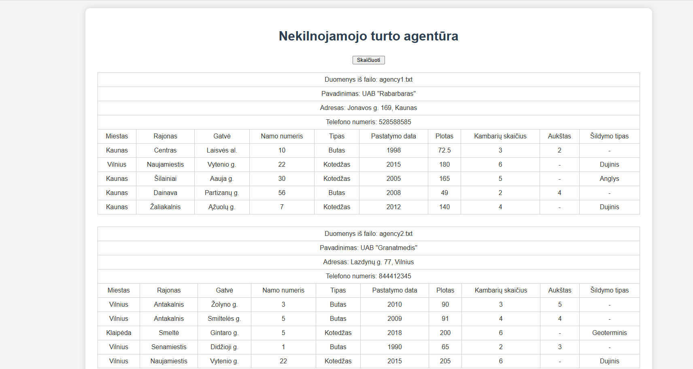

Pav.22 Rezultatai sąsajoje

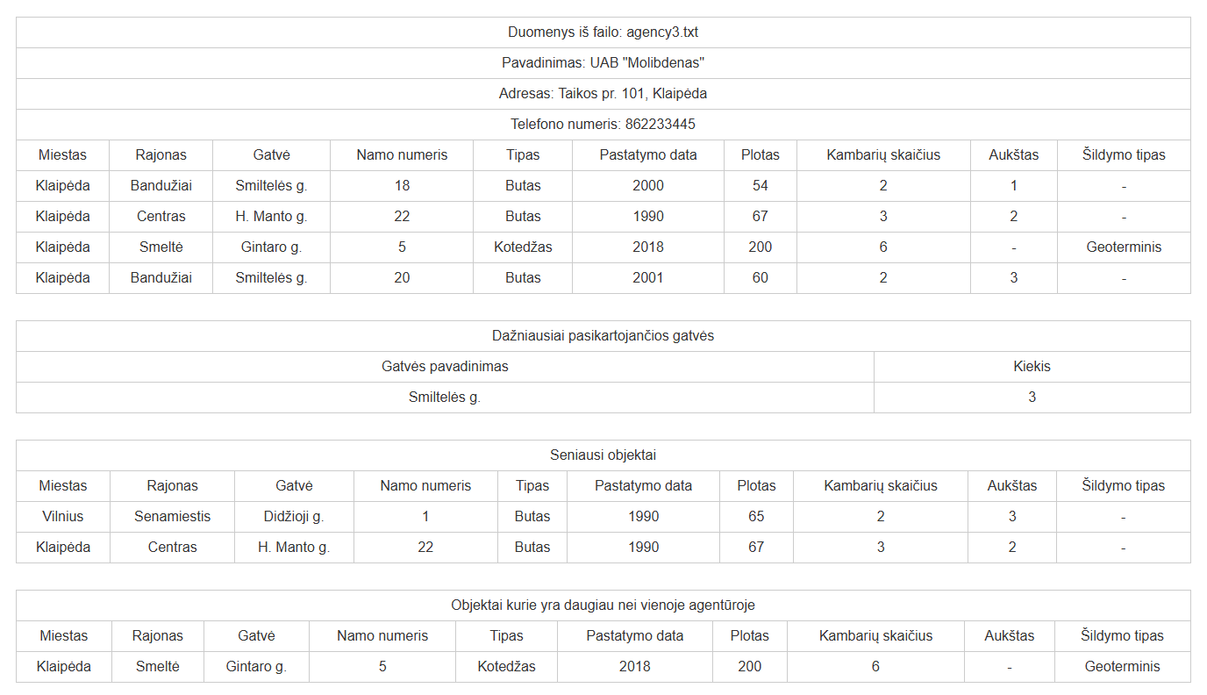

Pav.23 Rezultatai sąsajoje

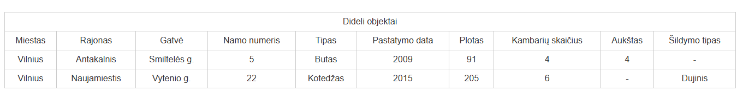

Pav.24 Rezultatai sąsajoje

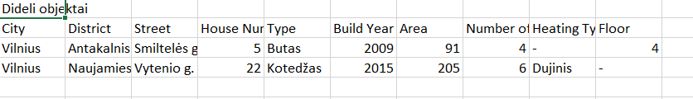

Pav.25 Rezultatai „Dideli.csv“

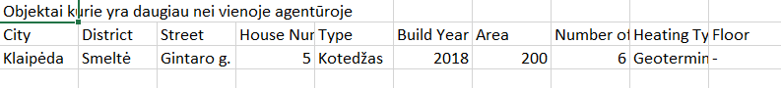

Pav.26 Rezultatai „Kartojasi.csv“

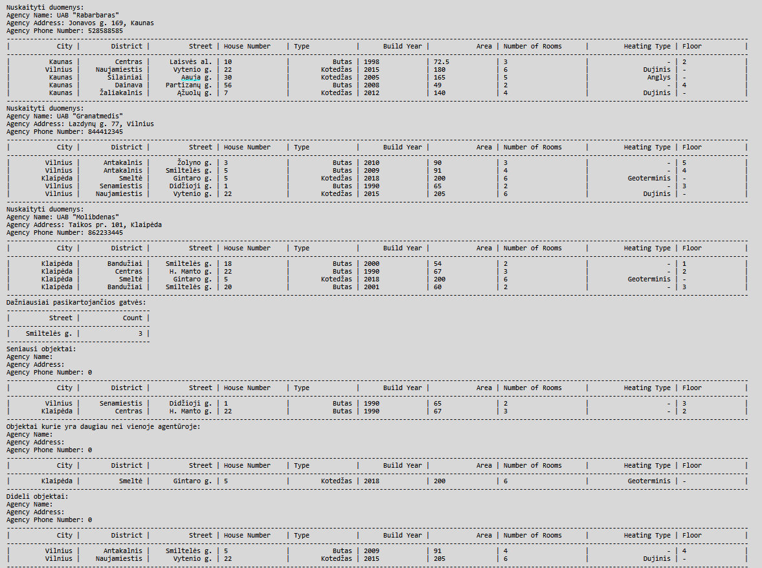

Pav.27 Rezultatai „ExternalData.txt“

Tikrinamas išimčių valdymas. Pridėti keli dideli objektai.

Duomenys nr. 2

Agency1.txt

UAB "Rabarbaras"

Jonavos g. 169, Kaunas

528588585

Kaunas;Centras;Laisvės al.;10;Butas;1998;8000;3;2

Vilnius;Naujamiestis;Vytenio g.;22;Kotedžas;2015;180;6;Dujinis

Kaunas;Šilainiai;Aauja g.;30;Kotedžas;2005;165;5;Anglys

Kaunas;Dainava;Partizanų g.;56;Butas;2008;3000;2;4

Kaunas;Žaliakalnis;Ąžuolų g.;7;Kotedžas;2012;140;4;Dujinis

Adsasssss

Agency2.txt

UAB "Granatmedis"

Lazdynų g. 77, Vilnius

844412345

Vilnius;Antakalnis;Žolyno g.;3;Butas;2010;90;3;5

Vilnius;Antakalnis;Smiltelės g.;5;Butas;2009;91;4;4

sadas;ddd

Klaipėda;Smeltė;Gintaro g.;5;Kotedžas;2018;200;6;Geoterminis

Vilnius;Senamiestis;Didžioji g.;1;Butas;1990;65;2;3

Vilnius;Naujamiestis;Vytenio g.;22;Kotedžas;2015;205;6;Dujinis

Agency3.txt

UAB "Molibdenas"

Taikos pr. 101, Klaipėda

862233445

Klaipėda;Bandužiai;Smiltelės g.;18;Butas;2000;54;2;1

Klaipėda;Centras;H. Manto g.;22;Butas;1990;67;3;2

Klaipėda;Smeltė;Gintaro g.;5;Kotedžas;2018;200;6;Geoterminis

Klaipėda;Bandužiai;Smiltelės g.;20;Butas;2001;60;2;3

Rezultatai

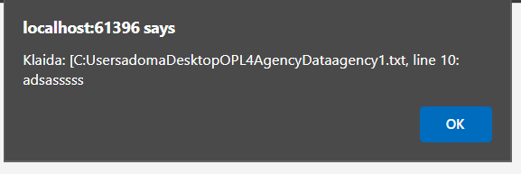

Pav.28 Klaidos pranešimas

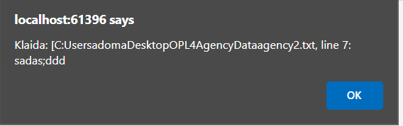

Pav.29 Klaidos pranešimas

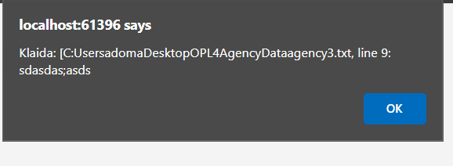

Pav.30 Klaidos pranešimas

Programa toliau tesia darbą, praleidusi eilutes kurios netinka.

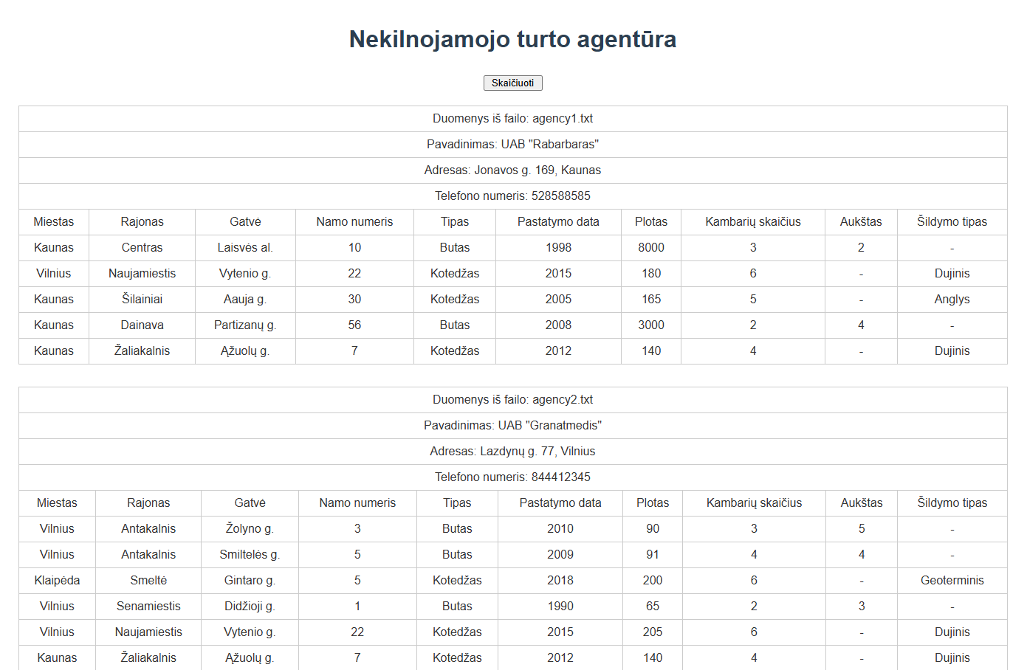

Pav.31 Rezultatai sąsajoje

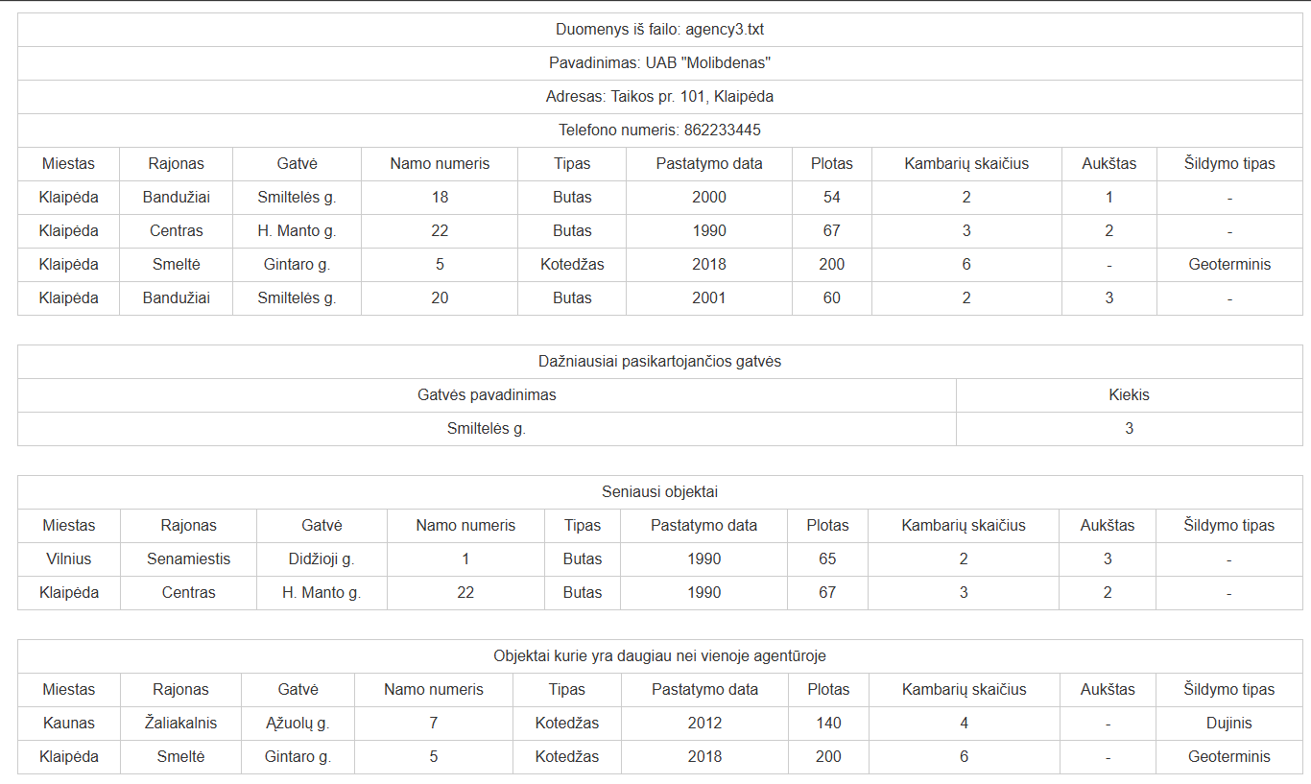

Pav.32 Rezultatai sąsajoje

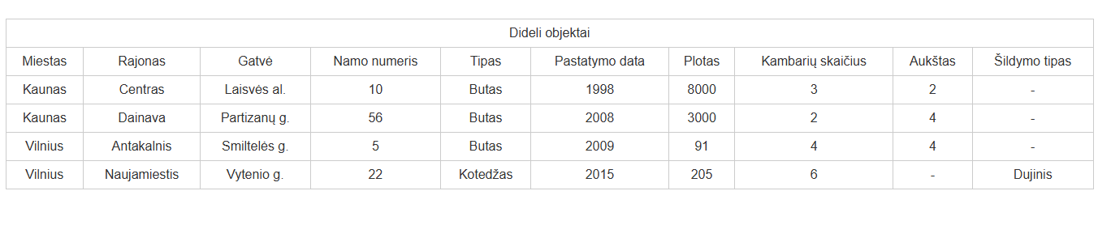

Pav.33 Rezultatai sąsajoje

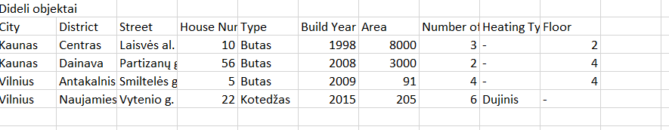

Pav.34 Rezultatai faile „Dideli.csv“

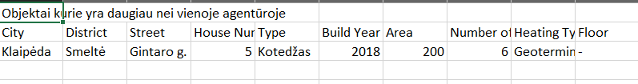

Pav.35 Rezultatai faile „Kartojasi.csv“

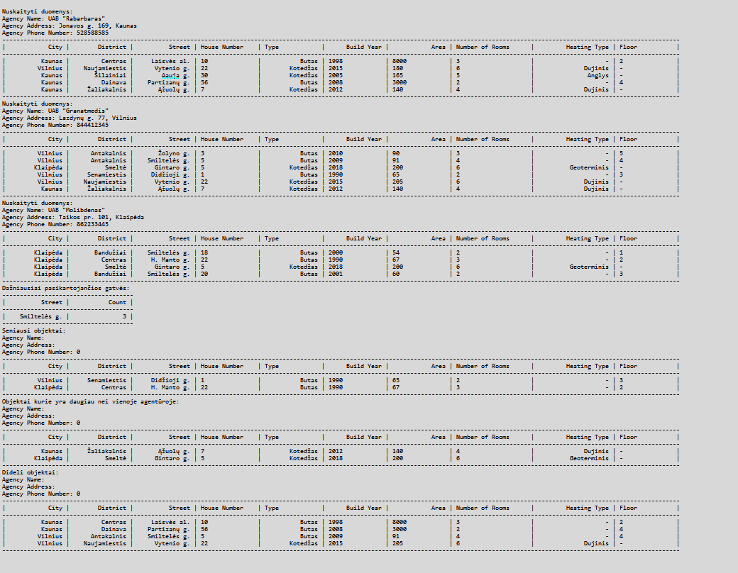

Pav.36 Rezultatai faile „ExternalData.txt“

Dėstytojo pastabos

2 taškai už testą

4 taškai už darbą

0,4 taškai už ataskaitą

Deklaratyvusis programavimas (L5)

Darbo užduotis

U5_6. Moduliai.
Pirmoje failo eilutėje nurodytas fakulteto pavadinimas (failų daug). Tekstiniame faile duota informacija apie studentų pasirenkamus modulius: modulio pavadinimas, studento pavardė, vardas, grupė. Atskirame faile yra informacija apie modulius: modulio pavadinimas, atsakingo dėstytojo pavardė, vardas, kreditų kiekis. Suskaičiuoti kiekvieno dėstytojo darbo krūvį, jei modulio kreditų skaičius dauginamas iš jį pasirinkusių studentų skaičiaus. Atspausdinti nurodyto dėstytojo (įvedama klaviatūra) kiekvieno modulio studentų sąrašus pagal grupes ir studentų pavardes.

Grafinės naudotojo sąsajos schema

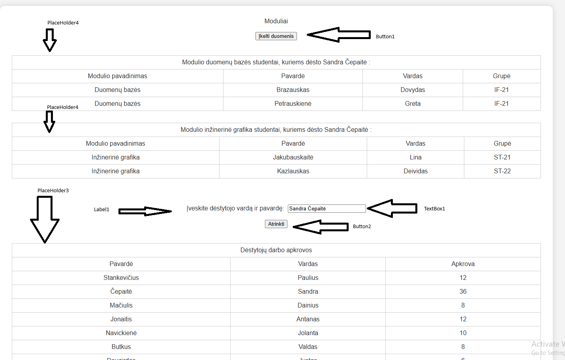

Pav.37 GUI schema

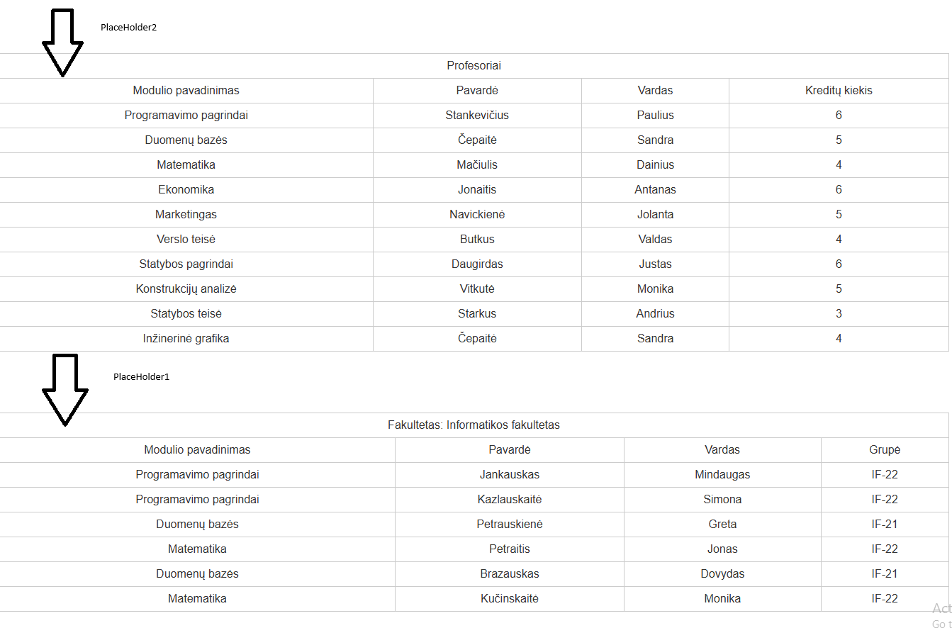

Pav.38 GUI schema

Sąsajoje panaudotų komponentų keičiamos savybės

Komponentas | Savybė | Reikšmė
Button1 | Text | „Įkelti duomenis“
PlaceHolder4 | ID | PH4
Label1 | Text | „Įveskite dėstytojo vardą ir pavardę“
 | Visible | False
TextBox1 | Width | 190px
 | Visible | False
Button2 | Visible | False
PlaceHolder3 | ID | PH3
PlaceHolder2 | ID | PH2
PlaceHolder1 | ID | PH1

Klasių diagrama

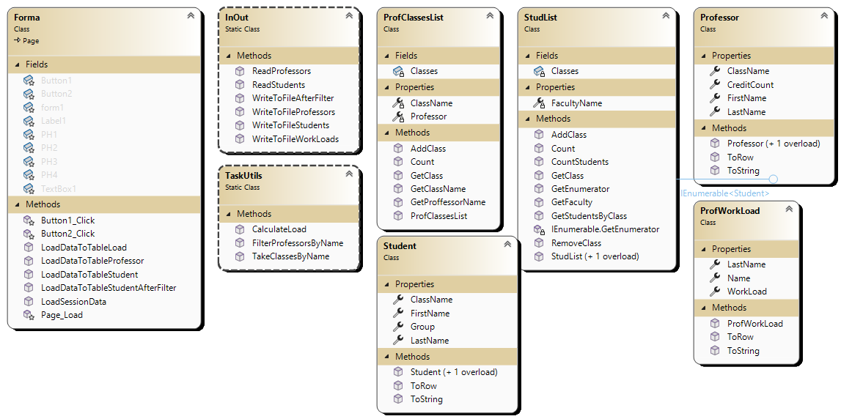

Pav.39 Klasių diagrama

Programos naudotojo vadovas

Visi failai su sudento duomenimis tuyri būti sukelti į katalogą AddData, kurį rasime projekto kataloge. ProfData.txt turi būti įkeltas į šakninį projekto katalogą. Paspaudus mygtuką programoje „Įkelti duomenis“, programa automatiškai nussikaito duomenis ir pateikia suskaičiuotą krūvį kiekvienam dėstytojui. Įvesdus į paieškos laukelį dėstytojo vardą ir pavardę ir paspaudus mygtuką „Atrinkti“, programa sudarys lenteles studentų, kurie lanko modulius pas nurodytą dėstytoją, sąrašus.

Programos tekstas

Student.cs
using System;
using System.Collections.Generic;
using System.Linq;
using System.Web;
using System.Web.UI.WebControls;

namespace LD5
{
/// <summary>
/// Represents a student with class, name, and group information.
/// </summary>
public class Student
{
/// <summary>
/// The class name.
/// </summary>
public string ClassName { get; set; }

/// <summary>
/// The last name.
/// </summary>
public string LastName { get; set; }

/// <summary>
/// The first name.
/// </summary>
public string FirstName { get; set; }

/// <summary>
/// The group.
/// </summary>
public string Group { get; set; }

/// <summary>
/// Creates a student with class name, last name, first name, and group.
/// </summary>
public Student(string classname, string lastName, string firstName, string group)
{
this.ClassName = classname;
this.LastName = lastName;
this.FirstName = firstName;
this.Group = group;
}

/// <summary>
/// Creates a student with last name, first name, and group.
/// </summary>
public Student(string lastName, string Name, string group)
{
this.LastName = lastName;
this.FirstName = Name;
this.Group = group;
}

/// <summary>
/// Converts the student data to a table row.
/// </summary>
public TableRow ToRow()
{
TableRow row = new TableRow();
row.Cells.Add(new TableCell() { Text = ClassName });
row.Cells.Add(new TableCell() { Text = LastName });
row.Cells.Add(new TableCell() { Text = FirstName });
row.Cells.Add(new TableCell() { Text = Group });
return row;
}

/// <summary>
/// Returns a string with student data in table format.
/// </summary>
public override string ToString()
{
return string.Format($"| {this.ClassName,25} | {this.LastName,25} | {this.FirstName,25} | {this.Group,15} |");
}
}
}

Professor.cs

using System;

using System.Collections.Generic;

using System.Linq;

using System.Web;

using System.Web.UI.WebControls;

namespace LD5

{

/// <summary>

/// Represents a professor with class name, last name, first name, and credit count.

/// </summary>

public class Professor

{

/// <summary>

/// The class name.

/// </summary>

public string ClassName { get; set; }

/// <summary>

/// The professor's last name.

/// </summary>

public string LastName { get; set; }

/// <summary>

/// The professor's first name.

/// </summary>

public string FirstName { get; set; }

/// <summary>

/// The credit count.

/// </summary>

public int CreditCount { get; set; }

/// <summary>

/// Creates a professor with all details.

/// </summary>

public Professor(string classname, string lastName, string firstName, int creditCount)

{

this.ClassName = classname;

this.LastName = lastName;

this.FirstName = firstName;

this.CreditCount = creditCount;

}

/// <summary>

/// Creates a professor with only last and first name.

/// </summary>

public Professor(string lastName, string firstName)

{

this.LastName = lastName;

this.FirstName = firstName;

}

/// <summary>

/// Converts professor data to a table row.

/// </summary>

public TableRow ToRow()

{

TableRow row = new TableRow();

row.Cells.Add(new TableCell() { Text = ClassName });

row.Cells.Add(new TableCell() { Text = LastName });

row.Cells.Add(new TableCell() { Text = FirstName });

row.Cells.Add(new TableCell() { Text = CreditCount.ToString() });

return row;

}

/// <summary>

/// Returns a formatted string with professor data.

/// </summary>

public override string ToString()

{

return string.Format($"| {this.ClassName,25} | {this.LastName,25} | {this.FirstName,25} | {this.CreditCount,-15} |");

}

}

}

ProfWorkLoad.cs

using System;

using System.Collections.Generic;

using System.Linq;

using System.Web;

using System.Web.UI.WebControls;

namespace LD5

{

/// <summary>

/// Holds information about a professor's workload.

/// </summary>

public class ProfWorkLoad

{

/// <summary>

/// Professor's first name.

/// </summary>

public string Name { get; set; }

/// <summary>

/// Professor's last name.

/// </summary>

public string LastName { get; set; }

/// <summary>

/// Amount of work assigned to the professor.

/// </summary>

public int WorkLoad { get; set; }

/// <summary>

/// Creates a new ProfWorkLoad with name, last name, and workload.

/// </summary>

public ProfWorkLoad(string name, string lastName, int workLoad)

{

this.Name = name;

this.LastName = lastName;

this.WorkLoad = workLoad;

}

/// <summary>

/// Converts the professor's data to a table row.

/// </summary>

public TableRow ToRow()

{

TableRow row = new TableRow();

row.Cells.Add(new TableCell() { Text = Name });

row.Cells.Add(new TableCell() { Text = LastName });

row.Cells.Add(new TableCell() { Text = WorkLoad.ToString() });

return row;

}

/// <summary>

/// Returns a formatted string with the professor's data.

/// </summary>

public override string ToString()

{

return string.Format($"| {this.Name,25} | {this.LastName,25} | {this.WorkLoad,-15} |");

}

}

}

StudList.cs

using System;

using System.Collections;

using System.Collections.Generic;

using System.Linq;

using System.Web;

namespace LD5

{

/// <summary>

/// Stores a list of students for a faculty.

/// Lets you add, remove, and find students by class.

/// </summary>

public class StudList : IEnumerable<Student>

{

private List<Student> Classes;

private string FacultyName { get; set; } = string.Empty;

/// <summary>

/// Makes a new student list for a faculty.

/// </summary>

/// <param name="facultyName">Name of the faculty</param>

public StudList(string facultyName)

{

Classes = new List<Student>();

this.FacultyName = facultyName;

}

/// <summary>

/// Makes a new empty student list.

/// </summary>

public StudList()

{

Classes = new List<Student>();

}

/// <summary>

/// Gets the faculty name.

/// </summary>

/// <returns>Faculty name</returns>

public string GetFaculty()

{

return FacultyName;

}

/// <summary>

/// Adds a student to the list.

/// </summary>

/// <param name="newClass">Student to add</param>

public void AddClass(Student newClass)

{

Classes.Add(newClass);

}

/// <summary>

/// Removes a student from the list.

/// </summary>

/// <param name="oldClass">Student to remove</param>

public void RemoveClass(Student oldClass)

{

Classes.Remove(oldClass);

}

/// <summary>

/// Gets a student by index.

/// </summary>

/// <param name="index">Index of student</param>

/// <returns>Student at index</returns>

public Student GetClass(int index)

{

return Classes[index];

}

/// <summary>

/// Gets the number of students in the list.

/// </summary>

/// <returns>Count of students</returns>

public int Count()

{

return Classes.Count;

}

/// <summary>

/// Counts students in a class.

/// </summary>

/// <param name="cn">Class name</param>

/// <returns>Number of students in the class</returns>

public int CountStudents(string cn)

{

return Classes.Count(s => s.ClassName == cn);

}

/// <summary>

/// Gets all students in a class.

/// </summary>

/// <param name="className">Class name</param>

/// <returns>List of students in the class</returns>

public List<Student> GetStudentsByClass(string className)

{

return Classes.Where(s => s.ClassName == className).ToList();

}

/// <summary>

/// Gets an enumerator for the students.

/// </summary>

/// <returns>Enumerator for students</returns>

public IEnumerator<Student> GetEnumerator()

{

return Classes.GetEnumerator();

}

IEnumerator IEnumerable.GetEnumerator()

{

return GetEnumerator();

}

}

}

ProfClassesList.cs

using System;

using System.Collections.Generic;

using System.Linq;

using System.Web;

namespace LD5.Lists

{

/// <summary>

/// Stores a list of students for a professor's class.

/// Keeps the class name and professor information.

/// </summary>

public class ProfClassesList

{

/// <summary>

/// List of students in the class.

/// </summary>

private List<Student> Classes;

/// <summary>

/// Name of the class.

/// </summary>

private string ClassName { get; set; }

/// <summary>

/// Professor who teaches the class.

/// </summary>

private Professor Professor { get; set; }

/// <summary>

/// Creates a new ProfClassesList with class name, students, and professor's name.

/// </summary>

/// <param name="className">Name of the class</param>

/// <param name="afterFilter">List of students</param>

/// <param name="Name">Professor's first name</param>

/// <param name="LastName">Professor's last name</param>

public ProfClassesList(string className, List<Student> afterFilter, string Name, string LastName)

{

this.Professor = new Professor(LastName, Name);

Classes = afterFilter;

this.ClassName = className;

}

/// <summary>

/// Adds a student to the class.

/// </summary>

/// <param name="newClass">Student to add</param>

public void AddClass(Student newClass)

{

Classes.Add(newClass);

}

/// <summary>

/// Gets a student by index.

/// </summary>

/// <param name="index">Index of the student</param>

/// <returns>Student at the given index</returns>

public Student GetClass(int index)

{

return Classes[index];

}

/// <summary>

/// Gets the number of students in the class.

/// </summary>

/// <returns>Count of students</returns>

public int Count()

{

return Classes.Count;

}

/// <summary>

/// Gets the class name.

/// </summary>

/// <returns>Class name</returns>

public string GetClassName()

{

return ClassName;

}

/// <summary>

/// Gets the professor's full name.

/// </summary>

/// <returns>Professor's first and last name</returns>

public string GetProffessorName()

{

return Professor.FirstName + " " + Professor.LastName;

}

}

}

TaskUtils.cs

using LD5.Lists;

using System;

using System.CodeDom;

using System.Collections.Generic;

using System.Diagnostics;

using System.Linq;

using System.Web;

using System.Web.UI.WebControls;

namespace LD5

{

public static class TaskUtils

{

/// <summary>

/// Calculates the workload for each professor.

/// Workload = total students in all classes * total credits.

/// </summary>

/// <param name="profClasses">List of professors with their classes.</param>

/// <param name="choises">List of student lists (choices).</param>

/// <returns>List of professor workloads.</returns>

public static List<ProfWorkLoad> CalculateLoad(List<Professor> profClasses, List<StudList> choises)

{

return profClasses

.GroupBy(prof => new { prof.LastName, prof.FirstName })

.Select(profGroup =>

{

int totalStudents = profGroup.Sum(prof =>

choises.Sum(cl => cl.CountStudents(prof.ClassName))

);

int totalCredits = profGroup.Sum(prof => prof.CreditCount);

int load = totalStudents * totalCredits;

return new ProfWorkLoad(profGroup.Key.LastName, profGroup.Key.FirstName, load);

})

.ToList();

}

/// <summary>

/// Gets a list of classes for each professor with students in those classes.

/// </summary>

/// <param name="profs">List of professors.</param>

/// <param name="studentsLists">List of student lists.</param>

/// <returns>List of professor classes with students.</returns>

public static List<ProfClassesList> TakeClassesByName(List<Professor> profs, List<StudList> studentsLists)

{

List<ProfClassesList> tempList = profs

.Select(prof => new ProfClassesList(

prof.ClassName,

studentsLists.SelectMany(s => s.GetStudentsByClass(prof.ClassName)).OrderBy(s => s.Group).ThenBy(s => s.LastName).ToList(),

prof.FirstName,

prof.LastName)).ToList();

return tempList;

}

/// <summary>

/// Finds professors by full name (FirstName LastName).

/// Shows alert if input is wrong.

/// </summary>

/// <param name="Name_LastName">Professor's full name (FirstName LastName).</param>

/// <param name="profesors">List of professors.</param>

/// <returns>List of professors matching the name.</returns>

public static List<Professor> FilterProfessorsByName(string Name_LastName, List<Professor> profesors)

{

List<Professor> filteredProfessors = new List<Professor>();

try

{

string[] parts = Name_LastName.Split(' ');

string name = parts[0];

string lastName = parts[1];

filteredProfessors = profesors

.Where(prof => prof.FirstName.Equals(name, StringComparison.OrdinalIgnoreCase) &&

prof.LastName.Equals(lastName, StringComparison.OrdinalIgnoreCase))

.ToList();

}

catch

{

HttpContext.Current.Response.Write(

String.Format($"<script>alert('Neteisingai įvestas dėstytojas" +

$" {Name_LastName}. Formatas: Vardas Pavardė')</script>"));

}

return filteredProfessors;

}

}

}

InOutUtils.cs

using LD5.Lists;

using System;

using System.Collections.Generic;

using System.IO;

using System.Linq;

using System.Text;

using System.Web;

namespace LD5

{

/// <summary>

/// Handles reading and writing student and professor data to files.

/// </summary>

public static class InOut

{

/// <summary>

/// Reads students from a file and returns a StudList.

/// </summary>

/// <param name="fileName">The file to read from.</param>

/// <returns>List of students.</returns>

public static StudList ReadStudents(string fileName)

{

StudList students = null;

using (StreamReader reader = new StreamReader(fileName, Encoding.UTF8))

{

string line;

int lineCounter = 1;

line = reader.ReadLine();

students = new StudList(line);

while ((line = reader.ReadLine()) != null)

{

try

{

string[] parts = line.Split(';');

string className = parts[0];

string lastname = parts[1];

string name = parts[2];

string group = parts[3];

Student student = new Student(className, lastname, name, group);

students.AddClass(student);

}

catch

{

HttpContext.Current.Response.Write(

String.Format($"<script>alert('Klaida failo" +

$" {fileName} eilutėje {lineCounter}')</script>"));

continue;

}

finally { lineCounter++; }

}

}

return students;

}

/// <summary>

/// Reads professors from a file and returns a list of Professor objects.

/// </summary>

/// <param name="fileName">The file to read from.</param>

/// <returns>List of professors.</returns>

public static List<Professor> ReadProfessors(string fileName)

{

List<Professor> profs = null;

using (StreamReader reader = new StreamReader(fileName, Encoding.UTF8))

{

string line;

int lineCounter = 1;

profs = new List<Professor>();

while ((line = reader.ReadLine()) != null)

{

try

{

string[] parts = line.Split(';');

string className = parts[0];

string lastname = parts[1];

string name = parts[2];

int credits = int.Parse(parts[3]);

Professor professor = new Professor(className, lastname, name, credits);

profs.Add(professor);

}

catch

{

HttpContext.Current.Response.Write(

String.Format($"<script>alert('Klaida failo" +

$" {fileName} eilutėje {lineCounter}')</script>"));

continue;

}

finally { lineCounter++; }

}

}

return profs;

}

/// <summary>

/// Writes a list of student lists to a file with a header.

/// </summary>

/// <param name="fileName">The file to write to.</param>

/// <param name="list">List of student lists.</param>

/// <param name="header">Header text.</param>

public static void WriteToFileStudents(string fileName, List<StudList> list, string header)

{

using (StreamWriter writer = new StreamWriter(fileName, true, Encoding.UTF8))

{

writer.WriteLine(header);

foreach (StudList studList in list)

{

writer.WriteLine("Fakultetas: " + studList.GetFaculty());

writer.WriteLine(new string('-', 103));

writer.WriteLine($"| {"Modulio pavadinimas",25} | {"Pavardė",25} | {"Vardas",25} | {"Grupė",15} |");

writer.WriteLine(new string('-', 103));

foreach (Student s in studList)

{

writer.WriteLine(s.ToString());

}

writer.WriteLine(new string('-', 103));

}

}

}

/// <summary>

/// Writes a list of professors to a file with a header.

/// </summary>

/// <param name="fileName">The file to write to.</param>

/// <param name="list">List of professors.</param>

/// <param name="header">Header text.</param>

public static void WriteToFileProfessors(string fileName, List<Professor> list, string header)

{

using (StreamWriter writer = new StreamWriter(fileName, true, Encoding.UTF8))

{

writer.WriteLine(header);

writer.WriteLine(new string('-', 103));

writer.WriteLine($"| {"Modulio pavadinimas",25} | {"Pavardė",25} | {"Vardas",25} | {"Kreditų kiekis",15} |");

writer.WriteLine(new string('-', 103));

foreach (Professor s in list)

{

writer.WriteLine(s.ToString());

}

writer.WriteLine(new string('-', 103));

}

}

/// <summary>

/// Writes a list of professor workloads to a file with a header.

/// </summary>

/// <param name="fileName">The file to write to.</param>

/// <param name="list">List of professor workloads.</param>

/// <param name="header">Header text.</param>

public static void WriteToFileWorkLoads(string fileName, List<ProfWorkLoad> list, string header)

{

using (StreamWriter writer = new StreamWriter(fileName, true, Encoding.UTF8))

{

writer.WriteLine(header);

writer.WriteLine(new string('-', 75));

writer.WriteLine($"| {"Vardas",25} | {"Pavardė",25} | {"Grupė",15} |");

writer.WriteLine(new string('-', 75));

foreach (ProfWorkLoad s in list)

{

writer.WriteLine(s.ToString());

}

writer.WriteLine(new string('-', 75));

}

}

/// <summary>

/// Writes filtered professor classes to a file with a header.

/// </summary>

/// <param name="fileName">The file to write to.</param>

/// <param name="listintList">List of filtered professor classes.</param>

/// <param name="header">Header text.</param>

public static void WriteToFileAfterFilter(string fileName, List<ProfClassesList> listintList, string header)

{

using (StreamWriter writer = new StreamWriter(fileName, true, Encoding.UTF8))

{

writer.WriteLine(header);

writer.WriteLine(new string('-', 103));

writer.WriteLine($"| {"Modulio pavadinimas",25} | {"Pavardė",25} | {"Vardas",25} | {"Grupė",15} |");

writer.WriteLine(new string('-', 103));

for (int i = 0; i < listintList.Count(); i++)

{

ProfClassesList profClass = listintList[i];

for (int j = 0; j < profClass.Count(); j++)

{

writer.WriteLine(profClass.GetClass(j).ToString());

}

}

writer.WriteLine(new string('-', 103));

}

}

}

}

Forma.aspx

<%@ Page Language="C#" AutoEventWireup="true" CodeBehind="Forma.aspx.cs" Inherits="LD5.Forma" %>

<!DOCTYPE html>

<html xmlns="http://www.w3.org/1999/xhtml">

<head runat="server">

<link href="Styles.css" rel="stylesheet" type="text/css" />

<title></title>

</head>

<body>

<form id="form1" runat="server" visible="True">

<div>

Moduliai<br />

<br />

<asp:Button ID="Button1" runat="server" OnClick="Button1_Click" Text="Įkelti duomenis" />

<br />

<br />

<asp:PlaceHolder ID="PH4" runat="server"></asp:PlaceHolder>

<br />

<br />

<asp:Label ID="Label1" runat="server" Text="Įveskite dėstytojo vardą ir pavardę:" Visible="False"></asp:Label>

&nbsp;<asp:TextBox ID="TextBox1" runat="server" Visible="False" Width="190px"></asp:TextBox>

<br />

<br />

<asp:Button ID="Button2" runat="server" OnClick="Button2_Click" Text="Atrinkti" Visible="False" />

<br />

<br />

<asp:PlaceHolder ID="PH3" runat="server"></asp:PlaceHolder>

<br />

<br />

<asp:PlaceHolder ID="PH2" runat="server"></asp:PlaceHolder>

<br />

<br />

<asp:PlaceHolder ID="PH1" runat="server"></asp:PlaceHolder>

</div>

</form>

</body>

</html>

Forma.aspx.cs

using LD5.Lists;

using System;

using System.Collections.Generic;

using System.IO;

using System.Linq;

using System.Web;

using System.Web.UI;

using System.Web.UI.WebControls;

namespace LD5

{

public partial class Forma : System.Web.UI.Page

{

protected void Page_Load(object sender, EventArgs e)

{

if (!IsPostBack)

{

Button2.Visible = false;

Label1.Visible = false;

TextBox1.Visible = false;

if (File.Exists(Server.MapPath("~/ExternalData.txt"))) File.Delete(Server.MapPath("~/ExternalData.txt"));

}

else

{

LoadSessionData();

}

}

protected void Button1_Click(object sender, EventArgs e)

{

string folderPath = Server.MapPath("~/AppData/");

string[] filePaths = Directory.GetFiles(folderPath, "*.txt");

List<StudList> studentsChoises = new List<StudList>();

List<Professor> professors = new List<Professor>();

if (filePaths.Length == 0)

{

HttpContext.Current.Response.Write("<script>alert('Nerasta jokių failų AppData aplanke.')</script>");

return;

}

try

{

studentsChoises = filePaths.Select(path => InOut.ReadStudents(path)).ToList();

InOut.WriteToFileStudents(Server.MapPath("~/ExternalData.txt"), studentsChoises, "Nuskaityti studentų duomenys");

}

catch

{

HttpContext.Current.Response.Write("<script>alert('Klaida skaitant studentų duomenis. Patikrinkite failus AppData aplanke.')</script>");

}

try

{

professors = InOut.ReadProfessors(Server.MapPath("~/ProfData.txt"));

InOut.WriteToFileProfessors(Server.MapPath("~/ExternalData.txt"), professors, "Nuskaityti dėstytojų duomenys");

}

catch

{

HttpContext.Current.Response.Write("<script>alert('Klaida skaitant dėstytojų duomenis. Patikrinkite ProfData.txt failą.')</script>");

return;

}

studentsChoises.ForEach(students =>

{

LoadDataToTableStudent(students, $"Fakultetas: {students.GetFaculty()}", PH1);

});

LoadDataToTableProfessor(professors, "Profesoriai", PH2);

Session["students"] = studentsChoises;

Session["professors"] = professors;

List<ProfWorkLoad> LoadCalc = new List<ProfWorkLoad>();

try

{

LoadCalc = TaskUtils.CalculateLoad(professors, studentsChoises);

InOut.WriteToFileWorkLoads(Server.MapPath("~/ExternalData.txt"), LoadCalc, "Dėstytojų darbo apkrovos");

}

catch

{

HttpContext.Current.Response.Write("<script>alert('Klaida skaičiuojant dėstytojų apkrovą.')</script>");

return;

}

LoadDataToTableLoad(LoadCalc, "Dėstytojų darbo apkrovos", PH3);

Session["Load"] = LoadCalc;

Button2.Visible = true;

Label1.Visible = true;

TextBox1.Visible = true;

}

protected void Button2_Click(object sender, EventArgs e)

{

string Name_LastName = TextBox1.Text.Trim();

List<Professor> filteredProfessors = TaskUtils.FilterProfessorsByName(Name_LastName, (List<Professor>)Session["professors"]);

List<ProfClassesList> filteredByClass = TaskUtils.TakeClassesByName(filteredProfessors, (List<StudList>)Session["students"]);

filteredByClass.ForEach(ProfClass =>

{

LoadDataToTableStudentAfterFilter(ProfClass, "Modulio "

+ ProfClass.GetClassName().ToLower() + " studentai, kuriems dėsto " + ProfClass.GetProffessorName() + " : ", PH4);

});

InOut.WriteToFileAfterFilter(Server.MapPath("~/ExternalData.txt"), filteredByClass, Name_LastName + " studentai: ");

}

}

}

FormaMethods.cs

using LD5.Lists;

using System;

using System.Collections.Generic;

using System.Linq;

using System.Web;

using System.Web.Routing;

using System.Web.UI.HtmlControls;

using System.Web.UI.WebControls;

namespace LD5

{

public partial class Forma : System.Web.UI.Page

{

/// <summary>

/// Loads filtered student data into a table and adds it to the given placeholder.

/// </summary>

/// <param name="classes">List of filtered student classes.</param>

/// <param name="header">Table header text.</param>

/// <param name="ph">Placeholder to add the table to.</param>

public void LoadDataToTableStudentAfterFilter(ProfClassesList classes, string header, PlaceHolder ph)

{

Table table = new Table();

TableRow headerRow = new TableRow();

headerRow.Cells.Add(new TableCell() { Text = string.Format(header), ColumnSpan = 4 });

table.Rows.Add(headerRow);

TableRow hRow1 = new TableRow();

hRow1.Cells.Add(new TableCell() { Text = "Modulio pavadinimas" });

hRow1.Cells.Add(new TableCell() { Text = "Pavardė" });

hRow1.Cells.Add(new TableCell() { Text = "Vardas" });

hRow1.Cells.Add(new TableCell() { Text = "Grupė" });

table.Controls.Add(hRow1);

for (int i = 0; i < classes.Count(); i++)

{

table.Rows.Add(classes.GetClass(i).ToRow());

}

ph.Controls.Add(table);

}

/// <summary>

/// Loads student data into a table and adds it to the given placeholder.

/// </summary>

/// <param name="classes">List of student classes.</param>

/// <param name="header">Table header text.</param>

/// <param name="ph">Placeholder to add the table to.</param>

public void LoadDataToTableStudent(StudList classes, string header, PlaceHolder ph)

{

Table table = new Table();

TableRow headerRow = new TableRow();

headerRow.Cells.Add(new TableCell() { Text = string.Format(header), ColumnSpan = 4 });

table.Rows.Add(headerRow);

TableRow hRow1 = new TableRow();

hRow1.Cells.Add(new TableCell() { Text = "Modulio pavadinimas" });

hRow1.Cells.Add(new TableCell() { Text = "Pavardė" });

hRow1.Cells.Add(new TableCell() { Text = "Vardas" });

hRow1.Cells.Add(new TableCell() { Text = "Grupė" });

table.Controls.Add(hRow1);

for (int i = 0; i < classes.Count(); i++)

{

table.Rows.Add(classes.GetClass(i).ToRow());

}

ph.Controls.Add(table);

}

/// <summary>

/// Loads professor data into a table and adds it to the given placeholder.

/// </summary>

/// <param name="classes">List of professors.</param>

/// <param name="header">Table header text.</param>

/// <param name="ph">Placeholder to add the table to.</param>

public void LoadDataToTableProfessor(List<Professor> classes, string header, PlaceHolder ph)

{

Table table = new Table();

TableRow headerRow = new TableRow();

headerRow.Cells.Add(new TableCell() { Text = string.Format(header), ColumnSpan = 4 });

table.Rows.Add(headerRow);

TableRow hRow1 = new TableRow();

hRow1.Cells.Add(new TableCell() { Text = "Modulio pavadinimas" });

hRow1.Cells.Add(new TableCell() { Text = "Pavardė" });

hRow1.Cells.Add(new TableCell() { Text = "Vardas" });

hRow1.Cells.Add(new TableCell() { Text = "Kreditų kiekis" });

table.Controls.Add(hRow1);

foreach (Professor p in classes)

{

table.Rows.Add(p.ToRow());

}

ph.Controls.Add(table);

}

/// <summary>

/// Loads professor workload data into a table and adds it to the given placeholder.

/// </summary>

/// <param name="loads">List of professor workloads.</param>

/// <param name="header">Table header text.</param>

/// <param name="ph">Placeholder to add the table to.</param>

public void LoadDataToTableLoad(List<ProfWorkLoad> loads, string header, PlaceHolder ph)

{

Table table = new Table();

TableRow headerRow = new TableRow();

headerRow.Cells.Add(new TableCell() { Text = string.Format(header), ColumnSpan = 3 });

table.Rows.Add(headerRow);

TableRow hRow1 = new TableRow();

hRow1.Cells.Add(new TableCell() { Text = "Pavardė" });

hRow1.Cells.Add(new TableCell() { Text = "Vardas" });

hRow1.Cells.Add(new TableCell() { Text = "Apkrova" });

table.Controls.Add(hRow1);

foreach (ProfWorkLoad l in loads)

{

table.Rows.Add(l.ToRow());

}

ph.Controls.Add(table);

}

/// <summary>

/// Loads data from session and fills tables for students, professors, and workloads.

/// </summary>

public void LoadSessionData()

{

try

{

if (Session["students"] != null)

{

List<StudList> studentsChoises = (List<StudList>)Session["students"];

studentsChoises.ForEach(students =>

{

LoadDataToTableStudent(students, $"Fakultetas: {students.GetFaculty()}", PH1);

});

}

if (Session["professors"] != null)

{

List<Professor> professors = (List<Professor>)Session["professors"];

LoadDataToTableProfessor(professors, "Profesoriai", PH2);

}

if (Session["Load"] != null)

{

List<ProfWorkLoad> LoadCalc = (List<ProfWorkLoad>)Session["Load"];

LoadDataToTableLoad(LoadCalc, "Dėstytojų darbo apkrovos", PH3);

}

}

catch (Exception)

{

HttpContext.Current.Response.Write("<script>alert('Klaida įkeliant sesijos duomenis.')</script>");

}

}

}

}

Styles.css

body {

font-family: Arial, sans-serif;

background-color: #f4f4f4;

color: #333;

margin: 0;

padding: 20px;

}

form {

background-color: white;

padding: 20px;

border-radius: 10px;

box-shadow: 0 0 10px rgba(0, 0, 0, 0.1);

text-align: center;

}

h1 {

text-align: center;

color: #2c3e50;

margin-bottom: 30px;

}

form {

width: 95%;

max-width: 1400px;

margin: auto;

background-color: white;

padding: 30px;

border-radius: 12px;

box-shadow: 0 0 15px rgba(0, 0, 0, 0.15);

text-align: center;

box-sizing: border-box;

overflow-x: auto;

}

table {

width: 100%;

border-collapse: collapse;

margin-top: 20px;

margin-bottom: 30px;

}

table, th, td {

border: 1px solid #ccc;

}

th, td {

padding: 8px;

text-align: center;

}

caption {

font-weight: bold;

margin-bottom: 10px;

}

Pradiniai duomenys ir rezultatai

Duomenys Nr. 1

IT.txt

Informatikos fakultetas

Programavimo pagrindai;Jankauskas;Mindaugas;IF-22

Programavimo pagrindai;Kazlauskaitė;Simona;IF-22

Duomenų bazės;Petrauskienė;Greta;IF-21

Matematika;Petraitis;Jonas;IF-22

Duomenų bazės;Brazauskas;Dovydas:21

Duomenų bazės;Brazauskas;Dovydas;IF-21

Matematika;Kučinskaitė;Monika;IF-22

Verslas.txt

Verslo fakultetas

Ekonomika;Bartkus;Matas;VE-21

Marketingas;Stonytė;Laura;VE-22

Verslo teisė;Navickas;Andrius;VE-22

Ekonomika;Grigaitė;Ema;VE-21

Verslo teisė;Rakauskas;Tomas;VE-21

Marketingas;Balčiūnaitė;Ieva;VE-22

Statyba.txt

Statybos fakultetas

Statybos pagrindai;Mickevičius;Lukas;ST-21

Konstrukcijų analizė;Mažeikaitė;Indrė;ST-22

Statybos teisė;Vaitkus;Mindaugas;ST-21

Konstrukcijų analizė;Jasaitis;Tadas;ST-22

Inžinerinė grafika;Jakubauskaitė;Lina;ST-21

Inžinerinė grafika;Kazlauskas;Deividas;ST-22

ProfData.txt

Programavimo pagrindai;Stankevičius;Paulius;6

Duomenų bazės;Čepaitė;Sandra;5

Matematika;Mačiulis;Dainius;4

Ekonomika;Jonaitis;Antanas;6

Marketingas;Navickienė;Jolanta;5

;;sd;;ds;'''as;;

Verslo teisė;Butkus;Valdas;4

Statybos pagrindai;Daugirdas;Justas;6

Konstrukcijų analizė;Vitkutė;Monika;5

Statybos teisė;Starkus;Andrius;3

sdsd;;s;;a;d;;;

Inžinerinė grafika;Čepaitė;Sandra;4

Rezultatai

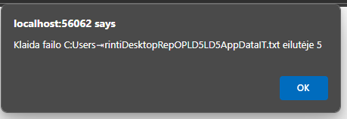

Pav.40 Klaida

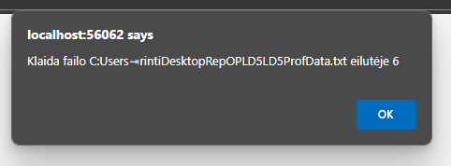

Pav.41 Klaida

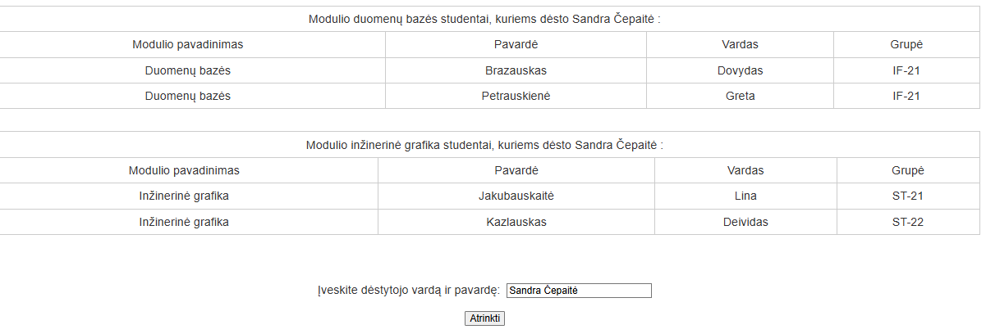

Pav. 42 Rezultatai po filtracijos

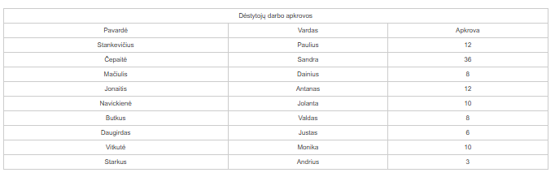

Pav.43 Dėstytojų krūvių rezultatai

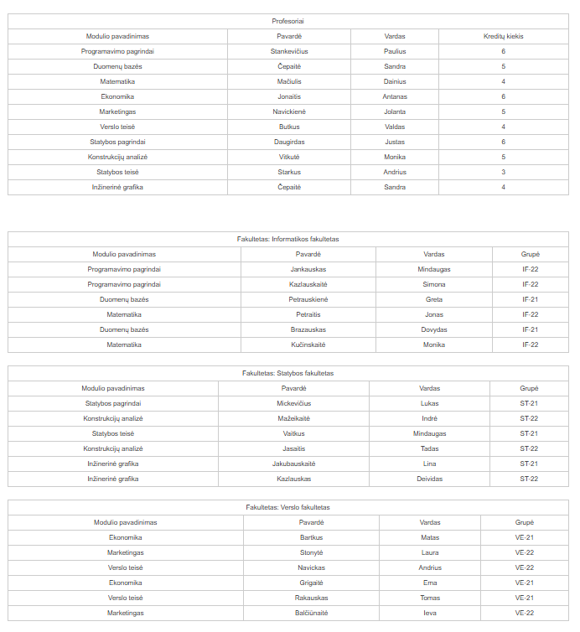

Pav.44 Nuskaityti duomenys

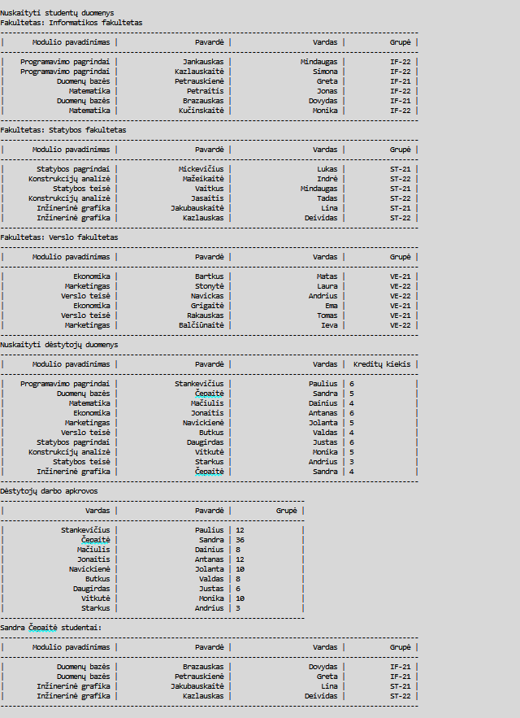

Pav.45 Rezultatai „ExternalData.txt“

Duomenys Nr. 2

IT.txt

Informatikos fakultetas

Programavimo pagrindai;Jankauskas;Mindaugas;IF-22

Programavimo pagrindai;Kazlauskaitė;Simona;IF-22

Duomenų bazės;Petrauskienė;Greta;IF-21

Matematika;Petraitis;Jonas;IF-22

Duomenų bazės;Brazauskas;Dovydas:21

Duomenų bazės;Brazauskas;Dovydas;IF-21

Matematika;Kučinskaitė;Monika;IF-22

Verslas.txt

Verslo fakultetas

Ekonomika;Bartkus;Matas;VE-21

Marketingas;Stonytė;Laura;VE-22

Verslo teisė;Navickas;Andrius;VE-22

Ekonomika;Grigaitė;Ema;VE-21

Verslo teisė;Rakauskas;Tomas;VE-21

Marketingas;Balčiūnaitė;Ieva;VE-22

Statyba.txt

Statybos fakultetas

Statybos pagrindai;Mickevičius;Lukas;ST-21

Konstrukcijų analizė;Mažeikaitė;Indrė;ST-22

Statybos teisė;Vaitkus;Mindaugas;ST-21

Konstrukcijų analizė;Jasaitis;Tadas;ST-22

Inžinerinė grafika;Jakubauskaitė;Lina;ST-21

Inžinerinė grafika;Kazlauskas;Deividas;ST-22

Itsort.txt

Informatikos fakultetas

Programavimas;Balčiūnas;Tomas;IF-21

Programavimas;Adamkevičius;Lukas;IF-22

Programavimas;Žukauskas;Marius;IF-22

Programavimas;Petraitis;Jonas;IF-21

Programavimas;Kazlauskas;Andrius;IF-21

Programavimas;Dulkytė;Eglė;IF-23

Programavimas;Bartkevičius;Simonas;IF-23

Programavimas;Jakubauskaitė;Laura;IF-22

Programavimas;Jurgelevičius;Dainius;IF-21

Programavimas;Vasiliauskaitė;Rasa;IF-23

ProfData.txt

Programavimo pagrindai;Stankevičius;Paulius;6

Duomenų bazės;Čepaitė;Sandra;5

Matematika;Mačiulis;Dainius;4

Ekonomika;Jonaitis;Antanas;6

Marketingas;Navickienė;Jolanta;5

Verslo teisė;Butkus;Valdas;4

Statybos pagrindai;Daugirdas;Justas;6

Konstrukcijų analizė;Vitkutė;Monika;5

Statybos teisė;Starkus;Andrius;3

Inžinerinė grafika;Čepaitė;Sandra;4

Rezultatai

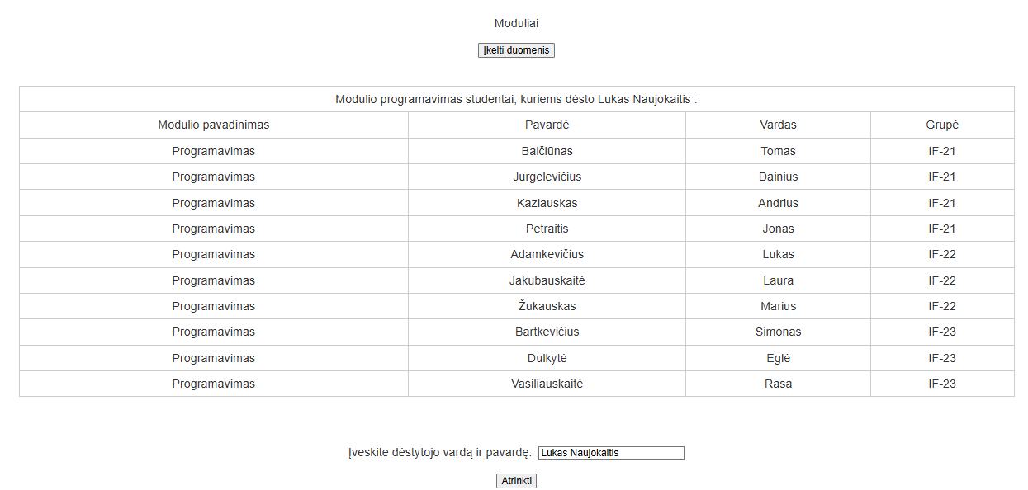

Pav.46 Rezultatai puslapyje

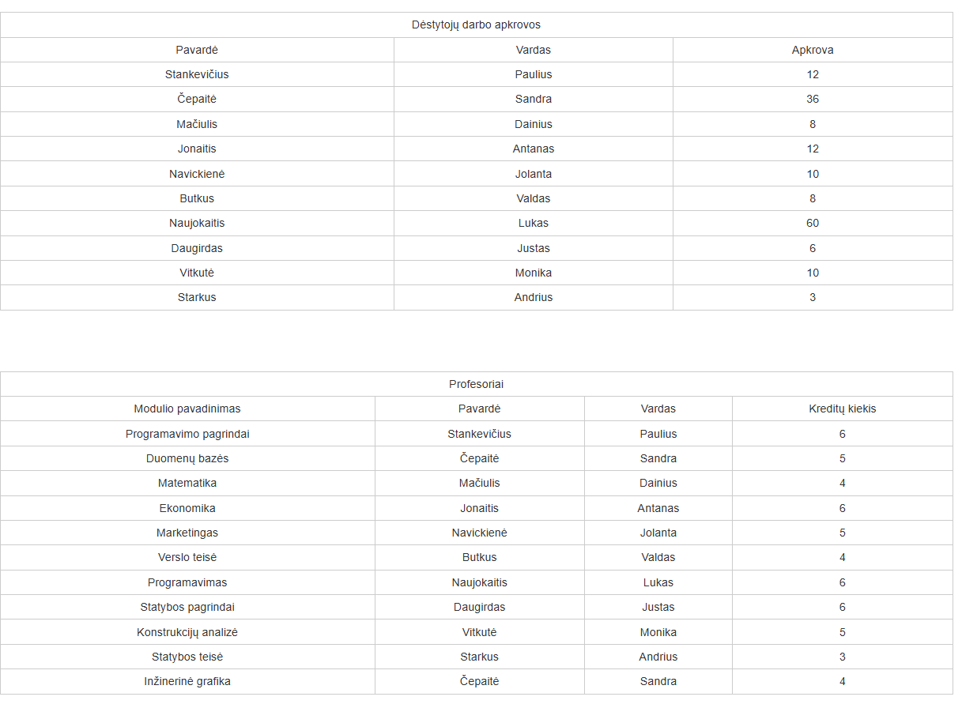

Pav.47 Rezultatai puslapyje

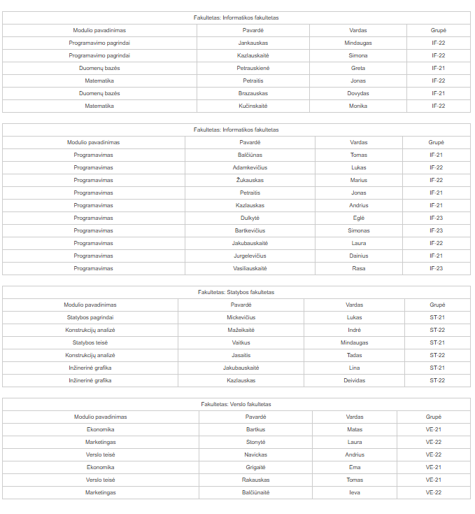

Pav.48 Rezultatai puslapyje

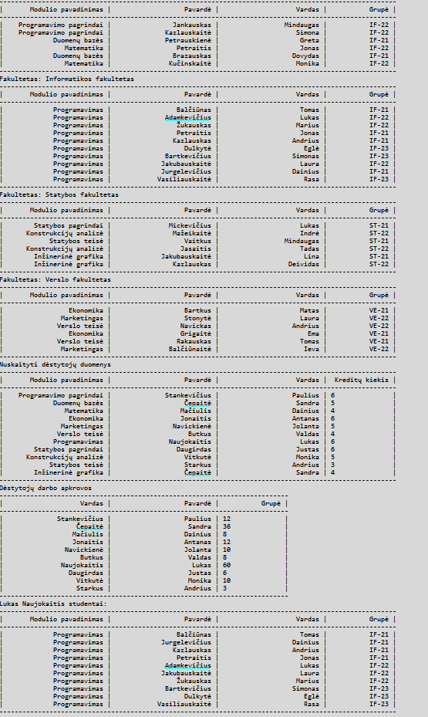

Pav.49 Rezultatai „ExternalData.txt“

Dėstytojo pastabos

