Achievement

1. 1st winer

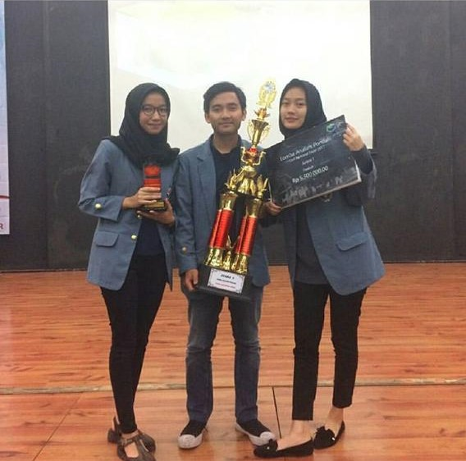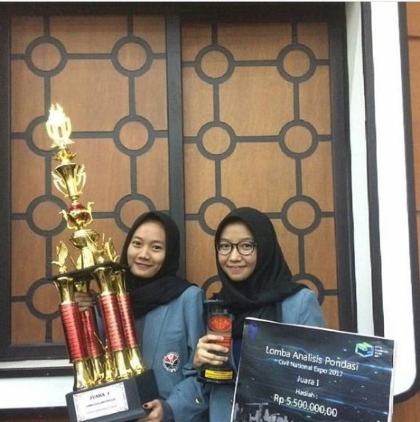

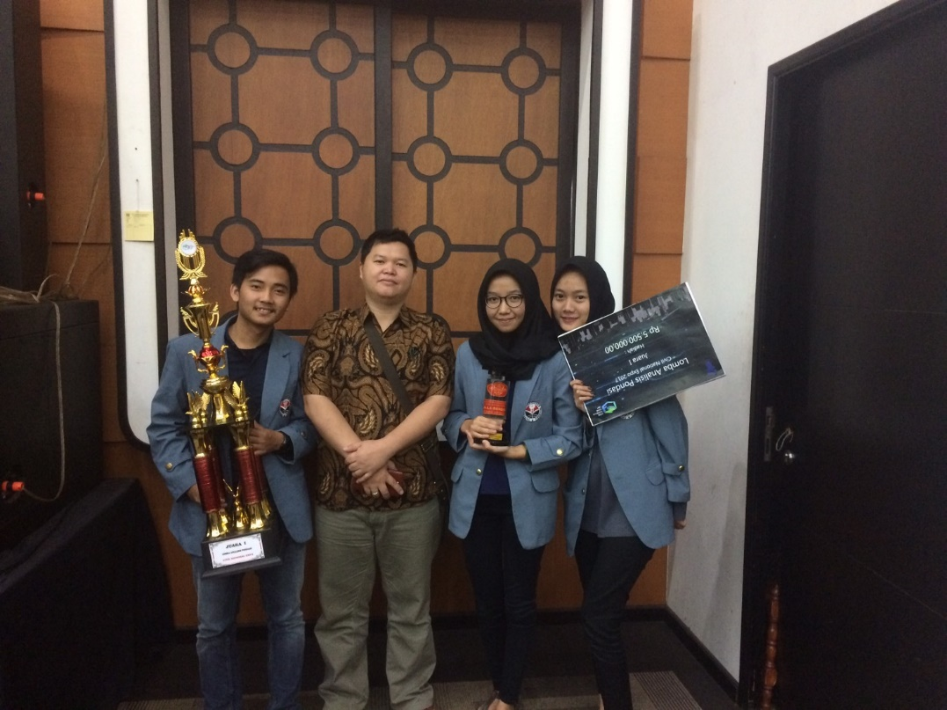

emphasized at problem of pile under lateral loading. inquiry the measurement data (bor hole is given, soil parameter use the typical condition based on related topic) for analyze working load under lateral. We use p-y methode for analyze and giving satisfactory result. the calculation of p-y methode is under Allpile program (FHWA code)

1. Finalist

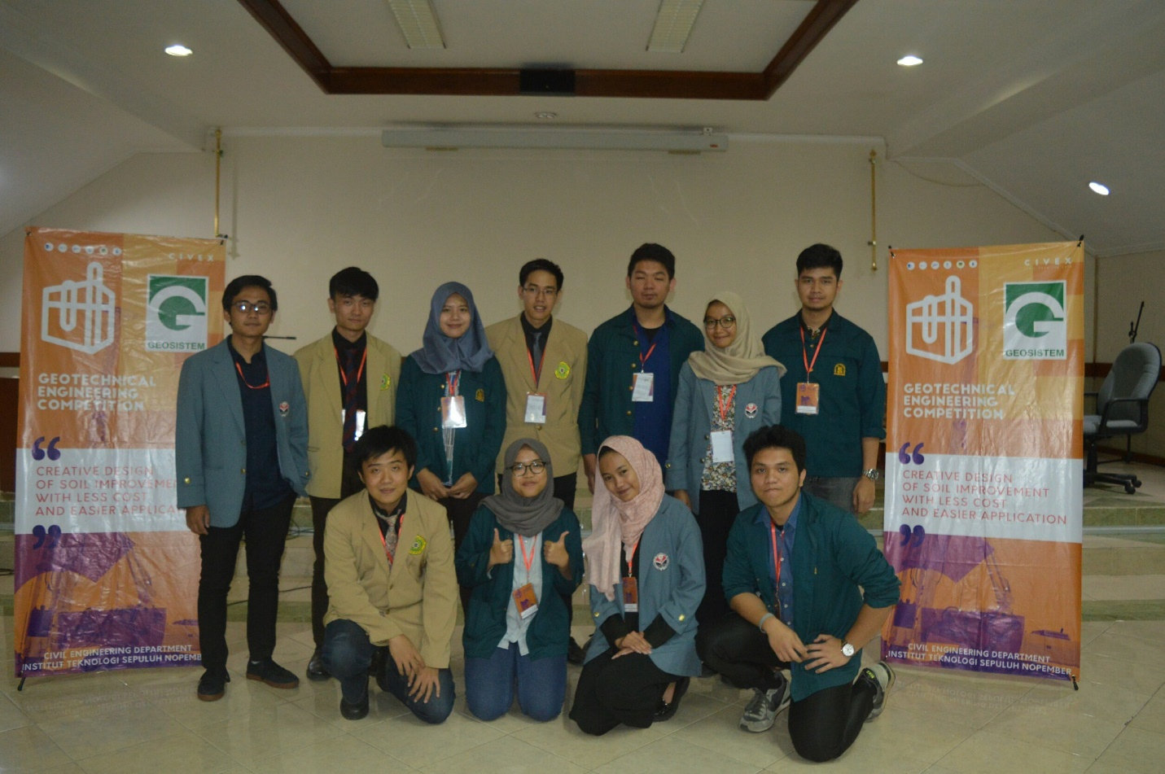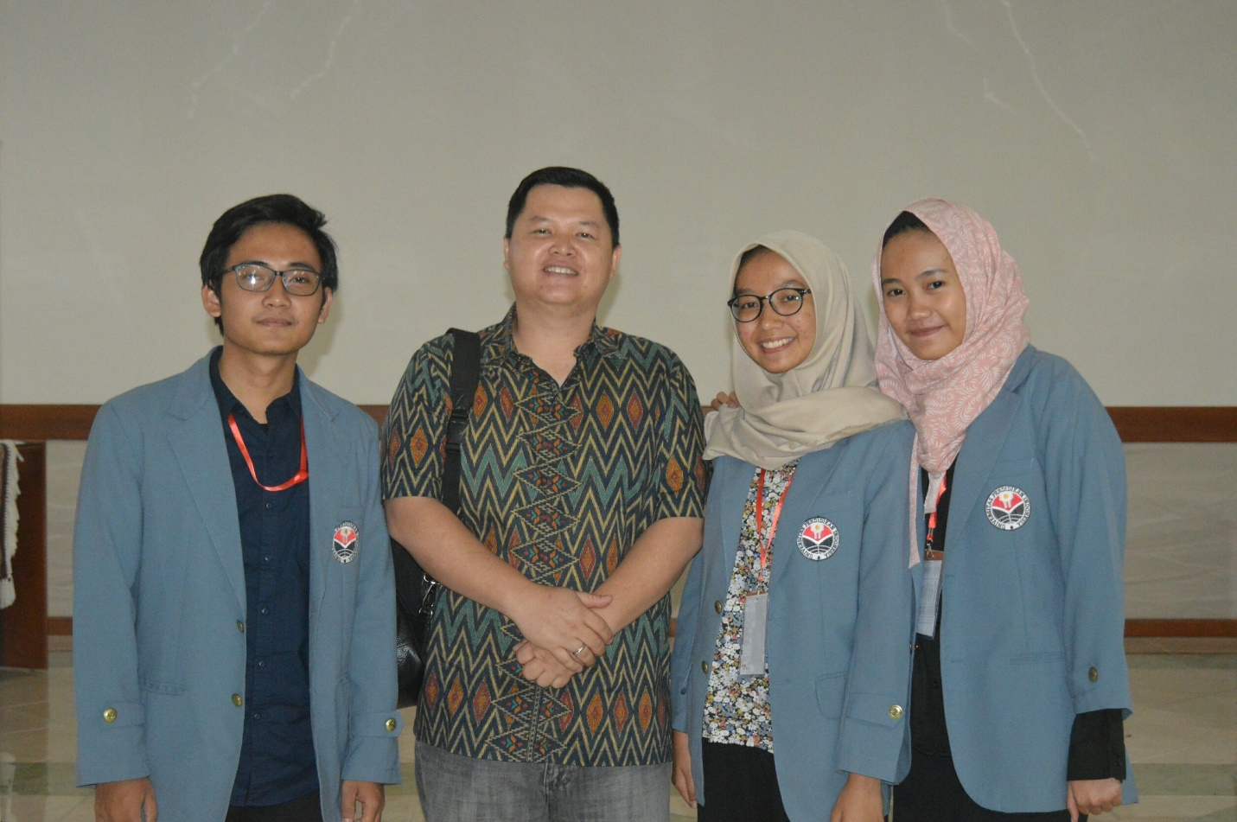

challenge on soil improvement for toll road project (gempol - pasuruan). Soil improvement needed for this project because of poor soil condition along the area. the time of consolidation too long and impossible for wait the proses during the project start. the elimination round emphasized at soil improvment (all methode approved), in this round we used the vacuum preloading methode. at the final round we must analyze with preloading methode.