**Statistical Analysis:**

We performed independent Ttest to confirm the number of arrivals has been affected by covid.

Null hypothesis: Covid has had no impact on the number of arrivals

Alternate hypothesis: covid has impacted on the number of arrivals i.e. reduced the number of people entering the country

Test Result:

Ttest_indResult(statistic=6.889103112023368,

pvalue=1.0747455813994277e-11)

Based on the P value we can conclude that our alternate hypothesis is correct i.e. covid has impacted on the number of arrivals i.e. reduced the number of people entering the country

**Number of arrivals by gender between 2005 and 2022**

Prior to COVID number of Male arrivals were higher than number of Female arrivals leading up to 2014. Years 2015, 2016 the gap was almost non-existent, 2017 and 2018 it increased again making number of Male arrivals higher than Females. In 2020, number of Male arrivals dropped and number of Female arrivals increased for the first time since 2005 only for a small period and is now again going back to the original state.

**Number of people arrived based on different age brackets between 2005-2022**

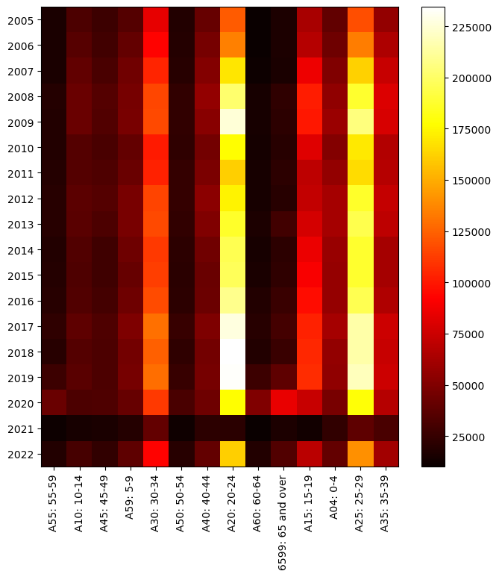

Overall 'A20: 20-24' is the most popular category followed by 'A25: 25-29', 'A30: 30-34' and 'A15: 15-19'

During years 2016 - 2019 we had the maximum number of arrivals

It appears that covid has made no impact on the popular age bracket categories and the same trend continues after covid.

**Popular states per gender:**

|  |  |
| --- | --- |
| Males | Females |
|  |  |

There appear to be no difference and the trend continues after covid

**Number of people entering each state per age bracket before and after covid**

|  |
| --- |
| Before covid |
|  |

|  |
| --- |
| After covid |
|  |

**Correlation matrix to show changes between different age brackets before and after covid**

|  |
| --- |
| Before Covid correlation matrix between different age brackets |
|  |

|  |
| --- |
| After Covid correlation matrix between different age brackets |
|  |

**Change in ‘Male-Female Ratio’ entering each state per age category**

Here positive change indicates ‘Number of Male arrivals’ has increased for the specific category while the negative change indicates ‘Number of Female arrivals’ has increased for the specific category.