General

* Use opencv, pytesseract (LSTM, CNN) to segment and OCR pages.
  + Use Autoencoder to generate perturbated dataset in order to augment PyTesseract Engine.
* Use NLTK + rf, chunk processing, GCP VM, census data to train gender classifier
* Use CNN or models to correct spelling, restrict answers to a name/ place dictionary.

0.0.11

Fixed bugs:

The get_mask() method does not perform well on new samples because of sizing issue.

Now resizing all inputs to (3663, 2831)

0.0.11.1

Another fix: imutils.rezie() -- need to specify the width and the height, otherwise reversed and the result will be wrong.

0.0.12

2020/11/14

Problems

1. Digits not recognized correctly (missing digits)
   1. Reason 1: some digits look like alphabet. E.g. 1 looks like “l”
      1. Maybe use customized train file.
   2. Reason 2: maybe because of some segmentation problem?
      1. Explore character segmentation or use other variations of pytesseract.
      2. 2020/11/14 Overlay segmentation mask in OCR.ROI_to_text() with original input, drawing, making clear the rectangle border.
2. Overall segmentation problem—character are not separate from each other, but most importantly for the digits.
3. Need to rewrite codes: delete rectangle if it intersects with the top.

2020/11/14-2

1. Establish a string cleaning meathod
   1. Fuzzy matching with reference to a dictionary
   2. Restrc
2. New segmentation problem: page title/ state name not on top of the page.
   1. Need to recognize title by the size of the block.
   2. Maybe check if tesseract’s regional proposal works.
   3. Or, first of all, use the old method (detect large blocks on the page with titles in two sections first.)

Research Notes

Section 1. OCR performance

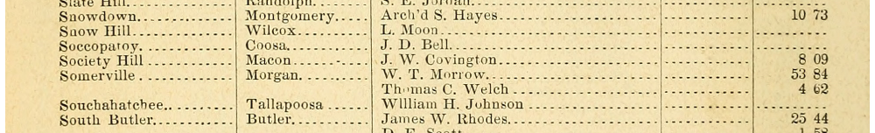

Figure 1-2 Preserve space VS not preserving space for col 0-3

Figure 1.

**if** col **in** [0, 1, 2, 3]:  
 data = pytesseract.image_to_string(result, lang=**'eng'**, config=**'--psm 6 -c tessedit_char_blacklist=0123456789 -c preserve_interword_spaces=1'**)  
**else**:  
 data = pytesseract.image_to_string(result, lang=**'eng'**, config=**'--psm 6 outputbase digits -c preserve_interword_spaces=1 -c tessedit_char_blacklist=.'**)

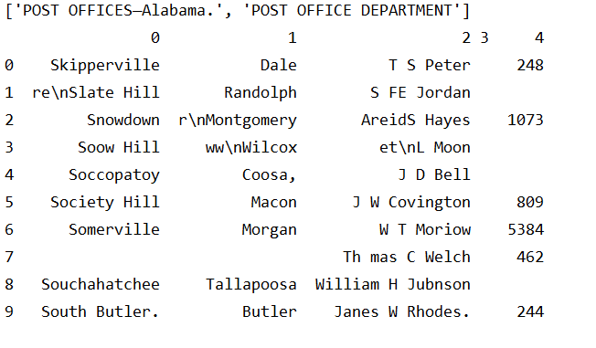

Figure 2. Not preserving space.

**if** col **in** [0, 1, 2, 3]:  
 data = pytesseract.image_to_string(result, lang=**'eng'**, config=**'--psm 6 -c tessedit_char_blacklist=0123456789'**)  
**else**:  
 data = pytesseract.image_to_string(result, lang=**'eng'**, config=**'--psm 6 outputbase digits -c preserve_interword_spaces=1 -c tessedit_char_blacklist=.'**)

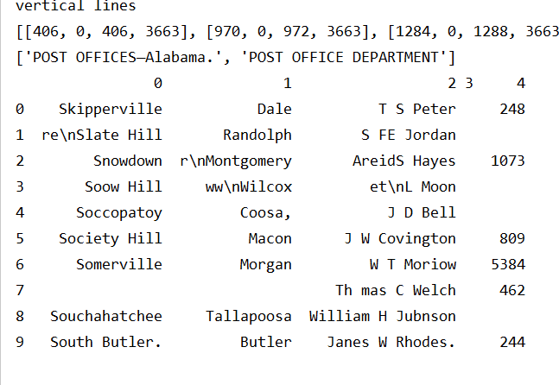

**if** col **in** [0, 1, 2, 3]:  
 data = pytesseract.image_to_string(result, lang=**'eng'**, config=**'--psm 7 -c tessedit_char_blacklist=0123456789'**)  
**else**:  
 data = pytesseract.image_to_string(result, lang=**'eng'**, config=**'--psm 7 outputbase digits -c preserve_interword_spaces=1 -c tessedit_char_blacklist=.'**)

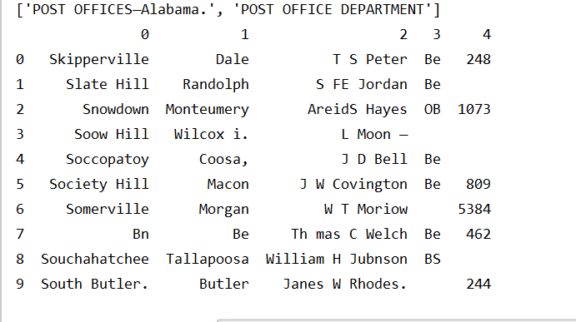

<http://www.cse.psu.edu/~deh25/post/Timeline_files/US-Official_Register.html>

Chunk Processing and Map Reduce:

<https://pythonspeed.com/articles/chunking-pandas/>

Gender Prediction:

<https://www.geeksforgeeks.org/python-gender-identification-by-name-using-nltk/>

<http://www.digitalhumanities.org/dhq/vol/9/3/000223/000223.html>

# Spelling Correction and Census Matching

* Denoise Autoencoders
  + https://github.com/Ezajac/denoising-autoencoder
    - Pretrained model
  + Explanation 1
    - <https://towardsdatascience.com/denoising-autoencoders-explained-dbb82467fc2>
    - Generate data with AE: https://towardsdatascience.com/how-to-generate-new-data-in-machine-learning-with-vae-variational-autoencoder-applied-to-mnist-ca68591acdcf
    - Use case: <http://www.opendeep.org/v0.0.5/docs/tutorial-your-first-model>
  + Explanation 2
    - <https://www.hindawi.com/journals/sp/2017/3610378/>
    - Denoising Autoencoder (DAE)
    - Generally, the structure of AE [27] is shown in Figure 1. Here, the whole system consists of two networks, that is, encoder and decoder. Its purpose is to make the reconstruction layer output as similar to the input as possible. The coding network will code and calculate the input and then reconstruct the result to by the decoder. And denoising automatic coding is developed according to the automatic coding, it will learn a more robust representation of the input signal and has stronger generalization ability than ordinary encoders by adding noise to the training data.
* Tesseract Training
  + <https://github.com/tesseract-ocr/tessdoc/blob/40c456ce6a479fc30cb519f9886ae433c0dff17e/TrainingTesseract-4.00.md>
* RNN, LSTM architecture
  + <http://colah.github.io/posts/2015-08-Understanding-LSTMs/>
* RNN for spelling correction mechanism
  + <https://lionbridge.ai/articles/difference-between-cnn-and-rnn/#:~:text=The%20main%20difference%20between%20CNN,as%20a%20sentence%20for%20example.&text=Whereas%2C%20RNNs%20reuse%20activation%20functions,next%20output%20in%20a%20series>.
* 1000 Faster, non deep learning
  + <https://towardsdatascience.com/symspellcompound-10ec8f467c9b>
  + Symmetric Deleting Method
    - 1) get a dictionary of words
    - 2) compute an expanded dictionary, based on the dictionary and a given edit distance. Len(dict) for a particular word of length N is N.
      * E.g. for “eye” and edit distance = 1, we have “ye”, “ee”, “ey”.
    - 3) For the given word, search the direct match in the expanded dictionary, rather than the word itself. This is computationally less expensive.
* OCR Errors
  + Survey of typical OCR errors
  + *Impact of OCR errors on paragraph, context recognition
    - <http://www.cse.lehigh.edu/~lopresti/tmp/AND08journal.pdf>
* Census Linking
  + <https://usa.ipums.org/usa/mlp_linking_method.shtml>

<https://www.ijcaonline.org/archives/volume143/number4/kumar-2016-ijca-910142.pdf>

# Academic

AHA Annual Meeting 2022, deadline 2021, February.

historians.org/about-aha-and-membership/annual-meeting/future-meetings

# Data Source Related Program

USPS data source

<https://about.usps.com/publications/pub119.pdf> (introduction to all sources of information about USPS in the 19th century).

<https://about.usps.com/publications/pub119/pub119_v03_026.htm#:~:text=The%20Record%20of%20Appointment%20of,are%20given%20beginning%20in%201824>. (general intro. )

<https://www.amazon.com/-/es/Richard-W-Helbock-ebook/dp/B0032FPVS6/ref=sr_1_2?dchild=1&ie=UTF8&keywords=United%20States%20Post%20Offices%20Richard%20Helbock&language=en_US&qid=1605451229&sr=8-2> (Richard-W-Helbock listing of post offices, data source.)

Record of Appointment of Postmasters, 1814–1971

“ The records show the names of Post Offices, the dates of their establishment and discontinuance, any name changes, and the names and appointment dates of postmasters. ”

Collected from appointment ledgers for postmasters.

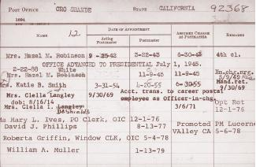 (1900s)

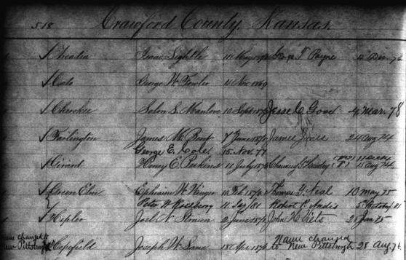

我在做的数据：美国central gov注册的所有雇员。数据包括邮递员的名字，工作邮局地点，可以推算邮局地址和邮局收入。 他的数据：1）主要差别是：没有任何收入信息；并且没有雇员姓名；局限于西部。2）而他的出版物使用的是别人整理的另外一个数据库，非中央政府的注册。“ 邮局部门”每雇佣一名雇员都有一个“注册簿”，和中央政府雇员分开统计。类似于打卡。收集这些注册簿的人因为技术问题似乎只收集了邮局地点和位置的变化。没有雇员的信息。

# Others

Visualize Software (UML diagrams)

<https://www.visual-paradigm.com/guide/uml-unified-modeling-language/uml-class-diagram-tutorial/>

<https://stackoverflow.com/questions/260165/whats-the-best-way-to-generate-a-uml-diagram-from-python-source-code>