Autonomic Networking Gets Serious

*By the ANIMA author team*

## Introduction

In May 2021, six RFCs about autonomic networking were published[5,6,7,8,9,10]as a result of the work of the “Autonomic Networking Integrated Model and Approach” (ANIMA) working group of the IETF. These RFCs complete the initial charter of that working group, which was started in late 2014 (see [11] for a summary of its inception ). This foundation allows the industry to build IETF-standardized network solutions for an “Autonomic Networking Infrastructure” (ANI) into every network device.

What is this all about? One way to sum it up is “plug and play” for the network. This can mean “plug and play for the ISP” or “for the enterprise.” or “for industrial networks”. This is a significant step forward from the well known idea of plug and play for home networks, which the IETF addresses in the HOMENET WG.

The term “autonomic computing” was coined as early as 20 years ago by IBM. It led naturally to the idea of autonomic networking, which became a topic of discussion and work in the IRTF Network Management Research Group. This resulted in RFCs[1,2] describing the outline of an envisioned autonomic networking infrastructure (ANI) and ultimately in the creation of the ANIMA WG. Since then, various aspects of the problem space were addressed in research, and in proprietary implementations by some vendors. But as always, the need is for interoperability, so proprietary methods have to give way to industry standards. This is the job of the ANIMA working group.

The goal is self-management of networks, including self-configuration, self-optimization, self-healing and self-protection (sometimes called self-X). Autonomic Networking (AN) puts operational intelligence into algorithms at the node level, to minimize dependency on human administrators and central management. Nodes capable of AN will discover information about the surrounding network and negotiate parameter settings with their neighbors and other nodes. Later, nodes may also have learning and cognitive capability, i.e. the ability to self-adapt their decision-making process based on information and knowledge sensed from their environment.

Science fiction? Not really. Distributed routing protocols as introduced with the ARPANET in the 1970s and later in the Internet are at their core autonomic: self-configuring, self-optimizing, self-healing. Examples include OSPF (Open Shortest Path First) and IS-IS (Intermediate System to Intermediate System). But over the decades since their original deployment, even those protocols have evolved to become provisioning monsters requiring the human configuration of “nerd-knob” parameters and policies for operators. A whole industry and research discipline for network Operations Administration and Management (OAM) evolved to define architectures consisting of an ever more complex multitude of layers between the actual intent for the service level objectives of the network (and by implication its protocols) and all those “magic” parameters that need to be provisioned consistently and dynamically into each network device whenever there is any change. (As evidence, consider that the IETF alone has standardized about 50 YANG modules, each of which contains sub-modules and many individual parameters.)

In today’s networks, these parameters are almost exclusively implemented through a highly complex and most often centralized set of “Software Defined Networking” (SDN) controller and orchestrator tools and by human operators. These solutions are difficult and expensive to build, maintain, validate, predict, secure and above all to make reliable and resilient. These problems are rarely seen from the outside, but only when network services are under oversight of regulatory entities that publish reports of those problems, such as[12]. SDN architectures are also highly proprietary, very often from a single vendor, and typically require significant customization through programming for any multi-vendor network deployment. They therefore require network owners to not only hire network operators but also have them become SDN developers.

Nevertheless, these SDN methods are the best option for existing large networks. They are marketed with terms that evolved in the last few years, such as “Zero Touch Networks”, “Intent Based Networking”, or “Self Driving Networks”. In the metaphor of a network being a car, Figure 1 shows how today’s networks are driven, and how ANIMA would like them to be.

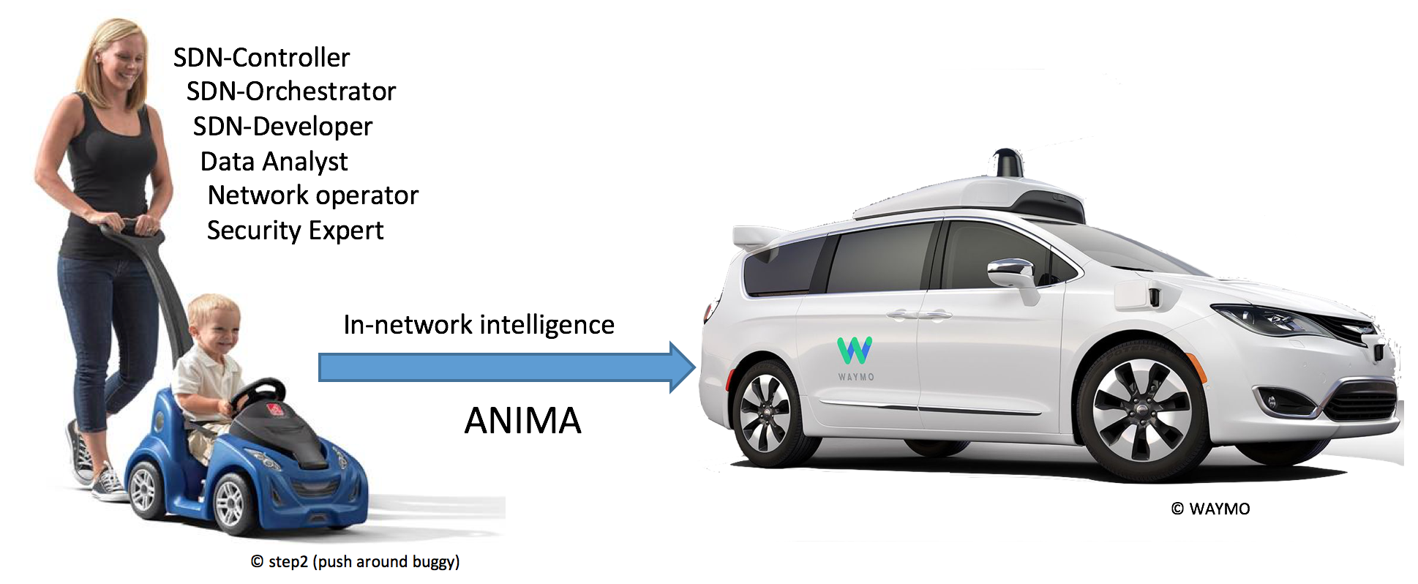

Figure 1: The automobile metaphor

The risk is that this picture is totally outside the IPJ guidelines. Great for a slide show, but in case we can’t use it:

In the metaphor of a network being a car, today’s networks are childrens’ pedal cars guided from behind by an attentive parent, whereas ANIMA wants them to be like a self-driving taxi.

Nevertheless, the long-term vision for ANIMA is broader than its published standards and short-term standardization goals. Much like the near term focus for most cars is rapidly improving driver-assist systems, the autonomic networking infrastructure (ANI) as defined in the recent ANIMA RFCs is intended to provide the foundational building blocks. These building blocks are meant to fit seamlessly with existing network and SDN/OAM designs and to improve their managerial metrics such as simplicity, reliability and security. Likewise, the ANI allows designers to more easily embed automation into network devices whenever there is a need. It is worth noting that today, unlike in the past, it is economic to provide enough computing power in network elements to support autonomy.

## What can the Autonomic Networking Infrastructure do for You ?

Instead of jumping directly into explanation of how the ANI works, let’s first give a simple example of what the operator experience of a typical simple ANI network could be.

In Figure 2 , an operator wants to deploy a new network of devices (routers and switches). The actual reception of the new, factory fresh equipment, unpacking and physical attachment is performed in different locations by other personnel. The operator only needs to set up an ANI seed router, called the ANI registrar (1), for example in a NOC. This setup consists of only three simple steps:

[A] Set up the router (1) as the registrar and assign a name to the ANI.

[B] Configure some local port(s) to provide link-layer access to the ANI, to connect management equipment such as a Notebook for manual access or an SDN controller.

[C] Register the certificate of the registrar with the Manufacturer Authorized Signing Authority (MASA) services of the vendors whose routers and switches are being used in the new network (we will see below what that does).

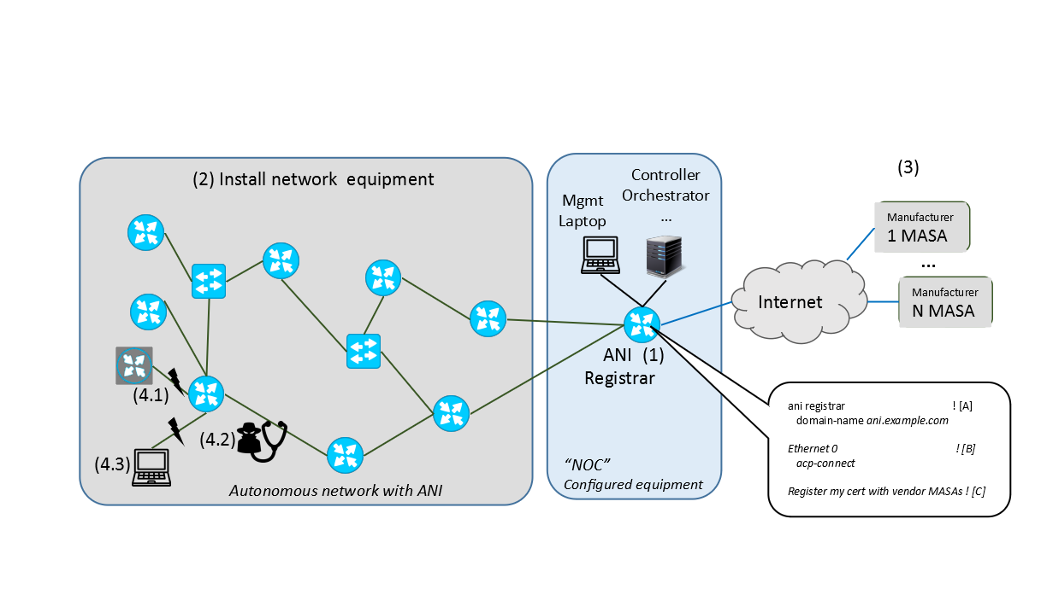

Figure 2: An Example Autonomic Network

Befor this seed setup is in place, new routers or switches may be physically interconnected, but they won’t do anything. Once they have connectivity to a configured registrar, they will automatically form an ANI as follows.

Each new ANI device (at that stage called a “pledge”) will automatically obtain a connection with the ANI registrar and attempt to get enrolled with an ANI certificate by that ANI so it can participate in the ABI. But the registrar needs to prove that it ‘owns’ the ANI device. To do that, the registrar communicates (for example over the Internet) with the MASA of the vendor of that device. That MASA has the information that this pledge is actually owned by this registrar’s network and returns a security voucher back to the pledge, such that the pledge may now trust the registrar. It will therefore accept an ANI certificate from the registrar. This process runs completely automatically without any further handholding or configuration. It is known as the Bootstrap of Remote Key Infrastructures (BRSKI) part of ANI.

Once a new device is enrolled with an ANI certificate it begins to establish an Autonomic Control Plane (ACP) connection with all its neighbors, authenticated and authorized mutually by the devices’ ANI certificates. This too happens without any further handholding or configuration.

Assume all devices were physically connected to each other as shown in Figure2 and the ANI registrar is connected last (after it was configured). Within minutes, all the devices will have run through BSKI, and set up the ACP. As a result, the network operator now has IP connectivity over the ACP from their management laptop and SDN controller to all ANI devices and can configure them manually or through SDN automation using this connectivity. Each ANI device has a permanent and private IP address within the ANI that does not change, even if the device is physically moved in the network.

But wait! How is this different from 30 year old Ethernet technology? Surely one can simply buy a set of inexpensive Ethernet switches, interconnect them, attach a configuration system at one point and have achieved the same thing?

Indeed, the simplicity of operating Ethernet networks an inspiration for the ANI, but beyond that, the ANI is fundamentally different. The ANI is above all secure, whereas the default behavior of traditional switches is not. An ANI device can only join the ANI if it is actually owned by the operator, as certified by its manufacturer’s MASA, for example via sales records. This means that a stolen device cannot be activated for the ANI in another network. It also means that a device not belonging to this network operator (4.1) cannot be enrolled in an ANI network to launch an attack.

All ACP traffic is hop-by-encrypted, therefore also all management traffic that uses the ACP including any legacy, not end-to-end encrypted management protocol cannot be snooped or spoofed by an attacker (4.2).

Last but not least, ANI devices even after having formed the ACP are still unconfigured, and ideally this means that they should behave like current unconfigured routers: There is nothing running that would provide likely undesirable network connectivity to any hosts that attach, like some user or attacker notebook (4.3). Such an attached device would get no connectivity whatsoever. In result, there is never a window of opportunity for attackers to attack unprotected equipment. Instead, the NOC has all the time it needs to remotely provision the devices. In later stages, such provisioning will occur autonomically, as we shall see below.

Compared to many other zero-touch solutions, the ANI does not only focus on so-called day-0/day-1 behavior up until the network is operational. Instead its services last through the whole lifecycle. The ANI provides automated certificate renewal for all ANI devices to maintain and refresh its security model. The ACP protects any network OAM traffic that uses it. By its use of hop-by-hop encryption it also continuously protects the whole network and attached OAM equipment from traffic injection or spoofing attacks.

We now delve into some more technical aspects of the ANIMA solution.

## Terminology

According to various dictionaries, there are differences between the terms *automatic, autonomous* and *autonomic.*

*Automatic:* as if done by a machine.

*Autonomous:* responding and reacting on its own, with no external control.

*Autonomic:* behaving spontaneously due to internal stimuli.

The last two are certainly similar, but following industry practice we prefer *autonomic.* The *autonomic nervous system* acts largely unconsciously and regulates bodily functions such as heart rate. *Autonomic computing* was defined by IBM in 2001 as referring to *“*self-managing distributed computing resources, adapting to unpredictable changes while hiding intrinsic complexity from operators and users.” We define an *autonomic network* as self-managing (self-configuring, selfprotecting, self-healing, self-optimizing) but allowing high-level guidance by a central entity.

*Autonomic Function:* A specific self-managing feature or function.

*Autonomic Service Agent (ASA)*: An agent that implements an autonomic function, in part (for a distributed function) or whole.

*Autonomic Node:* A node that embodies autonomic functions

*Autonomic Control Plane (ACP):* A self-configuring, fully secure, virtual network used for all autonomic messaging.

More details about these terms can be found in RFC7575[1] and RFC8993[8].

## Outline of the ANIMA model

As always in network management, there are literally thousands or millions of details that cannot be standardized or even described centrally. What we can do is define a model, a platform, and a toolkit, just as SNMP (Simple Network Management Protocol) and NETCONF (Network Configuration Protocol) have done in the past. The main items in the model are:

* Bootstrapping and trust infrastructure. This covers how nodes are authenticated and securely admitted to an autonomic network, and how they establish mutual trust.
* Secure Autonomic Control Plane (ACP). This is an automatically constructed encrypted virtual network, containing only authenticated nodes that rightfully belong to a particular autonomic domain.
* Discovery for autonomic nodes. This is a mechanism by which nodes attached to the ACP can discover each other. In practice, discovery occurs at a finer grain than nodes, since it really operates at the level of a node’s capabilities and objectives.
* Negotiation and synchronization for autonomic nodes. Once nodes have discovered each other, they can synchronize data between themselves, or actively negotiate parameters and resources.
* Autonomic functions operate by negotiating and synchronizing data with their peers in other nodes, and by directly configuring manageable devices in their own scope.
* Discovery, synchronization and negotiation proceed by use of the GeneRic Autonomic Signaling Protocol (GRASP).
* Autonomic service agents (ASAs) are composed of one or more autonomic functions.
* Centrally defined policy or configuration rules may be obtained by an ASA via GRASP synchronization, or if appropriate by conventional methods such as an interface to NETCONF or DNS-SD (DNS Service Discovery).

Figure 3 shows an outline of the model as a whole.

* 1. 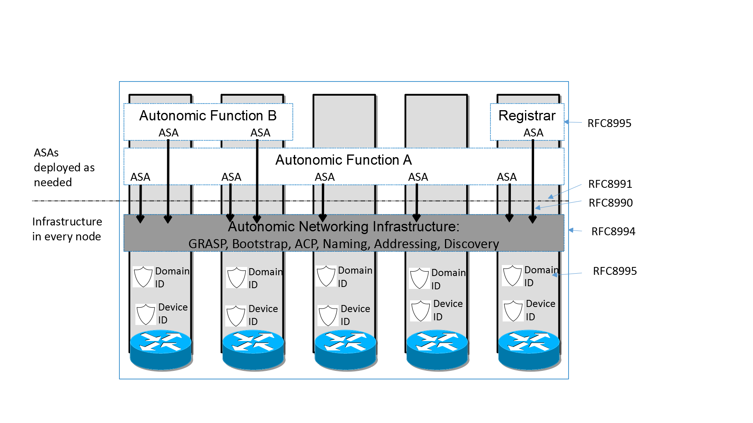
  2. Figure 3: Layered Model of Network with Autonomic Functions

## Self-confi**g**uring Security

As mentioned above, ANIMA does not attempt a monolithic bootstrap of a network from a predefined configuration. Instead, it proceeds step by step, and security comes first. The first stage of creating a secure autonomic control plane is bootstrapping a suitable key infrastructure that covers all the nodes that will constitute the ACP. This is done by the method known as BRSKI (pronounced “Brewski”, Bootstrapping Remote Secure Key Infrastructure[10]). This process uses manufacturer-installed X.509 certificates, in combination with a manufacturer’s authorizing service. The network administrator decides which devices are authorized to join the network (e.g., by serial number), but relies on the manufacturer to validate each device’s certificate whenever the device attempts to join the network via a local “join proxy”. These proxies all use a single “domain registrar” node that mediates the authorizing service. The join proxies themselves join the network by the same process; a GRASP mechanism is used for joining nodes (known as “pledges”) to find proxies, and for proxies to find each other and the registrar. Only the registrar needs to be configured in advance.

The ACP forms itself among pledges as soon as they have completed their BRSKI enrolment. It is best described as a Virtual Routing and Forwarding (VRF) instance. It is based on a virtual router at each node, consisting of a separate IPv6 forwarding table to which the ACP’s virtual interfaces are attached, and an associated IPv6 routing table separate from the data plane. Actual packet transmission occurs only as IPv6 link-local packets. This choice was made to ensure that there is no dependency on any pre-existing data plane (either IPv4 or IPv6), because autonomic functions must be able to operate *even if the normal data plane and normal routing are broken.* All that is required is for each node to create its own IPv6 link-local address on each physical interface, as any modern network device does by default. The VRF consists of point-to-point IPv6 links and is secured using IPsec (IP Security) or DTLS (Datagram Transport Layer Security), both via IKEv2 (Internet Key Exchange Protocol Version 2). From the viewpoint of autonomic service agents, the ACP uses an automatically generated IPv6 Unique Local Address prefix, and it uses RPL (Routing Protocol for Low-Power and Lossy Networks) internally. Like BRSKI, the ACP bootstraps itself, starting with a GRASP-based discovery process.

After the secure control plane has configured itself in this way, the next stage is to bootstrap connectivity for network management. When this has been achieved, conventional mechanisms (such as an SDN controller) can already reliably and securely reach remote nodes and configure them safely without risk of cutting themselves off. In addition, fully autonomic management mechanisms (i.e., ASAs) can start up. To understand how this works, we need to give more details about the GRASP protocol.

## GRASP

GRASP, the GeneRic Autonomic Signaling Protocol[5], is used for signaling between ASAs. These include special-purpose mini-ASAs that support BRSKI (discovery of join proxies and the domain registrar) and ACP creation (discovery of ACP neighbors). Readers will notice that these operations must take place *before* ACP security is in place, so they use a highly restricted subset of GRASP that is limited to specific link-local operations.

After that, GRASP runs over the ACP to guarantee security, so there are no restrictions on allowed operations and any two ASAs in the local domain may trust and communicate with each other. GRASP provides discovery, flooding, synchronization and negotiation mechanisms for the objectives supported by ASAs.

Rather than being a traditional type-length-value protocol, GRASP is based on CBOR (Concise Binary Object Representation) messages. This has the advantage of allowing very flexible encoding, and GRASP can therefore accommodate a very wide range of data types, with the possibility of mapping protocol elements directly into various high-level language representations.

The word “objective” has a special meaning in GRASP. It is a data structure whose main contents are a *name* and a *value*. An objective occurs in three contexts: discovery, negotiation, and synchronization. A single ASA may support multiple independent objectives.

The *name* of an objective is simply a unique string describing its purpose.

The *value* consists of a single configurable parameter or a set of parameters of some kind. The parameter(s) apply to a specific service or function or action. They may in principle be anything that can be set to a specific logical, numerical, or string value, or a more complex data structure. Basically, an objective is defined in the way that best suits its application; that is the great advantage of CBOR encoding. If desired, for example, an objective’s *value* could be expressed in JSON (JavaScript Object Notation). When an objective is shared between ASAs by flooding, synchronization or negotiation, each ASA will maintain its own copy of the objective and its latest value.

GRASP messages allow for *discovery* of an ASA that handles a given objective name; *flooding* a given objective to all ACP nodes (the simplest form of synchronization); *synchronization* of the value of a given objective between two peer ASAs; and *negotiation* of the value of a given objective with a peer ASA.

An Application Programming Interface (API) for GRASP has been defined[6] and implemented as part of a Python 3 prototype. This makes it very easy to implement demonstration ASAs in Python. A partial GRASP implementation has also been made as part of an ACP implementation in the RUST language.

## Talking to the NOC

As noted above, a key requirement for the success of ANIMA is smooth integration with existing network management tools and in particular with Network Operations Centers. To this end, an integration mechanism has been documented[4]. The simplest approach is for trusted edge devices in the ACP to “leak” the (otherwise encrypted) ACP natively to certain network management hosts, presumed to be well secured. These edge devices would act as default routers to those management hosts and provide them with IPv6 connectivity into the ACP. A more complex approach would allow the management hosts simultaneous connectivity into the ACP and the traditional data plane.

A related issue is that if the NOC uses DNS Service Discovery (DNS-SD) to announce management services to managed nodes, these announcements will not be automatically available in the ACP, which for security reasons will not have routed access to the data plane where the DNS is available. This again can be solved by a trusted edge device that obtains service information from DNS-SD and redistributes it within the ACP, possibly by the GRASP flooding mechanism. For example, the information for a service named *syslog* could be flooded in a GRASP objective named *SRV.syslog.* Here, the flexibility of CBOR encoding is of great value since a JSON-like representation of service data is common.

Extending that point, since GRASP easily allows for JSON (or practically any other format), it is possible to integrate ASAs communicating via GRASP into almost any part of an existing network management system. For example, an ASA acting as a NETCONF client could retrieve YANG documents from a NOC database via GRASP and the ACP.

## Example of an Autonomic Function

A use case that has been fully defined is a GRASP-based mechanism for managing and assigning IP address prefixes[7]. Firstly, we define two GRASP *objectives* for IPv4 or IPv6 prefix management at the edge of large-scale ISP networks. The first objective can be represented thus (in a simplified form):

["PrefixManager", [IP_version, prefix_length, prefix]]

and the second as

["PrefixManager.Params", parameter_info] .

The first objective will be used in GRASP negotiations between two “prefix manager” ASAs in nodes that need to delegate address space to subsidiary routers (using standard IPv6 prefix delegation), when one node is short of spare prefixes and the other one has an adequate pool of unused prefixes. If negotiation succeeds, prefixes will be transferred from one ASA’s pool to the other’s. If negotiation fails, the ASA that is short of prefixes will use GRASP discovery to find another ASA that can help it. This will completely obviate any need for human management of an ISP’s distributed pool of prefixes, beyond initially configuring the maximum pool in one place.

The second objective may be flooded to all “prefix manager” ASAs to convey relevant policy. For example, if the flooded parameter information is

[

[["role", "A"],["prefix_length", 34]],

[["role", "B"],["prefix_length", 44]],

[["role", "C"],["prefix_length", 56]]

]

it would mean that devices of type A are allowed to receive IPv6 prefixes of length 34 bits, and so on.

We can see from this example that GRASP’s use of CBOR and its easy representation of JSON-like formats gives it great expressiveness and flexibility. While much work remains to be done on individual autonomic functions, the ANI and GRASP provide a solid and flexible foundation for this.

## Conclusion

TBD

## **Rererences and Further Reading**

[1] RFC7575, Autonomic Networking: Definitions and Design Goals. M. Behringer, M. Pritikin, S. Bjarnason, A. Clemm, B. Carpenter, S. Jiang, L. Ciavaglia. June 2015. (DOI: 10.17487/RFC7575)

[2] RFC7576, General Gap Analysis for Autonomic Networking. S. Jiang, B. Carpenter, M. Behringer. June 2015. (DOI: 10.17487/RFC7576)

[3] RFC8366, A Voucher Artifact for Bootstrapping Protocols. K. Watsen, M. Richardson, M. Pritikin, T. Eckert. May 2018. (DOI: 10.17487/RFC8366)

[4] RFC8368, Using an Autonomic Control Plane for Stable Connectivity of Network Operations, Administration, and Maintenance (OAM). T. Eckert, Ed., M. Behringer. May 2018. (DOI: 10.17487/RFC8368)

[5] RFC8990, GeneRic Autonomic Signaling Protocol (GRASP). C. Bormann, B. Carpenter, Ed., B. Liu, Ed. May 2021. (DOI: 10.17487/RFC8990)

[6] RFC8991, GeneRic Autonomic Signaling Protocol Application Program Interface (GRASP API). B. Carpenter, B. Liu, Ed., W. Wang, X. Gong. May 2021. (DOI: 10.17487/RFC8991)

[7] RFC8992, Autonomic IPv6 Edge Prefix Management in Large-Scale Networks. S. Jiang, Ed., Z. Du, B. Carpenter, Q. Sun. May 2021. (DOI: 10.17487/RFC8992)

[8] RFC8993, A Reference Model for Autonomic Networking. M. Behringer, Ed., B. Carpenter, T. Eckert, L. Ciavaglia, J. Nobre. May 2021. (DOI: 10.17487/RFC8993)

[9] RFC8994, An Autonomic Control Plane (ACP). T. Eckert, Ed., M. Behringer, Ed., S. Bjarnason. May 2021. (DOI: 10.17487/RFC8994)

[10] RFC8995, Bootstrapping Remote Secure Key Infrastructure (BRSKI). M. Pritikin, M. Richardson, T. Eckert, M. Behringer, K. Watsen. May 2021. (DOI: 10.17487/RFC8995)

THE ANIMA AUTHOR TEAM is a group of participants in the IETF’s ANIMA Working Group, including Michael Behringer, Brian E. Carpenter, Toerless Eckert, Sheng Jiang, Yizhou Li, Michael Richardson, YOUR NAME HERE. They may be contacted at anima@ietf.org.