**LAB – 1: DATA PREPARATION FOR STAR SCHEMA**

**DATA WAREHOUSE:**

* A data warehouse is a system used for reporting and data analysis, and is considered a core component of business intelligence.
* It is a central repository of integrated data from one or more disparate sources, and is designed to enable and support business intelligence (BI) activities, especially analytics.
* Key characteristics of Data Warehouse are:
  1. Integration
  2. Subject-oriented
  3. Time-variant
  4. Non-volatile

**LAB PROCEDURES:**

1. **Create account in Snowflake.**
   1. Snowflake is a data platform that would harness the immense power of the cloud.
   2. Simply, it is a Data Warehouse.
   3. We created our account in this platform.
2. **Understand TPCH_SF10 Schema.**
   1. TPCH_SF10 Schema is a sample data provided by Snowflake.
   2. This schema contains 8 tables.
   3. The table is provided below:

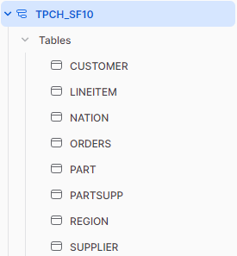

1. **Write SQL statements for the following:**
   1. **What is the total number of orders received in “1995-9-16”?**

SELECT COUNT(*) AS TOTAL_ORDER FROM ORDERS WHERE O_ORDERDATE = '1995-09-16';



* 1. **What is the total number of orders received in September 1995?**

SELECT COUNT(*) AS TOTAL_ORDER FROM ORDERS WHERE MONTH(O_ORDERDATE) = '9' AND YEAR(O_ORDERDATE) = '1995';



* 1. **What is the total number of orders received on each day of September?**

SELECT O_ORDERDATE, COUNT(*) FROM ORDERS

WHERE MONTH(O_ORDERDATE) = '9' AND YEAR(O_ORDERDATE) = '1995'

GROUP BY O_ORDERDATE;

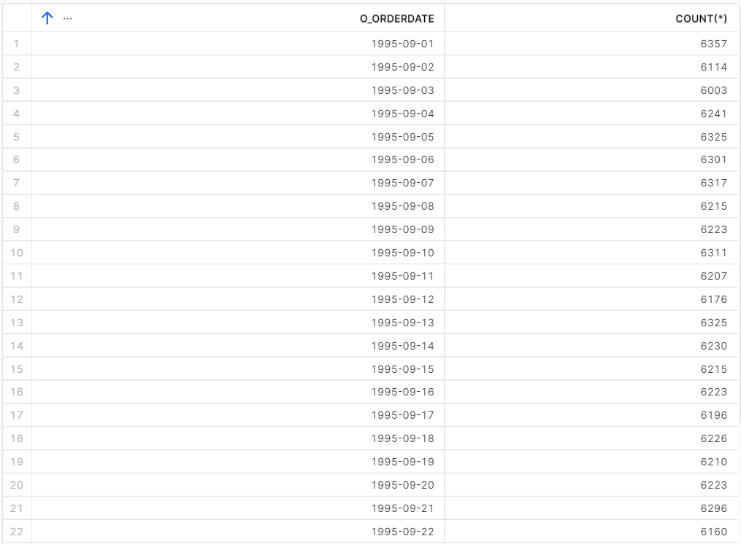

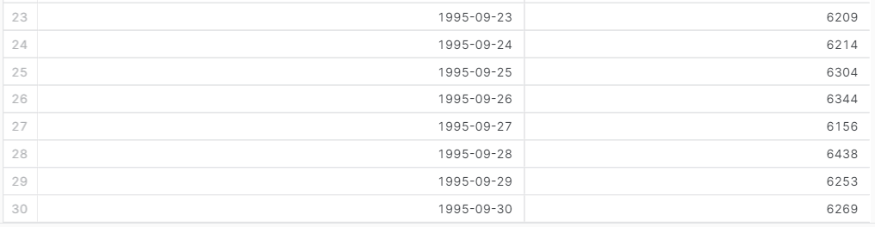

* 1. **What is the total number of orders received in each month of 1995?**

SELECT MONTH(O_ORDERDATE), COUNT(*) FROM ORDERS

WHERE YEAR(O_ORDERDATE) = '1995'

GROUP BY MONTH(O_ORDERDATE);

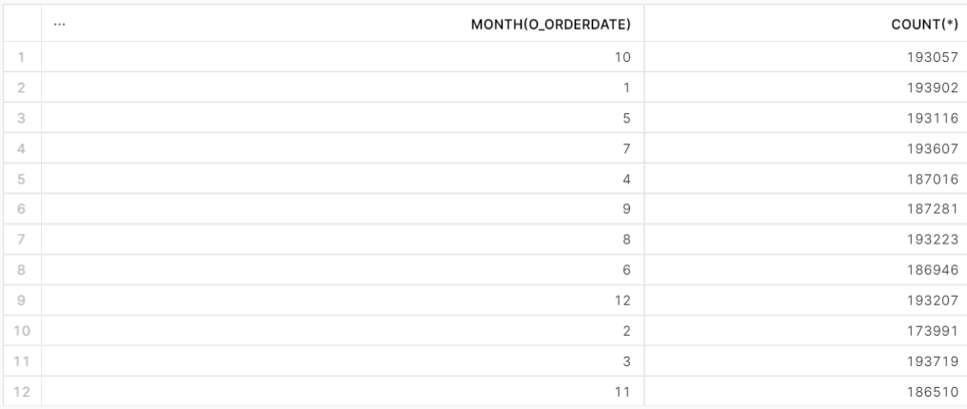

* 1. **What is the total number of orders received in all years?**

SELECT YEAR(O_ORDERDATE), COUNT(*) FROM ORDERS

GROUP BY YEAR(O_ORDERDATE);

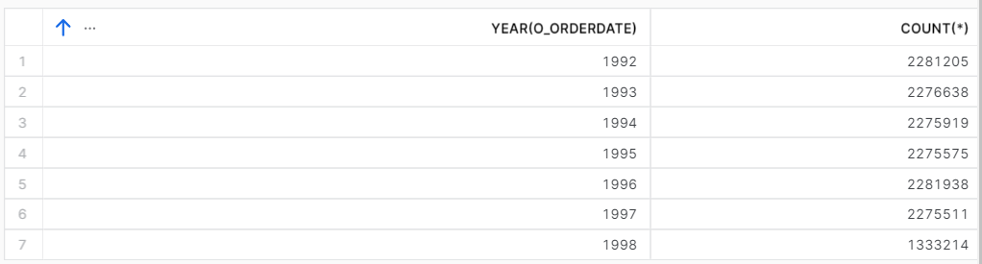

* 1. **What is the total number of orders received in all years?**

SELECT COUNT(*) FROM ORDERS

JOIN CUSTOMER ON ORDERS.O_CUSTKEY = CUSTOMER.C_CUSTKEY

JOIN NATION ON CUSTOMER.C_NATIONKEY = NATION.N_NATIONKEY

WHERE NATION.N_NAME = 'BRAZIL';

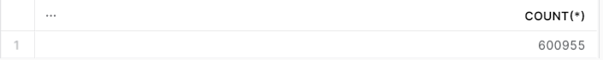

**CONCLUSION:**

In this lab, we made a Fact table of ORDERS and for Dimensions we used Time and Location.