# Lab – Data Analysis and Data Modeling in Visio

## Overview

In this lab, we will learn to draw with Microsoft Visio the ERD’s we created in class.

### Learning Objectives

Upon completion of this learning unit you should be able to:

* Understand the concept of data modeling
* Develop business rules
* Develop and apply good data naming conventions
* Construct simple data models using Entity Relationship Diagrams (ERDs)
* Develop entity relationships and define various types of attributes

### Lab Goals

Our lab goals are to:

1. Learn to build conceptual models in Microsoft Visio.
2. Create the 1 ERD in the Part 2 below and the 4 ERDs from class in Microsoft Visio.

You will have to hand in all 5 diagrams as one VISIO file in Blackboard.

### What you will need to begin

1. A copy of **Microsoft Visio 2016**
2. The class exercises from this week (should also be with the other files from week’s lesson.)

## Part 1: Getting Ready for Using Microsoft Visio for Conceptual Modeling

### Overview

This section will explain how to use Microsoft Visio to create conceptual Entity-Relationship data models. This guide will explain how you can maximize ***the Visio database tools*** for creating conceptual models. For those of you familiar with Visio, here are the heuristics we will follow to make Visio conceptual model friendly:

* Use Database Model Diagrams
* Modify the settings to be more user-friendly

### Step 1: Create New Document

After opening Visio 2016, the first step is to create a new document.

From the Visio template screen, choose “Crow’s Foot Database Notation.”

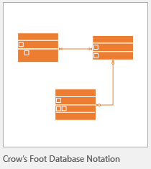

From the pop-up window, select “US Units” and click “Create”

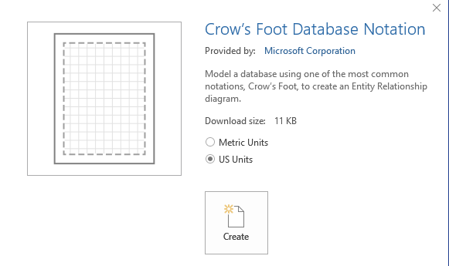

This will create your blank Visio page, and load the default database toolset.

### Step 2: familiarize yourself with the shapes stencil

You should see the following on the left. This contains the shapes we will be using for the lab.

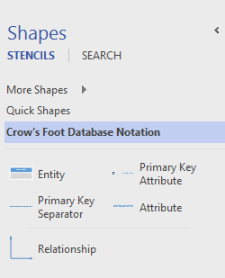

If you do not see these tools try this: On the left under STENCILS click on More Shapes -> Software and Database – Database -> Crow's Foot Database Notation

## Part 2: Microsoft Visio for Conceptual Modeling Walk-Thru

### Overview

In this section, we will walk-through creating a conceptual data model with Microsoft Visio. We will use the vBay! (E-bay “like” website case study as an example for conceptual modeling.)

### To Create an Entity:

Drag the C:\Users\jndaghir\AppData\Local\Microsoft\Windows\INetCache\Content.Word\2016-10-09 18_19_29-Drawing1 - Visio Professional.png icon onto the page and drop. Name the entity by double clicking “entity name”:

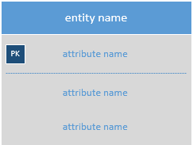

Because we do not indicate primary keys in conceptual modeling, we can erase the default one created. Click on the attribute to the right of “PK” and press the delete key. Your entity should look like this:

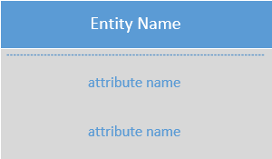

#### YOU DO IT:

**Now add these 4 Entities to your diagram:**

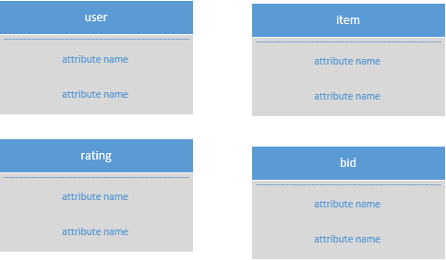

### To Add Attributes to the entity:

To add attributes to your entity, simply double click “attribute name” and enter in your column names. Be sure to include the appropriate **attribute characteristics [rucdm]** with the physical name. To add additional attributes to the entity, right click on one of the attributes and select “Insert ‘Attribute’ After.”

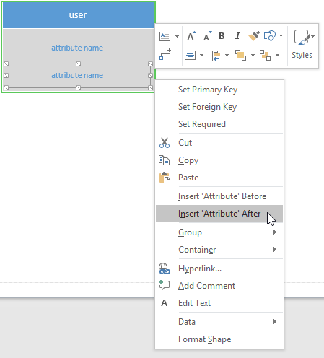

#### YOU DO IT:

**Now add attributes to all 4 entities, like this:**

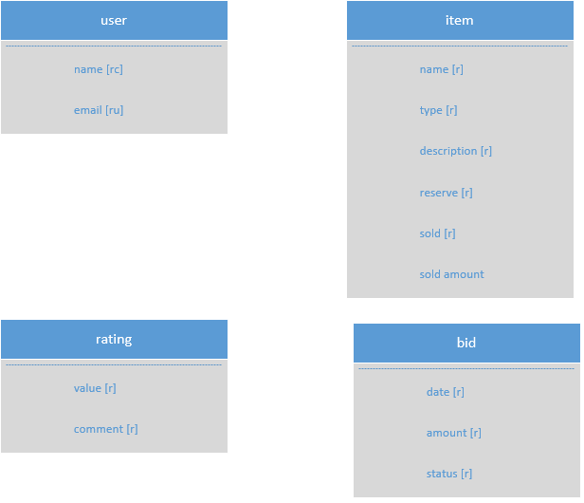

### To Add Relationships among the entities:

To Add Relationships, simply drag the relationship shape.  onto the page and connect the ends to each entity. To “snap” the line to the entity drag the line onto the box until it turns **green**, like this.

Green symbolizes the shapes are ***glued*** together**:**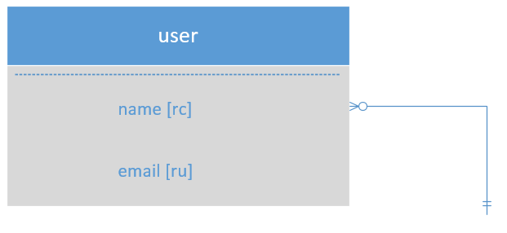

Click on the line and drag the other end to another entity to show the relationship between the two. You can **double-click** on the line to assign it a label. For example:

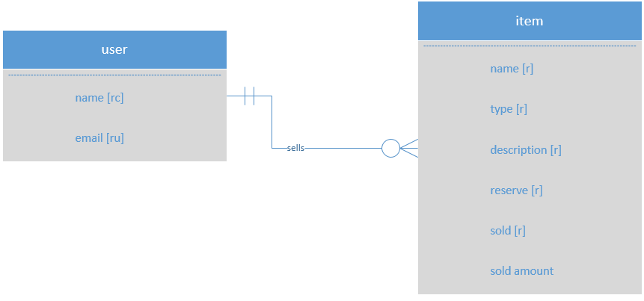

To change the cardinality right click on the connector and choose set begin symbol or set end symbol.

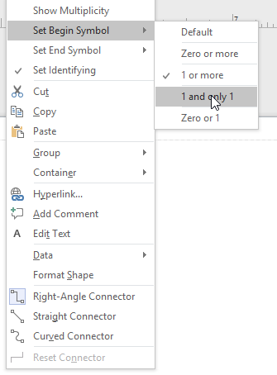

**Note:** You might have to juggle the shapes and lines around to achieve a best fit. It takes time and a whole lot of patience!

### Other Tips

**You can place multiple diagrams in one file!**

Just keep adding pages. To add a page, from the menu select: Insert 🡪 New Page, or click the plus button at the bottom of the window:

C:\Users\jndaghir\AppData\Local\Microsoft\Windows\INetCache\Content.Word\2016-10-09 19_08_29-Drawing1 - Visio Professional.png

To rename a page, right-click on the page and choose **Rename**

**You can add text to your diagram!**

Use the **Text** tool in the ribbon. Home 🡪 Text. When you’re finished, be sure to select the **Pointer Tool** again. 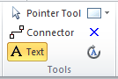

If you need to create a weak entity use the set identify option by right clicking on the connector.

## Part 3:

Continue your conceptual modeling with the problems below.

* Add a new tab to the document you created above for each of the 4 problems.
* Label the pages by problem number (example "problem 2")
* Save the document
* Upload the Visio document to blackboard when you are finished

Do not add anything to the conceptual model for problems 3-5 that is not in the specifications. You have to assume that a developer talked to the client and wrote the facts correctly.

### Problem 2

You will work in groups to role play a database developer collecting specification and I will role play a client for this problem. Make a tab ready for problem two – you can fill this answer in when the interview with me is complete.

### Problem 3

Can you translate the following into an ERD? This exercise focuses on building an ERD from the facts. To prevent ambiguity and misinterpretation, I’ve abstracted the entities and attributes.

Entities: A, B, C, D

Attributes:

* A: a1 – unique, required, a2, a3 – derived, a4 - composite
* B: b1 – required, b2 – required, b3 – multi-valued
* C: c1, c2, c3 – required, unique
* D: d1, d2 – required, unique, d3- required, composite

Relationships:

* An “A” develops one or more “B”, a “B” is developed by zero or one “A”
* A “B” produces zero or more “C” a “C” is produced by one or more “B”
* A “D” controls one and only 1 “A”, an “A” is controlled by 1 or more “D”

### Problem 4

The following is a simplified Netflix style database. Read through the facts and pick out the relevant attributes, characteristics, relationships, and cardinality.

**Entities**: Person, Title, Zip Code, Account

* A Person has a name, which is required.
* A Title has a name, type (movie, documentary, etc..) average rating, release year all of which are required.
* A title has genres which are multi-valued.
* An Account contains user information such as email, name and address. All of these are required, and the email should be different for each account.
* An Zip code contains a zip code city and state. All required.
* An Account lives in just one zip code, a zip code contains 1 or more accounts.
* A Person acts in one or more titles. A Title contains 1 or more people.
* A Person directs one or more Titles. A Title is directed by 1 or more people.
* An account requests 1 or more title, a title is requested by one or more accounts. (This is how users place movies in their queue).

### Problem 5

In this next example, I give you a list of facts, but I don’t organize them for you. You have to figure out what’s an entity, relationship attribute, etc.

* A car is made by only one manufacturer, but a manufacturer makes a lot of cars.
* A car has a make, model, vehicle identification number (vin), msrp, and color.
* A manufacturer has a name (which is unique and not always the same as the make) .
* A manufacturer has several plants where the cars are made. A plant is owned by just one manufacturer.
* A car is produced at just one single plant. And a plan produces several cars.
* A Plant has a name and address.
* Only cars of a certain make are produced at certain plants. For example, plant “A” might produce makes “X”, “Y”, and “Z”, while plant “B” might produce makes “W” and “Z” only.