**Control/Tracking Number:** 15-A-5770-HRS  
  
**Early Recurrence of Atrial Arrhythmias following Pulmonary Vein Antral Isolation: Does Timing of Early Recurrence Predict Long-Term Ablation Success?**   
  
**Author Block:** Jackson J. Liang, DO, Melissa A. Elafros, PhD, William W. Chik, MD, PhD, Pasquale Santangeli, MD, PhD, Erica S. Zado, PA, David S. Frankel, MD, FHRS, Gregory E. Supple, MD, Robert D. Schaller, DO, David Lin, MD, Fermin C. Garcia, MD, Mathew D. Hutchinson, MD, FHRS, Michael P. Riley, MD, PhD, David J. Callans, MD, Francis E. Marchlinski, MD, FHRS and Sanjay Dixit, MD, FHRS. Hospital of the University of Pennsylvania, Philadelphia, PA, Michigan State University, East Lansing, MI   
  
*Abstract:*  
**Introduction:**  
In patients (pts) undergoing atrial fibrillation (AF) ablation, early recurrence of atrial arrhythmias (ERAA) is associated with long-term AF recurrence. Whether timing or number of ERAA predicts subsequent AF recurrence remains unclear.  
  
**Methods:**  
Three hundred pts (100 paroxysmal, 100 persistent, 100 longstanding persistent) undergoing pulmonary vein antral isolation (PVAI) for AF were included. Pts underwent 30-day (d) trans-telephonic monitoring (TTM) immediately after PVAI, at 6mos and 1 yr. ERAA was defined as AF or organized atrial tachycardia on 1st TTM and categorized as early (first 15 ds), late (last 15 ds) or multiple (both early and late). Ablation failure was defined as ≥1 sustained (>30s) AF event over 1 yr following a single ablation (excluding 6 wk blanking period).  
  
**Results:**  
Mean pt age was 59.5±9.6 yr (79% males, AF duration 6.5±6.7 yr, LVEF 55±10%, left atrial size 4.6±0.7cm). ≥1 ERAA was detected in 143 pts (47.7%). ERAA occurred less frequently in pts with paroxysmal AF (OR: 0.49 [95% CI 0.30-0.80]). Early ERAA occurred in 42(29.4%), late ERAA in 27 (18.9%) and multiple ERAA in 74 (51.8%). Pt demographics and AF type were similar between ERAA groups (p>0.05). Occurrence of any ERAA predicted subsequent ablation failure (OR: 3.14 [95% CI: 1.96-5.03]). Freedom from AF at 1 yr was higher in pts experiencing early ERAA versus those with late or multiple ERAA (Table).  
  
**Conclusions:**  
ERAA after PVAI is common, occurs more frequently in pts with persistent or longstanding persistent AF, and predicts subsequent AF recurrence. Pts experiencing late or multiple ERAA in the 30-day post ablation monitoring period are more likely to experience long term AF recurrences.  
[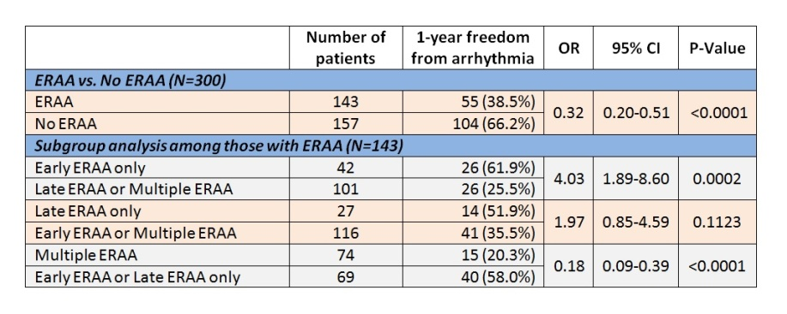](http://files.abstractsonline.com/CTRL/E7/F/0F5/D63/A57/4E6/098/DE9/2AF/ED4/841/E3/g5770_3.jpg)