**Control/Tracking Number:** 15-A-6133-HRS  
  
**Early Recurrent Atrial Arrhythmia after Pulmonary Vein Antral Isolation: Type of Early Recurrence does not Predict Rate or Nature of Long-Term Arrhythmia Recurrence**   
  
**Author Block:** Jackson J. Liang, DO, Melissa A. Elafros, PhD, William W. Chik, MD, PhD, Pasquale Santangeli, MD, PhD, Erica S. Zado, PA, David S. Frankel, MD, FHRS, Gregory Supple, MD, Robert Schaller, DO, David Lin, MD, Fermin C. Garcia, MD, Mathew D. Hutchinson, MD, FHRS, Michael P. Riley, MD, PhD, David J. Callans, MD, Francis E. Marchlinski, MD, FHRS and Sanjay Dixit, MD, FHRS. Hospital of the University of Pennsylvania, Philadelphia, PA, Michigan State University, East Lansing, MI   
  
*Abstract:*  
**Introduction:**  
Early recurrences of atrial arrhythmias (ERAA) after pulmonary vein antral isolation (PVAI) for atrial fibrillation (AF) are common and predict long-term AF recurrence. Whether the type of ERAA (atrial fibrillation [ERAF] or organized atrial tachycardia/flutter [EROAT]) predicts long-term arrhythmia recurrence is unknown.  
  
**Methods:**  
We studied 300 patients (pts) with AF (100 paroxysmal, 100 persistent, 100 longstanding persistent) who underwent first-time PVAI and elimination of non-PV triggers from 2006-2011. All pts with typical atrial flutter also underwent cavotricuspid isthmus ablation either before or during PVAI. All pts received 30-day transtelephonic monitors (TTM; n=3) and clinic visits at 6 wks, 6 mos and 1 yr. All ERAA episodes recorded on TTM in the first four wks after PVI were categorized as being either ERAF or EROAT. Ablation failure was defined as ≥1 confirmed, sustained (>30s) AF/OAT recurrence up to 1 yr after single ablation.  
  
**Results:**  
The cohort was 76% male with mean age 59.1±9.8y; LVEF 54.7±10.2%, LAd 4.6±0.7cm. One hundred and forty three pts (47.7%) experienced ERAA (101 [70.6%] ERAF alone, 6 [4.2%] EROAT alone, and 36 [25.2%] with both ERAF and EROAT). Over 1 yr, 86 pts (60.1%) experienced AF/OAT recurrence. The type of ERAA did not predict nature of long-term arrhythmia recurrence (p=0.1066). Long-term arrhythmia freedom was similar regardless of ERAA type (ERAF only: 38.7%, EROAT only: 33.3%, ERAF+EROAT: 41.7%; p=0.6477).  
  
**Conclusions:**  
ERAA after PVAI is common and may predict long-term ablation failure. However, type of ERAA (ERAF versus EROAT) does not appear to predict the rate or nature of long-term arrhythmia recurrence.  
[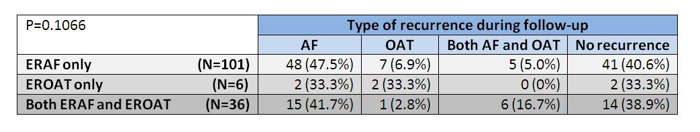](http://files.abstractsonline.com/CTRL/D7/C/105/B95/2FA/40B/98F/90B/5EC/249/6D0/4D/g6133_1.JPG)