**Control/Tracking Number:** 15-A-5429-HRS  
  
**Safety and Efficacy of Catheter Ablation for Ventricular Tachycardia in Elderly Patients with Structural Heart Disease**   
  
**Author Block:** Jackson J. Liang, DO, Shaan Khurshid, MD, Robert Schaller, DO, Pasquale Santangeli, MD, PhD, Francis E. Marchlinski, MD, FHRS and David S. Frankel, MD, FHRS. Hospital of the University of Pennsylvania, Philadelphia, PA, Massachusetts General Hospital, Boston, MA   
  
*Abstract:*  
**Introduction:**  
As patients with cardiomyopathy live longer, the number of elderly patients with ventricular tachycardia (VT) is increasing. Catheter ablation is an effective treatment for VT. The safety and efficacy of VT ablation in elderly patients remains unclear.  
**Methods:**  
We studied 238 consecutive patients with ischemic and non-ischemic cardiomyopathies who underwent catheter ablation for VT refractory to antiarrhythmic medications. Patients were divided into three age groups (Group A: ≤65 years old, Group B: 65-75 and Group C: ≥75).  
**Results:**  
Compared to Groups A and B, patients in Group C were more likely to have ischemic cardiomyopathy, lower left ventricular ejection fraction, longer mean VT cycle length and less likely to undergo epicardial ablation (all p values <0.05). Acute procedural success, complications, and 28 day survival were similar across groups (p=0.9, 0.3, and 0.3 respectively). Similarly, one-year VT-free survival did not differ between groups (Figure, p=0.9).  
**Conclusion:**  
VT ablation can be performed in elderly patients with structural heart disease with similar efficacy and complication rates as in younger patients. VT ablation should not be withheld for older age alone.  
[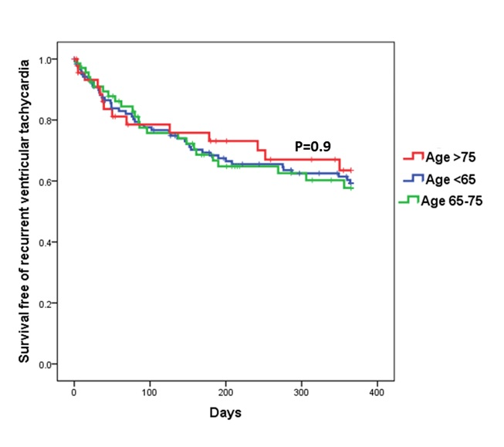](http://files.abstractsonline.com/CTRL/D0/C/120/A44/5D7/456/BBC/515/BFC/7CB/2FE/83/g5429_3.jpg)  
*:*