

Justice in Numbers pocketbook

July 2023

Contents

The information in this edition of the pocketbook represents the latest information available from [Justice in Numbers](https://data.justice.gov.uk/justice-in-numbers) on **27 July 2023**.

## Guidance

This pocketbook contains a printable version of the information presented in [Justice in Numbers](https://data.justice.gov.uk/justice-in-numbers). The QR code beneath each measure will take you to the relevant section of Justice in Numbers, where you can find additional trend data, as well as links to source material where additional context and caveats can be found to aid interpretation.

Some measures are presented as an annual trend, with data reported at fixed intervals. In some cases, more recent intermediate quarterly figures are published which do not align with these annual periods. These are highlighted in the 'Latest published data point' column of the Summary Tables, and above the relevant trend charts where applicable. The most recent and next publication dates are also listed for each measure. In cases where there is no next publication date listed, this is because a future publication date has not been announced.

Justice in Numbers can be accessed at <https://data.justice.gov.uk/justice-in-numbers>

Summary Tables

### Headline measures

| Description | Latest trend period | Latest trend value | Previous trend period | Previous trend value | Latest published data point | Last published | Next published |
| --- | --- | --- | --- | --- | --- | --- | --- |
| Crime figures from Crime Survey of England and Wales | Apr 2019 to Mar 2020 | 10.2 million | Apr 2018 to Mar 2019 | 11.2 million | Dec 2022 | 27 April 2023 | 20 July 2023 9:30am |
| Police recorded crime in England and Wales | Apr 2021 to Mar 2022 | 6.2 million | Apr 2020 to Mar 2021 | 5.3 million | Dec 2022 | 27 April 2023 | 20 July 2023 9:30am |
| Estimated total cost of crime in England and Wales | 2015/16 | £58.9bn |  |  |  | 23 July 2018 |  |
| Prison population | 30-Jun-2022 | 80,659 | 30-Jun-2021 | 78,324 | 31-Mar-2023 | 27 April 2023 | 27 July 2023 9:30am |
| Probation caseload | 31 Dec 2022 | 240,431 | 30 Sep 2022 | 240,674 |  | 27 April 2023 | 27 July 2023 9:30am |
| Proven reoffending rate | Apr - Jun 2021 | 24.8% | Jan - Mar 2021 | 24.3% |  | 27 April 2023 | 27 July 2023 9:30am |
| Crown court disposals | Jan - Dec 2022 | 91,609 | Jan - Dec 2021 | 95,768 |  | 29 June 2023 | 28 September 2023 9:30am |
| Crown court outstanding | 31 Dec 2022 | 62,511 | 31 Dec 2021 | 58,388 |  | 29 June 2023 | 28 September 2023 9:30am |
| Magistrates' courts disposals | Jan - Dec 2022 | 1,266,872 | Jan - Dec 2021 | 1,175,179 |  | 29 June 2023 | 28 September 2023 9:30am |
| Civil courts - total judgments | Jan - Dec 2022 | 901,278 | Jan - Dec 2021 | 980,474 |  | 1 June 2023 | 7 September 2023 9:30am |
| Family court - total cases disposed | Jan - Dec 2022 | 205,088 | Jan - Dec 2021 | 249,529 |  | 29 June 2023 | 28 September 2023 9:30am |
| Tribunals disposals - overall | Apr 2020 - Mar 2021 | 265,628 | Apr 2019 - Mar 2020 | 378,629 |  | 8 June 2023 | 14 September 2023 9:30am |

### Public protection

| Description | Latest trend period | Latest trend value | Previous trend period | Previous trend value | Latest published data point | Last published | Next published |
| --- | --- | --- | --- | --- | --- | --- | --- |
| Prison first receptions (quarterly) | Oct-Dec 2022 | 16,422 | Jul-Sep 2022 | 15,817 |  | 27 April 2023 | 27 July 2023 9:30am |
| Prison population | 30-Jun-2022 | 80,659 | 30-Jun-2021 | 78,324 | 31-Mar-2023 | 27 April 2023 | 27 July 2023 9:30am |
| Prison releases (quarterly) | Oct - Dec 2022 | 11,467 | Jul - Sep 2022 | 11,545 |  | 27 April 2023 | 27 July 2023 9:30am |
| Individuals released on temporary licence | Oct-Dec 2022 | 4,255 | Jul-Sep 2022 | 4,257 |  | 27 April 2023 | 27 July 2023 9:30am |
| Prison operational capacity | Jun 2022 | 82,759 | Jun 2021 | 81,154 | 30-Sep-2022 | 28 October 2022 |  |
| Prison staff in post (bands 3-5) | March 2023 | 22,288 | March 2022 | 22,001 |  | 22 May 2023 | 17 August 2023 9:30am |
| Crowding | Apr 2021 to Mar 2022 | 20.6 % | Apr 2020 to Mar 2021 | 20.2 % |  | 28 July 2022 |  |
| Prisoner on prisoner assaults per 1,000 prisoners | Apr 2021 to Mar 2022 | 174 | Apr 2020 to Mar 2021 | 159 | Dec-2022 | 27 April 2023 | 27 July 2023 9:30am |
| Assaults on staff per 1,000 prisoners | Apr 2021 to Mar 2022 | 90 | Apr 2020 to Mar 2021 | 97 | Dec-2022 | 27 April 2023 | 27 July 2023 9:30am |
| Self-harm incidents per 1,000 prisoners | Apr 2021 to Mar 2022 | 687 | Apr 2020 to Mar 2021 | 685 | Dec-2022 | 27 April 2023 | 27 July 2023 9:30am |
| Self inflicted deaths | Apr 2022 to Mar 2023 | 82 | Apr 2021 to Mar 2022 | 79 | Mar-2023 | 27 April 2023 | 27 July 2023 9:30am |
| Random mandatory drug testing (traditional drugs) | Apr 2019 to Mar 2020 | 10.5 % | Apr 2018 to Mar 2019 | 10.4 % |  | 28 July 2022 |  |
| Barricades or prevention of access | Apr 2021 to Mar 2022 | 1,273 | Apr 2020 to Mar 2021 | 1,217 |  | 28 July 2022 |  |
| Escapes from prison establishments and HMPPS escort | Apr 2021 to Mar 2022 | 1 | Apr 2020 to Mar 2021 | 0 |  | 28 July 2022 |  |
| Absconds | Apr 2021 to Mar 2022 | 95 | Apr 2020 to Mar 2021 | 101 |  | 28 July 2022 |  |
| Electronic monitoring caseload | 31 March 2023 | 17,350 | 31 March 2022 | 15,394 |  | 27 April 2023 | 20 July 2023 9:30am |
| Probation caseload | 31 Dec 2022 | 240,431 | 30 Sep 2022 | 240,674 |  | 27 April 2023 | 27 July 2023 9:30am |
| Staff in post (Probation Service) | March 2023 | 19,850 | March 2022 | 17,648 |  | 22 May 2023 | 17 August 2023 9:30am |
| Serious further offence convictions | Apr 2020- Mar 2021 | 245 | Apr 2019 - Mar 2020 | 314 |  | 27 April 2023 | 27 July 2023 9:30am |

### Reduce reoffending

| Description | Latest trend period | Latest trend value | Previous trend period | Previous trend value | Latest published data point | Last published | Next published |
| --- | --- | --- | --- | --- | --- | --- | --- |
| Proven reoffending rate | Apr - Jun 2021 | 24.8% | Jan - Mar 2021 | 24.3% |  | 27 April 2023 | 27 July 2023 9:30am |
| Housed on release from custody (SL014) | Jan-Mar 2022 | 77.6% | Oct-Dec 2021 | 76.4% |  | 26 August 2022 | 27 July 2023 9:30am |
| Settled accommodation at 3 months post release from custody (SL015a) | Jan-Mar 2022 | 71.0% | Oct-Dec 2021 | 67.9% |  | 26 August 2022 | 27 July 2023 9:30am |
| Settled accommodation at 3 months post community (SL015b) | Jan-Mar 2022 | 80.8% | Oct-Dec 2021 | 78.7% |  | 26 August 2022 | 27 July 2023 9:30am |
| Employed at 6 weeks post release from custody (SL016) | Jan-Mar 2022 | 12.7% | Oct-Dec 2021 | 11.9% |  | 26 August 2022 | 27 July 2023 9:30am |
| Employed at 6 months post release from custody (SL017a) | Jan-Mar 2022 | 19.8% | Oct-Dec 2021 | 16.6% |  | 26 August 2022 | 27 July 2023 9:30am |
| Employed at 6 months post community disposal (SL017b) | Jan-Mar 2022 | 38.9% | Oct-Dec 2021 | 36.2% |  | 26 August 2022 | 27 July 2023 9:30am |
| Random mandatory drug testing (traditional drugs) | Apr 2019 to Mar 2020 | 10.5 % | Apr 2018 to Mar 2019 | 10.4 % |  | 28 July 2022 |  |
| Random mandatory drug testing - new psychoactive substances only | Apr 2019 to Mar 2020 | 4.3 % | Apr 2018 to Mar 2019 | 9.0 % |  | 28 July 2022 |  |
| Prisoners completing treatment free from dependence | Apr 2020 - Mar 2021 | 32.5% | Apr 2019 - Mar 2020 | 26.3% |  | 27 January 2022 |  |

### Access to justice

| Description | Latest trend period | Latest trend value | Previous trend period | Previous trend value | Latest published data point | Last published | Next published |
| --- | --- | --- | --- | --- | --- | --- | --- |
| Crown court disposals | Jan - Dec 2022 | 91,609 | Jan - Dec 2021 | 95,768 |  | 29 June 2023 | 28 September 2023 9:30am |
| Crown court outstanding | 31 Dec 2022 | 62,511 | 31 Dec 2021 | 58,388 |  | 29 June 2023 | 28 September 2023 9:30am |
| Crown courts cracked trials | Jan - Dec 2022 | 26% | Jan - Dec 2021 | 29% |  | 29 June 2023 | 28 September 2023 9:30am |
| Crown courts ineffective trials | Jan - Dec 2022 | 37% | Jan - Dec 2021 | 23% |  | 29 June 2023 | 28 September 2023 9:30am |
| Magistrates' courts disposals | Jan - Dec 2022 | 1,266,872 | Jan - Dec 2021 | 1,175,179 |  | 29 June 2023 | 28 September 2023 9:30am |
| Employment tribunals disposals | Apr 2022 - Mar 2023 | 71,316 | Apr 2020 - Mar 2021 | 41,622 |  | 8 June 2023 | 14 September 2023 9:30am |
| Mean days from receipt at Crown Court to completion | Q1 (Jan-Mar) 2023 | 253 | Q4 (Oct-Dec) 2022 | 248 |  | 29 June 2023 | 28 September 2023 9:30am |
| Number of receipts of adult rape cases at the Crown Court | Q1 (Jan-Mar) 2023 | 605 | Q4 (Oct-Dec) 2022 | 512 |  | 29 June 2023 | 28 September 2023 9:30am |
| Civil courts - total judgments | Jan - Dec 2022 | 901,278 | Jan - Dec 2021 | 980,474 |  | 1 June 2023 | 7 September 2023 9:30am |
| Family court - total cases disposed | Jan - Dec 2022 | 205,088 | Jan - Dec 2021 | 249,529 |  | 29 June 2023 | 28 September 2023 9:30am |
| Tribunals disposals - overall | Apr 2020 - Mar 2021 | 265,628 | Apr 2019 - Mar 2020 | 378,629 |  | 8 June 2023 | 14 September 2023 9:30am |
| Legal aid - overall annual expenditure (£m) | Apr 2022 - Mar 2023 | 1,808 (£m) | Apr 2021 - Mar 2022 | 1,648 (£m) |  | 29 June 2023 | 28 September 2023 9:30am |

## Flow through the Criminal Justice System - Year ending March 2022

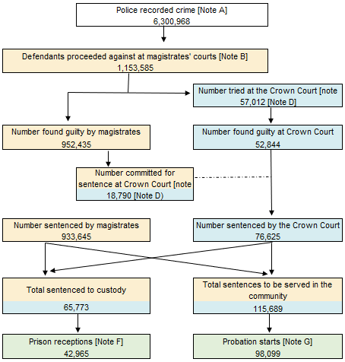

NOTES: Note A: Covers all indictable offences, including triable either way, plus a few closely associated summary offences. Excludes fraud offences recorded by Action Fraud/CIFAS/Financial Fraud Action UK.
Note B:Includes males, females, persons where sex 'Not Stated and other offenders, i.e. companies, public bodies, etc.
Note D:Defendants tried or sentenced at the Crown Court in a given year may have been committed for trial or sentence by a magistrate in a previous year.
Note F:Prison receptions of offenders sentenced to immediate custody, excluding fine defaulters.
Note G:Offenders starting Community Order or Suspended Sentence Order supervision by the Probation Service. Includes Suspended Sentence Orders without requirements.

## Headline measures

### Crime figures from Crime Survey of England and Wales

Incidents of crime against households and adults estimated from the Crime Survey for England and Wales. Includes fraud and computer misuse. Figures are survey estimates and subject to sampling variance. Therefore, figures in this chart are rounded to the nearest 100,000 incidents.

Latest published data: In the 12 months to Dec 2022 there were 9.0 million incidents of crime estimated from the CSEW

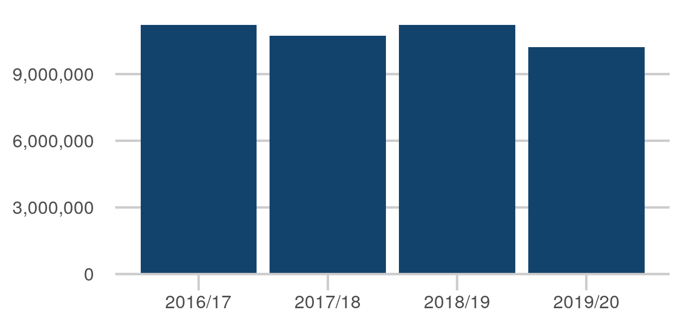

|  |  |
| --- | --- |
| Apr 2016 to Mar 2017 | 11.2 million |
| Apr 2017 to Mar 2018 | 10.7 million |
| Apr 2018 to Mar 2019 | 11.2 million |
| Apr 2019 to Mar 2020 | 10.2 million |

Last published: 27 April 2023

Next release: 20 July 2023

Source: [Crime in England and Wales](https://www.ons.gov.uk/peoplepopulationandcommunity/crimeandjustice/datasets/crimeinenglandandwalesappendixtables)

[Click here to view on Justice Data](https://data.justice.gov.uk/cjs-statistics/cjs-crime#ons-crime-survey) or use the QR code below:

### Police recorded crime in England and Wales

Police recorded crime statistics based on data from all 43 forces in England and Wales (including the British Transport Police). All offences including fraud and computer misuse.

Latest published data: In the 12 months to Dec 2022 there were 6.6 million incidents of crime recorded by police

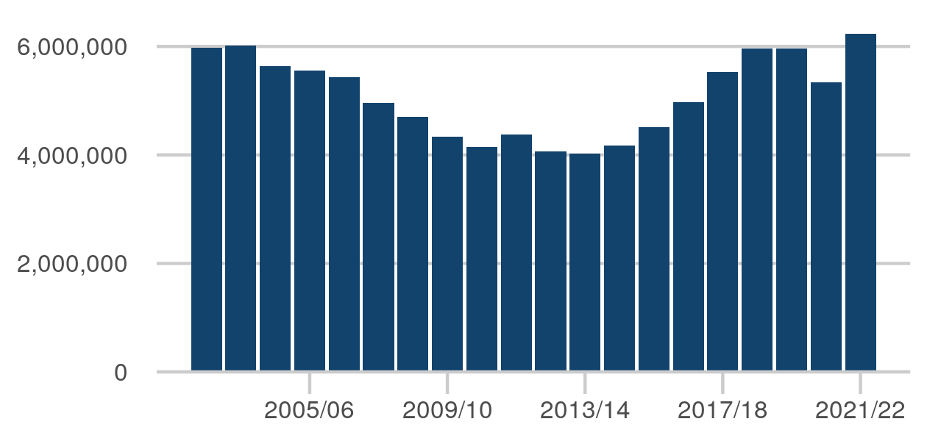

|  |  |
| --- | --- |
| Apr 2014 to Mar 2015 | 4.2 million |
| Apr 2015 to Mar 2016 | 4.5 million |
| Apr 2016 to Mar 2017 | 5.0 million |
| Apr 2017 to Mar 2018 | 5.5 million |
| Apr 2018 to Mar 2019 | 6.0 million |
| Apr 2019 to Mar 2020 | 6.0 million |
| Apr 2020 to Mar 2021 | 5.3 million |
| Apr 2021 to Mar 2022 | 6.2 million |

Last published: 27 April 2023

Next release: 20 July 2023

Source: [Crime in England and Wales](https://www.ons.gov.uk/peoplepopulationandcommunity/crimeandjustice/datasets/crimeinenglandandwalesappendixtables)

[Click here to view on Justice Data](https://data.justice.gov.uk/cjs-statistics/cjs-crime#ons-police-recorded-crime) or use the QR code below:

### Prison population

Total number of prisoners at a specific point in time each year.

Latest published data: The prison population at 31 Mar 2023 was 84,372.

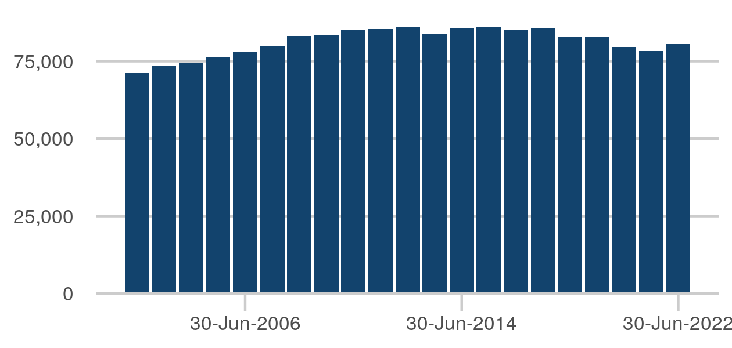

|  |  |
| --- | --- |
| 30-Jun-2015 | 86,193 |
| 30-Jun-2016 | 85,134 |
| 30-Jun-2017 | 85,863 |
| 30-Jun-2018 | 82,773 |
| 30-Jun-2019 | 82,710 |
| 30-Jun-2020 | 79,514 |
| 30-Jun-2021 | 78,324 |
| 30-Jun-2022 | 80,659 |

Last published: 27 April 2023

Next release: 27 July 2023

Source: [Offender management statistics quarterly](https://www.gov.uk/government/collections/offender-management-statistics-quarterly)

[Click here to view on Justice Data](https://data.justice.gov.uk/prisons/offender-management#population) or use the QR code below:

### Probation caseload

The statistics count each person once for each type of probation supervision being received on the date shown. In addition, each person is counted only once in each total or sub-total even if they were subject to several types of probation supervision at the year end (the examples above apply). Thus, the sum of the numbers receiving each type of court order probation supervision exceeds the number receiving court order probation supervision in total.

The figure for 31 Dec 2022 is 240,431, down 243 from 30 Sep 2022

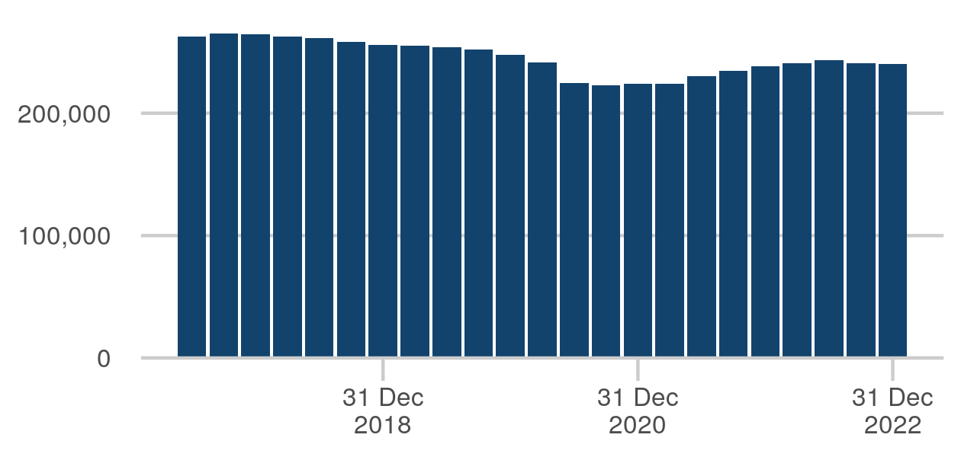

|  |  |
| --- | --- |
| 31 Mar 2021 | 224,174 |
| 30 Jun 2021 | 230,578 |
| 30 Sep 2021 | 234,827 |
| 31 Dec 2021 | 238,500 |
| 31 Mar 2022 | 240,922 |
| 30 Jun 2022 | 243,127 |
| 30 Sep 2022 | 240,674 |
| 31 Dec 2022 | 240,431 |

Last published: 27 April 2023

Next release: 27 July 2023

Source: [Offender management statistics quarterly](https://www.gov.uk/government/collections/offender-management-statistics-quarterly)

[Click here to view on Justice Data](https://data.justice.gov.uk/probation/offender-management#caseload-total) or use the QR code below:

### Proven reoffending rate

Proportion of all offenders who reoffend (%). This latest offender cohort period overlaps with operational restrictions imposed due to the COVID-19 pandemic and a period of on-going recovery for the courts. As a result, volatility continues to be seen in the reoffending figures, with overall proven reoffending down from the same quarter last year but up from the previous quarter.

The figure for Apr - Jun 2021 is 24.8%, up 0.5ppt from Jan - Mar 2021

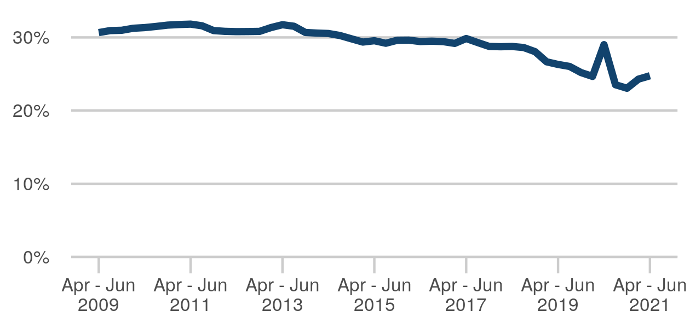

|  |  |
| --- | --- |
| Jul - Sep 2019 | 26.0% |
| Oct - Dec 2019 | 25.2% |
| Jan - Mar 2020 | 24.7% |
| Apr - Jun 2020 | 29.0% |
| Jul - Sep 2020 | 23.5% |
| Oct - Dec 2020 | 23.1% |
| Jan - Mar 2021 | 24.3% |
| Apr - Jun 2021 | 24.8% |

Last published: 27 April 2023

Next release: 27 July 2023

Source: [Proven reoffending statistics](https://www.gov.uk/government/collections/proven-reoffending-statistics)

[Click here to view on Justice Data](https://data.justice.gov.uk/cjs-statistics/cjs-reoffending#proven-reoffending) or use the QR code below:

### Crown court disposals

A count of the number of cases only when all the offences have been completed (following a validation process) in the reporting period. Disposals figures in this report may change if the case results are entered after the first collation of the data.

The figure for 2022 is 91,609, down 4,159 from 2021

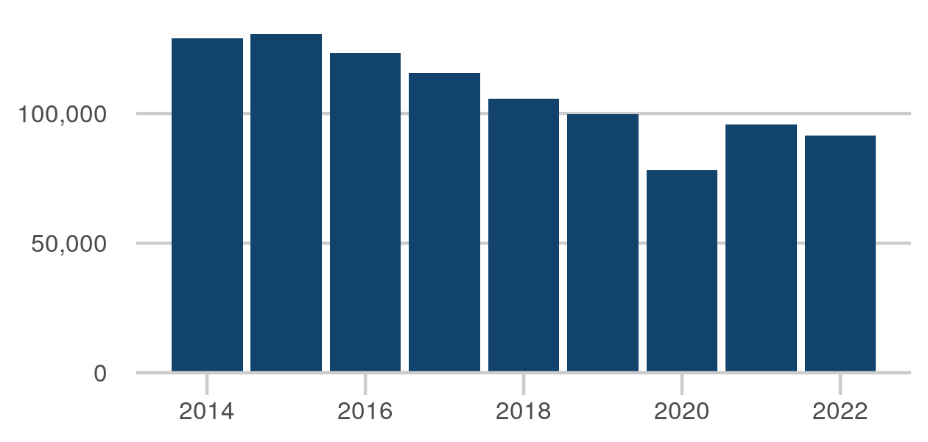

|  |  |
| --- | --- |
| Jan - Dec 2015 | 130,757 |
| Jan - Dec 2016 | 123,218 |
| Jan - Dec 2017 | 115,703 |
| Jan - Dec 2018 | 105,751 |
| Jan - Dec 2019 | 99,630 |
| Jan - Dec 2020 | 78,202 |
| Jan - Dec 2021 | 95,768 |
| Jan - Dec 2022 | 91,609 |

Last published: 29 June 2023

Next release: 28 September 2023

Source: [Criminal court statistics quarterly](https://www.gov.uk/government/collections/criminal-court-statistics)

[Click here to view on Justice Data](https://data.justice.gov.uk/courts/criminal-courts#courts-crowns-disposals) or use the QR code below:

### Crown court outstanding

A count of all cases where one or more offence remains incomplete. The data is a snapshot based on outstanding cases on the final day of the reporting period. This is a count of live cases on the system and is not a calculation based on receipts and disposals. Transferred cases may be double counted for a period while they show in both sending and receiving courts; offences subsequently entered in error may change the categorisation of the case.

The figure for 31 Dec 2022 is 62,511, up 4,123 from 31 Dec 2021

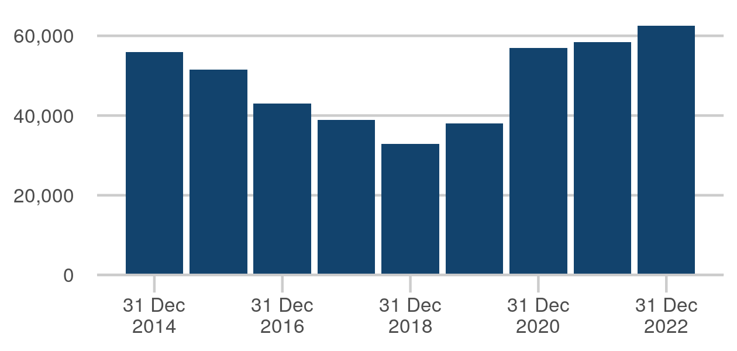

|  |  |
| --- | --- |
| 31 Dec 2015 | 51,585 |
| 31 Dec 2016 | 42,942 |
| 31 Dec 2017 | 38,828 |
| 31 Dec 2018 | 32,882 |
| 31 Dec 2019 | 37,958 |
| 31 Dec 2020 | 56,905 |
| 31 Dec 2021 | 58,388 |
| 31 Dec 2022 | 62,511 |

Last published: 29 June 2023

Next release: 28 September 2023

Source: [Criminal court statistics quarterly](https://www.gov.uk/government/collections/criminal-court-statistics)

[Click here to view on Justice Data](https://data.justice.gov.uk/courts/criminal-courts#courts-crowns-outstanding) or use the QR code below:

### Magistrates' courts disposals

A count of the number of cases only when all the offences have been completed (following a validation process) in the reporting period. Disposals figures in this report may change if the case results are entered after the first collation of the data.

The figure for 2022 is 1,266,872, up 91,693 from 2021

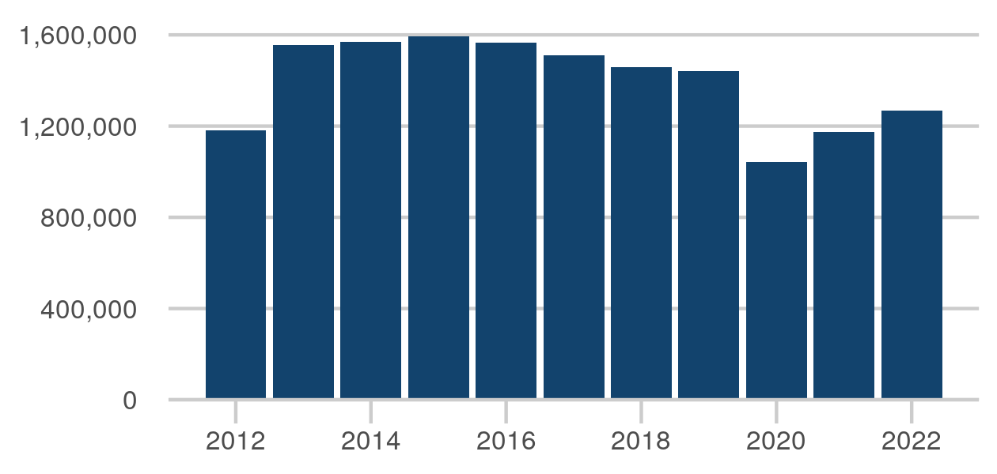

|  |  |
| --- | --- |
| Jan - Dec 2015 | 1,594,051 |
| Jan - Dec 2016 | 1,566,357 |
| Jan - Dec 2017 | 1,509,022 |
| Jan - Dec 2018 | 1,456,735 |
| Jan - Dec 2019 | 1,441,903 |
| Jan - Dec 2020 | 1,041,021 |
| Jan - Dec 2021 | 1,175,179 |
| Jan - Dec 2022 | 1,266,872 |

Last published: 29 June 2023

Next release: 28 September 2023

Source: [Criminal court statistics quarterly](https://www.gov.uk/government/collections/criminal-court-statistics)

[Click here to view on Justice Data](https://data.justice.gov.uk/courts/criminal-courts#courts-magistrates-disposals) or use the QR code below:

### Civil courts - total judgments

Total number of judgments in the county courts. Some civil cases are resolved via mediation or settled out of court and don't proceed to a judgement.

The figure for 2022 is 901,278, down 79,196 from 2021

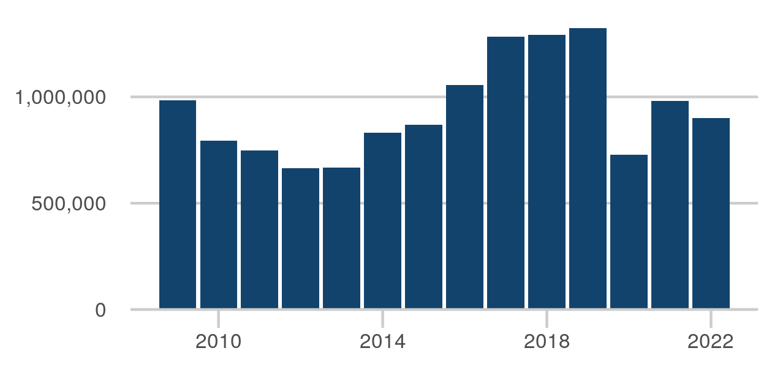

|  |  |
| --- | --- |
| Jan - Dec 2015 | 867,665 |
| Jan - Dec 2016 | 1,055,035 |
| Jan - Dec 2017 | 1,284,364 |
| Jan - Dec 2018 | 1,291,142 |
| Jan - Dec 2019 | 1,323,750 |
| Jan - Dec 2020 | 727,438 |
| Jan - Dec 2021 | 980,474 |
| Jan - Dec 2022 | 901,278 |

Last published: 1 June 2023

Next release: 7 September 2023

Source: [Civil justice statistics](https://www.gov.uk/government/collections/civil-justice-statistics-quarterly)

[Click here to view on Justice Data](https://data.justice.gov.uk/courts/civil-courts#courts-civil-total-judgments) or use the QR code below:

### Family court - total cases disposed

Total cases disposed at family court.

The figure for 2022 is 205,088, down 44,441 from 2021

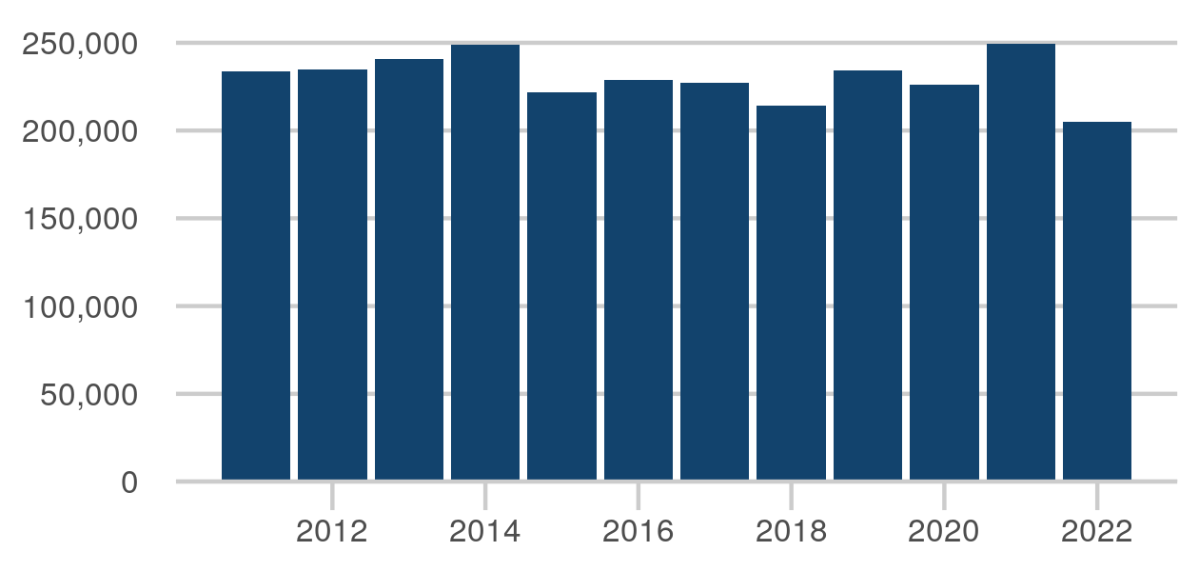

|  |  |
| --- | --- |
| Jan - Dec 2015 | 221,558 |
| Jan - Dec 2016 | 228,960 |
| Jan - Dec 2017 | 226,980 |
| Jan - Dec 2018 | 214,294 |
| Jan - Dec 2019 | 234,344 |
| Jan - Dec 2020 | 225,930 |
| Jan - Dec 2021 | 249,529 |
| Jan - Dec 2022 | 205,088 |

Last published: 29 June 2023

Next release: 28 September 2023

Source: [Family court statistics quarterly](https://www.gov.uk/government/collections/family-court-statistics-quarterly)

[Click here to view on Justice Data](https://data.justice.gov.uk/courts/family-courts#courts-family-total-disposals) or use the QR code below:

### Tribunals disposals - overall

Latest published data: Data for 2021/22 and 2022/23 is not available. Please refer to the publication.

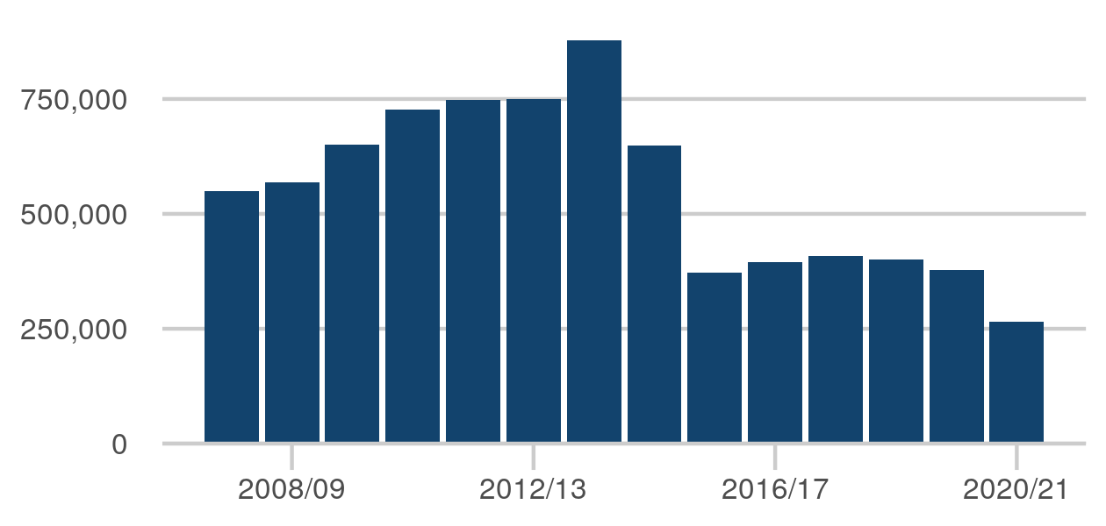

|  |  |
| --- | --- |
| Apr 2013 - Mar 2014 | 878,007 |
| Apr 2014 - Mar 2015 | 649,068 |
| Apr 2015 - Mar 2016 | 372,926 |
| Apr 2016 - Mar 2017 | 394,102 |
| Apr 2017 - Mar 2018 | 407,638 |
| Apr 2018 - Mar 2019 | 400,816 |
| Apr 2019 - Mar 2020 | 378,629 |
| Apr 2020 - Mar 2021 | 265,628 |

Last published: 8 June 2023

Next release: 14 September 2023

Source: [Tribunals statistics quarterly](https://www.gov.uk/government/collections/tribunals-statistics)

[Click here to view on Justice Data](https://data.justice.gov.uk/courts/tribunals#courts-tribunals-disposals-overall) or use the QR code below:

## Public protection

### Prison first receptions (quarterly)

A first reception is a measure which counts a prisoner's first movement into custody following a court hearing for a particular set of offences committed, and therefore gives the best indication of the number of new prisoners in the reporting period.

The figure for Oct-Dec 2022 is 16,422, up 605 from Jul-Sep 2022

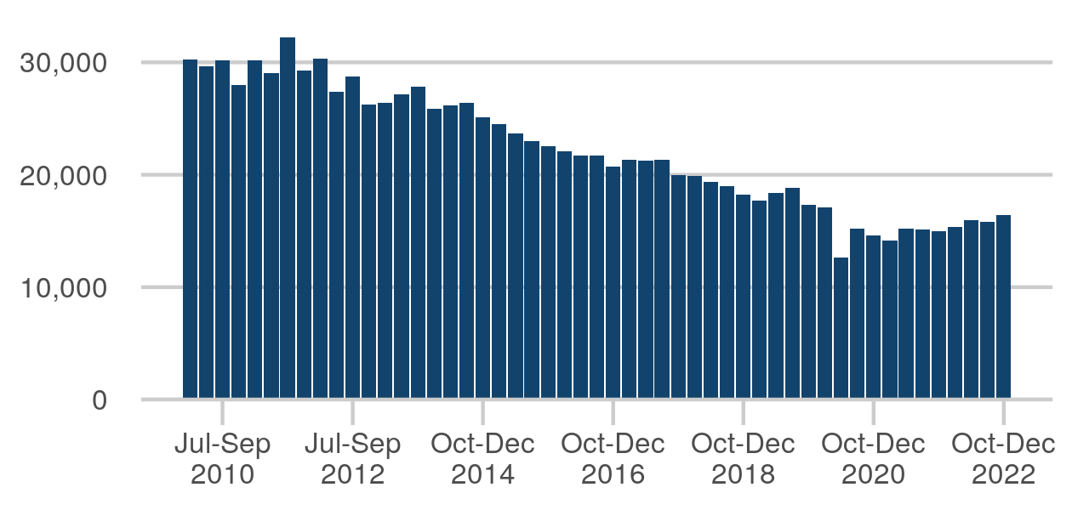

|  |  |
| --- | --- |
| Jan-Mar 2021 | 14,131 |
| Apr-Jun 2021 | 15,206 |
| Jul-Sep 2021 | 15,103 |
| Oct-Dec 2021 | 15,000 |
| Jan-Mar 2022 | 15,354 |
| Apr-Jun 2022 | 15,944 |
| Jul-Sep 2022 | 15,817 |
| Oct-Dec 2022 | 16,422 |

Last published: 27 April 2023

Next release: 27 July 2023

Source: [Offender management statistics quarterly](https://www.gov.uk/government/collections/offender-management-statistics-quarterly)

[Click here to view on Justice Data](https://data.justice.gov.uk/prisons/offender-management#receptions) or use the QR code below:

### Prison population

Total number of prisoners at a specific point in time each year.

Latest published data: The prison population at 31 Mar 2023 was 84,372.



|  |  |
| --- | --- |
| 30-Jun-2015 | 86,193 |
| 30-Jun-2016 | 85,134 |
| 30-Jun-2017 | 85,863 |
| 30-Jun-2018 | 82,773 |
| 30-Jun-2019 | 82,710 |
| 30-Jun-2020 | 79,514 |
| 30-Jun-2021 | 78,324 |
| 30-Jun-2022 | 80,659 |

Last published: 27 April 2023

Next release: 27 July 2023

Source: [Offender management statistics quarterly](https://www.gov.uk/government/collections/offender-management-statistics-quarterly)

[Click here to view on Justice Data](https://data.justice.gov.uk/prisons/offender-management#population) or use the QR code below:

### Prison population by sex: 31 Mar 2023

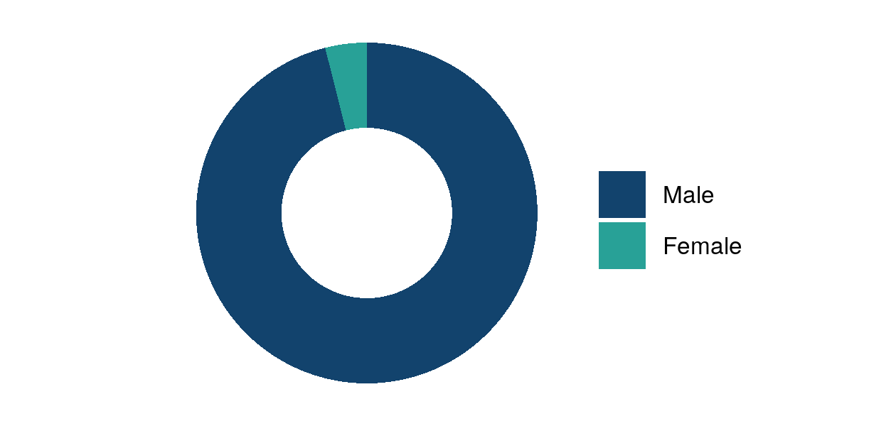

|  |  |
| --- | --- |
| Male | 81,057 prisoners |
| Female | 3,315 prisoners |

Last published: 27 April 2023

Next release: 27 July 2023

Source: [Offender management statistics quarterly](https://www.gov.uk/government/collections/offender-management-statistics-quarterly)

[Click here to view on Justice Data](https://data.justice.gov.uk/justice-in-numbers) or use the QR code below:

### Prison population by age: 31 Mar 2023

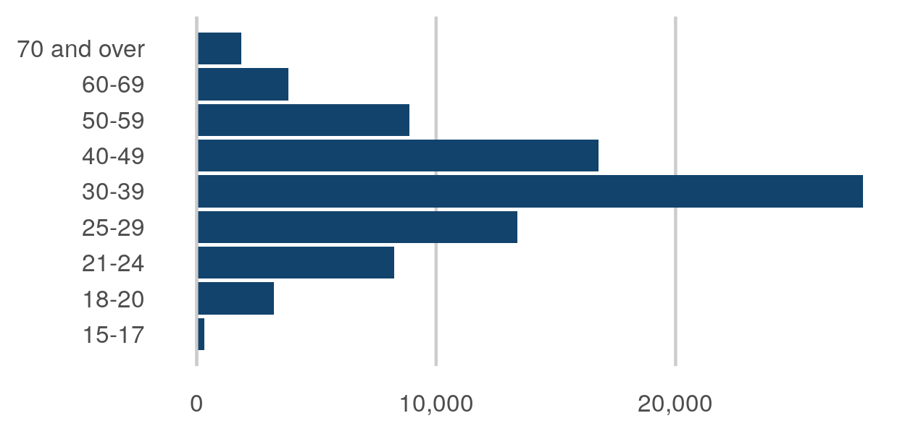

|  |  |
| --- | --- |
| 15-17 | 335 prisoners |
| 18-20 | 3,229 prisoners |
| 21-24 | 8,235 prisoners |
| 25-29 | 13,387 prisoners |
| 30-39 | 27,830 prisoners |
| 40-49 | 16,778 prisoners |
| 50-59 | 8,878 prisoners |
| 60-69 | 3,824 prisoners |
| 70 and over | 1,876 prisoners |

Last published: 27 April 2023

Next release: 27 July 2023

Source: [Offender management statistics quarterly](https://www.gov.uk/government/collections/offender-management-statistics-quarterly)

[Click here to view on Justice Data](https://data.justice.gov.uk/justice-in-numbers) or use the QR code below:

### Prison population by offence: 31 Mar 2023

Prison population under an immediate custodial sentence by offence group. Excludes remand and non-criminal prisoners.

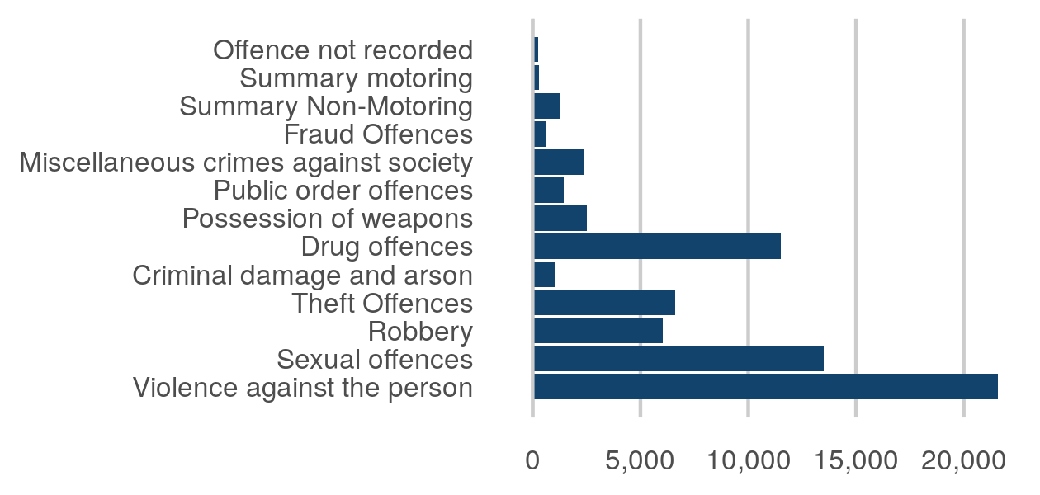

|  |  |
| --- | --- |
| Violence against the person | 21,582 |
| Sexual offences | 13,493 |
| Robbery | 6,048 |
| Theft Offences | 6,620 |
| Criminal damage and arson | 1,075 |
| Drug offences | 11,512 |
| Possession of weapons | 2,506 |
| Public order offences | 1,450 |
| Miscellaneous crimes against society | 2,396 |
| Fraud Offences | 605 |
| Summary Non-Motoring | 1,285 |
| Summary motoring | 283 |
| Offence not recorded | 240 |

Last published: 27 April 2023

Next release: 27 July 2023

Source: [Offender management statistics quarterly](https://www.gov.uk/government/collections/offender-management-statistics-quarterly)

[Click here to view on Justice Data](https://data.justice.gov.uk/justice-in-numbers) or use the QR code below:

### Prison releases (quarterly)

A release is defined as a release from prison where the prisoner has finished serving the custodial term of their sentence(s) and excludes: civil non-criminal prisoners; persons committed to custody for non-payment of a fine; releases to hospital; deported prisoners from HMPPS operated Immigration Removal Centres (IRCs); and releases following recall after release on licence, except occasions: where the offender has committed a new offence and is committed to custody for a new sentence and the subsequent release date falls after the sentence expiry date of the original sentence; or where upon release the offender is subject to the licence condition of the new custodial sentence.

The figure for Oct-Dec 2022 is 11,467, down 78 from Jul-Sep 2022

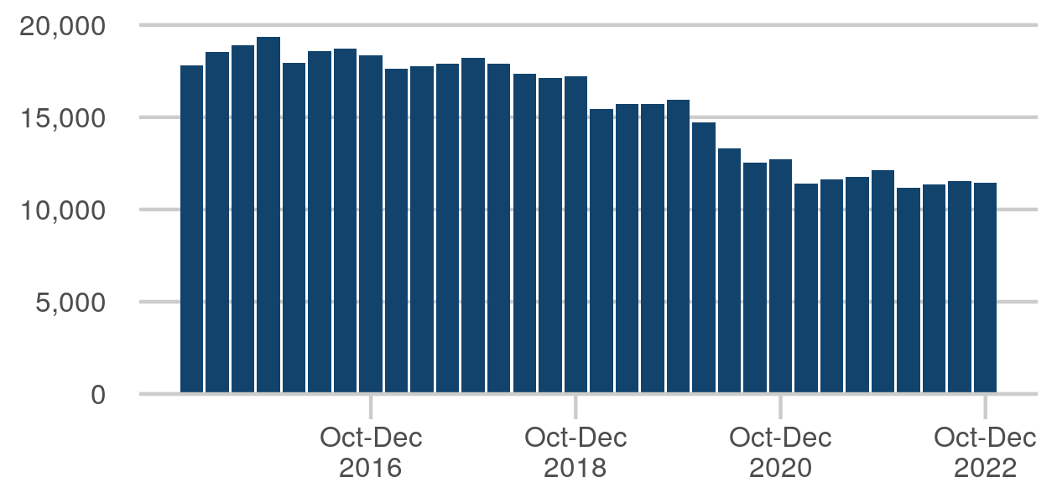

|  |  |
| --- | --- |
| Jan-Mar 2021 | 11,419 |
| Apr-Jun 2021 | 11,623 |
| Jul-Sep 2021 | 11,750 |
| Oct - Dec 2021 | 12,112 |
| Jan - Mar 2022 | 11,198 |
| Apr - Jun 2022 | 11,359 |
| Jul - Sep 2022 | 11,545 |
| Oct - Dec 2022 | 11,467 |

Last published: 27 April 2023

Next release: 27 July 2023

Source: [Offender management statistics quarterly](https://www.gov.uk/government/collections/offender-management-statistics-quarterly)

[Click here to view on Justice Data](https://data.justice.gov.uk/prisons/offender-management#releases) or use the QR code below:

### Individuals released on temporary licence

Release on Temporary Licence (ROTL) is the mechanism under which offenders may be released into the community, generally towards the end of their sentences, for rehabilitative purposes. It can play an important role in public protection by allowing risk management plans for offenders to be tested in the community under strict conditions before they are released. It also provides a valuable means of helping offenders prepare for their resettlement in the community by, for example, finding work or rebuilding links with their families, which helps to reduce reoffending.

The figure for Oct-Dec 2022 is 4,255, down 2 from Jul-Sep 2022

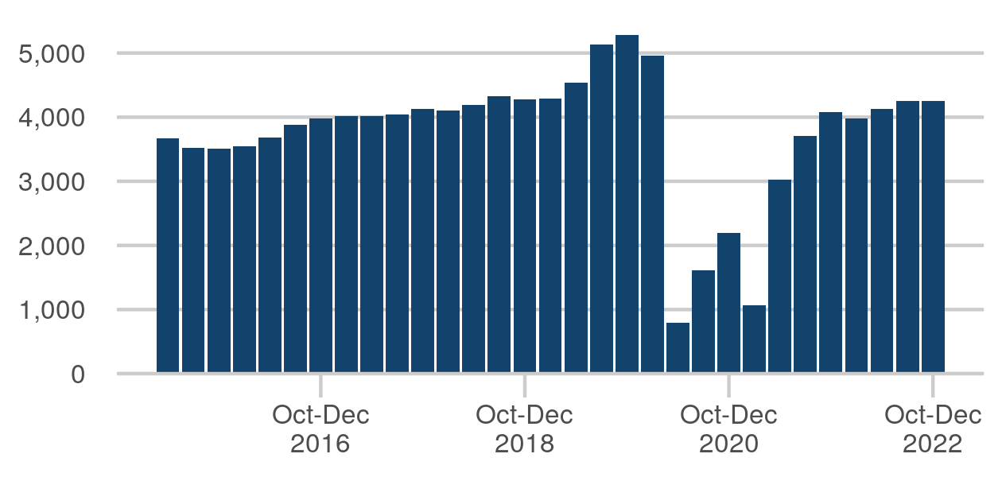

|  |  |
| --- | --- |
| Jan-Mar 2021 | 1,067 |
| Apr-Jun 2021 | 3,026 |
| Jul-Sep 2021 | 3,712 |
| Oct-Dec 2021 | 4,082 |
| Jan-Mar 2022 | 3,984 |
| Apr-Jun 2022 | 4,127 |
| Jul-Sep 2022 | 4,257 |
| Oct-Dec 2022 | 4,255 |

Last published: 27 April 2023

Next release: 27 July 2023

Source: [Offender management statistics quarterly](https://www.gov.uk/government/collections/offender-management-statistics-quarterly)

[Click here to view on Justice Data](https://data.justice.gov.uk/prisons/offender-management#rotl) or use the QR code below:

### Prison type - male / female: August 2022

Prisons count by male, female and children (under 18 years old) establishments.

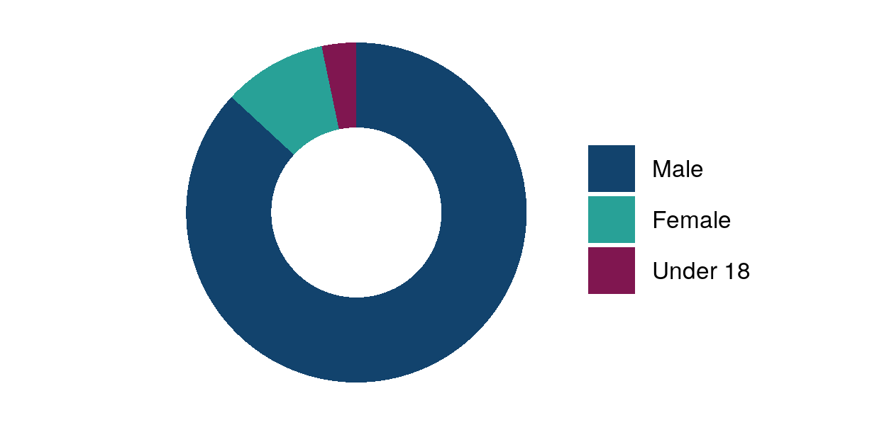

|  |  |
| --- | --- |
| Male | 106 prisons |
| Female | 12 prisons |
| Under 18 | 4 prisons |

Last published: 31 August 2022

Source: [Prisons and their resettlement providers](https://www.gov.uk/government/publications/prisons-and-their-resettlement-providers)

[Click here to view on Justice Data](https://data.justice.gov.uk/justice-in-numbers) or use the QR code below:

### Prison type - public / private: August 2022

Prisons count by ownership.

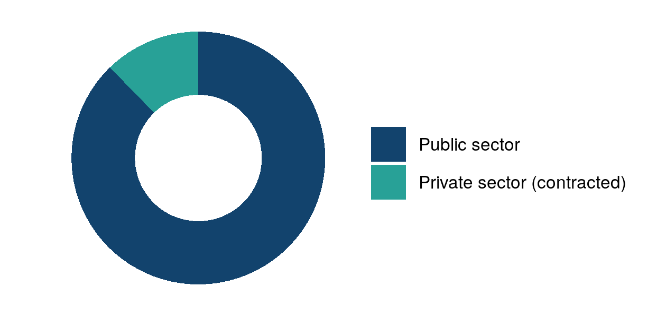

|  |  |
| --- | --- |
| Public sector | 107 prisons |
| Private sector (contracted) | 15 prisons |

Last published: 31 August 2022

Source: [Prisons and their resettlement providers](https://www.gov.uk/government/publications/prisons-and-their-resettlement-providers)

[Click here to view on Justice Data](https://data.justice.gov.uk/justice-in-numbers) or use the QR code below:

### Prison operational capacity

The operational capacity of a prison is the total number of prisoners that an establishment can hold taking into account control, security and the proper operation of the planned regime. This measure reports the useable operational capacity of the estate, which is the sum of all establishments' operational capacity less an operating margin. Figures are taken on the last working Friday of June each year.

Latest published data: At 30 Sep 2022 the useable operational capacity of the estate was 83,723.

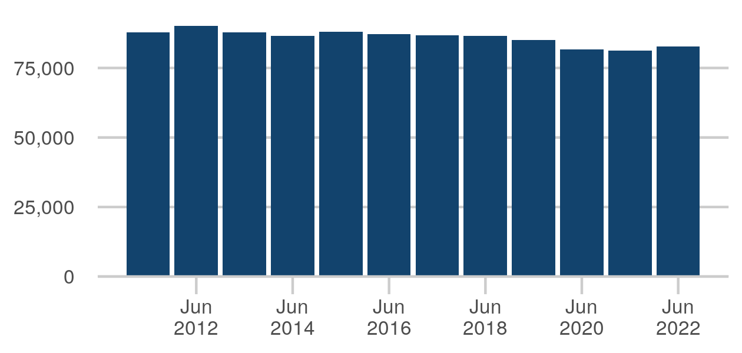

|  |  |
| --- | --- |
| Jun 2015 | 87,968 |
| Jun 2016 | 87,170 |
| Jun 2017 | 86,849 |
| Jun 2018 | 86,491 |
| Jun 2019 | 85,056 |
| Jun 2020 | 81,749 |
| Jun 2021 | 81,154 |
| Jun 2022 | 82,759 |

Last published: 28 October 2022

Source: [Prison population statistics](https://www.gov.uk/government/collections/prison-population-statistics)

[Click here to view on Justice Data](https://data.justice.gov.uk/prisons/offender-management#prison-opcap) or use the QR code below:

### Prison staff in post (bands 3-5)

The chart shows Band 3-5 prison officer staff (full time equivalent) at the end of each financial year.

The figure for March 2023 is 22,288, up 287 from March 2022

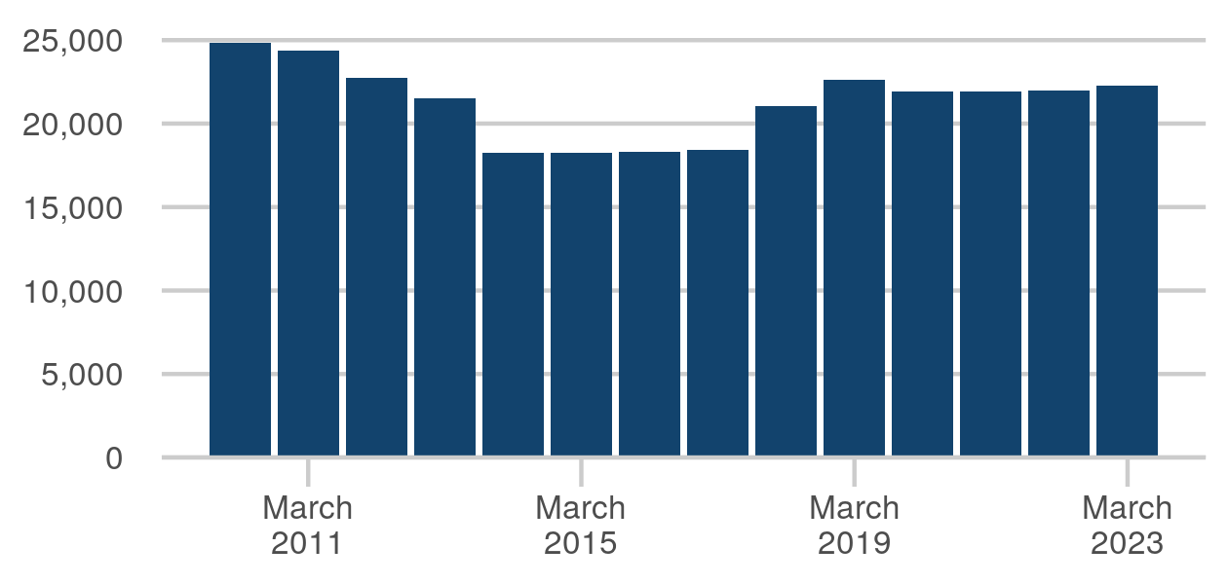

|  |  |
| --- | --- |
| March 2016 | 18,327 |
| March 2017 | 18,403 |
| March 2018 | 21,038 |
| March 2019 | 22,630 |
| March 2020 | 21,928 |
| March 2021 | 21,926 |
| March 2022 | 22,001 |
| March 2023 | 22,288 |

Last published: 22 May 2023

Next release: 17 August 2023

Source: [HM Prison and Probation Service workforce quarterly](https://www.gov.uk/government/collections/national-offender-management-service-workforce-statistics)

[Click here to view on Justice Data](https://data.justice.gov.uk/prisons/additional#prison-staff-in-post) or use the QR code below:

### Crowding

Percentage of prisoners held in crowded accommodation.

The figure for 2021-22 is 20.6 %, up 0.4ppt from 2020-21

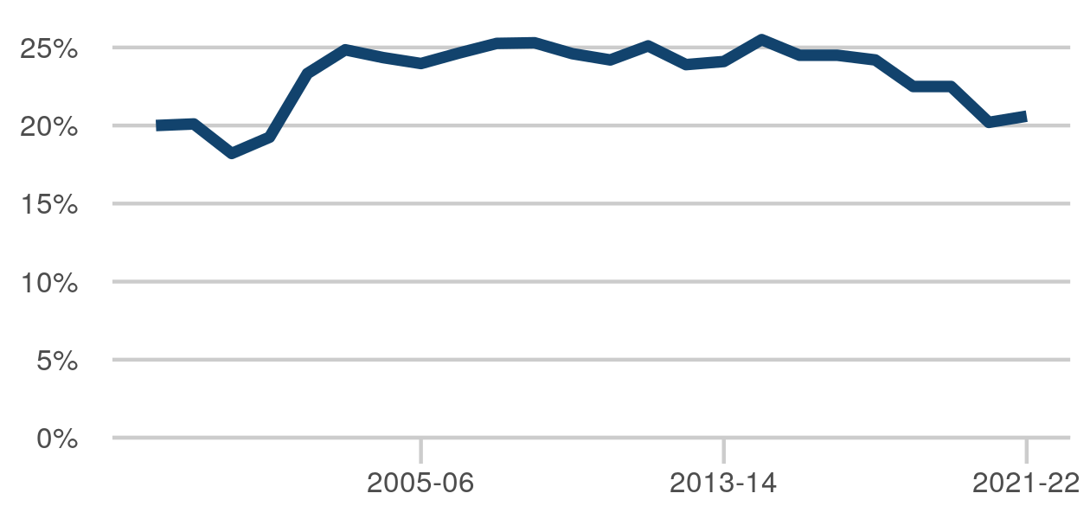

|  |  |
| --- | --- |
| Apr 2014 to Mar 2015 | 25.5 % |
| Apr 2015 to Mar 2016 | 24.5 % |
| Apr 2016 to Mar 2017 | 24.5 % |
| Apr 2017 to Mar 2018 | 24.2 % |
| Apr 2018 to Mar 2019 | 22.5 % |
| Apr 2019 to Mar 2020 | 22.5 % |
| Apr 2020 to Mar 2021 | 20.2 % |
| Apr 2021 to Mar 2022 | 20.6 % |

Last published: 28 July 2022

Source: [HM Prison and Probation Service annual digest](https://www.gov.uk/government/statistics/hmpps-annual-digest-april-2021-to-march-2022)

[Click here to view on Justice Data](https://data.justice.gov.uk/prisons/additional#crowding) or use the QR code below:

### Prisoner on prisoner assaults per 1,000 prisoners

Assaults in prison custody cover a wide range of violent incidents including fights between prisoners. From time to time, events in prison custody and developments within and outside the Ministry of Justice have changed the safety in prisons is viewed and managed. Some have resulted in changes to the way offenders are managed, others have affected the way statistics are collected and reported.

Latest published data: In the 12 months to Dec 2022 there were 174 prisoner on prisoner assaults per 1,000 prisoners.

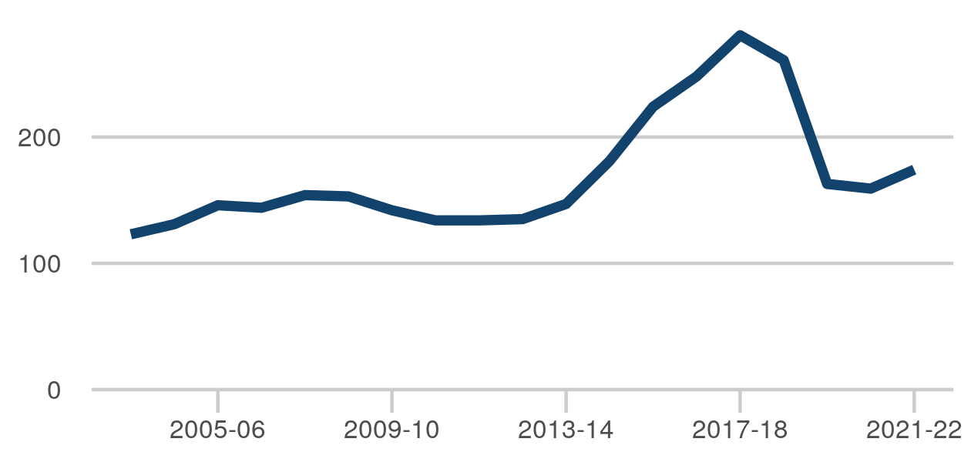

|  |  |
| --- | --- |
| Apr 2014 to Mar 2015 | 181 |
| Apr 2015 to Mar 2016 | 224 |
| Apr 2016 to Mar 2017 | 248 |
| Apr 2017 to Mar 2018 | 281 |
| Apr 2018 to Mar 2019 | 261 |
| Apr 2019 to Mar 2020 | 163 |
| Apr 2020 to Mar 2021 | 159 |
| Apr 2021 to Mar 2022 | 174 |

Last published: 27 April 2023

Next release: 27 July 2023

Source: [Safety in custody statistics](https://www.gov.uk/government/collections/safety-in-custody-statistics)

[Click here to view on Justice Data](https://data.justice.gov.uk/prisons/safety-and-order#assaults-rate-prisoner) or use the QR code below:

### Assaults on staff per 1,000 prisoners

Assaults in prison custody cover a wide range of violent incidents including attacks on staff. From time to time, events in prison custody and developments within and outside Ministry of Justice have changed the way safety in prisons is viewed and managed. Some have resulted in changes to the way offenders are managed, others have affected the way statistics are collected and reported.

Latest published data: In the 12 months to Dec 2022 there were 90 assaults on staff per 1,000 prisoners.

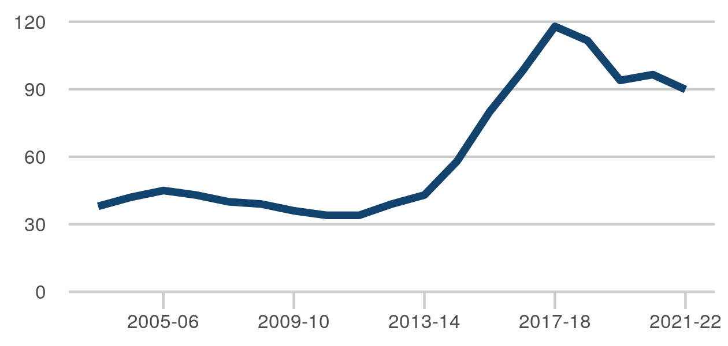

|  |  |
| --- | --- |
| Apr 2014 to Mar 2015 | 58 |
| Apr 2015 to Mar 2016 | 80 |
| Apr 2016 to Mar 2017 | 98 |
| Apr 2017 to Mar 2018 | 118 |
| Apr 2018 to Mar 2019 | 112 |
| Apr 2019 to Mar 2020 | 94 |
| Apr 2020 to Mar 2021 | 97 |
| Apr 2021 to Mar 2022 | 90 |

Last published: 27 April 2023

Next release: 27 July 2023

Source: [Safety in custody statistics](https://www.gov.uk/government/collections/safety-in-custody-statistics)

[Click here to view on Justice Data](https://data.justice.gov.uk/prisons/safety-and-order#assaults-rate-staff) or use the QR code below:

### Self-harm incidents per 1,000 prisoners

Self-harm in prison covers a wide range of severity and type of incident, including cutting, overdose or hanging.

Latest published data: In the 12 months to Dec 2022 there were 687 self-harm incidents per 1,000 prisoners.

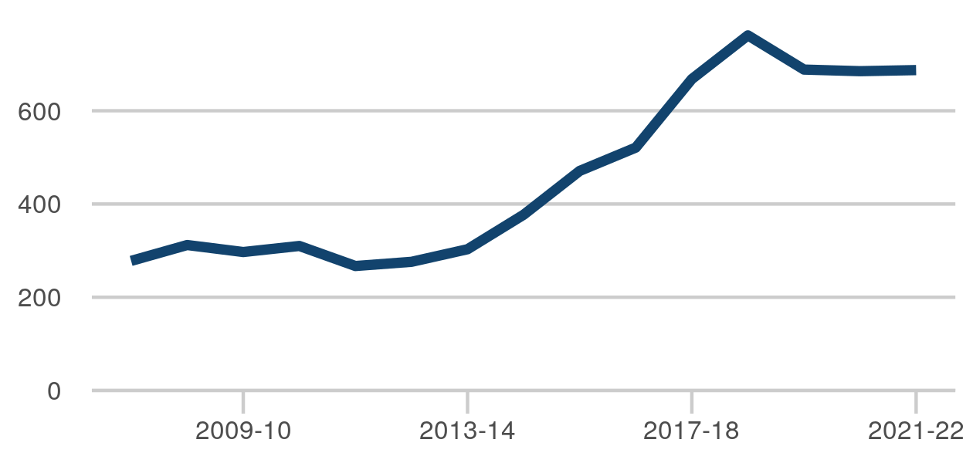

|  |  |
| --- | --- |
| Apr 2014 to Mar 2015 | 377 |
| Apr 2015 to Mar 2016 | 471 |
| Apr 2016 to Mar 2017 | 521 |
| Apr 2017 to Mar 2018 | 668 |
| Apr 2018 to Mar 2019 | 762 |
| Apr 2019 to Mar 2020 | 688 |
| Apr 2020 to Mar 2021 | 685 |
| Apr 2021 to Mar 2022 | 687 |

Last published: 27 April 2023

Next release: 27 July 2023

Source: [Safety in custody statistics](https://www.gov.uk/government/collections/safety-in-custody-statistics)

[Click here to view on Justice Data](https://data.justice.gov.uk/prisons/safety-and-order#self-harm-rate) or use the QR code below:

### Self inflicted deaths

The number of self inflicted deaths in prisons.

Latest published data: In the 12 months to Mar 2023 there were 82 self-inflicted deaths.

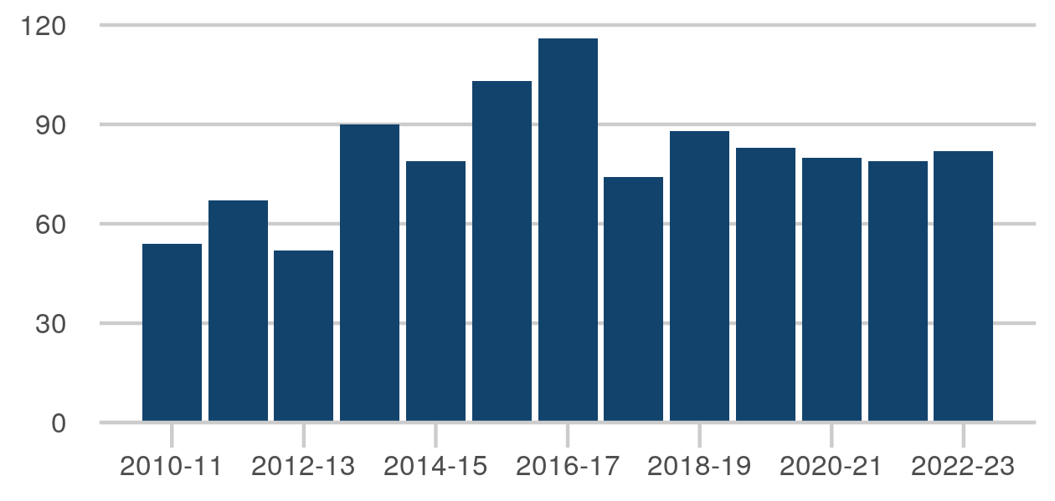

|  |  |
| --- | --- |
| Apr 2015 to Mar 2016 | 103 |
| Apr 2016 to Mar 2017 | 116 |
| Apr 2017 to Mar 2018 | 74 |
| Apr 2018 to Mar 2019 | 88 |
| Apr 2019 to Mar 2020 | 83 |
| Apr 2020 to Mar 2021 | 80 |
| Apr 2021 to Mar 2022 | 79 |
| Apr 2022 to Mar 2023 | 82 |

Last published: 27 April 2023

Next release: 27 July 2023

Source: [Safety in custody statistics](https://www.gov.uk/government/collections/safety-in-custody-statistics)

[Click here to view on Justice Data](https://data.justice.gov.uk/prisons/safety-and-order#self-inflicted-deaths) or use the QR code below:

### Random mandatory drug testing (traditional drugs)

The percentage of random mandatory drug tests which show drugs to be present, hence a downward trend is positive. This measure excludes tests for new psychoactive substances. The values for 2018/19 onwards are calculated using a new weighted methodology - please refer to the relevant publication for more details.

The figure for 2019-20 is 10.5 %, up 0.1ppt from 2018-19

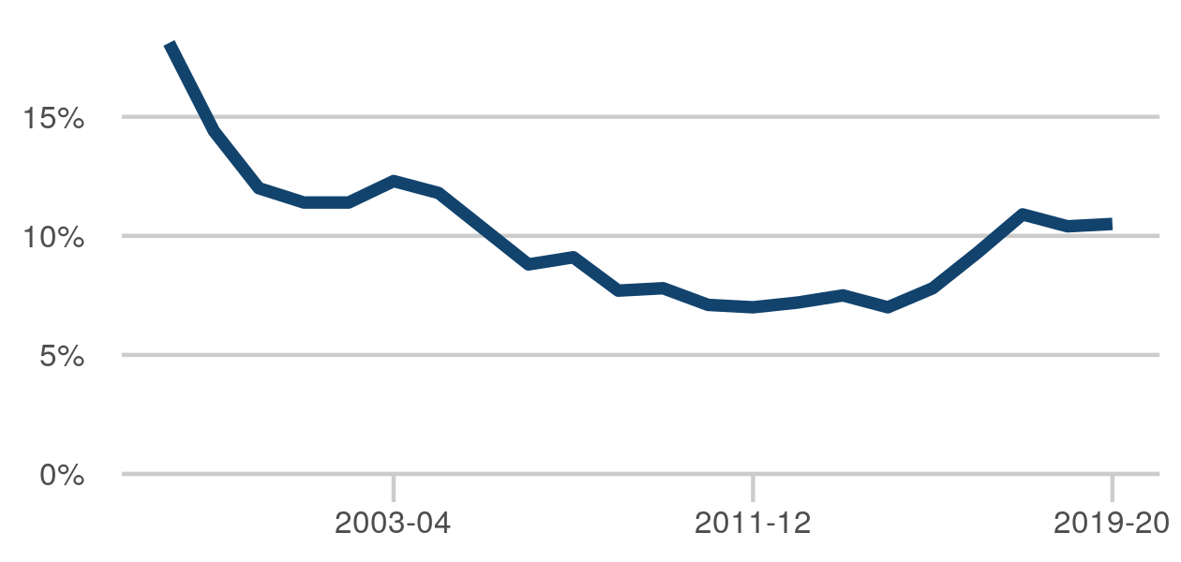

|  |  |
| --- | --- |
| Apr 2012 to Mar 2013 | 7.2 % |
| Apr 2013 to Mar 2014 | 7.5 % |
| Apr 2014 to Mar 2015 | 7.0 % |
| Apr 2015 to Mar 2016 | 7.8 % |
| Apr 2016 to Mar 2017 | 9.3 % |
| Apr 2017 to Mar 2018 | 10.9 % |
| Apr 2018 to Mar 2019 | 10.4 % |
| Apr 2019 to Mar 2020 | 10.5 % |

Last published: 28 July 2022

Source: [HM Prison and Probation Service annual digest](https://www.gov.uk/government/statistics/hmpps-annual-digest-april-2021-to-march-2022)

[Click here to view on Justice Data](https://data.justice.gov.uk/prisons/prison-reform#random-mandatory-drug-testing) or use the QR code below:

### Barricades or prevention of access

The number of incidents where where one or more offenders deny access to all or part of a prison to those lawfully empowered to have such access, by use of a physical barrier.

The figure for 2021-22 is 1,273, up 56 from 2020-21

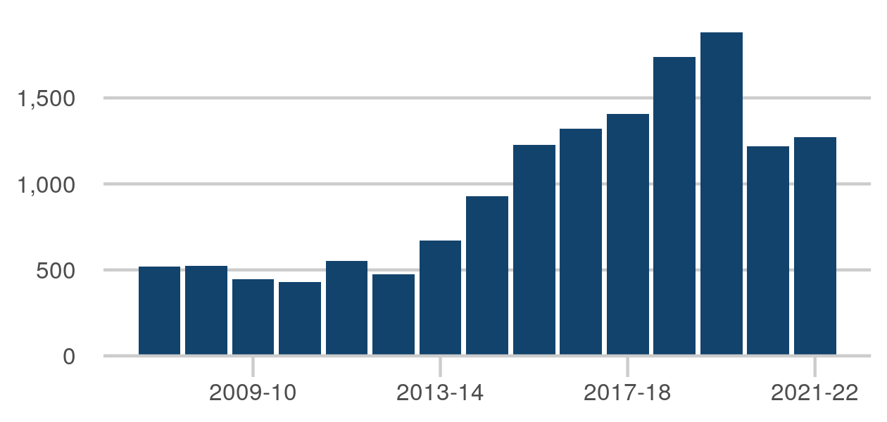

|  |  |
| --- | --- |
| Apr 2014 to Mar 2015 | 929 |
| Apr 2015 to Mar 2016 | 1,229 |
| Apr 2016 to Mar 2017 | 1,320 |
| Apr 2017 to Mar 2018 | 1,406 |
| Apr 2018 to Mar 2019 | 1,737 |
| Apr 2019 to Mar 2020 | 1,882 |
| Apr 2020 to Mar 2021 | 1,217 |
| Apr 2021 to Mar 2022 | 1,273 |

Last published: 28 July 2022

Source: [HM Prison and Probation Service annual digest](https://www.gov.uk/government/statistics/hmpps-annual-digest-april-2021-to-march-2022)

[Click here to view on Justice Data](https://data.justice.gov.uk/prisons/safety-and-order#barricades) or use the QR code below:

### Risk management audit: 2021-22

An announced audit to determine how effectively the prison is assessing and managing risks of violence and self-harm. The risk management audit is carried out approximately every three years. The data presented here shows the most recent assessment for each prison establishment. The summary percentage is based on audits published internally by HMPPS. The annual prison performance ratings publication includes audits which had not been published when it was released and were therefore suppressed from the data tables. Including these suppressed scores, the overall percentage of prisons scoring a 3 or 4 is 53.3%

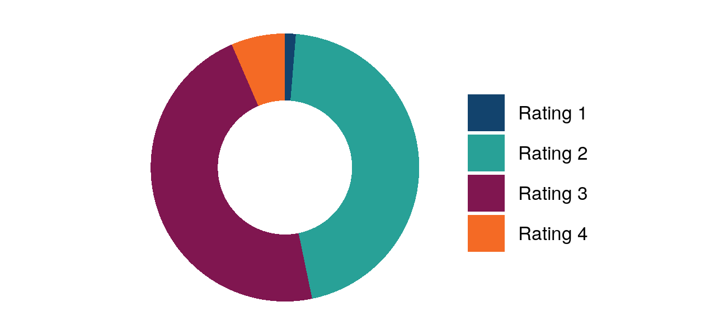

|  |  |
| --- | --- |
| Rating 1 | 1 prisons |
| Rating 2 | 35 prisons |
| Rating 3 | 36 prisons |
| Rating 4 | 5 prisons |

Last published: 28 July 2022

Next release: 27 July 2023

Source: [Prison performance ratings](https://www.gov.uk/government/collections/prison-and-probation-trusts-performance-statistics#prison-performance-statistics)

[Click here to view on Justice Data](https://data.justice.gov.uk/prisons/safety-and-order#risk-management-audit) or use the QR code below:

### Escapes from prison establishments and HMPPS escort

A prisoner escapes from prison if they unlawfully gain their liberty (for 15 minutes or more) by breaching the secure perimeter of a closed prison, or if during prison staff escort, overcome the control of escorting staff and leave the escort, the van or the building (hospital etc.). Those who escape for less than 15 minutes and commit an offence are also recorded as an escape. Escapes are monitored to analyse the frequency across the estate and identify any trends nationally, also taking into consideration the management of risk to the public.

The figure for 2021-22 is 1, up 1 from 2020-21

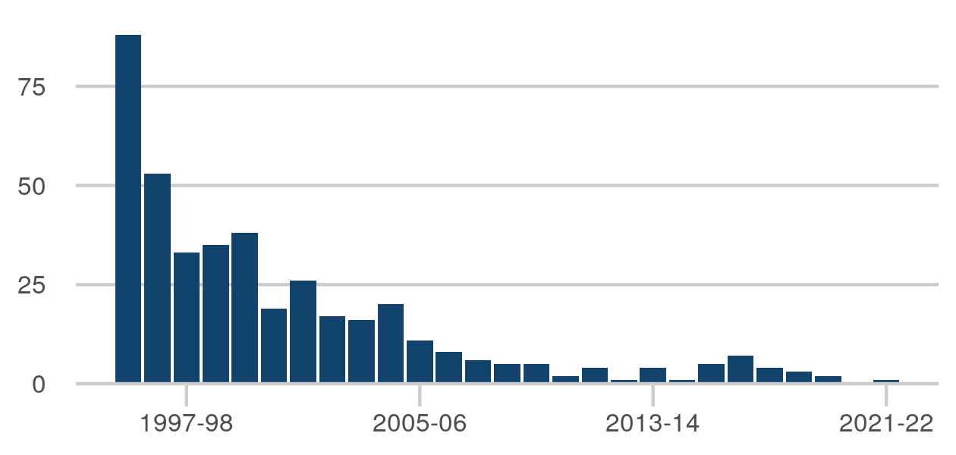

|  |  |
| --- | --- |
| Apr 2014 to Mar 2015 | 1 |
| Apr 2015 to Mar 2016 | 5 |
| Apr 2016 to Mar 2017 | 7 |
| Apr 2017 to Mar 2018 | 4 |
| Apr 2018 to Mar 2019 | 3 |
| Apr 2019 to Mar 2020 | 2 |
| Apr 2020 to Mar 2021 | 0 |
| Apr 2021 to Mar 2022 | 1 |

Last published: 28 July 2022

Source: [HM Prison and Probation Service annual digest](https://www.gov.uk/government/statistics/hmpps-annual-digest-april-2021-to-march-2022)

[Click here to view on Justice Data](https://data.justice.gov.uk/prisons/public-protection#escapes) or use the QR code below:

### Absconds

An abscond is an escape that does not involve overcoming a physical security restraint such as that provided by a wall or fence, locks, bolts or bars, a secure vehicle, handcuffs or the direct supervision of staff. Absconds are monitored to analyse the frequency across the open estate and identify any trends nationally also taking into consideration, the management of risk to the public. It is only possible to abscond from open prison conditions.

The figure for 2021-22 is 95, down 6 from 2020-21

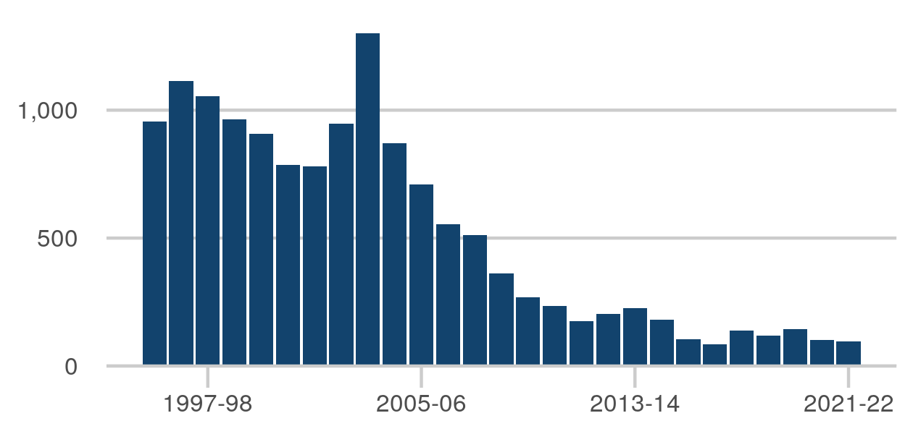

|  |  |
| --- | --- |
| Apr 2014 to Mar 2015 | 181 |
| Apr 2015 to Mar 2016 | 105 |
| Apr 2016 to Mar 2017 | 86 |
| Apr 2017 to Mar 2018 | 139 |
| Apr 2018 to Mar 2019 | 119 |
| Apr 2019 to Mar 2020 | 143 |
| Apr 2020 to Mar 2021 | 101 |
| Apr 2021 to Mar 2022 | 95 |

Last published: 28 July 2022

Source: [HM Prison and Probation Service annual digest](https://www.gov.uk/government/statistics/hmpps-annual-digest-april-2021-to-march-2022)

[Click here to view on Justice Data](https://data.justice.gov.uk/prisons/public-protection#absconds) or use the QR code below:

### Security audit: 2021-22

An internal audit that assesses, on a four point scale, the level to which effective security procedures are adhered to within each prison. There is no structured frequency for how often the security audit takes place, with the exception of long term high security prison establishments which are audited annually. The data presented here shows the most recent assessment for each prison establishment. The summary percentage is based on audits published internally by HMPPS. The annual prison performance ratings publication includes audits which had not been published when it was released and were therefore suppressed from the data tables. Including these suppressed scores, the overall percentage of prisons scoring a 3 or 4 is 85.8%

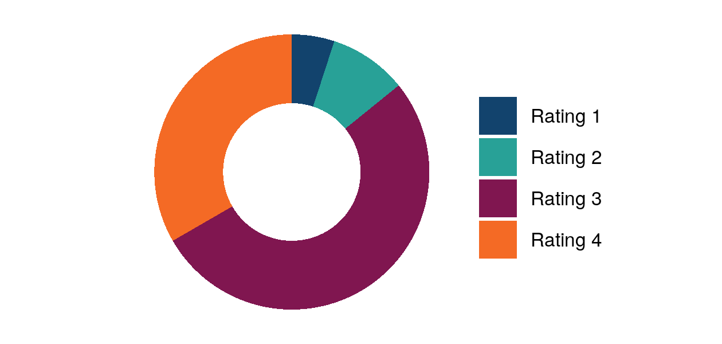

|  |  |
| --- | --- |
| Rating 1 | 6 prisons |
| Rating 2 | 11 prisons |
| Rating 3 | 63 prisons |
| Rating 4 | 40 prisons |

Last published: 28 July 2022

Next release: 27 July 2023

Source: [Prison performance ratings](https://www.gov.uk/government/collections/prison-and-probation-trusts-performance-statistics#prison-performance-statistics)

[Click here to view on Justice Data](https://data.justice.gov.uk/prisons/public-protection#security-audit) or use the QR code below:

### Electronic monitoring caseload

Total caseload.

The figure for Mar 2023 is 17,350, up 1,956 from Mar 2022

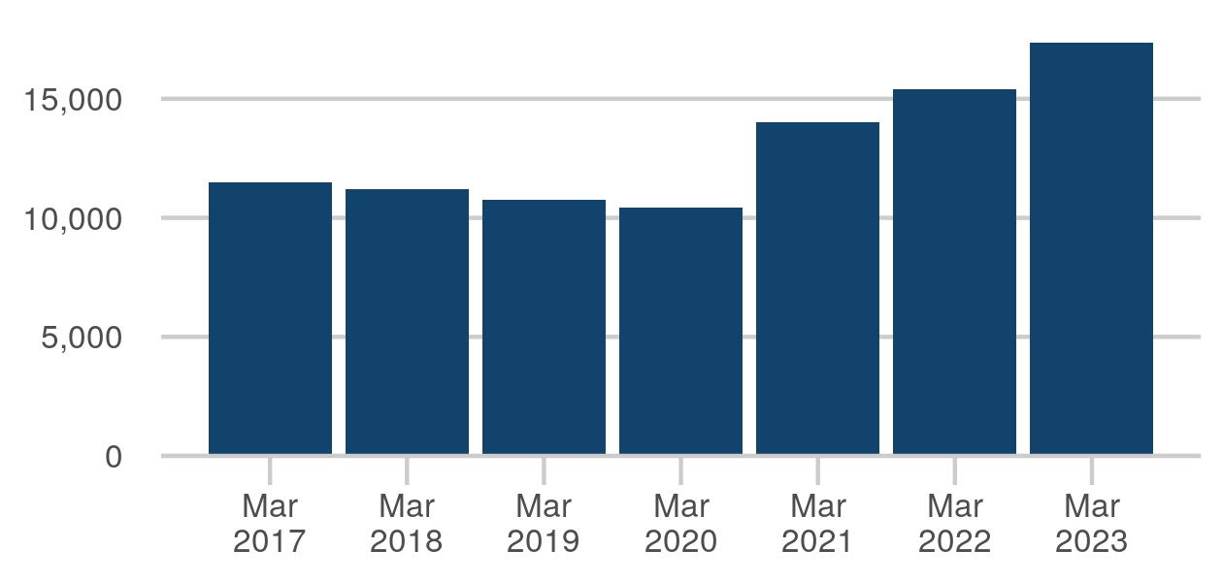

|  |  |
| --- | --- |
| 31 March 2017 | 11,490 |
| 31 March 2018 | 11,205 |
| 31 March 2019 | 10,771 |
| 31 March 2020 | 10,422 |
| 31 March 2021 | 13,996 |
| 31 March 2022 | 15,394 |
| 31 March 2023 | 17,350 |

Last published: 27 April 2023

Next release: 20 July 2023

Source: [Electronic Monitoring Statistics Publication](https://www.gov.uk/government/collections/electronic-monitoring-publication)

[Click here to view on Justice Data](https://data.justice.gov.uk/contracts/electronic-monitoring#em-total-caseload) or use the QR code below:

### Probation caseload

The statistics count each person once for each type of probation supervision being received on the date shown. In addition, each person is counted only once in each total or sub-total even if they were subject to several types of probation supervision at the year end (the examples above apply). Thus, the sum of the numbers receiving each type of court order probation supervision exceeds the number receiving court order probation supervision in total.

The figure for 31 Dec 2022 is 240,431, down 243 from 30 Sep 2022



|  |  |
| --- | --- |
| 31 Mar 2021 | 224,174 |
| 30 Jun 2021 | 230,578 |
| 30 Sep 2021 | 234,827 |
| 31 Dec 2021 | 238,500 |
| 31 Mar 2022 | 240,922 |
| 30 Jun 2022 | 243,127 |
| 30 Sep 2022 | 240,674 |
| 31 Dec 2022 | 240,431 |

Last published: 27 April 2023

Next release: 27 July 2023

Source: [Offender management statistics quarterly](https://www.gov.uk/government/collections/offender-management-statistics-quarterly)

[Click here to view on Justice Data](https://data.justice.gov.uk/probation/offender-management#caseload-total) or use the QR code below:

### Staff in post (Probation Service)

Full time equivalent staff in post for the Probation Service (PS) at the end of each financial year. (Workforce data for private sector Community Rehabilitation Companies is not published). During November and December 2019, over 1,200 PS staff moved to the Community and Interventions directorate, part of HMPPS HQ and areas services. In the same quarter, over 300 staff in Wales were transferred from privately run CRCs to HMPPS, into the new "PS Wales UM transition". In late June 2021, more than 7,000 staff from private sector Community Rehabilitation Companies (CRC) came together with probation staff already in the public sector in the new Probation Service.

The figure for March 2023 is 19,850, up 2,202 from March 2022

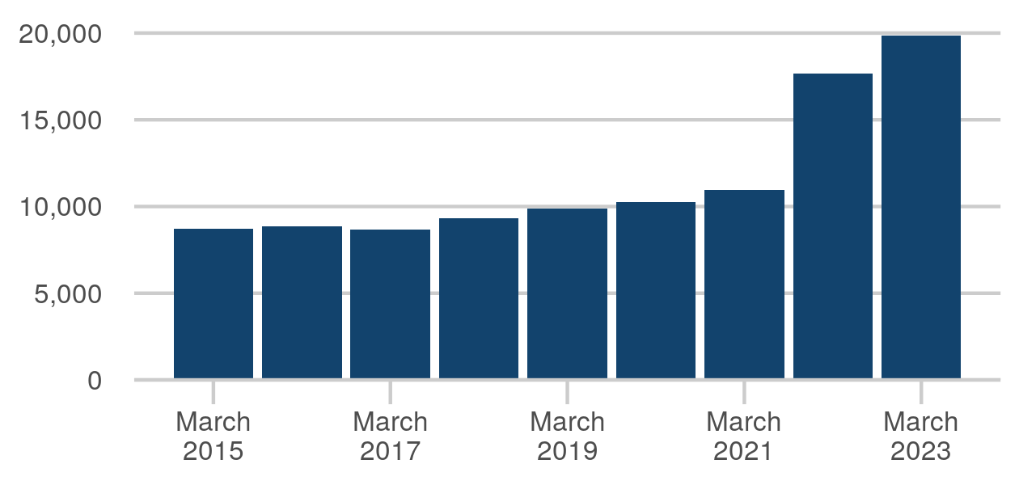

|  |  |
| --- | --- |
| March 2016 | 8,835 |
| March 2017 | 8,693 |
| March 2018 | 9,310 |
| March 2019 | 9,879 |
| March 2020 | 10,265 |
| March 2021 | 10,958 |
| March 2022 | 17,648 |
| March 2023 | 19,850 |

Last published: 22 May 2023

Next release: 17 August 2023

Source: [HM Prison and Probation Service workforce quarterly](https://www.gov.uk/government/collections/national-offender-management-service-workforce-statistics)

[Click here to view on Justice Data](https://data.justice.gov.uk/probation/additional#probation-staff-in-post) or use the QR code below:

### Serious further offence convictions

SFO conviction figures are reported by the date of SFO notification. This is the date on which the supervising probation region notifies HM Prison and Probation Service (HMPPS) that an offender under its supervision has appeared in court charged with an offence which qualifies for an SFO review.

The figure for 2020/21 is 245, down 69 from 2019/20

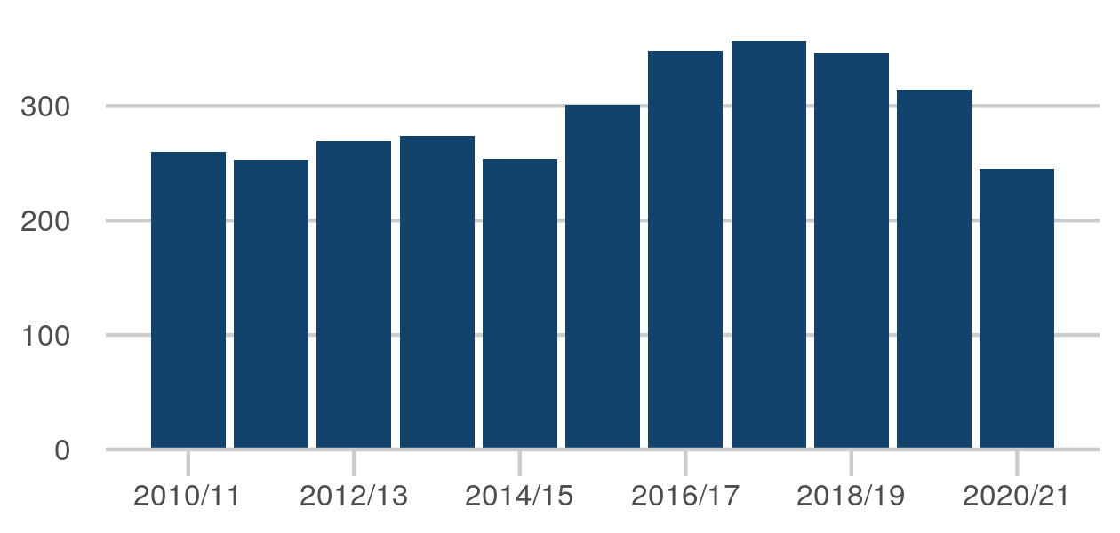

|  |  |
| --- | --- |
| Apr 2013 - Mar 2014 | 274 |
| Apr 2014 - Mar 2015 | 254 |
| Apr 2015 - Mar 2016 | 301 |
| Apr 2016 - Mar 2017 | 348 |
| Apr 2017 - Mar 2018 | 357 |
| Apr 2018 - Mar 2019 | 346 |
| Apr 2019 - Mar 2020 | 314 |
| Apr 2020- Mar 2021 | 245 |

Last published: 27 April 2023

Next release: 27 July 2023

Source: [Proven reoffending statistics](https://www.gov.uk/government/collections/proven-reoffending-statistics)

[Click here to view on Justice Data](https://data.justice.gov.uk/probation/offender-management#sfo-convictions) or use the QR code below:

## Reduce reoffending

### Proven reoffending rate

Proportion of all offenders who reoffend (%). This latest offender cohort period overlaps with operational restrictions imposed due to the COVID-19 pandemic and a period of on-going recovery for the courts. As a result, volatility continues to be seen in the reoffending figures, with overall proven reoffending down from the same quarter last year but up from the previous quarter.

The figure for Apr - Jun 2021 is 24.8%, up 0.5ppt from Jan - Mar 2021



|  |  |
| --- | --- |
| Jul - Sep 2019 | 26.0% |
| Oct - Dec 2019 | 25.2% |
| Jan - Mar 2020 | 24.7% |
| Apr - Jun 2020 | 29.0% |
| Jul - Sep 2020 | 23.5% |
| Oct - Dec 2020 | 23.1% |
| Jan - Mar 2021 | 24.3% |
| Apr - Jun 2021 | 24.8% |

Last published: 27 April 2023

Next release: 27 July 2023

Source: [Proven reoffending statistics](https://www.gov.uk/government/collections/proven-reoffending-statistics)

[Click here to view on Justice Data](https://data.justice.gov.uk/cjs-statistics/cjs-reoffending#proven-reoffending) or use the QR code below:

### Housed on release from custody (SL014)

The proportion of individuals in settled or temporary accommodation on the night of release from custody.

The figure for Jan-Mar 2022 is 77.6%, up 1.2ppt from Oct-Dec 2021

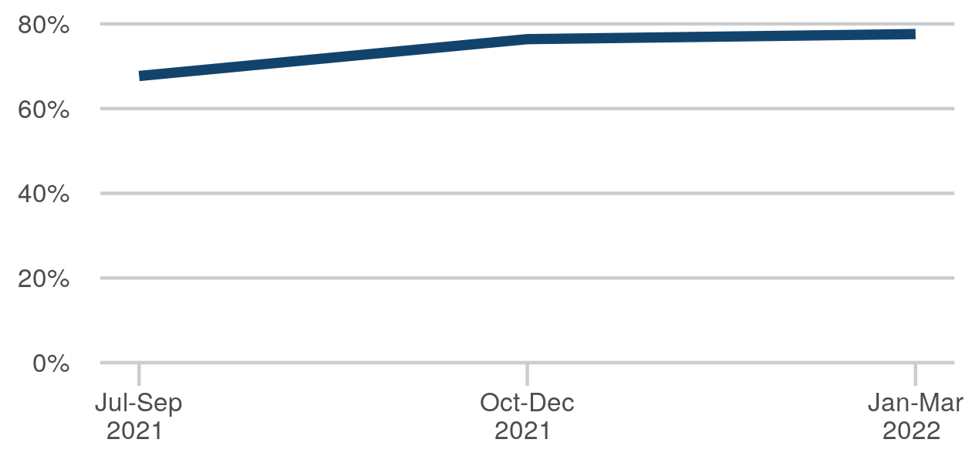

|  |  |
| --- | --- |
| Jul-Sep 2021 | 67.7% |
| Oct-Dec 2021 | 76.4% |
| Jan-Mar 2022 | 77.6% |

Last published: 26 August 2022

Next release: 27 July 2023

Source: [Community performance annual](https://www.gov.uk/government/collections/prison-and-probation-trusts-performance-statistics#community-performance-statistics)

[Click here to view on Justice Data](https://data.justice.gov.uk/probation/ps-performance#ps-sl014) or use the QR code below:

### Settled accommodation at 3 months post release from custody (SL015a)

The proportion of individuals in settled accommodation at three months post release for custodial sentences.

The figure for Jan-Mar 2022 is 71.0%, up 3.1ppt from Oct-Dec 2021

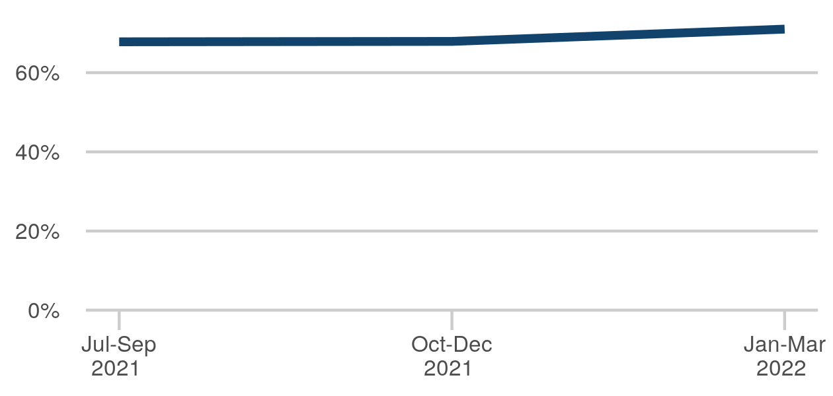

|  |  |
| --- | --- |
| Jul-Sep 2021 | 67.8% |
| Oct-Dec 2021 | 67.9% |
| Jan-Mar 2022 | 71.0% |

Last published: 26 August 2022

Next release: 27 July 2023

Source: [Community performance annual](https://www.gov.uk/government/collections/prison-and-probation-trusts-performance-statistics#community-performance-statistics)

[Click here to view on Justice Data](https://data.justice.gov.uk/probation/ps-performance#ps-sl015a) or use the QR code below:

### Settled accommodation at 3 months post community (SL015b)

The proportion of individuals in settled accommodation at three months post disposal for community sentences.

The figure for Jan-Mar 2022 is 80.8%, up 2.1ppt from Oct-Dec 2021

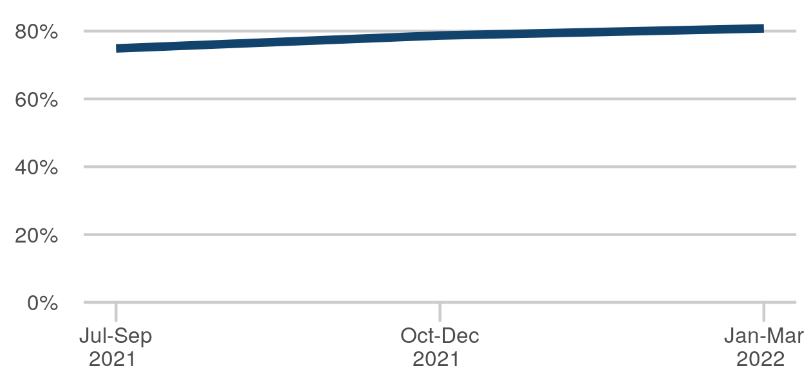

|  |  |
| --- | --- |
| Jul-Sep 2021 | 74.9% |
| Oct-Dec 2021 | 78.7% |
| Jan-Mar 2022 | 80.8% |

Last published: 26 August 2022

Next release: 27 July 2023

Source: [Community performance annual](https://www.gov.uk/government/collections/prison-and-probation-trusts-performance-statistics#community-performance-statistics)

[Click here to view on Justice Data](https://data.justice.gov.uk/probation/ps-performance#ps-sl015b) or use the QR code below:

### Employed at 6 weeks post release from custody (SL016)

The proportion of individuals in employment at six weeks after release from custody.

The figure for Jan-Mar 2022 is 12.7%, up 0.8ppt from Oct-Dec 2021

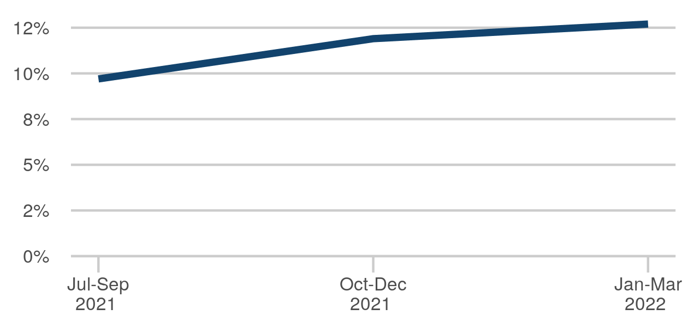

|  |  |
| --- | --- |
| Jul-Sep 2021 | 9.7% |
| Oct-Dec 2021 | 11.9% |
| Jan-Mar 2022 | 12.7% |

Last published: 26 August 2022

Next release: 27 July 2023

Source: [Community performance annual](https://www.gov.uk/government/collections/prison-and-probation-trusts-performance-statistics#community-performance-statistics)

[Click here to view on Justice Data](https://data.justice.gov.uk/probation/ps-performance#ps-sl016) or use the QR code below:

### Employed at 6 months post release from custody (SL017a)

The proportion of individuals in employment at six months post release for custodial sentences.

The figure for Jan-Mar 2022 is 19.8%, up 3.2ppt from Oct-Dec 2021

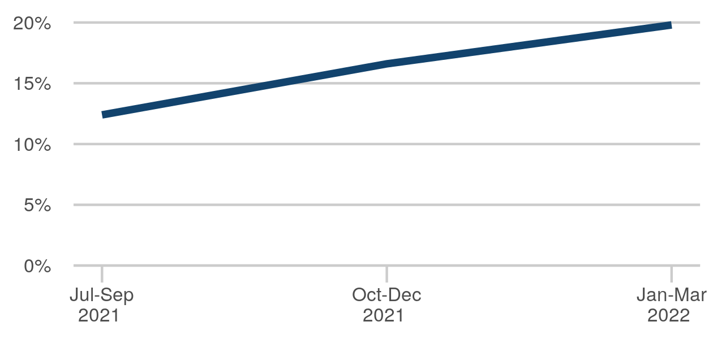

|  |  |
| --- | --- |
| Jul-Sep 2021 | 12.4% |
| Oct-Dec 2021 | 16.6% |
| Jan-Mar 2022 | 19.8% |

Last published: 26 August 2022

Next release: 27 July 2023

Source: [Community performance annual](https://www.gov.uk/government/collections/prison-and-probation-trusts-performance-statistics#community-performance-statistics)

[Click here to view on Justice Data](https://data.justice.gov.uk/probation/ps-performance#ps-sl017a) or use the QR code below:

### Employed at 6 months post community disposal (SL017b)

The proportion of individuals in employment at six months post disposal for community sentences.

The figure for Jan-Mar 2022 is 38.9%, up 2.7ppt from Oct-Dec 2021

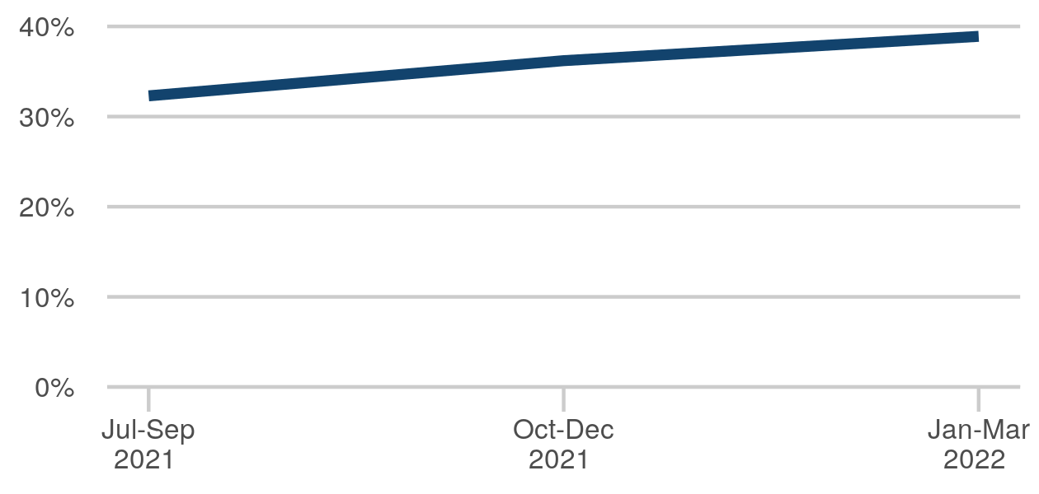

|  |  |
| --- | --- |
| Jul-Sep 2021 | 32.3% |
| Oct-Dec 2021 | 36.2% |
| Jan-Mar 2022 | 38.9% |

Last published: 26 August 2022

Next release: 27 July 2023

Source: [Community performance annual](https://www.gov.uk/government/collections/prison-and-probation-trusts-performance-statistics#community-performance-statistics)

[Click here to view on Justice Data](https://data.justice.gov.uk/probation/ps-performance#ps-sl017b) or use the QR code below:

### Random mandatory drug testing (traditional drugs)

The percentage of random mandatory drug tests which show drugs to be present, hence a downward trend is positive. This measure excludes tests for new psychoactive substances. The values for 2018/19 onwards are calculated using a new weighted methodology - please refer to the relevant publication for more details.

The figure for 2019-20 is 10.5 %, up 0.1ppt from 2018-19



|  |  |
| --- | --- |
| Apr 2012 to Mar 2013 | 7.2 % |
| Apr 2013 to Mar 2014 | 7.5 % |
| Apr 2014 to Mar 2015 | 7.0 % |
| Apr 2015 to Mar 2016 | 7.8 % |
| Apr 2016 to Mar 2017 | 9.3 % |
| Apr 2017 to Mar 2018 | 10.9 % |
| Apr 2018 to Mar 2019 | 10.4 % |
| Apr 2019 to Mar 2020 | 10.5 % |

Last published: 28 July 2022

Source: [HM Prison and Probation Service annual digest](https://www.gov.uk/government/statistics/hmpps-annual-digest-april-2021-to-march-2022)

[Click here to view on Justice Data](https://data.justice.gov.uk/prisons/prison-reform#random-mandatory-drug-testing) or use the QR code below:

### Random mandatory drug testing - new psychoactive substances only

The percentage of random mandatory drug tests which show drugs to be present, hence a downward trend is positive. This measure includes tests for new psychoactive substances ("NPS"), as defined in the Psychoactive Substances Act 2016. Note this measure replaces "random mandatory drug testing including new psychoactive substances".

The figure for 2019-20 is 4.3 %, down 4.7ppt from 2018-19

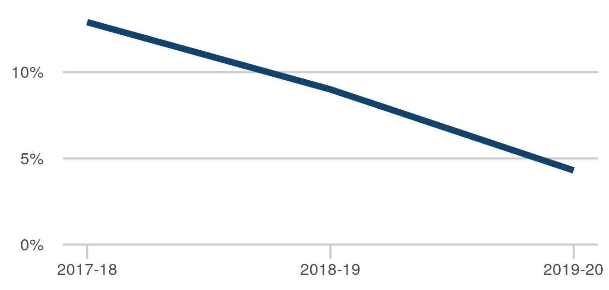

|  |  |
| --- | --- |
| Apr 2017 to Mar 2018 | 12.9 % |
| Apr 2018 to Mar 2019 | 9.0 % |
| Apr 2019 to Mar 2020 | 4.3 % |

Last published: 28 July 2022

Source: [HM Prison and Probation Service annual digest](https://www.gov.uk/government/statistics/hmpps-annual-digest-april-2021-to-march-2022)

[Click here to view on Justice Data](https://data.justice.gov.uk/prisons/prison-reform#random-mandatory-drug-testing) or use the QR code below:

### Prisoners completing treatment free from dependence

The percentage of adults exiting treatment free from dependence on drugs or alcohol.

The figure for 2020-21 is 32.5%, up 6.2ppt from 2019-20

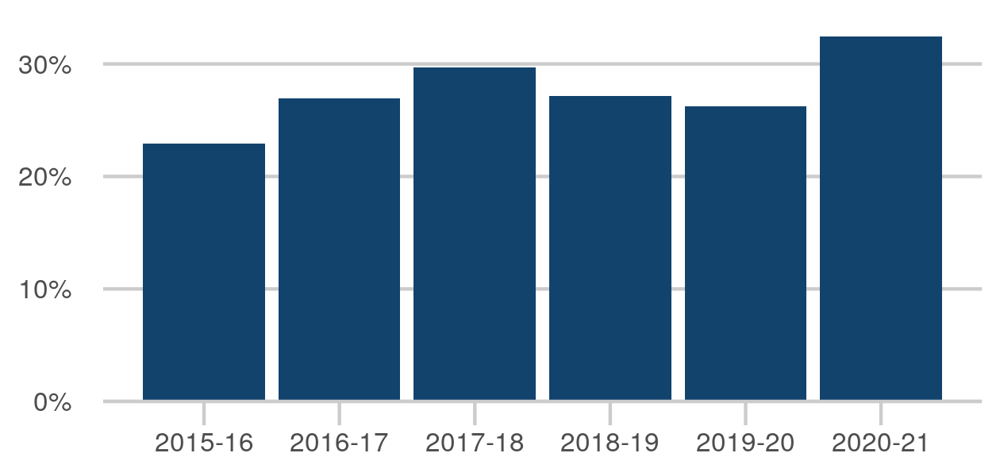

|  |  |
| --- | --- |
| Apr 2015 - Mar 2016 | 22.9% |
| Apr 2016 - Mar 2017 | 27.0% |
| Apr 2017 - Mar 2018 | 29.7% |
| Apr 2018 - Mar 2019 | 27.2% |
| Apr 2019 - Mar 2020 | 26.3% |
| Apr 2020 - Mar 2021 | 32.5% |

Last published: 27 January 2022

Source: [Alcohol and drug treatment statistics: prisons and secure settings](https://www.gov.uk/government/collections/alcohol-and-drug-misuse-and-treatment-statistics#alcohol-and-drug-treatment-statistics:-prisons-and-secure-settings)

[Click here to view on Justice Data](https://data.justice.gov.uk/prisons/prison-reform#alcohol-drug-treatment) or use the QR code below:

## Access to justice

### Crown court disposals

A count of the number of cases only when all the offences have been completed (following a validation process) in the reporting period. Disposals figures in this report may change if the case results are entered after the first collation of the data.

The figure for 2022 is 91,609, down 4,159 from 2021



|  |  |
| --- | --- |
| Jan - Dec 2015 | 130,757 |
| Jan - Dec 2016 | 123,218 |
| Jan - Dec 2017 | 115,703 |
| Jan - Dec 2018 | 105,751 |
| Jan - Dec 2019 | 99,630 |
| Jan - Dec 2020 | 78,202 |
| Jan - Dec 2021 | 95,768 |
| Jan - Dec 2022 | 91,609 |

Last published: 29 June 2023

Next release: 28 September 2023

Source: [Criminal court statistics quarterly](https://www.gov.uk/government/collections/criminal-court-statistics)

[Click here to view on Justice Data](https://data.justice.gov.uk/courts/criminal-courts#courts-crowns-disposals) or use the QR code below:

### Crown court outstanding

A count of all cases where one or more offence remains incomplete. The data is a snapshot based on outstanding cases on the final day of the reporting period. This is a count of live cases on the system and is not a calculation based on receipts and disposals. Transferred cases may be double counted for a period while they show in both sending and receiving courts; offences subsequently entered in error may change the categorisation of the case.

The figure for 31 Dec 2022 is 62,511, up 4,123 from 31 Dec 2021



|  |  |
| --- | --- |
| 31 Dec 2015 | 51,585 |
| 31 Dec 2016 | 42,942 |
| 31 Dec 2017 | 38,828 |
| 31 Dec 2018 | 32,882 |
| 31 Dec 2019 | 37,958 |
| 31 Dec 2020 | 56,905 |
| 31 Dec 2021 | 58,388 |
| 31 Dec 2022 | 62,511 |

Last published: 29 June 2023

Next release: 28 September 2023

Source: [Criminal court statistics quarterly](https://www.gov.uk/government/collections/criminal-court-statistics)

[Click here to view on Justice Data](https://data.justice.gov.uk/courts/criminal-courts#courts-crowns-outstanding) or use the QR code below:

### Crown courts cracked trials

Cracked trials as a percentage of total trials.

The figure for 2022 is 26%, down 3ppt from 2021

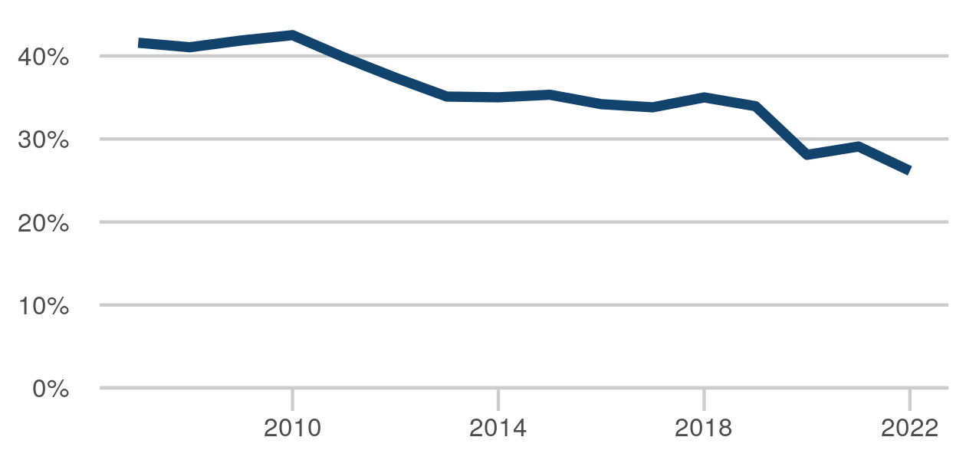

|  |  |
| --- | --- |
| Jan - Dec 2015 | 35% |
| Jan - Dec 2016 | 34% |
| Jan - Dec 2017 | 34% |
| Jan - Dec 2018 | 35% |
| Jan - Dec 2019 | 34% |
| Jan - Dec 2020 | 28% |
| Jan - Dec 2021 | 29% |
| Jan - Dec 2022 | 26% |

Last published: 29 June 2023

Next release: 28 September 2023

Source: [Criminal court statistics quarterly](https://www.gov.uk/government/collections/criminal-court-statistics)

[Click here to view on Justice Data](https://data.justice.gov.uk/courts/criminal-courts#courts-crowns-trials-cracked) or use the QR code below:

### Crown courts ineffective trials

Ineffective trials as a percentage of total trials.

The figure for 2022 is 37%, up 13ppt from 2021

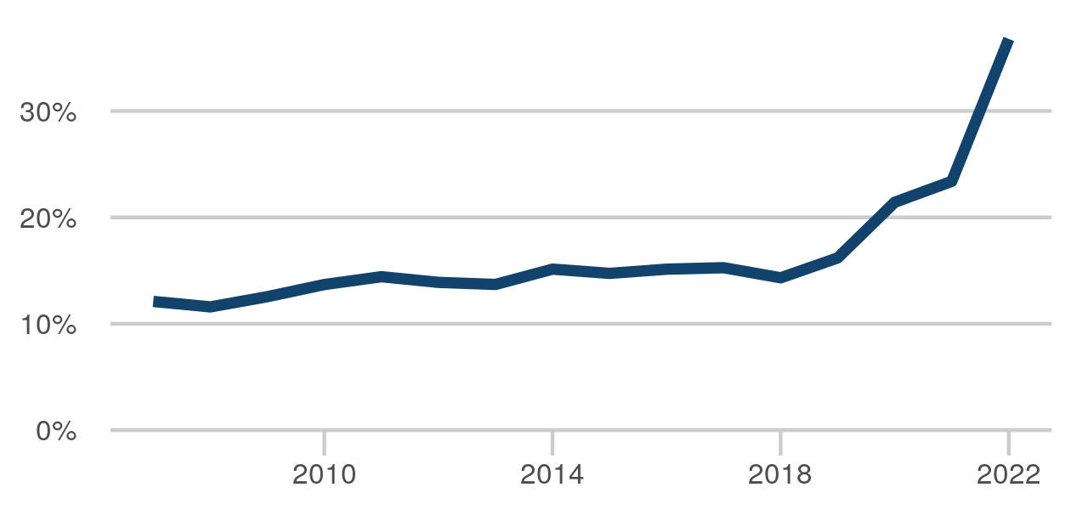

|  |  |
| --- | --- |
| Jan - Dec 2015 | 15% |
| Jan - Dec 2016 | 15% |
| Jan - Dec 2017 | 15% |
| Jan - Dec 2018 | 14% |
| Jan - Dec 2019 | 16% |
| Jan - Dec 2020 | 21% |
| Jan - Dec 2021 | 23% |
| Jan - Dec 2022 | 37% |

Last published: 29 June 2023

Next release: 28 September 2023

Source: [Criminal court statistics quarterly](https://www.gov.uk/government/collections/criminal-court-statistics)

[Click here to view on Justice Data](https://data.justice.gov.uk/courts/criminal-courts#courts-crowns-trials-ineffective) or use the QR code below:

### Magistrates' courts disposals

A count of the number of cases only when all the offences have been completed (following a validation process) in the reporting period. Disposals figures in this report may change if the case results are entered after the first collation of the data.

The figure for 2022 is 1,266,872, up 91,693 from 2021



|  |  |
| --- | --- |
| Jan - Dec 2015 | 1,594,051 |
| Jan - Dec 2016 | 1,566,357 |
| Jan - Dec 2017 | 1,509,022 |
| Jan - Dec 2018 | 1,456,735 |
| Jan - Dec 2019 | 1,441,903 |
| Jan - Dec 2020 | 1,041,021 |
| Jan - Dec 2021 | 1,175,179 |
| Jan - Dec 2022 | 1,266,872 |

Last published: 29 June 2023

Next release: 28 September 2023

Source: [Criminal court statistics quarterly](https://www.gov.uk/government/collections/criminal-court-statistics)

[Click here to view on Justice Data](https://data.justice.gov.uk/courts/criminal-courts#courts-magistrates-disposals) or use the QR code below:

### Employment tribunals disposals

Latest published data: Data for 2021/22 is not available. Please refer to the publication.

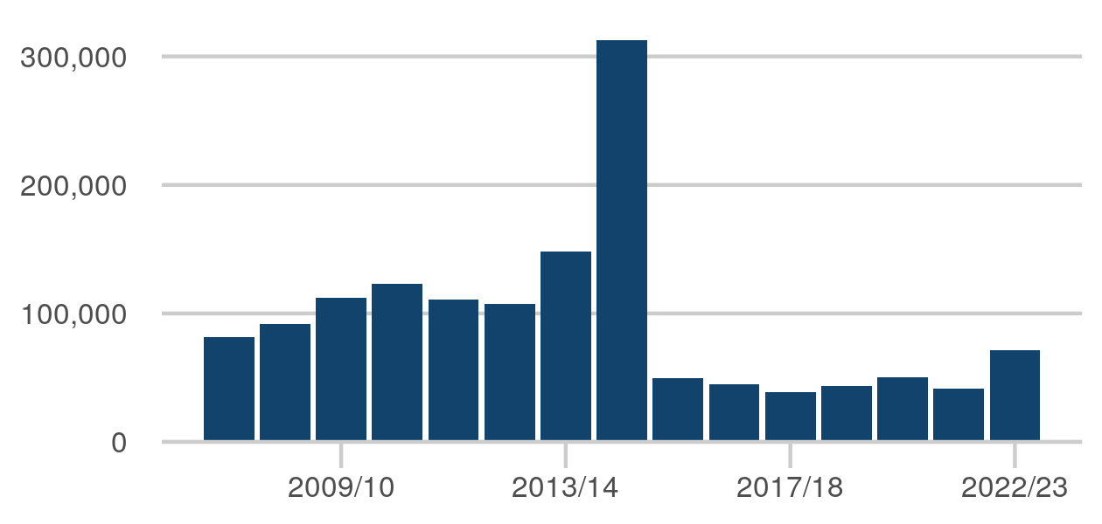

|  |  |
| --- | --- |
| Apr 2014 - Mar 2015 | 312,773 |
| Apr 2015 - Mar 2016 | 49,529 |
| Apr 2016 - Mar 2017 | 45,177 |
| Apr 2017 - Mar 2018 | 38,671 |
| Apr 2018 - Mar 2019 | 43,594 |
| Apr 2019 - Mar 2020 | 50,217 |
| Apr 2020 - Mar 2021 | 41,622 |
| Apr 2022 - Mar 2023 | 71,316 |

Last published: 8 June 2023

Next release: 14 September 2023

Source: [Tribunals statistics quarterly](https://www.gov.uk/government/collections/tribunals-statistics)

[Click here to view on Justice Data](https://data.justice.gov.uk/courts/tribunals#courts-tribunals-employment-disposals) or use the QR code below:

### Mean days from receipt at Crown Court to completion

Completion means any outcome, including guilty pleas, acquittals and convictions. Data from the Crown Court timeliness tool (all offences, all cases closed).

The figure for Jan-Mar 2023 is 253, up 5 days from Oct-Dec 2022

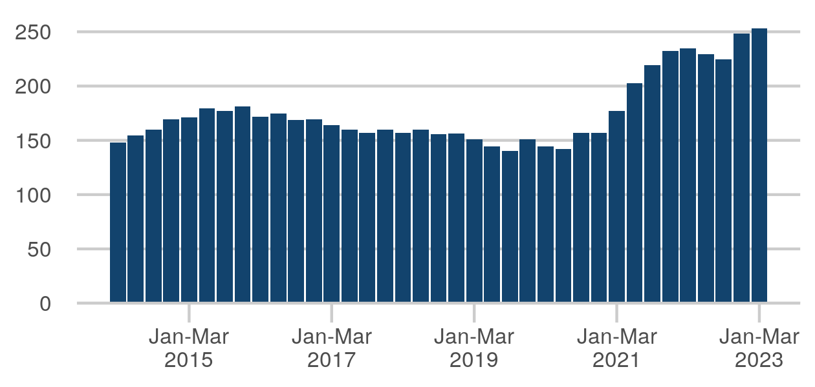

|  |  |
| --- | --- |
| Q2 (Apr-Jun) 2021 | 203 |
| Q3 (Jul-Sep) 2021 | 219 |
| Q4 (Oct-Dec) 2021 | 232 |
| Q1 (Jan-Mar) 2022 | 235 |
| Q2 (Apr-Jun) 2022 | 230 |
| Q3 (Jul-Sep) 2022 | 225 |
| Q4 (Oct-Dec) 2022 | 248 |
| Q1 (Jan-Mar) 2023 | 253 |

Last published: 29 June 2023

Next release: 28 September 2023

Source: [Criminal court statistics quarterly](https://www.gov.uk/government/collections/criminal-court-statistics)

[Click here to view on Justice Data](https://data.justice.gov.uk/justice-in-numbers) or use the QR code below:

### Number of receipts of adult rape cases at the Crown Court

Cases arriving at the Crown Court. Data from the Crown Court cases received, disposed and outstanding tool.

The figure for Jan-Mar 2023 is 605, up 93 from Oct-Dec 2022

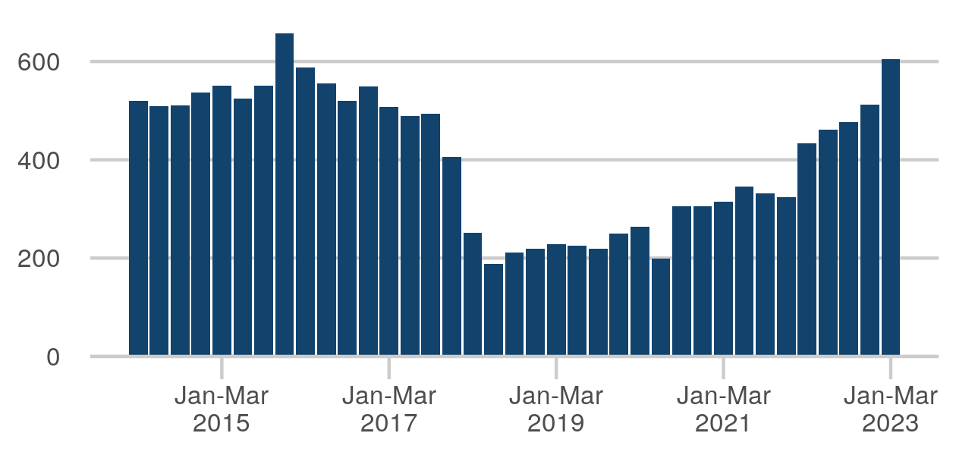

|  |  |
| --- | --- |
| Q2 (Apr-Jun) 2021 | 346 |
| Q3 (Jul-Sep) 2021 | 332 |
| Q4 (Oct-Dec) 2021 | 324 |
| Q1 (Jan-Mar) 2022 | 433 |
| Q2 (Apr-Jun) 2022 | 461 |
| Q3 (Jul-Sep) 2022 | 476 |
| Q4 (Oct-Dec) 2022 | 512 |
| Q1 (Jan-Mar) 2023 | 605 |

Last published: 29 June 2023

Next release: 28 September 2023

Source: [Criminal court statistics quarterly](https://www.gov.uk/government/collections/criminal-court-statistics)

[Click here to view on Justice Data](https://data.justice.gov.uk/justice-in-numbers) or use the QR code below:

### Civil courts - total judgments

Total number of judgments in the county courts. Some civil cases are resolved via mediation or settled out of court and don't proceed to a judgement.

The figure for 2022 is 901,278, down 79,196 from 2021



|  |  |
| --- | --- |
| Jan - Dec 2015 | 867,665 |
| Jan - Dec 2016 | 1,055,035 |
| Jan - Dec 2017 | 1,284,364 |
| Jan - Dec 2018 | 1,291,142 |
| Jan - Dec 2019 | 1,323,750 |
| Jan - Dec 2020 | 727,438 |
| Jan - Dec 2021 | 980,474 |
| Jan - Dec 2022 | 901,278 |

Last published: 1 June 2023

Next release: 7 September 2023

Source: [Civil justice statistics](https://www.gov.uk/government/collections/civil-justice-statistics-quarterly)

[Click here to view on Justice Data](https://data.justice.gov.uk/courts/civil-courts#courts-civil-total-judgments) or use the QR code below:

### Family court - total cases disposed

Total cases disposed at family court.

The figure for 2022 is 205,088, down 44,441 from 2021



|  |  |
| --- | --- |
| Jan - Dec 2015 | 221,558 |
| Jan - Dec 2016 | 228,960 |
| Jan - Dec 2017 | 226,980 |
| Jan - Dec 2018 | 214,294 |
| Jan - Dec 2019 | 234,344 |
| Jan - Dec 2020 | 225,930 |
| Jan - Dec 2021 | 249,529 |
| Jan - Dec 2022 | 205,088 |

Last published: 29 June 2023

Next release: 28 September 2023

Source: [Family court statistics quarterly](https://www.gov.uk/government/collections/family-court-statistics-quarterly)

[Click here to view on Justice Data](https://data.justice.gov.uk/courts/family-courts#courts-family-total-disposals) or use the QR code below:

### Tribunals disposals - overall

Latest published data: Data for 2021/22 and 2022/23 is not available. Please refer to the publication.



|  |  |
| --- | --- |
| Apr 2013 - Mar 2014 | 878,007 |
| Apr 2014 - Mar 2015 | 649,068 |
| Apr 2015 - Mar 2016 | 372,926 |
| Apr 2016 - Mar 2017 | 394,102 |
| Apr 2017 - Mar 2018 | 407,638 |
| Apr 2018 - Mar 2019 | 400,816 |
| Apr 2019 - Mar 2020 | 378,629 |
| Apr 2020 - Mar 2021 | 265,628 |

Last published: 8 June 2023

Next release: 14 September 2023

Source: [Tribunals statistics quarterly](https://www.gov.uk/government/collections/tribunals-statistics)

[Click here to view on Justice Data](https://data.justice.gov.uk/courts/tribunals#courts-tribunals-disposals-overall) or use the QR code below:

### Legal aid - overall annual expenditure (£m)

The closed-claim measure of expenditure shows the total value of payments made to legal aid providers in relation to pieces of work that are completed in each period, even where a portion of the work may have taken place over previous periods. Most expenditure figures in the legal aid statistics are shown on this basis.

The figure for 2022-23 is 1,808 (£m), up 160 (£m) from 2021-22

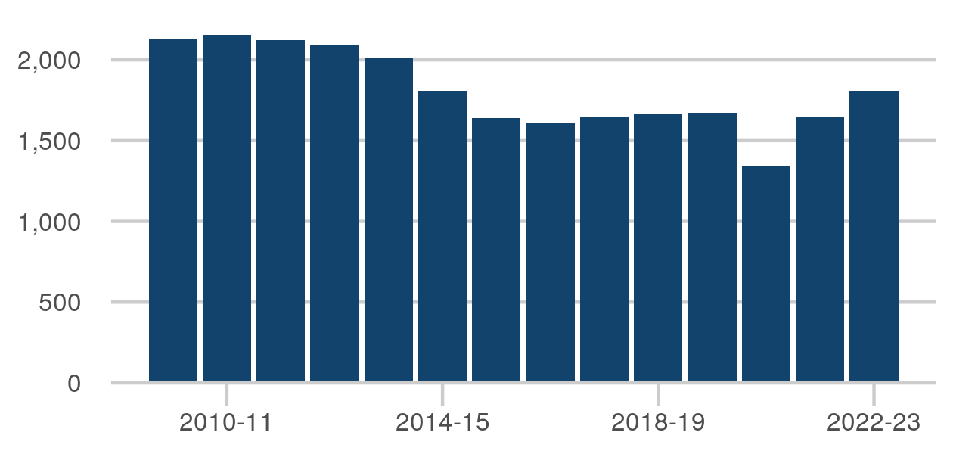

|  |  |
| --- | --- |
| Apr 2015 - Mar 2016 | 1,638 (£m) |
| Apr 2016 - Mar 2017 | 1,610 (£m) |
| Apr 2017 - Mar 2018 | 1,649 (£m) |
| Apr 2018 - Mar 2019 | 1,661 (£m) |
| Apr 2019 - Mar 2020 | 1,675 (£m) |
| Apr 2020 - Mar 2021 | 1,344 (£m) |
| Apr 2021 - Mar 2022 | 1,648 (£m) |
| Apr 2022 - Mar 2023 | 1,808 (£m) |

Last published: 29 June 2023

Next release: 28 September 2023

Source: [Legal aid statistics](https://www.gov.uk/government/collections/legal-aid-statistics)

[Click here to view on Justice Data](https://data.justice.gov.uk/justice-in-numbers) or use the QR code below: