22/May/2016

Design Document

For the MyAutoHome website

Rebecca Jou-I Lee (8017413/rlee291)

XYZ Home automation

(SOFTENG 350 - University of Auckland)

# Wireframe Walkthrough

## Persona

Julie Miyazaki is a woman in her fourties who lives with her husband Mr. Wright and her two children, Sandy and Patrick Wright. She works full-time as an account manager for ASB Bank in Auckland so she prefers to be in informed and in control of what is happening to her home and kids at all times.

## Scenario

Julie is on a vacation with her family, and decides to check up on the state of the house with her laptop to make sure that nothing is wrong. She notices that there is a new notification informing her about the dishwasher malfunctioning, and from the security camera she sees that there is water leaking out. She calls a technician over to fix the leak and uses the MyAutoHome system to let him in.

### Home Screen with notification

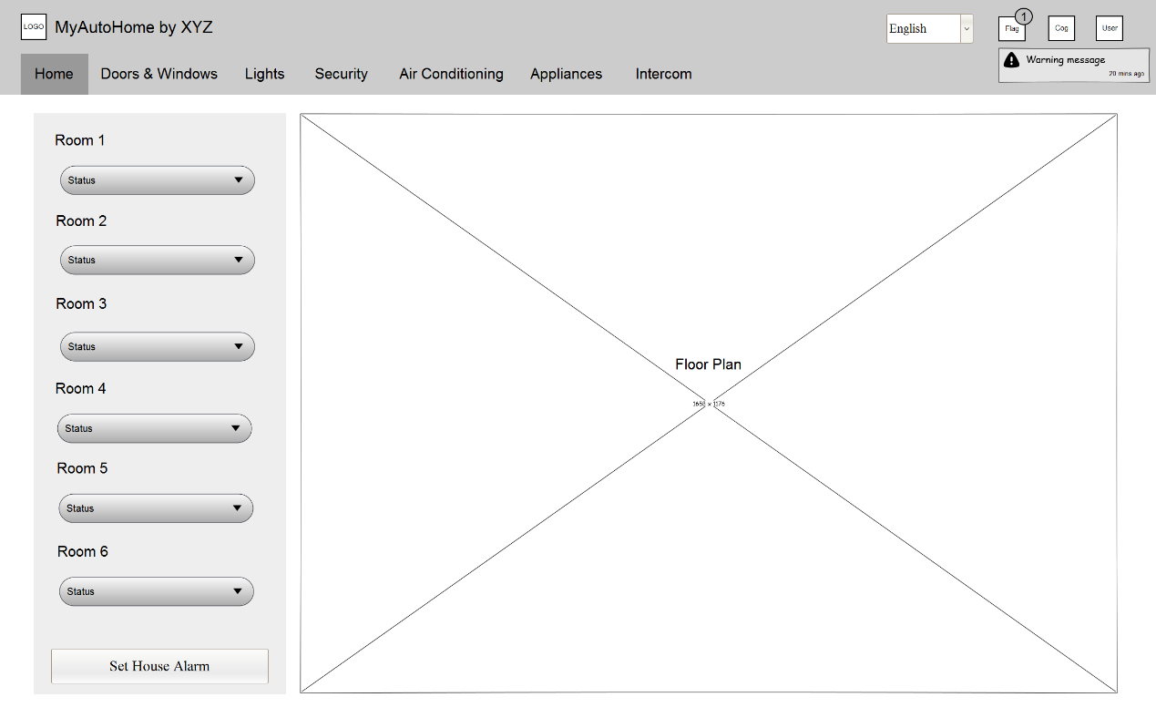

The main window shows the status and layout of the house which allows users to see which rooms have activity and which rooms are not being used. This may be useful when the user would like to set the alarm in the house, they could choose to set the alarm only after all rooms are secure, hence the ‘Set Alarm’ button at the bottom of the panel. The notification flag icon above has new notification, and displays the message once it is clicked.

### Security page

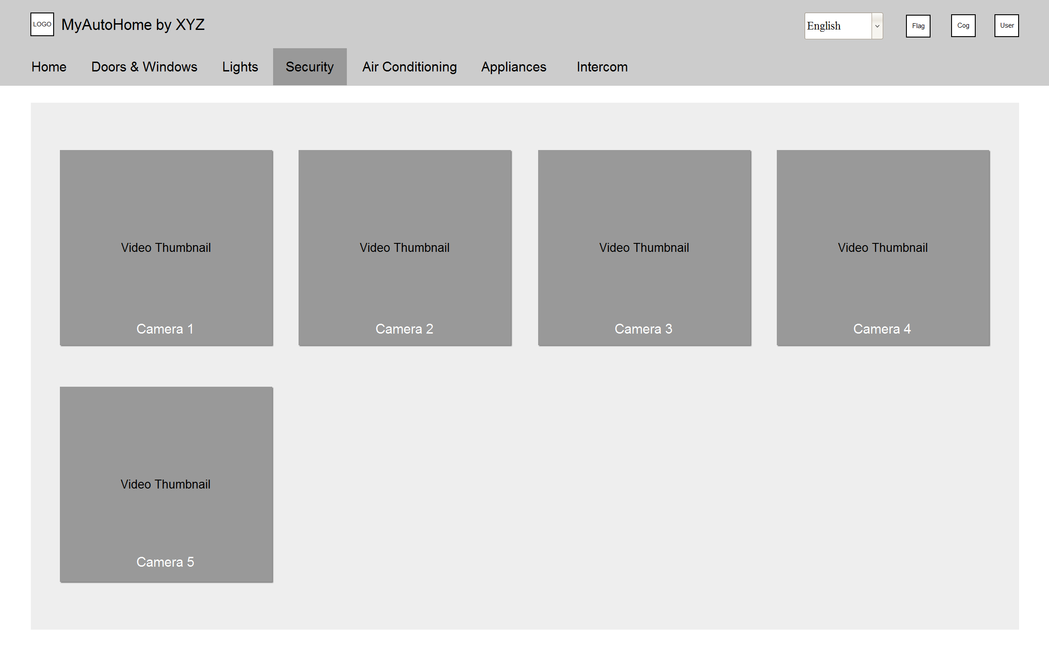

Video thumbnails are ordered in a grid fashion which allows users to see all camera and activities around the house in one go. Otherwise, footage can be enlarged when clicked if users want to get a closer look (shown below).

### Security page with enlarged footage

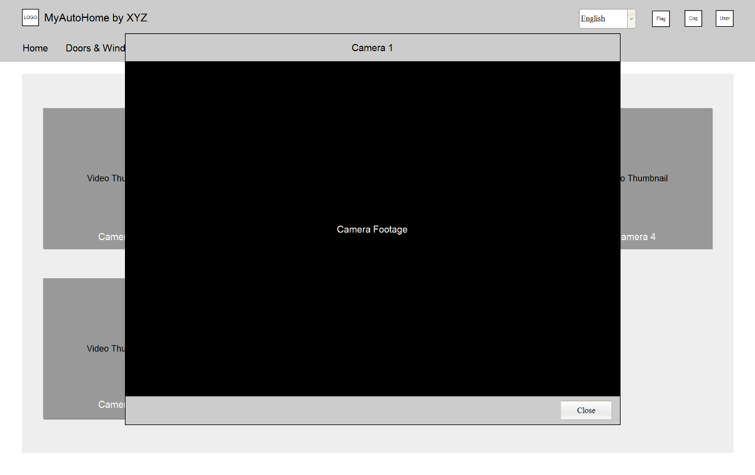

### Doors & Windows page

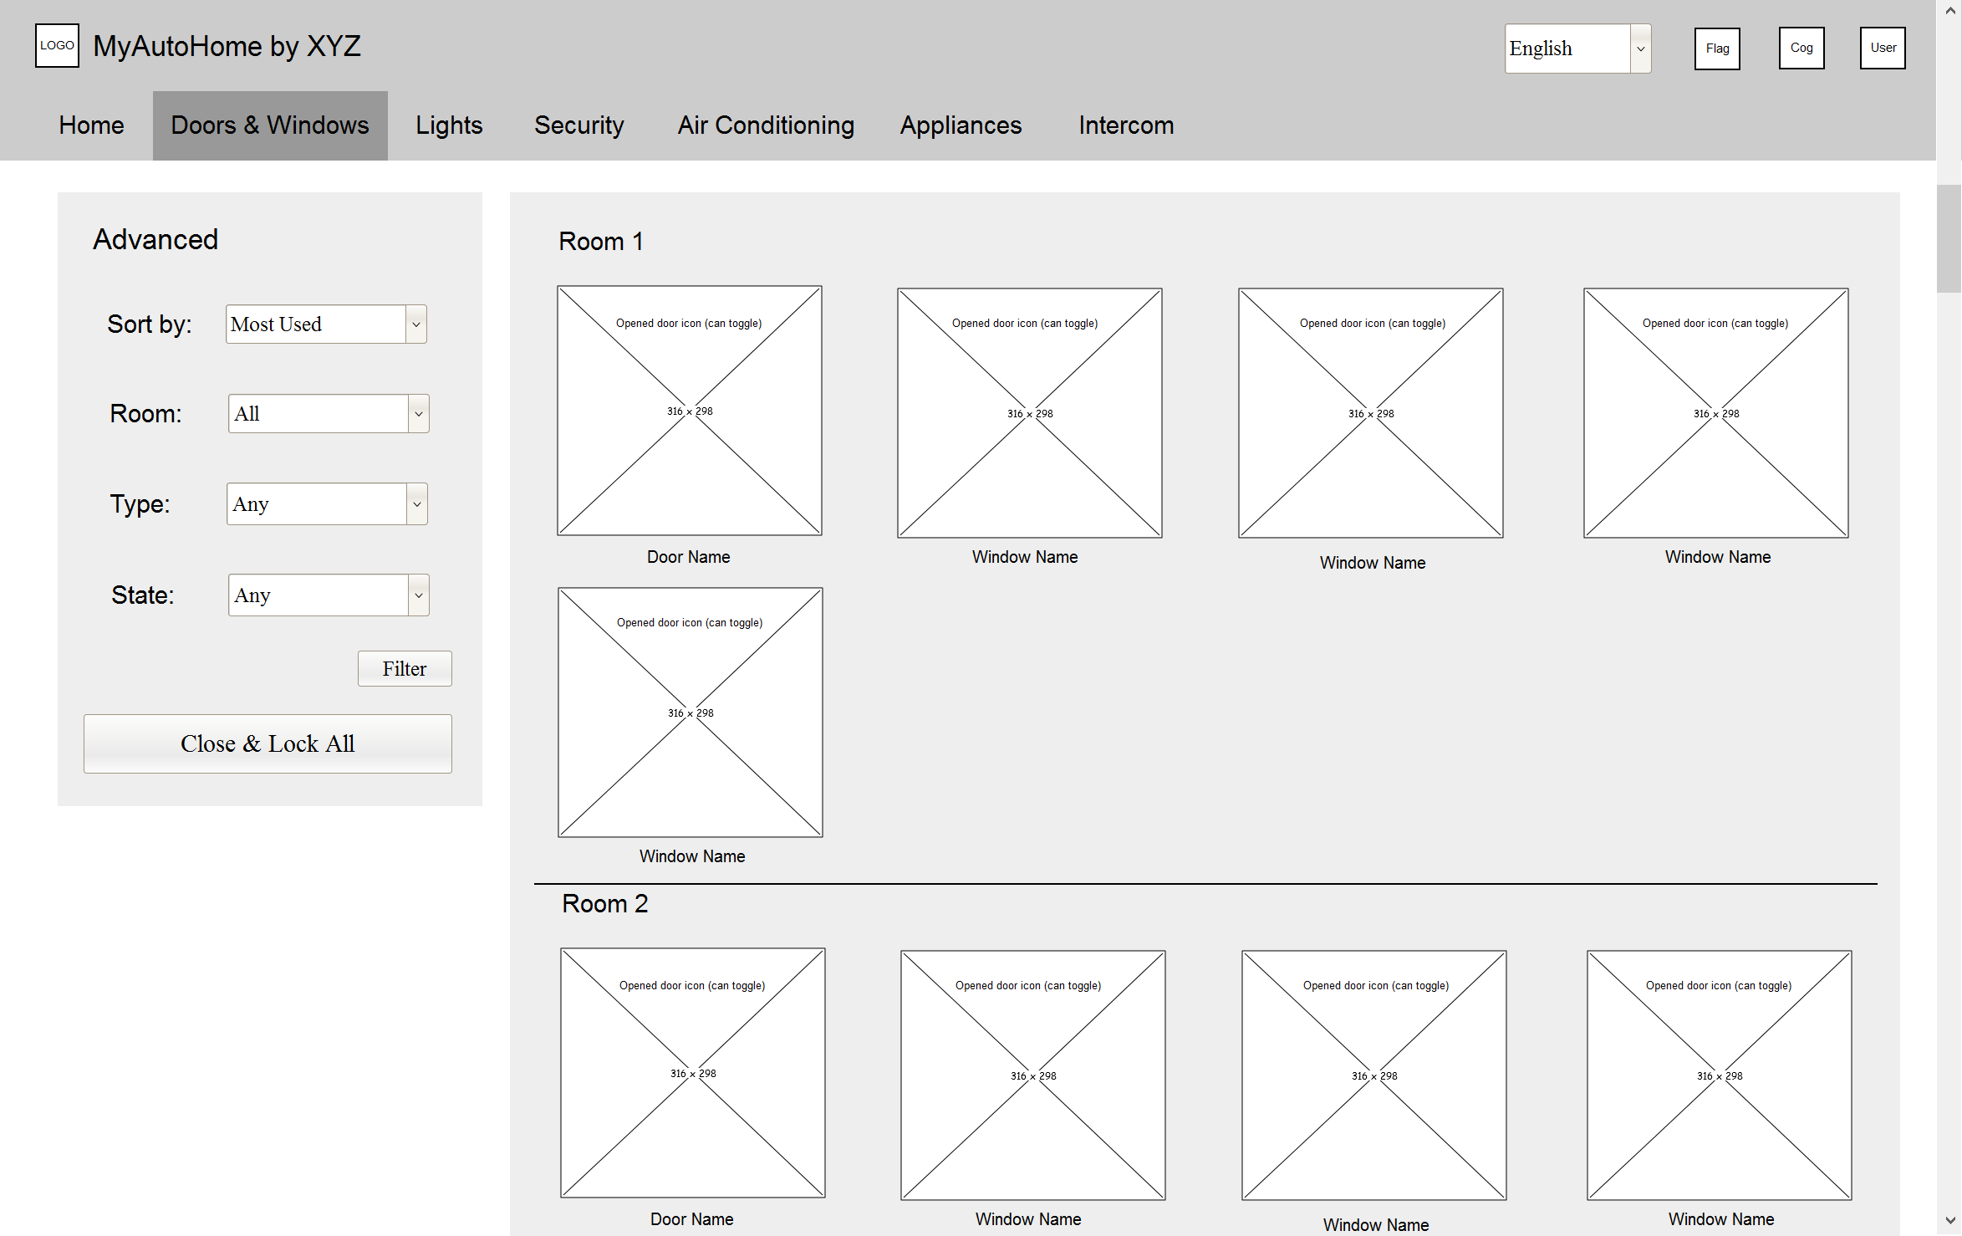

Starting from the left, a panel containing a filter form allows users to quickly find the door or window they want, and a button for quickly closing and locking all doors & windows. In the larger panel on the right, the doors and windows in each room are displayed with icons representing their respective states, for example, an open door for an unlocked door, and an open window for an open window. Clicking these will toggle the states between open and close (lock and unlock).

# Colour Scheme

## Light Blue

Hex: **#CCE7F0** R: **204** G: **231** B: **240**

Blah blah blah

## Bootstrap Default Light Grey

Hex: **#F5F5F5** R: **245** G: **245** B: **245**

Blah blah blah

(b) Colour scheme: Describe the basic type of your site’s colour scheme (e.g. monochromatic). List all the colours used in your prototype and their role, showing a block of colour and the RGB value. E.g. RGB: 53, 94, 145 Navigation pane background Provide a brief rationale (no more than 100 words) for your overall colour choices.

# Layout Scheme

## Lines, Borders, Grouping & Segmenting

## Icons, Backgrounds & Whitespace

(c) Layout scheme: Provide a description of your approach regarding choices of lines and borders, backgrounds, use of white space, icons and any other methods for grouping, segmenting or giving a particular graphical ‘feel’ to the site. You do not need to illustrate the components – presumably the prototype does this, but you should provide a brief overall description and rationale (no more than 150 words) that includes two to four specific aspects of your strategy.

# Resources Used

## External Tools

## Images

(d) Resources used: List all external resources used for Task Two as a bulleted list or table including the source and description of the role it plays in your design. This should include all JavaScript libraries you included and any images that you did not create yourself.

House floor plan:

<http://www.peppertreecourt.com/images/PTC_P2_1256_FloorPlan.gif>

camera footage thingy:

living: <http://photos2.spareroom.co.uk/images/flatshare/listings/large/20/91/2091469.jpg>

kitchen: <http://www.neuhausre.com/wp-content/uploads/3-full.jpg>

garage: <http://randomwallpapers.net/dark-garage-bmw-1920x1080-wallpaper529603.jpg>

office: <http://rgphoto.co.uk/images/ped2010/960_150110_Dark%20Office.jpg>