Polaris Partners — Follow-Up Responses
Draft | June 2026

1. Can the raise be downsized, if the focus becomes R&D through FIH on 2, not 6, programs?
In short, it is likely that we could raise less if we downsized our ambitions, but downsizing introduces risk and jumps ahead of natural, results-driven decision making.
Targeting only two programs from the start is a risky proposition, when only ~10% of all assets progress to Ph 1 studies for the drug discovery industry as a whole. We are not interested in becoming a single-asset company, dependent on singular clinical readouts for survival.
Instead, we will have initial screening results on 4-5 targets within the next three months. This readout will be a natural place where programs are continued based on evidence of early success or culled for lack of hits and/or execution difficulties. Our hit ID campaigns on ACP3, KLK2, CEACAM5, and MUC1-C are undeway, with CLDN1 trailing slightly due to transmembrane protein handling requirements. With this data in hand, we will re-evaluate each program based on: (i) binder affinity and selectivity, (ii) full conjugate performance (if available), (iii) clinical positioning vs existing programs, and (iv) indication diversification, likely one prostate and one non-prostate target.
Financially, narrowing to two programs (H2L through FIH) requires a spend of $XXX over the same 2.5 years. We could raise $XXX to give us [runway], but we carry significant risk that one program fails. [insert post LF1 analysis here]
We have conviction that Phase 0 human dosimetry on multiple targets is the highest-EV use of seed capital. OncoACP3 was acquired by BMS for $1.35B and Aktis was valued at $1.2B at IPO, both on Phase 0 dosimetry of a single lead compound. A multi-target Phase 0 dataset strengthens the Series A negotiating position beyond what a minimal-program path can deliver.

2. Can the full build cost be restructured into the TI to reduce the raise?
[Insert summary answer here] The current TI commitment is $6.5M within the building lease, offsetting approximately 40% of the $15M total build cost. Shifting additional build costs, for $15M total, into the TI structure would [comment on monthly spend, lifetime cost of TI, reduce the equity raise while increasing the lease obligation]

3. What is the value of internal manufacturing at this early stage? Why not wait to build this capability?
Sego’s Stage 1A manufacturing facility is a value-creating asset, saving us on manufacturing costs versus externalizing to CDMOs, increasing the overall value of the company and creating operational efficiency.
Internal production for Ph 0 and Ph 1 saves approximately 57% versus CDMO outsourcing over the first two years of clinical operations. The breakeven point is taking one molecule to Ph 0 and Ph 1. To support 2 programs through Ph 0 and Ph 1, radiochemistry manufacturing costs would be $6.4M internally (including GMP suite build costs) vs. $15.0M at a reputable CDMO.
The strategic case extends beyond cost savings on individual programs. Radiopharmaceutical acquirers place a premium on integrated manufacturing capability, as depicted below. Companies like Fusion ($2.4B exit value), RayzeBio ($4.1B), and POINT Biopharma ($1.3B) all had internal manufacturing at acquisition. Deals for without manufacturing capabilities like Mariana Oncology, 3B Pharmaceuticals were transacted at materially lower valuations, 4x to be precise. In our BD conversations, Roche, Novartis, and AbbVie have each flagged manufacturing infrastructure as a differentiator in their evaluation of potential partners.
Lastly, Sego’s single-site model, adjacent to Nusano’s isotope production facility, creates operational efficiency by eliminating decay-in-transit losses, simplifies the regulatory filing, and gives the team direct control over clinical supply from Phase 0 onward. The CDMO alternative adds approximately 12 months to program timelines through tech transfers and scheduling constraints. The facility build cost is structured efficiency – with approximately 40% of $3M build covered in Wasatch’s TI contribution and GMP equipment purchases are structured as a lease rather than capital expenditure. The shared HVAC, shielding, and waste handling infrastructure serves both the clinical manufacturing suite and the preclinical hot laboratory, amortizing the investment across all programs.
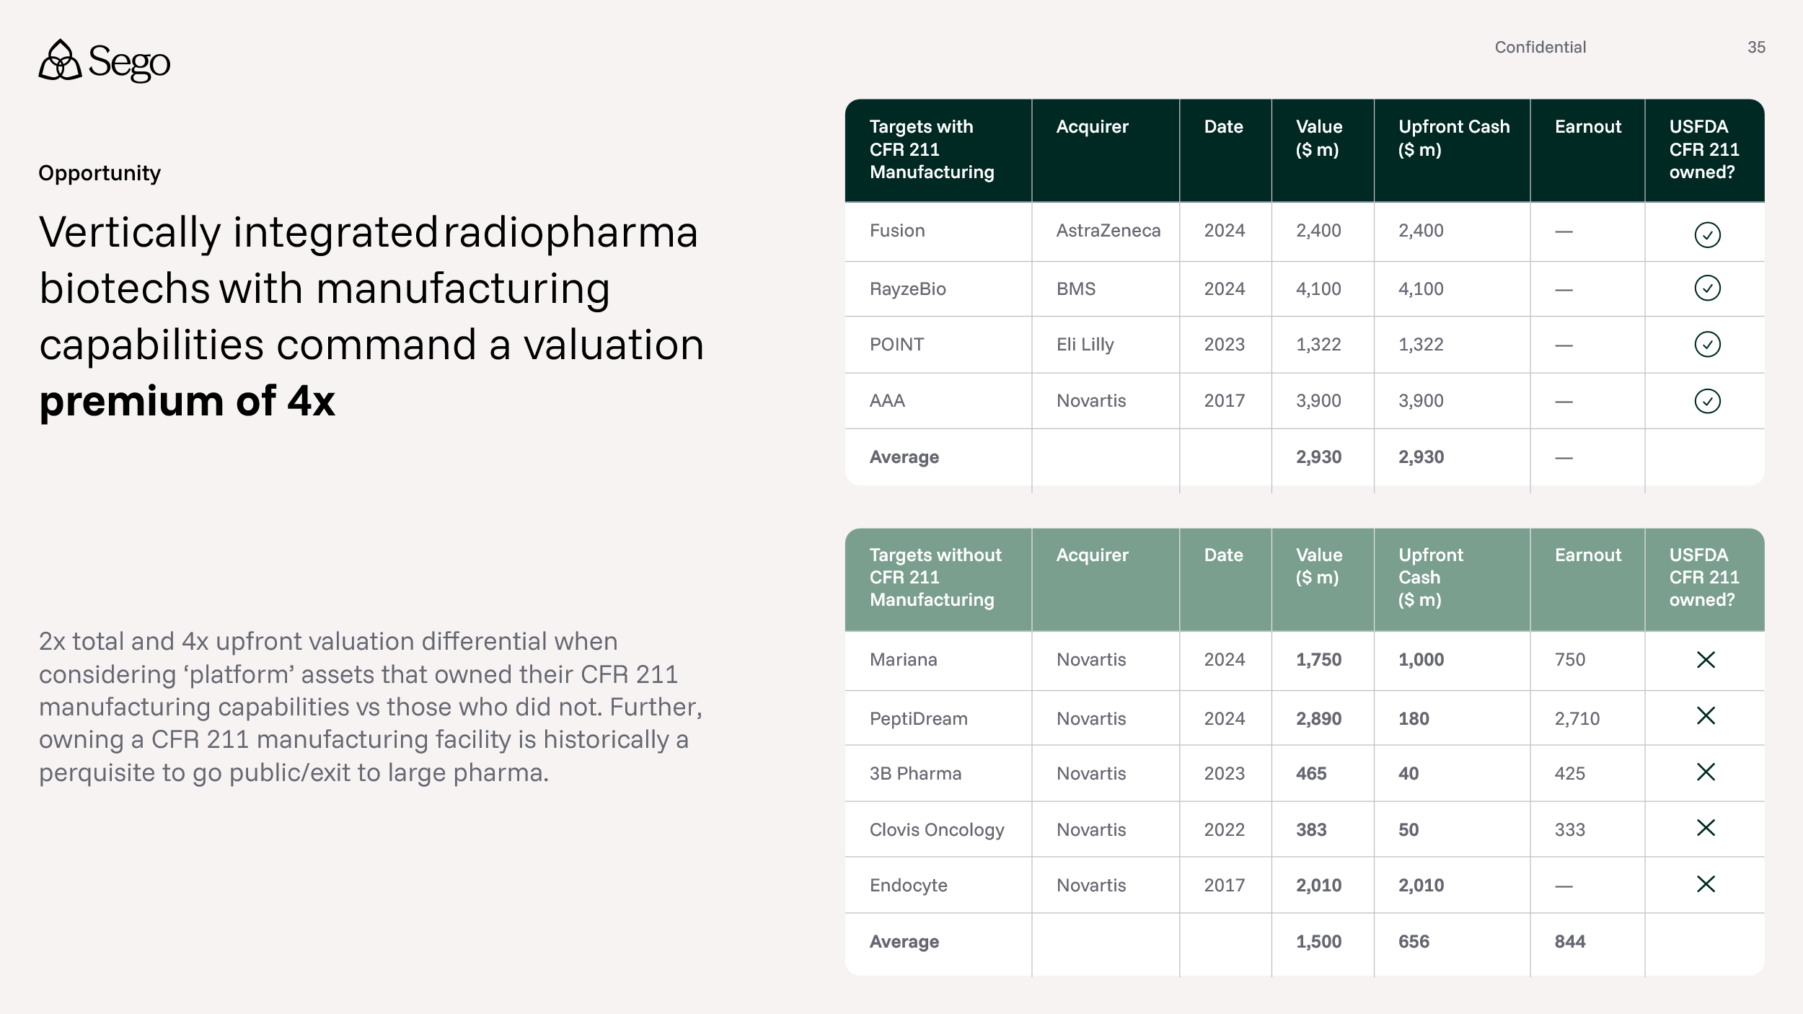

4. How does Sego's raise size compare to recent radiopharmaceutical seed and Series A rounds?

Sego's $80M seed is at the median for first raises in the RLT sector. Convergent ($90M), Mariana ($75M), and Aktis ($72M Series A, with an extension to the A of $84M) all raised at comparable scale. Fusion and RayzeBio raised less initially ($46M and $45M) but neither had manufacturing at first raise, adding it only by their third or fourth financing. Sego's seed funds both pipeline and GMP infrastructure in a single round, where peers required multiple raises over approximately 3 years to reach the same position. Further, Sego’s differentiated early Ph 0 strategy of evaluating multiple molecules requires internal GMP capabilities to be maximally cost effective.

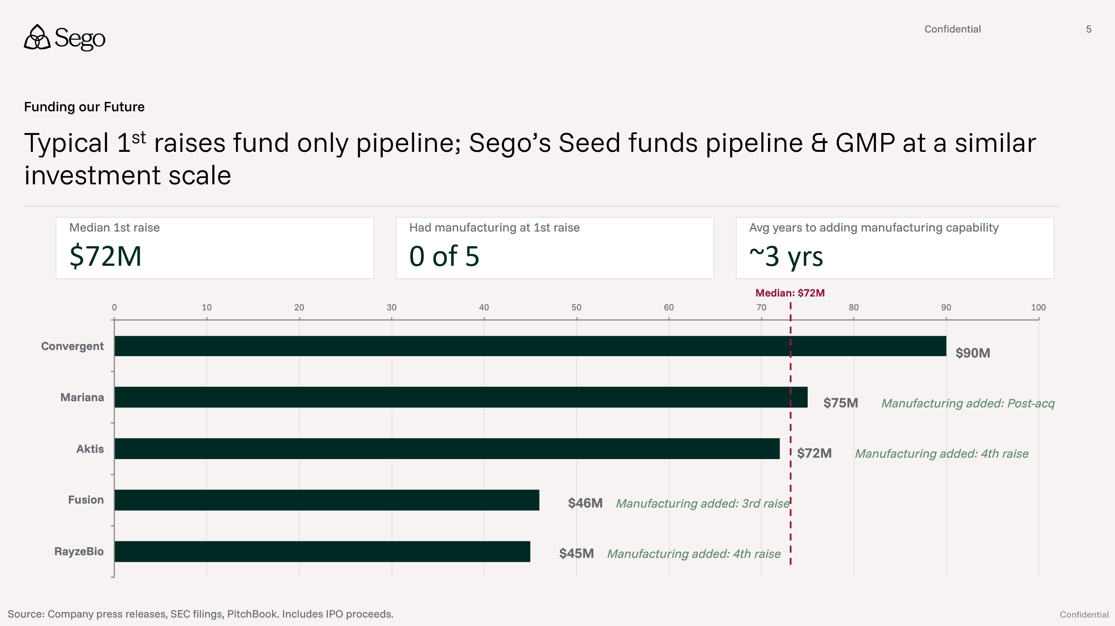

Given recent RLT transaction values ($1B+), what does the return profile look like for seed investors at this entry point?
5x returns on total investment are common in RLT, with first money in achieving returns estimated to be >10x (see below). This trend is consistent across 7 major transactions in the last 3 years. Early round investors captured the largest multiples. Series A participants in RayzeBio, Fusion and Point captured an estimated >10x return on their initial investments, because they backed the company prior to the clinical data that drove the large exit valuations. Sego’s $80M raise gives investors a similar opportunity: a multi-billion dollar outcome on seed capital invested.
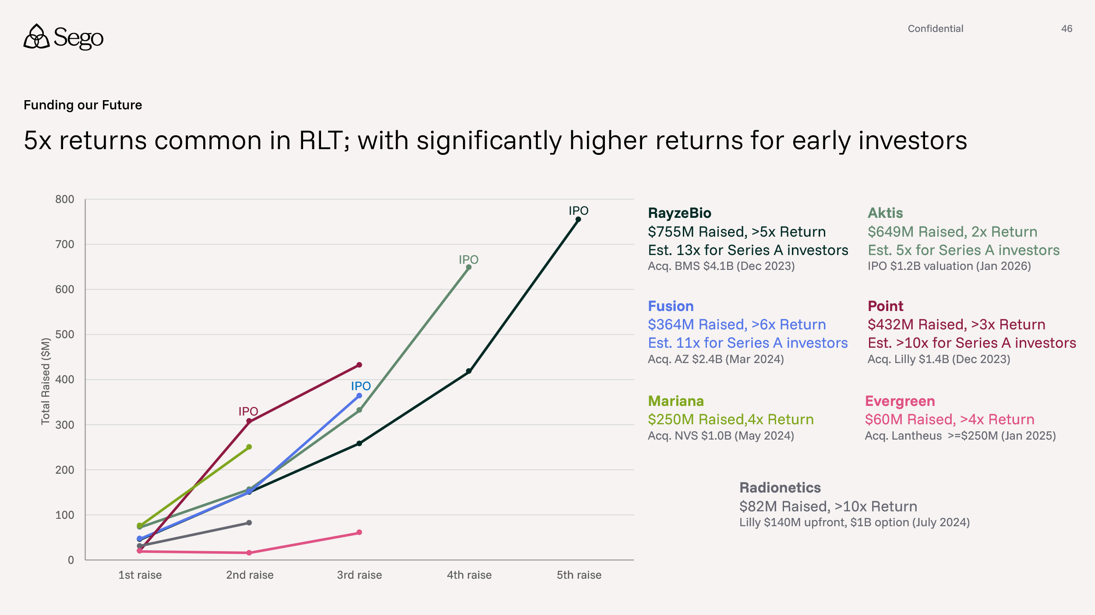

5. Wasatch Group is Sego’s founding investor, committed for the long term
Wasatch Group is Sego’s founding investor, providing $20M in equity plus build capital for the seed round, with an additional $10M committed in the form of a SAFE. Wasatch is a multi-billion-dollar diversified investment firm based in Salt Lake City with deep experience in life sciences real estate and infrastructure (see below). Their total financial commitment includes: (a) lease for Sego’s HQ (c) $6.5M in tenant improvements within the building lease (b) equipment purchase support structured as a lease covering the majority of equipment for the Stage 1A build (c) debt facilities and (d) an option in the IRA for an additional $20M equity participation at Series A.
Their involvement goes beyond capital: Wasatch is designing, building and operating an entire research campus dedicated to medical isotopes. This campus includes Nusano, Ratio and emerging plans for the Hansen Clinical Trials Center, a facility that will support early RLT clinical trials and capitalize on Utah’s new Right To Try regulations for early clinical research.
