25% Paired Assignment Draft
How to use: lavender italic text is a placeholder — click it and type your own words to replace it.
Your Class: ______ Pair no. _____
The conversation will last 6 minutes.
Student A, please download this copy as a Word document (.docx) and share it with Student B.
Start writing your script in a Google Doc. This template only serves as a survival kit.
To achieve a higher grade, you should practise fluency and pronunciation. Demonstrate your interactional and active listening skills, body language, and eye contact in your CA video. You are also encouraged to add more turns to ensure a minimum 5-minute conversation at a normal speed.
The draft will not be marked, but it can help you practice more smoothly.
Do not memorize any script. Express your own ideas naturally in your CA video.
Below are the QR codes for accessing useful learning resources.
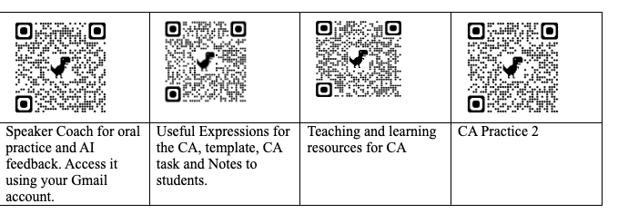
Student A (Name: ______) | Student B (Name: ______)
1. Greet your colleague and introduce yourself
A: 'Hi. I don't think we've met yet. I'm Role A's name and I'm from the Role A's department. It's nice to meet you.'
 | B: 'Hi. I'm Role B's name from the Role B's department. It's nice to meet you too.'
2a. Make small talk — Your weekend activities
A: 'So starting a casual conversation using an icebreaker for leisure?'
 | B: 'Very good, thanks for asking. I about B's weekend activity.'
A: 'echo key words on B's weekend activity? short reaction token giving positive comments or compliments'
 | B: 'Yes. I B's weekend activity.'
A: 'Really? That sounds interesting! follow-up question about the weekend activity.'
 | B: 'B's answer to the follow-up question. What about you? What did you do over the weekend?'
A: 'A's description of weekend activity using positive adjective.'
 | B: positive comment on A's answer and follow-up question
A: answer to the follow-up question
 | B: 'short reaction token positive comment on A's answer I'll have to check it out.'
2b. A project run by your department
 | B: 'So, what's your department working on these days?'
A: 'sharing of department project's three different stages.'
 | B: 'Sounds great! It'll be nice to positive comment no A's project.'
A: 'That's right. What about your department?'
 | B: 'sharing of department project's three different stages.'
A: 'I'm intrigued by the B's project already. It will surely help to benefit of B's project.'
 | B: 'Thank you, Student A's name. We are very enthusiastic about it.'
3. Share your opinions on a new company policy and support your views with reasons
 | B: 'By the way, what do you think about the policy our company introduced?'
A: 'State your opinion advantages/ disadvantages of the new company policy.'
 | B: 'State your opinion advantages/ disadvantages of the new company policy.'
A: 'Agreeing/ partly agreeing/ disagreeing politely + explanation/ elaboration.'
 | B: 'Yes. Hopefully, everything will run smoothly.'
4. End the conversation politely
A: 'Certainly. I've got to head back to my team. It was nice talking to you!'
 | B: 'Yes. It was great. I'm going to mingle a bit more. See you around.'
A: 'See you.'

