
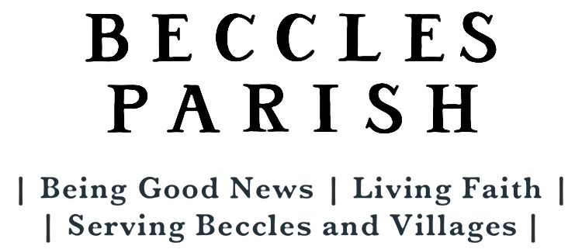
WELCOME TO WORSHIP TODAY | Sunday May 3rd Easter 5
‘Be my strong rock, a fortress to save me, for you are my rock and my stronghold; guide me and lead me for your name’s sake.’ Psalm 31v3
WORSHIP THIS SUNDAY- Easter 5  9.00am Holy Communion (BCP) St Michael’s  9.30am Holy Communion St Luke’s  10.30am GATHER St Michael’s  10.30am Morning Worship St Botolph’s  BIBLE READINGS  Acts 7: 55-60  John 14:1-14  WORSHIP NEXT SUNDAY – Easter 6  9.00am Holy Communion (BCP) St Michael’s  9.30am Morning Worship St Luke’s  10.30am Holy Communion (with choir) St Michael’s  5.30pm IGNITE St Michael’s |  |  | COLLECT  Almighty God,  who through your only begotten Son Jesus Christ  have overcome death and opened  to us the gate of everlasting life:  grant that, as by your grace going before us  you put into our minds good desires,  so by your continual help  we may bring them to good effect;  through Jesus Christ our risen Lord,  who is alive and reigns with you,  in the unity of the Holy Spirit,  one God, now and for ever.  Amen.
FOR YOUR PRAYERS
Prayer for the world:
God of power and might, your broken world cries out from the depths, a world dominated by the darkness of war, terror, pain and suffering. We think of the on-going and deepening conflict in Syria and the middle East.
We share the pain and anguish of those who have had to flee from their homes, countries and livelihoods, who risk their lives, desperate for a new start free from fear and war.
For community:
We pray for the flourishing of our community here in Beccles and the surrounding villages — spiritually, socially, and economically. May we work together to create a place where all are valued, where justice and righteousness prevail, and where the needs of the most vulnerable are met. We pray for those who are in positions of leadership within our community. Grant them wisdom, discernment, and humility as they serve the needs of the people. May they be guided by your truth and by your love. Finally, Lord, we thank you for the gift of community and for the bonds of love and fellowship that unite us. Help us to be instruments of your peace, shining your light and spreading your love wherever we go.
Mission Focus – CHRISTIAN AID
This month we pray especially for the work of Christian Aid and give thanks that, together with partner organisations, it works to bring practical help and support to people living on the edges in 29 countries across the world. We pray for generous giving during Christian Aid Week later this month.


North Cove Flower Festival
May 8th, 9th, 10th 10am-4pm
The theme is ‘Children’s TV’.
Refreshments served all day Stalls including crafts, books, CDs, DVDs, Lucky Straws

Help is needed with stalls, serving refreshments and with baking cakes. Please contact Judy Thacker for more details.

Food Festival Saturday May 23rd, help is needed on Friday 22nd at 4.30pm to get the church set up.
Saturday there are volunteers needed to help with serving refreshments and stewarding. There are lists for signing up in St Botolph's North Cove, St Luke's and St Michael's and for those who would like to support by baking there are lists in the same places. We aim to cater the firm favourites in sizes that are easy portion and for set prices which is why the lists are quite specific. Please contact Serena if you have any queries or are offering something different. This has been a really successful fundraiser for the Church so please help make it another great year.

Notice of APCM - The Annual Parochial Church Meeting will take place at St Luke's church on the 17th May starting at 2.40pm. The meeting will include the election of representatives to the Parochial Church Council and the Deanery Synod. The APCM will be preceded by a Vestry Meeting, starting at 2.30pm, during which church wardens will be elected. Please note that to be able to stand for election or to vote your name must be on the parish electoral roll.

Electoral Roll - If you live in the parish or have been attending services regularly for at least 6 months, you are eligible to have your name included on the parish electoral roll. Inclusion on the electoral roll allows you to stand for election as Church Warden or PCC member and/or to vote at the APCM. Printed copies of the current electoral roll will be available after services for the next few weeks. Please check your details are up to date. Please ask the church office for a form if your name does not currently appear and you would like to be included.
Connect through one of our regular coffee mornings |  |  |  | If you need food and support
Every Friday  Friends of St Michael’s  Coffee Morning  10am -12noon at St Michael’s   | Every Saturday  Coffee & Chat  9.30am -11am at St Luke’s  a chance to catch up over coffee, toast, or a bacon roll. |  |  | Foodbank at St Luke’s  Mondays 2-3pm Fridays 2-3.30pm  Parish Pantry Pop up Shop  Saturdays 9.30am-11am at St Luke’s  Christians Against Poverty  0800 328 0006
DIARY DATES
Friday -Sunday 8-10th May 10.00- 4.00pm North Cove Flower Festival St Botoph’s
Sunday 17th May 2.30pm Vestry meeting and APCM St Luke’s
Saturday 23rd May Beccles Food Festival St Michael’s

WORSHIP DURING THE WEEK - all are welcome to any or all of our services.
MORNING PRAYER – Monday & Tuesday 8.30am on Zoom, Wednesday 8.30am at St Luke’s.
Join on Zoom ID 985 0957 8510 passcode 405454 EVENING PRAYER Tuesday 3.30pm at St Botolph, North Cove
MIDWEEK COMMUNION Tuesday 10am at All Saints Worlingham, Thursday 10am at St Michael’s
Parish Office at St Luke’s Church Centre, 61 Rigbourne Hill NR34 9JQ
Administrator Doreen Page 01502 716370 becclesparish@gmail.com
Wednesday 8am-12noon, Thursday am (for printing) 11am-12pm
Rector: Revd Dimitri Theulings 07985320320  rev.dimitri@gmail.com (Day off Friday)
Associate Priest Revd Philip Cudmore 07709417515  phil.cudmore1@gmail.com (Day off Wednesday)
Curate: Revd Doreen Page 07585695064  revdoreenpage@gmail.com (Day off Friday)
Lay Minister
Faith Darch 01502 711318 faith@darch.plus.com
Licensed Youth Minister
Kate Cracknell 07403323373 kate@becclesparish.org.uk
Children and Families Minister
Clare Ayers 07426582819 clare@becclesparish.org.uk
Parish Safeguarding Officer
Serena Emberley 07947217868  sereeni@talktalk.net
Diocesan Safeguarding Officer
Karen Galloway 07785621319 karen.galloway@cofesuffolk.org
Churchwardens
Beccles St Michael Sue Son 07497101647
Beccles St Luke Roger Bennett  01502 712584 Fran Tuck 07717060728
Worlingham All Saints Position Vacant
North Cove St Botolph Ben Blower 07771 802643
Barnby St John Position Vacant
Please send any items for next week’s Bulletin to becclesparish@gmail.com by 12noon on TUESDAYS www.becclesparish.org.uk @becclesparish


