**Unit 5 Project:**

**Rebecca Sandford**

**Step 1: Define Audience / Tone**

* Who will visit your site?

*Potential employers, industry peers, prospective clients.*

*This site is about showcasing my abilities as a digital marketer and what projects I have been involved in during my career. I also want to add a bit of my personality to the page to make it a bit of fun also.*

* What can make you and/or your product stand out against your competitors?

*My broad skill-set which can be showcased through my portfolio of work.*

* How would you speak to your clientele if you were communicating in person? How could you translate that style and tone digitally?

*Approachable and easy going, helpful and understanding*

*I think this could be communicated through the tone of the site, so adding a slight edge to a professional page/ portfolio to provide a bit of personable insight into myself.*

*I love to travel and would like to someone help this shine through my site.*

* What colors represent you or your product?

*Blues for corporate professional tone (Perhaps inclusion of monochromatic colours here also? With perhaps a splash of a warm complimentary colour to break this up a bit.*

* What images illustrate your message?

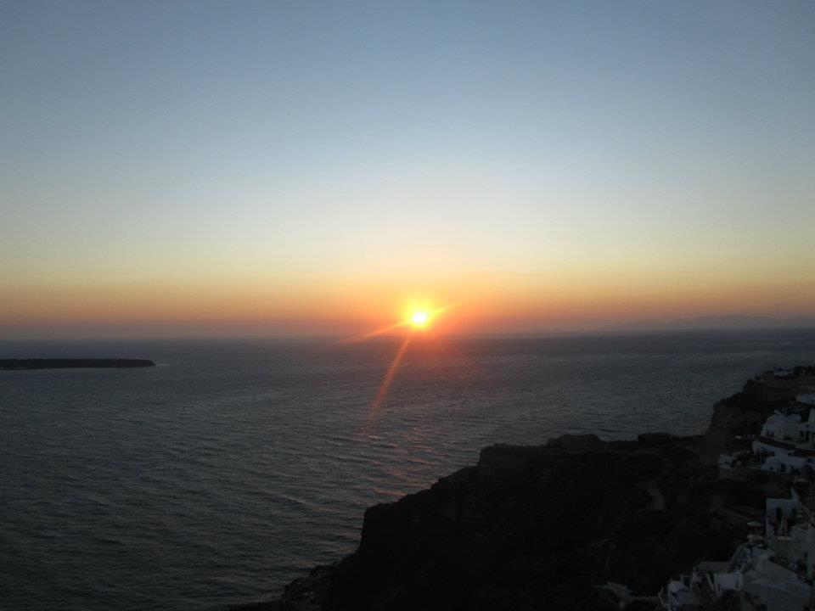

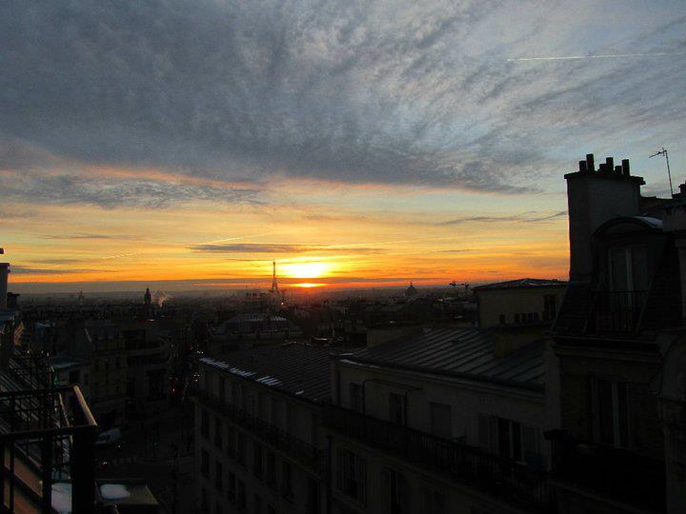

**Step 2: Define Site Structure**

What are the three-to-five pages titled?

*Work, About, and Contact*

What will be the purpose for each?

**Homepage**

*Header image with short intro to myself / perhaps a inspirational quote relating to travel / work / philosophy.*

**Work**

*Showcase my portfolio*

Contains:

* Title
* Navigation
* Thumbnails of my portfolio work
  + Project Title
  + Image
  + Brief outline of scope
  + Short Description solution
  + Tags of skill-sets used (i.e. project management, UX creation)

**About**

*Intro about me. Providing some insight into my personality my love of travel and outdoors.*

*List of my skills*

*(i.e. project management advanced, html beginner, CSS beginner, Digital Design intermediate etc etc)*

**Contact**

*Contact information*

* Contact Form or button to contact via email.
  + Name
  + Contact email
  + Message
* Map showing my current location as Brisbane Australia