# TNM098 – Lab 2

## Method

## Result

Seven regions found

|  |  |  |  |  |  |  |  |
| --- | --- | --- | --- | --- | --- | --- | --- |
| Noise | 0 | 1 | 2 | 3 | 4 | 6 | 5 |
| 195 | 291 | 41 | 64 | 22 | 58 | 17 | 56 |

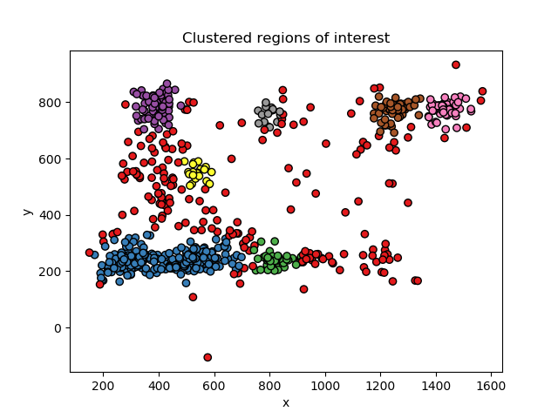

**1**

**6**

**7**

**5**

**4**

**3**

**2**