Security and Crypto System (CEF350)
Caesar Cipher implementation with C ++
Beching Rexzy Bate
FE24A240

INTRODUCITON
The Caesar cipher is one of the simplest ciphers and most widely know encryption techniques. Named after Julius Caesar, who reportedly used to protect military messages, it is a substitution cipher where each in the plaintext is shifted a fixed number of places down (or up) the alphabet
How it works
Imagine writing the alphabet in a circle. To encrypt, you pick a shift value (the “key”) and replace every letter with the one that stands a certain number of positions later. For decryption, you simply shift backwards by the same amount
The alphabet is treated cyclically: after Z comes A again. The standard alphabet is the 26-letter English one, but the idea works with any alphabet.
IMPLEMENTATION
We were asked to implement this cipher using the C ++ programming language. the source code of my implementation is found in the folder along with my report.
EXPLANATION OF MY CODE
For my implementation is used a more direct approach, and I utilized OOP features to make my program more modular and cleaner
From my source code file:
Line 1 to line 3 are comments that contained My name, Matriculation Number and the assignment Name
Line 4 is an empty line, line5 contains a comment for the header files (line6 to line8). Line 10 announces to the program that we will make used of the namespace “std” for standard operation, like reading and writing to the console. From line 12 to line 60 we have our Caesar cipher class, all the operations done in that cipher be it, encryption, decryption and all the logic that follows it are all implemented in that cipher. Now inside our class names Caesar Cipher we have private instance variables declared from line 14 to line 16, these variables are to hold the text the user enters (be it plaintext or ciphertext) and the key which will be used for our encryption of decryption. Line 19 to line 23 a helper function called “normalize Key” is implemented, its works is to make sure the key is within the standard English alphabet range (from 1 to 26) it will be used within the class not outside it as it is private. Line 26 to line 35 we have our method “shiftChar” which will be used to do the shifting of our letters , each time we need to apply the Caesar technique in substituting a particular character with our new one, based on our key, this method will do the substitutions which is in a sense us shifting to the replacement character. From line 37 to line 41 our constructor for the class is declared which is used primarily to assign the information the user inputs to their corresponding instance variables. If the user enters a key, the value is assigned to variable key likewise same with the text entered too. Line 43 to line 50 we have our encryption function which handles our encrypting, it works as follows: line 44 local variable result is declared which will be used to store our encrypted text, from the plaintext, from line 45 we have a for loop which loops through the message of text (plaintext) provided by the user, it takes each letter from that text and stores it in local variable “C” as seen in the loop, then from line 46 it checks if that character at that specific position is a “space”, if it is then we skip it, because space are ignored and not encrypted during encryption, if the character is not a space, we call our method “shiftChar” which as explains above does the substitution, it takes as parameters the current character and the key used for encrypting, the logic of substituting the old character with its encrypted one is implemented int that method , and the logic makes sure only letters of the standard English alphabet are encrypted foreign characters like digits, commas, colons or more are left like that, the result of that is returned to the encryption method which called it, and that result is appended to the string variable “result” which as mentioned earlier stores the result of our encryption, letter or character by character, after the loops must have gone through the entire text provided by the use, the encryption is completed , and the variable “result” now contains the fully enciphered text, this text is now return to the main method and then displayed to the user.
Line 52 to line 59 is our decryption function, just like the encryption function line 53 declares a local variable “result” which will hold our decrypted message after decryption. Now for decryption the key is not used directly so it is reversed before used. since during decryption we moved in the reversed direction. The local variables “reverseKey” holds the result of our key after it is reversed. Line 55 to 57 also declares a for loop which does exactly the same thing as that in the encryption function. And after our string is fully decrypted, the result is stored in local variable result, and it is return to the main method where it is displayed to the user.
Line 60 ends our class.
Line 62 to line 108 is our main method, there the user is prompted to choose what the wish to do, encrypt or decrypt a text, depending on their choice, the are asked for the key and plaintext or cipher text. And instance of our class CaesarCipher is created and those input provided by the user (key and text) are passed as parameters to the object constructor. And the result is gotten and displayed for the user to see the result. Of course, edge cases are all handled, like if the use enters an unknown character order than number for the key and more.
RESULT
- Encryption of the message: We attack tonight with key 5.
- Expected output: Bjfyyfhpjiytsnslmy
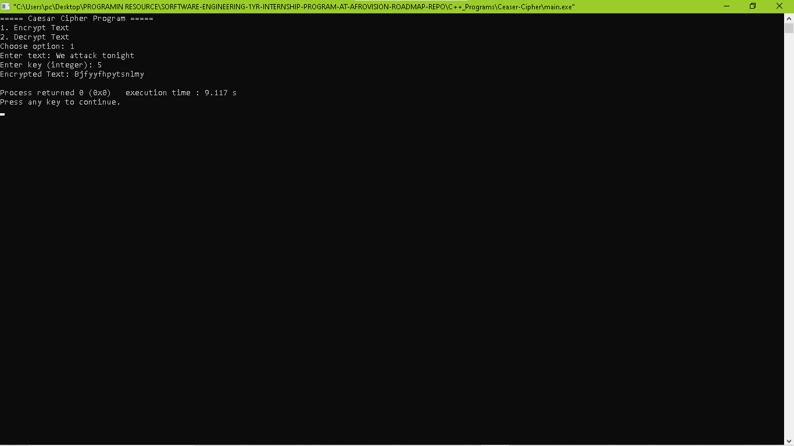

- Decrypting the message: Bjfyyfhpytsnlmy with key 5
- Expected output: Weattacktonight (when spaced out gives “We attack tonight”.
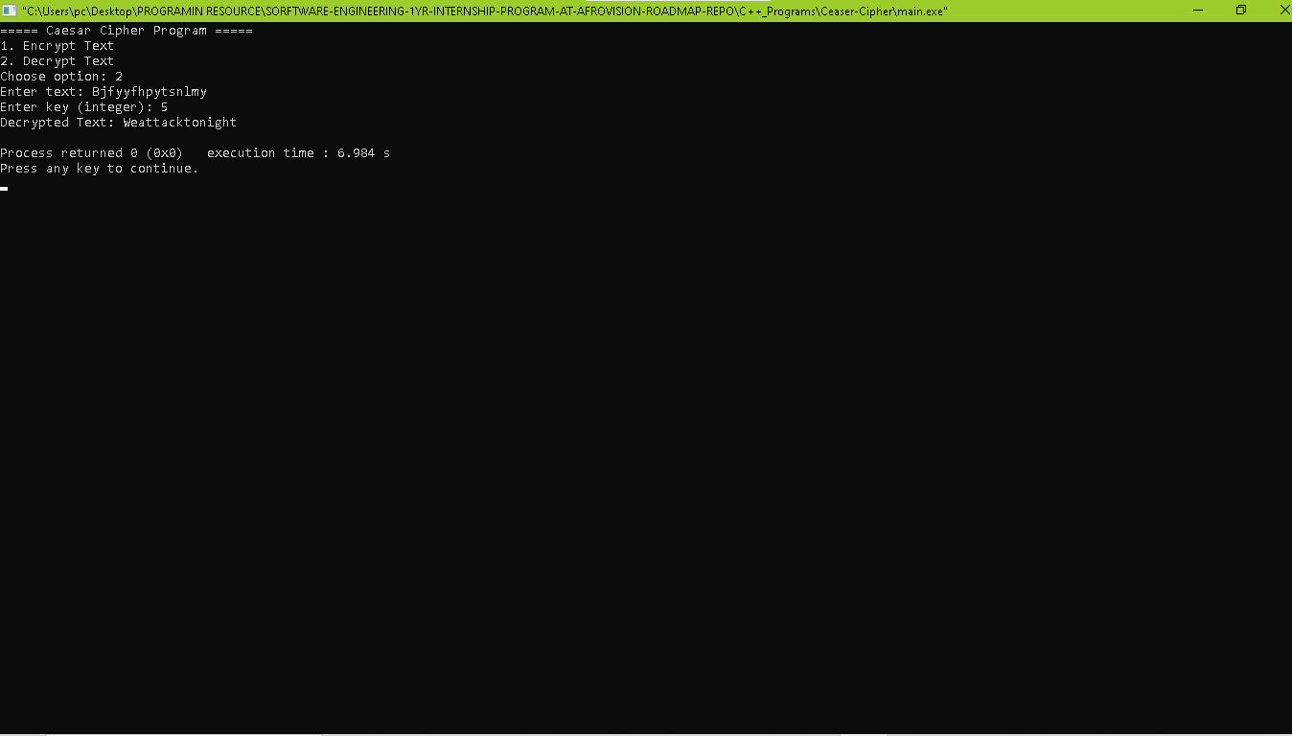
CONCLUSION
As we see the program works perfectly, with the source code provided you are free to test it out.
The Caesar cipher was successfully implemented using the C++ programming language

