Vision Based Navigation and Control for Autonomous Cassava Farm Robots
Complete Research Technical Report
Phase C Comparative Analysis
2026-09-28

Executive Summary
This report documents the Phase C validation of frozen Phase B evidence. Random Forest has the lowest saved-test error but uses oracle ground-truth-mask features. MobileNetV3 is the lowest-MAE image-only export. The common paired test set contains 42 images.

Dataset and workflow
The usable data contain 802 samples, 3 confirmed semantic classes and geometry-derived navigation targets. Classical ML and ANFIS use oracle feature inputs; direct CNN/transfer models use images. No physical robot claim is made.

Verified comparative results
Metrics were recomputed from saved actual/predicted pairs. Bootstrap confidence intervals use 5,000 image-level resamples; paired Wilcoxon tests use the 42 shared image IDs and Holm correction.
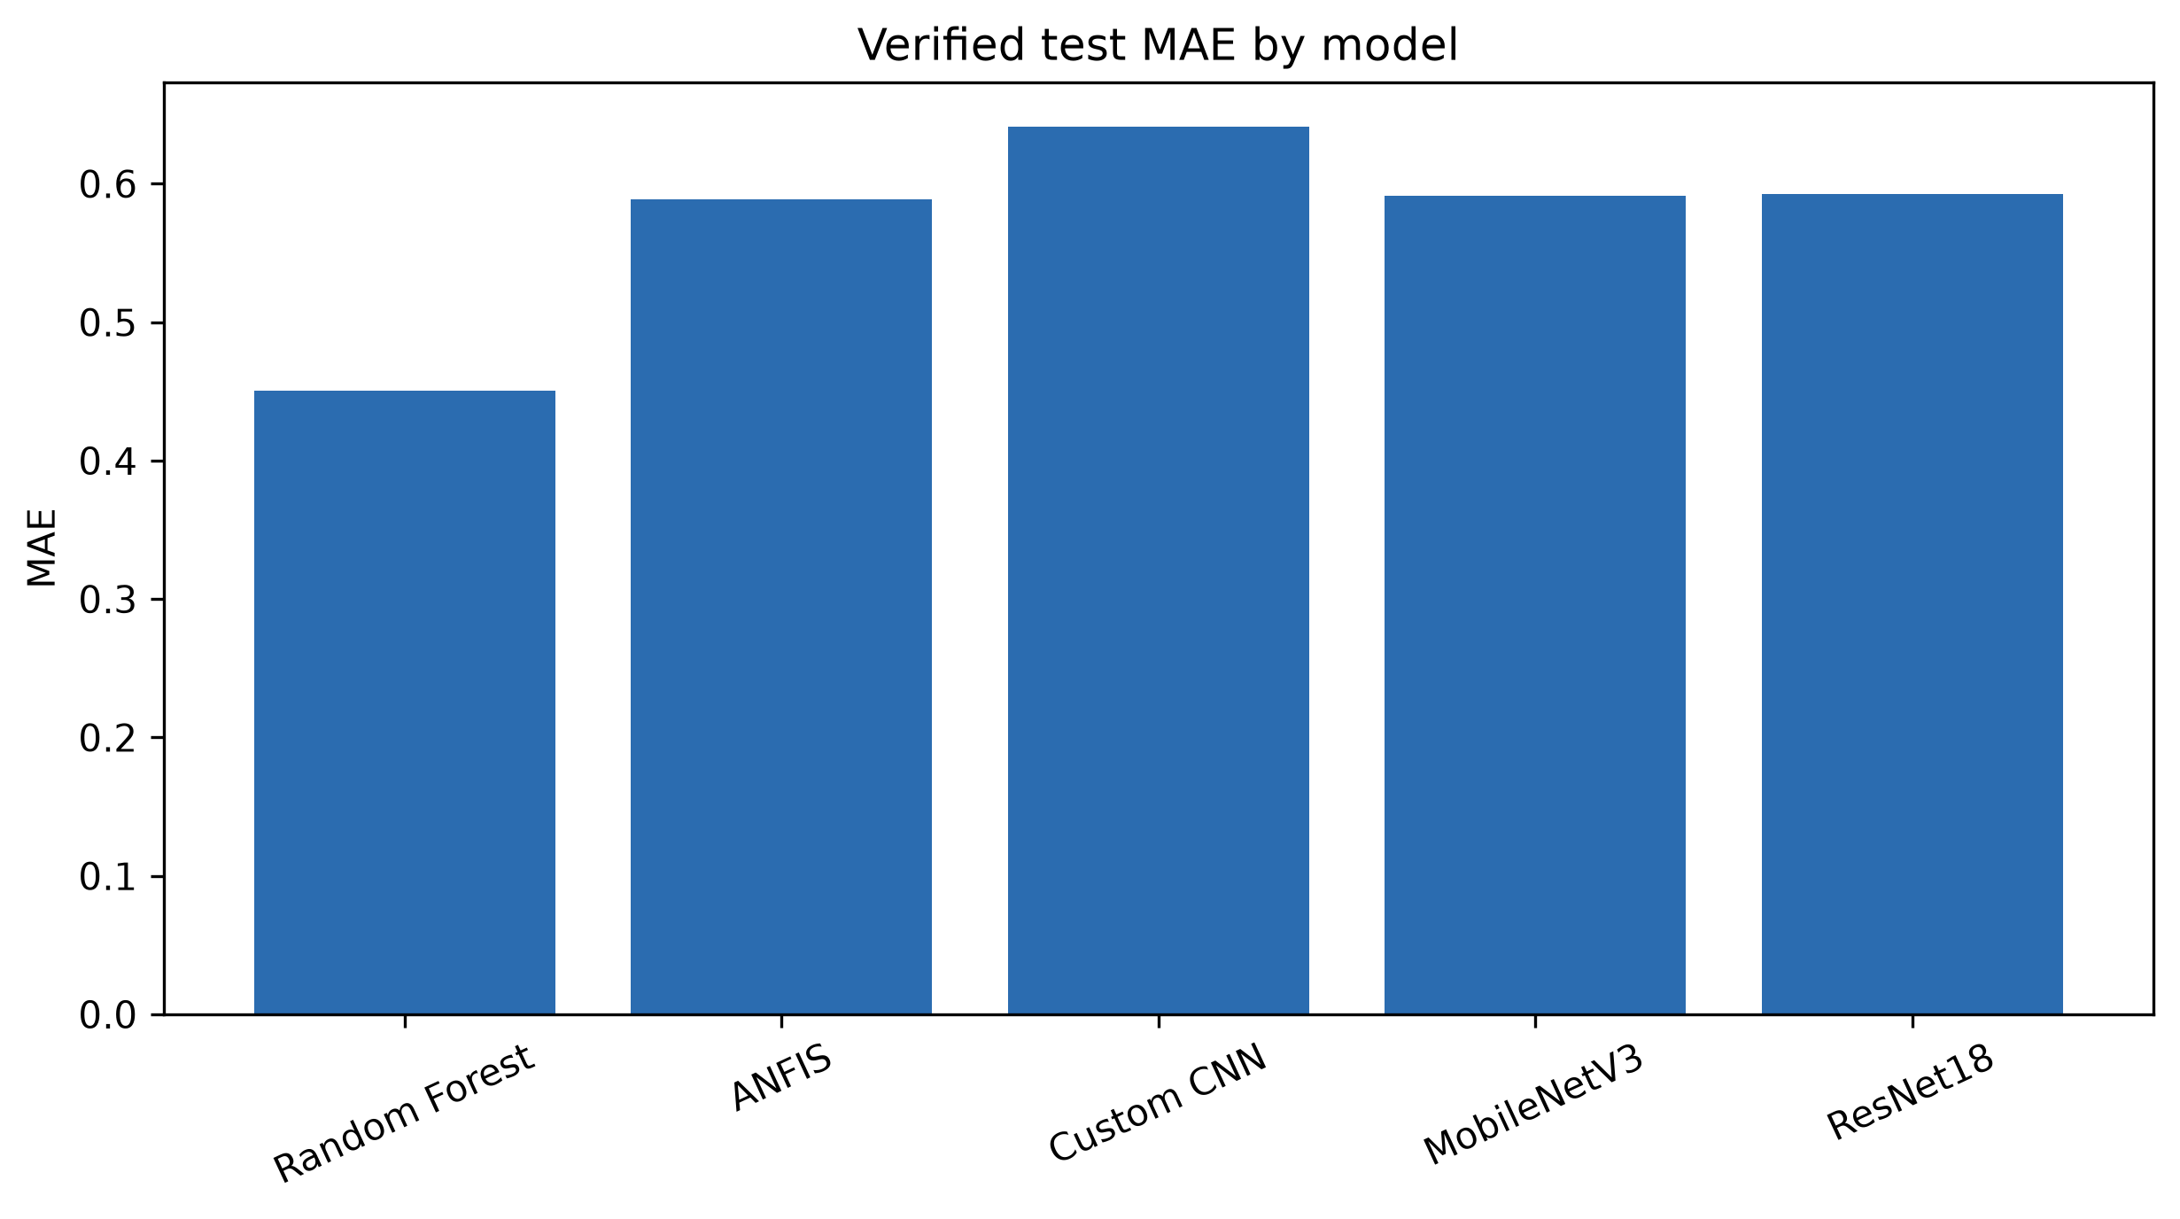
Figure - Verified test MAE by model
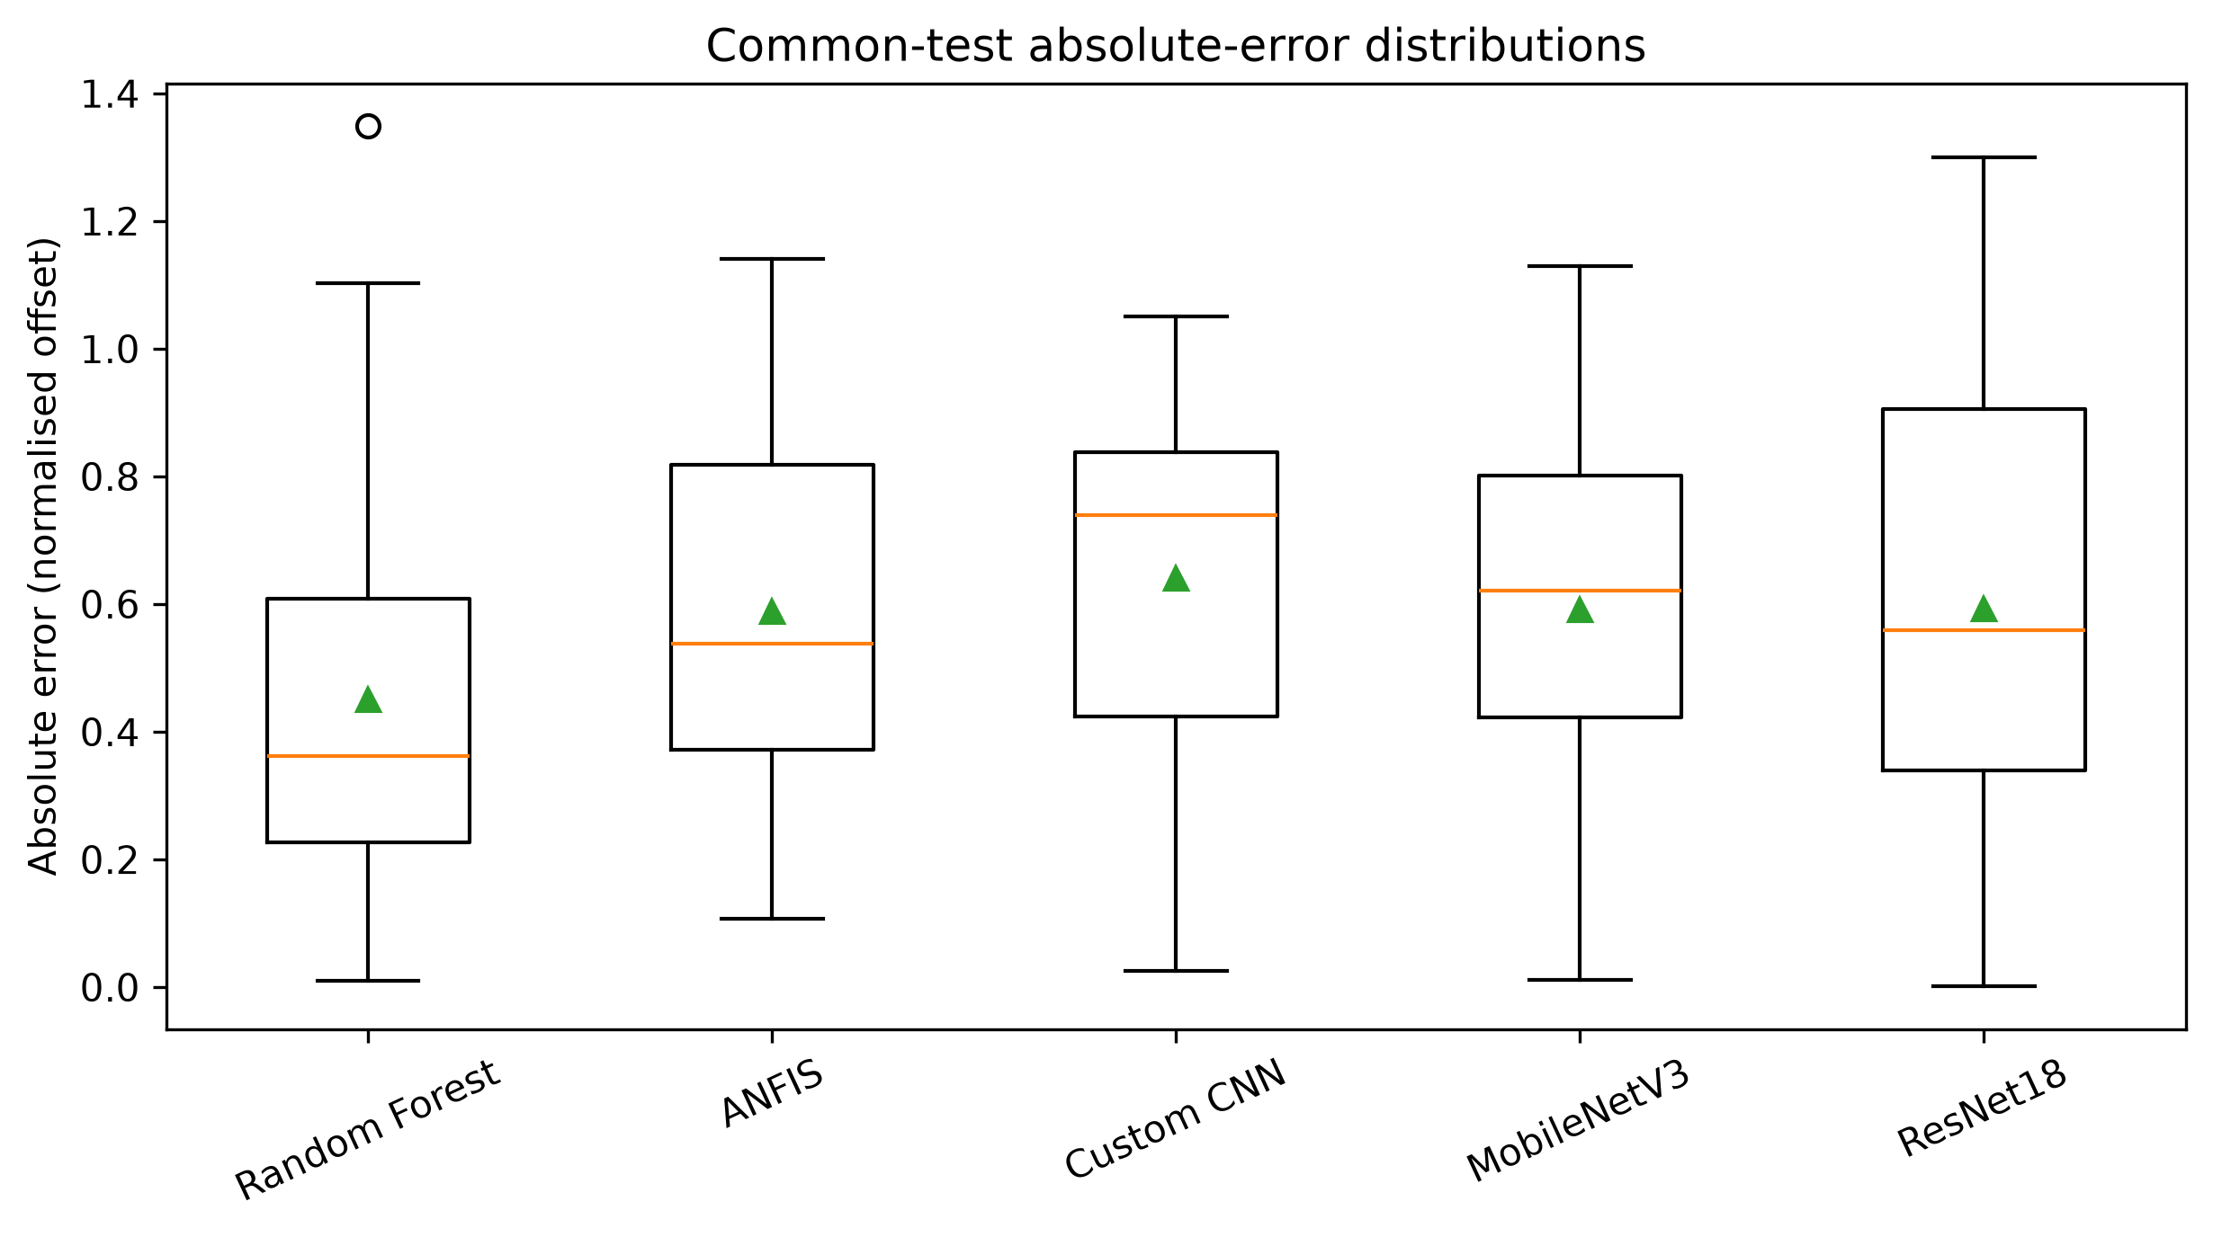
Figure - Paired absolute-error distribution
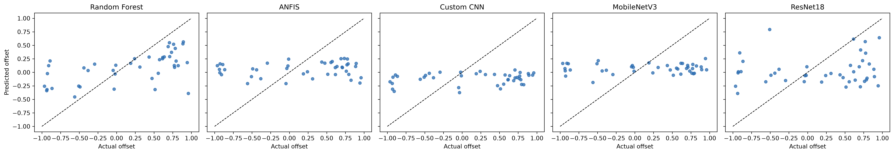
Figure - Actual versus predicted common-test offsets
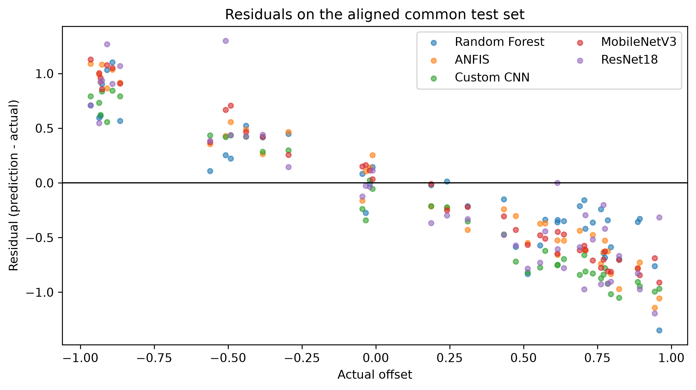
Figure - Residual comparison

Interpretation and limitations
The oracle/image-only distinction prevents a direct deployment ranking. Targets are not measured steering commands, and segmentation execution, predicted-mask features, edge testing and robot validation remain unavailable.

Verified regression table
Model | Feature source | N | MAE | RMSE
Random Forest | oracle ground-truth masks | 42 | 0.4505698017042929 | 0.5420931192289319
ANFIS | oracle ground-truth masks | 42 | 0.5886896949761904 | 0.6565839887087348
Custom CNN | images | 42 | 0.6414214591595238 | 0.6965784109611107
MobileNetV3 | images | 42 | 0.5915980909523809 | 0.6582767348218261
ResNet18 | images | 42 | 0.592889465952381 | 0.685875004015314

Appendix and reproducibility
See the accompanying Markdown report, figure catalogue, table catalogue, objective traceability and reproducibility guide for complete traceability.

