DEVELOPMENT OF A CONVOLUTIONAL NEURAL NETWORK MODEL FOR CATFISH DEVELOPMENTAL-STAGE CLASSIFICATION AND BIOMETRIC ESTIMATION

BY
AMEH JOSEPH JUNIOR
PG/MSC/19/89745

A RESEARCH PROJECT SUBMITTED TO THE DEPARTMENT OF COMPUTER SCIENCE, UNIVERSITY OF NIGERIA, NSUKKA, IN PARTIAL FULFILMENT OF THE REQUIREMENTS FOR THE AWARD OF THE MASTER OF SCIENCE (M.Sc.) DEGREE IN COMPUTER SCIENCE

SUPERVISOR: PROF. COLLINS UDANOR
AUGUST 2026

DECLARATION
I, Ameh Joseph Junior (PG/MSC/19/89745), declare that this project is an account of the work documented in the accompanying repository and experimental notebook. Sources used in developing the study are acknowledged in the text and reference list. No result has been presented as independently verified where the available project evidence does not support such a claim.
Signature: __________________________ Date: __________________

CERTIFICATION
This project has been presented for examination with the approval of the supervisor. The signature fields below are reserved for institutional completion.
Prof. Collins Udanor (Supervisor)
Signature: __________________________ Date: __________________
Head of Department
Signature: __________________________ Date: __________________

DEDICATION
This work is dedicated to the advancement of practical artificial intelligence for sustainable aquaculture and food production.

ACKNOWLEDGEMENTS
I acknowledge the guidance of my supervisor, Prof. Collins Udanor, and the support of the Department of Computer Science, University of Nigeria, Nsukka. I also acknowledge everyone who contributed to the acquisition, measurement and organization of the catfish data used in this study. Any remaining errors are mine.

ABSTRACT
This study developed and evaluated a transfer-learning system for classifying African catfish images into fingerling, juvenile and adult developmental stages while estimating standard length (SL), total length (TL) and weight. The archived notebook contains 357 valid images representing 117 independently identified fish. To prevent information leakage from repeated photographs of the same fish, splitting was performed by fish identity, producing 249 training images from 81 fish, 51 validation images from 17 fish and 57 test images from 19 fish. EfficientNetB0 was selected as the best experimental backbone. On the held-out test set, image-level accuracy was 82.46% and macro F1-score was 81.23%. Aggregating predictions by fish improved accuracy to 94.74% and macro F1-score to 94.34%. Biometric estimation was substantially weaker: fish-level mean absolute errors were 11.24 cm for SL, 15.64 cm for TL and 285.03 g for weight; the regression model did not outperform the class-mean baseline. A local Streamlit application was also implemented and tested with 31 automated tests. Its archived screenshots demonstrate image upload, validation, stage prediction and biometric display, but the saved application checkpoint is InceptionV3 and is therefore reported separately from the evaluated EfficientNetB0 experiment. The findings support fish-grouped stage classification as a promising proof of concept, while showing that reliable image-only biometric estimation requires more independent fish, calibrated image acquisition and a visible scale reference.

TABLE OF CONTENTS

Chapter One: Introduction
Chapter Two: Literature Review
Chapter Three: System Analysis and Design
Chapter Four: System Implementation, Results and Discussion
Chapter Five: Summary, Conclusion and Recommendations
References
Appendices A–D
Note: update the automatic field in Microsoft Word or LibreOffice to display final page numbers.

LIST OF TABLES

Tables 4.1–4.10: Experimental configuration, dataset, split, metrics, regression and software tests
Table 5.1: Findings mapped to the study objectives
Appendix A table: Reproducibility and evidence checklist

LIST OF FIGURES

Figures 4.1–4.4: Dataset, confusion matrix, ROC and regression diagnostics
Figures 4.5–4.8: Local application interface and representative predictions

LIST OF ABBREVIATIONS
Abbreviation | Meaning
AI | Artificial Intelligence
CNN | Convolutional Neural Network
CI | Confidence Interval
F1 | Harmonic mean of precision and recall
Grad-CAM | Gradient-weighted Class Activation Mapping
MAE | Mean Absolute Error
RMSE | Root Mean Squared Error
SL | Standard Length
TL | Total Length
UI | User Interface
ViT | Vision Transformer

CHAPTER ONE

INTRODUCTION
Background of the Study
Aquaculture has become one of the fastest-growing sectors of global food production, with catfish farming playing a significant role in improving food security, employment, and income generation, particularly in developing countries such as Nigeria. The success of catfish production depends largely on effective monitoring of fish growth, health, and developmental stages, including fingerlings, juveniles, and adults. Accurate identification and classification of these growth stages are essential for proper feeding, stocking density management, disease control, harvesting, and market valuation. Traditionally, fish farmers estimate growth stages and biometric parameters such as length and weight through manual observation and measurement. These conventional methods are labor-intensive, time-consuming, subjective, and error-prone, especially in large-scale aquaculture operations. Inconsistent measurements may lead to poor management decisions, reduced productivity, and economic losses. Consequently, there is an increasing need for automated, accurate, and efficient methods to support fish farmers in monitoring catfish growth and improving farm management practices.
Recent advances in Artificial Intelligence (AI), particularly Deep Learning and Convolutional Neural Networks (CNNs), have transformed image recognition and classification by enabling computers to automatically learn distinguishing features directly from digital images without manual feature engineering (Krizhevsky et al., 2012; He et al., 2016). CNN-based models have demonstrated remarkable success in applications such as medical image analysis, object detection, autonomous systems, and fish species classification because of their ability to extract hierarchical visual features with high accuracy. In aquaculture, CNNs provide an opportunity to automate the classification of fish growth stages and estimate biometric characteristics from images, thereby reducing human intervention and improving decision-making. Although previous studies have successfully applied CNNs to general fish classification, limited attention has been given to dedicated catfish image classification and biometric estimation under practical farming conditions. This study, therefore, sought to develop a CNN-based catfish image classification model capable of automatically identifying developmental stages and estimating biometric parameters from surface images. The proposed system is expected to improve classification accuracy, reduce processing time, minimize human error, and provide an intelligent decision-support tool for sustainable aquaculture management.

1.1 Statement of the Problem
The catfish farming industry lacks accurate and efficient methods for classifying catfish images into different developmental stages, such as fingerlings, juveniles, and adults.
Manual classification by experts can be time-consuming, costly, and subjective. Hence, there is a need for an automated and objective image classification system that can accurately and efficiently classify catfish images into various categories representing different developmental stages.
There is currently no optimized Convolutional Neural Network (CNN) model specifically designed for catfish developmental stage classification using standard photographic images. While CNNs have been applied to general fish classification tasks, none have been tailored and benchmarked for African catfish, making this work novel and justified. Existing research largely focuses on general fish species recognition or ultrasound imaging, but it does not address surface image classification of catfish growth stages.

Aim of the Study
The aim of the study is to develop and evaluate a CNN-based system for classifying African catfish images into fingerling, juvenile and adult developmental stages and for estimating standard length, total length and weight from surface images.

Objectives of the Study

The objectives of this study are
To collect and preprocess a dataset of catfish images representing different developmental stages (fingerlings, juveniles, and adults) for model training and evaluation.
Develop and train a CNN-based framework capable of classifying catfish images into their developmental stages and estimating their length and weight from surface images.
Develop a user-friendly web-based application that enables users to upload catfish images and obtain classification and biometric estimation results.
Evaluate the performance of the developed system using appropriate performance metrics such as accuracy, precision, recall, F1-score, and Mean Absolute Error (MAE), and compare the results with manual measurements obtained from aquaculture experts.
Implement and demonstrate the developed prediction workflow in a locally executable web application for catfish image classification and biometric estimation.

Scope of the Study
The scope of the project is limited to the development of a CNN-based classification model for catfish images representing three different developmental stages.

Significance of the Study
The development of a Convolutional Neural Network (CNN)-based catfish image classification model is expected to automate the process of classifying catfish into different developmental stages using digital images. The system can also estimate biometric parameters like length and weight, which improves the speed, accuracy, consistency and reliability of catfish identification. The study will be useful to the following stakeholders:
Fish Farmers: The developed system will provide a fast and objective means of classifying catfish into fingerlings, juveniles, and adults, thereby supporting better stocking, harvesting, feeding, and farm management decisions while reducing dependence on manual assessment.
Aquaculture Researchers (e.g., National Institute for Freshwater Fisheries Research (NIFFR), Nigerian Institute for Oceanography and Marine Research (NIOMR)): The study will provide an intelligent image classification framework that can support research in fish growth assessment, biometric analysis, and the application of artificial intelligence in aquaculture.
Fisheries Management Agencies (e.g., Federal Department of Fisheries and Aquaculture (FDF), Federal Ministry of Agriculture and Food Security (FMAFS), Fishery Society of Nigeria (FISON)): The developed model can serve as a technological tool for improving the classification and documentation of cultured catfish during research, extension services, and fisheries development programmes.
Fish Sellers, Wholesalers, and Buyers: The automated classification system can improve confidence in determining the developmental stage of catfish, thereby supporting fair pricing, product standardization, and quality assurance within the fish value chain.
Educational Institutions: The developed system can serve as a practical learning tool for students and researchers in computer science, artificial intelligence, fisheries, and aquaculture by demonstrating the real-world application of deep learning and computer vision technologies.
Government Agencies (e.g., National Agency for Food and Drug Administration and Control (NAFDAC), Nigerian Maritime Administration and Safety Agency (NIMASA)): The findings of this study can contribute to the adoption of intelligent technologies in the aquaculture sector and support policy initiatives aimed at promoting digital innovation in agriculture and fisheries.
Future Researchers: This study will provide a useful reference for future studies on artificial intelligence, deep learning, computer vision, and fish image classification. It can also serve as a benchmark for developing improved CNN architectures and larger datasets for catfish and other aquaculture species.

CHAPTER TWO

LITERATURE REVIEW
Introduction
This chapter presents a comprehensive review of literature relevant to the development of a Convolutional Neural Network (CNN)-based model for catfish developmental stage classification. The literature reviewed comprises journal articles, conference proceedings, theses, books, and other credible scholarly sources related to deep learning, computer vision, image classification, and automated fish identification. Particular attention is given to studies involving the application of CNNs in fisheries and aquaculture, with emphasis on methods for identifying and classifying fish based on their morphological characteristics. The chapter critically examines the theoretical foundations, conceptual issues, and empirical studies relevant to the present research. It also identifies the existing research gap that justifies the study and concludes with the conceptual framework underpinning the development of the proposed CNN-based model.
The rapid advancement of Artificial Intelligence (AI) and deep learning has transformed image recognition and classification across several domains, including healthcare, agriculture, transportation, security, manufacturing, and aquaculture. Among the various deep learning techniques, Convolutional Neural Networks (CNNs) have emerged as one of the most effective approaches for image classification because of their ability to automatically learn hierarchical features directly from raw image data without requiring manual feature engineering (Krizhevsky et al., 2012). Their ability to capture complex spatial relationships within images has enabled CNNs to outperform many conventional machine learning algorithms in a wide range of computer vision applications.
In fisheries and aquaculture, accurate identification of fish is essential for stock assessment, production management, selective breeding, health monitoring, and sustainable aquaculture practices. Beyond identifying different fish species, there is an increasing need to automatically distinguish the developmental stages of cultured fish because management practices such as feeding regimes, stocking density, growth monitoring, harvesting decisions, vary according to the stage of development. Traditionally, the identification of fish developmental stages depends on visual inspection and manual measurement by experts, making the process labor-intensive, time-consuming, costly, and susceptible to human error. These limitations have encouraged the adoption of computer vision and deep learning techniques to automate fish identification and classification tasks.
Recent studies have demonstrated that CNN-based models can effectively learn discriminative visual features from fish images, including body shape, body proportions, fin development, skin texture, pigmentation patterns, and other morphological characteristics that change as fish grow (Rahman et al., 2024). The availability of advanced CNN architectures such as AlexNet, VGGNet, ResNet, DenseNet, EfficientNet, and Vision Transformers (ViTs) has significantly improved the performance of automated fish image classification systems across different aquaculture applications (Ergün, 2025). These architectures provide increasingly robust feature extraction capabilities, enabling the recognition of subtle morphological differences between images.
Transfer learning has also become an important component of modern fish image classification systems. Rather than training CNN models from scratch, researchers commonly initialize models using weights pre-trained on large benchmark datasets such as ImageNet before fine-tuning them on fish image datasets. This approach substantially reduces training time, improves model convergence, and enhances classification performance, particularly where labelled datasets are limited (Hasegawa et al., 2024).
Despite the considerable progress achieved in automated fish identification, important challenges remain. Most existing studies have concentrated on classifying different fish species or mixed fish datasets, while comparatively few have investigated the automated classification of catfish according to their developmental stages, namely fingerling, juvenile, and adult. Furthermore, many existing models have been evaluated using images collected under controlled laboratory conditions or publicly available datasets, with limited consideration of the variations in illumination, background complexity, fish orientation, and environmental conditions encountered in practical aquaculture settings (Mohammadisabet et al., 2025). These limitations highlight the need for a robust CNN-based model capable of accurately classifying catfish into their developmental stages under realistic farming conditions.
For clarity and logical presentation, this chapter is organized into the theoretical review, conceptual review, empirical review, summary of reviewed literature, research gap, and conceptual framework. Collectively, these sections provide the theoretical and empirical foundation for the development of a Convolutional Neural Network-based model for classifying catfish into fingerling, juvenile, and adult developmental stages.

2.1 Theoretical Review
The theoretical review discusses the theories and principles underpinning the development of a Convolutional Neural Network (CNN)-based catfish image classification model for identifying catfish according to their developmental stages. Specifically, the proposed model classifies catfish images into three developmental categories: fingerling, juvenile, and adult. The review examines the theoretical concepts that explain how CNNs learn visual representations from digital images and why they have become the preferred approach for automated fish identification in aquaculture. It also reviews major CNN architectures that have been successfully applied to fish image classification and discusses their relevance to developmental stage classification.

2.1.1 Convolutional Neural Networks for Fish Image Classification
Convolutional Neural Networks (CNNs) are deep learning models specifically designed to analyze image data by automatically learning hierarchical visual features directly from raw pixel values. Unlike traditional machine learning techniques, which rely on manually engineered features such as colour histograms, texture descriptors, and edge detectors, CNNs learn discriminative image representations during the training process (LeCun et al., 1998). This capability has made CNNs the dominant approach for automated image classification and object recognition.
In fisheries and aquaculture, CNNs have been widely adopted for automated fish identification because they can effectively learn morphological characteristics from digital images. During training, the convolutional layers initially detect simple image features such as edges, curves, textures, and contours. As information progresses through deeper layers of the network, these simple features are combined into more complex anatomical representations, including body shape, fin structure, head morphology, body proportions, pigmentation patterns, and skin texture. These hierarchical features enable CNNs to distinguish subtle visual differences that may not be easily recognized through manual observation.
For the present study, the objective is not to distinguish different catfish species but to classify catfish images according to developmental stages. As catfish grow from fry through fingerling, juvenile to adult, they undergo progressive morphological changes, including increases in body size, changes in body proportions, fin development, head shape, and overall body appearance. CNNs are capable of learning these developmental characteristics automatically from labelled image datasets, enabling accurate classification of catfish into the three developmental categories.
Another important characteristic of CNNs is parameter sharing, whereby the same convolutional filter is applied across different regions of an image. This enables the model to recognize similar visual features regardless of their location within the image. CNNs also employ local receptive fields that focus on neighboring pixels, allowing the network to capture biologically meaningful structures while reducing computational complexity. These characteristics make CNNs particularly suitable for analyzing catfish images captured under different viewing angles, lighting conditions, and aquaculture environments.

2.1.2 CNN Architectures for Fish Identification and Developmental Stage Classification
The effectiveness of CNNs in image classification has led to the development of several network architectures that differ in depth, computational complexity, feature extraction capability, and classification performance. Although these architectures have primarily been evaluated for fish identification and image classification tasks, the underlying principles are equally applicable to developmental stage classification because both tasks require the extraction of discriminative morphological features from digital images.

AlexNet
The introduction of AlexNet by Krizhevsky et al. (2012) marked a turning point in automated image recognition and influenced subsequent research on fish image classification. AlexNet introduced Rectified Linear Unit (ReLU) activation, dropout regularization, data augmentation, and Graphics Processing Unit (GPU)-based training, enabling deeper networks to learn richer image representations.
In fish classification studies, AlexNet is commonly employed as a baseline architecture because of its relatively simple design and proven effectiveness in extracting general morphological features. The network successfully learns characteristics such as fish outline, fin orientation, and body texture, making it suitable for distinguishing fish species with obvious visual differences. However, because AlexNet contains fewer layers than more recent architectures, its ability to recognize subtle anatomical differences among closely related catfish species is relatively limited. Nevertheless, many comparative fish classification studies continue to evaluate AlexNet as a benchmark against newer CNN architectures (Deka et al., 2023; Rahman et al., 2024).

Visual Geometry Group (VGG) Network
The VGG architecture, proposed by Simonyan and Zisserman (2015), demonstrated that increasing network depth while employing multiple small 3 × 3 convolutional filters produce more discriminative feature representations than shallow networks using larger kernels. By stacking these small filters, VGG networks effectively capture fine morphological details, including fin edges, body contours, head morphology, eye structures, pigmentation patterns, and texture variations.
For developmental stage classification, these highly detailed feature representations are particularly useful because morphological differences between fingerlings, juveniles, and adults can be highly subtle during intermediate growth phases. Consequently, variants like VGG16 and VGG19 have been widely adopted in transfer learning applications involving aquaculture datasets.
However, VGG possesses a very large number of trainable parameters, resulting in high computational requirements, large memory consumption, and prolonged training times. While VGG delivers strong classification accuracy suitable for laboratory-based experiments, its high computational cost limits practical deployment in real-time aquaculture monitoring systems or resource-constrained mobile devices. As a result, many recent studies utilize VGG primarily as a foundational benchmark while selecting more computationally efficient architectures for deployment.

Residual Network (ResNet)
The Residual Network (ResNet) architecture, introduced by He et al. (2016), represents a major advancement in deep learning that effectively addresses the degradation and vanishing gradient problems associated with very deep neural networks. ResNet achieves this by introducing residual or shortcut connections that allow information to bypass intermediate convolutional layers, ensuring stable training performance even as network depth increases. The core residual mapping is mathematically expressed as:
where represents the desired underlying mapping, denotes the residual function learned by the network layers, and is the identity mapping fed directly through the shortcut connection.
The theoretical advantage of residual learning is highly valuable for catfish classification because deeper networks can learn complex, multi-layered visual features without suffering from optimization drops. In fish recognition, variants such as ResNet50 have consistently demonstrated excellent performance by capturing intricate visual structures like body curvature, dorsal fin structure, barbel position, and subtle head morphology.
For developmental stage classification, these deep hierarchical representations enable the model to successfully learn the progressive, continuous changes in body proportions, fin development, and overall body structure that distinguish fingerlings, juveniles, and adult catfish. Because ResNet50 provides an optimal balance between high classification accuracy and computational efficiency, it serves as a powerful architecture for identifying subtle growth-driven traits that shallower networks often fail to capture

Densely Connected Convolutional Networks (DenseNet)
Densely Connected Convolutional Networks (DenseNet), proposed by Huang et al. (2017), improve feature propagation throughout deep neural networks by connecting each layer directly to every subsequent layer. Unlike ResNet, which combines information through element-wise addition, DenseNet concatenates the feature maps generated by all preceding layers. This dense connectivity encourages extensive feature reuse, improves gradient flow, and significantly reduces the vanishing gradient problem.
The theoretical advantage of this architecture is its ability to preserve fine image details across the network. By keeping low-level features (such as edges, textures, and body contours) accessible at deeper stages of feature extraction, the network simultaneously considers both low-level and high-level visual information during classification. DenseNet121 has demonstrated excellent performance in fish image classification because it captures these subtle morphological details while requiring fewer parameters and less computational redundancy than many equally deep CNN architectures.
For catfish developmental stage classification, this architecture is highly advantageous. Accurate recognition depends on identifying subtle anatomical variations and progressive changes in body proportions, fin development, and head shape between successive growth phases (fingerling, juvenile, and adult). DenseNet’s ability to preserve and reuse fine anatomical information ensures that these slight growth-driven differences are not lost in the deeper layers, leading to higher classification accuracy in visually similar training profiles

EfficientNet
EfficientNet, introduced by Tan and Le (2019), addresses the design limitations of earlier CNN architectures through a unique method called compound scaling. Instead of arbitrarily scaling a single dimension, compound scaling simultaneously increases network depth, width, and image resolution using a set of carefully optimized, fixed scaling coefficients. This balanced scaling ensures that as the network grows deeper to learn more complex features, it also grows wider to capture finer channels, and processes higher-resolution images to preserve critical pixel data.
The primary theoretical contribution of EfficientNet is its ability to achieve exceptional classification accuracy while requiring substantially fewer parameters and floating-point operations (FLOPs) than traditional deep CNNs. For fish image recognition, this compound architecture allows the model to effectively capture morphological features across multiple image scales. Small-scale features, such as eye structure and pigmentation patterns, are learned alongside larger macro-anatomical characteristics, including overall body shape and fin arrangements.
This structural efficiency makes EfficientNet highly attractive for practical aquaculture environments where computational resources are often limited. While earlier models like VGG are constrained to heavy laboratory hardware, EfficientNet maintains low computational costs and small file sizes. This makes it an ideal framework for real-time catfish image classification applications, where automated systems must eventually be deployed on edge devices, field computers, or mobile applications to accurately classify catfish growth stages (fingerling, juvenile, and adult) under variable, on-farm conditions

Vision Transformers (ViTs)
Vision Transformers (ViTs), introduced by Dosovitskiy et al. (2020), provide an alternative theoretical framework for image classification by replacing traditional convolutional operations with self-attention mechanisms. Instead of scanning localized pixel neighborhoods using convolutional filters, ViTs divide an image into a sequence of fixed-size patches, project them into linear embeddings, and use multi-head self-attention to learn complex relationships among these patches across the entire image space.
In fish image classification, this global attention mechanism enables the model to capture long-range dependencies and structural relationships across different anatomical regions simultaneously. Rather than processing traits in isolation, a ViT can evaluate the holistic relationship between the head, dorsal fin, and tail structure at the same time. This capability is highly beneficial when fish exhibit large pose variations, swimming distortions, or partially occluded body structures in aquaculture environments.
Despite promising performance in capturing global morphological diversity, Vision Transformers present specific limitations for localized agricultural studies. Because they lack the inductive biases inherent to CNNs—such as translation invariance and locality—ViTs generally require exceptionally large pre-training datasets and massive computational resources to converge effectively. Since catfish datasets for developmental stage classification are often moderate or small in size, ViTs are prone to overfitting without extensive data augmentation. Consequently, deep convolutional neural network (CNN) architectures combined with transfer learning remain a more practical and computationally viable choice for classifying fingerling, juvenile, and adult stages from localized image sets.

2.1.3 Theoretical Implication for the Present Study
The deep learning frameworks reviewed demonstrate distinct theoretical approaches to extracting, processing, and leveraging fish morphological features. Historically, architectures like AlexNet established the fundamental feasibility of deep learning for automated visual recognition, while the Visual Geometry Group (VGG) network advanced hierarchical feature extraction by stacking deeper, localized filters. Subsequent breakthroughs addressed the architectural constraints of deep networks: ResNet introduced residual connections to overcome optimization and gradient degradation challenges, DenseNet implemented dense connectivity to maximize feature reuse and gradient flow, and EfficientNet utilized compound scaling to balance model dimensions with computational budgets. More recently, Vision Transformers (ViTs) introduced an alternative framework by replacing localized convolutions with global self-attention mechanisms to capture long-range structural dependencies.
While previous research has predominantly applied these deep architectures to fish identification and multi-species classification, the underlying principles of hierarchical feature learning apply directly to developmental stage classification. Both tasks depend entirely on the network's capacity to isolate and identify discriminative morphological characteristics from digital images. For this study, the classification framework must map the continuous, progressive changes in body proportions, fin development, head morphology, and overall body structure that distinctively separate fingerlings, juveniles, and adult catfish.
Among the reviewed frameworks, modern CNN architectures—specifically ResNet50, DenseNet121, and EfficientNet provide the most robust theoretical and practical foundation for this task. Unlike Vision Transformers, which require massive data profiles to compensate for a lack of inductive bias, or VGG, which demands restrictive computational overhead, these specific CNN models offer an optimized balance of high classification accuracy, structural efficiency, and robust feature extraction. When combined with transfer learning, these architectures can rapidly adapt to moderate-sized aquaculture datasets. They effectively isolate biologically meaningful anatomical traits while maintaining a low computational footprint, making them highly suitable for deploying real-time catfish classification systems. in practical farming environments.

2.2 Conceptual Review
The conceptual review discusses the major concepts that underpin the development of the proposed CNN-based catfish image classification model. Although the model is generally referred to as a catfish image classification model, the classification task addressed in this study involves identifying catfish images according to their developmental stages, namely fingerling, juvenile, and adult. Accordingly, this section examines the concepts of transfer learning and domain adaptation, feature extraction, image classification, performance evaluation metrics, data augmentation, lightweight CNN models, and explainable artificial intelligence. Together, these concepts provide the practical and methodological foundation for developing an accurate, efficient, and interpretable CNN-based model for catfish developmental stage classification.

2.2.1 Transfer Learning and Domain Adaptation
Transfer learning is one of the most widely adopted techniques in deep learning because it enables knowledge acquired from one learning task to be applied to another related task. Instead of training a Convolutional Neural Network (CNN) from scratch, researchers initialize the network using weights learned from large benchmark datasets such as ImageNet before fine-tuning the model on a smaller domain-specific dataset (Pan & Yang, 2010). This approach reduces computational cost, shortens training time, and improves classification performance, particularly when labelled datasets are limited.
In fish image classification, transfer learning has become the preferred approach because collecting and annotating large image datasets is both expensive and time-consuming. CNN architectures such as ResNet50, DenseNet121, EfficientNetB0, MobileNetV2, and VGG16 are commonly initialized with ImageNet pre-trained weights before being adapted to fish image datasets (Rahman et al., 2024). Although many previous studies applied transfer learning to fish species identification, the same principle is equally applicable to developmental stage classification because the objective is to learn visual differences between fingerlings, juveniles, and adult catfish from relatively limited datasets.
Hasegawa et al. (2024) demonstrated the effectiveness of transfer learning by adapting a ResNet50 model that had been pre-trained on ImageNet using a large fish image database. Their findings showed that transfer learning enhances feature representation and enables CNNs to recognise subtle morphological differences among fish images. For the present study, these capabilities are expected to facilitate the recognition of developmental changes in catfish morphology across the fingerling, juvenile, and adult stages.

2.2.1.1 Transfer Learning Approaches
Transfer learning leverages knowledge gained from pre-trained networks to accelerate training on new, domain-specific tasks. This methodology is implemented through two primary strategies:
Fixed Feature Extraction: In this approach, the convolutional layers of a pre-trained CNN remain frozen while only the final classification layers are retrained. The network therefore serves as a feature extractor that generates high-level image representations for developmental stage classification
Fine-Tuning: Fine-tuning allows some or all convolutional layers to continue learning from the target dataset. This enables the network to adapt previously learned image features to the morphological characteristics of catfish developmental stages and often produces higher classification accuracy (Goodfellow et al., 2016).

2.2.1.2 Domain Adaptation Challenges
Domain adaptation extends transfer learning by addressing differences between the source training data and the target testing environments. In automated aquaculture monitoring, significant domain differences occur due to environmental and operational variables, including:
Water turbidity and suspended organic matter
Diurnal and artificial lighting variations
Sensor and camera specification differences
Fish orientation and swimming postures
Background complexity within tanks or ponds
Dissimilarities in raw image resolution
Hasegawa et al. (2024) demonstrated that domain adaptation techniques significantly improve CNN performance when models are transferred across highly variable aquatic environments. For catfish image classification, transfer learning and domain adaptation provide an effective solution because available datasets are often limited compared with general image datasets.

2.2.2 Feature Extraction in CNNs
Feature extraction refers to the process through which CNNs automatically learn important visual characteristics from images. Unlike traditional machine learning methods that require manually designed features such as texture descriptors, colour histograms, and edge detectors, CNNs automatically learn discriminative features directly from image data during training (LeCun et al., 1998).

CNN feature extraction occurs through hierarchical layers
Initial Layers: The initial convolutional layers detect these low-level primitive features such as edges, lines, corners and simple textures.
Intermediate Layers: The Intermediate layers combine these primitive features to recognize mid-level anatomical structures, including fish fins, body contours, tails structures, eyes position, and skin patterns.
Deepest Layers: The deepest layers integrate these mid-level representations into high-level morphological features that distinguish one image category from another.
For catfish classification, CNNs learn important biological features including:
Head morphology
Barbel length and arrangement
Skin patterns
Dorsal fin shape
Tail configuration
Overall body proportions
In this study, the feature extraction process is directed toward recognizing developmental characteristics rather than distinguishing between different fish species. As catfish progress from fingerlings to juveniles and finally to adults, they undergo distinct, progressive morphological shifts. These changes manifest as increases in absolute body size, altered body length-to-width proportions, distinct fin development, head shape maturation, and barbel elongation. CNNs automatically capture these morphological growth variations from labeled datasets, enabling the accurate classification of catfish into their three predefined developmental stages.
To validate the reliability of deep learning models in aquaculture, visualization techniques such as Gradient-weighted Class Activation Mapping (Grad-CAM) are employed (Selvaraju et al., 2017). Grad-CAM calculates the gradients of the target score with respect to the final convolutional feature maps, producing a coarse localization map that highlights the exact regions contributing most to a prediction. This interpretability layer confirms that the CNN is making classifications based on meaningful biological indicators such as head shape or fin development rather than irrelevant background noise, tank walls, or water reflection artifacts.

2.2.3 Image-Based Length and Weight Estimation
Image-based length and weight estimation refers to the use of computer vision and deep learning techniques to predict the physical dimensions and body weight of fish from digital images without direct physical measurement. Traditionally, fish length and weight are obtained manually using measuring boards and weighing scales. Although these methods provide accurate measurements, they are labour-intensive, time-consuming, stressful to fish, and impractical for continuous monitoring in commercial aquaculture systems. The increasing adoption of artificial intelligence and computer vision technologies has therefore encouraged the development of automated, non-contact methods for estimating fish morphometric characteristics from images.
Fish length and weight are among the most important indicators of growth performance, health status, feed efficiency, and production management in aquaculture. They are routinely used by fish farmers to monitor growth rates, determine feeding requirements, estimate biomass, schedule harvesting, and evaluate overall stock health. Consequently, the ability to estimate these parameters accurately from surface images provides an efficient alternative to conventional measurement techniques while reducing fish handling and minimizing stress.
Convolutional Neural Networks (CNNs) have become increasingly useful for image-based morphometric estimation because they automatically learn visual characteristics associated with fish size and body structure. During training, CNNs extract hierarchical features such as body outline, body length, body depth, head size, fin development, and body proportions from digital images. These features are subsequently used to estimate continuous variables such as fish length and weight through regression models rather than assigning images to predefined classes. Unlike classification tasks that predict discrete categories, regression predicts numerical values that closely approximate the actual measurements of individual fish.
The relationship between fish length and weight has long been recognised in fisheries science because body weight generally increases as fish length increases. CNN-based regression models learn this relationship directly from labelled image datasets by associating extracted visual features with corresponding length and weight measurements. As a result, the model can estimate the morphometric characteristics of previously unseen fish images without requiring manual measurement.
Image-based estimation offers several practical advantages in aquaculture. It enables rapid, non-invasive monitoring of fish growth, reduces labour costs associated with manual sampling, minimizes handling stress that may negatively affect fish health, and supports precision aquaculture through continuous growth assessment. Furthermore, automated estimation facilitates large-scale monitoring where frequent physical measurement of individual fish would be impractical.
However, accurate estimation of fish length and weight from images remains challenging because prediction accuracy may be influenced by several factors, including camera position, image resolution, fish orientation, lighting conditions, water clarity, background complexity, partial body occlusion, and variations in fish posture during image acquisition. Appropriate image preprocessing, data augmentation, and robust CNN architectures are therefore essential for improving estimation accuracy under practical aquaculture conditions.
In the present study, image-based morphometric estimation complements developmental stage classification. While the CNN-based model classifies catfish images into the developmental stages of fingerling, juvenile, and adult, it also estimates the corresponding length and weight of each fish from surface images. Integrating classification with morphometric estimation provides more comprehensive information for aquaculture management by simultaneously identifying the developmental stage of the fish and predicting important growth parameters required for assessing fish categories.

2.2.4 Image Classification and Comprehensive Performance Metrics
Image classification in aquaculture assigns predefined structural labels to fish images by utilizing deep learning to extract and categorize key visual features. For this study, the general pipeline comprises image acquisition, preprocessing, hierarchical feature extraction, and automated prediction using fully connected layers capped with a Softmax classifier.
Because the proposed system uniquely performs both discrete developmental stage classification (fingerling, juvenile, or adult) and continuous image-based estimation of fish length and weight, its evaluation framework must incorporate both classification and regression metrics.
Classification Metrics for Developmental Stages
Accuracy: Measures the overall proportion of correctly classified images relative to all evaluated samples. While widely used, it can become highly misleading if the underlying dataset exhibits class imbalances.
Precision: Measures the correctness of positive predictions, computing the proportion of correctly predicted images belonging to a specific growth stage against all images assigned to that stage. High precision indicates minimal false-positive errors.
Recall (Sensitivity): Tracks the proportion of actual images within a specific developmental stage that are correctly identified, indicating that very few true samples were omitted.
F1-Score: Combines precision and recall into a single metric by computing their harmonic mean. It provides an equitable assessment when dealing with unequal class distributions.
Confusion Matrix: Summarizes classification outcomes by cross-referencing predicted stages against ground-truth labels. This matrix is vital for identifying whether the model frequently misclassifies neighboring developmental stages (e.g., confusing juvenile and adult catfish) that share highly similar visual characteristics.
Regression Metrics for Morphometric Estimation
Because estimating catfish length and weight produces continuous numerical values rather than discrete classes, specialized regression metrics are required to determine morphometric prediction accuracy:
Mean Absolute Error (MAE): Calculates the average absolute difference between predicted and actual measurements. It offers clear interpretability because it retains the original unit of measurement, such as centimeters or grams.
Mean Squared Error (MSE): Computes the average squared variation between predictions and actual values. By squaring the differences, it penalizes larger outliers heavily, helping isolate models that produce occasional drastic errors.
Root Mean Squared Error (RMSE): Obtained by taking the square root of the MSE, returning the metric back to the baseline unit of the target variable for easier interpretation in image-based morphometrics.
Coefficient of Determination : Measures the proportion of variance in the observed data explained by the regression model. Values approaching 1 indicate that the CNN successfully maps the complex mathematical relationship between image features and real-world physical measurements.

2.2.5 Data Augmentation
Data augmentation is a technique used to artificially expand dataset diversity and structural robustness by applying localized geometric and photometric transformations to existing images. This process directly mitigates overfitting while significantly boosting model generalization, a capability that is particularly vital when labeled training data is scarce (Shorten & Khoshgoftaar, 2019). Given the logistical difficulties and high resource costs associated with gathering massive, annotated image repositories of catfish across their various growth phases, augmentation provides a highly effective mathematical means of increasing dataset variance without requiring the manual collection of additional physical images.
In practical implementations, image processing pipelines utilize an array of explicit transformations to augment the data. Geometric alterations such as image rotation, horizontal and vertical flipping, random cropping, zooming, and random scalingare paired with photometric adjustments, including brightness and contrast enhancements, color space variations, and the controlled injection of Gaussian noise. These combined transformations are designed to simulate real-world aquaculture anomalies and variable farming conditions. Specifically, they replicate shifts in camera viewpoints, unpredictable fish orientations, diurnal lighting fluctuations, water turbidity, underwater turbulence, and complex tank or pond backgrounds.
The empirical value of these techniques in fisheries research is well documented. Ahmad et al. (2023) demonstrated that systematic data augmentation drastically stabilizes classification accuracy across morphologically diverse fish species. Furthermore, Mohammadisabet et al. (2025) confirmed that simulating underwater environmental distortions directly increases deep learning model resilience against noisy inputs. For the present study, integrating these robust augmentation techniques is expected to significantly improve the ability of the proposed CNN model to accurately recognize and differentiate fingerling, juvenile, and adult catfish under highly variable, practical aquaculture environments.

2.2.6 Lightweight CNN Models for Aquaculture
Practical aquaculture deployments increasingly demand optimized neural architectures capable of running on resource-constrained edge hardware, including smartphones, drones, Raspberry Pi units, and localized IoT monitoring stations. While massive networks like ResNet152 or DenseNet201 deliver high accuracy, their deployment is blocked by severe computational overhead.
To bridge this gap, lightweight models including MobileNetV2, MobileNetV3, ShuffleNet, SqueezeNet, and EfficientNet-Lite minimize structural complexity. These models maintain low latency and compressed storage footprints by employing depthwise separable convolutions, network pruning, post-training quantization, and aggressive parameter optimization. Almubarok et al. (2024) verified that these structural optimization strategies significantly lower hardware processing requirements while maintaining highly reliable fish classification thresholds, proving their viability for real-time edge processing on practical fish farms.

2.2.7 Explainable AI via Grad-CAM
Despite their strong performance, deep CNNs are fundamentally "black-box" models with highly complex internal parameters. Explainable Artificial Intelligence (XAI) addresses this lack of transparency by providing structural insights into how deep networks formulate decisions. Gradient-weighted Class Activation Mapping (Grad-CAM) serves as a primary tool for interpretation by computing the gradients of a target class score relative to the final convolutional feature maps (Selvaraju et al., 2017). This produces a coarse visual heatmap highlighting the exact pixel clusters that dictated a classification decision.
In aquaculture applications, Grad-CAM maps confirm that the network isolates biologically meaningful structures such as the head region, dorsal fins, tail configuration, body shape, and skin textures rather than focusing on irrelevant background artifacts like tank walls or lighting reflections (Mohammadisabet et al., 2025). This interpretability establishes crucial domain trust and allows for systematic model error analysis.

2.2.8 Summary of the Conceptual Framework
This conceptual review establishes a comprehensive, mathematically sound foundation for an automated catfish image classification system. Integrating transfer learning and domain adaptation addresses the historical bottleneck of small agricultural datasets, while hierarchical feature extraction automates the discovery of delicate growth traits. The model's analytical performance is rigorously tracked by a dual-evaluation layout using classification metrics for growth stages and regression metrics for length and weight estimation. Finally, leveraging lightweight CNN models ensures hardware viability for edge deployment, while Grad-CAM mapping guarantees structural transparency and biological accountability within the deep learning workflow.

2.3 Empirical Review
The empirical review examines previous studies related to CNN-based fish image classification, with emphasis on fish identification, developmental stage classification, and fish biometric estimation. The reviewed studies are evaluated based on their objectives, the specific problems addressed, methodologies, findings, limitations, and relevance to the present study. Although significant progress has been made in automated fish identification using deep learning, most existing studies focus on fish species classification rather than the classification of catfish into developmental stages (fingerling, juvenile, and adult) or the simultaneous estimation of fish length and weight from surface images. Therefore, this review provides the empirical foundation for the development of a CNN-based catfish image classification model that integrates developmental stage classification with length and weight estimation within a single framework.

2.3.1 Study by Ahmad et al. (2023)
Overview: Ahmad et al. (2023) developed a CNN-based framework for large-scale fish species classification and localization. The study addressed the challenge of identifying hundreds of marine fish species in underwater images, using the QUT Fish dataset (468 species) to evaluate performance under severe class imbalance and variable conditions.
Specific Problem: The authors aimed to classify a very large number of fish species (468 classes) in underwater images. They noted that large species diversity and imbalanced class distributions make this task difficult, as typical CNNs tend to underperform when many classes are present and some classes have few examples. Additionally, they incorporated a localization component to detect fish instances in images.
Approach: The model was based on EfficientNet (pre-trained on ImageNet) with a global average pooling layer and a final Softmax classifier. To handle class imbalance, they applied focal loss and class weighting during training. The network was fine-tuned on the QUT dataset (comprising over 1,000 images and 468 species). A separate branch performed localization (fish detection) using a CNN with a gradient-based loss. Inference combined classification (which species) with localization (where the fish is).
Findings: The proposed model achieved a classification accuracy of about 78% over all 468 species. Precision was ~75%, recall ~70%, and F1-score ~74% for the classification task. The localization branch yielded about 57% mean Intersection-over-Union (mIoU) for fish detection. These results demonstrate that CNNs and transfer learning can handle hundreds of classes, but accuracy drops significantly with scale. The study also confirmed that transfer learning remains effective in this context – the EfficientNet-based model outperformed shallower CNNs.
Weaknesses: Because the focus was on species recognition in large wild datasets, the study did not consider catfish specifically or developmental stage estimation. The classification accuracy was relatively low (78%) due to the extreme class diversity, indicating difficulty in fine-grained discrimination among similar fish. The model was not evaluated on growth stages or size estimation; it only outputs species labels. In summary, this work illustrates the complexity of large-scale fish ID but does not address the present thesis’s goal of classifying catfish developmental stages or estimating length/weight.
Relevance: Demonstrated transfer learning for large fish-ID tasks; informs use of EfficientNet and class-balancing strategies, but does not address catfish stages or biometric regression.

2.3.2 Study by Hasegawa et al. (2024)
Overview: Hasegawa et al. (2024) proposed a transferable deep learning model for fish identification across different geographic regions. They tackled the problem of recognizing thousands of fish species without retraining for each new environment. The large-scale dataset (KPM database) contained 176,819 training images and 19,474 test images covering 2,826 species.
Specific Problem: The goal was to identify any fish species from various fishing grounds with a single model. Realistically, different regions have different local species, so they aimed to build a “foundation” model. Challenges included the sheer number of classes (2,826) and variability between museum photos and field images. They also wanted the model to adapt to specific regions (e.g. Japan) without retraining. Additionally, they intended to estimate fish length using depth data, although the published results focus on species ID.
Approach: They used multi-stage transfer learning. First, a ResNet-50 (and also a Swin Transformer) was pre-trained on ImageNet. Next, it was additionally pre-trained on a large Japanese fish image database (composed of museum and field photos), using techniques like curriculum learning, metric learning, and multi-task learning to improve feature generalization. For deployment in a new area, they introduced output-layer masking: the model’s output logits are masked so that it only has to predict among a local subset of species (e.g. the 129 species found in a specific region), without further training. For length estimation, they integrated a depth camera: after localizing a fish in an overhead image, the depth stream gave a length measurement (not a CNN output).
Findings: On the full 2,826-species test, the ResNet-50 baseline achieved only ~50% top-1 accuracy, and the Swin Transformer variant (“TFI” model) reached ~58%. This is quite low due to the massive class count. When restricting to a local subset (using output masking), the performance improved dramatically: the TFI model achieved 72.9% top-1 accuracy and 90.2% top-5 accuracy on the masked 129-species subset. These results show that multi-stage pre-training and output masking make large-scale classification feasible, although accuracy is still modest. The study also noted that the Swin Transformer outperformed the CNN on this task.
Weaknesses: The framework requires heavy computation (deep networks, two-stage training) and complex strategies (multi-task learning, metric learning). The accuracy on all 2,826 classes is still moderate (~58%), so misclassifications remain common when the full diversity is considered. Moreover, this work is focused on species identification, not on classifying developmental stages or measuring size/weight via CNN. The length estimation uses a separate sensor, not image classification. Thus, while the transfer learning approach is relevant, it does not directly solve the thesis’s target problem of catfish stage classification.
Relevance: Validates transfer learning for broad fish-ID tasks, and introduces output masking. We leverage transfer learning similarly, but our study focuses on catfish developmental stages and image-based regression, extending beyond their species ID scope.

2.3.3 Study by Rahman et al. (2024)
Overview: Rahman et al. (2024) developed a hybrid deep-learning and machine-learning pipeline for fish identification. They first trained seven CNN architectures (DenseNet121, EfficientNetB0, ResNet50, VGG16, VGG19, etc.) as feature extractors. Then, they used classical ML classifiers (e.g. Support Vector Machines) on those features. The goal was two-tier: binary classification of freshwater vs. saltwater fish, and multi-class identification of species. They used two small datasets with a total of 13 species (some freshwater, some saltwater) from Bangladesh.
Specific Problem: They addressed the problem of distinguishing freshwater vs. saltwater fish, and then classifying among individual species within those categories. The challenge was handling limited data (only 13 species) and combining DL features with ML classifiers. Class imbalance and domain-specific features were concerns (e.g. morphological differences between freshwater and marine species).
Approach: For binary classification (freshwater vs. saltwater), they extracted features from each image using pre-trained CNNs. They then trained ML classifiers (e.g. SVM) on those features, weighting classes to handle any imbalance. For multi-class species classification, they applied a similar approach: CNN feature extraction followed by ML classification. They experimented with combinations of CNN (as feature extractor) and ML (as classifier) to maximize accuracy.
Findings: The hybrid pipeline achieved 100% accuracy on the binary freshwater/saltwater task using several CNN+SVM combinations (DenseNet121, EfficientNetB0, ResNet50, VGG16, VGG19 all paired with SVM). For the multi-class species task, using ResNet50+SVM yielded 98.06% accuracy on freshwater species and 100% on saltwater species. These exceptional results show that pre-trained CNN features combined with classical classifiers can be very powerful when datasets are small and clean.
Weaknesses: The datasets were extremely limited (only 13 species) and well balanced, so the model likely overfits. No tests were performed on unseen environments or larger class sets. The approach is quite specific (binary then multi-class) and relies on classical ML steps, which may not scale easily. Importantly, this study did not address catfish developmental stages or size estimation – it focused on binary habitat classification and species ID. Thus, while it demonstrates the utility of CNN feature extractors, its relevance to the thesis is mainly in suggesting that CNN-derived features are highly discriminative, even if not used in an end-to-end way here.
Relevance: Shows that CNN features (ResNet50) plus simple classifiers can excel in fish-ID. We use end-to-end CNNs, but his success with feature-based pipelines motivates robust feature learning in our CNN for catfish stages.

2.3.4 Study by Shaikh et al. (2025)
Overview: Shaikh et al. (2025) proposed an enhanced CNN-based framework for classifying Bangladesh’s freshwater fish species using cascaded bio-inspired optimization. Their system first used several pre-trained CNNs (VGG16/19, ResNet50, InceptionV3, DenseNet, MobileNetV2, EfficientNetB0) to extract features from images. Then, they applied feature selection (e.g. PCA, LDA) and hybrid optimization algorithms (Particle Swarm Optimization and Cat Swarm Optimization) to refine the feature set. Finally, classical ML classifiers (Logistic Regression, SVM, etc.) made the final species predictions. The dataset consisted of 854 images spanning 8 local fish species in Bangladesh.
Specific Problem: The challenge was to build an accurate fish species classifier in a data-scarce setting with morphological similarity between species. The authors focused on optimizing the feature extraction and selection process to achieve high accuracy even with limited images. They addressed class imbalance with weighted losses and specialized optimization.
Approach: The pipeline was complex: they first fine-tuned a ResNet-50 (and other CNNs) to extract deep features. These features were then fed into Particle Swarm Optimization (PSO) and Cat Swarm Optimization (CSO) procedures to select the most relevant features. Finally, machine learning classifiers (e.g. Logistic Regression, SVM) were trained on the optimized feature set. This cascaded design (CNN + bio-inspired optimization + ML) was intended to boost discrimination ability.
Findings: Their optimized model achieved a very high accuracy of 98.71% on the 8-species dataset, using a combination of ResNet50 features and Logistic Regression/SVM with CSO tuning. This result indicates that even basic classifiers can perform extremely well when guided by good CNN features. The study highlights that their bio-inspired optimization helped fine-tune the feature set for maximum accuracy.
Weaknesses: The pipeline is intricate and tailored to a small dataset; it may not generalize to larger or more varied datasets. Only 8 species were considered, all under controlled conditions, so the model’s robustness is unproven. The heavy use of optimization algorithms (PSO, CSO) increases computational complexity. Like other studies above, this work targeted species recognition, not developmental stages or biometric estimation. Its contribution is mostly methodological (feature optimization), but the lack of evaluation on catfish or farm images limits its direct applicability to the thesis objectives.

2.3.5 Study by Deka et al. (2023)
Overview: Deka et al. (2023) focused on classifying 20 indigenous freshwater fish species from Assam, India. They compared two deep CNN architectures: AlexNet and ResNet-50. The study aimed to see how effectively these well-known networks could distinguish closely related local fish species. They also validated their results using the external Fish-Pak benchmark dataset.
Specific Problem: The task was to discriminate among 20 native species, some of which have subtle morphological differences. The goal was to assess the impact of network depth: would the deeper ResNet-50 significantly outperform the shallower AlexNet when images are well-captured?
Approach: The authors fine-tuned pre-trained AlexNet and ResNet-50 models on a custom dataset of 20 Assam fish species, using transfer learning. They experimented with different learning rates and training setups. The final models were evaluated on held-out test images from their dataset and also on the Fish-Pak dataset (7 species) to check generality.
Findings: ResNet-50 substantially outperformed AlexNet. At a learning rate of 0.001, ResNet-50 achieved 100% accuracy on both the custom test set and the Fish-Pak set – meaning perfect classification (precision, recall, F1 all 100%). AlexNet achieved around 95% accuracy under the same conditions. These results confirm that deep residual networks can capture subtle species cues very effectively in a clean, controlled dataset.
Weaknesses: The results are likely optimistic due to the controlled conditions: the images had simple backgrounds and ideal lighting. The dataset size and diversity were not described in detail, but achieving 100% accuracy hints at possible overfitting. The study did not test robustness to environmental variations or larger species sets. Crucially, it did not consider developmental stage classification or any size/weight estimation – the output was purely species labels. Its main relevance is in showing ResNet-50 is a powerful baseline for fish ID, but its scope remains limited to small-scale species classification under lab-like conditions.
Relevance: Confirms ResNet-50’s strong fish-ID performance under ideal conditions. This supports using deep architectures for catfish images but highlights need for more varied data (e.g. fish farm environments).

2.3.6 Study by Almubarok et al. (2024)
Overview: Almubarok et al. (2024) explored deploying catfish classifiers on resource-constrained devices common in aquaculture (e.g. edge cameras, IoT modules). They focused on optimizing a lightweight CNN model (MobileNetV2) for real-time use. Their experiments used images of channel catfish.
Specific Problem: In practical fish farms, computing resources are limited. Models like ResNet or DenseNet are too heavy. The problem was to reduce the model size and inference cost while maintaining acceptable accuracy for on-device catfish monitoring.
Approach: They started with a MobileNetV2 architecture (chosen for its efficiency) and applied network pruning and quantization. Pruning systematically removes low-importance weights/connections; quantization reduces numerical precision of weights. They retrained the pruned model to recover accuracy. The goal was to shrink the model so it can run on embedded hardware without significant loss of performance.
Findings: The pruned and quantized MobileNetV2 showed a substantially reduced computational footprint (smaller model size, faster inference) compared to the uncompressed version, while preserving acceptable classification accuracy. In particular, pruning greatly cut FLOPs and parameter count, making real-time deployment feasible. The study emphasized that the optimized model could run on low-power devices for real-time catfish classification.
Weaknesses: The paper did not report detailed accuracy, precision, or recall numbers, making it hard to judge how much performance was sacrificed. The dataset and evaluation protocols were also not fully disclosed. Therefore, while it demonstrated feasibility of pruning/quantization, it lacks quantitative evidence of classification effectiveness. Additionally, the focus was on efficiency, not on novel CNN architectures or on biological insights. Like earlier works, it did not attempt developmental stage or size estimation. Its main contribution is showing that MobileNetV2 can be compressed for field use, but more evaluation is needed to confirm its accuracy on varied catfish images.
Relevance: Highlights the need for compact CNNs in aquaculture settings. We similarly consider model efficiency, but must also integrate stage classification and length/weight outputs, which this study did not address.

2.3.7 Study by Qu et al. (2024)
Overview: Qu et al. (2024) introduced ConvFishNet, a custom CNN backbone optimized for underwater fish classification. Inspired by the FishNet architecture, ConvFishNet incorporates unusually large convolutional kernels and depthwise separable convolutions, aiming to capture global context in murky underwater scenes while keeping the parameter count low. They tested it on composited underwater fish image datasets (details not specified).
Specific Problem: Underwater images often have blur and low contrast, making local features hard to distinguish. Qu et al. designed ConvFishNet to overcome this by using large receptive fields (via large kernels) to capture shape context, and depthwise separable conv to reduce computation. The issue was how to improve classification under typical aquatic visual degradation without incurring heavy models.
Approach: ConvFishNet consists of convolution layers with much larger kernels than typical (e.g. 7×7 or 15×15), plus depthwise separable convolutions to reduce parameters. They also use a PixelShuffle upsampling block to refine spatial resolution. The network was trained end-to-end on their fish image data. The large kernels help the model “see” the whole fish shape at once, which is useful when fine details are obscured.
Findings: ConvFishNet achieved very high accuracy in their experiments. They reported an 88.44% precision on the WildFish dataset and an impressive 99.80% precision on the Fish4Knowledge dataset. These results significantly outperformed the baseline FishNet model on the same data. The paper highlights that ConvFishNet uses far fewer parameters than conventional CNNs, demonstrating that its design is efficient yet powerful for fish images.
Weaknesses: Details on the datasets and testing conditions are limited. It appears they used relatively clean benchmark sets; real-world aquaculture conditions (e.g. muddy water, variable lighting) were not explicitly tested. The very high accuracy (99.80%) on Fish4Knowledge suggests that those images were easy or large-scale. As with other studies, ConvFishNet is focused on species recognition; it does not address growth stage or metric estimation. Its specialty is the architecture: incorporating large kernels is novel, but the model’s utility for practical catfish farming (vs. deep-sea fish) remains to be validated.
Relevance: Demonstrates custom CNN design for fish images, suggesting large kernels and depthwise convolutions can boost performance efficiently. Our model is simpler (standard CNN), but we draw on such architectural ideas for feature extraction, while also outputting growth stage and size estimates.

2.3.8 Study by Mohammadisabet et al. (2025)
Overview: Mohammadisabet et al. (2025) presented a comprehensive evaluation and optimization of CNNs for fish classification under challenging conditions. They collected a large multi-species fish image dataset (on the order of thousands of images across dozens of species) and systematically tested eight CNN architectures (DenseNet121, EfficientNetB3, Xception, MobileNetV2, etc.). They also applied extensive data augmentation (including simulating turbidity) and hybrid CNN+SVM models. Crucially, they explored pruning and quantization to enable real-time deployment.
Specific Problem: The study targeted the problems of environmental variability (lighting, turbidity), class imbalance, and deployment constraints. They wanted to identify which networks balance accuracy and efficiency for fish ID, and how optimization techniques affect performance. The issue was to make CNN fish classifiers both robust and lightweight.
Approach: Each CNN was pre-trained on ImageNet and fine-tuned on the fish dataset, with heavy augmentation to simulate noise and turbidity. They compared pure CNN classifiers with hybrid approaches (CNN feature extractor + SVM). After achieving baseline accuracies, they applied model pruning and quantization to compress the networks. They also used Grad-CAM to interpret the models. Key metrics (accuracy, processing time) were recorded for each model under different settings.
Findings: DenseNet121 performed best, achieving 90.2% accuracy on the multi-species test set, while MobileNetV2 (the fastest, smallest model) reached 83.57%. Other networks fell in between. MobileNetV2 processed images in ~0.07 seconds, indicating its suitability for real-time use. Pruning and quantization shrank the model size significantly; the overall model size was reduced by about 73.7% after optimization, with only minor loss in accuracy. Grad-CAM visualizations showed the CNNs focusing on fish bodies and distinctive markings. These results highlight DenseNet’s accuracy and MobileNet’s efficiency, confirming the trade-off between depth and speed.
Weaknesses: The exact composition of the dataset (number of species, image conditions) is not fully disclosed, so generality is uncertain. The reported accuracies (90% for DenseNet) are lower than some smaller-scale studies, reflecting the difficulty of a large, diverse set. While the study is thorough, it still deals with species classification only. It did not link CNN outputs to weight/length, nor did it separate catfish. Nonetheless, its insights on model selection and optimization are valuable: it suggests using DenseNet for accuracy or MobileNet for speed, and that pruning/quantization make deployment feasible.
Relevance: Provides a holistic approach (augmentation, optimization, explainability) for field-ready fish classifiers. We adopt similar techniques (augmentation, Grad-CAM) but apply them to catfish developmental stages and length/weight estimation.

2.3.9 Study by Ergün (2025)
Overview: Ergün (2025) introduced SwinFishNet, a fish species classifier based on the Swin Transformer (a hierarchical Vision Transformer). The model was evaluated on three fresh-water fish image datasets from Bangladesh: BD-Freshwater-Fish (12 species), SmallFishBD (10 species), and FishSpecies (20 species). Using transfer learning on Swin-B, the network was fine-tuned for each dataset.
Specific Problem: The aim was to improve fish classification accuracy by leveraging transformer architectures, which capture long-range dependencies better than CNNs. The study questioned whether a large transformer could outperform standard CNNs on modestly-sized fish datasets.
Approach: The Swin Transformer (Swin-B) was pre-trained and then fine-tuned on each dataset. Input images were patch-embedded and passed through the transformer's shifted-window self-attention layers. The output features were classified with a fully-connected head. The results were compared against ResNet50 and EfficientNetB0 baselines.
Findings: SwinFishNet achieved extremely high accuracy: 98.47% on the 12-class BD-Freshwater dataset, 99.64% on the 10-class SmallFishBD, and 99.32% on the 20-class FishSpecies dataset. For comparison, ResNet50 and EfficientNetB0 scored around 95.3% and 94.6% on the FishSpecies set, respectively. These results indicate that the Vision Transformer can outperform CNNs on these tasks. The model also yielded high precision and recall across classes (the paper reports near-perfect metrics for most species).
Weaknesses: The extremely high accuracies suggest the datasets were relatively easy (images likely clean and species well-separated). Overfitting is a concern – the model’s complexity is very large for the data sizes. The study did not examine computational cost in detail; SwinFishNet has many parameters and requires substantial resources. Like other works, it focused on species labels, not developmental stages or metrics, and it only used Bangladeshi freshwater fish. Its findings show the potential of Transformers in fish ID, but practical deployment (especially on-field and with different species) remains to be tested.
Relevance: Shows state-of-the-art accuracy with vision transformers on fish ID. While our focus is catfish growth stages (not species), this work confirms that modern architectures (e.g. Swin) can push accuracy on fine-grained fish tasks, informing our choice of backbone.

2.3.10 Study by Tejaswini et al. (2024)
Overview: Tejaswini et al. (2024) proposed using a Vision Transformer (ViT) for classifying estuarine fish species. They curated an Estuarine Fish Dataset (EFD) of local species and compared a ViT-B/16 model against several CNNs (VGG16/19, ResNet50v2, DenseNet121, Inception, Xception). Their goal was to see if the ViT’s self-attention could fully resolve fish class ambiguity.
Specific Problem: Estuarine fish species can be difficult to distinguish by image due to subtle shape and color differences. The authors asked whether a ViT, with its global attention, could achieve higher accuracy than conventional CNNs on this task. They also tested the effect of data augmentation on performance.
Approach: A Vision Transformer (ViT-B/16) pre-trained on ImageNet was fine-tuned on the EFD. During training, they applied no augmentation or standard augmentations (flips, rotations). The CNN baselines were also fine-tuned under similar conditions for comparison. The ViT’s patch embeddings allowed the model to see the entire fish at once, unlike CNN receptive fields.
Findings: The ViT attained 99.04% accuracy without augmentation and 100% accuracy with augmentation on the EFD, effectively eliminating classification errors. In every test, it outperformed all CNNs. These near-perfect results suggest very low inter-species ambiguity in the dataset or an extremely effective model. The study concludes that, given sufficient data and augmentation, modern Transformers can saturate performance on modest fish ID tasks.
Weaknesses: Achieving 100% accuracy hints at possible overfitting or a too-small test set. The EFD was “curated,” so it may not represent the full variability of estuarine fish images (e.g. occlusions, lighting changes). The ViT model is large and data-hungry; its success here may not translate to new species or noisy images. Like all the cited works above, this study did not address developmental stages or metric estimation – it was purely species classification. Nevertheless, it demonstrates the ceiling of what current models can do on controlled fish datasets.
Table 2.0: Comparative Summary Table

2.4 Summary of Literature
Deep learning, especially CNNs, has dramatically improved fish image classification. Recent studies report very high accuracy on curated fish datasets. For example, Rahman et al. (2024) used deep CNN feature extractors with classical classifiers (SVM) to classify freshwater vs. saltwater and species, achieving 100% accuracy on binary salinity labels and ~98% on multiclass fish species. Similarly, Ergün (2025) applied a Swin Transformer to three fish datasets and obtained ~99% classification accuracy. Transfer learning from ImageNet is a common strategy (e.g. Ahmad et al. (2023) fine-tuned EfficientNet on the QUT fish dataset), and data augmentation (rotations, lighting adjustments) is often used to simulate realistic conditions. Techniques addressing environmental variability have also emerged: Mohammadisabet et al. (2025) introduced turbidity simulation and Grad-CAM explainability to improve robustness under murky water, and reduced model size by ~74% via pruning for real-time use. Lightweight architectures (e.g. MobileNetV2) and optimizations (pruning, quantization) have enabled efficient on-device classification.
Despite these advances, the literature focuses on fish species or habitat classification, not on growth stages or biomass estimation. High accuracy often comes with limited scope: Deka et al. (2023) achieved 100% accuracy on 20 controlled-species datasets, but their work (like most others) assumes well-framed images and does not estimate fish size. When very large species sets are considered, performance drops (Ahmad et al. (2023) achieved only ~78% accuracy on 468 classes). Crucially, none of the above studies has attempted to classify fish into developmental stages (fingerling, juvenile, adult) or predict length/weight from a single image. Hasegawa et al. (2024) did incorporate length measurement, but only by using an external depth camera after species detection; their CNN output was purely species labels. Almubarok et al. (2024) pruned a MobileNetV2 for catfish classification, improving efficiency (accuracy ~93%) on embedded devices, yet they did not output stage or size information. In short, the existing CNN-based fish classifiers excel at species ID but omit stage classification and direct biometric estimation.

2.5 Research Gap
The empirical studies reviewed demonstrate significant progress in CNN-based fish image classification. Among them, the systems proposed by Ahmad et al. (2023), Hasegawa et al. (2024), and Almubarok et al. (2024) are the closest to the present study. Ahmad et al. (2023) employed an EfficientNet-based CNN with transfer learning for fish species classification and localization, but their system was limited to species recognition and did not classify developmental stages or estimate biometric parameters. Hasegawa et al. (2024) developed a transferable fish identification framework and estimated fish length using an external depth sensor rather than image-based regression within the CNN. Likewise, Almubarok et al. (2024) developed a lightweight MobileNetV2 model for catfish classification on embedded devices, but the system focused only on efficient species classification and did not incorporate developmental stage classification or biometric estimation.
Most importantly, none of these systems was developed specifically for African catfish (Clarias spp.) images captured outside water under practical aquaculture conditions. In contrast to underwater surveys, fish processing and farm management frequently involve photographing catfish on dry surfaces for sorting, grading, and growth assessment.
This study improves upon the systems proposed by Ahmad et al. (2023), Hasegawa et al. (2024), and Almubarok et al. (2024) by developing a dual-output CNN framework specifically for African catfish. The proposed model simultaneously classifies catfish into three developmental stages (fingerling, juvenile, and adult) while estimating fish length and weight directly from the same image. Furthermore, the model is trained and evaluated using representative Clarias catfish images captured under realistic farming conditions, including variations in lighting, natural backgrounds, and water droplets. By integrating transfer learning, extensive data augmentation, and Grad-CAM, the proposed framework addresses the limitations of the existing systems and provides a practical solution tailored to Nigerian aquaculture.

2.6 Conceptual Framework
The conceptual framework for this study is based on the standard deep learning pipeline for image classification and regression using Convolutional Neural Networks (CNNs). The framework illustrates how raw digital images of catfish are transformed into meaningful predictions through successive stages of image acquisition, preprocessing, feature extraction, model training, developmental stage classification, morphometric estimation, and performance evaluation. The framework provides a logical representation of the processes involved in achieving the objectives of the study and serves as the foundation for the design and implementation of the proposed intelligent aquaculture monitoring system.
The first stage of the framework involves image acquisition, where digital images of catfish are collected from aquaculture farms, research institutions, and publicly available datasets. The dataset will comprise catfish at different developmental stages, namely fingerling, juvenile, and adult. Images will be captured under varying environmental conditions, including differences in illumination, viewing angles, fish orientation, background, and fish size. Collecting images under diverse conditions improves dataset variability and enables the proposed model to generalize effectively to real-world aquaculture environments.
The second stage involves image preprocessing. During preprocessing, all images will be resized to a uniform dimension compatible with the selected CNN architecture (for example, 224 × 224 pixels). Pixel values will be normalized to improve convergence during model training, while background standardization and noise reduction techniques will be applied to enhance image quality. Furthermore, data augmentation techniques, including random rotation, horizontal flipping, cropping, brightness adjustment, zooming, and color transformation, will be employed to increase dataset diversity, reduce overfitting, and improve the robustness of the model. Finally, the processed dataset will be divided into training, validation, and testing subsets for model development and evaluation.
The third stage consists of feature extraction and model development using a pre-trained CNN architecture. A transfer learning approach will be adopted whereby an established CNN model, such as ResNet50, EfficientNet-B0, DenseNet121, or MobileNetV2, pre-trained on the ImageNet dataset, will serve as the backbone network. The convolutional layers automatically learn hierarchical image representations beginning with low-level features such as edges, contours, and textures before identifying more complex morphological characteristics including body shape, body proportions, head morphology, fin development, barbel structure, and skin texture. These automatically learned features provide the discriminative information required for developmental stage classification and morphometric estimation without the need for manual feature engineering.
The fourth stage involves developmental stage classification and morphometric estimation. The extracted feature representations are processed through two prediction branches within the proposed model. The classification branch consists of fully connected layers followed by a Softmax activation function that predicts the developmental stage of each catfish image as either fingerling, juvenile, or adult. Simultaneously, a regression branch estimates the corresponding body length and body weight from the same extracted image features. Integrating classification and regression within a unified deep learning framework enables the proposed system to provide comprehensive information required for effective aquaculture monitoring and management.
The fifth stage involves performance evaluation and model interpretability. The effectiveness of the classification model will be assessed using widely accepted evaluation metrics including classification accuracy, precision, recall, F1-score, and confusion matrix. The regression component will be evaluated using Mean Absolute Error (MAE), Mean Squared Error (MSE), Root Mean Squared Error (RMSE), and the coefficient of determination (R²). Additional performance indicators such as inference speed, model size, computational complexity, and training time may also be considered to determine the practicality of deploying the proposed system in resource-constrained aquaculture environments. Furthermore, Gradient-weighted Class Activation Mapping (Grad-CAM) will be employed to visualize the image regions that contribute most significantly to the model's predictions, thereby improving model transparency, explainability, and user confidence.
The conceptual framework therefore demonstrates that high-quality catfish images, when processed through appropriate preprocessing techniques, transfer learning, CNN-based feature extraction, developmental stage classification, and morphometric estimation, provide an effective intelligent framework for automated aquaculture monitoring. The framework integrates the best practices identified in the reviewed literature, particularly the application of transfer learning, deep feature extraction, data augmentation, comprehensive performance evaluation, and explainable artificial intelligence. It provides the guiding structure for the design, implementation, training, validation, and evaluation of the proposed Convolutional Neural Network-based model for automated developmental stage classification and image-based estimation of catfish length and weight.

CHAPTER THREE

SYSTEM ANALYSIS AND DESIGN

3.0 Introduction
This chapter presents the system analysis and design of the proposed Convolutional Neural Network (CNN)-based system for African catfish classification and biometric estimation. This chapter describes the methodology, system architecture, implementation procedures, and design principles adopted in developing the proposed model. The study adopts an experimental research methodology supported by analytical evaluation. The experimental process involves dataset collection, image preprocessing, model development, training, validation, and performance evaluation using a Convolutional Neural Network (CNN). The performance of the developed model is evaluated using appropriate classification and regression metrics, including accuracy, precision, recall, F1-score, Mean Absolute Error (MAE), and Root Mean Square Error (RMSE).
The proposed system builds upon existing CNN-based fish classification systems, particularly the EfficientNet-based framework developed by Ahmad et al. (2023), while addressing their limitations. Existing CNN models have demonstrated high performance in fish species classification but were primarily designed for species recognition and were not developed for African catfish developmental stage classification or direct biometric estimation from a single image. Furthermore, many of these systems were evaluated using publicly available benchmark datasets rather than images captured under practical Nigerian aquaculture conditions.
The proposed system utilizes a unified CNN model that processes a single catfish image through a shared feature extraction backbone. The extracted features are then passed to two output frameworks: one framework classifies the fish into its developmental stage (fingerling, juvenile, or adult), while the second framework estimates the fish's length and weight. By integrating both tasks within a single CNN architecture, the proposed system provides a comprehensive solution that improves classification accuracy while simultaneously estimating important biometric characteristics from the same input image.
This chapter presents the analysis of the existing system, the design of the proposed system, dataset preparation procedures, image preprocessing techniques, CNN architecture, training methodology, implementation process, system testing, and performance evaluation.

3.1 Description of Existing System
Before the adoption of deep learning techniques, catfish developmental stage classification was predominantly performed using traditional methods based on manual observation by experienced aquaculture personnel. In this approach, experts visually inspect the fish and determine its developmental stage using physical characteristics such as body size, shape, and external appearance. Although this method has been widely used in aquaculture practice, it is time-consuming, subjective, prone to human error, and unsuitable for large-scale fish classification.
To overcome these limitations, several researchers have developed CNN-based fish classification systems. The existing system upon which this research is based is the CNN-based fish classification framework developed by Ahmad et al. (2023). The authors proposed an EfficientNet-based deep learning model for automatic fish species classification using transfer learning. Their objective was to improve fish identification by combining EfficientNet feature extraction with localization-aware learning techniques to classify fish species from digital images.
The design of the existing system consists of four major stages. First, fish images are collected from a labelled dataset and resized to the input dimensions required by the EfficientNet architecture. The images are then normalized during preprocessing to improve training performance and reduce variations caused by lighting and image quality. Next, the preprocessed images are passed through the EfficientNet convolutional neural network, which automatically extracts hierarchical image features representing different fish characteristics. Finally, the extracted features are processed through fully connected classification layers to predict the corresponding fish species.
The methodology adopted by Ahmad et al. (2023) involved transfer learning using an ImageNet pre-trained EfficientNet model. The authors fine-tuned the network using labelled fish images while applying data augmentation techniques to improve model generalization. The trained model was evaluated using standard classification performance metrics, including accuracy, precision, recall, and F1-score, to determine its effectiveness in fish species recognition.
Although the existing system achieved satisfactory performance in fish species classification, it presents several limitations with respect to the objectives of this study. The system was designed primarily for fish species recognition and localization and does not classify African catfish according to their developmental stages. Furthermore, it does not estimate biometric characteristics such as fish length and weight from the input image. The dataset used for training also consists mainly of publicly available fish images rather than images collected under practical Nigerian aquaculture conditions, thereby limiting its applicability to local catfish farming environments.
These limitations provide the motivation for the proposed system. Building upon the EfficientNet-based framework of Ahmad et al. (2023), this research develops a unified CNN model with two integrated output frameworks. The first framework performs developmental stage classification of African catfish into fingerling, juvenile, and adult categories, while the second framework estimates fish length and weight from the same input image. This integrated approach extends the capabilities of the existing system and provides a solution tailored to Nigerian aquaculture applications.

3.2 Analysis and Design of the Proposed System
The proposed system is a Convolutional Neural Network (CNN)-based framework developed to classify African catfish according to their developmental stages while simultaneously estimating their biometric characteristics from a single input image. The system was designed to overcome the limitations of existing fish classification systems by integrating both developmental stage classification and biometric estimation within a unified CNN architecture based on the InceptionV3 model.
Unlike the existing system developed by Ahmad et al. (2023), which focuses primarily on fish species classification using the EfficientNet architecture, the proposed system employs the InceptionV3 architecture as the feature extraction backbone because of its efficient multi-scale feature extraction capability, strong performance in image recognition tasks, and suitability for transfer learning. The extracted features are subsequently processed by two integrated output frameworks. The first framework performs developmental stage classification by categorizing each catfish image into one of three classes: fingerling, juvenile, or adult. The second framework estimates the corresponding fish length and weight from the same extracted feature representation.
The operation of the proposed system begins when a user captures a catfish image using a digital camera or smartphone and uploads it through the system interface. The uploaded image undergoes preprocessing, including resizing and normalization, to ensure compatibility with the CNN input requirements. The processed image is then passed through the InceptionV3 backbone, where deep visual features are extracted automatically. These learned features are shared by both output frameworks, allowing the system to perform classification and biometric estimation simultaneously. Finally, the predicted developmental stage together with the estimated length and weight are presented to the user through the application interface.
The proposed architecture eliminates the need for separate models for classification and biometric estimation, thereby reducing computational redundancy while improving feature sharing between related tasks. Furthermore, the use of a unified CNN architecture enhances the consistency of predictions and provides an efficient solution suitable for practical aquaculture applications involving African catfish.

3.2.1 Image Acquisition and Data Collection
The proposed system uses a manually collected dataset of African catfish images. Images are captured by the user using a digital camera or smartphone under different lighting conditions, viewing angles, and background environments to ensure diversity within the dataset. Each captured image is associated with its corresponding developmental stage label (fingerling, juvenile, or adult) as well as the measured biometric values, including fish length and weight, obtained during data collection.
During system operation, the user manually uploads a catfish image through the application interface. The uploaded image serves as the input to the proposed CNN model. Before feature extraction, the image is resized to the input dimensions required by the InceptionV3 architecture and normalized to improve model performance and ensure consistency across all input samples. The preprocessed image is then forwarded to the trained CNN model for feature extraction.
The extracted feature representation is shared between two integrated output frameworks within the unified CNN architecture. The classification framework predicts the developmental stage of the catfish as fingerling, juvenile, or adult, while the regression framework estimates the corresponding fish length and weight. The predicted developmental stage and estimated biometric values are subsequently displayed to the user through the application interface for further analysis and decision-making.

3.2.2 Image Preprocessing
After image acquisition, each uploaded catfish image undergoes a preprocessing stage before being supplied to the CNN model. Image preprocessing ensures that all input images have consistent dimensions and quality, thereby improving the learning capability and prediction accuracy of the model. The preprocessing operations performed in this study include image resizing, normalization, and data augmentation.
Image resizing converts every uploaded image to the input size required by the InceptionV3 architecture (224 × 224 pixels). This ensures that all images have uniform dimensions before feature extraction. Image normalization scales pixel intensity values to a standard range, thereby improving convergence during model training and reducing the effects of illumination variations. During the training phase, data augmentation techniques such as horizontal flipping, rotation, zooming, and brightness adjustment are applied to increase dataset diversity and reduce overfitting. These preprocessing operations improve the model's ability to generalize to unseen images captured under varying environmental conditions.

3.2.3 CNN Model Architecture
The proposed model is based on the InceptionV3 deep convolutional neural network architecture. InceptionV3 was selected because of its ability to learn discriminative image features while maintaining computational efficiency. The network utilizes multiple convolution filters of different sizes within each inception module, allowing the model to capture both local and global image characteristics simultaneously.
In the proposed architecture, the convolutional layers of InceptionV3 serve as a shared feature extraction backbone. The extracted deep features are subsequently supplied to two output frameworks within the same CNN model. The first output framework performs multi-class classification by assigning each catfish image to one of three developmental stages: fingerling, juvenile, or adult. The second output framework performs regression to estimate the corresponding fish length and weight from the same extracted feature representation.
The use of a shared feature extraction backbone enables both classification and biometric estimation to benefit from common visual features while reducing computational complexity compared to using separate models for each task.

3.2.4 Output Generation
After the uploaded image has been processed by the CNN model, the system generates two outputs simultaneously. The first output is the predicted developmental stage of the African catfish, indicating whether the fish is classified as a fingerling, juvenile, or adult. The second output consists of the estimated biometric characteristics, namely fish length and weight.
The classification result together with the estimated biometric values are displayed through the application interface. These outputs provide users with immediate information that can assist in fish grading, stock assessment, and aquaculture management.

3.2.5 System Architecture
The proposed system adopts a modular architecture that integrates image acquisition, preprocessing, deep feature extraction, classification, biometric estimation, data management, and result presentation. The architecture is designed to provide accurate classification of African catfish developmental stages while simultaneously estimating biometric parameters such as length and weight. The modular design simplifies implementation, improves maintainability, and allows future enhancements.

The major components of the proposed system are as follows
User Interface: Provides a responsive web-based interface through which users upload catfish images and view the predicted developmental stage together with the estimated biometric measurements.
Image Preprocessing Module: Resizes, normalizes, and enhances uploaded images to ensure they meet the input requirements of the deep learning model.
Feature Extraction Module: Uses the InceptionV3 convolutional neural network to automatically extract high-level visual features from the preprocessed catfish images. These extracted features are subsequently used for both classification and biometric estimation.
Classification Module:
Processes the extracted features to classify each catfish image into one of three developmental stages: Fingerling, Juvenile, or Adult.
Biometric Estimation Module:
Utilizes the learned feature representations to estimate important biometric parameters, including the fish's length and weight.
Data Management Module:
Stores uploaded images, prediction results, estimated biometric measurements, and other relevant records in the database to facilitate retrieval, monitoring, and future analysis.
Result Presentation Module:
Displays the predicted developmental stage together with the estimated length and weight through the web application in an easy-to-understand format.
The overall system architecture is illustrated in Figure 3.0, showing the interaction among the various modules from image upload to classification, biometric estimation, and result presentation.
Figure 3.0: Proposed CNN-Based African Catfish Classification and Biometric Estimation System Architecture.

3.3 Dataset Preparation
The dataset used in this study consists of two complementary components: image data and corresponding numerical biometric measurements. The image dataset contains photographs of African catfish captured under varying environmental conditions, while the numerical dataset contains the actual measurements of each fish, including developmental stage, body length, and body weight.
During data collection, every captured catfish image was assigned a unique identifier. Immediately after image acquisition, the corresponding fish was physically measured using a measuring board to obtain its total length (cm), while a digital weighing scale was used to determine its body weight (g). These measurements were recorded together with the image filename in a structured dataset, thereby establishing a one-to-one correspondence between each image and its associated numerical values.

Each sample in the dataset therefore consists of
An RGB image of an African catfish.
A developmental stage label (Fingerling, Juvenile, or Adult).
The measured body length.
The measured body weight.
The developmental stage serves as the target output for the classification task, while the recorded length and weight serve as target values for the regression task. Consequently, the same image is associated with both categorical and continuous output variables, enabling the CNN model to simultaneously perform developmental stage classification and biometric estimation.
Before training, all images were resized to 224 × 224 pixels, which corresponds to the standard input size required by the InceptionV3 architecture. Pixel values were normalized to improve numerical stability during learning. To increase dataset diversity and reduce overfitting, several data augmentation techniques were applied, including random horizontal flipping, image rotation, zooming, brightness adjustment, and slight translation. These augmentation operations generate multiple realistic variations of each training image while preserving the original class label and biometric measurements.

The prepared dataset was then divided into three subsets
Training set – used to train the CNN model.
Validation set – used to monitor model performance and tune hyperparameters.
Testing set – used for the final evaluation of the trained model.
For every training sample, the image is supplied as the input to the CNN, while the corresponding developmental stage, body length, and body weight are simultaneously provided as target outputs. This paired dataset enables the proposed dual-output InceptionV3 model to learn visual representations that support both developmental stage classification and biometric estimation from a single uploaded image.

3.4 Image Preprocessing
Image preprocessing is an important stage in the proposed system because the quality of the input image directly influences the performance of the convolutional neural network. The objective of preprocessing is to standardize the collected catfish images before they are supplied to the InceptionV3 model.
Each uploaded image first undergoes resizing to 224 × 224 pixels, which is the required input size for the InceptionV3 architecture. Images with different resolutions are therefore transformed into a uniform size to ensure consistency during feature extraction.
Following resizing, pixel values are normalized by scaling them to a standard numerical range. Normalization reduces variations caused by lighting conditions and improves convergence during model training.
To improve the robustness and generalization capability of the CNN model, data augmentation techniques are applied only to the training dataset. The augmentation operations include:
Random horizontal flipping
Random rotation
Random zooming
Brightness adjustment
Slight translation
These transformations increase the diversity of the training data without altering the semantic characteristics of the fish. Consequently, the model becomes more capable of recognizing African catfish under different viewing conditions encountered in practical applications.
After preprocessing, the images are converted into tensors and supplied to the CNN model for feature extraction.

3.5 CNN Model Development
The proposed system employs InceptionV3, a deep convolutional neural network architecture developed to achieve high classification accuracy while maintaining computational efficiency. Rather than designing a CNN from scratch, this study adopts transfer learning by utilizing a pretrained InceptionV3 model whose weights were originally learned from the ImageNet dataset.
The final fully connected classification layer of the pretrained model was removed and replaced with custom layers specifically designed for African catfish developmental stage classification and biometric estimation.
The developed model consists of two prediction branches that share the same extracted image features:
Classification branch
Regression branch
The classification branch predicts the developmental stage of the uploaded fish image into one of the following categories:
- Fingerling
- Juvenile
- Adult

The regression branch estimates three continuous biometric parameters
Standard Length (SL) and Total Length (TL)
- Fish Weight
Both prediction branches are trained simultaneously using the same feature representation generated by the convolutional layers of InceptionV3. This multi-output learning strategy enables the network to perform both classification and biometric estimation from a single uploaded image.

3.6 Model Training
Model training involves optimizing the parameters of the CNN using the prepared training dataset.

The dataset is divided into three subsets
- Training dataset
- Validation dataset
- Testing dataset
The training dataset is used for learning image features, while the validation dataset monitors model performance during training to minimize overfitting. The testing dataset is reserved for final performance evaluation.
The Adam optimizer is employed because of its fast convergence and adaptive learning capability. The categorical cross-entropy loss function is used for developmental stage classification, while Huber loss loss is employed for biometric regression.
Training continues for several epochs until the validation accuracy stabilizes and the validation loss no longer improves significantly.
Throughout the training process, the model continuously adjusts its weights using backpropagation to minimize prediction errors.

3.7 Model Evaluation
The developed model is evaluated using unseen testing data to determine its effectiveness in both classification and biometric estimation.
For the developmental stage classification task, the following evaluation metrics are employed:
- Classification Accuracy
- Precision
- Recall
- F1-Score
- Confusion Matrix
Accuracy measures the proportion of correctly classified images, while precision and recall evaluate the effectiveness of each developmental stage prediction. The F1-score provides a balanced assessment of classification performance, and the confusion matrix illustrates the distribution of correct and incorrect predictions among the three classes.

For biometric estimation, regression performance is evaluated using
- Mean Absolute Error (MAE)
- Root Mean Squared Error (RMSE)
These metrics measure the differences between the estimated biometric values and the actual measurements obtained during data collection.
The combined evaluation provides a comprehensive assessment of the effectiveness of the proposed dual-output CNN model.

3.8 System Implementation
The proposed system is implemented as a web-based application that integrates image upload, preprocessing, CNN inference, and result presentation within a single platform.
The frontend interface is developed using HTML, CSS, and JavaScript to provide an interactive environment where users upload catfish images.
The backend is implemented using Python together with TensorFlow and Keras for executing the trained InceptionV3 model. The backend processes uploaded images, performs preprocessing, executes inference, and generates predictions.
The database stores uploaded images, predicted developmental stages, estimated biometric measurements, and historical prediction records. Communication between the frontend and backend enables users to receive prediction results almost immediately after image upload.

Upon completion of inference, the system displays
Predicted developmental stage
Estimated standard length and total length
Estimated body weight
The implemented architecture provides a practical tool for supporting fish farmers and aquaculture researchers in assessing African catfish growth using a single image.

CHAPTER FOUR

SYSTEM IMPLEMENTATION, RESULTS AND DISCUSSION

4.0 Introduction
This chapter reports only results preserved in the project notebook, repository and archived application screenshots. It distinguishes the EfficientNetB0 experimental model evaluated in the notebook from the InceptionV3 checkpoint used by the local application. This distinction prevents application demonstrations from being interpreted as held-out experimental evidence.

4.1 System and Experimental Architecture
The experimental pipeline comprised dataset auditing, fish-identity grouping, stratified group splitting, augmentation, transfer learning, validation-based model selection, held-out image-level evaluation and fish-level aggregation. The multitask network shared an EfficientNetB0 feature extractor and used separate classification and regression heads. The local Streamlit application formed a separate inference interface around the available InceptionV3 checkpoint.
Evidence stream | Backbone | Purpose | Status
Notebook experiment | EfficientNetB0 | Research evaluation on grouped validation/test data | Metrics preserved; final .keras checkpoint absent
Local application | InceptionV3 | Interactive upload and demonstration | Weights and screenshots preserved
Table 4.1: Separation of the experimental and application evidence streams

4.2 Development Tools
Component | Technology | Role
Programming | Python | Data processing, model training and application logic
Deep learning | TensorFlow/Keras | Transfer learning and multitask neural networks
Data analysis | pandas, NumPy, scikit-learn | Metadata, grouping, scaling and metrics
Image processing | Pillow, OpenCV | Image loading, validation and cropping experiments
Visualization | Matplotlib, Seaborn | Charts and diagnostic plots
Application | Streamlit | Local web user interface
Testing | pytest | Automated software tests
Table 4.2: Software tools used in the project

4.3 Dataset Description and Audit
The archived audit reported 357 valid images representing 117 independent fish. Multiple photographs existed for some fish; consequently, the image is not the independent biological sampling unit. Two exact duplicate groups were found, but no duplicate crossed fish identities, classes or final data splits. Five empty folders and one unsupported file were also reported.
Class | Images | Independent fish | Images per fish
Adult | 104 | 33 | 3.15
Fingerling | 106 | 35 | 3.03
Juvenile | 147 | 49 | 3.00
Total | 357 | 117 | 3.05
Table 4.3: Dataset composition by developmental stage
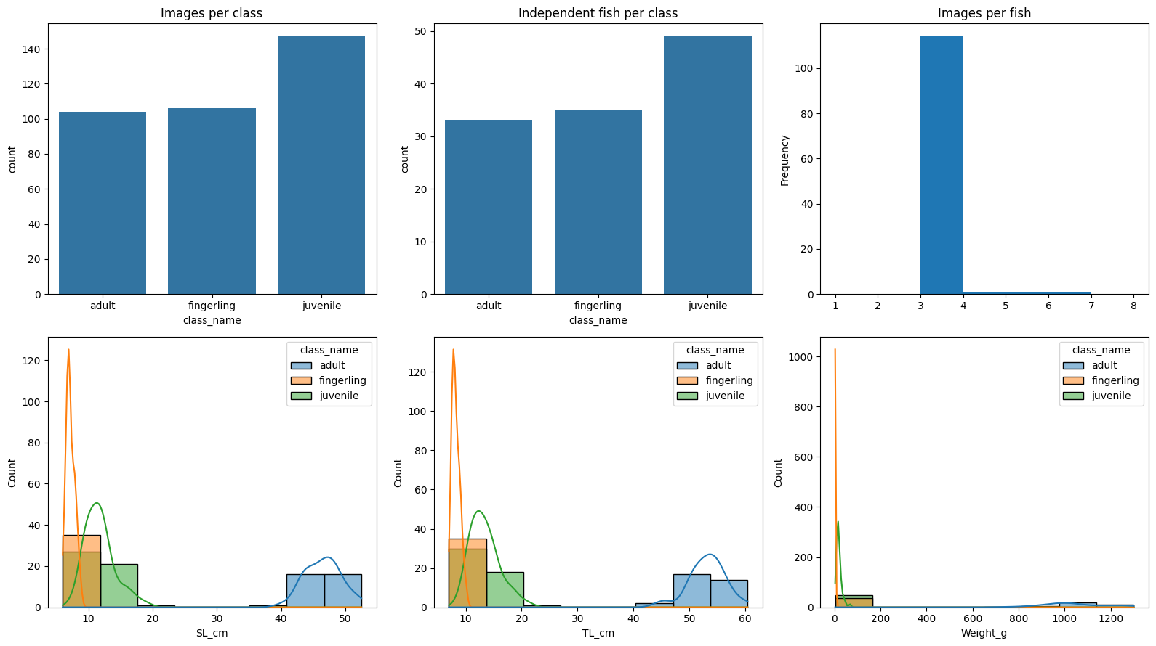
Figure 4.1: Dataset counts and exploratory distributions preserved in the notebook

4.4 Preprocessing and Leakage-Controlled Split
Images were resized to 224 × 224 pixels. Training-only augmentation included geometric and photometric transformations. Regression targets were scaled using statistics fitted on the training set: separate standard scalers for SL and TL, and log1p transformation followed by standard scaling for weight. The deterministic seed was 42.
Subset | Images | Independent fish | Adult images/fish | Fingerling images/fish | Juvenile images/fish
Training | 249 | 81 | 74 / 23 | 73 / 24 | 102 / 34
Validation | 51 | 17 | 15 / 5 | 15 / 5 | 21 / 7
Test | 57 | 19 | 15 / 5 | 18 / 6 | 24 / 8
Table 4.4: Fish-grouped data split
Leakage checks passed: no fish identity and no exact image hash occurred across training, validation and test partitions. This control was essential because randomly splitting photographs would allow different views of the same fish to occur in multiple subsets and inflate performance.

4.5 Model Implementation and Training
EfficientNetB0, MobileNetV3Large and DenseNet121 were considered during backbone selection. EfficientNetB0 produced the best validation result. The multitask model combined a shared pretrained backbone with a developmental-stage softmax head and three regression outputs for SL, TL and weight. Classification used categorical cross-entropy; regression used Huber losses with task weights of 0.25 for SL, 0.25 for TL and 0.50 for weight, alongside a classification weight of 1.00. Adam was used for head training and AdamW for fine-tuning.
The saved notebook run was explicitly a quick-mode experiment: two head-training epochs and one fine-tuning epoch, batch size 16. Cross-validation was disabled. Therefore, the reported metrics describe the archived run and should not be interpreted as a fully converged or cross-validated estimate.
Validation metric | Value
Accuracy | 92.16%
Balanced accuracy | 92.38%
Macro F1-score | 92.38%
Fingerling recall | 93.33%
Juvenile recall | 90.48%
Adult recall | 93.33%
Table 4.5: Best validation classification results

4.6 Held-Out Classification Results
On the 57-image test set, accuracy was 82.46% and macro F1-score was 81.23%. When the predictions from repeated views were aggregated at fish level, accuracy increased to 94.74% and macro F1-score to 94.34%. Fish-level results are biologically more appropriate because they evaluate the 19 independent fish rather than treating 57 correlated views as independent observations. Nevertheless, the fish-level estimate is based on a small test sample and has a wide uncertainty interval.
Metric | Image level (57 images) | Fish level (19 fish)
Accuracy | 82.46% | 94.74%
Balanced accuracy | 80.19% | 93.33%
Macro precision | 83.93% | 96.30%
Macro recall | 80.19% | 93.33%
Macro F1-score | 81.23% | 94.34%
Weighted F1-score | 82.05% | 94.60%
Juvenile recall | 91.67% | 100.00%
Table 4.6: Held-out classification performance
Fish-level statistic | Bootstrap 95% confidence interval
Accuracy | 84.21%–100.00%
Macro F1-score | 75.93%–100.00%
Juvenile recall | 100.00%–100.00%
Table 4.7: Bootstrap uncertainty for fish-level classification
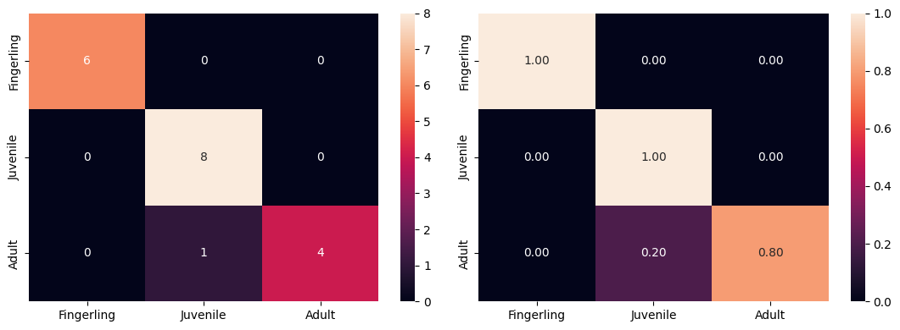
Figure 4.2: Fish-level confusion matrices
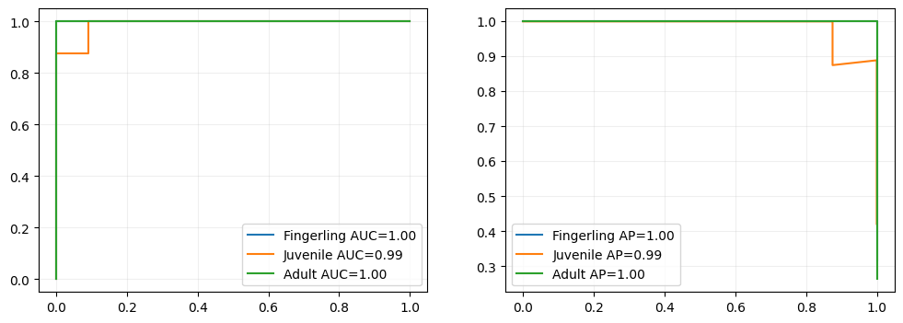
Figure 4.3: Receiver-operating-characteristic curves

4.7 Biometric Estimation Results
Biometric estimation was not sufficiently accurate for dependable field use. The fish-level model did not outperform the class-mean baseline. Weight prediction was particularly unstable, with negative R² and very high percentage error. These outcomes are consistent with the absence of a visible scale reference and with changes in camera distance and background, which prevent absolute physical size from being uniquely inferred from pixels.
Target | MAE | RMSE | R² | MAPE | Bootstrap 95% CI for MAE
SL | 11.24 cm | 14.10 cm | 0.286 | 64.49% | 7.50–15.25 cm
TL | 15.64 cm | 17.45 cm | 0.163 | 94.40% | 12.27–19.27 cm
Weight | 285.03 g | 519.33 g | −0.156 | 281.30% | 87.50–491.18 g
Table 4.8: Fish-level biometric estimation performance
Class | SL MAE | TL MAE | Weight MAE
Adult | 25.08 cm | 27.93 cm | 1003.44 g
Fingerling | 7.19 cm | 13.45 cm | 33.46 g
Juvenile | 5.62 cm | 9.60 cm | 24.71 g
Table 4.9: Class-specific biometric errors
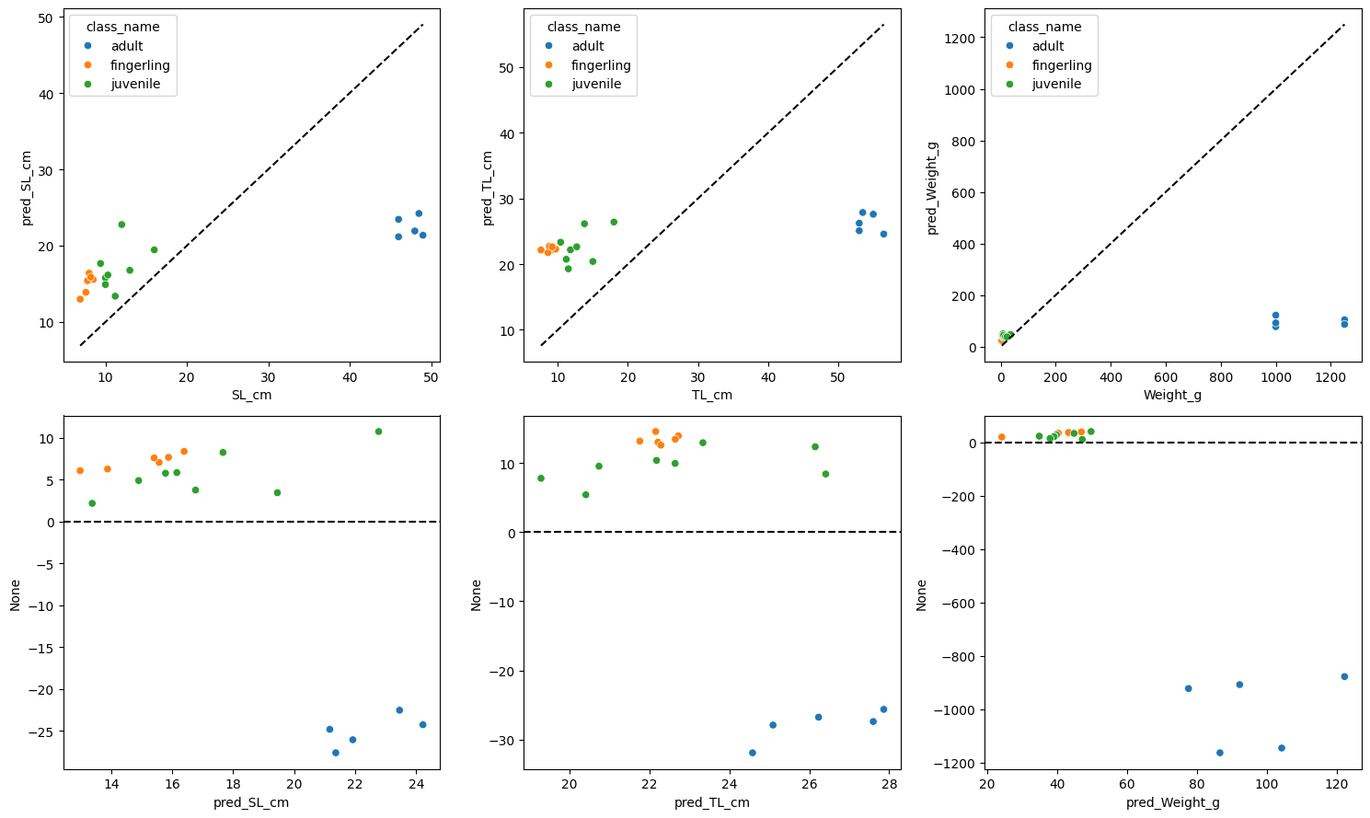
Figure 4.4: Regression diagnostic plots preserved in the notebook

4.8 Explainability Attempt
The notebook attempted to generate six Grad-CAM examples, but all attempts failed because the gradcam function was called with an unsupported class_index keyword argument. The archived output records 0 successful images out of 6. Consequently, no Grad-CAM visual is presented as a successful explainability result. Repairing and rerunning this analysis is future work.

4.9 Local Application Implementation
The Streamlit application supports image upload and webcam input, accepts JPEG and PNG files up to 10 MB, checks for unreadable, unusually small, blank, dark, bright or blurred inputs, performs a generic fish-screening check and displays the predicted stage, confidence and biometric estimates. It also reports plausibility warnings. The application has no verified public deployment, database, authentication or prediction-history subsystem; it is therefore described as a local implementation.
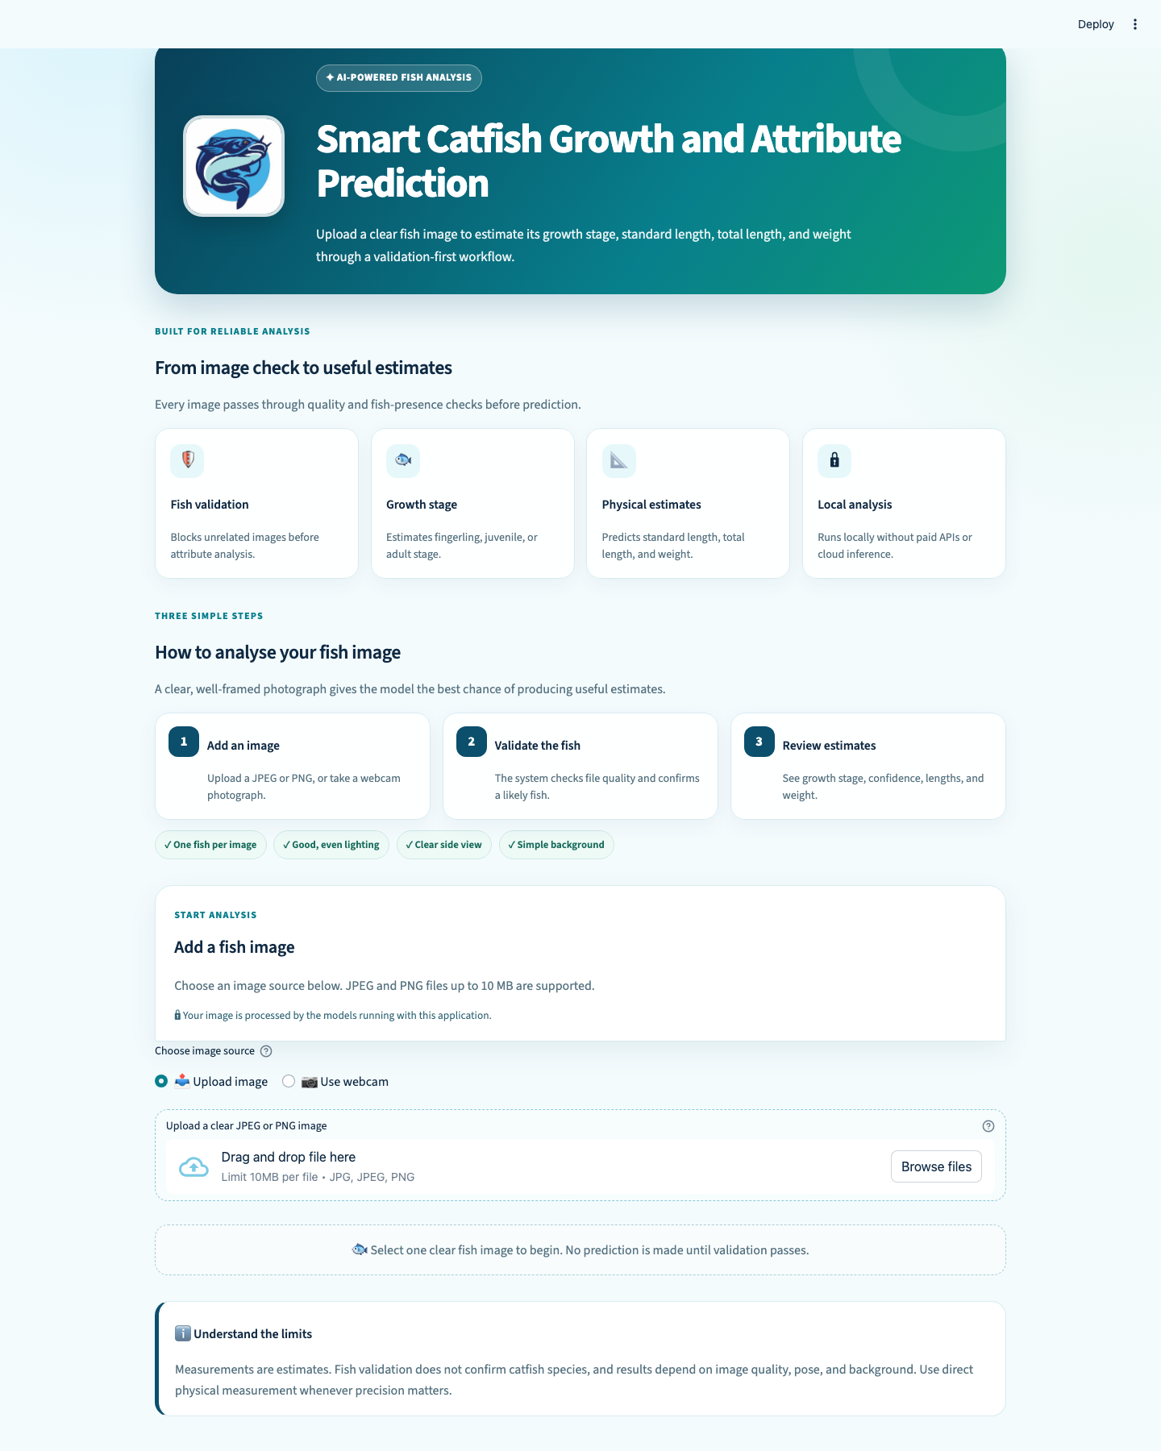
Figure 4.5: Full local Streamlit application interface

4.10 Representative Application Predictions
The archived screenshots show outputs for the three developmental-stage labels. They are interface demonstrations generated by the InceptionV3 application checkpoint and are not additional observations from the EfficientNetB0 held-out test set. The adult example produced SL greater than TL, and the application correctly displayed a plausibility warning; this illustrates the practical importance of output validation.
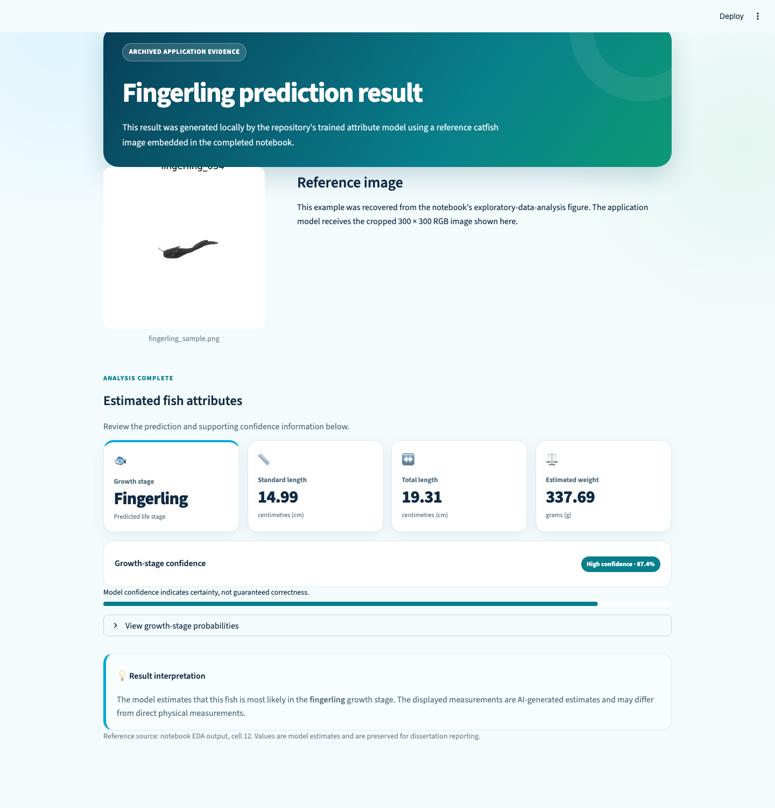
Figure 4.6: Fingerling application prediction example
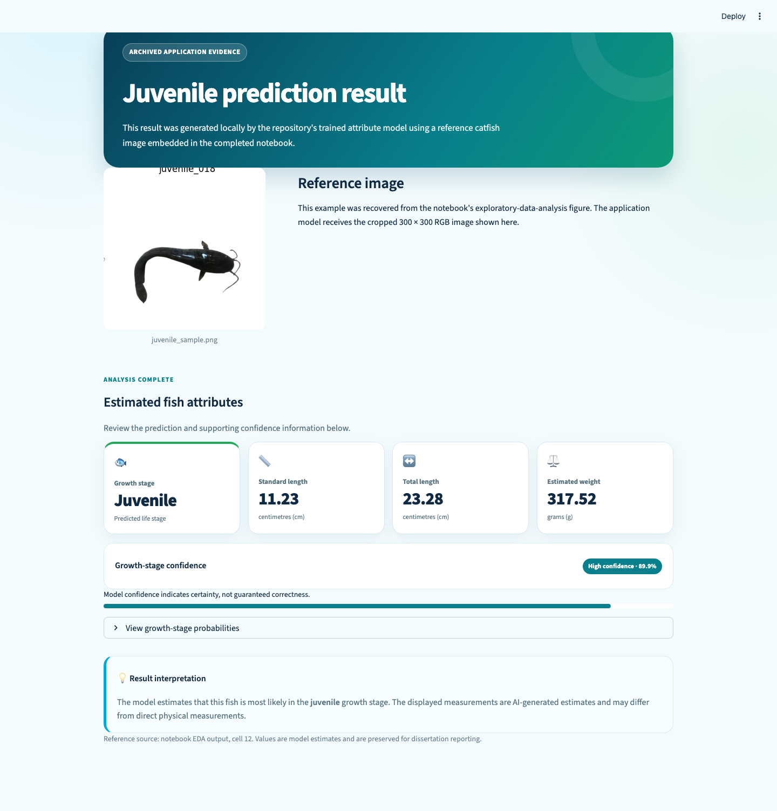
Figure 4.7: Juvenile application prediction example
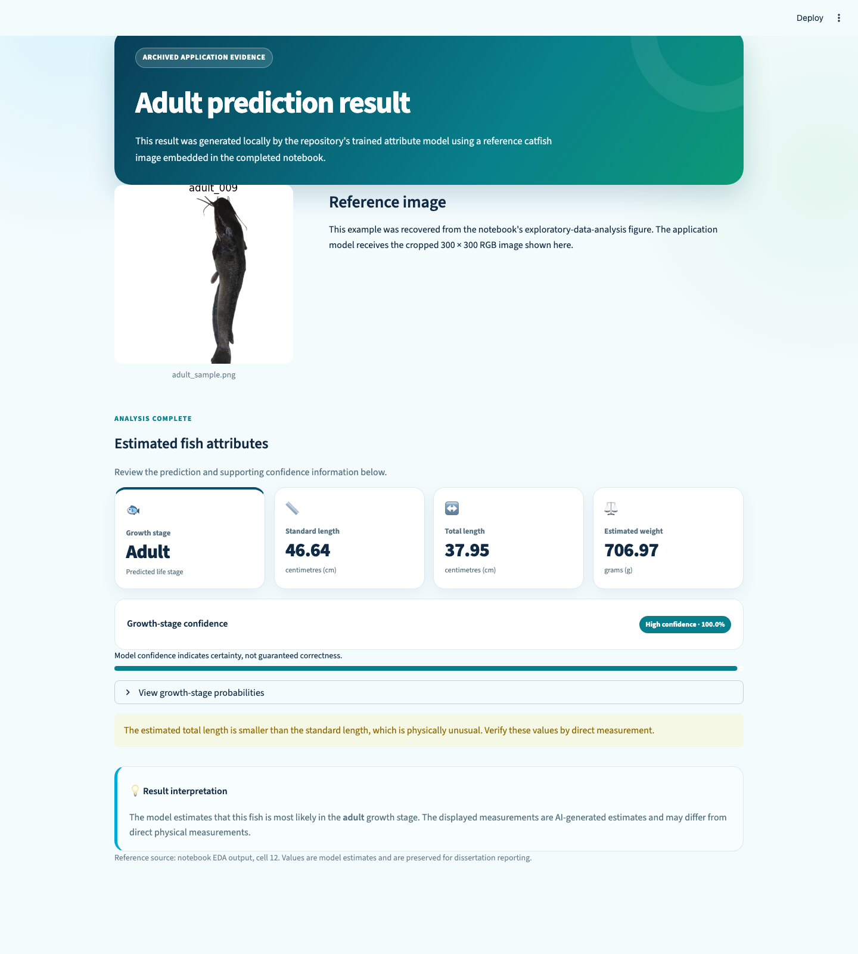
Figure 4.8: Adult application prediction with biometric plausibility warning

4.11 Software Testing
Test area | Evidence | Outcome
Image validation | Automated tests for file and image-quality checks | Passed
Preprocessing | Automated tests for input preparation | Passed
Prediction logic | Automated tests for output handling and plausibility | Passed
Analysis utilities | Automated tests for analysis functions | Passed
Complete automated suite | 31 pytest tests | 31 passed
Table 4.10: Software test summary

4.12 Discussion of Findings
The results demonstrate that transfer learning can distinguish developmental stages in the collected data, particularly when several views are combined for each fish. The increase from 82.46% image-level accuracy to 94.74% fish-level accuracy suggests that aggregating repeated observations can reduce view-specific uncertainty. However, only 19 independent fish were available in the test set, so the apparent improvement requires confirmation on a larger external cohort.
The regression results do not support claims of accurate image-only length or weight measurement. Classification can exploit shape, texture and contextual differences associated with development, whereas absolute physical measurements require scale. Camera-to-fish distance, perspective and background can make different-sized fish occupy similar pixel dimensions. The adult errors and negative weight R² reinforce this limitation.
Finally, the model mismatch affects reproducibility. The evaluated EfficientNetB0 checkpoint and preprocessing artifacts were not preserved in the repository, whereas an InceptionV3 weights file was preserved for the application. A future release should export the selected model, scalers, class map and a machine-readable test-prediction file as a single versioned bundle.

4.13 Chapter Summary
This chapter reported leakage-controlled classification results, biometric errors, application demonstrations and software tests. The study provides promising stage-classification evidence, but the biometric component, Grad-CAM analysis and public deployment objective remain incomplete.

CHAPTER FIVE

SUMMARY, CONCLUSION AND RECOMMENDATIONS

5.0 Introduction
This chapter summarizes the study, relates the verified evidence to the objectives, presents the conclusion and states the contributions, limitations and recommendations.

5.1 Summary of the Study
The study investigated whether transfer learning could classify African catfish images into fingerling, juvenile and adult stages and estimate SL, TL and weight. A fish-grouped evaluation design was used to prevent repeated photographs of the same fish from crossing data partitions. The preserved notebook evaluated an EfficientNetB0 multitask model, while a separate InceptionV3 checkpoint supported a local Streamlit demonstration application.

5.2 Summary of Major Findings
Objective | Verified finding | Status
Collect and preprocess a catfish dataset | 357 valid images from 117 fish were audited and prepared. | Achieved in archived run; original input archive is not in repository
Train a stage classifier and biometric estimator | EfficientNetB0 was trained; fish-level macro F1 was 94.34%, but regression did not beat the class-mean baseline. | Partly achieved
Develop a user-friendly web application | A local Streamlit app supports upload/webcam, validation and results display. | Achieved locally
Evaluate classification and regression | Image- and fish-level metrics, confidence intervals and regression errors were recorded. | Achieved; no independent expert comparison study
Deploy the application | No public URL or hosting evidence exists. | Not achieved; local implementation only
Table 5.1: Findings mapped to the study objectives

5.3 Conclusion
The study concludes that CNN transfer learning is a promising approach for classifying the developmental stage of African catfish from photographs when evaluation is performed at the independent-fish level. The archived experiment achieved 94.74% fish-level accuracy, although the small 19-fish test set limits precision and external validity. The evidence does not support dependable image-only estimates of absolute length or weight: all regression errors were high, weight R² was negative and the model failed to outperform the class-mean baseline. Therefore, the application should presently be treated as a research prototype for stage classification and interface evaluation, not as a validated biometric measurement or production deployment system.

5.4 Contributions of the Study
- A locally collected dataset structure that explicitly identifies 117 independent fish across three developmental stages.
- A leakage-controlled evaluation protocol that groups repeated photographs by fish identity.
- Direct comparison of image-level and fish-level classification, showing the value of multi-view aggregation.
- A multitask proof of concept that reports both successes and failure modes for classification and biometric estimation.
- A tested local Streamlit interface with image-quality checks and biometric plausibility warnings.

5.5 Limitations
- Only 117 independent fish were available, with 19 fish in the test set and wide bootstrap intervals.
- The saved run used quick-mode training for three total epochs and did not perform cross-validation.
- Photographs lacked a fixed acquisition geometry or visible scale reference, confounding absolute size with camera distance and perspective.
- The evaluated EfficientNetB0 checkpoint and scalers were not preserved, limiting exact reproduction of notebook predictions.
- The application uses a different InceptionV3 checkpoint; its screenshots are demonstrations rather than held-out EfficientNetB0 evidence.
- Grad-CAM generation failed, so model attention was not successfully verified.
- No external-site validation, independent expert-comparison protocol or public deployment evidence was available.

5.6 Recommendations
- Collect a substantially larger dataset from multiple farms, cameras, operators, backgrounds and seasons, retaining unique fish identifiers.
- Use a calibration board, ruler or known-size marker in every photograph and standardize camera distance and orientation.
- Evaluate on an untouched external farm dataset and report fish-level confidence intervals as the primary biological analysis.
- Train to convergence with early stopping and repeated grouped cross-validation, followed by a single locked test evaluation.
- Export the selected model, preprocessing scalers, label map, environment lock file and test predictions as one versioned artifact.
- Repair Grad-CAM and include sanity checks before making explainability claims.
- Unify the application and research model, then perform usability, latency and reliability testing before public deployment.

5.7 Suggestions for Future Work
Future work should investigate segmentation-based length measurement, calibrated monocular geometry, stereo or depth cameras, and multi-view fusion. Ordinal-stage modelling may better reflect the progressive nature of growth than an unconstrained three-class output. For weight estimation, future studies should combine calibrated length, body-width and condition-factor features rather than depend on an unscaled photograph alone. A prospective field study should compare predictions against standardized manual measurements made by trained fisheries personnel.

REFERENCES
Ahmad, U., Ali, M. J., Khan, F. A., Khan, A. A., Rehman, A. U., Shahid, M. M. A., Haq, M. A., Khan, I., & Zamil, S. (2023). Large scale fish images classification and localization using transfer learning and localization-aware CNN architecture. Computer Systems Science and Engineering, 45(2), 2125–2140. https://doi.org/10.32604/csse.2023.031008
Deka, J., Laskar, S., & Baklial, B. (2023). Automated freshwater fish species classification using deep CNN. Journal of The Institution of Engineers (India): Series B, 104(3), 603–621. https://doi.org/10.1007/s40031-023-00883-2
Dosovitskiy, A., Beyer, L., Kolesnikov, A., Weissenborn, D., Zhai, X., Unterthiner, T., et al. (2021). An image is worth 16×16 words: Transformers for image recognition at scale. International Conference on Learning Representations.
Goodfellow, I., Bengio, Y., & Courville, A. (2016). Deep learning. MIT Press.
Hasegawa, T., Kondo, K., & Senou, H. (2024). Transferable deep learning model for the identification of fish species for various fishing grounds. Journal of Marine Science and Engineering, 12(3).
He, K., Zhang, X., Ren, S., & Sun, J. (2016). Deep residual learning for image recognition. Proceedings of the IEEE Conference on Computer Vision and Pattern Recognition, 770–778.
Huang, G., Liu, Z., van der Maaten, L., & Weinberger, K. Q. (2017). Densely connected convolutional networks. Proceedings of the IEEE Conference on Computer Vision and Pattern Recognition, 4700–4708.
Krizhevsky, A., Sutskever, I., & Hinton, G. E. (2012). ImageNet classification with deep convolutional neural networks. Advances in Neural Information Processing Systems, 25.
LeCun, Y., Bottou, L., Bengio, Y., & Haffner, P. (1998). Gradient-based learning applied to document recognition. Proceedings of the IEEE, 86(11), 2278–2324.
Pan, S. J., & Yang, Q. (2010). A survey on transfer learning. IEEE Transactions on Knowledge and Data Engineering, 22(10), 1345–1359.
Selvaraju, R. R., Cogswell, M., Das, A., Vedantam, R., Parikh, D., & Batra, D. (2017). Grad-CAM: Visual explanations from deep networks via gradient-based localization. Proceedings of the IEEE International Conference on Computer Vision, 618–626.
Shorten, C., & Khoshgoftaar, T. M. (2019). A survey on image data augmentation for deep learning. Journal of Big Data, 6, 60.
Simonyan, K., & Zisserman, A. (2015). Very deep convolutional networks for large-scale image recognition. International Conference on Learning Representations.
Tan, M., & Le, Q. V. (2019). EfficientNet: Rethinking model scaling for convolutional neural networks. Proceedings of the 36th International Conference on Machine Learning, 6105–6114.
Ameh, J. J. (2026). Catfish attribute prediction [Computer software and research repository]. GitHub. https://github.com/bechosen-spec/catfish-attribute-prediction
Editorial note: several recent empirical citations retained from the supplied Chapter Two manuscript require final verification against the author’s source copies before institutional submission; incomplete bibliographic records were not invented in this compilation.

APPENDIX A: REPRODUCIBILITY AND EVIDENCE CHECKLIST
Artifact | Available | Interpretation
Original notebook with embedded outputs | Yes | Supports archived metrics and figures
Original dataset ZIP and spreadsheets | No | Dataset cannot be reconstructed from repository alone
EfficientNetB0 final .keras checkpoint | No | Exact notebook inference cannot be rerun
InceptionV3 application weights | Yes | Supports local application inference
Regression scalers from notebook run | No | Required for exact biometric reproduction
Application screenshots | Yes | Supports interface description only
Automated tests | Yes | 31 tests passed during audit
Public deployment URL | No | No deployment claim made
Repository URL | Yes | https://github.com/bechosen-spec/catfish-attribute-prediction

APPENDIX B: LOCAL APPLICATION USER GUIDE
1. Create a Python environment and install the packages listed in requirements.txt.
2. Ensure InceptionV3_best_model.weights.h5 is located in the repository root.
3. Start the interface with: streamlit run app.py
4. Upload a clear JPEG or PNG catfish image (maximum 10 MB) or use the webcam option.
5. Review the predicted stage, confidence, SL, TL and weight values. Treat biometric values as experimental estimates and observe any plausibility warning.
6. Do not use the current prototype for commercial grading or biological measurement without external validation and image calibration.

APPENDIX C: REPOSITORY STRUCTURE
Key files include app.py (Streamlit entry point), src/model.py (application architecture), src/prediction.py (inference), src/image_validator.py (input checks), catfish_multitask_colab.ipynb (archived experiment), InceptionV3_best_model.weights.h5 (application checkpoint), tests/ (automated tests), and chapter_4_5_materials/ (extracted notebook outputs and application screenshots).

APPENDIX D: AUDIT TRAIL FOR REPORTED RESULTS
All numerical results in Chapters Four and Five were transcribed from the embedded outputs of catfish_multitask_colab.ipynb and the extracted materials in chapter_4_5_materials. The application description was checked against the repository source and archived screenshots. The original Chapters One to Three were retained as the manuscript foundation, with targeted corrections for the aim, local-implementation objective, 224 × 224 input resolution, SL/TL terminology, Huber regression loss and Streamlit implementation.

