Stable Transitional Strato/Altocumulus Clouds
MCEN 5151 - Clouds First
9/29/25 6:45 PM, Chautauqua Park, Boulder, CO
Beck Hermann

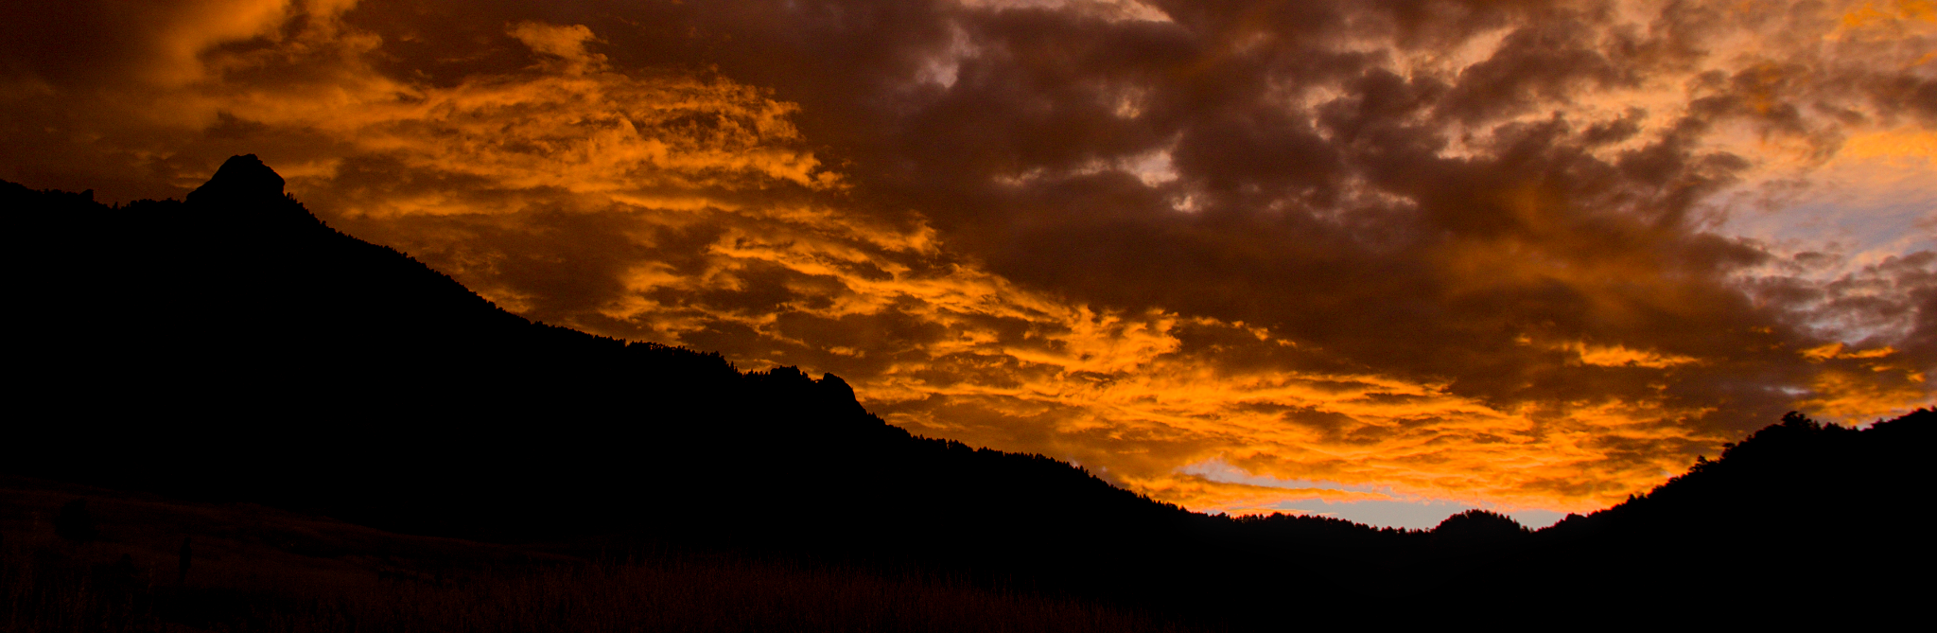
Figure 1: Clouds First Submission, by Beck Hermann

This picture was taken for the Clouds First assignment. The sun was going down, and as soon as I got out of class that day, I rushed up to the park because I hoped to capture the brilliance of the clouds at sunset. The mountain backdrop was also a goal of mine, and I am happy to have captured a panoramic view of the Flatirons and Flagstaff Mountain.
The photograph was captured on September 29th, at 6:45 PM, at the base of Chautauqua Park in Boulder, CO. The camera was at an elevation of 5,700 feet and aimed towards the west-northwest and angled about 15 degrees above the horizontal to capture all the context.
The clouds are most likely stable transitional strato/altocumulus clouds, covering a large area above the mountains and park. I came to this conclusion by comparing the general look of the clouds to a reference chart on FlowVis.org that described differently cloud types. Additionally, I referenced a cielometer reflectivity chart by the University of Colorado. The chart from the day and time can be seen in Figure 2, and it can be seen that there is cloud activity at ~2km. This confirms that the identification of the clouds in my image is transitional from alto to strato.

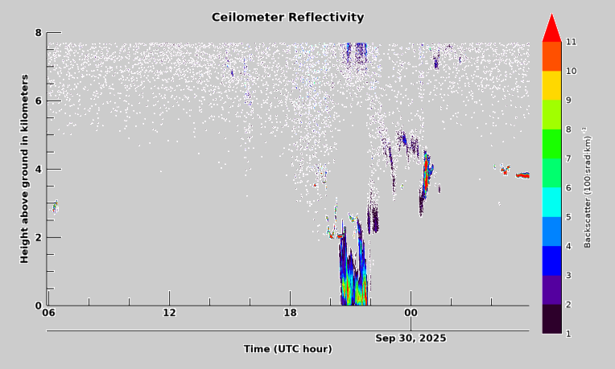
Figure 2: Ceilometer Data during my cloud formation
The rest of the sky around the Boulder/Front Range area was also cloudy, but showed more altostratus and general grey skies. The previous weather that day had light cirrus clouds and some very light showers (0.21”) a couple hours before my image was taken. Throughout the days leading up to September 29th, Wunderground reported 0’ precipitation and no front was observed before or after. In Figure 3 below, you can see an all-sky cloud taken by CU Skywatch Observatory that shows the day of.

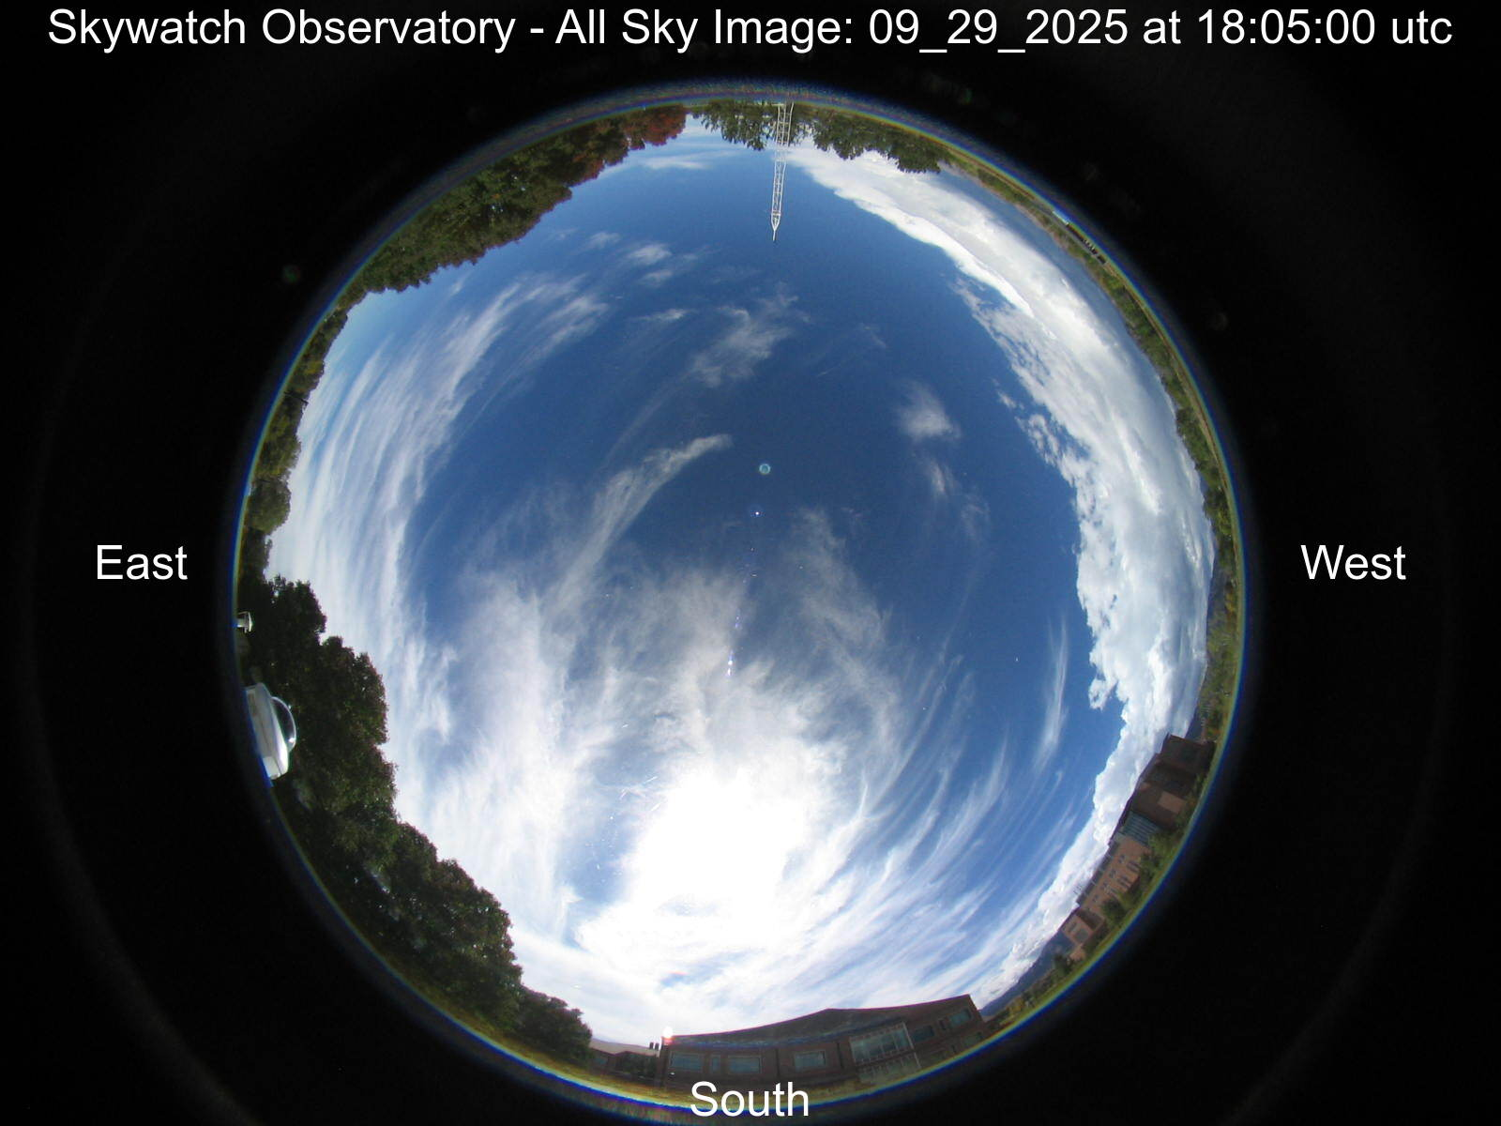
Figure 3: Skywatch Observatory all-sky image from September 29, 2025

The days after September 29th were quite like the ones leading up to it: nealy no precipitation, very little winds and clouds, and no fronts expected. I was lucky to have captured such a unique cloud formation during the day I chose to go out. The stability of the atmosphere was stable, which was detremiend by analyzing the CAPE number from a Skew T diagram from Grand Junction (seen below in Figure 4). The number was 17, which on a scale of 0-1000, is very low and indicates a stable atmosphere.

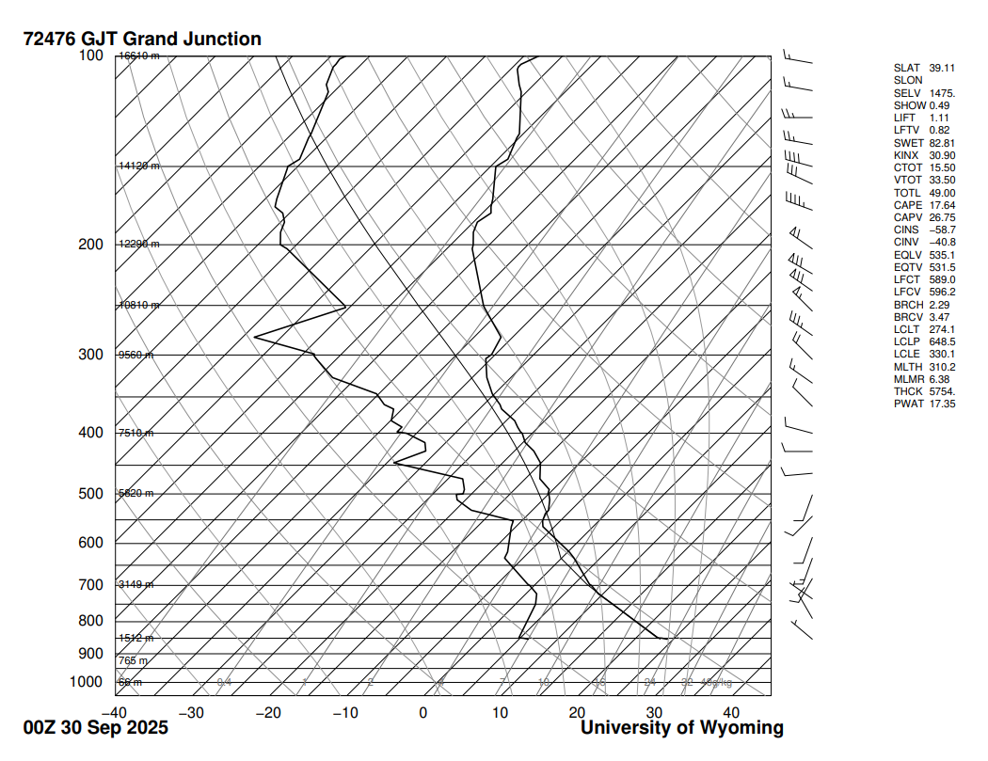
Figure 4: Skew T Diagram GJT

As discussed above, the elevation, atmospheric stability, and weather conditions support my cloud identification and one would normally expect to see alto or stratocumulus clouds. The physics behind this cloud formation starts with rising air cooling into a visible cloud layer. This cloud formation stars to mix and create turbulence as the tops of the clouds loose heat, the clouds sink, and the falling creates mixing that brings air back up and repeats the cycle (Barrett 2020).
My camera is a digital Canon Rebel T3i that shot the image with an original size of 5202x3464 pixels and edited to be 4601x1502 pixels. The lens has a 18-135mm focal range with a 67mm diameter. The image was shot in RAW with an f stop of f/6.3, shutter speed of 1/250, and ISO of 200. All editing I did was to color balance and make the orange more brilliant. I changed the exposure, increased the contrast, and make sure to use the rgb curve to capture the best warm colors I could get. The RAW image is below, in Figure 5.
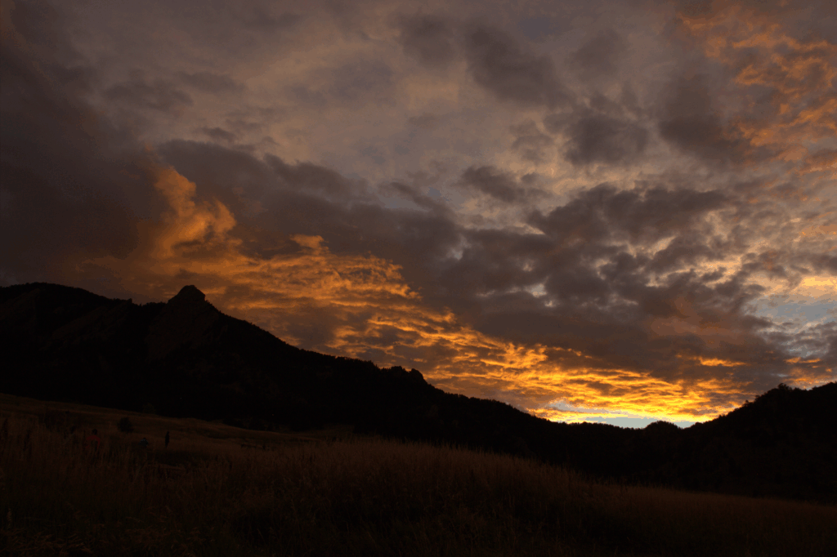
Figure 5: RAW Clouds Image

I personally love my image very much and might get it framed! The panorama of the shillouettted Flatirons brings out everything I wanted the image to be. The colors are stunning and representative of what I saw with my eyes. I am incredibly proud and am looking forward to the second clouds assignment. I am happy to have captured a beautiful cloud formation at sunset. In the future, I would try to get a different angle/location to view the mountains.

Sources

University of Colorado Boulder Skywatch Observatory: All-sky camera archive (Boulder, CO), available at: https://skywatch.colorado.edu/
(last access: 21 October 2025).

Flow Visualization (University of Colorado Boulder): Clouds 1 – Names (cloud identification guide), available at: https://www.flowvis.org/Flow%20Vis%20Guide/clouds-1-names/
(last access: 21 October 2025).

Weather Underground: Weekly Weather History – Boulder, CO (KBDU), week of 24 September 2025, available at: https://www.wunderground.com/history/weekly/us/co/boulder/KBDU/date/2025-9-24
(last access: 21 October 2025).

Barrett, P. A., Blyth, A., Brown, P. R. A., and Abel, S. J.: The structure of turbulence and mixed-phase cloud microphysics in a highly supercooled altocumulus cloud, Atmos. Chem. Phys., 20, 1921–1939, https://doi.org/10.5194/acp-20-1921-2020, 2020.

