Stable Altocumulus Undulatus Clouds
MCEN 5151 - Clouds Second
11/12/2025 08:28 AM, University of Colorado Boulder Campus, Boulder, CO
Beck Hermann

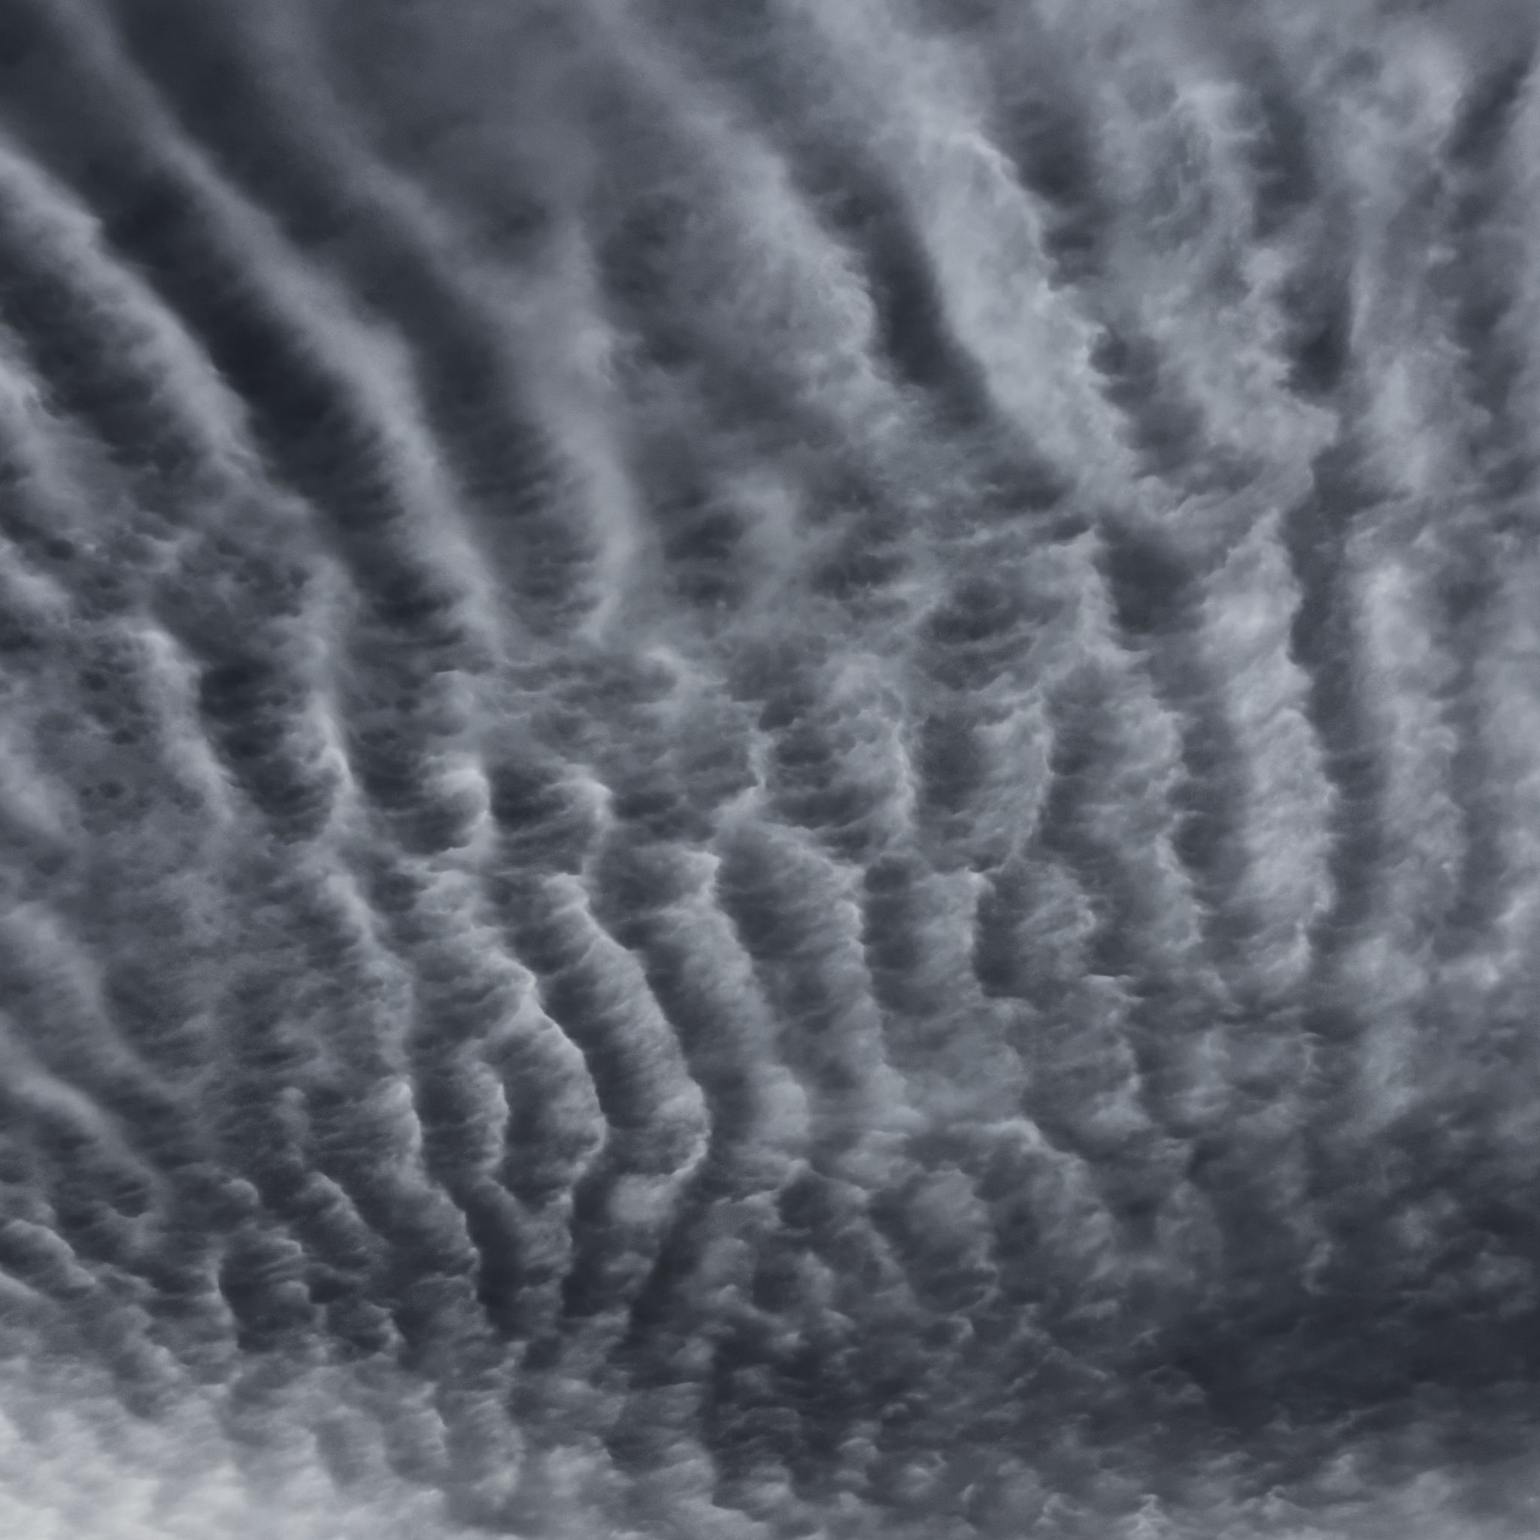
Figure 1: Clouds Second Submission, by Beck Hermann

This picture was taken for the Clouds Second assignment. For weeks, in Boulder, there had been incredible cloud formations that always caught my eye, but on this day, during my walk to class, the clouds above me had something different about them that I knew I had to capture. I did not know at first what type of clouds these were, but they reminded me of what the sand looks like underneath the ocean on a summer day. I researched later what they could be, and became fascinated that these cloud shapes are formed the same way the sand ripples are formed in the water.
The photograph was captured on November 12th, at 8:28 AM, on CU Boulder’s campus just north of the Engineering Center in Boulder, CO. The exact coordinates are 40.00755 N, 105.26559 W. The camera was at an elevation of 5,388 feet and aimed towards the east, and angled about 65 degrees above the horizontal.
The clouds are most likely stable transitional stable altocumulus undulatus clouds that were covering a large area above campus and east campus. I came to this conclusion by comparing the general look of the clouds to a reference picture from The International Cloud Atlas, and the description that they are “arranged in ranks and files having the appearance of two distinct systems of undulations” (International Cloud Atlas). Additionally, I referenced a cielometer reflectivity chart by the University of Colorado. The chart from the day and time can be seen in Figure 2, and it can be seen that there is cloud activity at ~6km at the time of my image, 8:30 AM. This confirms the altocumulus identification of the clouds in my image because “Medium clouds [form] base usually between 6,500 and 20,000 ft over [the ground]” (Cloud Types for Observers, pg 2). This converts to 2km - 6km. My clouds may be transitional from altocumulus to stratocumulus.

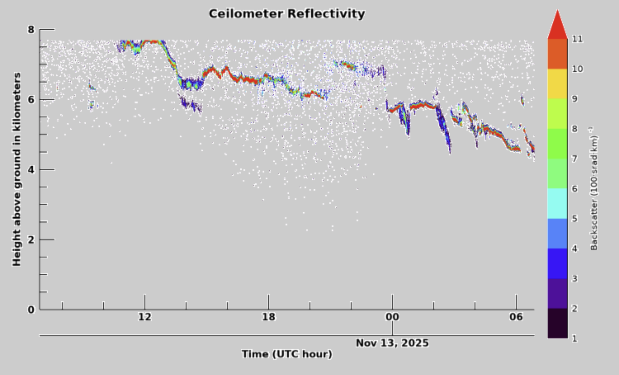
Figure 2: Ceilometer Data during my cloud formation

The rest of the sky around the Boulder/Front Range area was semi-cloudy and had some unique, smooth-looking clouds in other areas of the sky. The previous weather that day was slightly overcast with no precipitation. Throughout the days leading up to November 12th, Wunderground reported 0’ precipitation, and no front was observed before or after. In Figure 3 below, you can see an all-sky cloud taken by CU Skywatch Observatory that shows the day of.

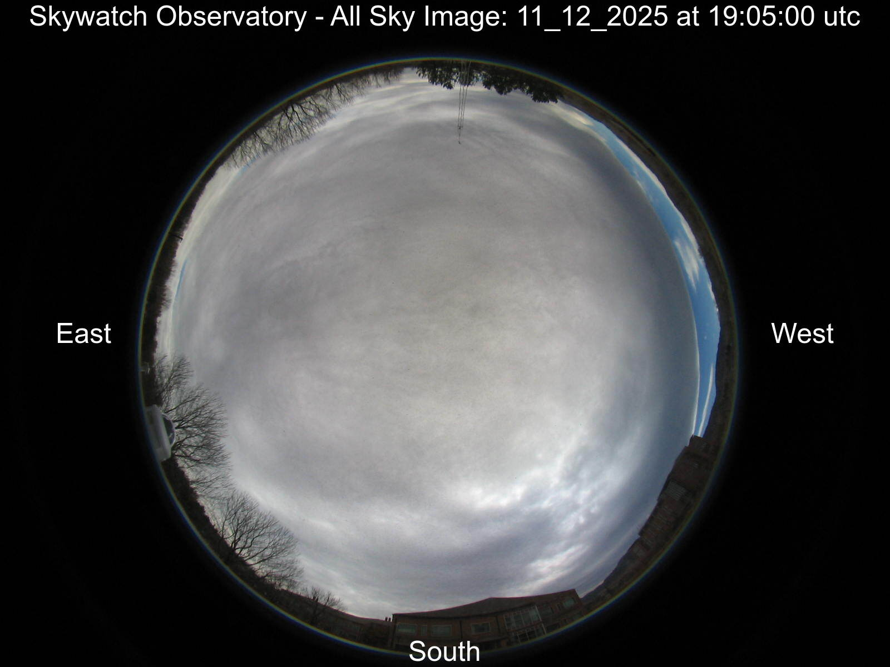
Figure 3: Skywatch Observatory all-sky image from November 12, 2025

The days after November 12th were quite like the ones leading up to it: nearly no precipitation, light to high wind, clouds covering, and no fronts expected. I was lucky to have captured such a unique cloud formation during my walk to class. The stability of the atmosphere was stable, which was determined by analyzing the CAPE number from a Skew T diagram from Grand Junction (seen below in Figure 4). The number was 0, which on a scale of 0-1000, indicates a stable atmosphere.

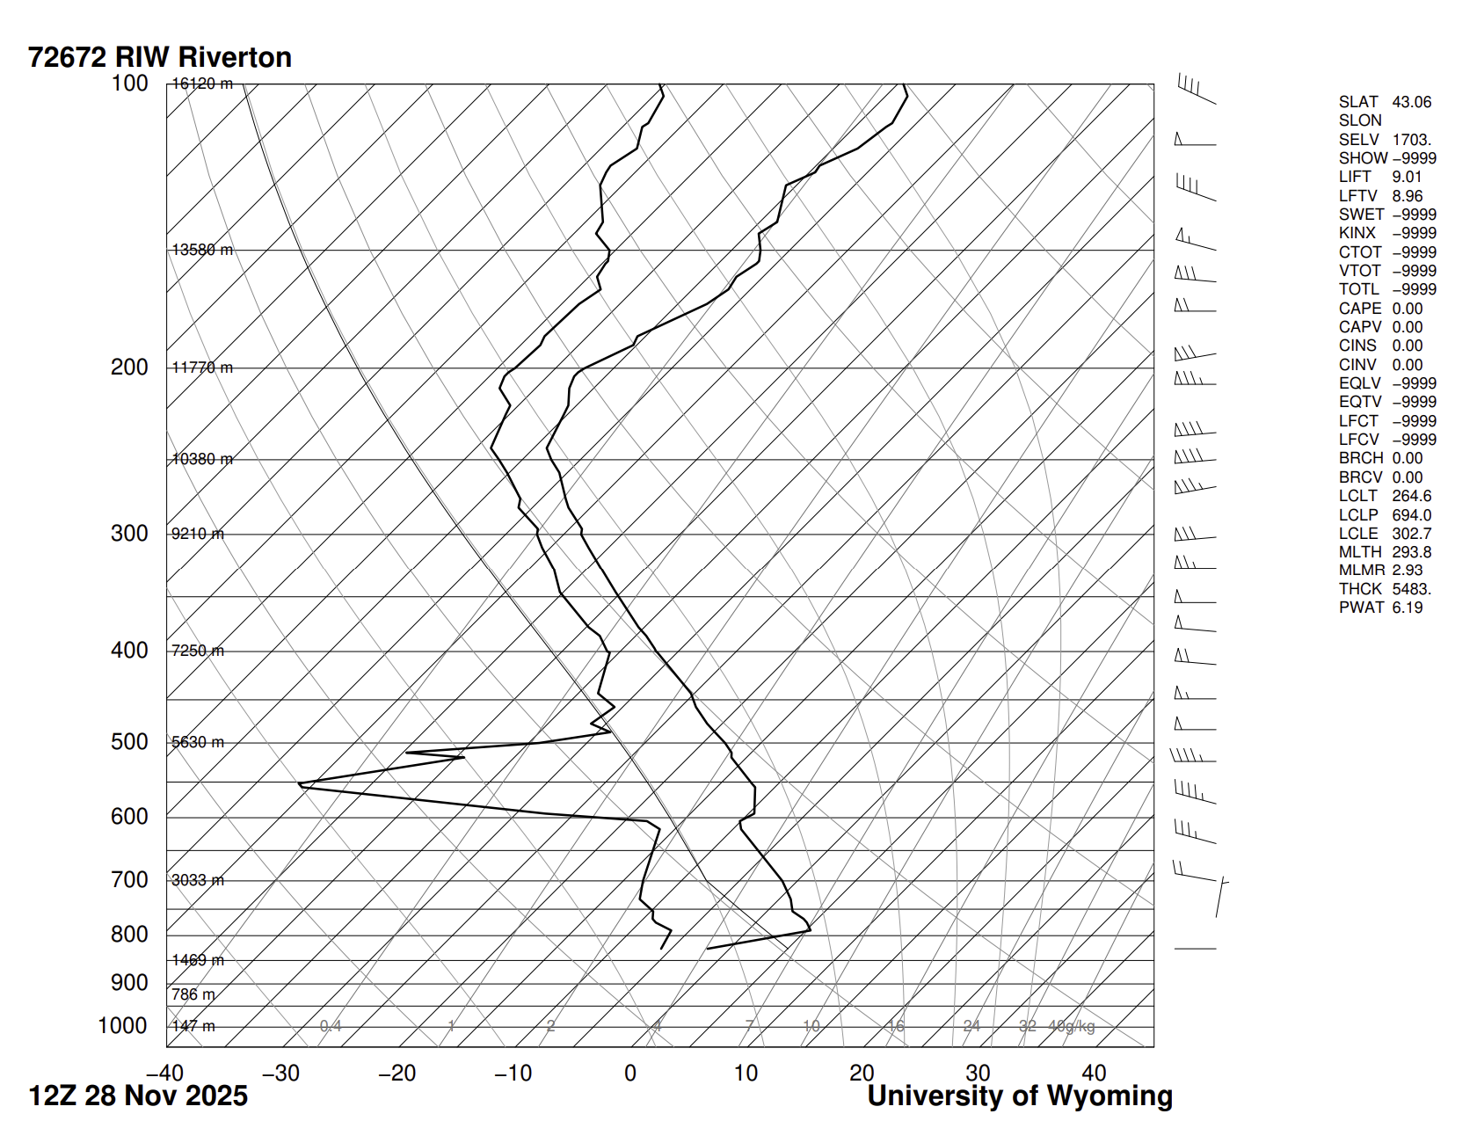
Figure 4: Skew T Diagram GJT

As discussed above, the elevation, atmospheric stability, and weather conditions support my cloud identification, and one would normally expect to see altocumulus clouds. The physics behind this cloud formation starts with rising air cooling into a visible cloud layer. This cloud formation starts to mix and as the air near the clouds sinks and gets warmer, the “initial disturbance creates a propagating wave” (NASA) that spreads and continuously forms the wave-like crests that create the look of sand in the ocean. Sand under the ocean creates these same patterns by the same physics as the continuous propagation of disturbances makes the peaks and dips.
I did not have my good camera on my walk to class, so I shot the image with my iPhone 15 with an original image size of 4284x5712 pixels and edited it to be 3913x3913 pixels. The phone had a focal length of 6mm and an f-stop of f/1.6, shutter speed of 1/1418, and ISO of 50. All editing I did was to increase the look of the “waves.” I wanted to get a dark image that showed the depth of the ripples and achieved this by modifying mainly the RGB curve and local contrast. The unedited image is below, in Figure 5.
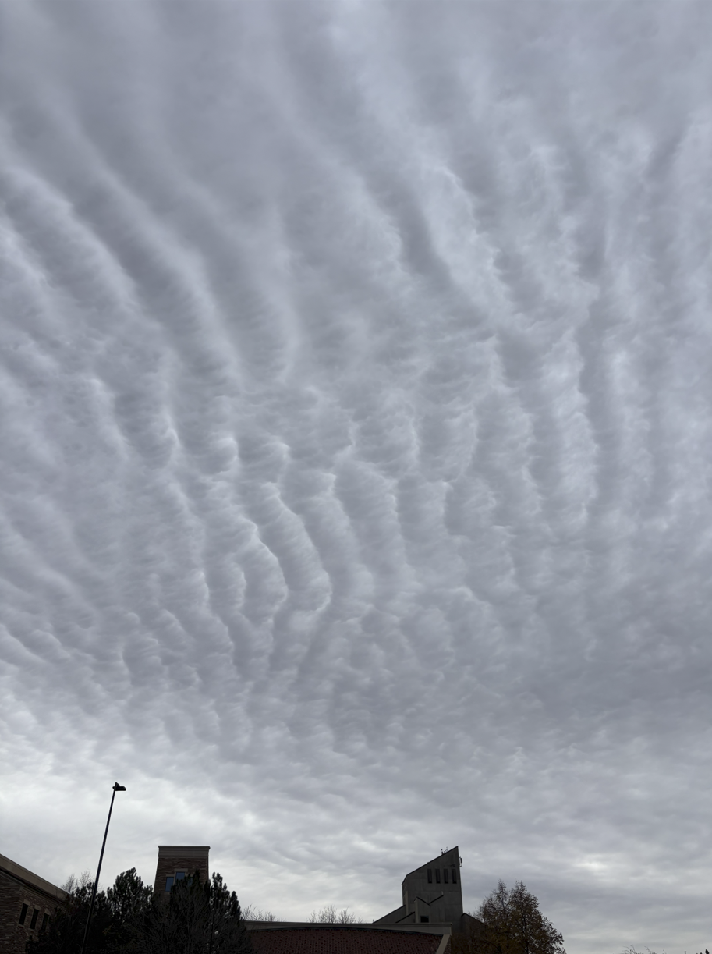
Figure 5: Original Clouds Image

I personally love my image very much and would love to see it on a large screen, such as a projector! The editing I did brings out everything I wanted the image to be. The dark colors are stunning and reveal emotions of uncertainty and coldness, like winter. I am incredibly proud and will now start looking up at every cloud more often. I am happy to have captured a beautiful cloud formation while walking to class. In the future, I would try more post-processing to see what other emotions I could invoke.

Sources

University of Colorado Boulder Skywatch Observatory: All-sky camera archive (Boulder, CO), available at: https://skywatch.colorado.edu/
(last access: 2 December 2025).

Cloud Types for Observers Reading the Sky, www.metoffice.gov.uk/binaries/content/assets/metofficegovuk/pdf/research/library-and-archive/library/publications/weather--climate-guides/cloud_types_for_observers_rev_2014.pdf. Accessed 3 Dec. 2025.

Wmo. “Altocumulus Undulatus (AC UN).” International Cloud Atlas, cloudatlas.wmo.int/en/varieties-altocumulus-undulatus-ac-un.html. Accessed 2 Dec. 2025.

“The Undulations of Wave Clouds.” NASA, NASA, earthobservatory.nasa.gov/images/147380/the-undulations-of-wave-clouds. Accessed 2 Dec. 2025.

