Sinking Bubbles
MCEN 5151 - Get Wet
Beck Hermann, 9/16/2025
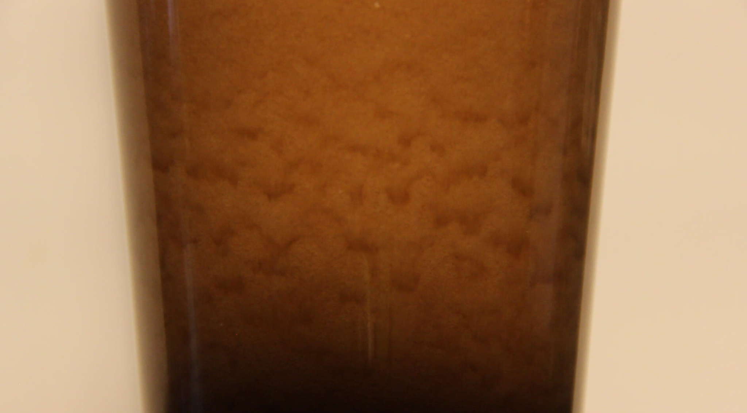
Figure 1: Screenshot from my video submission titled “Sinking Bubbles”

Sinking Bubbles is my video submission for 2025 Get Wet. The video depicts a pint glass immediately after Guinness had been poured into it, focusing on the time period when the nitrogen air pockets in the stout are cascading along the sides of the glass. I successfully captured the waves of sinking bubbles as they travel down the angled glass surface to collect at the bottom and settle.
A sloped glass, such as the 16-oz pint glass used in my video, is one of the reasons Guinness bubbles sink. A straight glass or anti-pint glass would not achieve the same effect, so a classic pint glass was used to contain my liquid (Benilov 2013). The physics as to why a sloped glass is necessary will be discussed later in this report. The flow was produced by pouring a fresh can of Guinness stout into the glass, where the only boundary was the sides of the glass. When poured, the can was directly upside down and no more than ½” away from the rising liquid level to preserve taste and bubble quantity. Please refer to Figure 2, below, for a diagram of the flow apparatus.
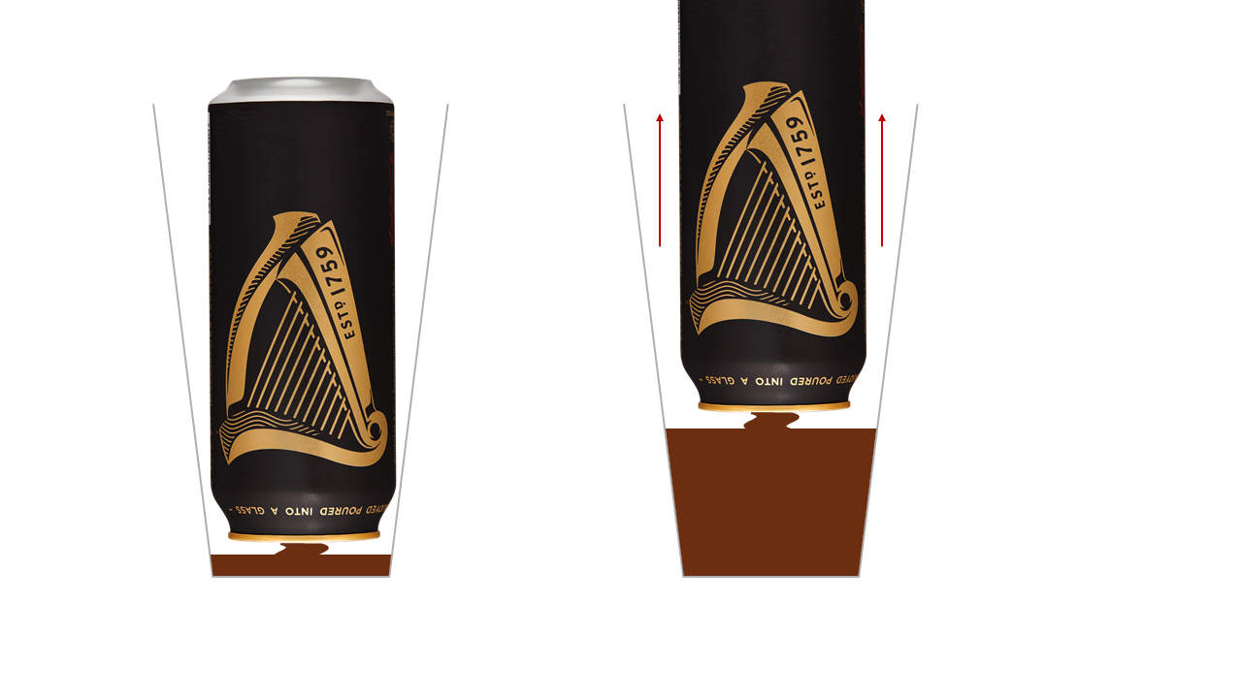
Figure 2: Flow apparatus sketch showing the proximity of the can to the liquid level when pouring the pint

The sinking bubbles phenomenon is a result of the small size of nitrogen bubbles in Guinness, the sloped shape of a pint glass, and the many forces that drive a circular flow within the liquid once the initial churn has settled (Benilov 2013). Eugene Benilov, from the University of Limerick, and others studied in depth what drives Guinness bubbles down. Why do bubbles in Guinness sink? by Benilov et al presents the above reasons as drivers of my flow.
The first property relevant to my flow phenomenon is the dimensionless bond number, which determines if the effects of surface tension are dominant (Benilov 2013). This was calculated by Benilov to be 0.002, meaning the bubbles in Guinness are proven to be spherical, and Stokes’ formula for a rigid sphere can be used to calculate the characteristic bubble velocity u_{b}:
$u_{b}=\frac{(ρ_{l}-ρ_{b})gd_{b}^{2}}{18μ_{l}}=\frac{(1007\frac{kg}{m^{3}} - 1.223\frac{kg}{m^{3}})(9.81\frac{m}{s^{2}})(122μm)^{2}}{18(2.06×10^{-3}Pa)}≈4 mm/s$
This number describes the speed at which Guinness bubbles rise (in the absence of non-buoyant forces), where ρ_{l} and ρ_{b} are the densities of the liquid and the bubble, d_{b} is the characteristic diameter, and μ_{l} is the viscosity of the liquid. These values were measured and verified by the researchers who authored Why do bubbles in Guinness sink?. The characteristic velocity can be used to calculate the Reynolds number, another nondimensional number that tells us more about the flow:
$Re=\frac{ρ_{l}μ_{b}d_{b}}{μ_{l}}=\frac{(1007\frac{kg}{m^{3}})(0.017×10^{-3}Pa)(122μm)}{2.06×10^{-3}Pa} ≈ 0.25$
The extremely small Reynolds’ number means that viscous forces will dominate the inertial forces in the flow, and that the bubbles will move slowly and gently without any turbulence. Although the characteristic bubble velocity is 4 mm/s, the bubbles only rise at this rate and fall much faster at around 25-30 mm/s (Benilov 2013) due to the vortex, which I will discuss next.
The main force on the bubbles that start the sinking effect is the buoyancy. This Archimedean force pulls them up through a direct upward current through the center cylinder of the pint glass. Once they reach the top of the glass, they are pulled back down the walls to create the wave effect. The reason the bubbles fall along the walls of the glass is due to a circulatory flow that is formed by a bubble density gradient along the walls. Figure 3, created by Benilov, shows this flow in a pint and an anti-pint glass.
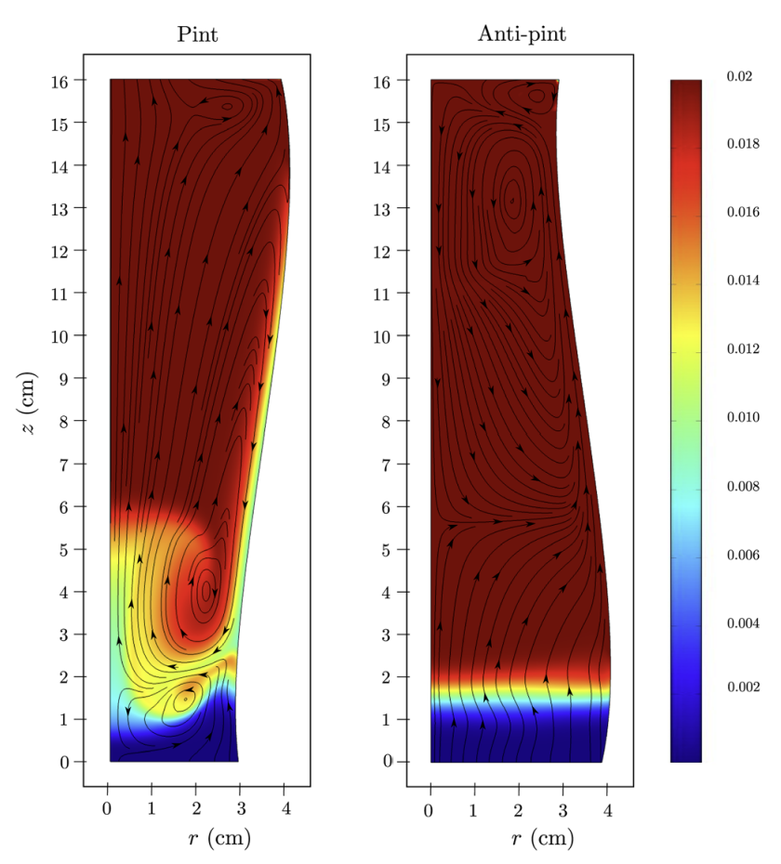
Figure 3: Bubble streamline and density gradient along the walls of a pint glass, Benilov 2012
The third mechanism is the shape of a pint glass. The upward motion of a bubble along a slanted pint wall creates a low bubble density zone where bubbles from above rush to fill the gap, as seen in Figure 3 and visualized in Figure 4, below (Benilov 2013). This is the opposite of what happens in an anti-pint:
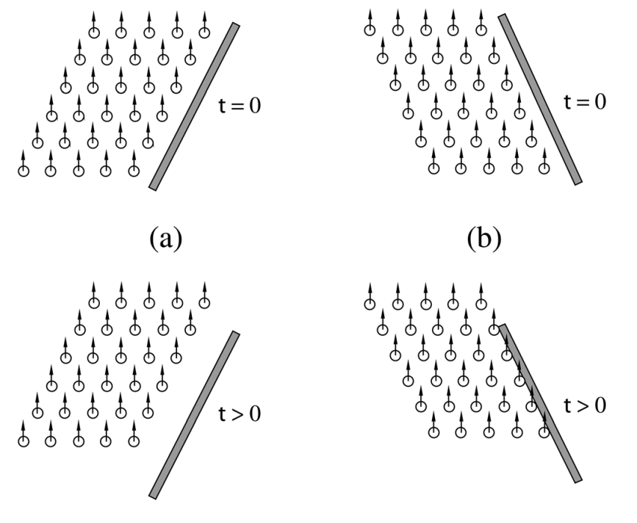
Figure 4: Bubble evolution near a wall, Benilov 2012
Benilov attributes this effect to the boycott effect from sedimentation theory, which says that the kinematic forces that drive density gradients in sloped vessels, like a pint glass, cause the circulation in Guinness. Bubbles redistribute unevenly in a tapered glass, adding to this effect.
Another interesting nondimensional number that can be applied to the flow physics of Guinness bubbles is the Froude number. This number describes wave stability conditions in fluid mechanics. Marguerite Robinson et al is another group of researchers at the University of Limerick that studied Guinness and wrote the paper Waves in Guinness (2008). Their research supports Benilov's, and connections can be made by analyzing the Froude number. The calculation is as follows:
$F=\frac{U_{0}}{\sqrt{gl}}=\frac{18\frac{mm}{s}}{\sqrt{(9.81\frac{m}{s^{2}})(0.03mm)}}≈1.05$
Where U₀ is the characteristic flow velocity, g is gravity, and l is the characteristic length. These values were calculated by Robinson. When 1 < F < 2, theory suggests rolling periodical waves in shallow liquids are formed (Robinson 2008). Robinson showed that Guinness bubble equations are comparable to shallow liquid equations, which provided relevance to this number and also introduced a mechanism that explains why Guinness bubbles sink in waves.
A final note about the physics and flow forces that I would like to mention is the discrepancy between Robinson’s characteristic flow velocity (CFV), 18 mm/s, and Benilov’s characteristic bubble velocity (CBV), 4 mm/s. The CFV describes the circulation speed within the vortex, and the CBV describes rising bubbles due to buoyancy. While Benilov’s slow rise time seems to disagree with Robinson, they actually calculate the velocity near the walls to be ~30 mm/s, which complements Robinson’s characteristic flow velocity. This means the bubbles in circulation exceed the rise speed, so the bubbles end up being pulled downwards, explaining the sinking bubble effect.
The visualization technique used was simply a fresh can of Guinness and a clear glass. No dyes, seeding, or special lighting was used, only the beautiful magic of fluids! The Guinness was locally sourced (Hazel’s Beverage World), and the can was fitted with the ball of nitrogen that gave us the stunning visual of sinking bubbles. The lighting used was a warm white LED bulb from a desk lamp directly behind and above the camera, and concentrated on the glass. This can be seen in Figure 5.
The field of view was chosen to be about 5” across and 3” tall to show the boundaries of the pint glass, allowing the viewer to have context about the sloped nature. I set the lens plane 18” from the glass and zoomed in to capture the desired FOV using a point in the middle of an 18-135mm focal range on a 67mm diameter lens. See Figure 5 below. My camera is a digital Canon Rebel T3i that shot the video with an original size of 1920x1088 pixels, which I cropped to 1080 wide. As shot and as playback, the frame rate is 30 frames/second.
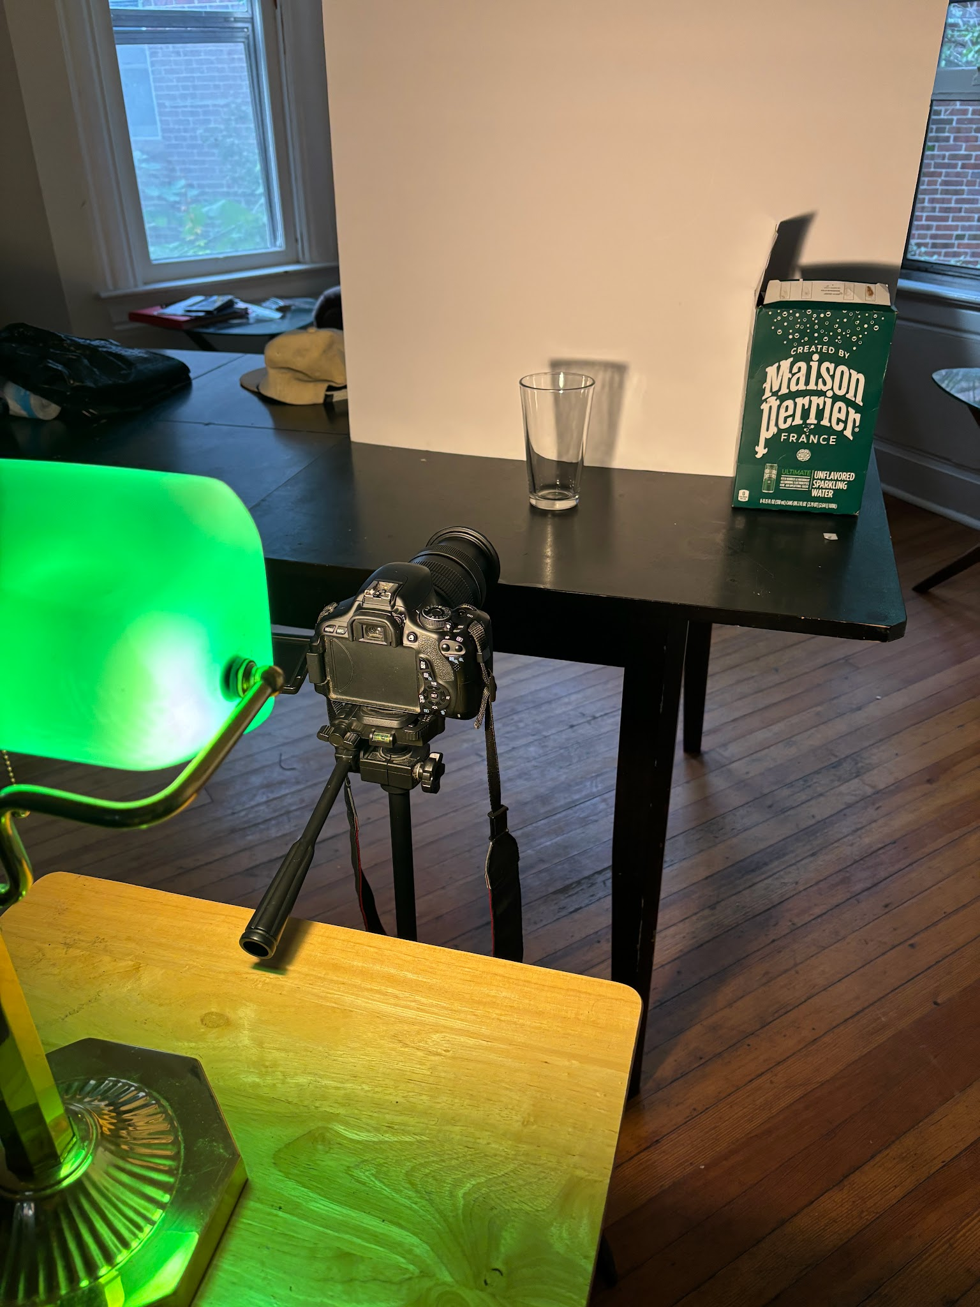
Figure 5: Camera setup
Overall, I am extremely satisfied with how my video came out, and I am glad I decided to visualize the sinking bubbles because after I travelled to Dublin in March 2025 and visited the Guinness Storehouse, I became fascinated with the phenomenon. The video captures the physics as it shows the periodic falling waves very clearly, and it is also long enough to see the rising level where the bubbles turn into liquid. I wish I could have gotten better lighting and had a sharper video quality, and in the future, I would work these out with more trials. This was such a fun assignment and I am looking forward to the rest of the class!

Sources:

Benilov, E. S., Cummins, C. P., & Lee, W. T. (2013). Why do bubbles in Guinness sink? American Journal of Physics, 81(2), 88–91. https://doi.org/10.1119/1.4769377
Robinson, M., Fowler, A. C., Alexander, A. J., & O’Brien, S. B. G. (2008). Waves in Guinness. Physics of Fluids, 20(6), 067101. https://doi.org/10.1063/1.2929369

