Bernoulli Progression
MCEN 5151 - Team Third
Beck Hermann, 11/21/2025
Team 5: Domenic Decaro, Duncan Laird
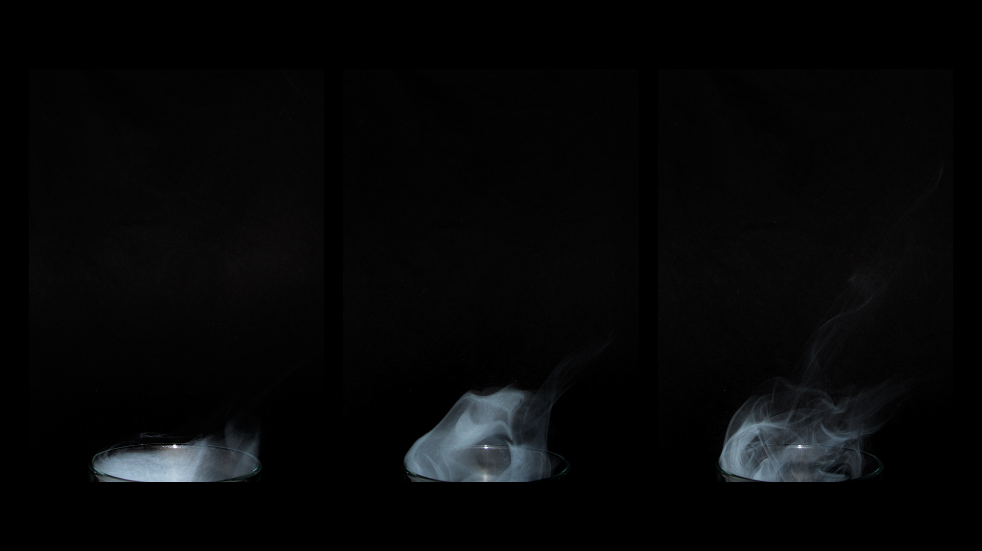
Figure 1: Team Third Submission, Bernoulli Progression, by Me

Bernoulli Progression is my image submission for 2025 Team Third. My submission is a series of 3 side-by-side images of incense smoke flowing up and out of a pint glass due to the Bernoulli effect from a cordless air duster on the right. Each image shows a different step of the flow, aligned left to right to show the time progression. They have been placed on a black background so the smoke is highlighted and the focus of my work. My team, Duncan Laird and Domenic Decarco, and I wanted to capture the unique nature of the Bernoulli effect, and I chose to use progression pics to show this, inspired by other work done in this class. My team helped with all steps of the setup and photography.
The flow apparatus used was a simple pint glass that had collected incense smoke. The density of the smoke is greater than that of the air, so the smoke stayed in the glass until it was disturbed by the Bernoulli effect. The diameter of the outlet of the air duster was 1.6 cm, and about 4” away from the rim of the glass. See Figure 2 for a sketch of our setup.
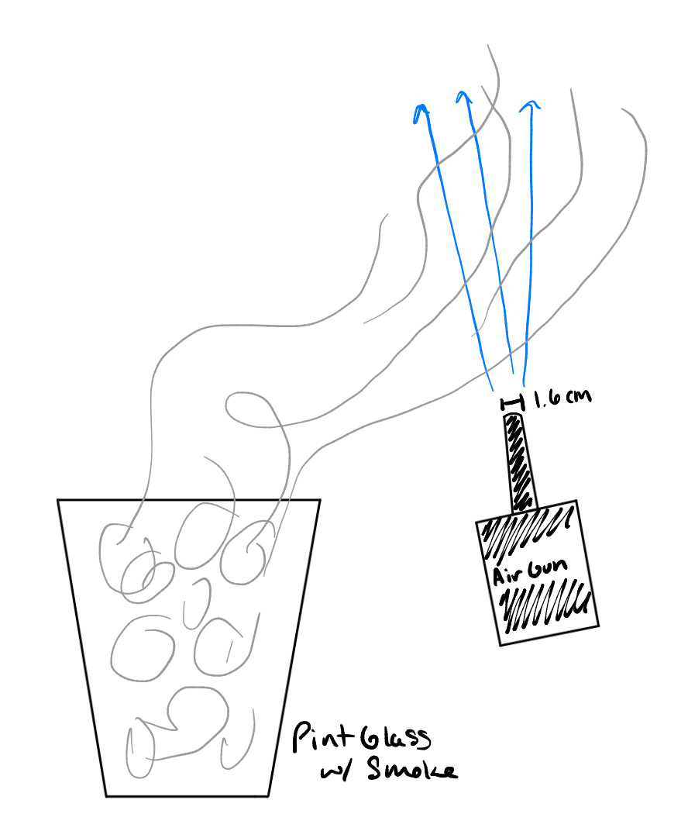
Figure 2: Set up
The smoke flowing out of the glass and propagating up into the jet stream from the air duster is a great visualization of Bernoulli’s Principle. This states that along a streamline of incompressible flow, increases in fluid velocity (such as the jet stream) will lead to a density gradient that “pulls” air into the streamline. Agamenon R. E. Oliveira, a mechanical engineer and history of science professor at the Polytechnic School of Rio de Janeiro, wrote about the history of Bernoulli and states that “an increase in the speed of the fluid occurs simultaneously with a decrease in pressure or a decrease in the fluid’s potential energy” (Oliveira 2019). When the fast-moving air creates a pressure gradient above the glass, the smoke is pulled out of the glass and upwards to the area of low pressure that the fast jet created.
A nondimensional number associated with our flow visualization is Reynolds’ Number, Re. This number, for our experiment, will represent the type of flow associated with the air duster. See the equation below for the Re calculation. Since the manufacturer has not published the velocity of the air coming from the duster, I have estimated the characteristic velocity, V, to be ~30 m/s based on other products’ listings. The diameter of the flow has been measured to be 1.6 cm, and the density and viscosity values have been pulled from the engineeringtoolbox.com.
$Re=\frac{ρVD}{μ}=\frac{(1.2kg/m^{3})(30m/s)(0.016 m)}{(1.8*10^{-5}Pa s)}=32,000$
From the calculations, we can determine that the flow coming from the air gun is turbulent because Re >> 4000. This means that it entrains a large amount of surrounding air, including the smoke in the glass, which accounts for the rising and pulling. The plume motion that is described by my progression pictures perfectly captures the Bernoulli Effect.
In my progression pictures, the smoke is relatively flat and steady, but once the air duster turns on, the fluid is pulled upwards. To explain why we can see the smoke progress upwards, we can analyze the Froude number. This describes the ratio between inertial forces and gravitational forces. It is defined below, where U is the characteristic velocity, g is gravitational acceleration, and l is the characteristic length.
$Fr=\frac{U}{\sqrt{gl}}=\frac{30m/s}{\sqrt{(9.8m/s^{2})(0.016m)}}=78.8$
Because Fr >> 1, this means that the flow is inertia-dominated and the smoke (the heavier fluid) can be lifted, tilted, and mixed. The high-velocity air stream is able to overcome gravity and buoyancy forces, explaining the progression seen in my pictures. The physics behind my setup can be compared to that of large-scale tunnel ventilation engineering. Ying Zhen Li and Haukur Ingason at the University of Sweden performed an analysis of tunnel smoke and confirmed that the threshold between buoyancy dominant and intertal dominant smoke motion can be identified using a critical Froude number, where values much greater than one result in the smoke being swept away instead of remaining trapped or back layering (Li 2108). While the researchers determined that the common critical Froude number, 4.5, was not viable for long tunnels with longitudinal ventilation, they still discussed the importance of Fr >> 1.

The visualization technique used was incense smoke that had been collected in a cup. They were conical units with a vertical hole through the central axis, which allowed for the smoke to fall down instead of drifting up and away. The lighting used was the flash from my camera, which worked exceptionally well in capturing the smoke with no motion blur.
The field of view was originally about 18” across and 12” tall, with the camera being a distance of 12” from the cup, so everything would be in frame and the team could crop as we wished. The focal length was 18mm on a Canon Rebel T3i. Originally, each image was 5202x3464 pixels, then I cropped them to be 2030x2842 pixels. This made it so they were portrait-oriented to show only the smoke rising and allow for the progression to fit nicely on a landscape sheet. The ISO was 400, the f-stop f/5, and the exposure 1/200s. The post-processing that was done mainly consisted of making the background as black as possible and the smoke as bright and defined as possible. You can see the original image of one of the three progression pictures in Figure 3, and the post-processing settings in Figure 4.

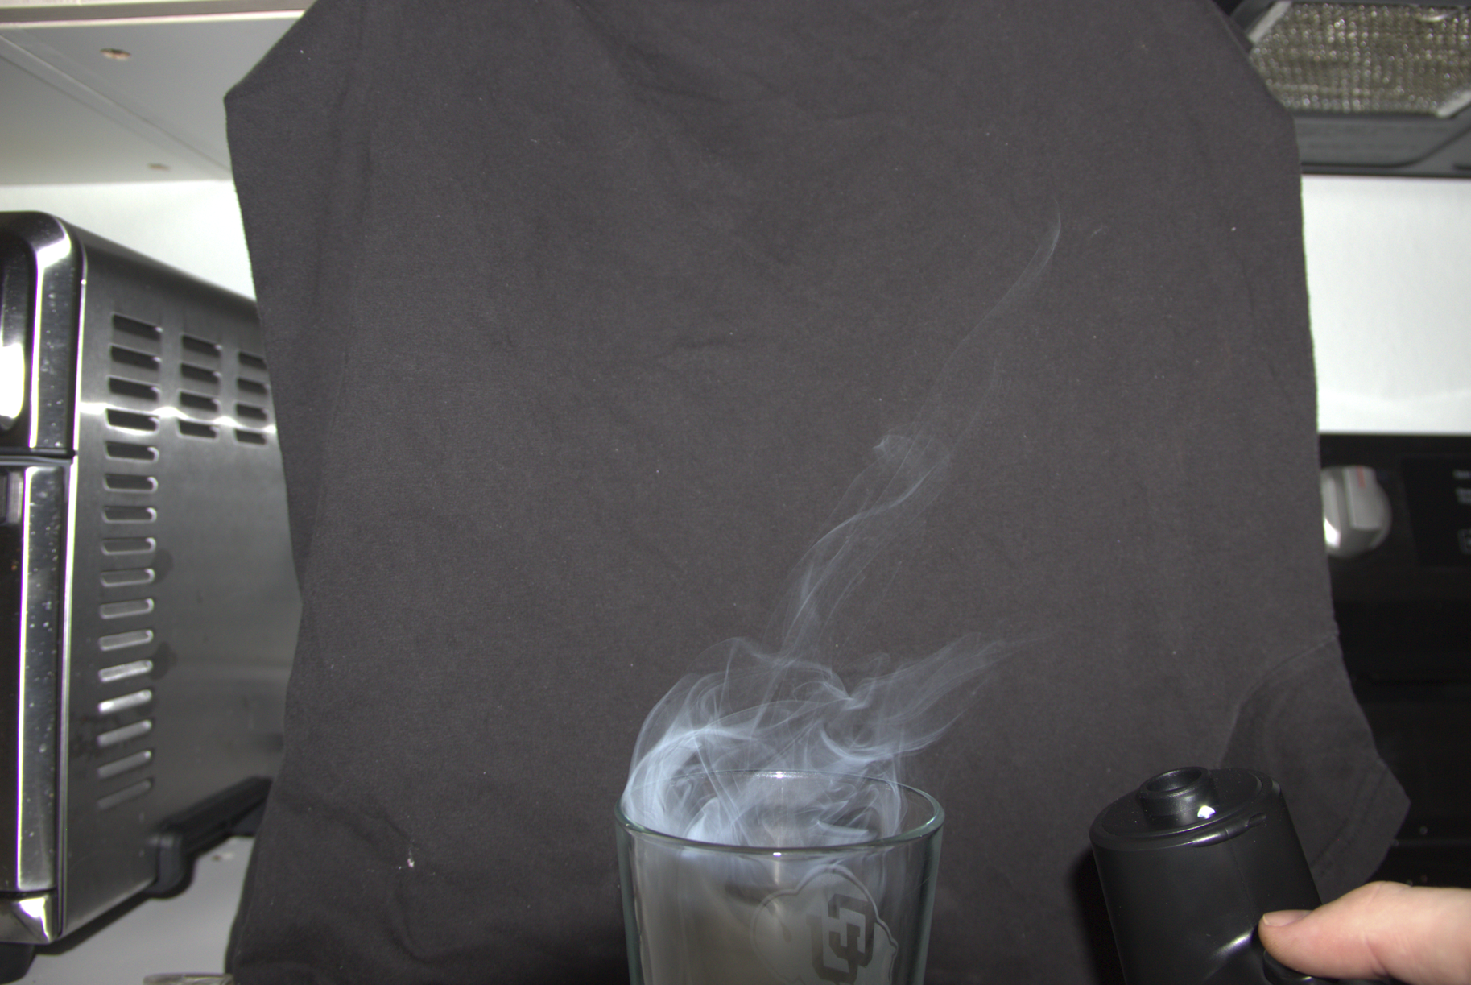
Figure 3 (left) and Figure 4 (right): Original image and Post Processing

Overall, the image shows a unique phenomenon of the Bernoulli Effect and the smoke coming out of the glass allows for a beautiful flow visualization. I like how I was able to get three really good pictures that show progression. It was my first series of images, and I very much like how it turned out. I think the fluid physics are shown very well, and my intent was fulfilled, and I would be proud to hang this image up and present it. I would like to develop this idea more by perhaps finding a way to dye the smoke.

Sources

Oliveira, A.R.E. (2019). History of the Bernoulli Principle. In: Uhl, T. (eds) Advances in Mechanism and Machine Science. IFToMM WC 2019. Mechanisms and Machine Science, vol 73. Springer, Cham. https://doi.org/10.1007/978-3-030-20131-9_115

Ying Zhen Li, Haukur Ingason,
Discussions on critical velocity and critical Froude number for smoke control in tunnels with longitudinal ventilation, Fire Safety Journal, Volume 99, 2018, Pages 22-26, ISSN 0379-7112, https://doi.org/10.1016/j.firesaf.2018.06.002.

