Blue
MCEN 5151 - Team First
Beck Hermann, 10/3/2025
Team 5: Domenic Decaro, Duncan Laird
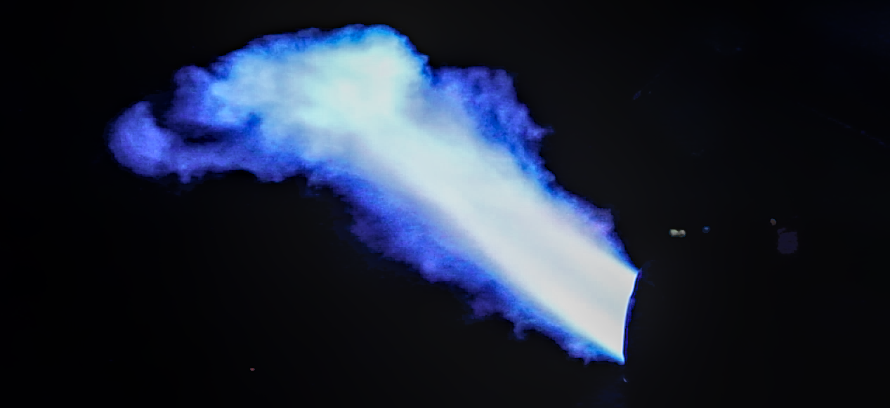
Figure 1: Team First Submission, Blue, by Me

Blue is my image submission for 2025 Team First. The image depicts the ignited backfire coming from the exhaust of Domenic’s 2011 Yamaha fz8 motorcycle with an 800cc, 4-stroke gasoline engine. The team wanted to photograph the laminar and turbulent flow of the oxidized exhaust particles. I successfully exported this frame from a 30-second video of multiple backfires using a code written for Microsoft PowerShell, a program meant for video and photo editing.
The engine and exhaust pipe are the flow apparatus relevant to this image. The exhaust pipe acts as a nozzle from the four-stroke engine; within the exhaust pipe, the fuel/air mixture from the engine is ignited by the hot exhaust gases and expelled downstream as a jet flame (Gao 2022). The basic flow was created by revving the bike’s engine, and is turbulent through a 10cm diameter exhaust tip. See Figure 2, below, for a diagram of the flow apparatus.

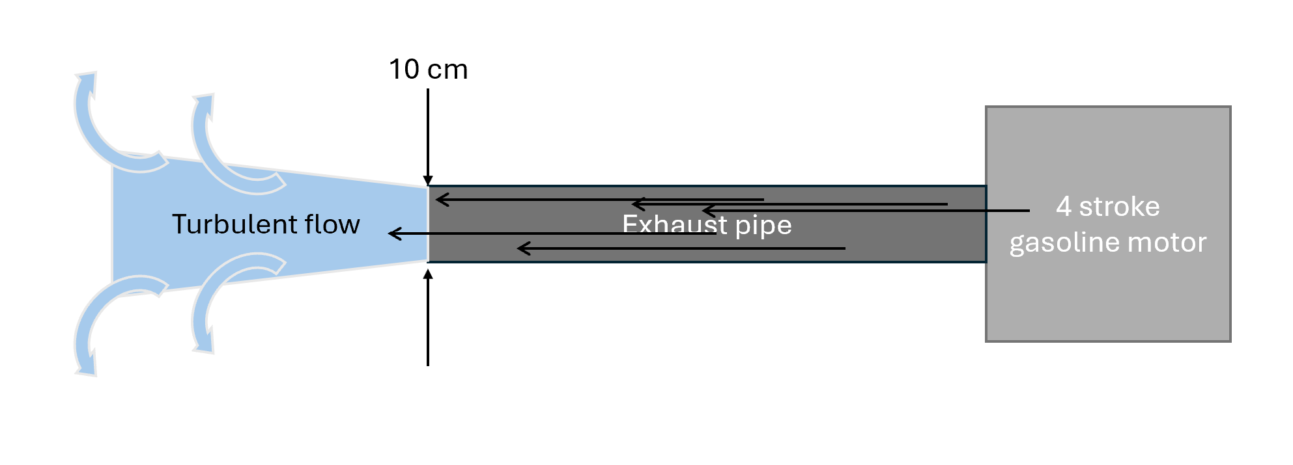
Figure 2: Flow apparatus sketch showing the system of engine, pipe, and flame jet. Not to scale

The flames seen in my image are created during a late combustion process within the engine/exhaust system. Unburned hydrocarbons are ignited late by the burning gases and exhaust heat (Vera 2011). The hydrocarbons are expelled through the exhaust pipe and ignite when met with oxygen. This is called post-flame oxidation and is common for rich fuel types and modded engines, where the fuel can be met with 1000॰ K residual exhaust gas, igniting the hydrocarbons (Gao 2022). Although Gao analyzes backfire events in hydrogen port-injection engines, the same physics of hot gases igniting unburned fuel apply to gasoline backfire in motorcycle exhausts.
Now that I have described why these flames exist, I will lay out the flow physics and discuss appropriate non-dimensional scales. To calculate the Reynolds number, we first need to determine the characteristic velocity. To calculate this, I looked back at the original video to determine the time from no flame to peak flame. The flame took 0.04 seconds to travel 0.75 m, leaving the characteristic velocity, U, equal to 19 m/s. The Reynolds number is also determined by the characteristic length, which is 0.1m diameter exhaust pipe, and the kinematic viscosity, which is 118 m²/s x 10⁻⁶ at 1000॰ K, according to a calculator on EngineeringToolbox.com. The Re calculation is as follows:
$Re=\frac{UD}{ν}=\frac{(19\frac{m}{s})(0.1m)}{(118\frac{m^{2}}{s}⋅{10}^{-6})}≈16,100$
Since Re >> 4000, the flow is fully turbulent. Although the centerline appears laminar and smooth, the wispy tails that propagate away from the central jet flow show the turbulence. These wisps are formed because turbulent production and visualization are highest at the edges, where shear is the highest. The velocity difference between the jet flame and the surrounding air creates Kelvin-Helmholtz instabilities, which are indicators of turbulent flow (Drazin 2003). The shear layer is unstable and breaks up the smooth jet. This propagation in the flow is what my group and I wanted to capture, which I believe we did well.
The visualization technique used was simply to find a very open, cement lot with nothing flammable around and let the modded engine do its work. The bike was driven enough to get the engine to a high enough temperature to expel flames and not hurt the components. To get the best possible shot of the flames, we made sure all artificial light from phones, car headlights, and cameras was turned off. Next, we attempted to take rapid images using a tripod and burst mode on our cameras, but we determined that there was not enough light and the flames dissipated so quickly that it would be luck to get one in frame. When we decided that burst photography was not a viable option, we switched to taking a video where we first focused on the tip of the exhaust pipe and initiated backfires by revving the engine at high throttle. Using this method, we were able to capture 6 to 7 bursts of flames in 30 seconds and relied on the light of the flame to brighten the video. The code I used to crop the video and export frames as individual PNGs will be in the appendix of this report. All combustion guidelines were followed so we could create a safe environment for ourselves and our equipment.
The field of view was about 5 feet across and 3 feet tall to ensure we could get even the largest flames in frame. We were a safe distance from the exhaust and made sure to be angled away from the direction of the flame, putting us about 5 feet away, and the camera zoomed in to capture the desired FOV using a point in the middle of an 18-135mm focal range on a 67mm diameter lens. My camera is a digital Canon Rebel T3i that shot the video with an original size of 1920x1088 pixels, and I cropped my image to 1267x581 pixels. As shot and as playback, the frame rate is 30 frames/second. A lot of post-processing was done so I could get the sharpest and best color from my image, but the majority was cropping and contrast adjustments. Figure 3 shows the list of active modules used in Darktable, and Figure 4 shows the original image before editing.
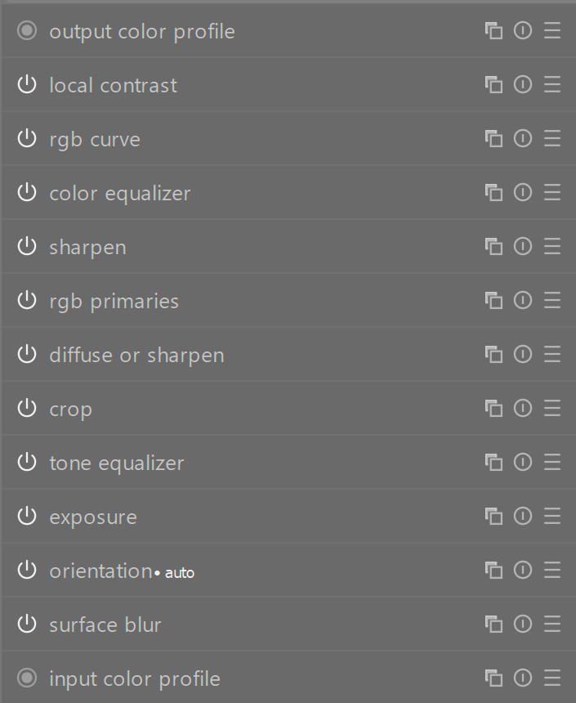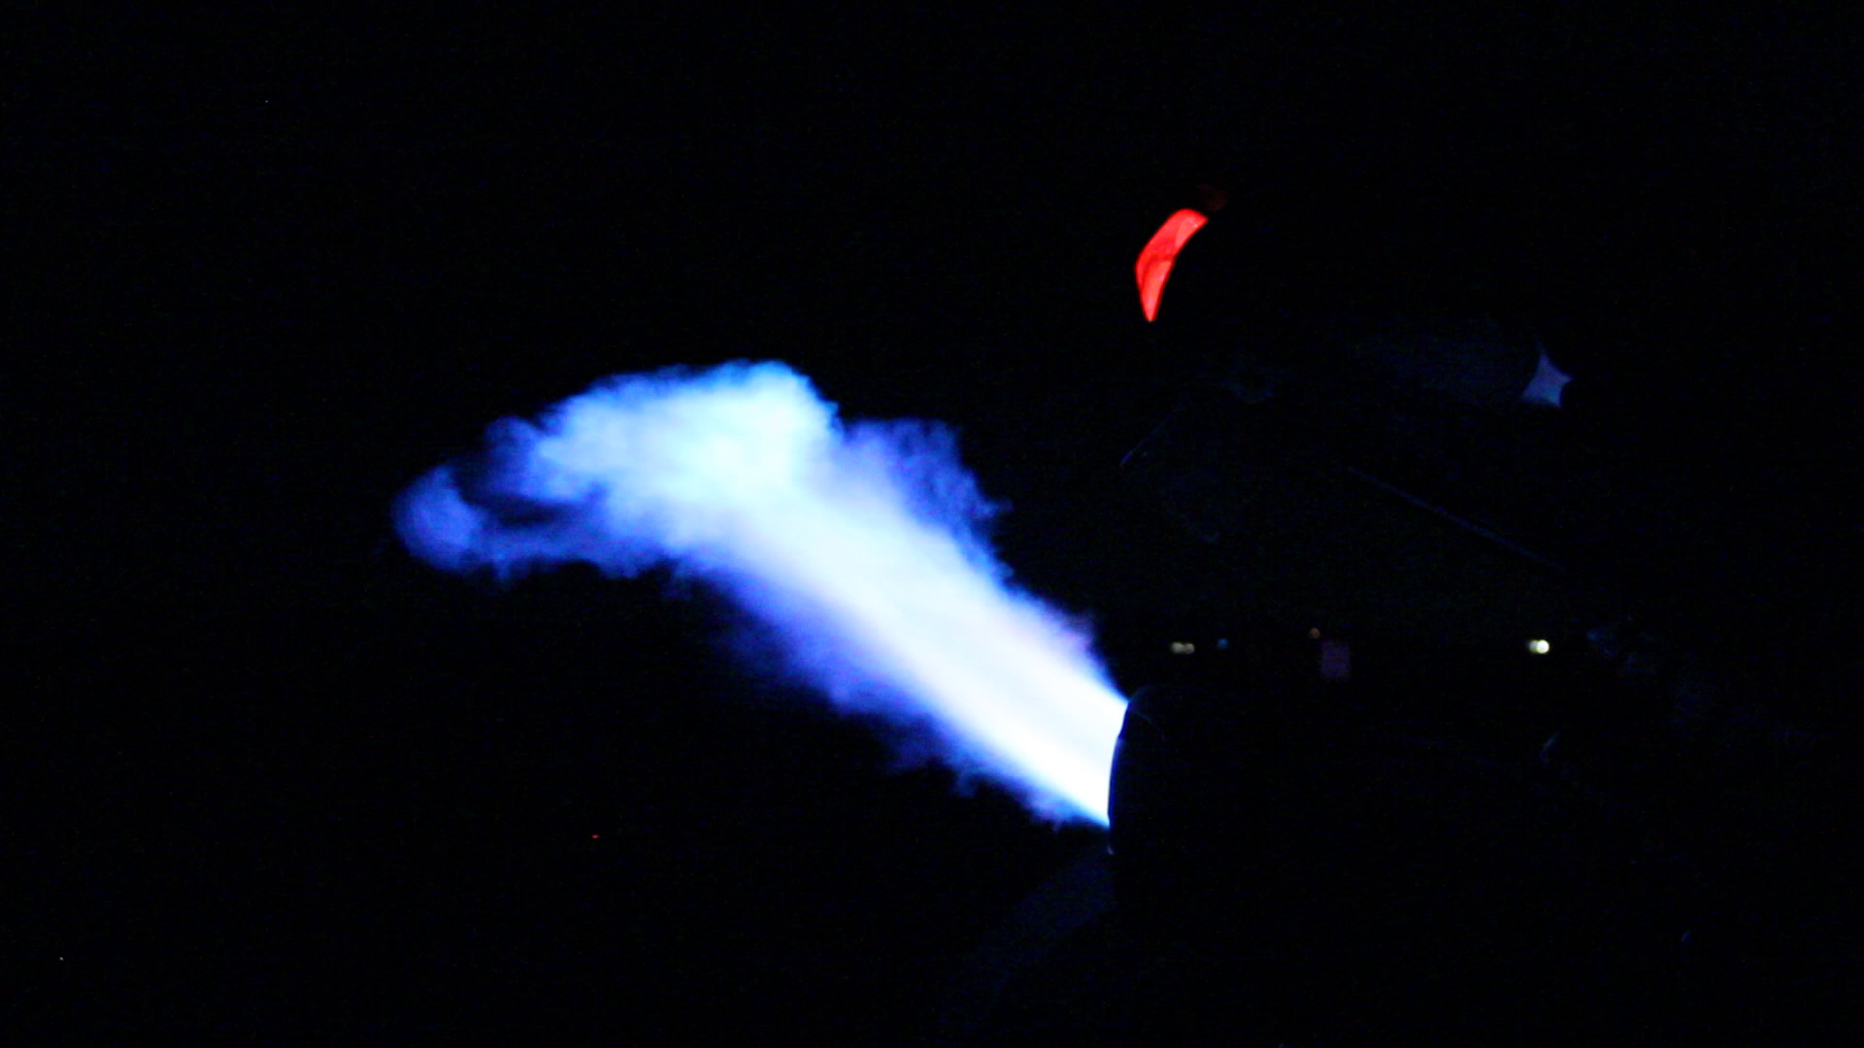
Figure 3 (left) and Figure 4 (right): Post-processing modules and original image

Overall, the image shows a unique phenomenon of turbulent flow, unburned hydrocarbons, and Kelvin-Helmholtz instabilities all coming together to produce a beautiful flow visualization. I like how I was able to get the crop right to get rid of the red taillight and how the colors post-processing are stunning against the black background. I think the fluid physics are shown very well, and my teammates' images provide even more context because we each chose a different flame instance. My intent was fulfilled, and I would be proud to hang this image up and present it. I would like to increase the sharpness of the image and would develop this idea further by trying different times of day, trying slow-motion videography, and trying to hone down the burst mode. I am looking forward to working with my group further.

Sources
Jianbing Gao, Xiaochen Wang, Panpan Song, Guohong Tian, Chaochen Ma,
Review of the backfire occurrences and control strategies for port hydrogen injection internal combustion engines, Fuel, Volume 307, 2022, 121553, ISSN 0016-2361, https://doi.org/10.1016/j.fuel.2021.121553.

Thorpe, S. A. (2003). Kelvin–Helmholtz Instability. In J. R. Holton, J. A. Curry, & J. A. Pyle (Eds.), Encyclopedia of Atmospheric Sciences (pp. 1161–1169). Academic Press. https://doi.org/10.1016/B0-12-227090-8/00190-1

Vera, Javier & Ghandhi, Jaal. (2011). Investigation of Post-Flame Oxidation of Unburned Hydrocarbons in Small Engines. SAE International Journal of Engines. 4. 67-81. 10.4271/2011-01-0141.

Appendix
Code for video editing in PowerShell:

# Make output folders (once)
mkdir frames_6665, frames_6666

# --- MVI_6665 ---
ffmpeg -hide_banner -y -i MVI_6665.MOV `
-vf "select='between(t,4.57,4.60)+between(t,6.4,6.6)+between(t,8.4,8.55)+between(t,9.5,9.65)+between(t,10.7,10.85)+between(t,11.9,12.00)+between(t,13.05,13.17)+between(t,14.25,14.32)+between(t,15.3,15.4)+between(t,18.3,18.4)'" `
-vsync vfr "frames_6665/6665_%05d.png"

# --- MVI_6666 ---
ffmpeg -hide_banner -y -i MVI_6666.MOV `
-vf "select='between(t,7.3,7.43)+between(t,13.4,13.5)+between(t,14.5,14.63)+between(t,16.75,16.9)+between(t,17.8,17.95)+between(t,19.00,19.2)+between(t,20.20,20.3)+between(t,21.55,21.7)'" `
-vsync vfr "frames_6666/6666_%05d.png"

