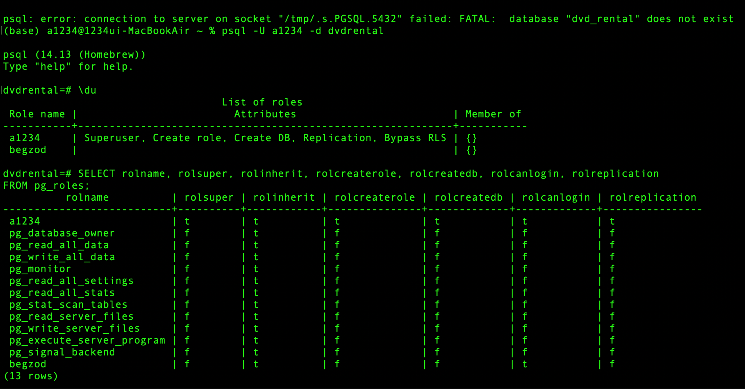

As can be seen in the screenshot, a1234 and begzod are the only users in the database. The user a1234 has all the privileges, while begzod user has only login privilege.