Recruitment agency
Logo / Image

Contents
1 Business Description 3
1.1 Business background 3
1.2 Problems. Current Situation 3
1.3 The benefits of implementing a database. Project Vision 3
2 Model description 3
2.1 Definitions & Acronyms 3
2.2 Logical Scheme 3
2.3 Objects 3

Business Description

Business background
Recruitment agency manages job listing, candidate registration, application tracking, matches between candidates and job listening based on criteria like skills, experience, location and preferences, interviews, and placements. Moreover, agency offers additional services like resume writing, interview coaching, and skills development to help candidates improve their job prospects

Problems. Current Situation
An organized database system can answer some crucial business questions, including:
- Cities or locations with the most job listings (and thus job opportunities)
- Average years of experience required in a certain job title
- Job titles that attract the most applications
- Average years of experience of candidates with a certain job title
- Most demanded services among the candidates

In the presented model, the above questions could be answered with the following SQL queries:

1) Cities with the most job listings
SELECT l.city, COUNT(j.id) AS job_count
FROM job j
JOIN location l ON j.location = l.id
GROUP BY l.city
ORDER BY job_count DESC;

2) Average years of experience required
SELECT j.title, AVG(j.experience_in_numbers) AS avg_experience_years
FROM job j GROUP BY j.title;

3) Job titles that attract the most applications
SELECT
j.title,
COUNT(a.id) AS application_count
FROM
application a
JOIN
job j ON a.jobId = j.id
GROUP BY
j.title
ORDER BY
application_count DESC;

SELECT
j.title,
COUNT(a.id) AS application_count
FROM
application a
JOIN
job j ON a.jobId = j.id
GROUP BY
j.title
ORDER BY
application_count DESC;

4) Average years of experience of candidates with a certain job title
SELECT
c.title,
AVG(c.experience_in_number) AS avg_experience_years
FROM
candidate c
GROUP BY
c.title;

5) Most demanded services among the candidates

SELECT
s.name AS service_name,
COUNT(rs.order_id) AS order_count
FROM
resume_service rs
JOIN
services s ON rs.service_id = s.id
GROUP BY
s.name
ORDER BY
order_count DESC;

the Benefits of implementing a database. Project Vision
The expected benefits include:
- Relationship between the tables enables querying and finding answers for key business questions
- Easy CRUD operations for database tables unlike in the traditional databases like spreadsheets
- Provides more safety to keep the data in an online database management system
- Accessible to all employees of the company and seamlessly integrates the data collected by all departments

Vision
Moving from the traditional clunky spreadsheet system to an online DBMS system for ease of use and better control over the company data

Model description

Definitions & Acronyms
- FK – Foreign Key
- PK – Primary Key
- CFK – Compound Foreign Key

Logical Scheme
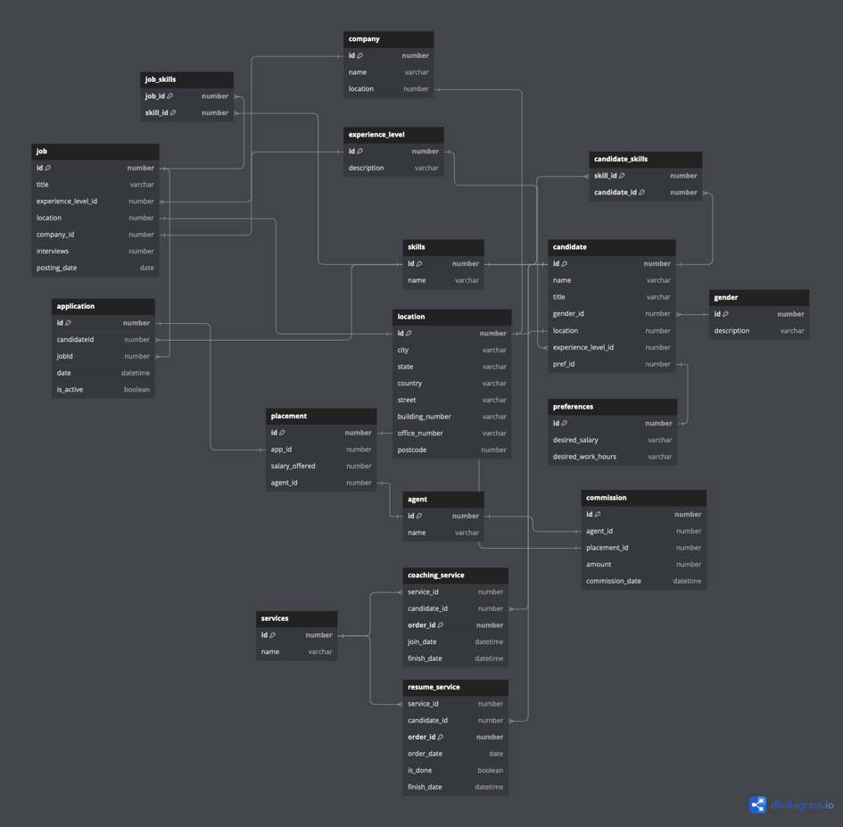

Objects

Skills table
Table that displays ID’s and names for the existing skills. E.g. Python coding, SQL database management, etc.

Table Name | Field name | Field Description | Data Type
skills | id | Id of the skill, PK/FK | Int
 | name | Name of the skill, e.g. python coding, SQL database management | Text

It has one to many relationship with job_skills and candidate_skills tables

Example with data

skills.id | job_skills.id | candidate_skill.id
1 | 1 | 1

Job_skills table
A bridge table that displays correspondence of job_id’s to skill_id’s, i.e. connects the table job with skills tables. This helps identify what exact skills are being demanded in a particular job listing.

Table Name | Field name | Field Description | Data Type
job_skills | job_id | Id of the job, CFK/FK | Int
 | skill_id | Id of the skill, CFK/FK | Int

It has many-to-one relationship with skills and job tables

Example with data

job_skills.skill_id | Skills.id | Job_skills.job_id | Job.id
1 | 1 | 2 | 2

Candidate_skills table
A bridge table that connects the table candidate with skills tables. This helps identify what exact skills a particular candidate has to offer

Table Name | Field name | Field Description | Data Type
candidate_skills | job_id | Id of the job, CFK/FK | Int
 | cand_id | Id of the candidate, CFK/FK | Int

It has many-to-one relationship with skills and candidate tables

Example with data

candidate_skills.skill_id | Skills.id | Candidate_skills.cand_id | Candidate_id
1 | 1 | 2 | 2

Candidate table
A table that stores data about all the candidates

Table Name | Field name | Field Description | Data Type
candidate | id | Id of the job, CFK/FK | Int
 | Name | Name of the candidate | Text
 | Title | Job title | Text
 | Gender | Male or Female | Text
 | Location | Location id | Int
 | Experience | Entry | Intermediate | Senior | varchar
 | Pref_id | Id of the preferences, FK | Int
 | Experience_level_id, FK | Id of the experience | Int

It has one to many relationship with candidate_skills and many to many relationship with services tables

Job table
A table that stores data about all the job listings

Table Name | Field name | Field Description | Data Type
job | Id | Id of the job, PK, FK | Int
 | Title | Title of the job | Text
 | Experience_level_id | Id of the experience, FK | Int
 | Location | Location id, FK | Int
 | Interviews | Number of interviews | Int
 | Company_id | Id of the company, FK | Int
 | Posting_date | Date | Datetime

It has one to many relationship with job_skills and application tables, as well as one to one relationship with location table

Location table
A table that stores data about locations

Table Name | Field name | Field Description | Data Type
location | Id | Id of the location, PK, FK | Int
 | City |  | Text
 | State |  | Text
 | Country |  | Text
 | Postcode |  | Int
 | Building_number |  | Int
 | Office_number |  | Int
 | Street |  | Text

It has one to one relationship with job and company tables

Application table
A table that stores data about job applications made by the candidates

Table Name | Field name | Field Description | Data Type
Application | Id | Id of the application, PK | Int
 | candidate_id | Id of the candidate who applied, FK | Int
 | Job_id | Id of the job application made, FK | Int
 | date | date | Datitime
 | Is_active | Is the application active or no | Boolean

It has many-to-one relationship with job and candidate tables

Placement table
A table that stores data about job placemenets following an application

Table Name | Field name | Field Description | Data Type
Placement | Id | Id of the placement, PK | Int
 | App_id | Id of the application, FK | Int
 | Salary_offered | Salary offered | Int
 | Agent_id | FK to Agent | int

It has one-to-one relationship with application table
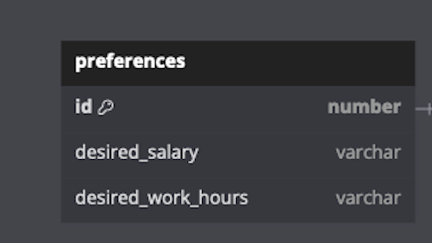
Preferences table
A table that stores data about candidate preferences

Table Name | Field name | Field Description | Data Type
Preferences | Id | Id of the preference, PK/FK | Int
 | Desired_salary | Amount of salary range | Text
 | Desired_work_hours | Desired work hours in range | Int

It has one-to-one relationship with candidate table

Services table
A table that stores data about services provided to candidates. Services include resume writing, coaching and skills development

Table Name | Field name | Field Description | Data Type
Services | Id | Id of the service, PK/FK | Int
 | Name | Name of the service | Text

It has many-to-many relationship with candidate, and one-to-many relationship with resume_service and coaching_service tables

Resume service table
A table that stores data resume services

Table Name | Field name | Field Description | Data Type
Resume_service | Service_id | Id of the service, FK | Int
 | Order_id | Id of the order, PK | Text
 | Order_date | Date ordered | datetime
 | Is_done | Whether finished | Boolean
 | Finish_date | Date of finishing | datetime

It has many-to-one relationship with services table

Coaching service table
A table that stores services like coaching or skills development

Table Name | Field name | Field Description | Data Type
Coaching_service | Order_id | Id of the order, PK | Int
 | Service_id | Id of the service, FK | Text
 | Join_date | Date when the candidate joined the service | datetime
 | Finish_date | Date of finishing | datetime

It has many-to-one relationship with the services table

Company table
A table that stores services like coaching or skills development

Table Name | Field name | Field Description | Data Type
Company | Id | Id of the company, PK | Int
 | name | Id of the service, FK | Text
 | Location | FK to location | int

It has one-to-many relationship with job and one to one relationship with the location tables

Agent table
A table that stores data about the agent

Table Name | Field name | Field Description | Data Type
Gender | Id | Id of the agent | Int
 | Name |  | Text

Gender table
A table that stores data about genders

Table Name | Field name | Field Description | Data Type
Gender | Id | Id of the gender, e.g. 0 or 1 | Int
 | Description | Male or Female | Text

Experience level
A table that stores data about experience levels

Table Name | Field name | Field Description | Data Type
Experience_level | Id | Id of the experience, e.g. 0, 1, 2 | Int
 | Description | e.g. Junior, Middle, Senior | Text

Comission table
A table that stores data about the comissions

Table Name | Field name | Field Description | Data Type
Comission | Id | Id of the comission, PK | Int
 | Agent_id | Id of the admin, FK | Int
 | Placement_id | Id of the placement, FK | Int
 | Amount | Amount of commission | Int
 | Comission_date | Date when commission is issued | datetime

