Activity Geolocation to Odoo v14
This module tracks the user's geolocation when an Activity is marked as done with customer distance restriction.
a. Configure the maximum distance in meters accepted to mark as done activities between the Salesvendor and the Customer Location.
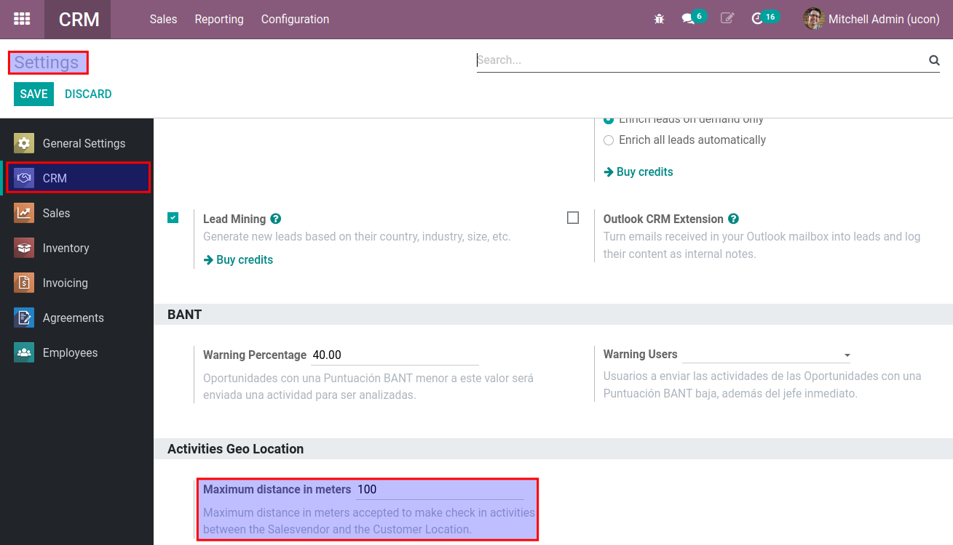

b. Configure the Activity Types that use geolocation.
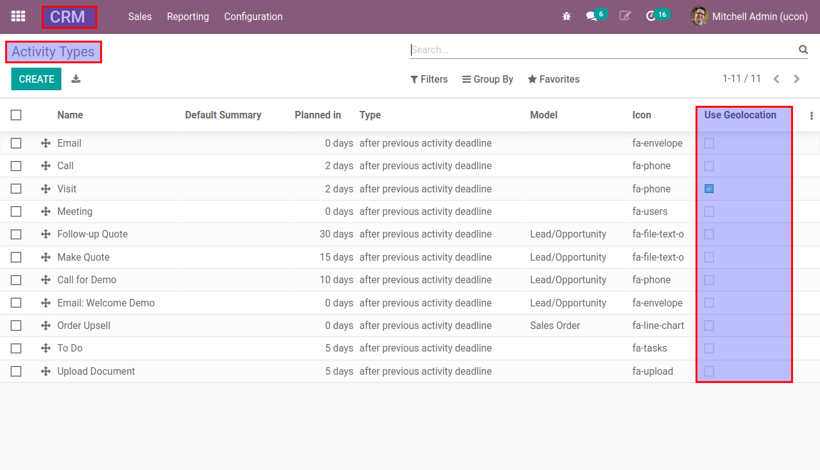
c. Configure the geoposition of your customers.
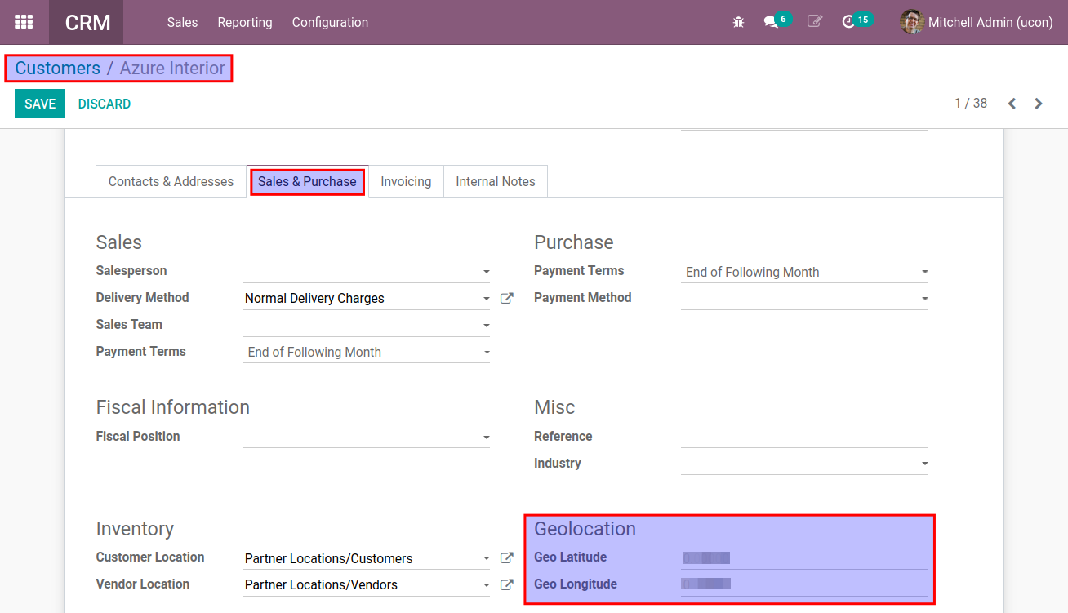

d. Schedule an activity that use geolocation and mark as done the activity, if the distance between the user and the client assigned to the opportunity is greater than the setting, the user will see an error and the activity will not be marked as done.
Note: If is the first time that use geolocation, the navigator will ask you if you want to share your location to this site, please allow this and remember this decision.
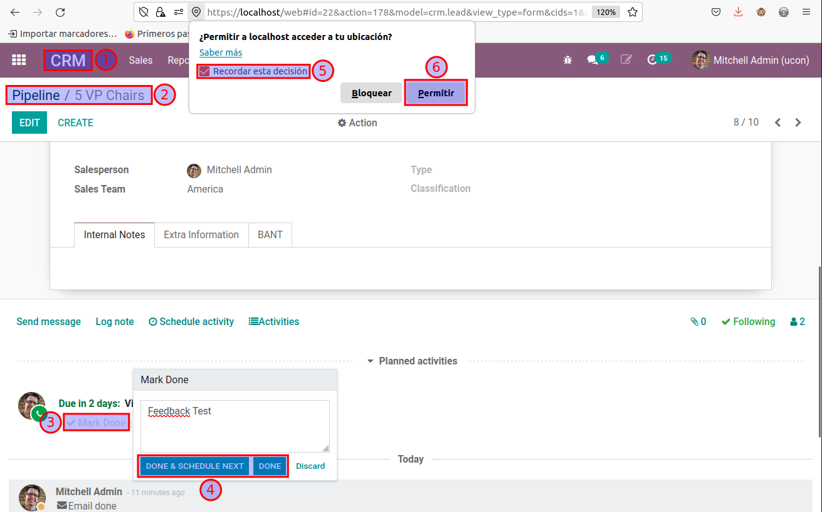

e. Another way to mark as done an activity.
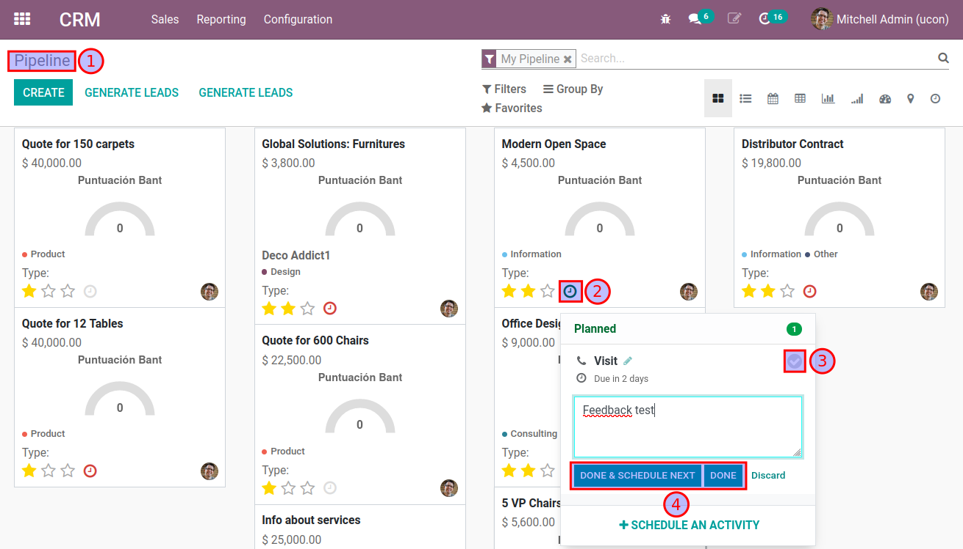
f. To view the geolocation position of activities marked as done, go to Messages.
