**Van der Linden (2006) lognormal Model:**

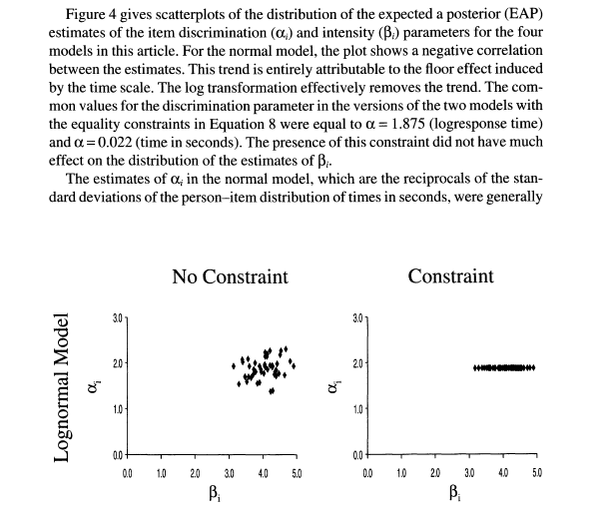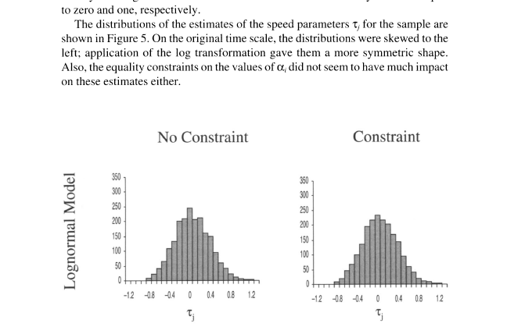

**Van der Linden (2010) better person estimation via RTs**

Simulation

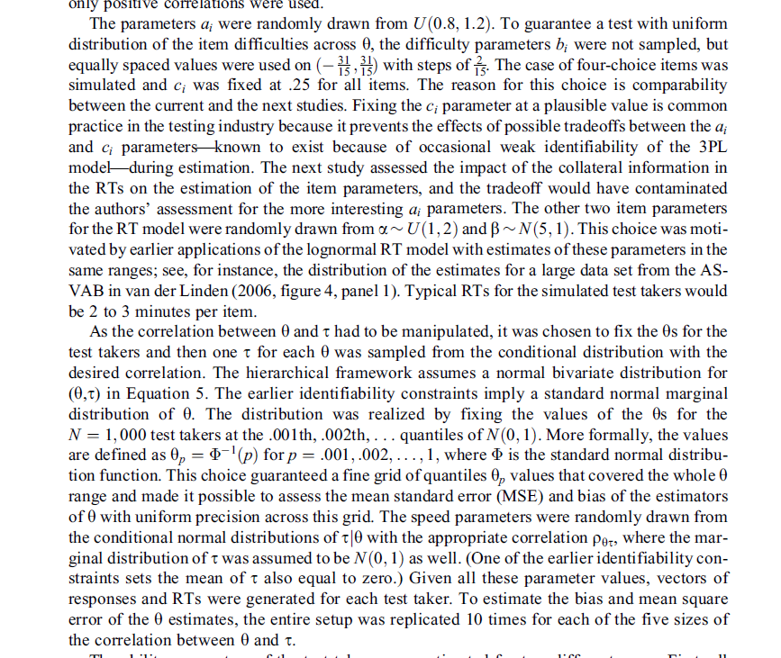

**Molenaar (2016) intraperson RT differences**

Simulation

