**Industrial Interaction Report on**



**Salesforce CRM Administration Internship**





**Frans Global Infotech PVT. LTD**

**Submitted in partial fulfilment of the requirement for the award of the degree of**

**BACHELOR OF TECHNOLOGY**

**IN**

**COMPUTER SCIENCE & ENGINEERING**

**Submitted by:**

**Student Name: Syed Amaan Hasan**  **University Roll No.: 2019173**



**Department of Computer Science and Engineering**

**Graphic Era (Deemed to be University)**

**Dehradun, Uttarakhand**

**2024-25**



**CANDIDATE’S DECLARATION**

I hereby certify that the work which is being presented in the Industrial Interaction report entitled **“Salesforce CRM Administration Internship”** in partial fulfillment of the requirements for the award of the Degree of Bachelor of Technology in Computer Science and Engineering in the Department of Computer Science and Engineering of the Graphic Era (Deemed to be University), Dehradun shall be carried out by the undersigned under the supervision of **Mr. Nazish Khan**, Director, Frans Global Infotech PVT. LTD.

Student Signature

Student Name

University Roll Number

Branch

**Certificate**

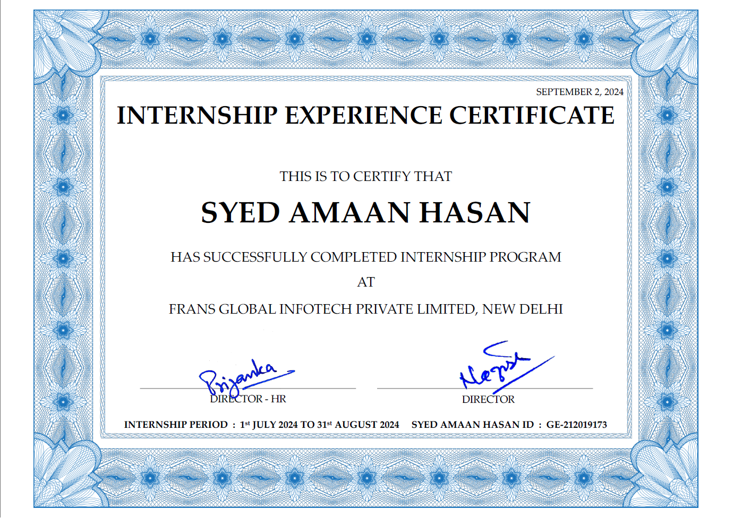

**HR**

Name: Mr. Nazish Khan’

Phone No.:

Website:

**Table of Contents**

|  |  |  |
| --- | --- | --- |
| **Chapter No.** | **Description** | **Page No.** |
| Chapter 1 | Introduction |  |
| Chapter 2 | Literature Survey |  |
| Chapter 3 | Methodology |  |
| Chapter 4 | Result and Discussion |  |
| Chapter 5 | Conclusion and Future Work |  |
|  | References |  |

**Acknowledgement**

I would like to express my heartfelt gratitude to Frans Global Infotech for providing me with the opportunity to intern with them as a Salesforce CRM Administration intern for two months. During my time here, I had the privilege of gaining hands-on experience with Salesforce CRM, which has significantly enhanced my skills and deepened my understanding of customer relationship management.

I am especially thankful to my mentor, Mr. Nazish Khan, and my colleagues for their guidance, support, and encouragement throughout the internship. Their insights and feedback were invaluable in helping me build a solid foundation in Salesforce CRM administration.

Thank you once again for this enriching experience and for supporting my growth in the field of CRM administration.

**About the Company**

Frans Global is a systems integrator specializing in wireless, optical, and fixed campus networks, with expertise in LAN and WAN solutions. Offering proactive and reactive technical support, the company ensures dependable service for a wide range of client networking needs. Frans Global prioritizes innovation and excellence, staying at the forefront of new technologies to deliver high-quality, effective solutions.

The company’s core values emphasize long-term relationships, teamwork, and collaboration. By valuing and respecting each team member's contribution, Frans Global fosters a supportive environment where excellence and client dedication are at the center of every project. The team includes certified professionals experienced in working with multiple vendors, providing versatile, turnkey solutions tailored to each client.

Quality and reliability are essential to Frans Global's approach, with a strong focus on project management, timely delivery, and strict adherence to service-level agreements (SLAs). With extensive experience in the local market, the company upholds high standards while remaining cost-effective, making it a trusted partner in networking and communications. Whether addressing simple or complex needs, Frans Global delivers dependable networking solutions, ensuring clients achieve their communication goals with efficiency and confidence.

**Work Responsibilities**

**Work Details**

**Skills Learned**

**Conclusion**