Name | Roshan George
Contact Information | +91 8925339652
Current Occupation | SDE Intern at Vivin – 2 months | Student
Educational Details | Amrita Vishwa Vidyapeetham – B.Tech Artificial Intelligence
Technical Skills with level | ReactJS – Expert  NodeJS – Intermediate  RestAPIs/JSON Schema – Intermediate  Javascript – Intermediate  MongoDB – Intermediate

Title: Beckn QR - QR Code Generation and Interpretation Platform

Summary
I propose to work on the Beckn QR project, which aims to create a platform that generates various types of interoperable Beckn-compliant QR codes. The project will enable users to scan QR codes representing various objects and events on a Beckn-enabled network, triggering instantaneous catalog import, product marketing and discovery, quote fetching, single-click orders, and status updates through Beckn APIs.

Project Detail
- Project Overview

The Beckn protocol is a set of open specifications aimed to create a common language that enables interoperability for economic transactions between disparate platforms of any size and form. The Beckn QR project will enable users to scan QR codes representing various objects and events on a Beckn-enabled network. Scanning such QR codes by Beckn-aware applications can potentially trigger instantaneous catalog import, product marketing and discovery, quote fetching, single-click orders, and status updates through Beckn APIs.

Without a mobile-friendly platform, potential users who primarily use smartphones to access Beckn-enabled networks may be hesitant to adopt the protocol, which could limit its potential growth and adoption. Therefore, it is crucial to ensure that the Beckn QR project is mobile-friendly and compatible with a wide range of devices and operating systems.
Without the ability to scan and interpret QR codes representing various objects and events, product marketing and discovery could be slower and less efficient. The process of catalog import, quote fetching, single-click orders, and status updates through Beckn APIs could also be negatively impacted.

One critical problem that could significantly impact the success of the Beckn QR project is the issue of compatibility. The platform must generate QR codes that can be scanned by various types of QR code scanners, and ensuring interoperability with different devices and operating systems could be a challenging task. If the QR codes are not compatible with a wide range of devices and operating systems, the platform will have limited accessibility, which could significantly reduce its potential user base.

The Beckn QR project could help solve the critical problem of limited accessibility, which could significantly impact the potential user base of Beckn-enabled networks. By implementing a standardized QR code generation and interpretation platform, the project could provide a user-friendly and intuitive mechanism for scanning and interpreting Beckn-compliant QR codes. This would enable a broader user base to access and interact with Beckn-enabled networks, which could facilitate seamless economic transactions.

The Beckn QR project's mobile-friendly platform could also help address the limited accessibility problem by making it easier for users who primarily use smartphones to access and interact with Beckn-enabled networks. The QR code generation and interpretation platform could provide a more efficient and streamlined process for catalog import, product marketing and discovery, quote fetching, single-click orders, and status updates through Beckn APIs, which could enhance the user experience and reduce the manual effort required.

Overall, the Beckn QR project's standardized QR code generation and interpretation platform could help address the critical problem of limited accessibility, which could significantly impact the potential user base and adoption of Beckn-enabled networks. The project's mobile-friendly platform and streamlined process could enhance the user experience and facilitate seamless economic transactions, making the platform more accessible and inclusive.

- Implementation Details with timelines

Week 1: Research and Design

- Understand the Beckn protocol and its specifications.
- Review the purpose, goals, and target audience of the Beckn QR project to understand what the requirements should be.
- Creating Design for the UI of the QR Code Interpretation Dashboard
- Creating Design for the UI of the QR Code Scanner Dashboard

Week 2: Modifying the System Architecture based on User Feedback
- The Research taken through Week 1 is studied to modify the existing System Architecture, and choose the tech stack accordingly.

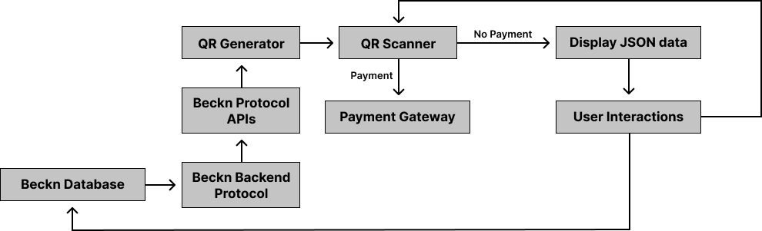

Week 3: Developing Backend Architecture
- Develop the backend infrastructure for generating and storing the QR codes through NodeJS.
- Develop APIs for integrating the QR codes with Beckn-aware applications.

Week 4: Developing the UI
- Developing the frontend of the QR Code Interpreter/Management dashboard with ReactJS
- Developing the Frontend of the QR Code Scanner
- Creating appropriate routes for the SDK

Week 5: Integrating the backend architecture created to the frontend
- Calling relevant APIs to the appropriate routes through Axios.
- Modifying the API Endpoints with ExpressJS for seamless calling of APIs

Week 6: Making the SDK portable and scalable
- Ensuring the SDK created works properly with other Beckn user end products.
- Conduct end-to-end testing to ensure that the QR codes can be scanned and trigger the appropriate actions.

Week 7: Ensuring if the SDK fulfills the main criteria of the project
- Enable Users for using Beckn QR code scanner for implementing the Rating and Reputation Infrastructure
- Deploy the Beckn QR project to a staging environment for final testing.

Week 8: Demonstration of live QR Scanner
- Demonstrating the live working of QR Code Scanner and its Interpretation through the SDK developed.

Tech stack
NodeJS: The Beckn server component is built using NodeJS to handle API requests and responses.
ExpressJS: To build the Beckn server component, on appropriate routes.
Axios: For seamless facilitation in API Calls from client side.
ReactJS: The Beckn user interface component is built using ReactJS to provide a responsive and interactive experience to the users.
MongoDB: The Beckn database component is built using MongoDB to store and retrieve data related to the Beckn protocol.

Availability
Number of hours able to dedicate to this project per week | 28 Hours
Do you have any other engagements during this period? | No

Personal Information
My name is Roshan George. Currently I am a 3rd year student pursuing Artificial Intelligence from Amrita Vishwa Vidyapeetham Chennai Campus. My native is Vellore, Tamilnadu. I have experience working with software development field for over 3 years. I have especially worked with MERN stack, Blockchain, and AI related domains during my Internships.

About Me
I have been a contributor as well as mentor for various open-source projects at various open-source events. I have specific interest towards Blockchain and its applications.

What is your motivation to apply to this project?
- My main motive is to be in part of an exciting opportunity by the government of India and help them develop a cutting-edge solution to tackle the issues through Beckn protocol. Being so much into the Blockchain domain and with all the experience I believe to provide a cutting edge solution in terms of scalability for the Beckn protocol.

- Why not? It is a really interesting project like for example:
Suppose a user is walking by a local coffee shop and sees a Beckn-compliant QR code displayed outside. They scan the QR code using a Beckn-aware application on their mobile device. The application recognizes the QR code as a Beckn-compliant code and triggers an API call to the Beckn server.
The Beckn server retrieves information about the coffee shop, such as its name, location, menu, and offers, from the coffee shop's Beckn-enabled system. The application then displays the coffee shop's information, allowing the user to browse through the menu and check out the latest offers.
Suppose the user finds a coffee they like and wants to place an order. They select the coffee, customize it according to their preferences, and confirm their order. The application generates a Beckn-compliant QR code containing the order details and payment information.
The user can then scan the QR code at the coffee shop to confirm their order and pay for it. The coffee shop's Beckn-aware application receives the QR code and triggers an API call to the Beckn server to update the order status and process the payment.
The user can track the status of their order through the Beckn-aware application, which receives updates from the Beckn server. Once the coffee is ready, the coffee shop's Beckn-aware application generates another Beckn-compliant QR code containing the order details.
The user can scan this QR code to pick up their coffee and enjoy it. The user also has the option to leave a rating and review about their experience, which will be stored securely on the blockchain and used to build the coffee shop's reputation.

Previous/experience with open source projects?
Project Name | Project Description | Links
Edunity | A MERN stack site which lets students preparing for competitive exams to connect directly with their seniors for guidance. | https://github.com/roshangeorge97/Edunity
Guardian Wallet ETH | A Wallet that offers Bio-Metric authentication to bypass unnecessary Metamask Signs. The owner of a Guardian wallet has a joint ownership of many trusted private keys to ensure multiple security and recovery options. | https://github.com/roshangeorge97/GuardianWalleth-UI
DSA Courses | Added DSA Courses to the repository in the JSON Schema | Latest Commit
PoolTrex | Created the frontend for Pooltrex, a D-App which lets users to raise development funding for their web3 projects. | Latest Commit

Mention any issue you have solved for this C4GT Projects?
Link to the Issue | Resolution description in short | Link to pull request
https://github.com/beckn/beckn-qr-code-generator/issues/1 | Beckn Protocol – Designed UI of QR Generator dashboard and QR Scanner dashboard on Figma | https://github.com/beckn/beckn-qr-code-generator/pull/2

