**Step 1:**

If you don’t have the latest eclipse eversion, get it. On windows, mine is:

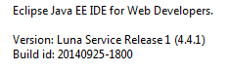

https://www.eclipse.org/downloads/

**Step 2:**

Create a new plug-in project.

Name it “testPlugin”. Use the default options.

Pick the “Hello, World Command” template and finish.

**Step 3:**

Before you continue, run the project as an Eclipse application and see if the template works.

The extra feature for the template plugin should be in the toolbar and called Sample Menu -> Sample Command. You should get the Hello, Eclipse world popup when you click the button.

**Step 4:**

Go to the shared folder on Google Drive SENG541/Working Files.

Replace the plugin.xml file with the copy in Google Drive.

Download the CustomHandler.java file in the shared folder and import that into the package testplugin.handlers

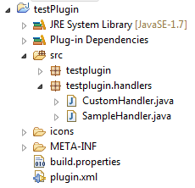

**Step 5:**

Now, run the project as an Eclipse application again.

Right click in the Project or Package explorer and there should be two buttons. API Migration is the important one and it’s what we need to work on next.

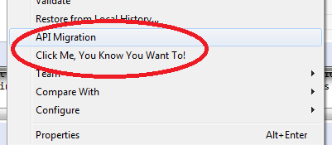

Apparently, there’s a Package and a Project Explorer:

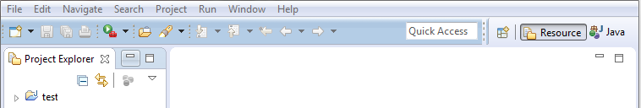

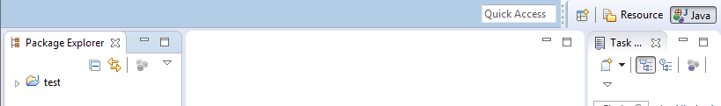

If you look in the plugin.xml, I added a menu item for each explorer which are both handled by the same handler.

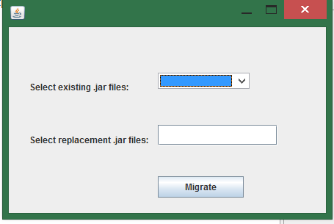

Closing the pop window for API Migration closes the Eclipse program as well..

**Step 6:**

Not perfect but let’s try to get everyone on the same page for now.