# Relational Databases with MySQL Week 4 Coding Assignment

**Points possible:** 70

|  |  |  |
| --- | --- | --- |
| Category | Criteria | % of Grade |
| Functionality | Does the code work? | 25 |
| Organization | Is the code clean and organized? Proper use of white space, syntax, and consistency are utilized. Names and comments are concise and clear. | 25 |
| Creativity | Student solved the problems presented in the assignment using creativity and out of the box thinking. | 25 |
| Completeness | All requirements of the assignment are complete. | 25 |

**Instructions:** Using a text editor of your choice, write the queries that accomplishes the objectives listed below. Take screenshots of the queries and results and paste them in this document where instructed below. Create a new repository on GitHub for this week’s assignments and push this document, with your Java project code, to the repository. Add the URL for this week’s repository to this document where instructed and submit this document to your instructor when complete.

**Coding Steps:**

Write 5 stored procedures for the employees database.

Write a description of what each stored procedure does and how to use it.

Procedures should use constructs you learned about from your research assignment and be more than just queries.

**Screenshots:**

**sumSalaryOneYear – provides total of salaries from 01/01/1990 to 12/31/1990**

DROP PROCEDURE IF EXISTS sumSalaryOneYear;

CREATE DEFINER=`root`@`localhost` PROCEDURE `sumSalaryOneYear`()

select sum(if(from_date >= '1990-01-01' and to_date <= '1990-12-31' ,Salary,0)) as TotalAmount from Salaries

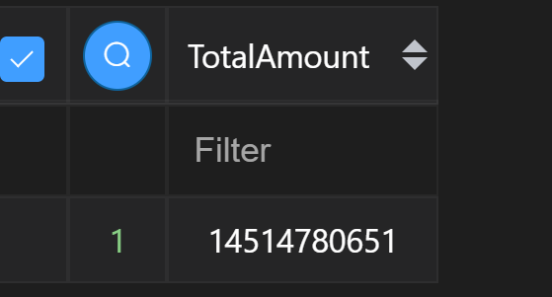

**Attempt to find employees where their first name starts with Ann**

DROP PROCEDURE IF EXISTS firstNameLikeAnn;

CREATE DEFINER=`root`@`localhost` PROCEDURE `firstNameLikeAnn`()

select

  emp_no,

  first_name,

  last_name,

  CASE When first_name like 'Ann%' Then "The employee's first name starts with A." END

from

  employees

limit

  20

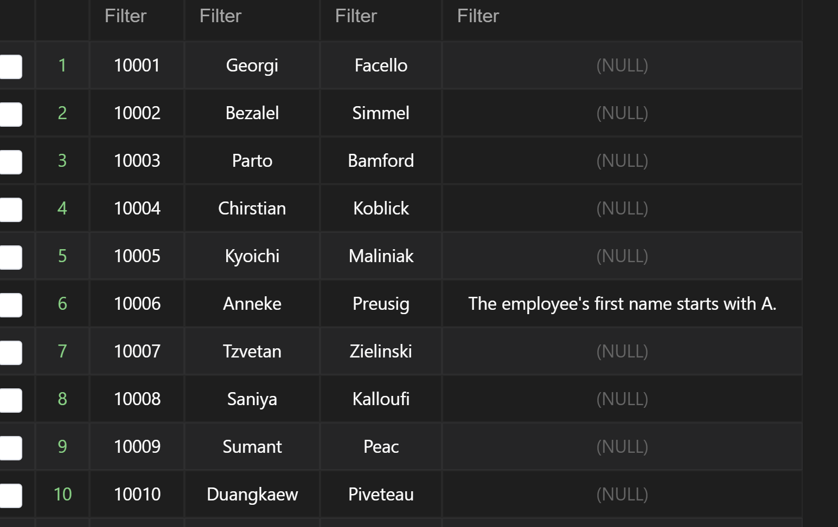

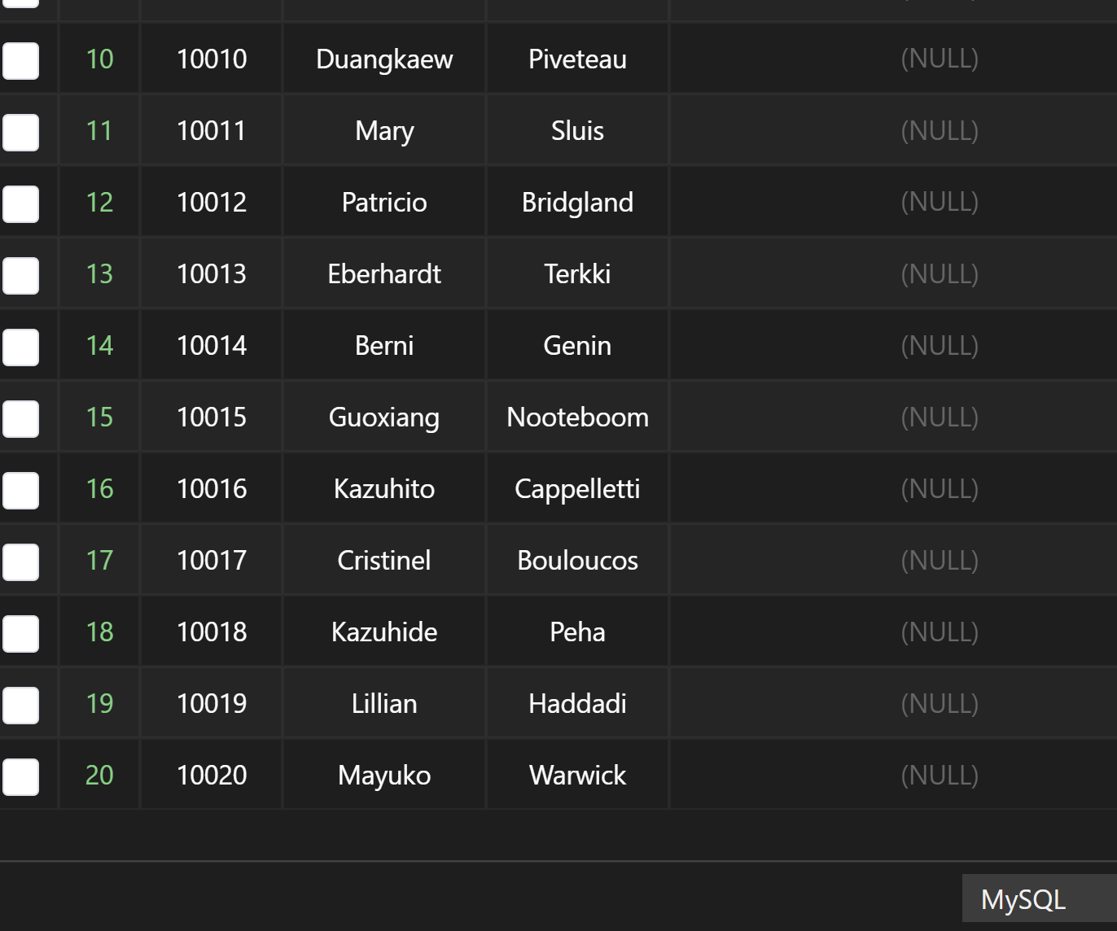

**Mark employees that have salaries over 158k**

DROP PROCEDURE IF EXISTS markHighestSalary;

CREATE DEFINER=`root`@`localhost` PROCEDURE `markHighestSalary`()

select

  emp_no,

  salary,

  CASE When salary > 158000 Then "You have the highest salary" END

from

  salaries where salary >158000



**Procedure to concatenate the first and last name for the first 20**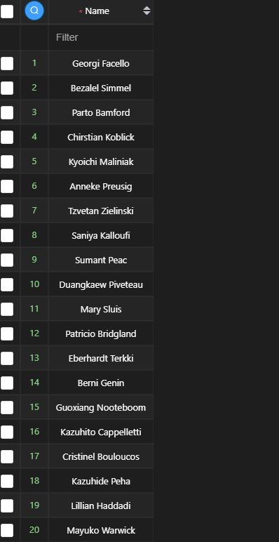

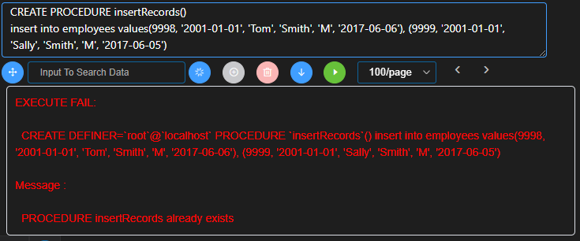

**URL to GitHub Repository:**

[becktrb/mysqlWk4 (github.com)](https://github.com/becktrb/mysqlWk4)