ESAm 211 Final Project

Becky Clow and Priscilla Hare

2/27/2020

library(popbio)

## Warning: package 'popbio' was built under R version 3.5.2

library(primer)

## Warning: package 'primer' was built under R version 3.5.2

## Loading required package: deSolve

## Warning: package 'deSolve' was built under R version 3.5.2

## Loading required package: lattice

library(tidyverse)

## ── Attaching packages ─────────────────────────────────────── tidyverse 1.2.1 ──

## ✔ ggplot2 3.1.0 ✔ purrr 0.3.1   
## ✔ tibble 2.0.1 ✔ dplyr 0.8.0.1  
## ✔ tidyr 0.8.3 ✔ stringr 1.4.0   
## ✔ readr 1.1.1 ✔ forcats 0.3.0

## Warning: package 'tibble' was built under R version 3.5.2

## Warning: package 'tidyr' was built under R version 3.5.2

## Warning: package 'purrr' was built under R version 3.5.2

## Warning: package 'dplyr' was built under R version 3.5.2

## Warning: package 'stringr' was built under R version 3.5.2

## ── Conflicts ────────────────────────────────────────── tidyverse_conflicts() ──  
## ✖ dplyr::filter() masks stats::filter()  
## ✖ dplyr::lag() masks stats::lag()

Starting stages: seedbank:5000 rosette:500 adult:100

Alliaria petiolate Matrix

gb = 0.3171  
s = 0.025  
f = 616  
v = 0.8228  
gi = 0.5503  
  
life_stages <- c("Seedbank", "Rosette", "Adult")  
original_matrix <- matrix(c(1-gb, 0, f*v*(1-gi),  
 gb, 0, f*v*gi,  
 0, s, 0),  
 nrow = 3, ncol = 3, byrow = TRUE, dimnames = list(life_stages,life_stages))  
  
print(original_matrix)

## Seedbank Rosette Adult  
## Seedbank 0.6829 0.000 227.9281  
## Rosette 0.3171 0.000 278.9167  
## Adult 0.0000 0.025 0.0000

Part 2: Projecting the Matrix

n_0 <- c(5000, 500, 100) #initial abundance  
pop_1 <- pop.projection(original_matrix, n_0, iterations = 25) #initial population  
stage.vector.plot(pop_1$stage.vector) #proportions

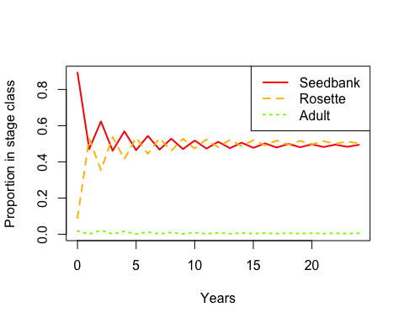

stage.vector.plot(pop_1$stage.vector, proportions = FALSE)

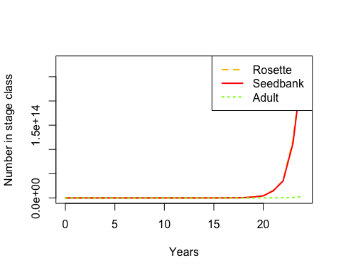

plot(pop_1$pop.sizes, xlab = "Year", ylab = "Population Size")

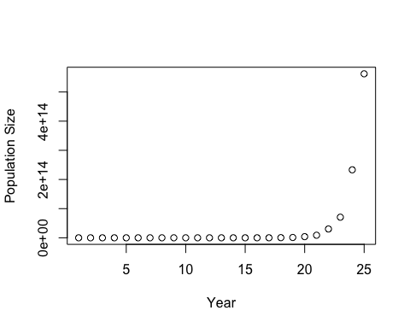

plot(pop_1$pop.changes)

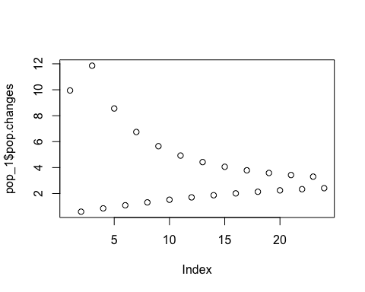

lambda(original_matrix)

## [1] 2.797733

stable.stage(original_matrix)

## Seedbank Rosette Adult   
## 0.48836941 0.50709925 0.00453134

DemoInfo(original_matrix)

## $lambda  
## [1] 2.797733  
##   
## $SSD  
## [1] 0.48836941 0.50709925 0.00453134  
##   
## $RV  
## [1] 1.000000 6.669294 746.356228  
##   
## $Sensitivities  
## [,1] [,2] [,3]  
## [1,] 0.0673394 0.06992199 0.0006248093  
## [2,] 0.4491063 0.46633030 0.0041670369  
## [3,] 50.2591802 52.18671031 0.4663303003  
##   
## $Elasticities  
## Seedbank Rosette Adult  
## Seedbank 0.01643691 0.0000000 0.05090249  
## Rosette 0.05090249 0.0000000 0.41542781  
## Adult 0.00000000 0.4663303 0.00000000  
##   
## $PPM  
## Seedbank Rosette Adult  
## Seedbank 0.6829 0.000 227.9281  
## Rosette 0.3171 0.000 278.9167  
## Adult 0.0000 0.025 0.0000

Manual sensitivity analysis

#Manipulating seedling survival s  
original_matrix[3,2] <- 0.02  
lambda(original_matrix)

## [1] 2.522702

original_matrix[3,2] <- 0.01  
lambda(original_matrix)

## [1] 1.846676

original_matrix[3,2] <- 0.008  
lambda(original_matrix)

## [1] 1.677164

original_matrix[3,2] <- 0.004  
lambda(original_matrix)

## [1] 1.268578

original_matrix[3,2] <- 0.002  
lambda(original_matrix)

## [1] 1.003999

original_matrix[3,2] <- 0.0019  
lambda(original_matrix)

## [1] 0.9891297

original_matrix[3,2] <- 0.025  
  
#manual manipulation f  
gb = 0.3171  
s = 0.025  
f = 49  
v = 0.8228  
gi = 0.5503  
  
life_stages <- c("Seedbank", "Rosette", "Adult")  
original_matrix_f <- matrix(c(1-gb, 0, f*v*(1-gi),  
 gb, 0, f*v*gi,  
 0, s, 0),  
 nrow = 3, ncol = 3, byrow = TRUE, dimnames = list(life_stages,life_stages))  
  
lambda(original_matrix_f)

## [1] 1.002318

#f would have to be below 49 to get below a 1 lambda

Part 4: Sensitivity

gb = 0.3171  
s = 0.025  
f = 616  
v = 0.8228  
gi = 0.5503  
  
original_matrix <- matrix(c(1-gb, 0, f*v*(1-gi),  
 gb, 0, f*v*gi,  
 0, s, 0),  
 nrow = 3, ncol = 3, byrow = TRUE, dimnames = list(life_stages,life_stages))  
  
original_matrix

## Seedbank Rosette Adult  
## Seedbank 0.6829 0.000 227.9281  
## Rosette 0.3171 0.000 278.9167  
## Adult 0.0000 0.025 0.0000

DemoInfo(original_matrix)

## $lambda  
## [1] 2.797733  
##   
## $SSD  
## [1] 0.48836941 0.50709925 0.00453134  
##   
## $RV  
## [1] 1.000000 6.669294 746.356228  
##   
## $Sensitivities  
## [,1] [,2] [,3]  
## [1,] 0.0673394 0.06992199 0.0006248093  
## [2,] 0.4491063 0.46633030 0.0041670369  
## [3,] 50.2591802 52.18671031 0.4663303003  
##   
## $Elasticities  
## Seedbank Rosette Adult  
## Seedbank 0.01643691 0.0000000 0.05090249  
## Rosette 0.05090249 0.0000000 0.41542781  
## Adult 0.00000000 0.4663303 0.00000000  
##   
## $PPM  
## Seedbank Rosette Adult  
## Seedbank 0.6829 0.000 227.9281  
## Rosette 0.3171 0.000 278.9167  
## Adult 0.0000 0.025 0.0000

highest elasticity: rosette to adult, adult to rosette (not biologically possible)

Part 5: elasticity to vital rates

A.vr <- expression(1-gb, 0, f*v*(1-gi),  
 gb, 0, f*v*gi,  
 0, s, 0)  
  
vr.vals <- list(gb = 0.3171, f = 616, v = 0.8228, gi = 0.5503, s = 0.025)  
  
vitalsens(A.vr, vr.vals)

## estimate sensitivity elasticity  
## gb 0.3171 0.381766867 0.04327013  
## f 616.0000 0.002117967 0.46633030  
## v 0.8228 1.585643848 0.46633030  
## gi 0.5503 1.795359661 0.35313819  
## s 0.0250 52.186710314 0.46633030

f, v, and s are the most elastic