LLM-Enhanced Multimodal Product Recommendation with Review Aspect-Specific Knowledge Graphs
I-Ni Ho, Duen-Ren Liu
Institute of Information Management, National Yang Ming Chiao Tung University, Hsinchu 300, Taiwan
* Corresponding author: Professor Duen-Ren Liu, dliu@nycu.edu.tw

ABSTRACT
With the rapid development of e-commerce, leveraging product information, user reviews, and historical behavior data to improve the accuracy of product recommendation systems and achieve personalized recommendations has become a critical trend and a highly discussed research topic for e-commerce platforms. In this study, a novel multimodal product recommendation approach is proposed that integrates aspect analysis, knowledge graphs, contrastive learning, and deep learning with Large Language Models (LLMs). While deep learning and knowledge graphs have been applied in product recommendation in existing research, most methods still rely on traditional techniques for building knowledge graphs or clustering, failing to fully exploit the semantic processing advantages of LLMs. The proposed method utilizes LLMs to optimize the results of LDA-based aspect analysis and perform aspect identification. Moreover, existing studies have not explored multimodal product recommendation using LLMs to generate aspect-specific knowledge graphs and apply contrastive learning. Therefore, this project proposes a method for constructing aspect-specific knowledge graphs from unstructured reviews via LLMs. These graphs not only encompass user-product interactions but also reveal implicit associations, enhancing the deep semantic understanding and multidimensionality of the graphs. To further improve representation quality, contrastive learning is employed to enhance intra-aspect knowledge graph homogeneity and inter-aspect distinctiveness. Additionally, fine-tuned LLMs are used to generate user purchase intentions and product image captions, enriching user and product representations. These multimodal features are ultimately integrated via attention mechanisms to improve recommendation performance. The proposed product recommendation method offers both academic innovation and practical value. It is implemented and evaluated on user and product data from the Amazon product review dataset, demonstrating significant performance improvements in experiments. The approach can be effectively applied to real-world recommendation systems, delivering meaningful and practical contributions to e-commerce platforms.
Keywords: Multi-modal Product Recommendation, Large Language Model, Review Aspect Analysis, Knowledge Graph, Contrastive Learning

- Introduction
With the rapid development of e-commerce, consumers have gradually shifted from traditional brick-and-mortar shopping to online platforms. In addition to offering a wide range of products, these online marketplaces must also help users efficiently find items of interest from an overwhelming selection. Consequently, leveraging data such as product information, user reviews, and historical behavior to improve the accuracy of recommendation systems and achieve personalized recommendations has become a key development trend and an ongoing research focus in the e-commerce domain.
Modern product recommendation systems often integrate multimodal data—such as textual descriptions, images, user reviews, and behavioral history—to generate high-quality recommendations [27, 33, 44, 45, 55]. For example, Tian et al. [45] improved recommendation accuracy by integrating text and image data into a unified latent space, thereby simplifying the learning process and enhancing model discriminability. Tao et al. [44] constructed multimodal interaction graphs and used a gated attention mechanism to weigh the influence of each modality on user preferences. Liu et al. [33] constructs a multimodal entity graph by extracting semantic-rich entities from visual and textual data, integrating them into the user-item interaction graph. A symmetric linear graph convolutional network is then employed to capture high-order semantic correlations and collaborative filtering signals, facilitating the learning of refined multimodal embeddings. These multimodal features not only help systems gain a more comprehensive understanding of product characteristics but also enable them to capture user purchase intentions and both short- and long-term interests, thereby enhancing recommendation accuracy and personalization. In addition to modeling from user and item attributes, user reviews also provide valuable insights into individual preferences. Therefore, this study focuses on developing methods for extracting and utilizing informative review-based features to enhance personalized recommendations.
In this study, we propose a novel deep learning–based multimodal product recommendation approach that integrates Large Language Models (LLMs), knowledge graphs, and contrastive learning. In particular, we focus on leveraging LLMs for review aspect analysis and for constructing aspect-specific knowledge graphs within a unified multimodal recommendation framework. This approach aims to identify the specific attributes users care about through aspect-based review analysis. LLMs are leveraged not only to refine the aspect clustering results, but also to uncover implicit semantic relationships in reviews and help construct aspect-specific knowledge graphs that capture multi-entity relationships and semantic structures between users and items, thereby improving both the accuracy and diversity of recommendations and enhancing the overall shopping experience.
Recent studies have explored recommendation systems that consider both reviews and ratings [9, 26, 32, 36, 69]. In the field of natural language processing, convolutional neural networks (CNNs) have proven effective in extracting generalized contextual features for building recommendation systems [42, 43]. However, not all features equally influence the output. To address this, some studies [42, 70] have combined CNNs with attention mechanisms to learn user and item representations, allowing the model to focus more on informative content while reducing the impact of less relevant terms. Other works have further performed aspect-level analysis on reviews [6, 11, 19, 31], investigating how aspect-based modeling can help capture specific attributes that users care about. For instance, Hasan et al. [19] fine-tuned a BERT model for review text and added an aspect representation layer to extract features related to aspects such as price, location, and service for predicting corresponding aspect-level ratings. Jain et al. [26] introduced sparsity into the attention mechanism during aspect computation to enhance the fine-tuning performance of BERT. Zhao et al. [69] suggested that jointly extracting aspect terms and their sentiment polarities can improve training efficiency. Y. Cui et al. [11] combined text summarization with Aspect-Based Sentiment Analysis (ABSA) to extract aspects and sentiments from Amazon book reviews. Chehal et al. [6] compared several topic modeling methods including LDA, LSA, and PLSA, finding LDA most effective for extracting topics from user reviews in e-commerce. Latent Dirichlet Allocation (LDA) [3] is a topic modeling technique that infers latent topics or aspects in text based on word co-occurrence patterns. In recommendation systems, LDA can help identify aspects in reviews—such as quality, price, and functionality—thus enabling the model to better understand consumer concerns.
Most existing aspect analysis methods are based on traditional techniques such as LDA. However, as a topic modeling approach, LDA primarily relies on word frequency and co-occurrence patterns, which limits its ability to capture implicit semantic relationships between words. Consequently, the quality of the extracted aspects may be constrained. To date, limited research has explored the integration of LLMs to enhance LDA-based aspect analysis in user reviews. LLMs possess a deeper understanding of semantic relationships and are capable of identifying multiple aspects within a single sentence, enabling more enriched and precise aspect clustering. By combining LLMs with LDA, it becomes possible to retain the structured clustering advantage of LDA while enhancing its semantic comprehension, thereby improving the effectiveness of recommendation systems. Therefore, this study employs LLMs to refine LDA-derived aspect groupings and to generate descriptive summaries of each aspect, which serve as prompts for subsequent LLM-based aspect identification. Additionally, LLMs are used to conduct fine-grained analysis of review texts by splitting sentences and identifying multiple latent aspects or topics, enabling more precise and in-depth aspect analysis of user reviews.
In recent years, numerous research have utilized graph-based methods for product recommendation [4, 57, 65, 67]. For example, Cai et al. [4] employed graph structures to capture key interaction features between users and items, generating more accurate recommendations through graph contrastive learning and singular value decomposition(SVD) techniques. Wu et al. [54] performed information propagation on the user-item interaction graph to capture collaborative filtering signals, focusing on extracting multi-dimensional features between users and items. However, traditional graphs mainly emphasize structural relationships and are limited to representing connections between entities, making it difficult to uncover latent semantic associations or complex attributes.
In contrast, knowledge graphs have been increasingly adopted in product recommendation research in recent years [23, 37, 49, 56, 72], as they emphasize semantic relations and logical structures among entities, allowing for the capture of deeper semantic information. For instance, Yang et al. [56] proposed a personalized product recommendation algorithm based on knowledge graphs, modeling the semantic relationships between users and items to identify deeper associations among item attributes and predict user interest in unseen items. Zhen et al. [23] integrated user-item interaction graphs with knowledge graphs by mapping semantic features from the knowledge graph into the embedding space of the interaction graph to reduce the semantic gap between the two representations. Ma et al. [37] designed a joint learning framework that integrates knowledge graphs with recommendation systems, enhancing model interpretability through the inductive use of interpretable rules derived from knowledge graphs.
We propose a novel method for constructing aspect-specific knowledge graphs based on prompt engineering and LLMs, serving as an innovative tool for aspect-based review analysis in product recommendation systems. Existing research on aspect-based reviews typically employs deep learning models to extract keywords and sentiment in order to analyze users’ specific needs for products. For example, Da’u et al. [13] utilized a multi-channel deep convolutional neural network (MCNN) to extract sentiment polarities related to different aspects in user reviews and to generate ratings for each specific aspect. F. Li et al. [29] first applied LDA to balance textual data, then combined CNN with word embeddings to extract local semantic features, and finally employed BiLSTM for sentiment classification. Similarly, Yang et al. [59]focused on capturing aspect-level sentiment scores and user preferences from reviews, and dynamically adjusted the weights of each aspect through an attention mechanism.
However, such analysis methods are often limited to a single sentiment or specific aspect, making it difficult to fully capture the multi-level semantic structures embedded in user reviews. In light of this, many researchers have begun to explore aspect-based knowledge graph recommendation systems [10, 12]. Constructing knowledge graphs that incorporate review aspects enables the systematic organization of fragmented review information and facilitates the discovery of complex relationships between entities within the aspects. For example, Cui et al. [10] employed syntactic parsing and Google’s pre-trained word embedding model to extract fine-grained aspect features from user reviews, effectively identifying item attributes and sentiments and aligning them with entities and relations in a knowledge graph. In another research, Cui et al. [12] adopted aspect-based sentiment analysis to identify aspect features and construct a knowledge graph, recognizing aspects mentioned in reviews based on context and analyzing the sentiment associated with each aspect.
However, traditional methods for constructing knowledge graphs [71] often rely on predefined rules or structured data, which typically require extensive manual annotation and domain expertise. These methods are time-consuming and difficult to scale, especially when dealing with unstructured data such as user reviews. As a result, they often fall short in effectively capturing implicit or latent aspects not explicitly mentioned in the text.
In recent years, with the rapid advancement of generative AI, LLMs now offer powerful tools for extracting implicit semantics from large-scale unstructured reviews. With its strong understanding of complex linguistic structures, LLMs are capable of inferring hidden aspects and relationships—extending beyond sentiment analysis to capture richer dimensions of meaning. By integrating knowledge graphs with LLMs, it becomes possible to extract entities, attributes, implicit semantics, and interrelations from unstructured data, while also enabling knowledge inference. Even when certain items or aspects are not directly connected in the data, potential relationships can still be inferred through implicit paths, thereby mitigating cold-start and data sparsity issues. As a result, utilizing LLMs for knowledge graph construction has emerged as a promising research direction. For instance, Zhang et al. [64] proposed an iterative prompting strategy that decomposes tasks at various stages of knowledge graph construction and enhances LLM performance using pretrained modules to improve the accuracy of automatic triple extraction. Vizcarra et al. [47] employed LLMs to assist with text annotation, data synthesis, entity recognition, and topic identification, thereby supporting knowledge graph construction and improving overall model performance.
However, existing research has yet to explore the use of LLMs for aspect-based analysis of user reviews and the subsequent construction of aspect-specific knowledge graphs. To address this gap, our study proposes a novel approach that leverages LLMs and prompt engineering to construct aspect-specific knowledge graphs from unstructured user reviews. This enables the extraction of fine-grained information for each aspect and reveals multi-level semantic associations between reviews and item attributes. By doing so, the recommendation model can more precisely handle the diversity of user reviews and capture deeper semantic features, thereby enriching the system's knowledge base and improving recommendation accuracy and diversity. Once the aspect-specific knowledge graphs are constructed, we employ a Graph Attention Network (GAT) [46] to process both the semantic and structural information within the graphs. This facilitates the generation of user and item aspect-based review embeddings, further enhancing the effectiveness of the recommendation system.
Our study also introduces the concept of contrastive learning [35, 50, 51, 61] to address the current lack of specialized learning on review aspect-specific knowledge graphs. In prior research, Liu et al. [35] applied random perturbations to graph structures to learn user-item associations and proposed a debiased contrastive loss to mitigate sample bias, preventing over-reliance on specific instances. Yi et al. [61] introduced innovative augmentation methods such as modality edge dropping and modality masking to construct diverse views of users and items. Although contrastive learning on graphs has been explored, existing approaches have not focused on contrastive learning tailored to aspect-specific knowledge graphs. As a result, they often fail to resolve ambiguities between different review aspects or to fully aggregate features within similar groups in the same aspect.
To overcome these limitations, our study performs both inter-aspect and intra-aspect contrastive learning on the aspect-specific knowledge graphs. This allows the model to better distinguish between different aspects mentioned in reviews and to capture consumer preferences more effectively. Subsequently, an attention mechanism is employed to dynamically assign weights based on the importance of each aspect, thereby enhancing recommendation accuracy. Once the aspect-level features are generated, a self-attention mechanism is further applied to learn the optimal combination of multimodal features, which are then fused to produce the final user and item embeddings for recommendation.
In summary, existing research has not fully integrate LLMs, aspect analysis, knowledge graphs, and contrastive learning for enhancing recommendation accuracy. Our study utilizes the Amazon Product Review Dataset [25], which contains rich information such as item descriptions, images, user reviews, and purchase histories, to uncover users' implicit preferences. By analyzing these data, we aim to extract users’ behavioral patterns and preferences, and further identify the specific aspects they care about in items, thereby supporting personalized recommendations.
The objective of our study is to develop a multimodal deep product recommendation model that integrates LLMs, aspect analysis, knowledge graphs, and contrastive learning. Specifically, the model employs LLM-enhanced aspect-based review analysis to deeply uncover the fine-grained user concerns and assist in aspect identification. Additionally, LLMs are leveraged to uncover implicit semantic relationships in reviews for constructing aspect-specific knowledge graphs that capture multi-entity relationships and semantic structures between users and items, thereby improving both the accuracy and diversity of recommendations and enhancing the overall shopping experience.
To further understand consumer purchasing intentions and better capture their core needs and latent preferences, we also fine-tune LLM to generate user purchase intention data that are not present in the original dataset. This augmentation enriches the model's understanding of user intent. Moreover, LLM-generated textual descriptions of item images are combined with visual features extracted by ResNet50 to enhance the richness of item representations and strengthen the model’s overall understanding of items, thereby improving recommendation performance comprehensively.
The main contributions of our approach include:
- We address the limitations of prior aspect-aware recommendation methods that rely on shallow semantic clustering or handcrafted aspect extraction by integrating LLMs to extract fine-grained, multi-aspect information from reviews, enabling richer and more accurate semantic representations.
- We use LLM to construct aspect-specific knowledge graphs based on LLM-refined clusters to model both explicit and implicit relationships among aspects—an area often overlooked in previous graph-based recommendation methods—thereby enhancing the interpretability and semantic depth of aspect reasoning.
- To improve aspect-level discrimination and generalization, we apply both intra- and inter-aspect contrastive learning with attention mechanisms to optimize feature representations, effectively learning disentangled aspect representations without supervision.
- We incorporate diverse LLM-enhanced multimodal signals—including item images, generated image captions, and inferred user intentions—and apply a self-attention mechanism to adaptively weigh their importance, mitigating the effects of imbalanced or noisy modality contributions.
- We conduct extensive experiments showing that our model consistently outperforms state-of-the-art baselines across multiple metrics. The effectiveness of each module is further validated through ablation studies, demonstrating their respective contributions to improved ranking accuracy and semantic precision.
- Related Work
  - Product and Multimodal Recommendation System
Product recommendation systems provide personalized suggestions by analyzing user behavior, historical data, and other key features. These systems often incorporate various features to predict user demands and preferences, including product name, category, brand, price, description, user purchase intention, click behavior, and purchase history. Social interactions and feedback, such as ratings and reviews, also influence the recommendation outcomes, enabling the system to better capture user preferences.
Multimodal recommendation systems integrate diverse types of data (e.g., text, images, video) to enhance recommendation effectiveness [27, 33, 44, 45, 55]. For instance, Tian et al. [45] improve recommendation accuracy by fusing text and image data into a shared latent space, enhancing model discriminability. Lei et al. [27] construct multimodal similarity graphs based on item and user preference to integrate user-item collaborative signals. Tao et al. [44] proposed a multimodal graph attention network that builds multimodal interaction graphs and employs a gated attention mechanism to weigh the influence of each modality on user preferences.
Liu et al. [33] constructs a multimodal entity graph by extracting semantic-rich entities from visual and textual data, integrating them into the user-item interaction graph, and apply a symmetric linear graph convolutional network to capture high-order semantic correlations and collaborative filtering signals, facilitating the learning of refined multimodal embeddings.
Motivated by the effectiveness of integrating diverse modalities, our approach employs LLMs to generate enriched multimodal features, which are integrated to enhance the recommendation performance.
  - Graph Neural Networks
Graph Neural Networks (GNNs) [41] are powerful tools for modeling graph-structured data, capable of capturing multi-level structural information by iteratively aggregating features from neighboring nodes. In recommendation systems, this allows for a more accurate understanding of complex relationships between users and items. In such graphs, nodes represent entities (e.g., users, items), and edges denote interactions or relationships (e.g., purchases, friendships), making it well-suited for modeling complex real-world networks and provides a deep learning framework that enables feature learning while preserving topological information. The core goal of GNNs is to iteratively update each node's embedding by aggregating not only its own features but also the structural and attribute information of its neighboring nodes. A commonly used aggregation method is mean aggregation, where a node’s embedding is updated by averaging the features of its neighbors.
With the introduction of attention mechanisms, attention-based aggregation allows the model to assign different weights to neighbors based on their importance, enhancing adaptability to heterogeneous interaction data. For example, Veličković et al. [46] proposed the Graph Attention Network (GAT), , which incorporates attention mechanisms to dynamically adjust the influence of different neighbors according to their importance. He et al. [22] proposed LightGCN, a simplified graph convolutional model that adopts simplified weighted sum aggregation to normalize the influence of nodes with varying degrees, thereby preventing embeddings from excessively growing with deeper convolution layers. By removing nonlinear activation functions and feature transformations, LightGCN retains only weighted summation operations, which significantly reduces computational cost while still effectively capturing neighborhood information. This makes it particularly well-suited for large-scale recommendation scenarios.
In addition to these common aggregation strategies, GNN-based recommendation research has continued to evolve, proposing various models to address the needs for accuracy, diversity, and stability. Wang et al. [48] aggregate information from multiple sources or features—including social networks, contextual signals, similar users, and similar items—allowing the model to capture user preferences from different perspectives and improve both the precision and diversity of recommendations. For improving recommendation stability, Li et al. [30] leverage GNNs to capture complex user–item relationships, incorporating personalized negative sampling and diversity-aware scoring mechanisms. Malitesta et al. [38] address popularity bias in multimodal recommendation systems by employing GNN-based models such as MMGCN and GRCN to model user–item interaction structures and multimodal features. Guo et al. [18] utilize local graph embeddings to capture users’ fine-grained interests in interactions and adopt hypergraph learning to model global dependencies.
While GNNs have demonstrated strong capabilities in modeling complex user-item interactions, current approaches still struggle with effectively identifying the importance of different semantic relationships. Our approach leverages aspect-specific GAT models to better capture significant relations within each aspect.
  - Recommendation based on Graph and Knowledge Graph
In recent years, user–item relationships in e-commerce recommendation scenarios have become increasingly complex, making it difficult for traditional recommendation methods to fully capture these interactions. Graphs, by structuring user–item interactions and other relevant information, have become a powerful tool for representing such relationships, prompting a growing number of research to adopt GNNs to enhance recommendation systems. For example, Zhang et al. [67] proposed a Time-aware Item Transition Graph (TITG) to analyze temporal correlations between items, leveraging GCNs to process the graph data, and incorporating contrastive learning to improve recommendation accuracy. Yang et al. [57] applied GNNs to product recommendation by selecting diverse neighborhood data and adjusting attention weights across layers, giving additional weight to unpopular items to better balance popular and long-tail items. Zhan et al. [65] extracted aspect-level sentiment information from user reviews and constructed multiple aspect-aware graphs to understand users’ fine-grained preferences for items, integrating these preferences into the final recommendation via a dynamic fusion mechanism. Yu et al. [63] applied contrastive learning on user and item graphs to optimize the distribution uniformity of graph embeddings, thereby generating more balanced recommendation outcomes. Mao et al. [39] proposed a simplified GCN model that bypasses the traditional multi-layer message-passing process and instead simulates infinite-layer convolution using a constraint loss.
In addition, compared to general graphs, knowledge graphs—which incorporate entities and relations and emphasize semantic connections—are increasingly applied in product recommendation research due to their ability to capture deep semantic information [23, 37, 49, 56, 72]. For instance, Yang et al. [56] proposed a personalized product recommendation algorithm based on knowledge graphs that models semantic relationships between users and items, captures high-order associations among item attributes and identify items closely aligned with user preferences by calculating item similarity and user interest, effectively addressing cold-start and data sparsity issues. He et al. [23] combined bipartite interaction graphs with knowledge graphs and mapped semantic features from the KG into the interaction graph space to reduce the semantic gap between the two types of representations. Wang et al. [49] focused on extracting high-order relations from numerous paths within knowledge graphs and applied attention mechanisms to differentiate the importance of neighbors within the KG. MCCLK [72] integrated knowledge graphs with multi-level cross-view contrastive learning by combining user–item graphs, item–entity graphs, and complete structure graphs to capture both collaborative relations and semantic similarity, while performing contrastive learning at multiple levels to further enhance recommendation accuracy.
However, traditional methods for constructing knowledge graphs often rely on predefined rules or structured data, which typically require extensive manual annotation and domain expertise, and often fall short in effectively capturing implicit or latent aspects not explicitly mentioned in the text. Therefore, we construct aspect-specific knowledge graphs with LLMs to capture fine-grained user-item relationships between entities within each aspect.
  - Product Recommendation based on Rating、Review and Aspect
Product recommendation research based on ratings, reviews, and aspects [8, 19, 26, 31, 69] has primarily focused on sentiment analysis and aspect-based latent factor analysis. These approaches are widely applied to rating prediction by integrating textual reviews, analyzing sentiment across different aspects to infer users’ preferences. For example, Cheng et al. [8] proposed the Aspect-aware Latent Factor Model (ALFM), which improves upon the traditional Correlated Topic Model (CTM)-based recommendation methods. In recent years, research has increasingly adopted deep learning-based methods. Li et al. [31] integrated sentiment analysis from user reviews, using BERT and BiGRU to extract semantic and sentiment features, which are then combined with the DeepFM algorithm to enhance recommendation accuracy. E. Hasan et al. [19] proposed a recommendation system based on multi-criteria ratings and aspect representation learning, where a fine-tuned BERT model with an added aspect representation layer is used to predict criteria-level ratings. Jain et al. [26] improved BERT fine-tuning performance by incorporating sparsity into the attention mechanism when computing aspect-level attention from reviews. Zhao et al. [69] suggested that combining aspect term extraction and aspect polarity classification from reviews can effectively improve training efficiency.
In addition, Heterogeneous Graph Neural Networks (HAGNNs) [2] have also been applied to aspect-based sentiment analysis (ABSA). Zhang et al. [68] focused on specific aspects such as product price, quality, or service details to analyze user opinions and deeply explore various aspects mentioned in reviews. Zheng et al. [70] combined user and item reviews, applying CNNs to learn semantic features that serve as user and item representation vectors. Moreover, many research have adopted attention mechanisms to dynamically adjust the distribution of importance weights, aiming to allow models to focus on specific regions of information when processing large amounts of input, thereby enhancing interpretability and visualization of model behavior. Yang et al. [58] designed an auxiliary network during training to focus specifically on the reviews of the target item, while the main network concentrates on modeling user–item interactions and aspect-level information. Seo et al. [42] first employed CNNs to capture the latent representations of users and items, and then used local and global attention mechanisms to focus on information across different aspects.
However, these methods are often constrained by limited sentiment granularity, making it difficult to fully capture the multi-level semantic structures embedded in user reviews. In light of this, we first partition reviews into aspect-specific groups and employ LLMs to refine LDA-derived groupings and to generate descriptive summaries for each aspect, which serve as prompts for subsequent LLM-based aspect identification. Furthermore, fine-grained analysis of review is performed using LLMs by splitting sentences and identifying multiple latent aspects or topics, enabling a more precise and comprehensive aspect analysis of user opinions.
  - Large Language Model and Prompt Engineering
Large Language Models (LLMs) [1, 14, 34, 62] possess strong generalization capabilities and leverage attention-based architectures, enabling them to handle complex semantics effectively. Prominent models such as LLaMA, GPT-4, Gemini, and Claude represent the current state-of-the-art in this domain. One key advancement in utilizing LLMs is prompt engineering, which enables the model to adapt to downstream tasks without the need for fine-tuning. By designing task-specific prompts, users can effectively guide model behavior to handle a wide range of tasks [34].
Yin and Jiang [62] introduced the concept of zero-shot classification (ZSC), aiming to classify text inputs based solely on label descriptions without using any examples. Agrawal and Dang et al. [1, 14] explored few-shot prompting, where a limited number of input-output examples are provided to support in-context learning, helping LLMs better understand tasks and improve performance in challenging scenarios. Additionally, Wei et al. [52] proposed Chain-of-Thought (CoT) prompting, designed to guide LLMs through a structured and coherent step-by-step reasoning process, enabling more organized responses than traditional prompts. In contrast, the Tree-of-Thoughts (ToT) framework [60] extends CoT by organizing intermediate reasoning steps into a tree structure and using search algorithms to systematically explore promising reasoning paths, thereby enhancing the model’s inference capabilities.
Given the effectiveness of prompt engineering, recent studies [40, 66] have integrated this technique into data preprocessing, enabling more effective handling of noise, missing values, inconsistencies, and data heterogeneity. Furthermore, LLMs have been increasingly applied to knowledge graph construction. For instance, Vizcarra et al. [47] utilized LLMs to support tasks such as text annotation, data synthesis, entity recognition, and topic identification, thereby improving the quality and efficiency of knowledge graph construction. Zhang et al. [64] proposed an iterative prompting strategy that decomposes and processes key phases in knowledge graph construction, leveraging pretrained components to enhance the LLM’s ability to extract relevant information and improve the accuracy of automatically generated triples.
Building on the effectiveness of prompt engineering and the capabilities of LLMs, our study proposes a novel approach that leverages prompt-driven LLMs to construct aspect-specific knowledge graphs, enabling fine-grained analysis of reviews for recommendation systems. In addition to knowledge graph construction, we also utilize LLMs to generate user purchase intention data and image captions for items, thereby enriching multimodal features and further enhancing recommendation performance.
  - Contrastive Learning
The concept of contrastive learning enhances a model’s ability to learn effective representations by introducing positive and negative samples during training, encouraging similar instances to be closer in the embedding space while maximizing distinctions between dissimilar ones. As a widely adopted self-supervised learning technique [7, 20, 24] , contrastive learning aims to maximize mutual information (MI) between positive sample pairs while minimizing it for negative pairs, thus revealing shared semantic information across different perspectives.
In recent years, contrastive learning has been integrated into recommendation systems, demonstrating significant potential in improving user and item representations. For example, Li et al. [28] combine contrastive learning with multi-interest recommendation, employing latent item categories to construct a multi-interest encoder and designing a contrastive multi-interest loss to enhance the diversity and quality of interest embeddings, thereby improving recommendation performance. Wei et al. [53] improved cold-start representation learning by maximizing the mutual information between user-item interactions and item embeddings.
More recently, contrastive learning has been incorporated into graph-based recommendation models, extending self-supervised learning to graph representation learning. Yi et al. [61] proposed novel augmentation strategies, such as modality edge dropout and modality masking, to generate diverse user and item views. Wang et al. [51] introduced an adaptive contrastive view generator to augment data for enhancing collaborative filtering, using both graph generative models and graph denoising mechanisms for contrastive learning.
Given the effectiveness of contrastive learning in improving representation quality, our approach incorporates it into the proposed framework to perform both intra-aspect and inter-aspect contrastive learning. This design encourages the model to align feature representations within the same aspect while distinguishing those across different aspects, thereby capturing fine-grained semantic distinctions and enhancing the quality of user and item embeddings derived from aspect-specific knowledge graphs.
- Proposed Approach
  - Overview
Our study proposes a novel framework, RAKG-LMR (LLM-Enhanced Multimodal Product Recommendation with Review Aspect-Specific Knowledge Graphs), that integrates LLMs, aspect analysis, knowledge graphs, contrastive learning, and deep learning-based recommendation techniques. The framework is structured into five major stages.
The first stage focuses on extracting multimodal features beyond textual reviews. Specifically, fine-tuned LLMs are utilized to generate user purchase intentions and produce textual descriptions of item images. Semantic features are then derived from item descriptions, image captions, and purchase intentions using pre-trained language models, while visual features are extracted from item images via ResNet50.
The second to fourth stages concentrate on review feature modeling using our proposed LLM-enhanced Multi-Aspect Knowledge Graph Embedding module (LLM-MAKGE), which incorporates aspect-based review analysis, knowledge graph construction, contrastive learning, and self-attention mechanisms to generate aspect-specific user and item review embeddings.
In the second stage, LLMs are integrated with LDA for aspect-based review analysis. The LLMs are used to refine LDA topic assignments and improve aspect identification, thereby enabling fine-grained segmentation of review texts.
In the third stage, aspect-specific knowledge graphs are constructed using LLMs to leverage their semantic understanding capabilities for extracting rich aspect-level features of users and items.
The fourth stage applies contrastive learning on the aspect-specific knowledge graphs to enhance intra-aspect similarity and inter-aspect discrimination. Additionally, a GAT is employed to aggregate node-level features while dynamically learning the importance of neighboring nodes, thereby enhancing the expressiveness of the knowledge graph embeddings. A self-attention mechanism is further introduced to weight the relative importance of each aspect, resulting in more precise aspect-aware user and item embeddings.
Finally, the fifth stage aggregates multimodal user and item features using a self-attention mechanism to generate unified user and item representations. These features are projected into a common latent space to ensure dimensional compatibility across modalities. The unified embeddings are then used to model user-item interactions, ultimately producing predicted preference scores for personalized product recommendation.
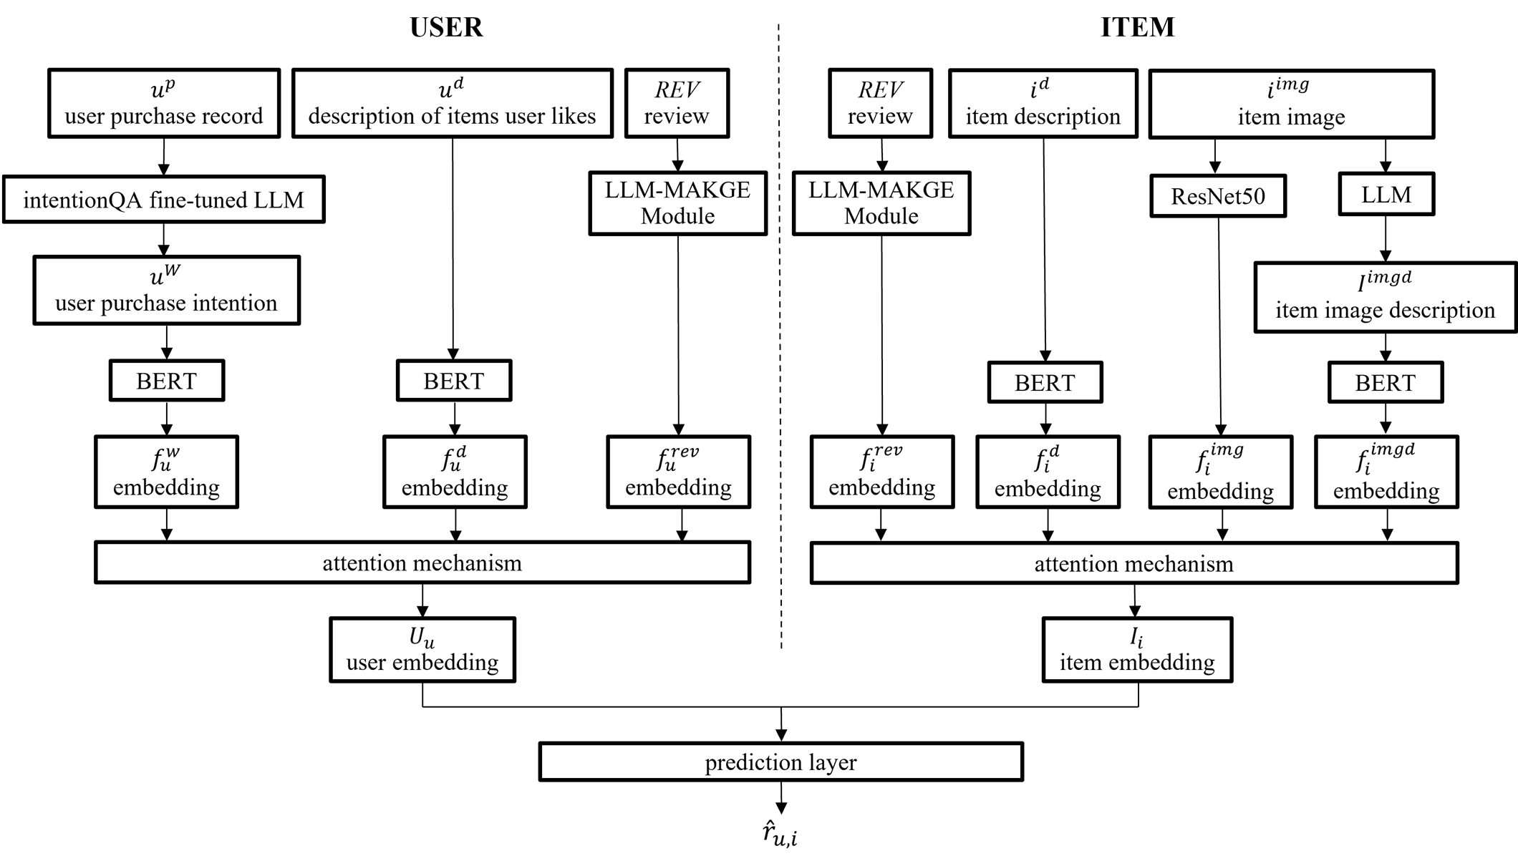Figure 1: Overview of RAKG-LMR.
The overall architecture of our proposed multimodal product recommendation model is illustrated in Figure 1 and Figure 2. The framework consists of the following stages:
- Multimodal Feature Extraction:
We begin by extracting features from multiple sources beyond reviews. This includes generating user purchase intentions using fine-tuned LLMs, producing captions of item images via LLMs, extracting semantic representations from item descriptions and purchase intentions using BERT, and deriving visual features from item images using ResNet50.
- Aspect-Based Review Analysis:
To identify fine-grained aspects from reviews, we combine LLMs with LDA. LLMs are employed to refine LDA-generated topics and improve aspect identification, allowing more accurate segmentation of review content.
- Aspect-Specific Knowledge Graph Construction:
For each identified aspect, we leverage the semantic capabilities of LLMs to construct aspect-specific knowledge graphs that capture aspect-level features of users and items in a structured and interpretable way.
- Contrastive Learning on Aspect-Specific Knowledge Graph:
To improve representation learning, we incorporate contrastive learning to strengthen the consistency of representations within each aspect while emphasizing the distinctions between different aspects. We then use GAT to aggregate node features, allowing the model to adaptively learn the importance of neighboring nodes. Finally, a self-attention mechanism is applied to weigh the relative significance of each aspect, resulting in more informative and discriminative aspect-aware review embeddings for users and items.
- Multimodal Fusion and Embedding Alignment:
We first project all extracted user and item features—including user purchase intentions and preferred item descriptions, item textual descriptions, image features, and image captions extracted from step (1), as well as aspect-aware review embeddings from steps (2) to (4)—into a shared latent space to ensure dimensional alignment. Subsequently, attention mechanisms are applied to fuse the multi-source features for users and items, respectively. The resulting unified embeddings are then used to model user-item interactions , enabling effective and accurate personalized recommendations.
- Model Implementation and Evaluation:
Finally, we implement the proposed recommendation method and conduct comprehensive experiments to evaluate its performance against existing baselines.
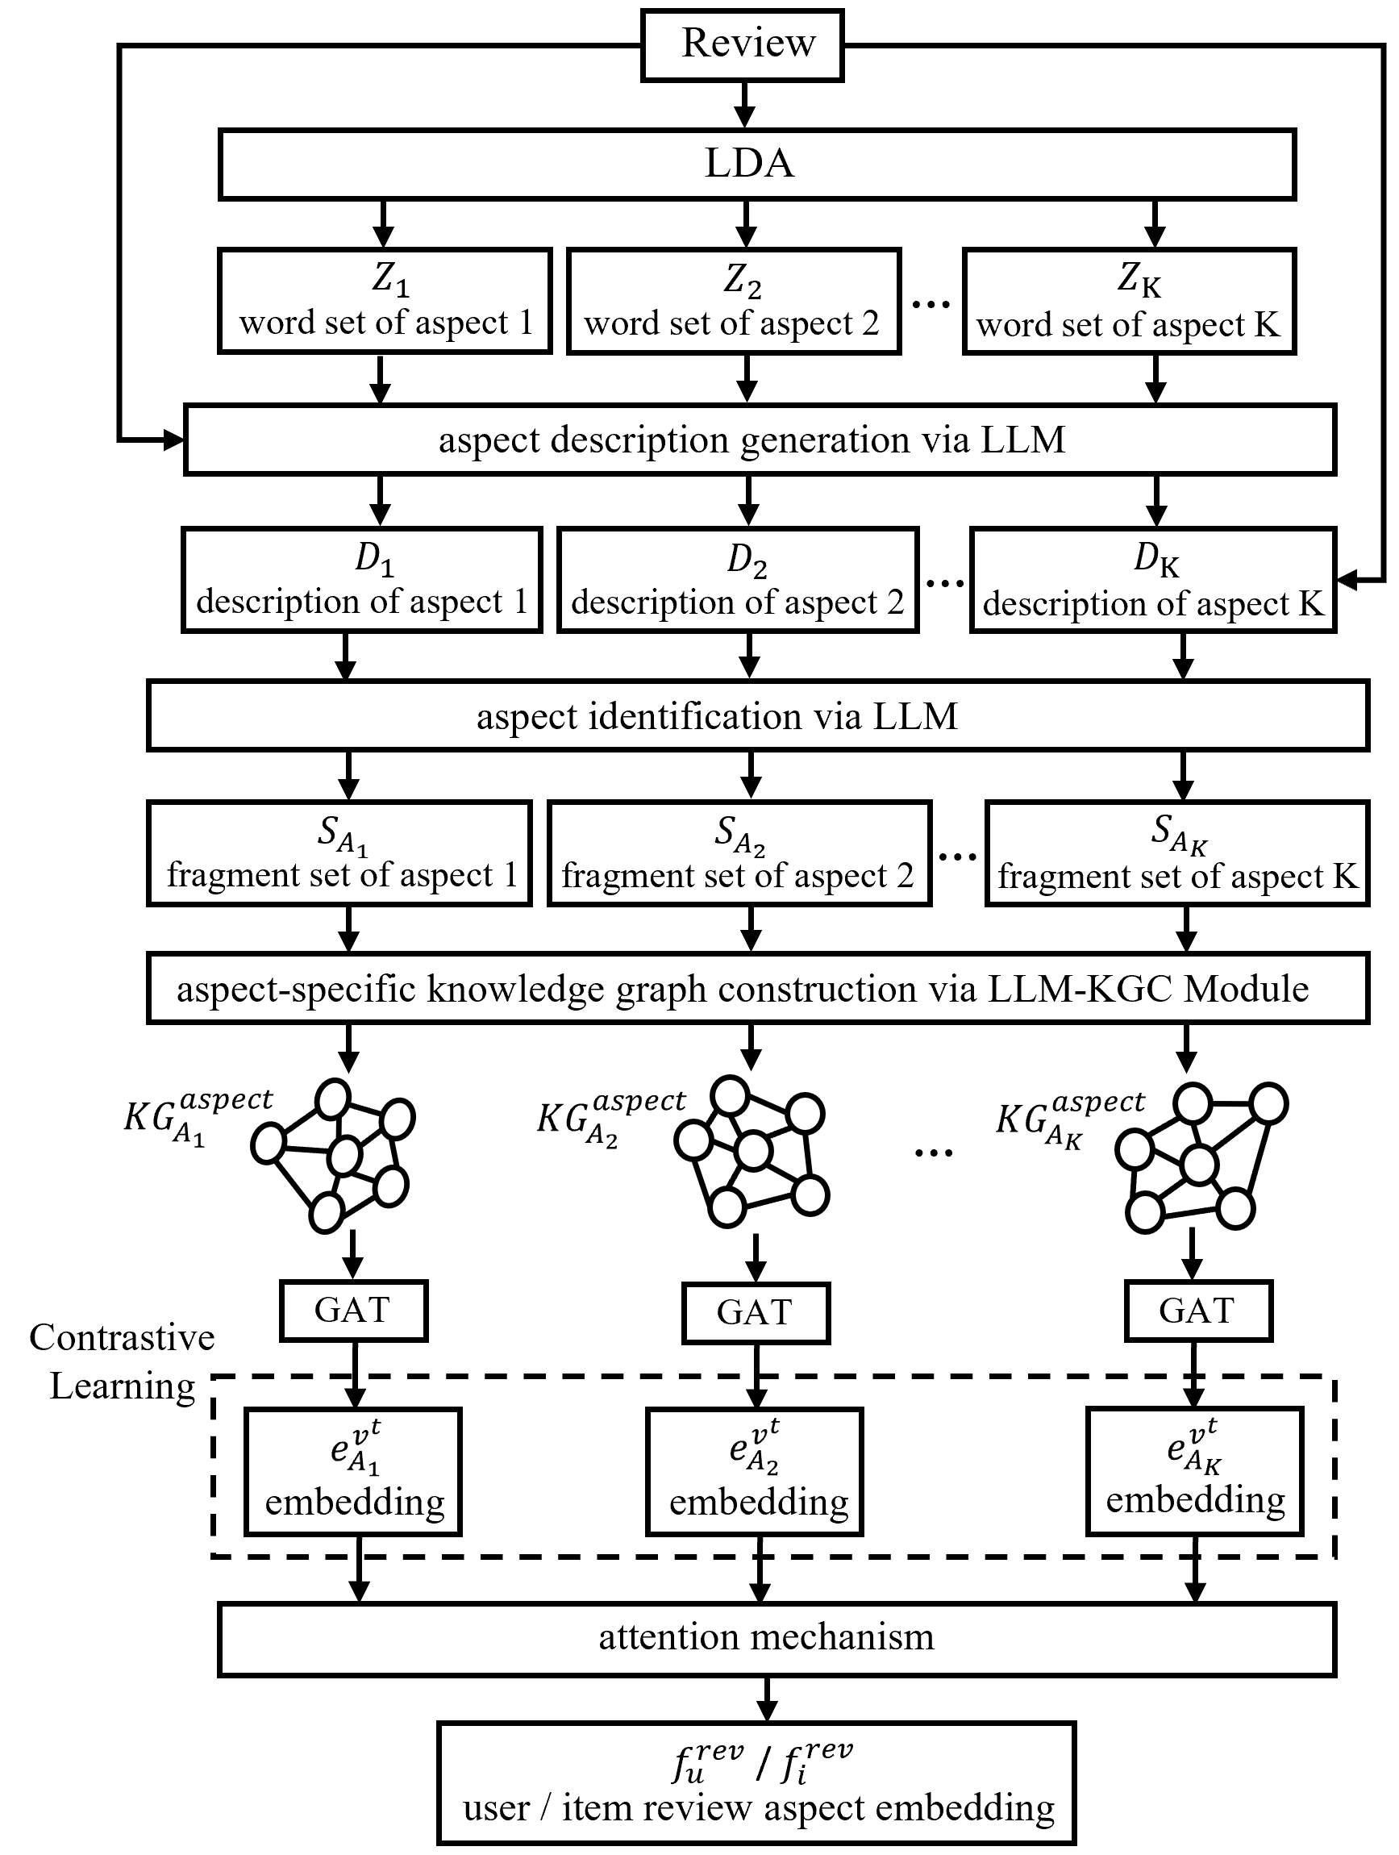
Figure 2: LLM-Enhanced Multi-Aspect Knowledge Graph Embedding Module (LLM-MAKGE).
  - Feature Extraction based on Multimodal Data
    - Purchase Intention Generation via Fine-tuned LLM
In recommendation systems, understanding user purchase intentions can significantly enhance recommendation accuracy by aligning system outputs with users’ latent needs. Ding et al. [16] proposed a dual-task multiple-choice benchmark dataset focused on purchase intention, designed to evaluate language models’ ability to understand and utilize purchase intent in e-commerce scenarios. The dataset includes two tasks—intention understanding and intention utilization—which help models more accurately capture users’ purchasing needs, thereby improving recommendation performance.
However, the dataset used in our study lacks explicit purchase intention annotations. To better infer users’ purchasing motivations and effectively identify their core needs and latent preferences, we employ LLM to generate purchase intentions. Specifically, we adopt TinyLlama-1.1B-Chat-v1.0 (hereafter referred to as TinyLlama), a lightweight instruction-tuned model that balances computational efficiency with strong language generation capabilities. To further enhance its understanding of purchase intentions and improve the quality of the generated outputs, we fine-tune TinyLlama on the IntentionQA dataset. The resulting model is then used to generate a purchase intention for each user, as shown in Eq. (1)：
$${TinyLlama}_{IntentionQA}=Fintune\left({TinyLlama}_{base}, {Data}_{IntentionQA}\right)$$ | (1)
where ${Data}_{IntentionQA}$ refers to the purchase intention dataset，${TinyLlama}_{base}$ denotes the pre-trained TinyLlama model, and ${TinyLlama}_{IntentionQA}$ represents the TinyLlama model fine-tuned on the IntentionQA dataset.
Specifically, let $U^{p}=\left\{u_{1}^{p}, u_{2}^{p}, …, u_{M}^{p}\right\}$ be the set of all users’ purchase histories, where each $u^{p}$ represents an individual user's purchase history, and $M$ is the total number of users. To generate the set of purchase intentions $U^{w}$, each user's purchase history $u^{p}$, together with the designed prompt $Pt^{intention}$, is input into ${TinyLlama}_{IntentionQA}$ to produce the corresponding purchase intention $u^{w}$, as shown in Eq. (2)：
$$u^{w}={TinyLlama}_{IntentionQA}\left(u^{p},Pt^{intention}\right), u^{p}∈U^{p}, u^{w}∈U^{w}$$ |  |  | (2)
Here, $U^{w}=\left\{u_{1}^{w}, u_{2}^{w}, …, u_{M}^{w}\right\}$ is the set of generated purchase intentions for all users. The prompt $Pt^{intention}$ is designed to guide TinyLlama in generating purchase intentions. This generation process not only helps capture users’ motivations behind their purchasing behaviors but also enhances the system’s ability to understand users' true needs—ultimately improving the effectiveness and personalization of product recommendations.
    - Item Image Caption Generation via LLM
To enhance the richness of item information, this study not only relies on existing item metadata and titles but also utilizes LLM to generate detailed textual descriptions for item images, thereby enriching item representation. In this work, we employ Qwen/Qwen2.5-VL-7B-Instruct (hereafter referred to as the Qwen model) as the LLM. Specifically, given a set of item images $I^{imgd}$, we input each image into the Qwen model along with a predefined prompt $Pt^{imgd}$ (e.g., “Please describe the item shown in this image in detail”), allowing the model to generate a set of image caption $I^{imgd}$, as shown in Eq. (3)：
$$I^{imgd}=Qwen\left(I^{img},Pt^{imgd}\right)$$ | (3)
For example, as shown in Figure 3:
Figure 3: Image Caption Example.
The Qwen model can generate detailed captions for item images. Instead of simply identifying visible elements, the model may describe implicit attributes such as style, texture, or context, thereby enriching the original item information and fully utilizing the representational power of item images. Moreover, when combined with visual features extracted in subsequent steps, the resulting image representations become more comprehensive. This multimodal integration provides a more layered and holistic understanding of item characteristics. By better leveraging the semantic depth of item images, the system can more accurately align recommendations with user preferences, ultimately enhancing both the effectiveness and precision of personalized recommendations.
    - Semantic Feature Extraction via BERT
This step extracts semantic features from user purchase intentions, item image captions, and textual descriptions using the pre-trained BERT model [15]. The model enables deep semantic extraction from textual data, capturing implicit relationships among item attributes, user preferences, and latent purchase motivations, thereby generating semantically rich embedding representations. The process is defined as Eqs. (4)-(6)：
$$f_{u}^{w}=BERT\left(u^{w}\right)$$ | (4)
where $u^{w}$ represents an individual user’s generated purchase intention, and $f_{u}^{w}$ denotes the embedding of that user’s purchase intention.
$$f_{i}^{imgd}=BERT\left(i^{imgd}\right)$$ | (5)
where $i^{imgd}$ represents an individual item’s image caption, and $f_{i}^{imgd}$ denotes the embedding of that item’s image caption.
$$f_{i}^{d}=BERT\left(i^{d}\right)$$ | (6)
where $i^{d}$ represents an individual item’ description, and $f_{i}^{d}$ denotes the embedding of that item’s description.
In addition, to capture user preferences, we also utilize BERT to extract semantic features from the textual descriptions of positively rated items, denoted as $u^{d}$. These features are incorporated as part of the user representation, as defined in Eq. (7)：
$$f_{u}^{d}=BERT\left(u^{d}\right)$$ | (7)
Here, $f_{u}^{d}$ denotes the embedding of the description of user-preferred items.
This design enables the system to better capture user preferences by incorporating the core attributes of preferred items into the user embeddings, thereby improving matching accuracy and satisfaction in personalized recommendations.
    - Item Image Feature Extraction via CNN
In the field of computer vision, CNNs have achieved remarkable success. Many pretrained models have been developed and shown to yield excellent results. Our study adopts the ResNet50 [21] pretrained model to extract image features of items. The ResNet50 model is trained on ImageNet dataset and utilizes residual connections and bottleneck layers to mitigate vanishing gradients and enhance training efficiency. When using this pretrained model, the weights of the earlier layers are frozen, and only the final hidden layers are updated during fine-tuning with the data used in this study. This enables the model to adapt to the domain while retaining general visual patterns. The extracted image features are then input into the recommendation framework. The feature extraction process is defined as Eq. (8)：
$$f_{i}^{img}=CNN\left(i^{img}\right)$$ | (8)
where $i_{ }^{img}$ is the image of item, and $f_{i}^{img}$ denotes the extracted image feature of the item.
  - Review Aspect Analysis with LDA and LLM
In addition to the previously mentioned features, user reviews play a crucial role in product recommendation systems, as they offer authentic consumer feedback and reveal users’ needs and preferences during the purchasing process. Our study integrates LDA with LLM to conduct comprehensive aspect analysis of reviews. LDA is first employed to generate coarse-grained aspect clusters based on topic modeling, after which LLM is used to refine these initial clusters by enhancing their semantic coherence and interpretability. Furthermore, the LLM generates descriptive summaries for each aspect group, which serve as prompts for subsequent aspect identification.
Leveraging the semantic reasoning capabilities of LLM, we further utilize it to assign more accurate aspect labels to LDA-generated groups. This aspect identification process enhances the interpretability and consistency of aspect clusters.
By combining LDA’s strength in structured topic modeling with the semantic reasoning and generative capabilities of LLMs, this hybrid approach not only captures latent features in user reviews but also facilitates the extraction of richer, multi-layered semantic information.
    - Refine LDA grouping via LLM
Building on LDA-based topic grouping, our method further employs an LLM to refine and enhance the semantic coherence of the clusters, enabling better adaptation to subtle nuances in review semantics and improving aspect-level analysis.
We begin by applying LDA to the review set $REV$, dividing the content into $K$ aspects (e.g., price, quality). Each aspect is associated with a set of keywords, denoted as Eq. (9):
$$Z=LDA\left(REV, K\right), Z=\left\{Z_{1}, Z_{2},⋯, Z_{K}\right\}$$ | (9)
where $Z$ represents the set of keyword groups for all aspects, $Z_{k}$ denotes the set of keywords for aspect $k$. These aspect keyword groups, along with the original review and predefined prompt for aspect description task $Pt^{ad}$, are then jointly fed into an LLM to generate enriched aspect descriptions. We adopt the sshleifer/distilbert-cnn-12-6 model (hereafter referred to as the distilbert-cnn model) for this task. The refinement process is defined as Eq. (10)：
$$D=distilbert-cnn\left(Z, REV, Pt^{ad}\right), D=\left\{D_{1}, D_{2},⋯, D_{K}\right\}$$ | (10)
where $D$ represents the set of the aspect descriptions generated by the distilbert-cnn model, and $D_{k}$ denotes the refined and semantically enriched description for aspect $k$.
This model jointly considers aspect keywords and contextual review content to generate detailed and coherent textual descriptions for each aspect based on the provided prompt, thereby enabling deeper abstraction and improving aspect interpretability. These enriched descriptions are subsequently used as input for LLM-based aspect identification.
By combining the structural topic modeling capability of LDA with the semantic reasoning and generative strengths of LLMs, this hybrid approach not only captures latent aspects from user reviews but also produces more coherent and meaningful aspect descriptions.
    - Aspect Identification via LLM
In the aspect identification phase, this study leverages an LLM to analyze the semantic content of reviews and perform more accurate aspect-level classification. The model identifies and labels distinct semantic segments within each review, mapping each segment to their corresponding aspects. This enables a comprehensive representation of the multi-layered semantics embedded in the reviews. Such fine-grained analysis not only enhances the accuracy of aspect identification but also facilitates the construction of more precise aspect-specific knowledge graphs for downstream recommendation tasks, allowing the system to better understand and respond to diverse user needs.
Specifically, the aspect descriptions $D$ generated in step (2.1), along with the original review and predefined prompt for aspect identification task $Pt^{ai}$, are then jointly fed into an LLM to identify the review aspect and perform fine-grained review segmentation. We adopt the sentence-transformers model all-MiniLM-L6-v2 (hereafter referred to as the all-MiniLM model) for this task. The process is defined as Eq. (11)-(12)：
$$S_{rev}=all-MiniLM\left(D, REV, Pt^{ai}\right)$$ | (11)
$$S_{rev}=\left\{S_{rev_{1}}, S_{rev_{2}},…, S_{rev_{Q}}\right\}$$ | (12)
where $S_{rev}$ represents the set of the review segment, and $Q$ denotes the total number of the review segments. This process allows the LLM to assign each review segment to its corresponding aspect based on the contextual semantic information provided by $D$ and $REV$.
Next, during the aspect assignment phase, the LLM assigns each review segment to a specific aspect based on its semantic features and records the corresponding aspect label for each segment $S_{rev_{q}}$, as defined in Eq.(13)-(14)：
$$S_{A}=Aspect\left(S_{rev}\right)$$ | (13)
$$S_{A}=\{S_{A_{1}},S_{A_{2}},…,S_{A_{K}}\}$$ | (14)
where$S_{A}$ represents the collection of review segment sets for all aspects, and${ S}_{A_{K}}$ denotes the set of review segments assigned to aspect $A_{k}$. These aspect-specific review sets served as the foundation of constructing aspect-specific knowledge graphs, enabling finer-grained aspect-aware representations in recommendation.

  - Aspect-Specific Knowledge Graph Construction via LLM
Subsequently, this study utilizes an LLM to extract complex entities and relations from the aspect-specific review, generating an aspect-specific knowledge graph $KG_{A_{k}}^{aspect}$ for each aspect $A_{k}$​. These knowledge graphs incorporate multiple types of entities (e.g., users, items, and concepts) and reveal multi-layered relationships between users and items across different aspects, which facilitates more comprehensive modeling of user–item interactions.
The inputs for knowledge graph construction are derived from the aspect-specific review segments $S_{A_{k}}$, including the associated review texts and titles, denoted as ${u^{revtxt}/i}^{revtxt}$ and ${u^{revttl}/i}^{revttl}$, respectively.
We adopt an LLM Knowledge Graph Construction Module (LLM-KGC) to perform this task, which consists of two components: the Unified Summary Generation Module and the Knowledge Graph Triplets Extraction Module, as illustrated in Figure 4：
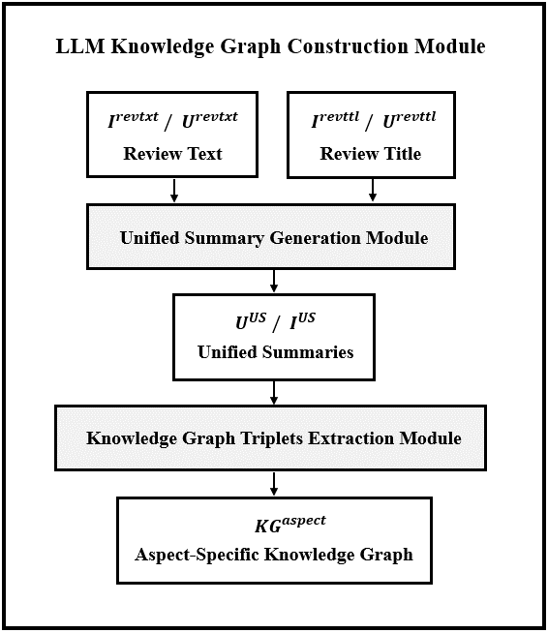
Figure 4: LLM Knowledge Graph Construction Module (LLM-KGC).
In this framework, the unified summary generation module first generates unified summaries from user or item review. These summaries are then passed to the KG triplets extraction module, which extracts knowledge graph triplets and ultimately constructs the aspect-specific knowledge graphs.
    - Unified Summary Generation Module
Within the unified summary generation module, different summarization strategies are applied based on the quantity of reviews associated with each user or item. Specifically, the 50th and 85th percentiles of review counts are used as thresholds to determine the appropriate summarization strategy. Three strategies—Strategy A, B, and C—are designed accordingly. Depending on the selected strategy, either the BART-large-CNN-Samsum model (hereafter referred to as the BART model) [17] or the Mistral-7B-Instruct-v0.2 model (hereafter referred to as the Mistral model) [5] is used to perform unified summary generation, as shown in Figure 5 and Figure 6：
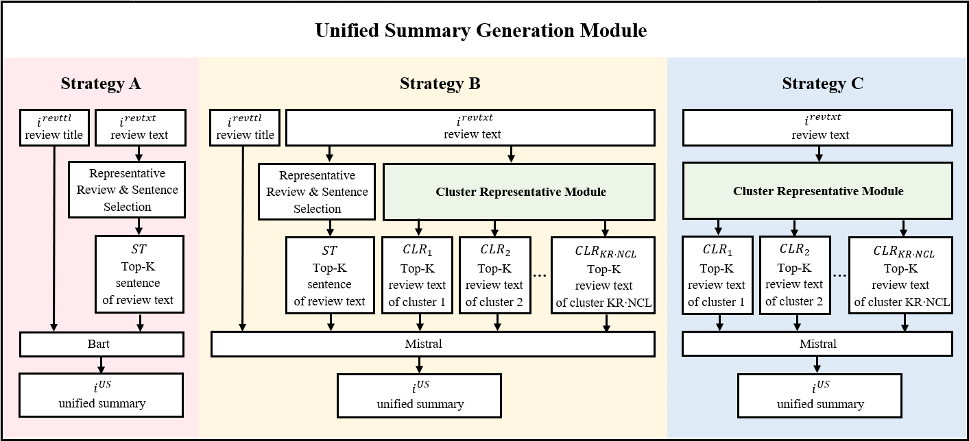
Figure 5: Unified Summary Generation Module in LLM-KGC Module.
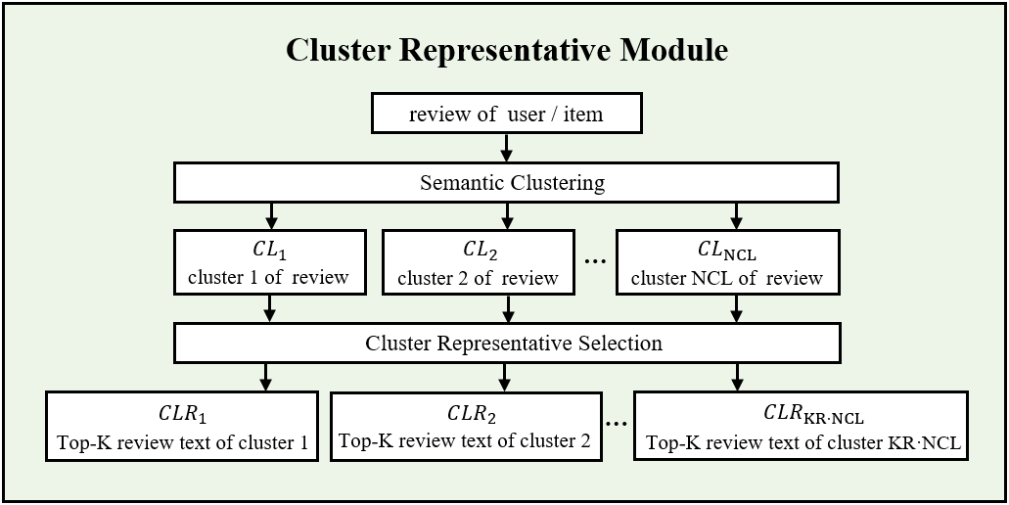
Figure 6: Cluster Representative Module.
Each strategy follows a distinct pipeline of semantic representation, filtering, and summarization. The detailed formulations of each strategy, using the item as an example, are as follows:
- Strategy A（Few Reviews）：
First, we use $all-MiniLM$ sentence transformer to encode all review texts of item, denoted as $i^{revtxt}$, into embeddings, as shown in Eq. (15):
$$EMB = all-MiniLM(i^{revtxt}), EMB=\{EMB_{1}, EMB_{2}, …, EMB_{NREV}\}$$ | (15)
where $EMB$is the set of embeddings for all $NREV$ review texts。
Next, we compute semantic similarity scores by performing the inner item between each embedding in $EMB$ and the mean embedding vector ${EMB}^{mean}$, which serves as the semantic centroid of all review texts for the item. Based on these scores, the top $KR$ most semantically similar review texts are selected as representative review texts, as presented in Eqs. (16)-(17):
$$RTR= topK\left(EMB {EMB}^{mean}\right)$$ | (16)
$$RTR=\{{RTR}_{1}, {RTR}_{2}, …, {RTR}_{KR}\}$$ | (17)
where $RTR$ is the set of the top $KR$ representative review text embeddings selected by $topK()$ based on the computed similarity scores, and ${RTR}_{kr}$ denotes the $kr$th representative review text embedding.
Next, for each representative review text, we split it into a set of review sentences, denoted as $RTRS=\{{RTRS}_{1}, {RTRS}_{2}, …, {RTRS}_{KR}\}$. We then select the top $KS$ most representative sentences based on cosine similarity, as shown in Eqs. (18)-(19):
$$ST = topK\left(sim\left(RTRS, RTRS\right)\right)$$ | (18)
$$ST=\left\{{ST}_{1}, {ST}_{2}, …, ST_{ks}\right\}$$ | (19)
where $sim(RTRS, RTRS)$ is the cosine similarity matrix between representative sentence embedding，and $ST$ is the set of the top $KS$ representative sentence embeddings selected by $topK()$ based on the cosine similarity scores, and ${ST}_{ks}$ denotes the $ks$-th representative sentence embedding.
Finally, $ST$ and review title $i^{revttl}$ are fed into the BART model to generate the unified summary for item $i^{US}$, as shown in Eq. (20):
$$i^{US} = \operatorname{BART}{(ST, i^{revttl})}$$ | (20)
- Strategy B（Moderate Number of Reviews）：
For $i^{revtxt}$, we adopt the same procedure as Strategy A to extract $ST$. In addition, the review text embeddings are clustered using either cosine similarity-based clustering or MiniBatchKMeans, depending on the number of review texts, as shown in Eqs. (21)-(22):
$$CL= \left\{\begin{aligned}\operatorname{clustering}\left(\operatorname{sim}\left(EMB, EMB\right)\right), if number of revcmb<threshold; \\ \operatorname{MiniBatchKMeans}\left(EMB\right), otherwise.\end{aligned}\right.$$ | (21)
$$CL=\{CL_{1}, CL_{2}, …, CL_{NCL}\}$$ | (22)
Here,$\operatorname{clustering}\left(\operatorname{sim}\left(EMB, EMB\right)\right)$ denotes cosine similarity-based semantic clustering, and $\operatorname{MiniBatchKMeans}\left(EMB\right)$ represents the mini-batch version of the KMeans clustering algorithm. The choice between the two clustering methods depends on a predefined $threshold of the number of review text$. The result is a set of review clusters $CL$ consisting of $CL$ ​clusters.
Next, for every cluster, we compute semantic similarity scores by performing the inner item between each embedding in the $ncl$-th cluster $EMB_{ncl}$ and the mean embedding vector of the $ncl$-th cluster ${EMB}_{ncl}^{mean}$, which serves as the semantic centroid of all review texts in that cluster for the item. Based on these scores, the top $KR$ most semantically similar review texts are selected as representative review text, as presented in Eqs. (23)-(24):
$$CLR = topK\left(EMB_{ncl} {EMB}_{ncl}^{mean}\right)$$ | (23)
$$CLR=\{{CLR}_{1}, {CLR}_{2}, …, {CLR}_{KRNCL}\}$$ | (24)
where $KR$=1. Thus, $CLR$ is the set of the top-1 representative review text embedding selected by $topK()$ based on the computed similarity scores, and ${CLR}_{krncl}$ denotes the $kr$-th representative review text embedding in the $ncl$-th cluster. Therefore, the total number the representative review text embedding for all clusters is$KRNCL$, representing $KR$ representative reviews per each of the $NCL$ clusters.
Finally, $CLR$, $ST$ and review title $i^{revttl}$ are fed into the Mistral model to generate the unified summary for item $i^{US}$, as shown in Eq. (25):
$$i^{US} = \operatorname{Mistral}{(CLR, ST, i^{revttl})}$$ | (25)

- Strategy C（(Many Reviews)）：
This strategy does not utilize the review title $i^{revttl}$ and only relies solely on the review content $i^{revtxt}$. It adopts the same approach as Strategy B for processing $i^{revcmb}$, with the key difference being the number of representative review texts selected from each review cluster—Strategy B selects one representative review text per cluster（$KR$＝1）, while Strategy C selects three（$KR$＝3）. Once the representative review text set CLR generated, it is fed into the Mistral model to obtain the unified summary $i^{US}$, as shown in Eq. (26):
$$i^{US} = \operatorname{Mistral}{(CLR)}, CLR=\{{CLR}_{1}, {CLR}_{2}, …, {CLR}_{KRNCL}\}$$ | (26)
    - KG Triplets Extraction Module
Based on the unified summaries generated by the unified summary generation module, the KG triplets extraction module subsequently constructs knowledge graphs for both items and users, as illustrated in Figure 7:

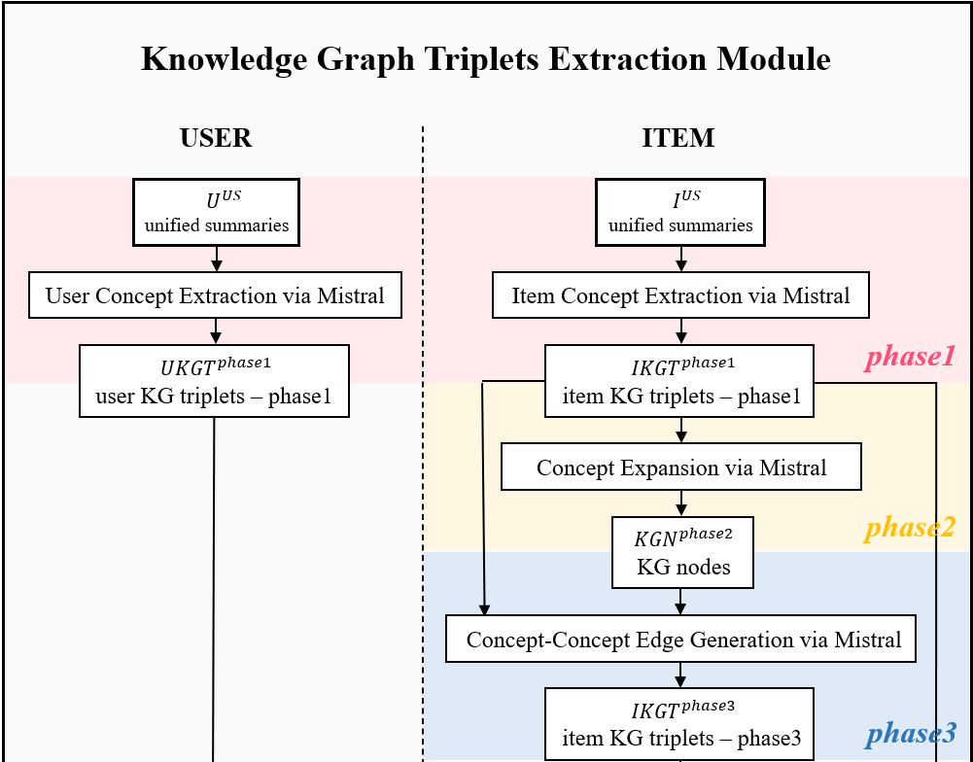

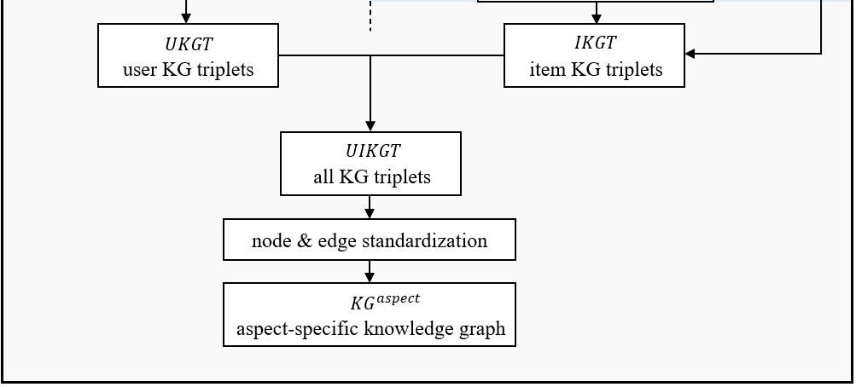
Figure 7: Knowledge Graph Triplets Extraction Module in LLM-KGC Module.
In KG triplets extraction module, the unified summaries of both items and users are processed separately. For the unified summary of an item $i^{US}$, we employ prompt engineering to design a three-stage triplet extraction process, which is used to construct item knowledge graph triplets, denoted as $IKGT$. The following illustrates the implementation of this triplet extraction procedure, taking items as an example, where $N$ denotes the total number of items.
      - Phase1: Item Concept Extraction
In the first phase, the goal is to extract explicit semantic edges directly related to the item itself. To achieve this, a prompt is designed to constrain the Mistral model such that one node of each extracted triplet must be the item, while the other node is semantically related and identified from the unified summary $i^{US}$, as shown in Eq.(27):
$${ikgt}_{n}^{phase1} = \operatorname{Mistral}\left(i^{US}, {Pt}_{i}^{phase1}\right), {ikgt}_{n}^{phase1} ϵ IKGT^{phase1}$$ | (27)
where ${IKGT}^{phase1} =\{{ikgt}_{1}^{phase1}, {ikgt}_{2}^{phase1}, …, {ikgt}_{N}^{phase1}\}$ is the set of the item-related knowledge graph triplets extracted in phase 1, and ${Pt}_{i}^{phase1}$ is the prompt designed for item-related extraction in phase1. Here, ${ikgt}_{n}^{phase1}$ denotes the item-related knowledge graph triplets for item $n$.
      - Phase2: Concept Expansion
In the second phase, the goal is to take the explicit semantic concept nodes extracted in phase 1 as the base concepts and expand them into implicit semantic nodes that share similar semantic directions or abstract-level meanings. This is achieved by prompting the Mistral model to infer and generate related semantic concepts, as shown in in Eq. (28):
$${kgn}_{n}^{phase2} = \operatorname{Mistral}\left({ikgt}_{n}^{phase1}, {Pt}_{i}^{phase2}\right), {kgn}_{n}^{phase2} ϵ KGN^{phase2}$$ | (28)
where ${KGN}^{phase2}=\left\{kgn_{1}^{phase2}, kgn_{2}^{phase2}, …, kgn_{N}^{phase2}\right\}$ is the set of the knowledge graph nodes extracted in phase 2, and ${Pt}_{i}^{phase2}$ is the prompt designed for phase 2. Here, ${kgn}_{n}^{phase2}$ denotes the knowledge graph nodes for item $n$.
      - Phase3: Concept-Concept Edge Generation
In the third phase, the goal is to establish semantic edges between the implicit semantic nodes expanded in phase 2. The Mistral model is prompted to identify meaningful semantic relations among these nodes, forming new knowledge graph triplets, as shown in Eq. (29):
$${ikgt}_{n}^{phase3} = \operatorname{Mistral}\left({kgn}_{n}^{phase2}, {Pt}_{i}^{phase3}\right), {ikgt}_{n}^{phase3} ϵ IKGT^{phase3}$$ | (29)
where ${IKGT}^{phase3} =\{{ikgt}_{1}^{phase3}, {ikgt}_{2}^{phase3}, …, {ikgt}_{N}^{phase3}\}$ is the set of the item-related knowledge graph triplets extracted in phase 3, and ${Pt}_{i}^{phase3}$ is the prompt designed for phase1. Here, ${ikgt}_{n}^{phase3}$ denotes the item-related knowledge graph triplets for item $n$.
An example of the three-phase extraction outputs for item $n$—including ${ikgt}_{n}^{phase1}$, ${kgn}_{n}^{phase2}$, and ${ikgt}_{n}^{phase3}$—is shown in
Figure 8：
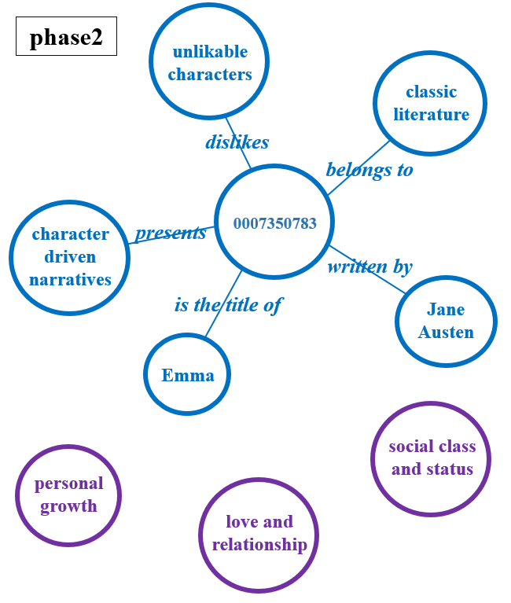
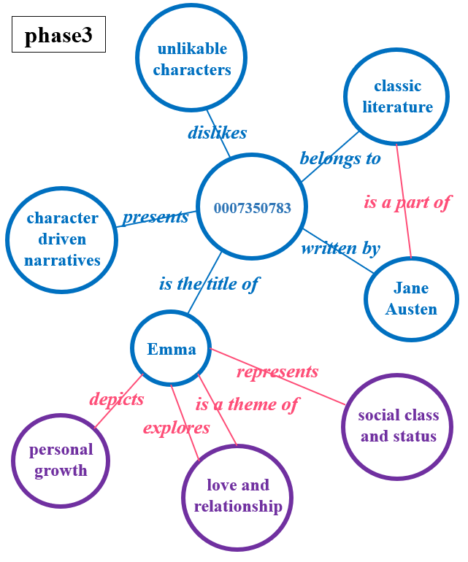
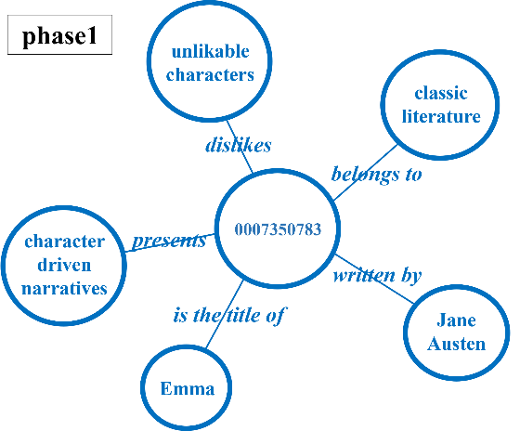

Figure 8: KG Triplets Example for Item.
For users, only phase 1 is performed to extract knowledge graph triplets from their unified summaries $u^{US}$, without proceeding to the subsequent phases. The goal is to prompt the Mistral model to identify both explicit semantic relations and implicit preferences from the input $u^{US}$, as shown in Eq.(30):
$${ukgt}_{m}^{phase1} = \operatorname{Mistral}\left(u^{US}, {Pt}_{u}^{phase1}\right), {ukgt}_{m}^{phase1} ϵ UKGT^{phase1}$$ | (30)
where $UKGT^{phase1}= \{{ukgt}_{1}^{phase1}, {ukgt}_{2}^{phase1}, …, {ukgt}_{M}^{phase1}\}$ is the set of the user-related knowledge graph triplets extracted in phase 1, $M$ is the number of users, and ${Pt}_{u}^{phase1}$ is the prompt designed for user-related extraction in phase1. Here, ${ikgt}_{n}^{phase1}$ denotes the user-related knowledge graph triplets for user $m$ in phase 1, its example is shown in Figure 9:
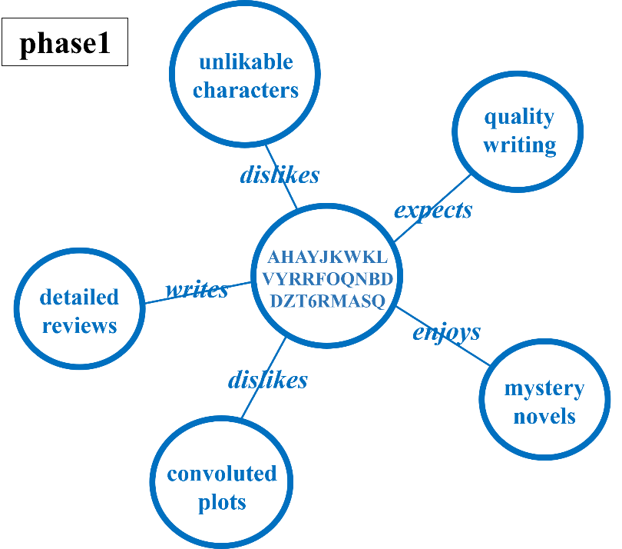
Figure 9: KG Triplets Example for User.
The three-phase knowledge graph triplet extraction leverages prompt engineering techniques, including instruction prompting and one-shot prompting. The former guides the Mistral model to focus on identifying structured knowledge elements from the summary and to output triplet information in a specific format. The latter provides the model with an example that illustrates the expected output structure and conceptual relationships, thereby improving the precision and consistency of semantic extraction. The prompt design for each phase in three-phase knowledge graph triplet extraction are shown in Figure 10 to Figure 13:
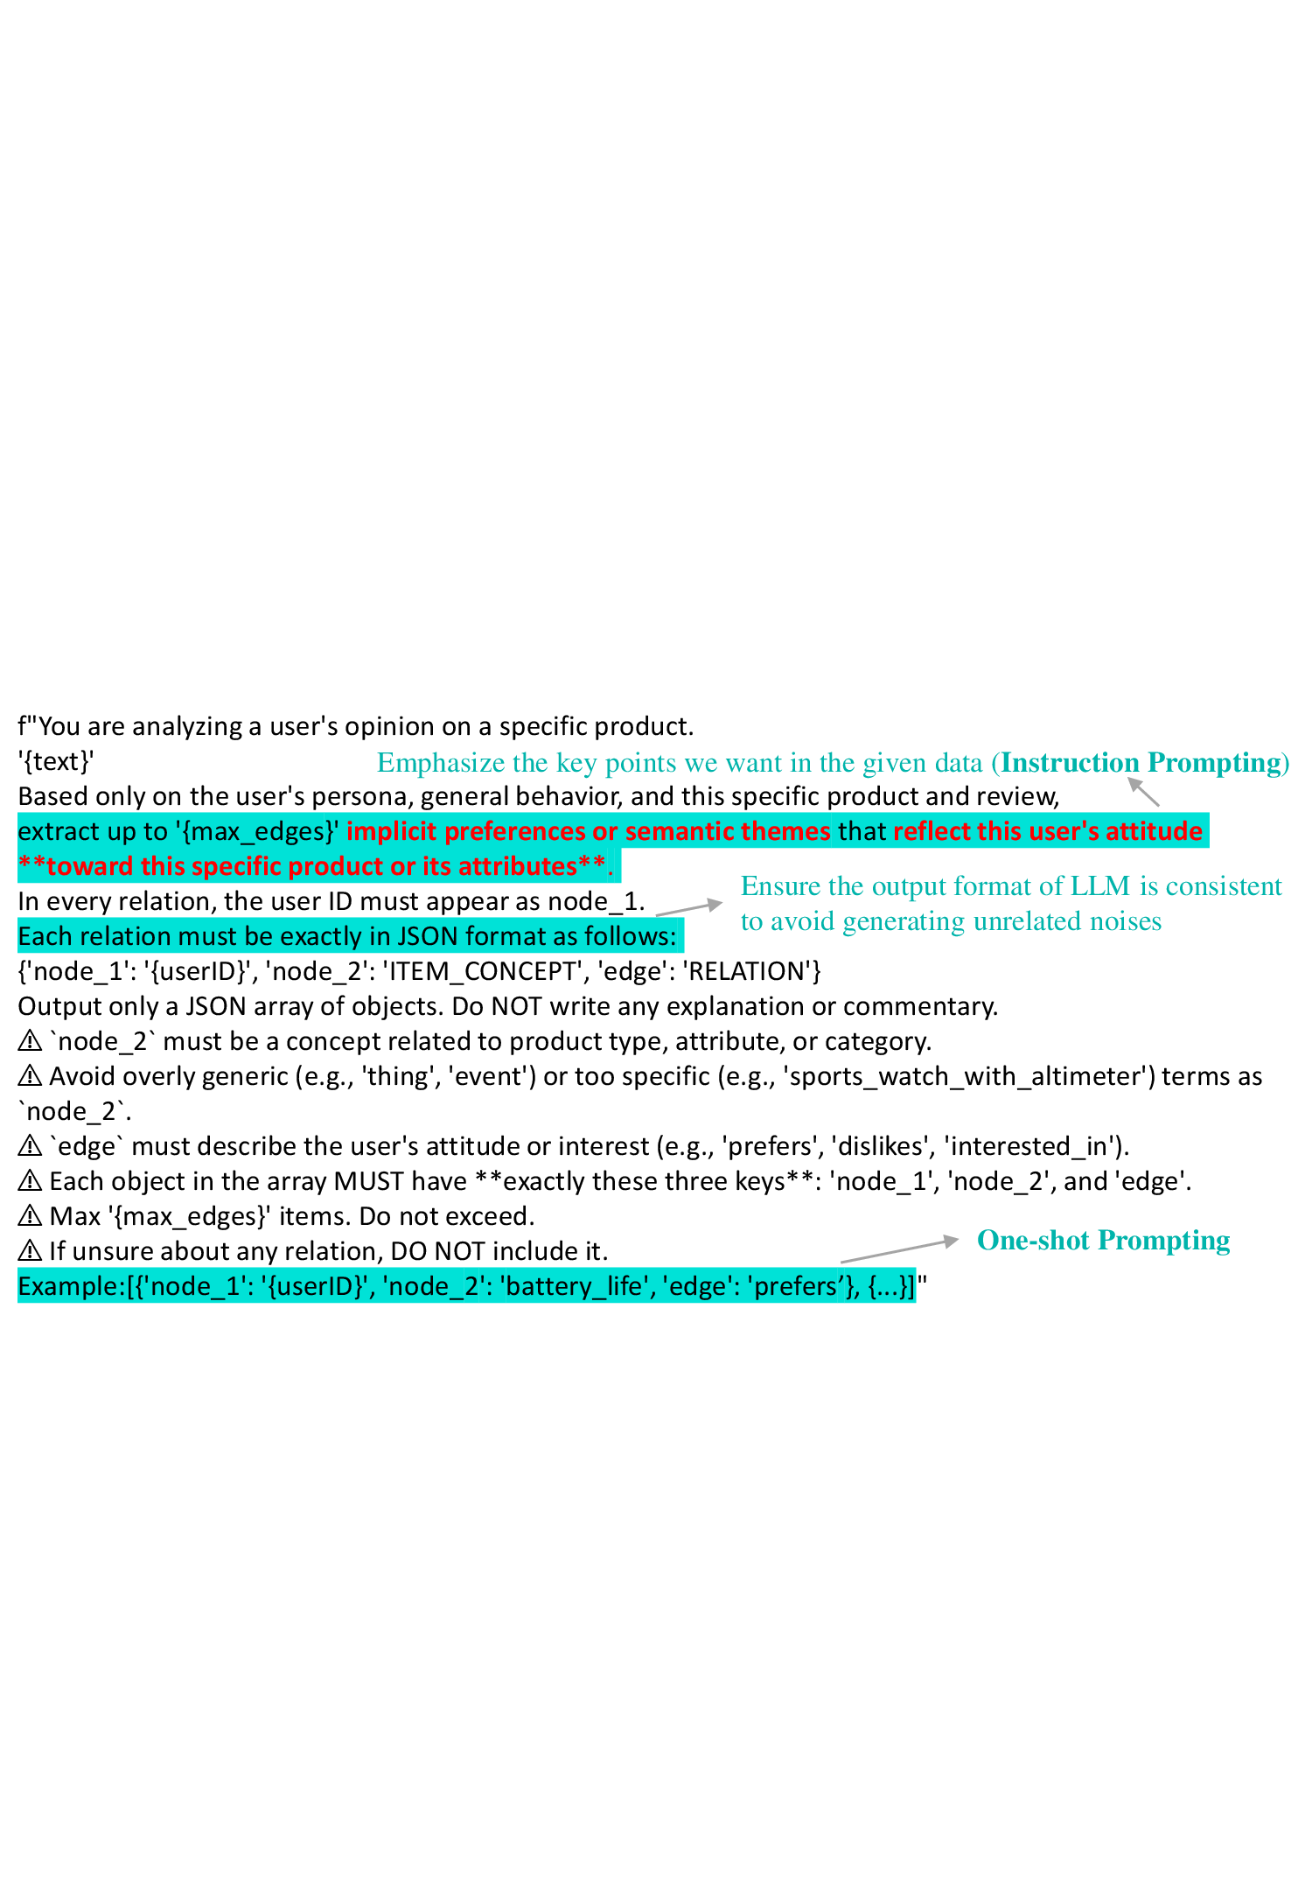
Figure 10: Phase 1 Prompt Design for User in Three-Phase Knowledge Graph Triplet Extraction.
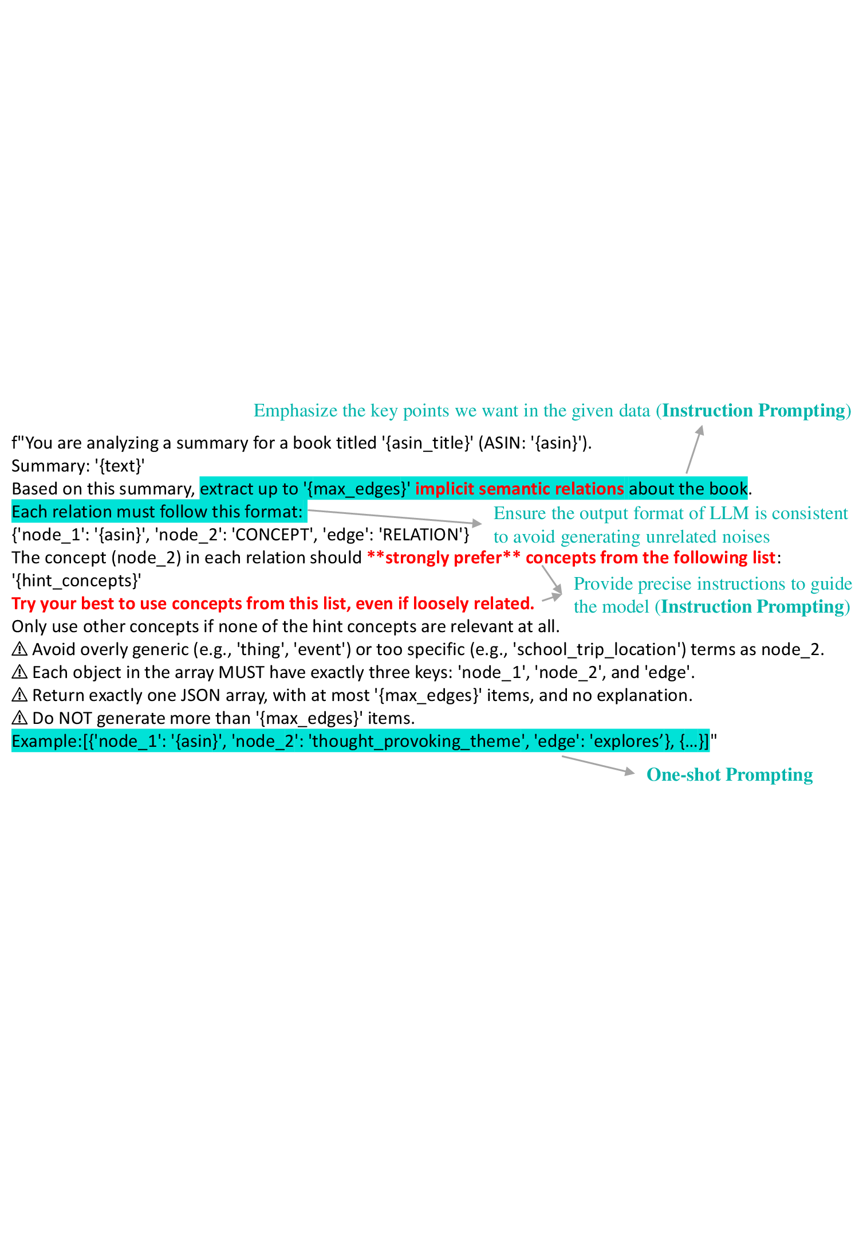
Figure 11: Phase 1 Prompt Design for Item in Three-Phase Knowledge Graph Triplet Extraction.
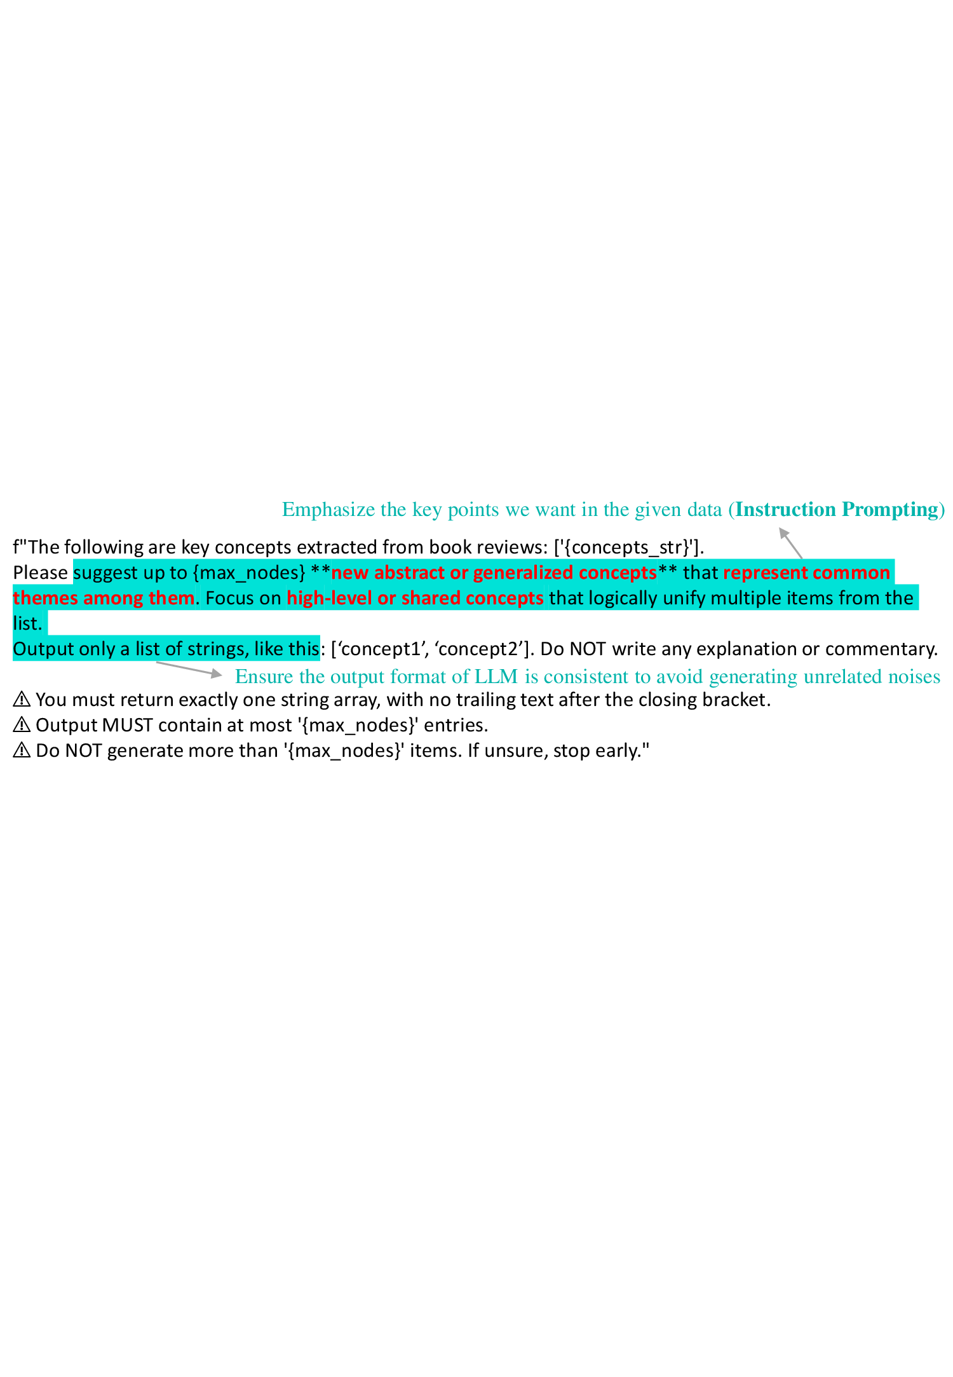
Figure 12: Phase 2 Prompt Design for Item in Three-Phase Knowledge Graph Triplet Extraction.
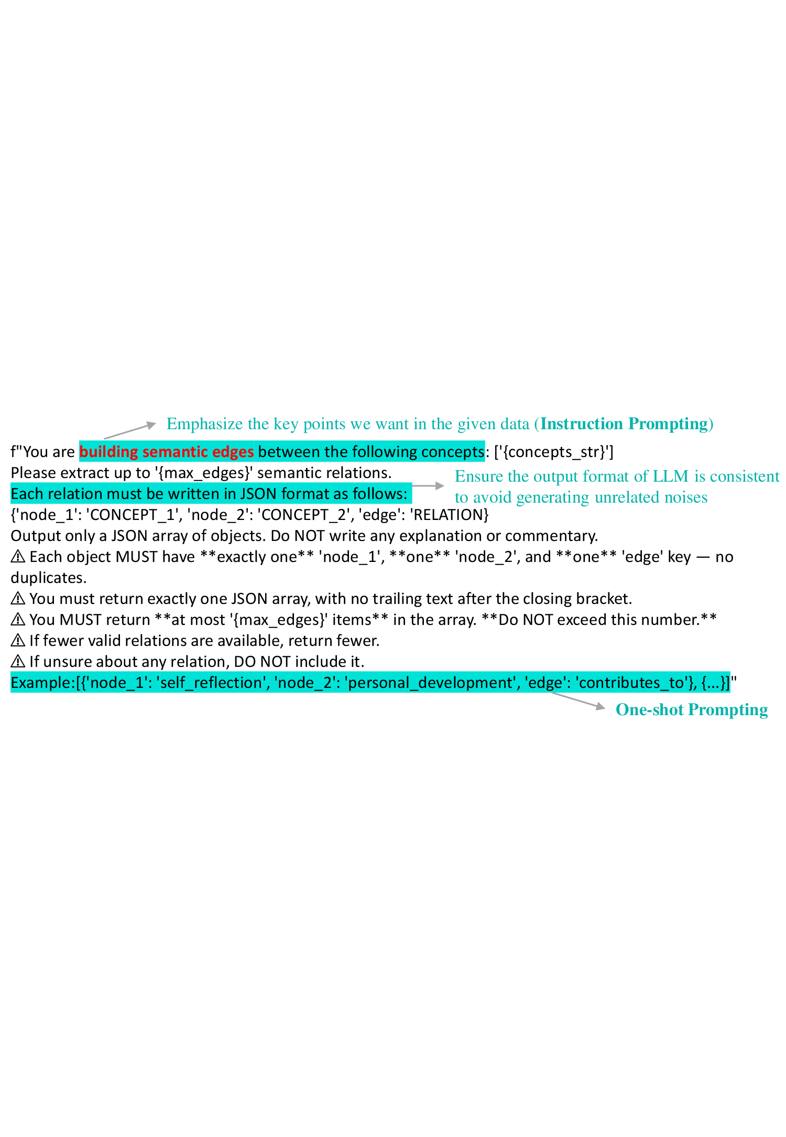
Figure 13: Phase 3 Prompt Design for Item in Three-Phase Knowledge Graph Triplet Extraction.
Based on the aforementioned knowledge graph triplet extraction process, we construct a raw knowledge graph that integrates diverse user-item interaction data, review semantics, and other heterogeneous information sources. This raw knowledge graph incorporates entities and semantic relations derived from review, allowing implicit semantic correlations between users and items to be effectively represented. However, as the triplets are extracted directly from natural language models, the resulting raw graph inevitably contains redundant relations, semantically duplicated nodes, and densely clustered entities. Therefore, a subsequent standardization process is necessary to improve the structural quality of the knowledge graph. An illustration of this raw knowledge graph is shown in Figure 14:
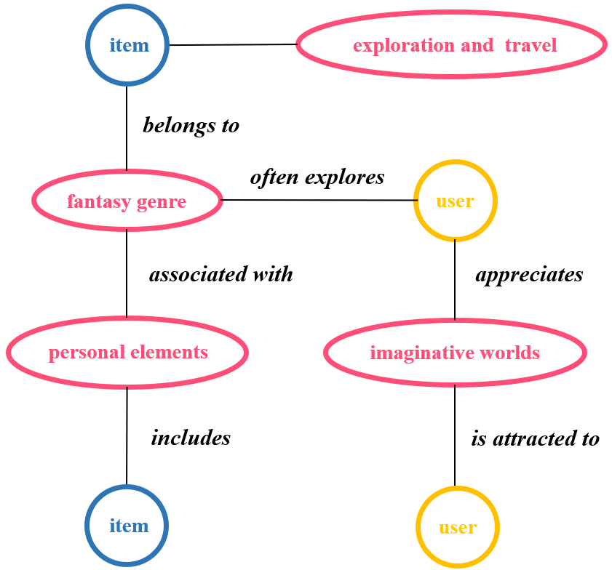
Figure 14: Example of Raw Knowledge Graph.
Upon extracting the user knowledge graph triplets $UKGT=UKGT^{phase1}$and the item knowledge graph triplets $IKGT=\{IKGT^{phase1}, IKGT^{phase3}\}$, we proceed to integrate both into a unified set $UIKGT$, followed by node standardization and edge standardization. This process results in the construction of the final aspect-specific knowledge graph $KG_{A_{K}}^{aspect}$, as defined in Eqs. (31)-(32):
$$UIKGT=UKGT+IKGT$$ | (31)
$$KG_{A_{K}}^{aspect}=node-edge-standardize\left(UIKGT\right)$$ | (32)
Here, $node-edge-standardize$() denotes the process of performing node standardization and edge standardization on the extracted knowledge graph triplets.
Node standardization is implemented by first converting each node’s content into embeddings and then clustering them based on semantic similarity. Within each cluster, the node whose embedding is closest to the cluster’s centroid is selected as the representative term. All other nodes in the cluster are then replaced with this representative term, reducing redundancy and semantic overlap among nodes and enhancing the consistency and expressiveness of the graph structure.
Edge standardization involves different strategies depending on the node types. To balance computational efficiency and data volume, edge candidates are first filtered:
- edges between user nodes: filter out inactive users and retain only user pairs with shared interests.
- edges between item nodes: only popular (best-selling) items are considered, and their connections are filtered based on user interaction patterns.
- edges between user and item nodes: only interactions present in the review are preserved.
After filtering, if a node pair is connected by multi-hop paths (i.e., paths involving more than two nodes), those paths are collapsed into a single semantic edge. This semantic edge summarizes the intermediate nodes and relations into a compressed, information-rich representation.
Both standardization steps aim to improve the sparsity and semantic compactness of the knowledge graph, thereby enhancing the generalization ability of subsequent GNNs in semantic learning and recommendation tasks.
  - Contrastive Learning for Aspect-Specific Knowledge Graph
This study also incorporates contrastive learning techniques to enhance both intra-aspect and inter-aspect feature learning. When generating user embeddings, contrastive learning is applied exclusively to user nodes to strengthen the consistency and stability of user preference representations within a specific aspect. Similarly, for item embedding generation, contrastive learning is applied to item nodes to ensure more accurate and discriminative representations.
This approach not only reinforces intra-aspect homogeneity but also amplifies inter-aspect diversity, thereby improving the model’s ability to capture aspect-aware user and item characteristics. Furthermore, GAT is employed for feature aggregation, allowing the model to dynamically learn the importance of neighboring nodes and enhance the expressive power of the aspect-specific knowledge graph.
Finally, a self-attention mechanism is used to integrate features across different aspects, enabling the model to assign weights according to the relative importance of each aspect. This results in more precise and interpretable user and item review embeddings, ultimately improving the performance of the recommendation system.
    - Intra-Aspect Contrastive Learning
Within each aspect, for a given target node, contrastive learning is performed by selecting neighboring nodes (with hop count ≤ ${HC}_{n}$) as positive samples, and distant nodes (with hop count > ${HC}_{f}$) as negative samples. Here, $HC_{n}$ and ${HC}_{f}$ are user-defined hyperparameters that determine the proximity thresholds for sample selection. Take user target user node$v^{t}$as an example, its set of neighbor user nodes is defined as $B\left(v^{t}\right)=\left\{v^{n} ∣ Hop\left(v^{t}, v^{n}\right)≤{HC}_{n}\right\}$, and its set of distant user nodes is$F\left(v^{t}\right)=\left\{v^{f} ∣ Hop\left(v^{t}, v^{f}\right)>{HC}_{f}\right\}$. The intra-aspect contrastive learning loss is then formulated as Eq. (33)：
$$L_{intra}=-\frac{1}{\left|B\left(v^{t}\right)\right|}\sum_{v^{n}∈B\left(v^{t}\right)}{\log{\frac{\exp\left(sim\left(e_{A_{k}}^{v^{t}}, e_{A_{k}}^{v^{n}}\right)\right)}{\sum_{v^{n}∈B\left(v^{t}\right)}^{ }{\exp\left(sim\left(e_{A_{k}}^{v^{t}}, e_{A_{k}}^{v^{n}}\right)\right)}+\sum_{v^{f}∈F\left(v^{t}\right)}^{ }{\exp\left(sim\left(e_{A_{k}}^{v^{t}}, e_{A_{k}}^{v^{f}}\right)\right)}}}}$$ | (33)
where $e_{A_{k}}^{v^{t}}$ denotes the embedding of the target node $v$ under aspect $A_{k}$, $e_{A_{k}}^{v^{n}}$ denotes the embedding of a neighboring node under aspect $A_{k}$, $e_{A_{k}}^{v^{f}}$ denotes the embedding of a distant node under aspect $A_{k}$；$sim\left( \right)$ is the cosine similarity function.
With this design, the embeddings of the same user or item are encouraged to be more compact and consistent within each aspect, thereby enhancing intra-aspect homogeneity. This, in turn, the model can better capture fine-grained preference features under different aspects, ultimately improving recommendation performance.
    - Inter-Aspect Contrastive Learning
To enhance inter-aspect differentiation, the embeddings of the same user or item in other aspects are treated as negative samples. This approach helps the model distinguish between different aspects more effectively and prevents the confusion of semantic representations across aspects. Let $TA\left(v^{t}\right)$ denote the subset of aspects where the target node $v^{t}$ exists. The inter-aspect contrastive loss is defined in Eqs. (34)-(35)：
$$TA\left(v^{t}\right)=\left\{A_{k} ∣ v^{t} ∃ KG_{A_{k}}^{aspect}\right\}$$ | (34)
$$L_{inter} = -\frac{1}{\left|TA\left(v^{t}\right)\right|}\sum_{A_{k}∈TA\left(v^{t}\right)}{\log{ }\frac{\exp\left(sim\left(e_{A_{k}}^{v^{t}}, e_{A_{k}}^{v^{t}}\right)\right)}{\sum_{{\tilde{A}}_{k}∈TA\left(v^{t}\right), {\tilde{A}}_{k}≠A_{k}}^{ }{\exp\left(sim\left(e_{A_{k}}^{v^{t}}, e_{{\tilde{A}}_{k}}^{v^{t}}\right)\right)}}}$$ | (35)
where $e_{A_{k}}^{v^{t}}$ denote the embedding of the target node $v^{t}$ under aspect $A_{k}$, and ；$e_{{\tilde{A}}_{k}}^{v^{t}}$ denotes the embedding of the same node $v^{t}$ under a different aspect ${\tilde{A}}_{k}$ (used as negative samples).
    - Graph Feature Aggregation via GAT
Since the influence and importance of different nodes may vary in aspect-specific knowledge graphs, aggregating features solely based on the average of all neighboring nodes may lead to weakened important signals or amplified redundant information. To address this, we adopt the Graph Attention Network (GAT) [46], which dynamically learns attention weights among neighboring nodes and aggregates features based on their relative importance. The attention mechanism in GAT adaptively assigns higher weights to more relevant nodes, thereby enhancing the accuracy and semantic expressiveness of feature representations. This approach improves the capability of aspect-specific knowledge graphs in capturing multi-level relations and semantic dependencies among nodes.
    - Aspect-based Review Feature Generation via Self-Attention Mechanism
To generate the final aspect-based review features for users and items, this study incorporates self-attention mechanism to learn the importance weights of different aspects. This design enhances the recommendation system’s ability to capture user preferences and item characteristics more accurately.
      - User Aspect-based Review Feature Generation
Given $f_{u, A_{k}}^{rev}$, which represents the embedding of user $u$’s node in the aspect-specific knowledge graph $e_{A_{k}}^{v^{t}}$ and serves as the aspect-based review feature of user$u$, the attention weight $α_{u, A_{k}}^{rev}$ for each aspect is computed through a learnable weight matrix $W$.
Finally, the overall user aspect-based review feature $f_{u}^{rev}$ is obtained by performing a weighted sum of $f_{u, A_{k}}^{rev}$ and their corresponding attention weights $α_{u, A_{k}}^{rev}$ which reflects the relative importance of each aspect. The calculation is shown in Eq. (36)-(37):
$$α_{u,A_{k}}^{rev}=\frac{\exp\left(\tanh\left(W⋅f_{u, A_{k}}^{rev}\right)\right)}{\sum_{l=1}^{K}{\exp\left(\tanh\left(W⋅f_{u, A_{l}}^{rev}\right)\right)}}$$ | (36)
$$f_{u}^{rev}=\sum_{k=1}^{K}{α_{u,A_{k}}^{rev}}⋅f_{u, A_{k}}^{rev}$$ | (37)
      - Item Aspect-based Review Feature Generation z
Given $f_{i, A_{k}}^{rev}$, which represents the embedding of item $i$’s node in the aspect-specific knowledge graph $e_{A_{k}}^{v^{t}}$ and serves as the aspect-based review feature of item$i$, the attention weight $α_{i, A_{k}}^{rev}$ for each aspect is computed through a learnable weight matrix $W$.
Finally, the overall item aspect-based review feature $f_{i}^{rev}$ is obtained by performing a weighted sum of $f_{i, A_{k}}^{rev}$ and their corresponding attention weights $α_{i, A_{k}}^{rev}$ which reflects the relative importance of each aspect. The calculation is shown in Eq. (38)-(39)
$$α_{i,A_{k}}^{rev}=\frac{\exp\left(\tanh\left(W⋅f_{i, A_{k}}^{rev}\right)\right)}{\sum_{l=1}^{K}{\exp\left(\tanh\left(W⋅f_{i, A_{l}}^{rev}\right)\right)}}$$ | (38)
$$f_{i}^{rev}=\sum_{k=1}^{K}{α_{i,A_{k}}^{rev}}⋅f_{i, A_{k}}^{rev}$$ | (39)
Through this approach, the aspect-based review features of users and items are generated by aggregating the embeddings across different aspects with learned attention weights. The attention mechanism dynamically captures the importance of each aspect based on data characteristics, enabling the model to more accurately identify user preferences and item features. This ultimately enhances both the performance and interpretability of the recommendation system.
  - Multimodal Feature Fusion and Recommendation
To generate the final user and item embeddings, this study adopts an attention mechanism that dynamically learns the importance weights of various feature types. This mechanism adjusts the contribution of each modality according to its relative significance, effectively integrating multimodal features such as reviews, purchase intentions, and images attributes. Such integration not only enhances the representational capacity of the model across different modalities but also improves the overall performance and accuracy of the recommendation system. For users and items, the initial multimodal feature representations are derived from the following sources:
- user feature：purchase intention, description of liked items, and review
- item feature：review, image, image caption, and description
The initial feature vectors are defined in Eq. (40)-(41)：
$$F_{u}=\left\{f_{u}^{w}, f_{u}^{d}, f_{u}^{rev}\right\}$$ | (40)
$$F_{i}=\left\{f_{i}^{rev}, f_{i}^{img}, f_{i}^{imgd}, f_{i}^{d}\right\}$$ | (41)
where $F_{u}$ and $F_{i}$ denote the set of the multimodal features of user and item, respectively.
    - User and Item Embedding Generation
For each modality-specific feature, this study applies a self-attention mechanism to learn its corresponding importance weight. The same computation process is used for both users and items. Taking items as an example, the attention weights for different modalities are calculated as shown in Eqs. (42)-(45)：
$$α_{i}^{rev} = \frac{\exp\left({sc}_{i}^{rev}\right)}{\sum_{j ϵ \{rev, img, imgd, d\}}^{ }{\exp\left({sc}_{i}^{j} \right)}}$$ | (42)
$$α_{i}^{img} = \frac{\exp\left({sc}_{i}^{img}\right)}{\sum_{j ϵ \{rev, img, imgd, d\}}^{ }{\exp\left({sc}_{i}^{j} \right)}}$$ | (43)
$$α_{i}^{imgd} = \frac{\exp\left({sc}_{i}^{imgd}\right)}{\sum_{j ϵ \{rev, img, imgd, d\}}^{ }{\exp\left({sc}_{i}^{j} \right)}}$$ | (44)
$$α_{i}^{d} = \frac{\exp\left({sc}_{i}^{d} \right)}{\sum_{j ϵ \{rev, img, imgd, d\}}^{ }{\exp\left({sc}_{i}^{j} \right)}}$$ | (45)
where $α_{i}^{rev}$、$α_{i}^{img}$、$α_{i}^{imgd}$、$α_{i}^{d}$ represent the attention weights for review features $f_{i}^{rev}$, image features $f_{i}^{img}$, image caption features $f_{i}^{imgd}$, and item description features $f_{i}^{d}$, respectively. These weights reflects the relative importance of each modality in the feature fusion process across all samples.
The attention scores ${sc}_{i}^{rev}$、${sc}_{i}^{img}$、${sc}_{i}^{imgd}$、${sc}_{i}^{d}$ are global relevance scores learned via a Scaled Dot-product Attention mechanism, which evaluates how well each feature aligns with a global query vector. Taking ${sc}_{i}^{rev}$ for example, the calculation is shown is Eq. (46)：
$${sc}_{i}^{rev}= \frac{g_{q} ⋅f_{i}^{rev}}{\sqrt{dim⁡(f_{i}^{rev})⁡}}$$ | (46)
where $g_{q}$is the global query vector representing the desired fused representation, and $g_{k,rev}$ denotes the global aggregated representation of feature $f_{i}^{rev}$ (e.g., mean or weighted sum). The dot product $g_{q} ⋅ f_{i}^{rev}$measures the similarity between the query and key vectors. The denominator $\sqrt{dim⁡(f_{i}^{rev})⁡}$ is the square root of the dimensionality of the key vector $f_{i}^{rev}$, which serves as a scaling factor to prevent excessively large dot-product values when the vector dimension is high, thereby stabilizing the output of the softmax function.
Based on the learned attention weights, the final item embedding $I_{i}$ for item $i$ is computed by the weighted sum of each modality-specific feature, as shown in Eqs (47)-(51)：
$$IREV_{i}=α_{i}^{rev}∙f_{i}^{rev}$$ | (47)
$$IIMG_{i}=α_{i}^{img}∙f_{i}^{img}$$ | (48)
$$IIMGD_{i}=α_{i}^{imgd}∙f_{i}^{imgd}$$ | (49)
$$ID_{i}=α_{i}^{id}∙f_{i}^{id}$$ | (50)
$$I_{i}=IREV_{i}+IIMG_{i}+IIMGD_{i}+ID_{i}$$ | (51)
The user embedding $U_{u}$​ is constructed in a similar manner, as shown in Eq. (52)：
$$U_{u}=UW_{u}+UD_{u}+UREV_{u}$$ | (52)
    - User-Item Interaction Embedding Generation
The final recommendation score is computed based on the interaction between the user and item embeddings. The interaction prediction is defined as Eq. (53)：
$${\hat{r}}_{u,i}=sigmoid\left(U_{u}∙I_{i}\right)$$ | (53)
where ${\hat{r}}_{u,i}$ denotes the predicted score for user $u$ and item $i$, indicating the user's estimated interest or preference toward the item.
- Experiment and Evaluation
In this section, we start with an overview of the dataset used in our study. Following that, we outline the experimental setups and methodologies employed. Finally, we report the results achieved and provide an in-depth analysis.
  - Dataset
We use the Amazon Product Review dataset [25] provided by Amazon.com, which is widely used for product recommendation research. Specifically, we select the Amazon-Book subset, as it is a large-scale book review dataset commonly used in knowledge graph-based recommendation algorithms. We download both the review and metadata files and apply preprocessing steps to ensure data quality, such as retaining users and items with a minimum number of interactions.
    - Data Filtering
The dataset we downloaded initially contained 4,493,336 items, 10,297,355 users, 29,475,453 reviews. To ensure the quality and reliability of the data used in our experiments, we applied the following preprocessing steps:
First of all, we removed all duplicate entries and retained only those reviews written in English. To address the class imbalance in the original dataset—where 85% of the reviews (user-item pairs) were labeled as like—we first applied a user-level filtering strategy based on the like ratio. Specifically, we removed users with overwhelmingly biased opinions and retained only those whose like ratios fell between 30% and 90%, thereby rebalancing the distribution of positive and negative samples. After that, we applied iterative filtering based on interaction counts to remove inactive users and unpopular items, retaining only users with at least 20 reviews and items with at least 30 reviews. Furthermore, we split each review into sentences and discarded those with fewer than three words, as they often lack meaningful content. Following this sentence-level filtering, we repeated the user/item filtering step to maintain the integrity of the data distribution. Finally, we applied the like ratio filter once again to ensure that all remaining users still satisfied the specified like ratio constraint after the preceding steps.
After completing all the above steps, the refined dataset we used to conduct the experiments consisted of 1,399 unique items, 905 unique users, and 30,876 reviews; 72.1% of the label $Y$ is marked as like, and the rest as dislike. The final dataset statistics used in our experiments are summarized in Table 1.
Table 1: Dataset Statistics.
 | Reviews | Items | Users | Like Ratio
Original | 29,475,453 | 4,493,336 | 10,297,355 | 0.849
After Filtered | 30,876 | 1,399 | 905 | 0.721
    - Training and Testing Dataset
After data preprocessing, we partition the refined dataset into three subsets: 70% for training, 10% for validation (used for hyper-parameter tuning), and 20% for testing (used to evaluate model performance). To ensure consistency in user preferences across all splits, we fix the like-to-dislike ratio of each user during data partitioning. For instance, if a user has 100 reviews, 60 of which are labeled as like, then 42 (60 × 0.7) like reviews are placed in the training set, 6 in the validation set, and 12 in the testing set. The remaining 40 dislike reviews are distributed in the same proportion.
Additionally, to simulate a real-world scenario in which the platform recommends items to users, we expand the test set by augmenting the candidate item pool for each user. Specifically, for each user, we randomly sample additional items—unseen by the user—from the rest of the dataset and add them to the test set until each user has 100 user-item pairs. As a result, the size of the testing set increases to 90, 500 pairs, as we include 100 pairs per user for all 905 users. Since these additional items are all labeled as dislike, the like ratio in the final test set is significantly reduced to 7.85%.
  - Experimental Setting
In this section, we introduce the experimental setup details and the evaluation metrics we used to evaluate the performance of our proposed model, RAKG-LMR.
    - Experimental Settings
We conducted our experiments using Python 3.11.11 and PyTorch 2.6.0 + cu126 on GPU machines equipped with NVIDIA GeForce RTX 4090. In our proposed RAKG-LMR model, the embedding dimension was unified to 768 across all components to ensure a fair comparison.
For text and image processing, we used bert-base-uncased as the encoder for textual features and Resnet50 as the image feature extractor. To generate user intention representations, we fine-tuned the TinyLLaMA-1.1B-Chat model on intention QA data using the AdamW optimizer (learning rate = 2e-5, batch size = 8).
For training the aspect-specific GAT models, we adopted the Adam optimizer with a learning rate of 0.01 and a hidden dimension of 64. Models were trained for 10 epochs without batching, as full-graph training was performed.
Regarding graph construction and contrastive learning, the number of neighbors k used in constructing KNN-based user and item graphs was set to 10 and 20, respectively, while the maximum hop distance for intra-aspect contrastive learning was set to 2.
Additionally, several LLMs and pre-trained encoders tailored for specific tasks were incorporated into our pipeline. The LLMs used include TinyLlama-1.1B-Chat, Qwen2.5-VL-7B-Instruct, and Mistral-7B-Instruct, each of which was employed in different components of the system. Other pre-trained models, such as sentence-transformers and BART variants, were used for semantic encoding and summarization tasks:
- Intention Generation: TinyLlama/TinyLlama-1.1B-Chat-v1.0
- Image Caption Generation: Qwen/Qwen2.5-VL-7B-Instruct
- Top-K Sentence Selection: sentence-transformers/paraphrase-MiniLM-L6-v2
- Review Title Summarization: philschmid/bart-large-cnn-samsum
- Knowledge Triplet Generation: mistralai/Mistral-7B-Instruct-v0.2
- Node-level Semantic Encoding: intfloat/e5-large-v2
- Edge-level Semantic Encoding: sentence-transformers/all-MiniLM-L6-v2
    - Evaluation Metrics
When evaluating our performance, we utilized five metrics: Hit ratio (HR), Precision (P), F1-score (F1), Mean Average Precision (MAP), and Normalized Discounted Cumulative Gain (NDCG). The Hit ratio indicates the proportion of accurate recommendations among all recommendations containing at least one item matching the ground truth. Precision denotes the percentage of correct recommendations in our list. F1-score offers a metric to assess the balance between precision and recall. NDCG and MAP focus on the ranking position of correct items in the recommendation list, offering a more accurate assessment of recommendation quality.
  - Comparison with Baseline Models
To evaluate the performance of our proposed RAKG-LMR model, we compare it against several advanced recommendation approaches that incorporate multimodal features, semantic analysis, and knowledge graphs, such as KGAT [49]、ASKAT [12]、RAKCR [10]、MAGNNs [65] , and we briefly introduce them as follows:
- KGAT [49]: This method uses historical user interaction data to model higher-order relationships in a knowledge graph attention network, thereby extracting collaborative signals from collective behavior for use in recommendations.
- ASKAT [12]: This method incorporates aspect-level attention into knowledge-aware recommendation by aligning user preferences with item aspects extracted from textual reviews. It leverages both the knowledge graph and aspect-level semantic representations to improve interpretability and performance.
- RAKCR [10]: This method introduces relation-aware knowledge context reasoning to enhance recommendation. It constructs user-item interaction graphs and integrates knowledge triples with customized attention to capture contextual signals across various relations.
- MAGNNs [65]: This method employs modality-aware graph neural networks that adaptively weigh multimodal signals (e.g., textual, visual) based on their relevance to different user-item pairs. By capturing heterogeneous interactions across modalities, it enhances representation quality and recommendation performance.
These baselines represent a spectrum of state-of-the-art methods leveraging knowledge graphs, aspect modeling, and multimodal information, providing a comprehensive benchmark for assessing the effectiveness of our RAKG-LMR model.
  - Evaluation
    - Evaluation of Aspect-Aware Modeling: Review With vs. Without Aspect
We conduct experiments to evaluate the impact of incorporating aspect-aware modeling in reviews. Specifically, we compare models that utilize aspect-based review representations (denoted as review w/ aspects) with those do not (denoted as review w/o aspects). In our setting, K denotes the number of aspects extracted from reviews, where K=4 for the aspect-based model and K=1 for the non-aspect baseline. The results are presented in Table 2:
Table 2: Comparison of review with vs. without aspect under Top-10 and Top-20 recommendation.
 | HR |  | P |  | F1 |  | MAP |  | NDCG
 | @10 | @20 | @10 | @20 | @10 | @20 | @10 | @20 | @10 | @20
review w/o aspect (K=1) | 0.5569 | 0.7779 | 0.0741 | 0.0725 | 0.0135 | 0.0242 | 0.1725 | 0.1684 | 0.0732 | 0.0723
review w/ aspect (K=4) | 0.5945 | 0.8188 | 0.0820 | 0.0785 | 0.0149 | 0.0262 | 0.1943 | 0.1842 | 0.0825 | 0.0798
%Improv. | 6.75% | 5.26% | 10.66% | 8.28% | 10.37% | 8.26% | 12.64% | 9.38% | 12.70% | 10.37%
The results show that introducing aspect classification consistently improves recommendation performance across multiple metrics. For instance, under the top-10 recommendation, incorporating aspects leads to a 6.75% increase in HR@10 and a 12.64% increase in MAP@10. Similar improvements are observed in precision, F1, and NDCG. Notably, the gains are more prominent in the top-10 scenario, suggesting that modeling fine-grained semantic structures in reviews is particularly beneficial for high-precision recommendations. By extracting aspect-specific signals, the model better captures user preferences aligned with item attributes, leading to more accurate user–item matching and enhanced overall recommendation performance.
    - Evaluation of the Number of Aspect
To evaluate the impact of the number of aspects in pre-trained LDA on performance, we further investigate how varying the number of aspects $K$ in the pre-trained LDA model affects recommendation performance. A larger $K$ indicates that each group represents a more specific aspect, while a smaller $K$ implies that each group represents a more complex combination of aspects. Therefore, we designed the following experiments to test the effects of different group numbers $K$, the experiment results are show in Table 3 :
Table 3: Comparison of the number of aspects under Top-10 and Top-20 recommendation.
 | HR |  | P |  | F1 |  | MAP |  | NDCG
 | @10 | @20 | @10 | @20 | @10 | @20 | @10 | @20 | @10 | @20
K=4 | 0.5945 | 0.8188 | 0.0820 | 0.0785 | 0.0149 | 0.0262 | 0.1943 | 0.1842 | 0.0825 | 0.0798
K=5 | 0.5613 | 0.8066 | 0.0754 | 0.0743 | 0.0137 | 0.0248 | 0.1738 | 0.1750 | 0.0744 | 0.0740
K=6 | 0.5702 | 0.8033 | 0.0788 | 0.0759 | 0.0143 | 0.0253 | 0.1979 | 0.1810 | 0.0805 | 0.0766
The results show that a higher number of aspects does not necessarily lead to better performance. While increasing $K$ from 4 to 5 or 6 leads to slight improvements in certain metrics—for example, MAP@10 increases to 0.1979 when $K$=6—but the overall performance tends to decline or fluctuate. Notably, HR@10 drops from 0.5945 at $K$=4 to 0.5613 at $K$=5, reflecting a trade-off between granularity and generalization. Similar trends are seen at both top-10 and top-20 levels, where K=4 generally yields superior performance in key metrics, compared to higher aspect counts. These findings suggest that overly fine-grained clustering may fragment semantic patterns and weaken the effectiveness of aspect signals. Conversely, too few aspects may oversimplify user preferences and obscure meaningful distinctions. Therefore, it is essential to find a proper balance in aspect granularity to ensure that the clustering captures diverse yet coherent topics. Based on our experimental findings, the model achieved the best overall performance when the number of clusters was set to $K$= 4.
    - Ablation Studies on Proposed Model (RAKG-LMR)
To investigate the contribution of each component in the proposed RAKG-LMR model, we conduct an ablation study by selectively removing one component at a time: Intention, Description, Image Caption, Image, Aspect-based Review. The results under Top-10 and Top-20 recommendation settings are presented in Table 4 and Table 5：

Table 4: Ablation Studies on RAKG-LMR under Top-10 recommendation.
 | HR @10 | P @10 | F1 @10 | MAP @10 | NDCG @10
RAKG-LMR | 0.5945 | 0.0820 | 0.0149 | 0.1943 | 0.0825
RAKG-LMR w/o image caption | 0.5779 | 0.0808 | 0.0147 | 0.1844 | 0.0798
RAKG-LMR w/o intention | 0.5635 | 0.0770 | 0.0140 | 0.1768 | 0.0757
RAKG-LMR w/o description | 0.5403 | 0.0762 | 0.0139 | 0.1782 | 0.0761
RAKG-LMR w/o image | 0.5215 | 0.0725 | 0.0132 | 0.1643 | 0.0715
RAKG-LMR w/o aspect-based review | 0.5260 | 0.0715 | 0.0130 | 0.1780 | 0.0732
Table 5: Ablation Studies on RAKG-LMR under Top-20 recommendation.
 | HR @20 | P @20 | F1 @20 | MAP @20 | NDCG @20
RAKG-LMR | 0.8188 | 0.0785 | 0.0262 | 0.1842 | 0.0798
RAKG-LMR w/o image caption | 0.8000 | 0.0758 | 0.0253 | 0.1816 | 0.0767
RAKG-LMR w/o intention | 0.8044 | 0.0775 | 0.0258 | 0.1723 | 0.0765
RAKG-LMR w/o description | 0.7912 | 0.0748 | 0.0249 | 0.1762 | 0.0751
RAKG-LMR w/o image | 0.7724 | 0.0723 | 0.0241 | 0.1669 | 0.0717
RAKG-LMR w/o aspect-based review | 0.7702 | 0.0701 | 0.0234 | 0.1735 | 0.0716
Overall, the full model (with all components) consistently achieves the best performance across all metrics, confirming the effectiveness of jointly modeling user intention, multimodal item content, and aspect-aware reviews. Among these components, the aspect-based review module is particularly critical: its removal results in the most significant performance degradation. This module is further enhanced by constructing aspect-specific knowledge graphs based on LLM-refined semantic clusters of review content, followed by inter- and intra-aspect contrastive learning—highlighting the importance of fine-grained, LLM-enhanced semantics in improving personalization and ranking quality.
In terms of content modalities, both image and description features contribute positively to performance. Among them, the absence of image features leads to the greatest decline in ranking-based metrics—resulting in a 12.3% drop in HR@10 and a 15.4% drop in MAP@10—underscoring the role of visual information in multimodal representations. This decline is more pronounced than that observed when removing textual descriptions (e.g., HR@10 drops to 0.5215 without images vs. 0.5403 without descriptions), suggesting that visual cues offer slightly greater discriminative power in our setting. Furthermore, excluding LLM-generated image captions also leads to notable declines in performance, validating their role in bridging visual semantics and textual understanding.
As for the intention module, it also plays a crucial role. Its removal results in a 9.0% decrease in MAP@10 and a 1.8% decrease in HR@20, indicating that latent motivational cues derived from user behavior effectively complement observable interactions. While not as dominant as visual or aspect-based features, LLM-generated intention embeddings still provide valuable semantics that enrich user modeling.
In conclusion, the aspect-based review module serves as a pivotal component in enhancing fine-grained semantic precision, whereas image features play a vital role in improving ranking accuracy. Intention embeddings further complement these by introducing latent motivational signals. These findings confirm that all components contribute positively to overall performance, with aspect-based review modeling having the most significant impact, followed by image, description, intention, and image caption features. The results validate the effectiveness of our model design, which integrates LLM-enhanced semantics and multimodal representations within a unified recommendation framework.
    - Comparisons with the State-of-the-art Models
We evaluate the performance of the proposed model with several representative baselines, including KGAT, ASKAT, and RAKCR, using common Top-K recommendation metrics (HR, Precision, F1, MAP, and NDCG at K = 10 and 20).The results of the evaluation are presented in Table 6 and Table 7, where the performance of our RAKG-LMR and the most effective baseline method are highlighted in bold and underlined, respectively. Furthermore, we calculated the performance improvement of RAKG-LMR over the best baseline model.

Table 6: Comparison of RAKG-LMR and baseline methods under Top-10 recommendation.
 | HR @10 | P @10 | F1 @10 | MAP @10 | NDCG @10
KGAT | 0.5094 | 0.0693 | 0.0126 | 0.168 | 0.0705
ASKAT | 0.5304 | 0.0729 | 0.0133 | 0.1666 | 0.0729
RAKCR | 0.5425 | 0.0744 | 0.0135 | 0.1681 | 0.0734
MA-GNNs | 0.5569 | 0.0755 | 0.0137 | 0.1824 | 0.0763
RAKG-LMR (proposed) | 0.5945 | 0.082 | 0.0149 | 0.1943 | 0.0825
%Improv. | 6.75% | 8.61% | 8.76% | 6.52% | 8.13%
Table 7: Comparison of RAKG-LMR and baseline methods under Top-20 recommendation.
 | HR @20 | P @20 | F1 @20 | MAP @20 | NDCG @20
KGAT | 0.7669 | 0.0693 | 0.0231 | 0.1668 | 0.0695
ASKAT | 0.7646 | 0.0735 | 0.0245 | 0.1672 | 0.0734
RAKCR | 0.8133 | 0.0745 | 0.0248 | 0.1709 | 0.0739
MA-GNNs | 0.7912 | 0.0736 | 0.0245 | 0.1786 | 0.0746
RAKG-LMR (proposed) | 0.8188 | 0.0785 | 0.0262 | 0.1842 | 0.0798
%Improv. | 0.68% | 5.37% | 5.65% | 3.14% | 6.97%
The results show that the performance of our proposed model, RAKG-LMR, is remarkable—consistently outperforming all baselines across all evaluation metrics under both top-10 and top-20 settings—demonstrating its robustness and effectiveness.
First, under the Top-10 recommendation setting, RAKG-LMR achieves the best performance in all evaluation metrics. It reaches an HR@10 of 0.5945, surpassing the best-performing baseline (RAKCR at 0.5425) by 6.75%. In terms of Precision@10, RAKG-LMR records 0.082, which is 8.61% higher than RAKCR. Furthermore, F1@10 improves by 8.76%, indicating that our model not only identifies relevant items but also maintains a balance between precision and recall—especially valuable in scenarios requiring precise top-k results. Regarding ranking-based metrics such as MAP and NDCG, RAKG-LMR also leads with notable improvements. It achieves a MAP@10 of 0.1943 and an NDCG@10 of 0.0825, exceeding the best baseline MAP and NDCG scores by 6.52% and 8.13%, respectively. These results demonstrate that RAKG-LMR is not only capable of retrieving relevant items but also effectively ranks them at the top of recommendation lists, thereby enhancing user satisfaction.
Second, under the Top-20 setting, RAKG-LMR maintains consistent superiority. It achieves an HR@20 of 0.8188, MAP@20 of 0.1842, and NDCG@20 of 0.0798, with improvements of 0.68%, 3.14%, and 6.97% over the best-performing baseline, respectively. Precision@20 and F1@20 also improve to 0.0785 and 0.0262, further confirming the model’s robustness across different recommendation depths.
Third, while KGAT captures high-order connectivity via knowledge graph attention networks, its improvements remain relatively constrained. Similarly, ASKAT and RAKCR incorporate user-item interactions through attention-based mechanisms, and MA-GNNs leverage review texts to construct aspect-aware graph structures. However, these approaches lack deep semantic modeling capabilities and comprehensive integration of multimodal content—including images, user purchase intentions, or LLM-refined textual features—thereby limiting their ability to model nuanced user-item relationships.
In contrast, RAKG-LMR introduces a more comprehensive architecture. It not only integrates diverse modalities—including user purchase intentions, item images, and image captions generated by LLMs—but also utilizes LLM to enhance the semantic granularity of review aspect modeling. Specifically, it first conducts LDA-based aspect clustering, followed by LLM-based semantic refinement to ensure interpretability and coherence across aspects. These refined aspects are then used to construct aspect-specific knowledge graphs , which are generated by LLMs and further enhanced through inter- and intra-aspect contrastive learning. This design enables it to capture fine-grained user-item relationships, enrich semantic understanding and enhance representational expressiveness.
In summary, RAKG-LMR achieves state-of-the-art performance in both accuracy and ranking quality by effectively integrating multimodal signals, LLM-enhanced knowledge structures, and contrastive learning in an aspect-aware framework. Its robust and consistent results across various recommendation depths demonstrate its robustness and practical applicability for personalized product recommendation.
Finally, one of the key advantages of RAKG-LMR lies in its explicit modeling of review aspects. Rather than treating user preferences as monolithic, our method identifies and separates aspect-level signals using LDA-based clustering and semantic refinement.
- Conclusion and Future Work
In this paper, we propose RAKG-LMR, a novel framework for multimodal product recommendation that integrates LLMs, aspect-aware knowledge graphs, contrastive learning, and multimodal content into a unified recommendation pipeline.
Unlike previous methods that rely mainly on static user-item interactions or shallow content features, RAKG-LMR leverages the semantic understanding and generative capabilities of LLMs to enrich both user and item representations. Specifically, LLMs are leveraged to generate user purchase intentions and item image captions, provide contextual cues, improve review aspect classification, and construct fine-grained aspect-specific knowledge graphs. In addition, contrastive learning is also applied to enhance intra-aspect consistency and inter-aspect discrimination, further refining representation quality.
Experimental results show that RAKG-LMR outperforms state-of-the-art knowledge graph-based recommendation methods such as KGAT, ASKAT, RAKCR, and MAGNNs, consistently achieving superior performance across multiple recommendation metrics. Ablation studies further validate the effectiveness of aspect-aware modeling, user intention generation, and multimodal knowledge integration.
In future work, we plan to enhance our framework along two main directions. First, we aim to incorporate dynamic user modeling and fine-grained aspect-level sentiment analysis to better capture evolving user preferences and distinguish nuanced user opinions, thereby improving personalization. Second, we intend to explore efficient and scalable extensions of the knowledge graph, including real-time triplet update mechanisms and cross-domain or cross-market transferability, to enhance both the responsiveness and generalizability of the recommendation system.
Overall, this study contributes to the advancement of LLM-based recommendation systems and demonstrates the practical potential of combining aspect-specific semantics with generative AI to achieve more accurate and personalized product recommendations.

References
[1] M. Agrawal, S. Hegselmann, H. Lang, Y. Kim, D. Sontag. Large language models are few-shot clinical information extractors, 2022, https://arxiv.org/abs/2205.12689.
[2] W. An, F. Tian, P. Chen, Q. Zheng, Aspect-based sentiment analysis with heterogeneous graph neural network, IEEE Transactions on Computational Social Systems, 10 (1), 2022, pp. 403-412.
[3] D.M. Blei, A.Y. Ng, M.I. Jordan, Latent dirichlet allocation, Journal of machine Learning research, 3 (Jan), 2003, pp. 993-1022.
[4] X. Cai, C. Huang, L. Xia, X. Ren. LightGCL: Simple yet effective graph contrastive learning for recommendation, 2023, https://arxiv.org/abs/2302.08191.
[5] D.S. Chaplot. Albert q. jiang, alexandre sablayrolles, arthur mensch, chris bamford, devendra singh chaplot, diego de las casas, florian bressand, gianna lengyel, guillaume lample, lucile saulnier, lélio renard lavaud, marie-anne lachaux, pierre stock, teven le scao, thibaut lavril, thomas wang, timothée lacroix, william el sayed, 2023, https://arxiv.org/abs/2310.06825.
[6] D. Chehal, P. Gupta, P. Gulati, Implementation and comparison of topic modeling techniques based on user reviews in e-commerce recommendations, Journal of Ambient Intelligence and Humanized Computing, 12, 2021, pp. 5055-5070.
[7] T. Chen, S. Kornblith, M. Norouzi, G. Hinton, A simple framework for contrastive learning of visual representations, International conference on machine learning, Vienna, Austria, 2020, pp. 1597-1607.
[8] Z. Cheng, Y. Ding, L. Zhu, M. Kankanhalli, Aspect-aware latent factor model: Rating prediction with ratings and reviews, Proceedings of the 2018 world wide web conference, Lyon, France, 2018, pp. 639-648.
[9] Y.-C. Chou, H.-Y. Chen, D.-R. Liu, D.-S. Chang, Rating prediction based on merge-CNN and concise attention review mining, IEEE Access, 8, 2020, pp. 190934-190945.
[10] Y. Cui, H. Yu, X. Guo, H. Cao, L. Wang, RAKCR: Reviews sentiment-aware based knowledge graph convolutional networks for Personalized Recommendation, Expert Systems with Applications, 248, 2024, pp. 123403.
[11] Y. Cui, P. Zhou, K. Li, B. Seng, H. Cao, Extracting Aspect Sentiment from Users’ Book Reviews for Recommendation, 2024 International Conference on Computational Linguistics and Natural Language Processing (CLNLP), Yinchuan, China, 2024, pp. 101-103.
[12] Y. Cui, P. Zhou, H. Yu, P. Sun, H. Cao, P. Yang, ASKAT: Aspect Sentiment Knowledge Graph Attention Network for Recommendation, Electronics, 13 (1), 2024, pp. 216.
[13] A. Da'u, N. Salim, I. Rabiu, A. Osman, Recommendation system exploiting aspect-based opinion mining with deep learning method, Information Sciences, 512, 2020, pp. 1279-1292.
[14] H. Dang, L. Mecke, F. Lehmann, S. Goller, D. Buschek. How to prompt? Opportunities and challenges of zero-and few-shot learning for human-AI interaction in creative applications of generative models, 2022, https://arxiv.org/abs/2209.01390.
[15] J. Devlin. Bert: Pre-training of deep bidirectional transformers for language understanding, 2018, https://arxiv.org/abs/1810.04805.
[16] W. Ding, W. Wang, S.H.D. Kwok, M. Liu, T. Fang, J. Bai, X. Liu, C. Yu, Z. Li, C. Luo. Intentionqa: A benchmark for evaluating purchase intention comprehension abilities of language models in e-commerce, https://arxiv.org/abs/2406.10173.
[17] B. Gliwa, I. Mochol, M. Biesek, A. Wawer. SAMSum corpus: A human-annotated dialogue dataset for abstractive summarization, 2019, https://arxiv.org/abs/1911.12237.
[18] Z. Guo, J. Li, G. Li, C. Wang, S. Shi, B. Ruan, LGMRec: Local and Global Graph Learning for Multimodal Recommendation, Proceedings of the AAAI Conference on Artificial Intelligence, Vancouver, Canada, 2024, pp. 8454-8462.
[19] E. Hasan, C. Ding, Aspect-Aware Multi-Criteria Recommendation Model with Aspect Representation Learning, 2023 IEEE International Conference on Web Intelligence and Intelligent Agent Technology (WI-IAT), Venice, Italy, 2023, pp. 268-272.
[20] K. He, H. Fan, Y. Wu, S. Xie, R. Girshick, Momentum contrast for unsupervised visual representation learning, Proceedings of the IEEE/CVF conference on computer vision and pattern recognition, Seattle, WA, USA, 2020, pp. 9729-9738.
[21] K. He, X. Zhang, S. Ren, J. Sun, Deep residual learning for image recognition, Proceedings of the IEEE conference on computer vision and pattern recognition, Las Vegas, NV, USA, 2016, pp. 770-778.
[22] X. He, K. Deng, X. Wang, Y. Li, Y. Zhang, M. Wang, Lightgcn: Simplifying and powering graph convolution network for recommendation, Proceedings of the 43rd International ACM SIGIR conference on research and development in Information Retrieval, Xi'an, China, 2020, pp. 639-648.
[23] Z.-Y. He, J.-Q. Lin, C.-D. Wang, M. Guizani, Interaction-knowledge semantic alignment for recommendation, Neural Networks, 181, 2025, pp. 106755.
[24] R.D. Hjelm, A. Fedorov, S. Lavoie-Marchildon, K. Grewal, P. Bachman, A. Trischler, Y. Bengio. Learning deep representations by mutual information estimation and maximization, 2018, https://arxiv.org/abs/1808.06670.
[25] Y. Hou, J. Li, Z. He, A. Yan, X. Chen, J. McAuley. Bridging language and items for retrieval and recommendation, 2024, https://arxiv.org/abs/2403.03952.
[26] P.K. Jain, W. Quamer, R. Pamula, V. Saravanan, SpSAN: Sparse self-attentive network-based aspect-aware model for sentiment analysis, Journal of Ambient Intelligence and Humanized Computing, 14 (4), 2023, pp. 3091-3108.
[27] F. Lei, Z. Cao, Y. Yang, Y. Ding, C. Zhang, Learning the user’s deeper preferences for multi-modal recommendation systems, ACM Transactions on Multimedia Computing, Communications and Applications, 19 (3s), 2023, pp. 1-18.
[28] B. Li, B. Jin, J. Song, Y. Yu, Y. Zheng, W. Zhou, Improving micro-video recommendation via contrastive multiple interests, Proceedings of the 45th International ACM SIGIR Conference on Research and Development in Information Retrieval, Madrid, Spain, 2022, pp. 2377-2381.
[29] F. Li, An Sentiment Analysis Model of Online Product Reviews Based on Deep Learning, 2022 3rd International Conference on Information Science, Parallel and Distributed Systems (ISPDS), Guangzhou, China, 2022, pp. 450-456.
[30] F. Li, H. Li, R. Dong, PRDG: Personalized Recommendation with Diversity Based on Graph Neural Networks, 2024 International Joint Conference on Neural Networks (IJCNN), Yokohama, Japan, 2024, pp. 1-8.
[31] S. Li, S. Li, W. Peng, A Hybrid Deep Learning Approach for Recommendation Systems: Fusing Review Sentiment Analysis, 2023 7th International Conference on Electrical, Mechanical and Computer Engineering (ICEMCE), Xi'an, China, 2023, pp. 875-878.
[32] H. Liu, Y. Wang, Q. Peng, F. Wu, L. Gan, L. Pan, P. Jiao, Hybrid neural recommendation with joint deep representation learning of ratings and reviews, Neurocomputing, 374, 2020, pp. 77-85.
[33] K. Liu, F. Xue, D. Guo, L. Wu, S. Li, R. Hong, MEGCF: Multimodal entity graph collaborative filtering for personalized recommendation, ACM Transactions on Information Systems, 41 (2), 2023, pp. 1-27.
[34] P. Liu, W. Yuan, J. Fu, Z. Jiang, H. Hayashi, G. Neubig, Pre-train, prompt, and predict: A systematic survey of prompting methods in natural language processing, ACM Computing Surveys, 55 (9), 2023, pp. 1-35.
[35] Z. Liu, Y. Ma, Y. Ouyang, Z. Xiong. Contrastive learning for recommender system, 2021, https://arxiv.org/abs/2101.01317.
[36] Y. Lu, R. Dong, B. Smyth, Coevolutionary recommendation model: Mutual learning between ratings and reviews, Proceedings of the 2018 World Wide Web Conference, Lyon, France, 2018, pp. 773-782.
[37] W. Ma, M. Zhang, Y. Cao, W. Jin, C. Wang, Y. Liu, S. Ma, X. Ren, Jointly learning explainable rules for recommendation with knowledge graph, The world wide web conference, San Francisco, CA, USA, 2019, pp. 1210-1221.
[38] D. Malitesta, G. Cornacchia, C. Pomo, T. Di Noia, On popularity bias of multimodal-aware recommender systems: a modalities-driven analysis, Proceedings of the 1st International Workshop on Deep Multimodal Learning for Information Retrieval, Ottawa, ON, Canada, 2023, pp. 59-68.
[39] K. Mao, J. Zhu, X. Xiao, B. Lu, Z. Wang, X. He, UltraGCN: ultra simplification of graph convolutional networks for recommendation, Proceedings of the 30th ACM international conference on information & knowledge management, Gold Coast, Queensland, Australia, 2021, pp. 1253-1262.
[40] D. Qi, J. Wang. CleanAgent: Automating Data Standardization with LLM-based Agents, 2024, https://arxiv.org/abs/2403.08291.
[41] F. Scarselli, M. Gori, A.C. Tsoi, M. Hagenbuchner, G. Monfardini, The graph neural network model, IEEE transactions on neural networks, 20 (1), 2008, pp. 61-80.
[42] S. Seo, J. Huang, H. Yang, Y. Liu, Interpretable convolutional neural networks with dual local and global attention for review rating prediction, Proceedings of the eleventh ACM conference on recommender systems, Como, Italy, 2017, pp. 297-305.
[43] A. Severyn, A. Moschitti, Twitter sentiment analysis with deep convolutional neural networks, Proceedings of the 38th international ACM SIGIR conference on research and development in information retrieval, Santiago, Chile, 2015, pp. 959-962.
[44] Z. Tao, Y. Wei, X. Wang, X. He, X. Huang, T.-S. Chua, Mgat: Multimodal graph attention network for recommendation, Information Processing & Management, 57 (5), 2020, pp. 102277.
[45] J. Tian, J. Zhao, Z. Wang, Z. Ding. Mmrec: Llm based multi-modal recommender system, 2024, https://arxiv.org/abs/2408.04211.
[46] P. Velickovic, G. Cucurull, A. Casanova, A. Romero, P. Lio, Y. Bengio, Graph attention networks, stat, 1050 (20), 2017, pp. 10-48550.
[47] J. Vizcarra, S. Haruta, M. Kurokawa, Representing the Interaction between Users and Products via LLM-assisted Knowledge Graph Construction, 2024 IEEE 18th International Conference on Semantic Computing (ICSC), Laguna Hills, CA, USA, 2024, pp. 231-232.
[48] W. Wang, Z. Quan, S. Zhao, G. Sun, Y. Li, X. Ben, J. Zhao, User-Context Collaboration and Tensor Factorization for GNN-Based Social Recommendation, IEEE Transactions on Network Science and Engineering, 10 (6), 2023, pp. 3320-3330.
[49] X. Wang, X. He, Y. Cao, M. Liu, T.-S. Chua, Kgat: Knowledge graph attention network for recommendation, Proceedings of the 25th ACM SIGKDD international conference on knowledge discovery & data mining, Anchorage, AK, USA, 2019, pp. 950-958.
[50] Y. Wang, X. Wang, X. Huang, Y. Yu, H. Li, M. Zhang, Z. Guo, W. Wu. Intent-aware recommendation via disentangled graph contrastive learning, 2024, https://arxiv.org/abs/2403.03714.
[51] Y. Wang, K. Zhou, R. Miao, N. Liu, X. Wang, Adagcl: Adaptive subgraph contrastive learning to generalize large-scale graph training, Proceedings of the 31st ACM International Conference on Information & Knowledge Management, Atlanta, GA, USA, 2022, pp. 2046-2055.
[52] J. Wei, X. Wang, D. Schuurmans, M. Bosma, F. Xia, E. Chi, Q.V. Le, D. Zhou, Chain-of-thought prompting elicits reasoning in large language models, Advances in neural information processing systems, 35, 2022, pp. 24824-24837.
[53] Y. Wei, X. Wang, Q. Li, L. Nie, Y. Li, X. Li, T.-S. Chua, Contrastive learning for cold-start recommendation, Proceedings of the 29th ACM International Conference on Multimedia, Virtual Event, China, 2021, pp. 5382-5390.
[54] W. Wu, C. Wang, D. Shen, C. Qin, L. Chen, H. Xiong, Afdgcf: Adaptive feature de-correlation graph collaborative filtering for recommendations, Proceedings of the 47th International ACM SIGIR Conference on Research and Development in Information Retrieval, Washington D.C., USA, 2024, pp. 1242-1252.
[55] Y. Xu, L. Zhu, Z. Cheng, J. Li, Z. Zhang, H. Zhang, Multi-modal discrete collaborative filtering for efficient cold-start recommendation, IEEE Transactions on Knowledge and Data Engineering, 35 (1), 2021, pp. 741-755.
[56] K.Y. Yang, J. Yang, Z.X. Sun, Commodity personalized recommendation algorithm based on the knowledge graph, 2023 IEEE Intl Conf on DASC/PiCom/CBDCom/CyberSciTech, Abu Dhabi, UAE, 2023, pp. 0564-0569.
[57] L. Yang, S. Wang, Y. Tao, J. Sun, X. Liu, P.S. Yu, T. Wang, Dgrec: Graph neural network for recommendation with diversified embedding generation, Proceedings of the sixteenth ACM international conference on web search and data mining, Singapore, 2023, pp. 661-669.
[58] P. Yang, Y. Xiao, W. Zheng, X. Jiao, K. Zhu, C. Sun, L. Liu, MAN: Main-auxiliary network with attentive interactions for review-based recommendation, Applied Intelligence, 53 (10), 2023, pp. 12955-12970.
[59] S. Yang, Q. Li, H. Lim, J. Kim, An attentive aspect-based recommendation model with deep neural network, IEEE Access, 2024, pp. 5781 - 5791.
[60] S. Yao, D. Yu, J. Zhao, I. Shafran, T. Griffiths, Y. Cao, K. Narasimhan. Tree of thoughts: Deliberate problem solving with large language models, 2024, https://arxiv.org/abs/2305.10601.
[61] Z. Yi, X. Wang, I. Ounis, C. Macdonald, Multi-modal graph contrastive learning for micro-video recommendation, Proceedings of the 45th International ACM SIGIR Conference on Research and Development in Information Retrieval, Madrid, Spain, 2022, pp. 1807-1811.
[62] S. Yin, L. Jiang. Multi-method Integration with Confidence-based Weighting for Zero-shot Image Classification, 2024, https://arxiv.org/abs/2405.02155.
[63] J. Yu, X. Xia, T. Chen, L. Cui, N.Q.V. Hung, H. Yin, XSimGCL: Towards extremely simple graph contrastive learning for recommendation, IEEE Transactions on Knowledge and Data Engineering, 36 (2), 2023, pp. 913-926.
[64] B. Zhang, H. Soh. Extract, Define, Canonicalize: An LLM-based Framework for Knowledge Graph Construction, 2024, https://arxiv.org/abs/2404.03868.
[65] C. Zhang, S. Xue, J. Li, J. Wu, B. Du, D. Liu, J. Chang, Multi-aspect enhanced graph neural networks for recommendation, Neural Networks, 157, 2023, pp. 90-102.
[66] H. Zhang, Y. Dong, C. Xiao, M. Oyamada. Jellyfish: A large language model for data preprocessing, https://arxiv.org/abs/2312.01678.
[67] S. Zhang, L. Chen, C. Wang, S. Li, H. Xiong, Temporal Graph Contrastive Learning for Sequential Recommendation, Proceedings of the AAAI Conference on Artificial Intelligence, Vancouver, Canada, 2024, pp. 9359-9367.
[68] W. Zhang, X. Li, Y. Deng, L. Bing, W. Lam, A survey on aspect-based sentiment analysis: Tasks, methods, and challenges, IEEE Transactions on Knowledge and Data Engineering, 35 (11), 2022, pp. 11019-11038.
[69] G. Zhao, Y. Luo, Q. Chen, X. Qian, Aspect-based sentiment analysis via multitask learning for online reviews, Knowledge-Based Systems, 264, 2023, pp. 110326.
[70] L. Zheng, V. Noroozi, P.S. Yu, Joint deep modeling of users and items using reviews for recommendation, Proceedings of the tenth ACM international conference on web search and data mining, Cambridge, UK, 2017, pp. 425-434.
[71] L. Zhong, J. Wu, Q. Li, H. Peng, X. Wu, A comprehensive survey on automatic knowledge graph construction, ACM Computing Surveys, 56 (4), 2023, pp. 1-62.
[72] D. Zou, W. Wei, X.-L. Mao, Z. Wang, M. Qiu, F. Zhu, X. Cao, Multi-level cross-view contrastive learning for knowledge-aware recommender system, Proceedings of the 45th international ACM SIGIR conference on research and development in information retrieval, Madrid, Spain, 2022, pp. 1358-1368.

