The Hang Man Game

# Files:

# Purpose:

A command line application that allows the game master to input words and phrases and the player has to guess the secret word or phrases via hints.

# Specification:

The hang man game is a command line application that would allow users to guess the answer via hints. This application allows the user to keep guessing until they guess the secret word or phrase.

# User Guide:

Provided is a executable jar file.

Open up the command line. Enter the below command

java -jar Assignment1Q2_Hangman.jar

# Structure:

The project has a simple structure, it has a client and a class where the functionality of the application is programmed.

# Design

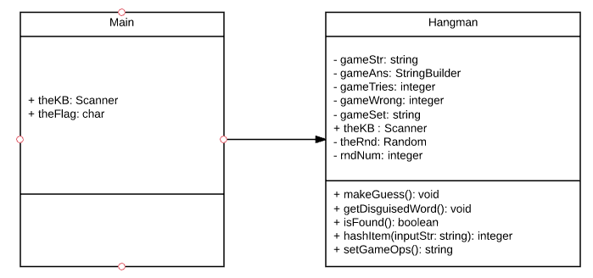

# Algorithm

/**********************************************************

Authors: Rebecca Lim

Date: 27/08/2017

Purpose: The hangman game

***********************************************************/

Begin

Class Hangman

declare private string gameStr

declare private string gameAns

declare private integer gameTries

declare private integer gameWrong

declare private string gameSet

declare private char tempAns

declare private string tempTest

public procedure new(String inputStr)

gameStr = inputStr

gameSet = call gameSetOps

gameTries = 0;

end procedure

public function integer getGameTries()

return gameTries

end function

public functions String getGameStr()

return gameStr

end function

public function string getGameAns()

return gameAns

end function

public function integer getGameWrong()

return gameWrong

end function

public function void StudentInfo()

print "Name: Rebecca Lim"

print "Student Number: 33111264"

print "Enrolment: Internal"

print "Tutor: Mark Abernethy"

print "Tutorial: Thursday, 10.30am"

end function

public function void makeGuess()

do

call getDisguisedWord

print "Guess a letter:"

read tempAns

temptest = (string) tempAns

if tempAns isDigit

print "Sorry your guess must be an alphabet character froma to z."

else

if gameStr contains tempTest

if gameAns contains tempTest

print "You have made this guess already!"

else

gameAns append tempAns

print "Correct. Guesses made", gameTries,"with",gameWrong,"wrong"

end if

else

gameWrong = gameWrong + 1

print "Incorrect. Guesses Made", gameTries, "with", call gameWrong,"wrong."

end if

end if

gameTries = gameTries + 1;

while !Call isFound()

print "Congratulations, you found the secret word: ", call getGameStr()

end function

public function void getDisguisedWord()

boolean found = false

int j = 0

print "The disguised word is <"

if gameAns.length() == 0

for i to gameStr.length

print "?"

end for

else

for i to gameStr.length()

while (found == false && j < gameAns.length())

if(gameAns.charAt(j) == gamestr.charAt(i))

print gameStr.charAt(i)

found = true

end if

j++

end while

if(found == false)

print "?"

end if

found = false

j=0

end for

end if

print "> \n"

end function

public function boolean isFound()

boolean theFlag = false

integer hashedStr

integer hashedAns

hashedStr = call HashItem(gameSet)

if (hashedStr == hashedAns)

theFlag == true

end if

return theFlag

end function

public function integer HashItem(string inputStr)

int HashTot = 0

int hash = 0

char str

for i to inputStr.length()

str = inputStr.charAt(i)

hash = 53 * str

hashTot += hash

end for

return HashTot

end function

public function string gameSetOps()

string setResults = ""

for i to gameStr.length()

if (!setResults contain value of gameStr.charAt(i))

setResults += value of gameStr.charAt(i)

end if

end for

return setResults

end function

public function void setGameAns(string gameAns)

gameAns = gameAns

end function

end class

class Assignment1Q2_Hangman

declare public char theFlag = 'y'

do

new Hangman("abracadabra")

print "Let's play a round of hangman"

print "We are playing hangman."

gameOne.makeGuess()

new Hangman("jazz");

print "Let's play another round of hangman"

print "We are playing hangman."

gameTwo.makeGuess()

new Hangman("quick");

print "Let's play the final round of hangman");

print "We are playing hangman."

gameThree.makeGuess()

print "Would you like to continue? (Y/N)"

read theFlag

while (theFlag == 'y')

end class

end

# Limitations

The limitation of this application is that it is unable to accept null characters on input, it generates an empty array while trying to access the character at position 0. Using a try-catch it is able to show a error

# Testing: