Becky's LSSS Results for volumetric flow rate input
Mass flow = Q*rho(T_in)
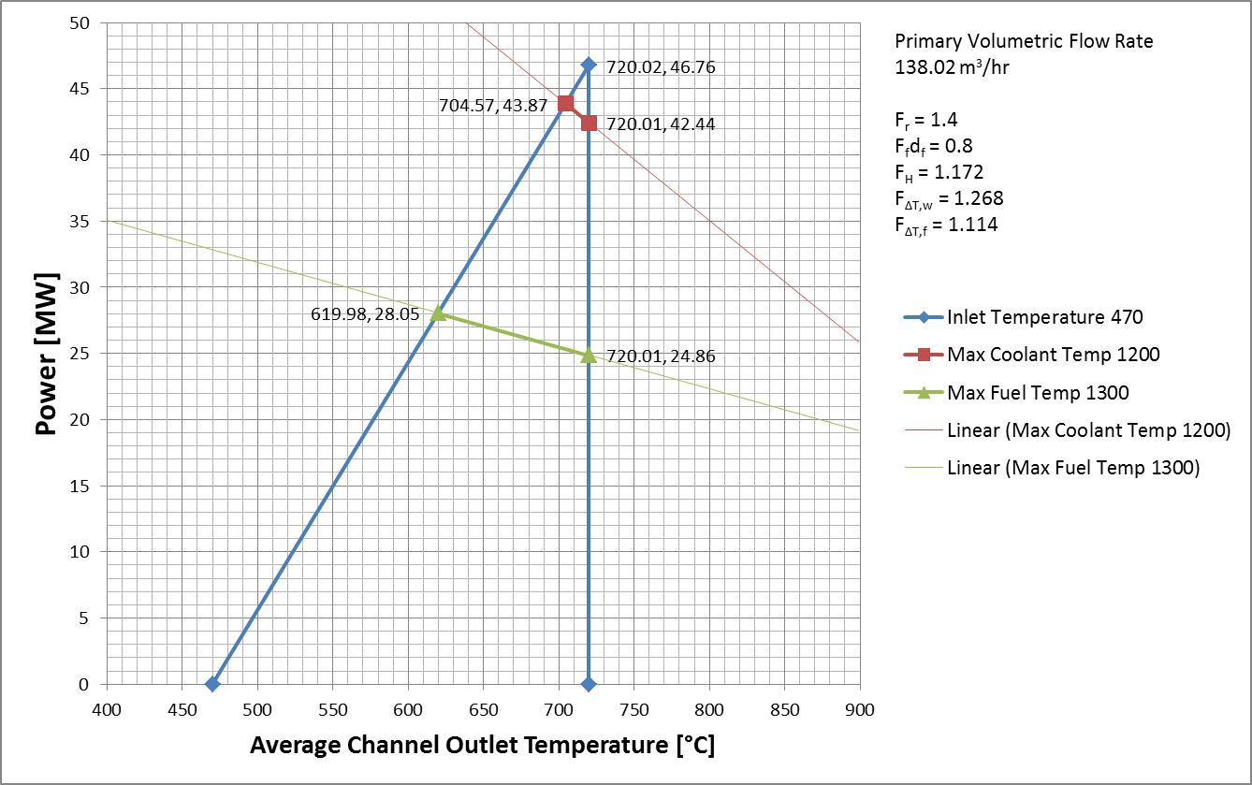

==================================================================

SINGLE POWER LEVEL OUTPUT OF 20000000.0000000

TEMPERATURES IN AVERAGE CHANNEL
W TC TW TG TCL TCLT
84.600 | 600.672 | 690.518 | 747.822 | 905.995 | 936.768
84.600 | 603.724 | 683.619 | 735.182 | 878.520 | 905.591
84.600 | 608.407 | 685.190 | 735.012 | 873.844 | 899.948
84.600 | 613.045 | 690.502 | 740.829 | 881.014 | 907.606
84.600 | 617.802 | 697.614 | 749.449 | 893.607 | 921.358
84.600 | 622.737 | 705.103 | 758.567 | 907.001 | 936.021
84.600 | 627.847 | 712.412 | 767.296 | 919.454 | 949.632
84.600 | 633.114 | 719.487 | 775.559 | 930.842 | 962.045
84.600 | 638.503 | 725.940 | 782.764 | 940.034 | 971.975
84.600 | 643.969 | 731.696 | 788.811 | 946.883 | 979.250
84.600 | 649.474 | 737.022 | 794.150 | 952.301 | 984.898
84.600 | 654.969 | 741.276 | 797.778 | 954.357 | 986.729
84.600 | 660.402 | 744.910 | 800.442 | 954.550 | 986.447
84.600 | 665.733 | 747.824 | 801.998 | 952.617 | 983.758
84.600 | 670.916 | 749.875 | 802.238 | 948.168 | 978.226
84.600 | 675.910 | 751.234 | 801.450 | 941.789 | 970.528
84.600 | 680.692 | 752.336 | 800.348 | 934.912 | 962.293
84.600 | 685.255 | 753.114 | 798.826 | 927.330 | 953.291
84.600 | 689.609 | 754.245 | 797.984 | 921.263 | 946.028
84.600 | 693.843 | 757.453 | 800.594 | 922.300 | 946.795
84.600 | 697.639 | 765.663 | 811.643 | 940.927 | 967.480

LSSS Results
POWER Q T_IN T_OUT TC_MAX TF_MAX
20.00 153.35 600.000 699.330 765.663 954.550

==================================================================

TEMPERATURES IN HOT CHANNEL
W TC TW TG TCL TCLT
67.680 | 601.377 | 783.102 | 857.285 | 1090.522 | 1142.244
67.680 | 607.638 | 768.580 | 835.709 | 1048.258 | 1093.602
67.680 | 617.243 | 770.981 | 835.819 | 1041.684 | 1085.405
67.680 | 626.755 | 780.944 | 846.233 | 1053.537 | 1098.145
67.680 | 636.511 | 794.473 | 861.426 | 1073.778 | 1120.434
67.680 | 646.633 | 808.707 | 877.453 | 1095.230 | 1144.129
67.680 | 657.115 | 822.552 | 892.822 | 1115.227 | 1166.181
67.680 | 667.917 | 835.917 | 907.421 | 1133.597 | 1186.381
67.680 | 678.970 | 848.074 | 920.276 | 1148.647 | 1202.766
67.680 | 690.181 | 858.900 | 931.248 | 1160.180 | 1215.094
67.680 | 701.471 | 868.937 | 941.094 | 1169.596 | 1224.970
67.680 | 712.741 | 876.975 | 948.182 | 1174.002 | 1229.046
67.680 | 723.884 | 883.896 | 953.747 | 1175.665 | 1229.945
67.680 | 734.817 | 889.522 | 957.559 | 1174.194 | 1227.223
67.680 | 745.449 | 893.594 | 959.282 | 1169.004 | 1220.214
67.680 | 755.691 | 896.434 | 959.379 | 1160.964 | 1209.944
67.680 | 765.500 | 898.854 | 958.994 | 1152.201 | 1198.881
67.680 | 774.858 | 900.719 | 957.946 | 1142.396 | 1186.666
67.680 | 783.789 | 903.277 | 957.991 | 1134.848 | 1177.095
67.680 | 792.473 | 909.699 | 963.564 | 1137.885 | 1179.708
67.680 | 800.258 | 925.280 | 982.437 | 1166.869 | 1212.298

LSSS Results
POWER Q T_IN T_OUT TC_MAX TF_MAX
20.00 153.35 600.000 803.725 925.280 1175.665

==================================================================
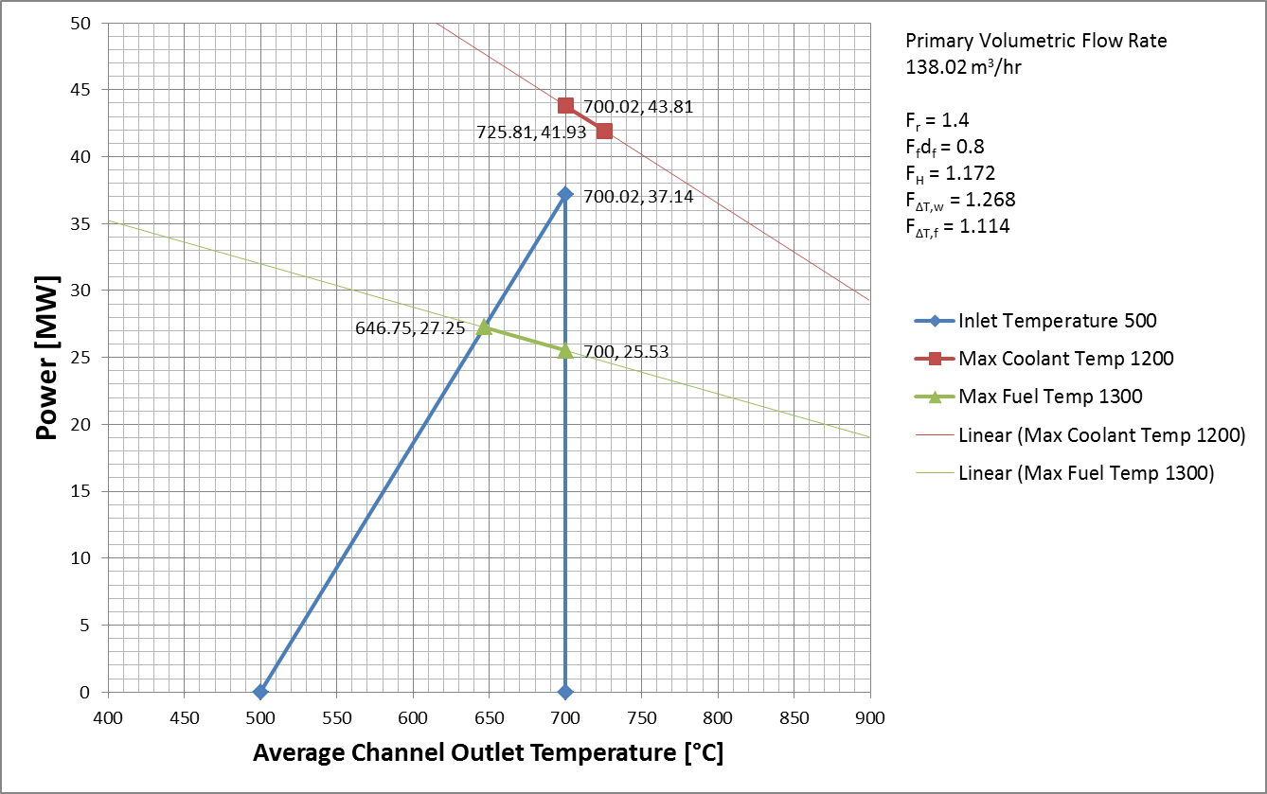

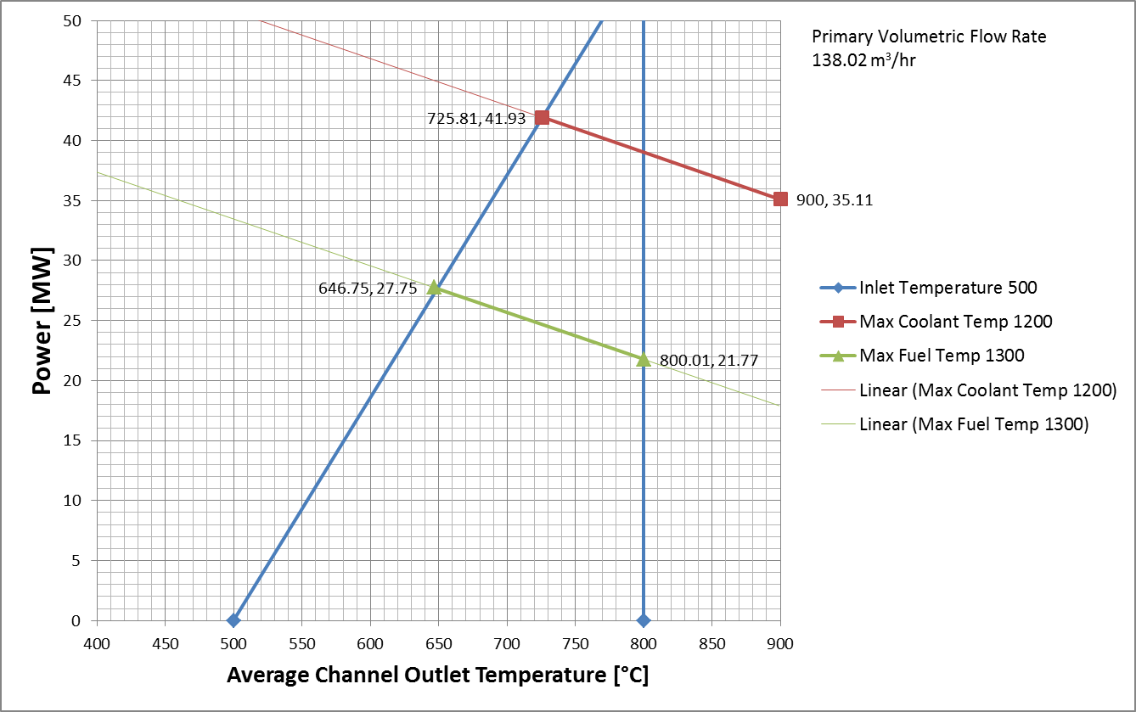

Becky's LSSS Results for mass flow rate input

- NT Paper:

Mass flow rate: 76.14 kg/s
Maximum fuel temperature limit: 1300°C
Maximum coolant temperature limit: 1200°C
Minimum inlet temperature limit: 470°C
Maximum outlet temperature limit: 720°C

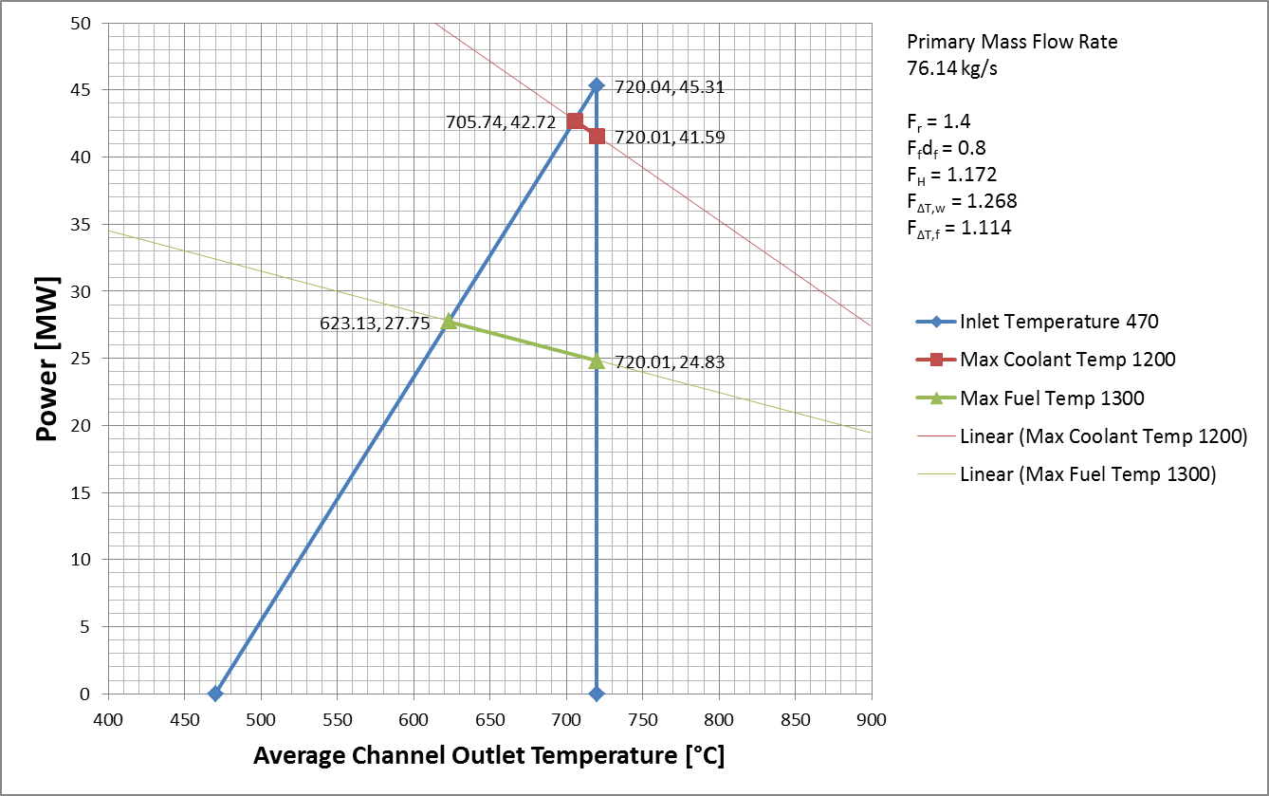

- High Power Mode II

TEMPERATURES IN AVERAGE CHANNEL [°C] |  |  |  |  | LSSS RESULTS
TC | TW | TG | TCL | TCLT
600.672 | 690.518 | 747.822 | 905.995 | 936.768 | POWER
603.724 | 683.619 | 735.182 | 878.520 | 905.591 | 20.00
608.407 | 685.190 | 735.012 | 873.844 | 899.948
613.045 | 690.502 | 740.829 | 881.014 | 907.606 | W
617.802 | 697.614 | 749.449 | 893.607 | 921.358 | 84.600
622.737 | 705.103 | 758.567 | 907.001 | 936.021
627.847 | 712.412 | 767.296 | 919.454 | 949.632 | T_IN
633.114 | 719.487 | 775.559 | 930.842 | 962.045 | 600.000
638.503 | 725.940 | 782.764 | 940.034 | 971.975
643.969 | 731.696 | 788.811 | 946.883 | 979.250 | T_OUT
649.474 | 737.022 | 794.150 | 952.301 | 984.898 | 699.330
654.969 | 741.276 | 797.778 | 954.357 | 986.729
660.402 | 744.910 | 800.442 | 954.550 | 986.447 | TC_MAX
665.733 | 747.824 | 801.998 | 952.617 | 983.758 | 765.663
670.916 | 749.875 | 802.238 | 948.168 | 978.226
675.910 | 751.234 | 801.450 | 941.789 | 970.528 | TF_MAX
680.692 | 752.336 | 800.348 | 934.912 | 962.293 | 954.550
685.255 | 753.114 | 798.826 | 927.330 | 953.291
689.609 | 754.245 | 797.984 | 921.263 | 946.028
693.843 | 757.453 | 800.594 | 922.300 | 946.795
697.639 | 765.663 | 811.643 | 940.927 | 967.480

TEMPERATURES IN HOT CHANNEL [°C] |  |  |  |  | LSSS RESULTS
TC | TW | TG | TCL | TCLT
601.377 | 783.102 | 857.285 | 1090.522 | 1142.244 | POWER
607.638 | 768.580 | 835.709 | 1048.258 | 1093.602 | 20.00
617.243 | 770.981 | 835.819 | 1041.684 | 1085.405
626.755 | 780.944 | 846.233 | 1053.537 | 1098.145 | W
636.511 | 794.473 | 861.426 | 1073.778 | 1120.434 | 67.680
646.633 | 808.707 | 877.453 | 1095.230 | 1144.129
657.115 | 822.552 | 892.822 | 1115.227 | 1166.181 | T_IN
667.917 | 835.917 | 907.421 | 1133.597 | 1186.381 | 600.000
678.970 | 848.074 | 920.276 | 1148.647 | 1202.766
690.181 | 858.900 | 931.248 | 1160.180 | 1215.094 | T_OUT
701.471 | 868.937 | 941.094 | 1169.596 | 1224.970 | 803.725
712.741 | 876.975 | 948.182 | 1174.002 | 1229.046
723.884 | 883.896 | 953.747 | 1175.665 | 1229.945 | TC_MAX
734.817 | 889.522 | 957.559 | 1174.194 | 1227.223 | 925.280
745.449 | 893.594 | 959.282 | 1169.004 | 1220.214
755.691 | 896.434 | 959.379 | 1160.964 | 1209.944 | TF_MAX
765.500 | 898.854 | 958.994 | 1152.201 | 1198.881 | 1175.665
774.858 | 900.719 | 957.946 | 1142.396 | 1186.666
783.789 | 903.277 | 957.991 | 1134.848 | 1177.095
792.473 | 909.699 | 963.564 | 1137.885 | 1179.708
800.258 | 925.280 | 982.437 | 1166.869 | 1212.298

- Different LSSS temperature limits 500-700°C

Mass flow rate: 76.14 kg/s
Maximum fuel temperature limit: 1300°C
Maximum coolant temperature limit: 1200°C
Minimum inlet temperature limit: 500°C
Maximum outlet temperature limit: 700°C

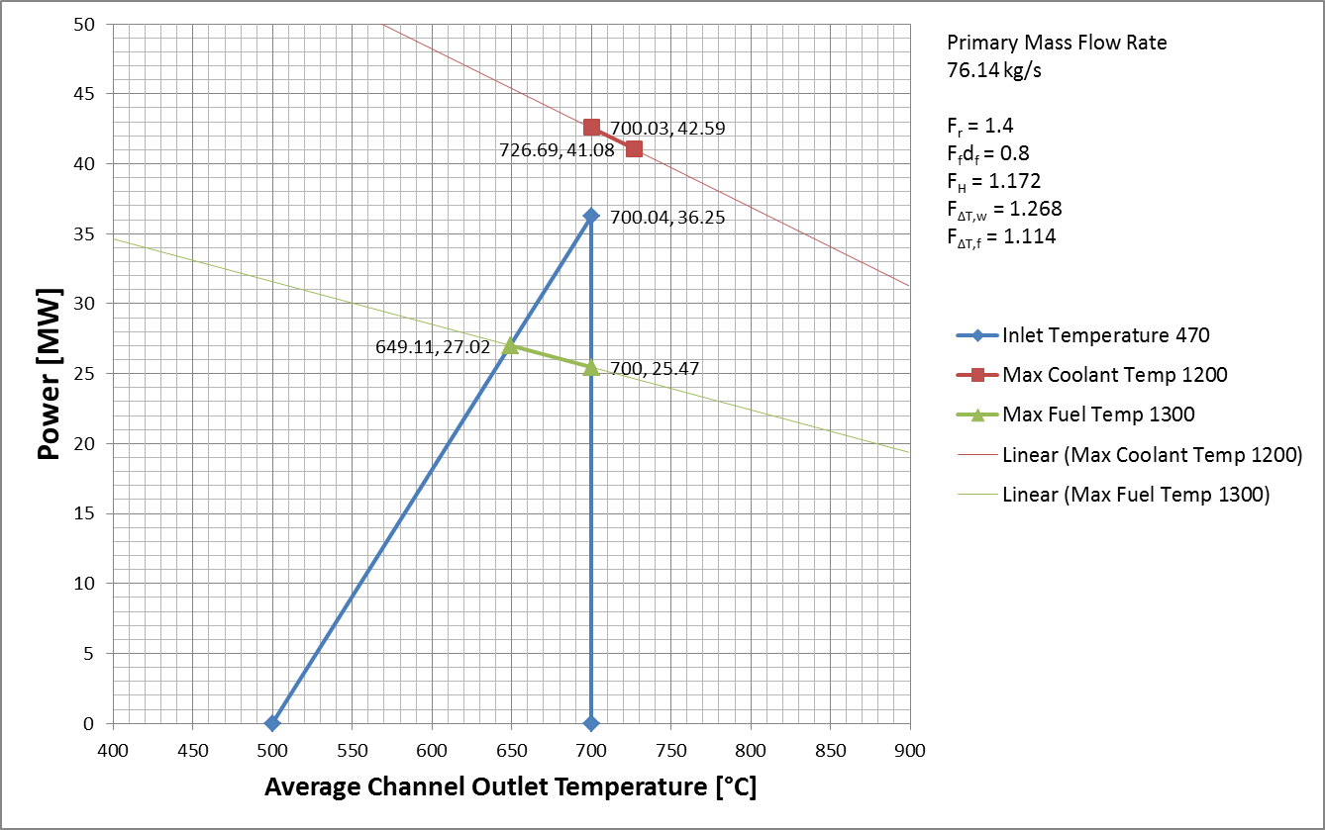

- Different LSSS temperature limits 500-800°C

Mass flow rate: 76.14 kg/s
Maximum fuel temperature limit: 1300°C
Maximum coolant temperature limit: 1200°C
Minimum inlet temperature limit: 500°C
Maximum outlet temperature limit: 800°C

