Download latest git version from <https://git-scm.com/downloads>

At the time of this writing, latest version is 2.11.0

1. Accept license – hit Next

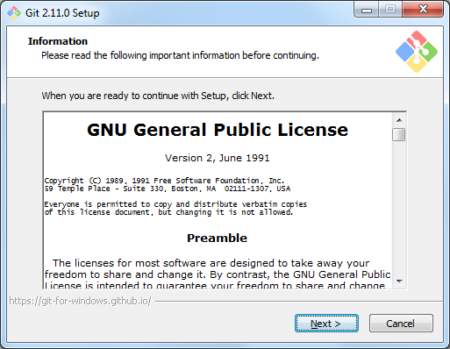

1. Make sure the following options are selected. Check the quicklaunch and desktop boxes if you want those shortcuts.

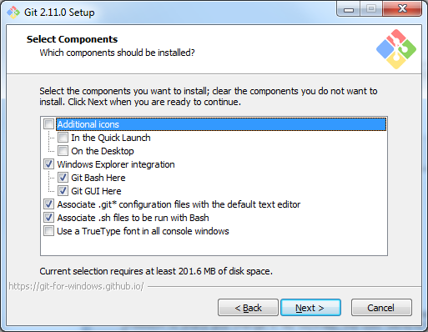

1. Select “Use Git from Git Bash only”

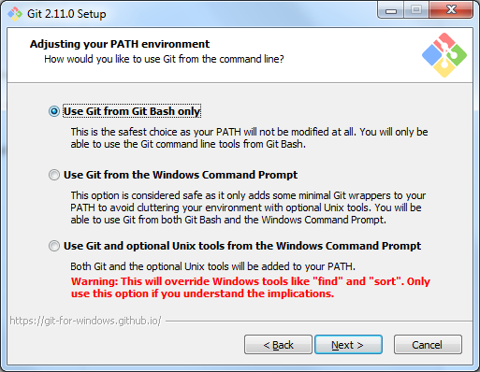

1. Leave “Use OpenSSH” selected

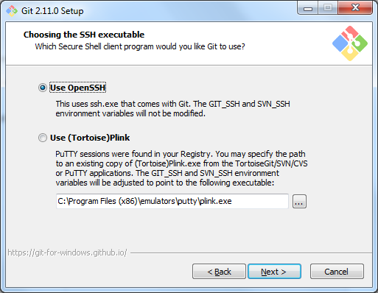

1. Leave the default for line ending conversions

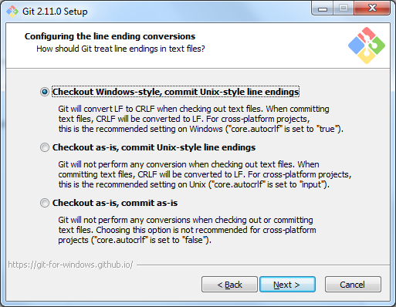

1. Leave the default terminal emulator (MinTTY) selected

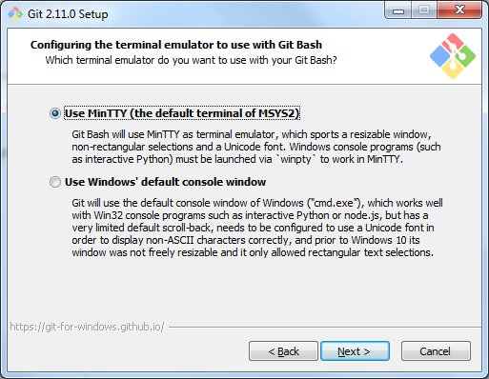

1. Select all three extra feature options

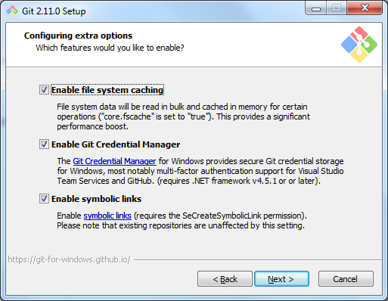

1. Leave experimental difftool unchecked

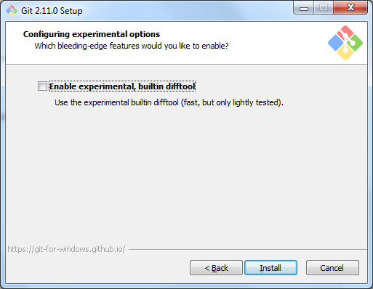

1. Hit “Install”