ABSTRACT

This project emphasizes on creating and managing system of database for effective management as well as improvement operation of video game parlour. The system was storing and processing data related to customers and session. Management of book as well as roles of staff along side machines and consoles were stored by this system. Also, normalization was applied to 3NF for minimizing data redundance and ensuring data integrity. SQL queries will facilitate for data insertion, update and delete. The main theme of the project was to enhance parlour operation effectively and support growth by giving structured and scalable solution of database.

Table of Content

1.INTRODUCTION 1

2.AIM 1

3.OBJECTIVES 2

3.PROBLEM STATEMENT 3

4.FEATURES AND FUNCTIONALITITES 3

5.SCOPE OF PROJECT 4

6.DEVELOPMENT METHODOLODY 4

7.DESING ARCHITECUTRE 4

7.1 NORMALIZATION 4

8.VERSION CONTROL 22

CONCLUSION 23

References 24

LIST OF FIGURES

Figure 1:AIM 1

Figure 2:OBJ 2

# INTRODUCTION

This database coursework includes design of rational system of database of video game parlor. It demonstrates effective and normalized database system. Information on customers, sessions, bookings etc were stored on this database system. Operations efficiency, streamline session management and betterment on experience of customers was provided by this platform. Data integrity and reduce of redundancy was successful due to fully normalization of database. SQL queries implement was for manipulation of data to enable seamless operations from starting like booking session to last generating reports. The service and operations were maintained smoothly with the help improvement in database.

# 1.AIM

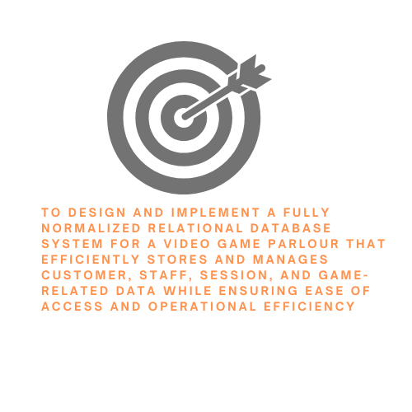

Figure 1:AIM

The main was design and implement database with fully normalization for video game parlor which improve effective stores and manages customers, staff session with ensuring easy access and efficiency in operations.

# 2.OBJECTIVES

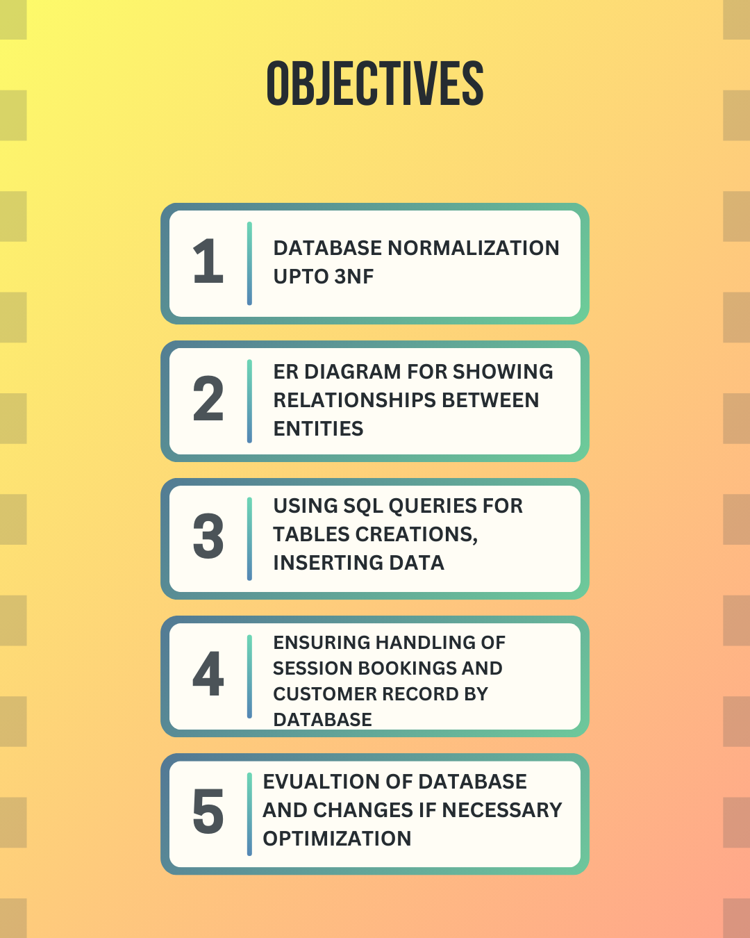

Figure 2:OBJ

To normalize database into 3NF was one of the objectives. Also, er diagram was made for showing the relationship between different entities. Also, query of SQL was used to insert data in system. Handling of session and customers record were also ensured. At last, database was evaluated for any changes need for optimization.

# 3.PROBLEM STATEMENT

It solves the problem like managing session bookings, customer details, staff roles, machine and console assignment as well as game management in video game parlour. Existing data handling methods are improved as they were inefficient which leads towards errors and delays. It main was to design and implement a well-structured database to address these challenges and enhance operational efficiency.

# 4.FEATURES AND FUNCTIONALITITES

There are different function and functionalities in database. Customer management was one of them it is used for tracking member details, with types, fees and booking of members. Also, record session schedules, types, fees and floor allocation was managed by session management. Booking system was used for managing bookings, both prepaid and non-paid bookings. Staff session based on roles like counter, maintenance, café was assigned according to staff assignments. Track machine and console usage per session was used for machine and console allocation. Session bookings, customer attendance and machine utilization were used for reporting.

# 5.SCOPE OF PROJECT

To manage all aspects of customer service from session booking to traffic staff roles and machine usage for database system for the video game parlour. This project mainly focused on design of relational database for storing all data efficiently as well as development of SQL queries for performing CURD (create, read, update and delete) operation in database.

# 6.DEVELOPMENT METHODOLODY

At first, normalization was used for minimizing data redundancy. 1NF was done for removing atomicity as well as one primary key in each table. Duplicate row and column were also removed in 1NF. Each column and row must contain one value was also ensured. In 2NF, parital dependency is removed by making all non-key attributes must fully be dependent on a primary key. In 3NF, transitive dependency by making all non-prime attribute is dependent on another non-prime attribute. After that, designing tool like visual paradigm was used for ER diagram. DBMS (Data base management system) was used for creating and managing the database in structured way. SQL programming languages was used for inserting data, updating, deleting as well as data manipulation.

# 7.DESING ARCHITECUTRE

## 7.1 NORMALIZATION

Process of data organization to reduce data redundancy and improving integrity of data which involves divides large tables into small ones and defining relationships between them. It helps in reducing repeating data well as making storage and retrieval more efficiently. Moreover, it’s aim was to keep consistent and remove data irregularities for making information formatted and structured (Tomar, n.d.). Types of normalization was discussed below:

1.1NF (First normal form)

Here, table was made unique as well as no repetition of groups of data was checked. Here, each entry has a unique identifier called as primary key.

2. 2NF (Second normal form)

All non-key attributes are functionally dependent on primary key as well as non-key attributes fully functionally dependent on primary key.

3. 3NF (Third normal form)

Here, transitive functionality was checked. Every non-principal column should be non-transitively dependent on each key within the table.

Then, 1NF of given question was done and nothing was changed.

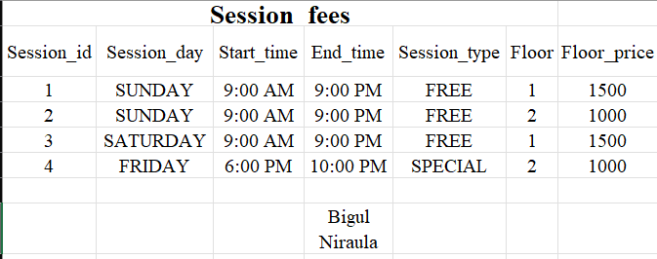

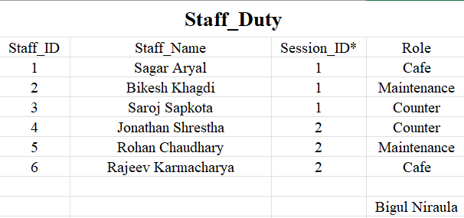

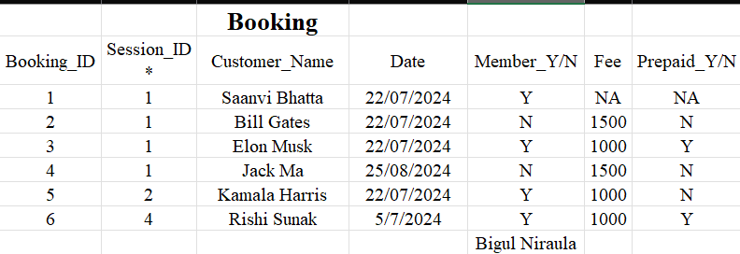

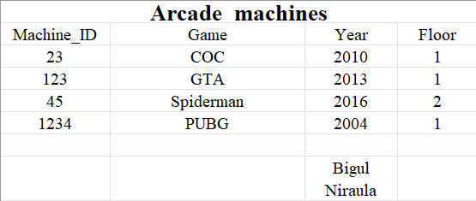

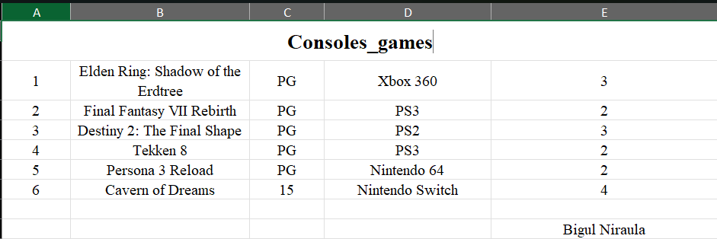

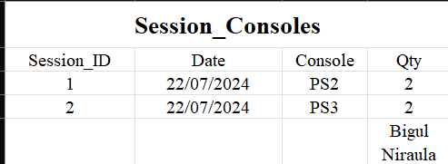

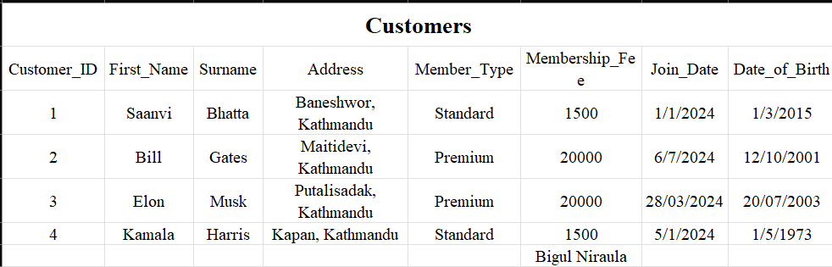

IN 2NF, tables were breakdown and 10 tables was made to reduce data partial dependency.

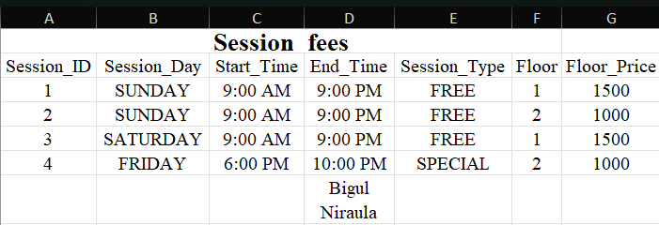

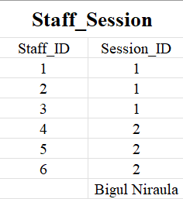

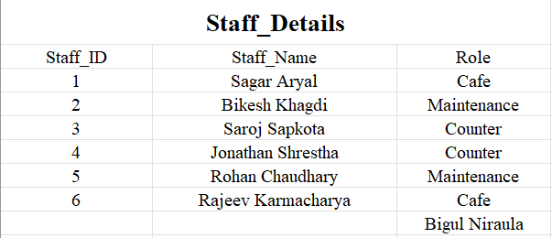

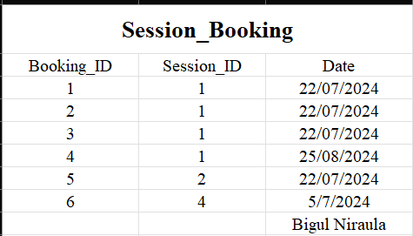

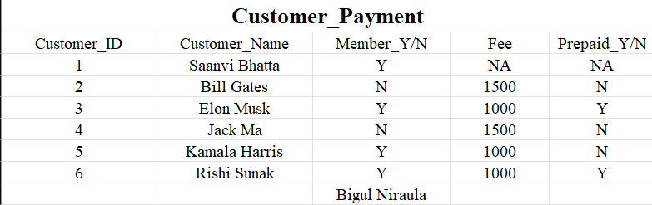

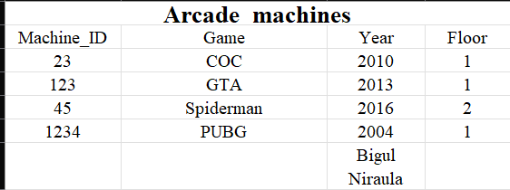

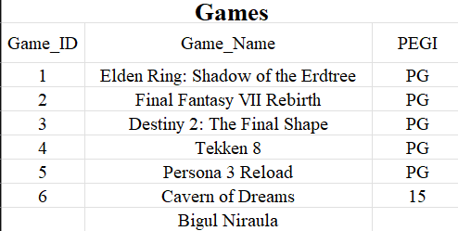

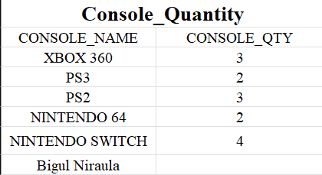  
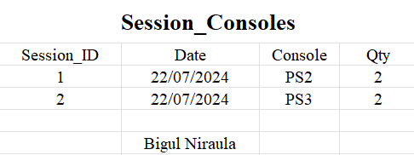

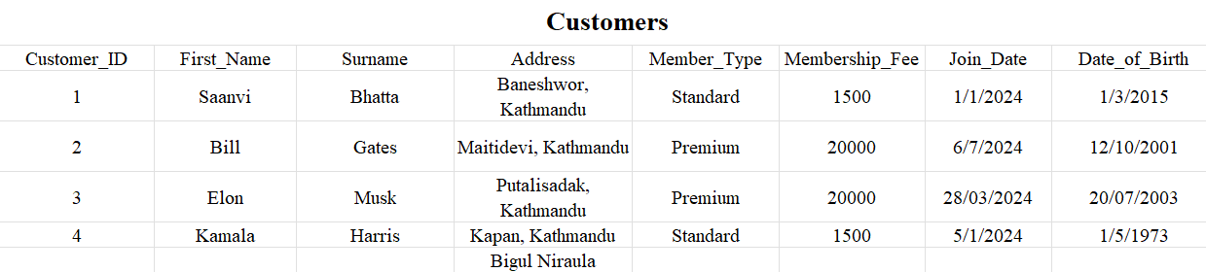

After that, 3NF was done to non-prime attribute dependent on another non-prime attribute.

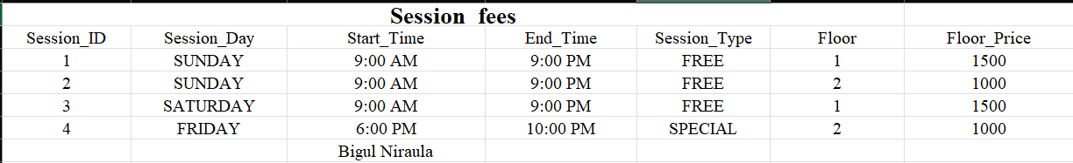

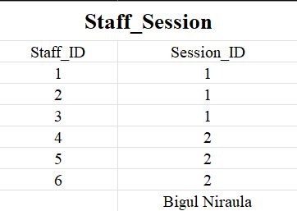

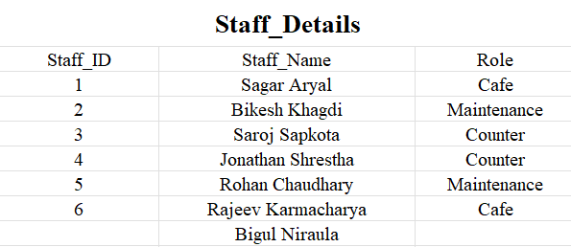

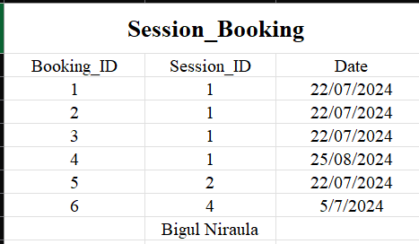

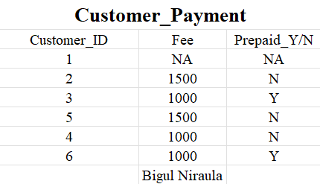

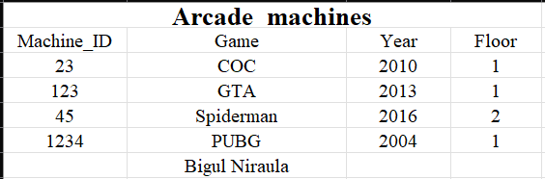

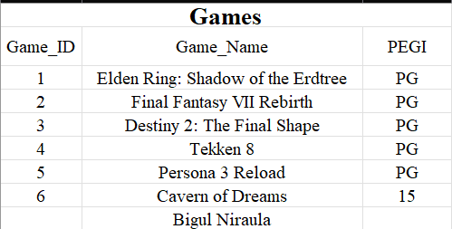

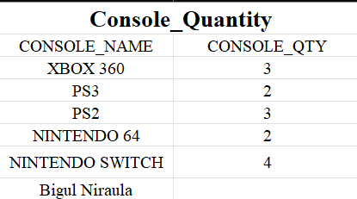

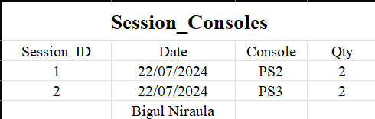

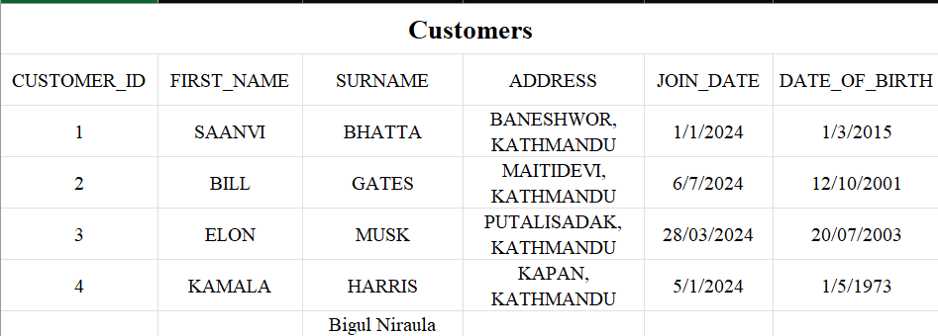

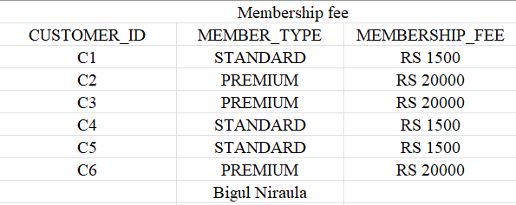

At first every table was on 1NF so nothing was changed.

## 7.2 ER -DIAgram

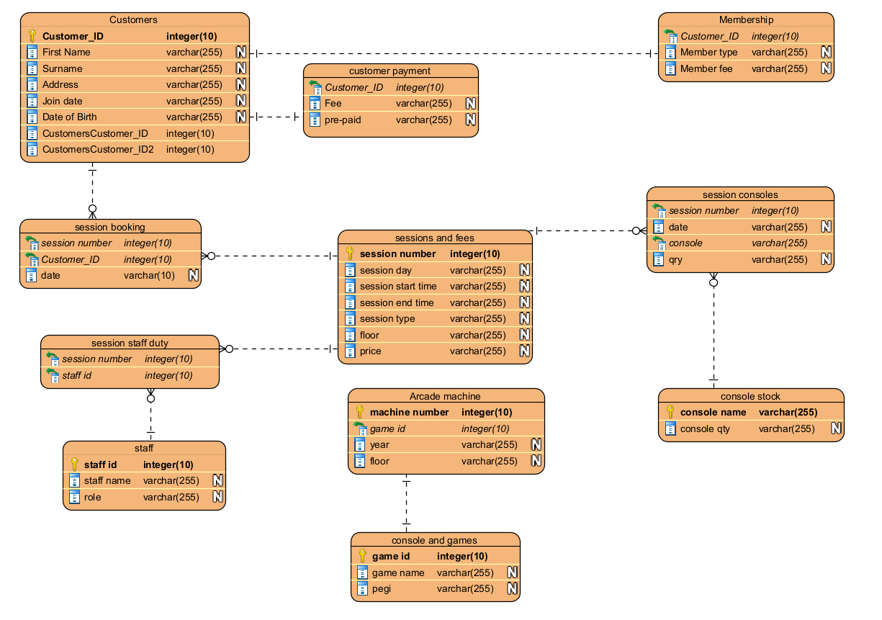

Figure 3:dia

## 7.3 dictionary of data

## 7.4 Creating data and data insert

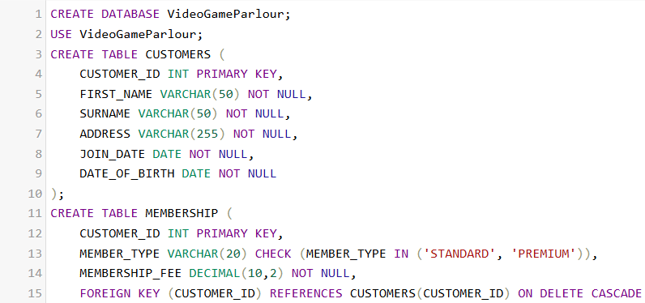

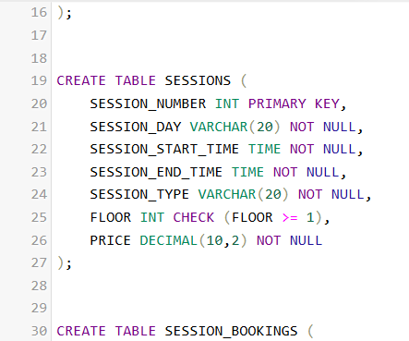

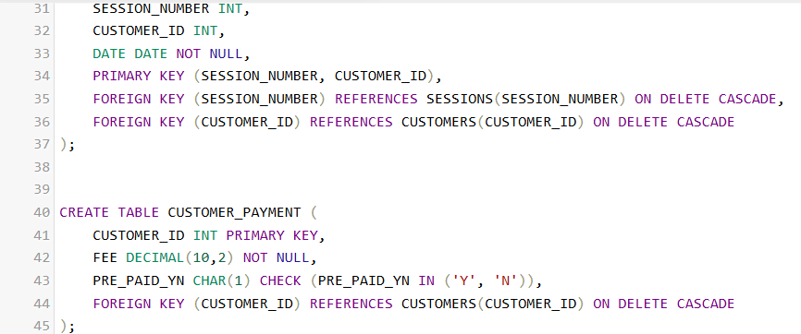

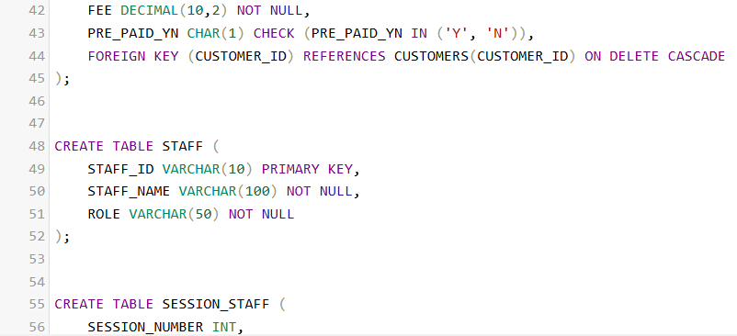

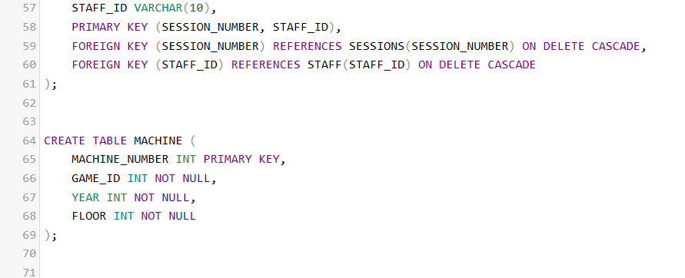

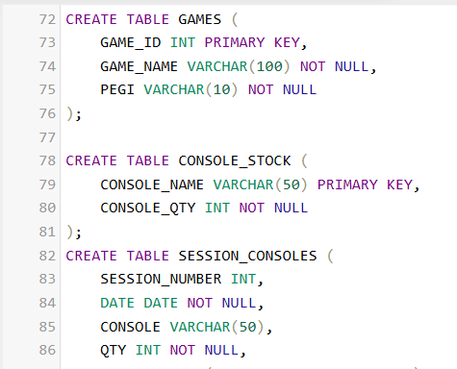

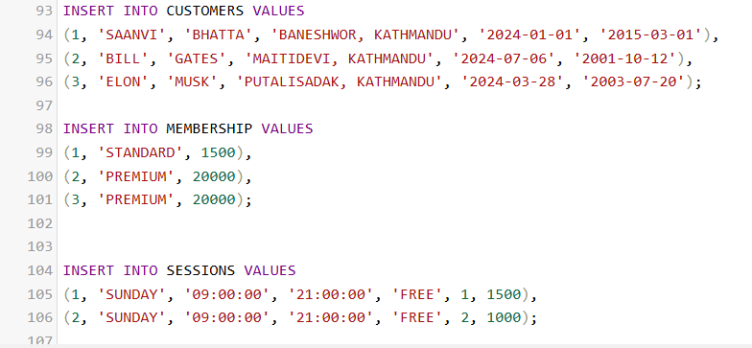

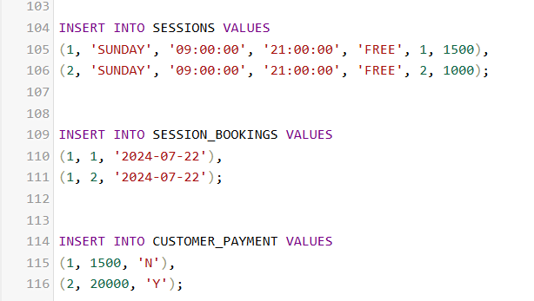

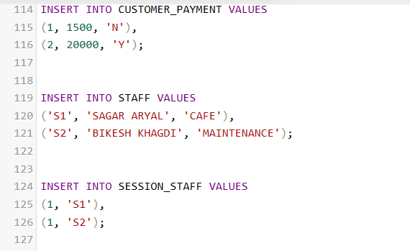

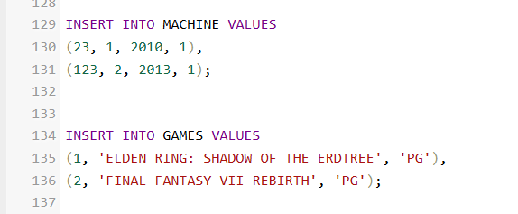

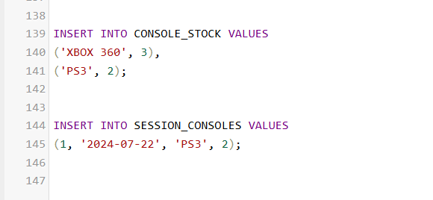

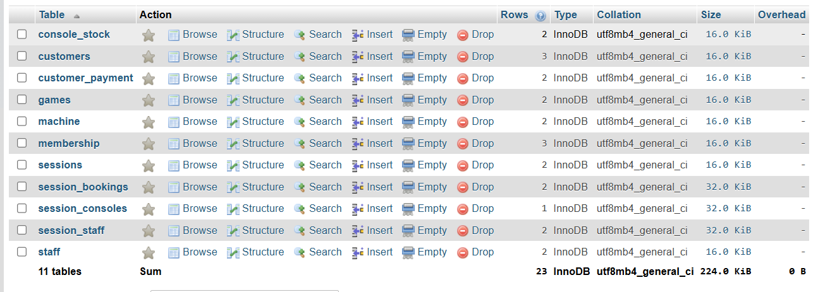

## 7.5 Database queries

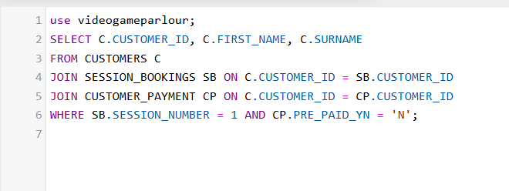



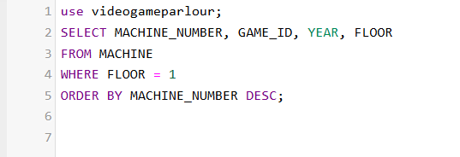

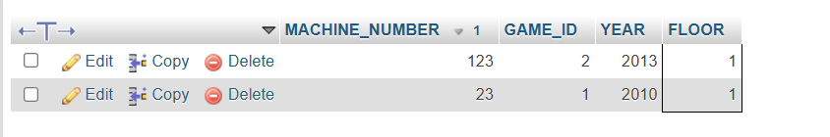

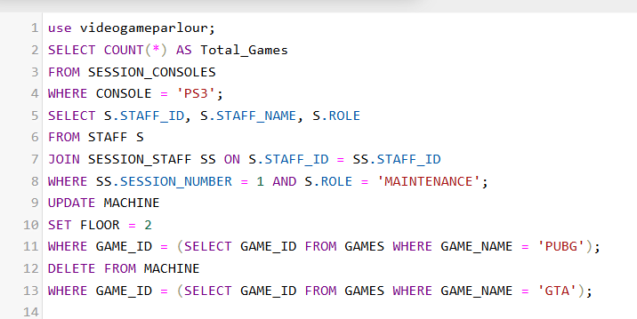

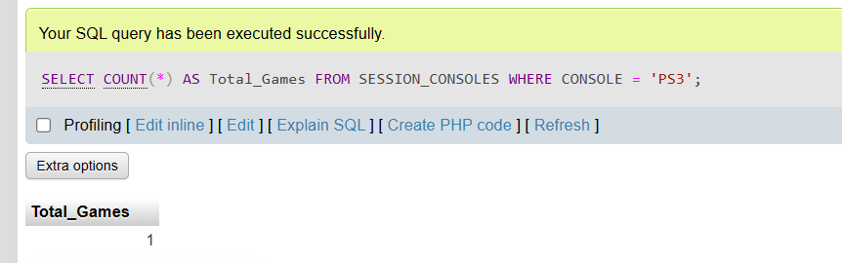

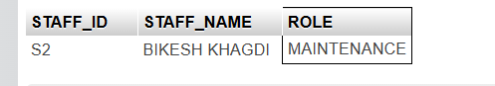

# 8.VERSION CONTROL

Github = <https://github.com/becool1321/2nd-sem-web-cw2.git>

Youtube = <https://youtu.be/jUwg1vBfD6Q>

# CONCLUSION

Overall, this database system provides systematic solution for managing different types of operations in video game parlour like ensuring data integrity, efficiency as well as improvement in scalability. Also, normalization and SQL queries was implemented for data storage and retrieval process in the system of database which made smoothness for customer bookings, assignment of staff, details of different session and equipment usage. It not only meets current need but also support its scalability for future. For enhancing in efficient operations as well as customers service and contributing overall success of business this database was successful implemented.

# References

Tomar, N. (n.d.). Normalization and its Types. <https://www.c-sharpcorner.com/uploadfile/nipuntomar/normalization-and-its-types/>