**Admin Panel**

* **Add Product Section :**
  + Tax type GST - As per as mentioned in requirement Please add **Tax type** list -“15% GST” or Without “GST” which are can be configure through Settings.
  + Remove Product Dimension.
  + Product Picture - Optional
  + Supplier Product Code - As per as mentioned in requirement add “Supplier Product Code”
  + Unit Of Measurement : Add “**Unit Of Measurement”** List - ex “KG” which are can be configure through Settings.
* **Create Customer Section :**
  + **C**ustomer Tax ID : Add “Customer Tax ID”
* **Create Supplier Section :**
  + **Supplier** Tax ID : Add “Supplier Tax ID”
* **Settings :**
  + **Tax Type:** Add, Delete, Edit Tax Type
  + **Unit Of Measurement** : Add, Delete, Edit Unit Of Measurement Type
* **Export Order :** Asper as mentioned in requirement Order Should export and Email in Three formats XL, Word, and PDF.

**Customer Panel**

* **Create Order :**
  + Select Category : Show only categories which are only belongs to Supplier . Not All Categories.  
    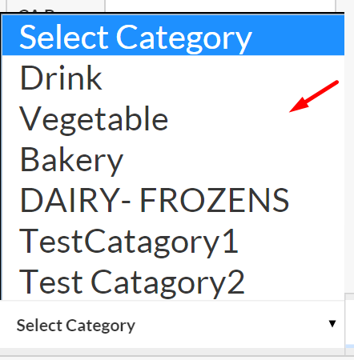

**Other Issue**

* Few user interaction needs to be change. We will figure it out later
* Export Order Template and file Name needs to be change.
* In Future we are going to add few more things to **Settings .**