**Exercise: DOM Events**

Submit your solutions in the SoftUni judge system at:

<https://alpha.judge.softuni.org/contests/dom-manipulation-and-events-exercise/2763>

**Environment Specifics**

Please, be aware that every JS environment may **behave differently** when executing code. Certain things that work in the browser are not supported in **Node.js**, which is the environment used by **Judge**.

The following actions are **NOT** supported:

* **.forEach()** with **NodeList** (returned by **querySelector()** and **querySelectorAll()**)
* **.forEach()** with **HTMLCollection** (returned by **getElementsByClassName()** and **element.children**)
* Using the **spread-operator** (**...**) to convert a **NodeList** into an array
* **append()** in Judge (use only **appendChild()**)
* **prepend()**
* **replaceWith()**
* **replaceAll()**
* **closest()**
* **replaceChildren()**
* Always turn the collection into a **JS array** (forEach, forOf, et.)

If you want to perform these operations, you may use **Array.from()** to first convert the collection into an array.

## Sections

You will receive an **array** of strings. For each string, create a **div** with a **paragraph** with the **string** in it. Each paragraph is initially **hidden (display:none)**. Add a **click** **event** **listener** to **each div** that **displays** the **hidden** paragraph. Finally, you should **append** all divs to the element with an **id** "**content**".

### Example

 🡪 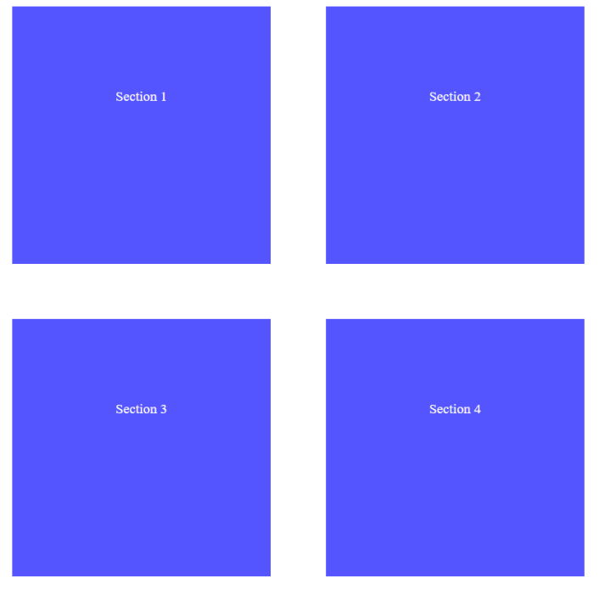

## Time Converter

Create a program that **converts** different time units. Your task is to add a **click** event listener to **all** [**CONVERT**] **buttons**. When a button is **clicked**, read the **corresponding** input field, **convert** the value to the **three other** time units and **display** it in the input fields.

### Example

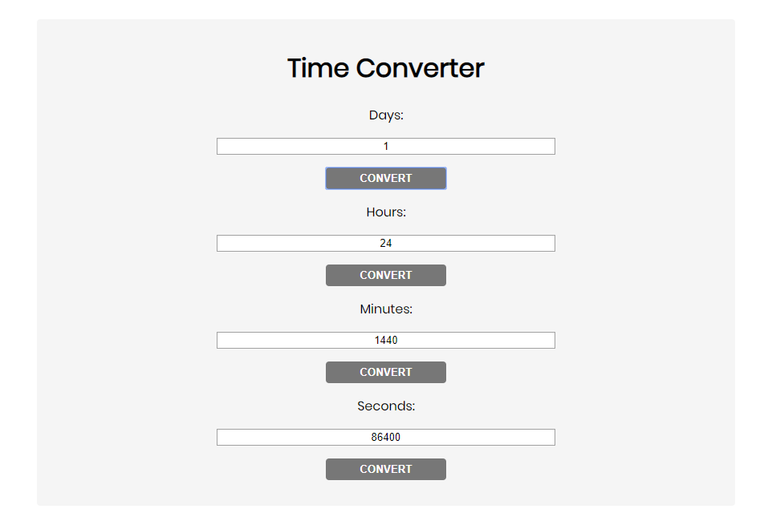

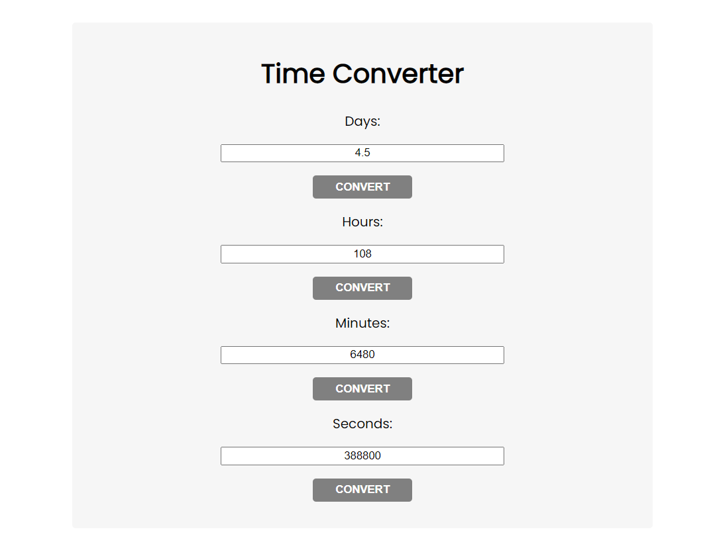

One day is equal to 24 hours/1440 minutes/86400 seconds. Whichever button we **click,** the input fields should **change** depending on the added value on the left. (For example, if we enter 48 hours and press the "Convert" button below the corresponding field, the value in the days field should change to 2.).

## Locked Profile

In this problem, you should **create a JS functionality** that **shows** and **hides** the additional information about users.

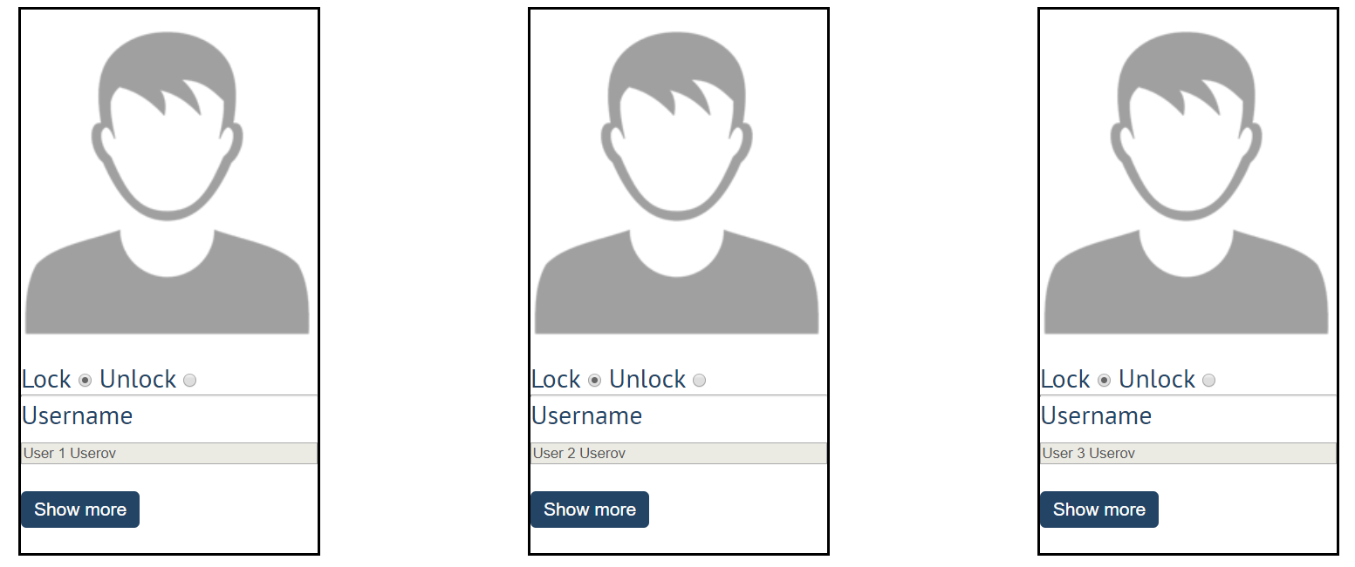

When one of the [**Show more**] **buttons** is clicked, the **hidden information** inside the div should

be shown, only if **the profile is not locked**! If the current profile is **locked,** nothing should happen.

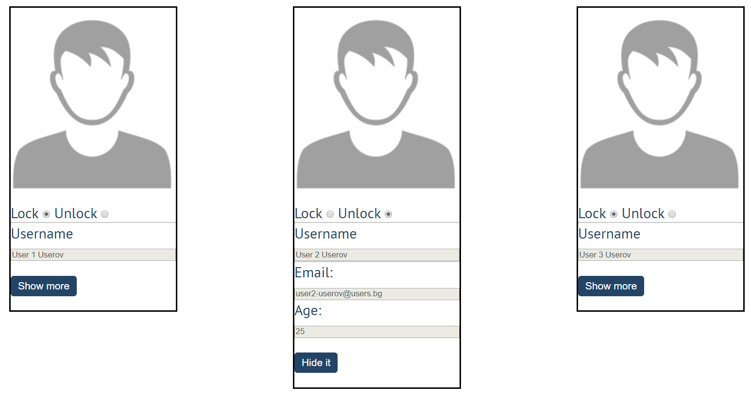

If the **hidden information is displayed** and we **lock** **the profile again**, the [**Hide it**] button should **not be working**!

Otherwise, when the profile is **unlocked** and we click on the [**Hide it**] button, the new fields must hide again.

## Fill Dropdown

Your task is to take values from **input** fields with **ids "newItemText"** and **"newItemValue"**.Then you should create and append an **<option>** to the **<select>** with **id** **"menu".**

### Example

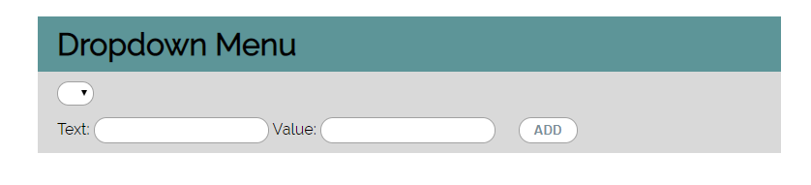

### Hints

* Your function should take the values of **newItemText** and **newItemValue**. After that, you should create a new **option** element and set its **textContent** and its **value** to the newly taken ones.
* Once you have done all of that, you should **append** the newly created **option** as a **child** to the **select** item with id **"menu".**
* Finally, you should **clear** the value of the two **input** fields.

## Encode and Decode Messages

In this problem, you should **create a JS functionality** that **encodes and decodes some messages which travel to**

**the network.**

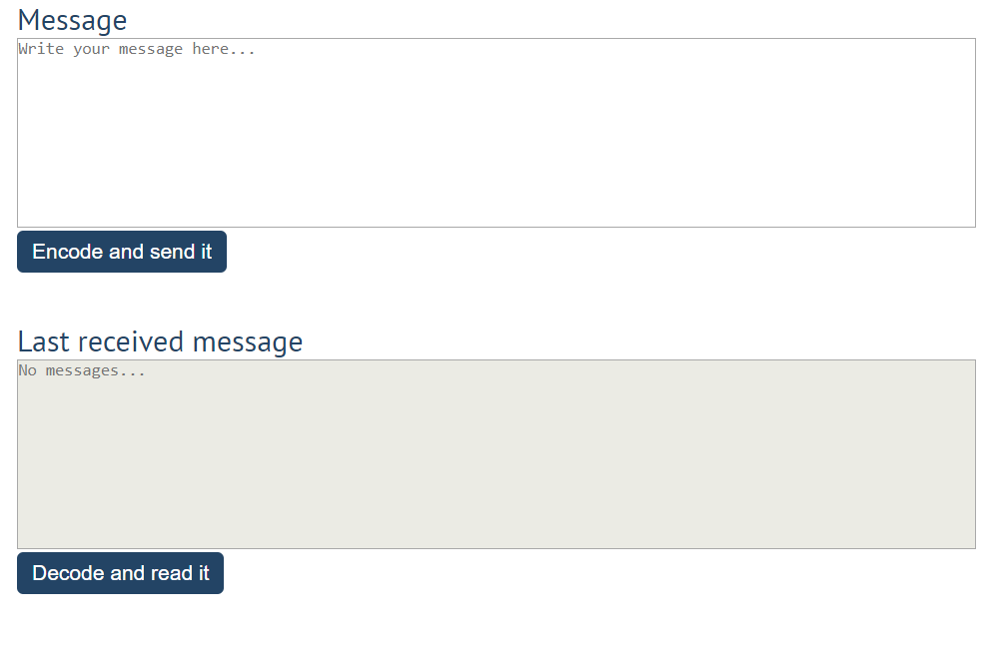

This program should contain **two functionalities**.

The first one is to **encode the given message** and **send it** to the **receiver**.

The second one is to **decode the received message** and **read it (display it)**.

When the [**Encode and send it**] **button** is clicked, you should get the given message from the first **textarea**. When you get the current message, you should encode it as follows:

* **Change** the **ASCII CODE** on **every single character** in that message when you **add 1** to the current **ASCII NUMBER**, that represents the current character in that message
* **Clear** the **sender** **textarea** and **add** the encoded message to the **receiver textarea**

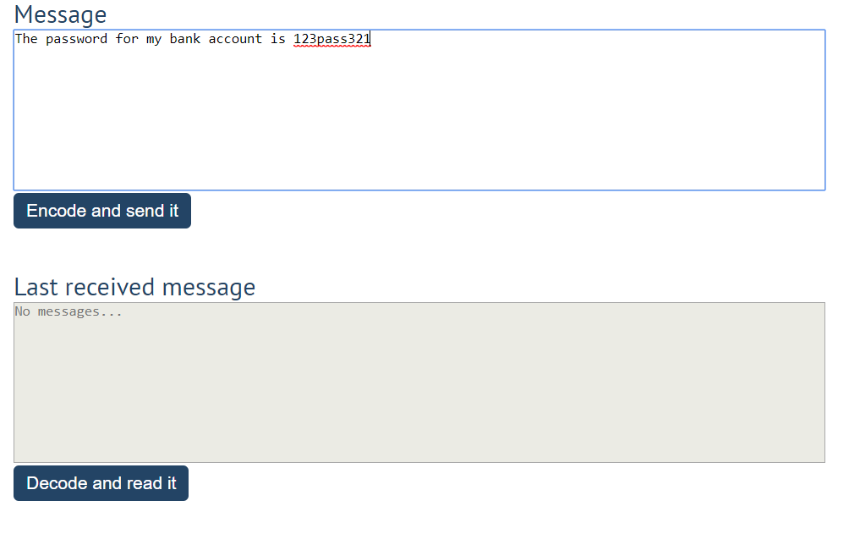

After clicking the [**Encode and send it**] **button** the result should be:

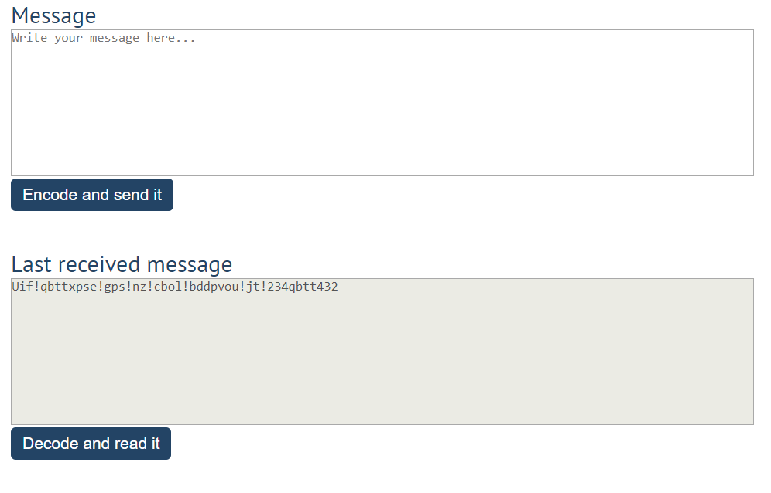

After that, when the [**Decode and read it**] **button** is clicked. You need to get the **encoded message** from **the receiver textarea** and do the **opposite logic** from encoding:

* **Subtract 1** from the current **ASCII NUMBER**, that represents the current character in that message
* Replace the **encoded message** with the already **decoded message** in the receiver **textarea**, to make it readable

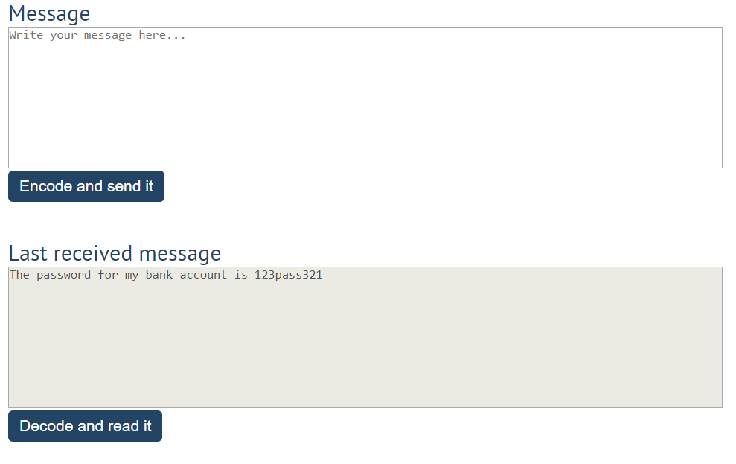

## Furniture

You will be given some furniture as an **array of objects**. Each object will have a name, a price, and a decoration factor.

When the [**"Generate"**] **button is clicked**, add a **new row to the table** for each piece of furniture with image**,** name**,** price, and decoration factor(code example below).

When the [**"**Buy**"**] button is clicked, get all **checkboxes that are marked** and show in the result textbox the **names** of the piece of furniture that **were checked**, separated by a **comma** and **single** **space** (**", "**) in the following format: **"Bought furniture: {furniture1}, {furniture2}…"**.

On the next line, print the total price in the format: **"Total price: {totalPrice}"** (formatted to the second decimal point). Finally, print the average decoration factor in the format: **"Average decoration factor: {decFactor}"**

### Input Example

**[{"name": "Sofa", "img": "https://res.cloudinary.com/maisonsdumonde/image/upload/q_auto,f_auto/w_200/img/grey-3-seater-sofa-bed-200-13-0-175521_9.jpg", "price": 150, "decFactor": 1.2}]**

### Examples

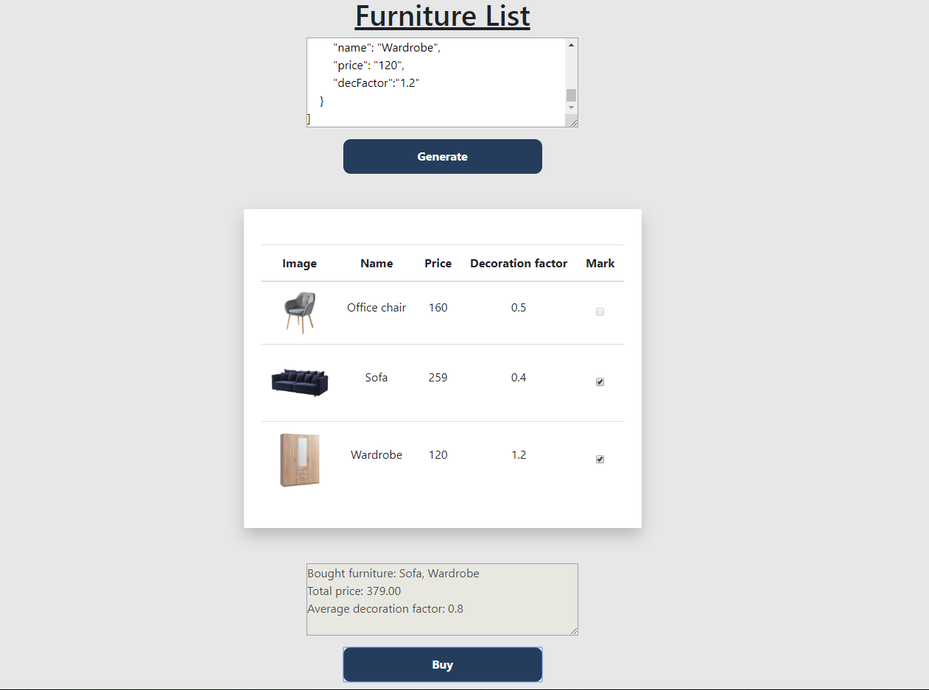

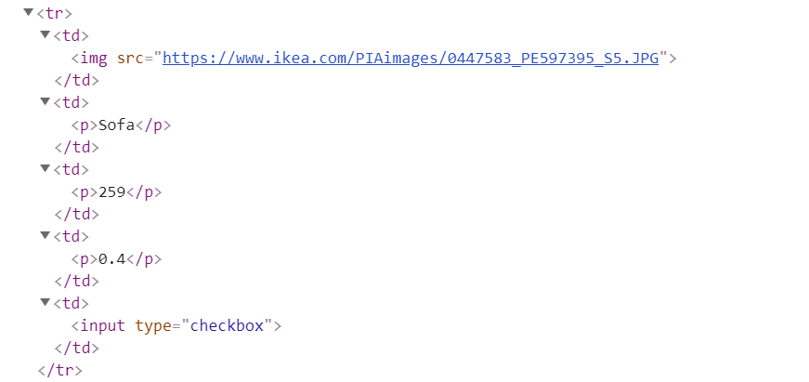

## Distance Converter *

Your task is to convert from **one** distance unit to **another** by adding a **click** event listener to a button. When it is clicked, **read** the value from the input field and **get** the **selected** option from the **input** and **output** units dropdowns. Then **calculate** and **display** the converted value in the **disabled** output field.

### Example

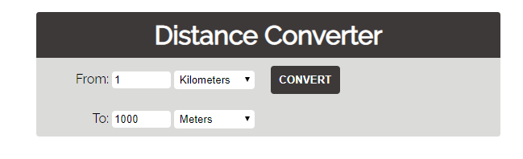

### Hints

* Multiply the incoming distance by the following conversion rates to convert to meter
* Divide to convert from meters to the required output unit
* To see which option is selected, read the properties of its parent: **value** gives you the value of the selected option (as displayed in the HTML), **selectedIndex** gives you the 0-based index of the selected option. For example, if miles are selected, **inputUnits.value** is "**mi**", **inputUnits.selectedIndex** is **4**. Option text is irrelevant
* Use the following table information to do that:

|  |  |
| --- | --- |
| **1 km** | **1000 m** |
| **1 m** | **1 m** |
| **1 cm** | **0.01 m** |
| **1 mm** | **0.001 m** |
| **1 mi** | **1609.34 m** |
| **1 yrd** | **0.9144 m** |
| **1 ft** | **0.3048 m** |
| **1 in** | **0.0254 m** |

## Sudomu *

Write a function that implements **SUDOMU** (**Sudoku inside the DOM**).

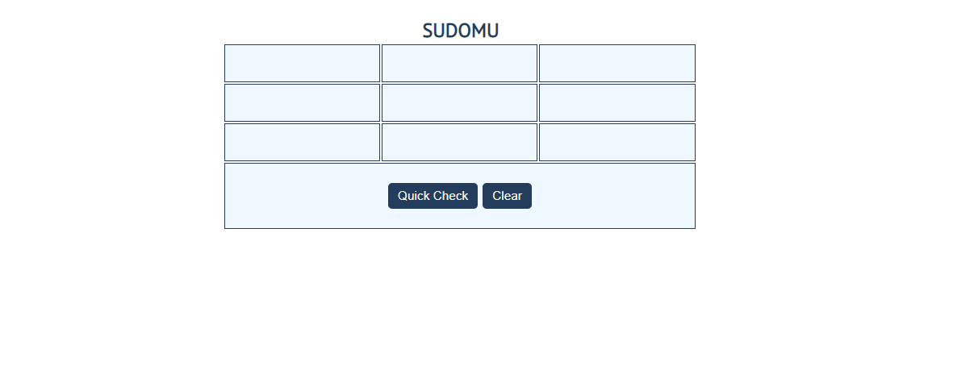

The rules are simple and they are **the same** as the **typical sudoku game** (for more information, click [here](https://sudoku.com/how-to-play/sudoku-rules-for-complete%20beginners/)).

If the table is filled with the **right numbers**, and the ["Quick Check"] button is **clicked**, the expected result should

be:

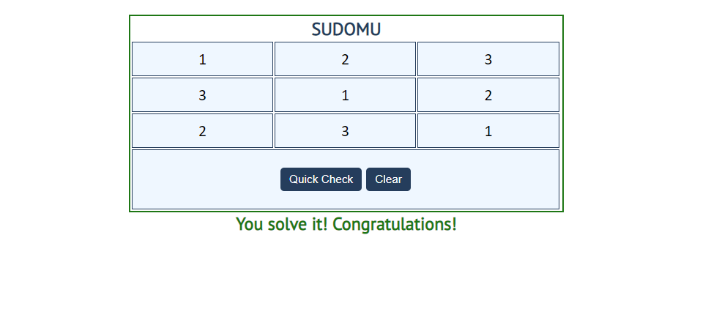

The table borer should be changed to: "2px solid green**".** The text content of the paragraph

inside the div with an **id** "check" must be "You solve it! Congratulations!"

The text color of that paragraph must be **green.**

Otherwise, when the filled table **does not solve** **the sudomu,** the result should be:

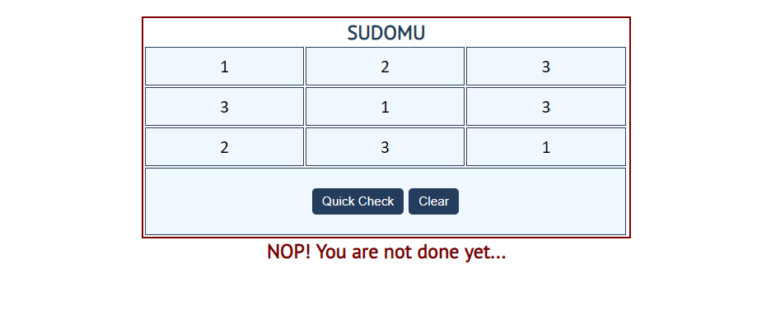

The table border should be changed to: "2px solid red". The text content of the paragraphinside the div

with an **id** "check" must be: "NOP! You are not done yet..."

The text color of thatparagraph must be **red!**

The["Clear"]button **clears the whole** **SUDOMU (removes all numbers)** and the **paragraph**

**which contains the messages. It also removes the table border.**



## JavaScript Quizz *

Write a function that has the functionality of a quiz.

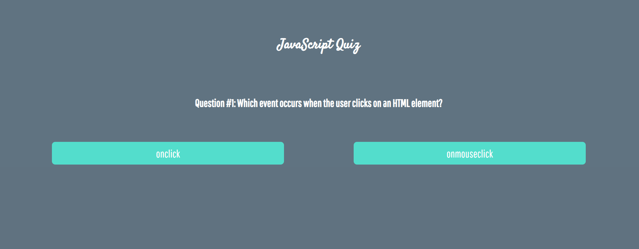

Three sections contain **one question** **and 2 possible answers.**

**The right answer is only one!**

When one of the **list elements is clicked,** the next section **must appear (if any…)**.

After all three questions have been answered, the results ul must **appear,** (Use **'none'** and **'block**' to hide and show the question sections), and the **results** must be added in the **h1**.

If all questions are answered correctly, you should print the following message:   
"You are recognized as top JavaScript fan!"

Otherwise, just print "You have {rightAnswers} right answers".

The right answers are:

* onclick
* JSON.stringify()
* A programming API for HTML and XML documents



