1. Pre-processing
   1. Checks
      1. Check a cell DF + other tests
      2. Validate cell DF
   2. Delete <Empty>
2. Data Cell and Attribute Cell Separation

**Definitive function**

1. get_group_id
2. get_direction_df

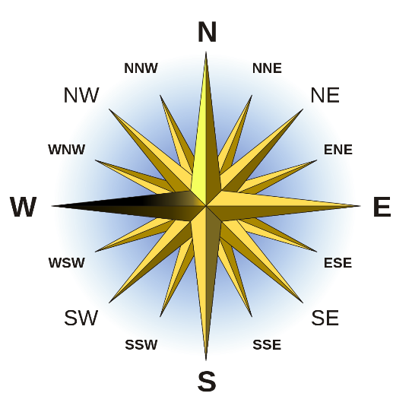

**Ai function**

1. ai_get_data_attr_map_main
   1. ai_get_data_attr_map
      1. get_direction_df (this I think can be linked to intra block dist)
   2. ~~if crude_join~~ (this is problematic) (delinked)
      1. ~~ai_crude_data_block_joins~~
   3. ai_relative_data_split_attr (main place to work)
   4. ~~ai_get_data_attr_map_details~~ renamed to ai_get_dimention_analysis_details
2. ai_data_gid_join
   1. is_attachable
   2. ~~get_links_df~~ (this seems unnecessarily complicated) removed as gid_map_link_tune introduced.
   3. get_group_id_join_gids

**ai_get_data_attr_map**

ai_get_data_attr_map <- function(dat_boundary,

att_gid_map,

attr_to_near_data = FALSE, leave_inside = FALSE)

Need to fix (can be kept without if block)

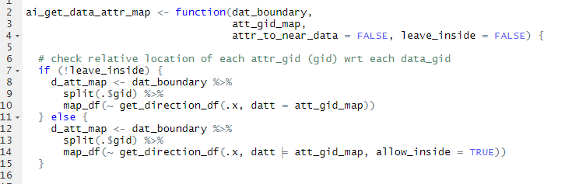

d_att_map has all maps wrt each data boundary

d_gid_att_map gets md min dist between each attr_gid and data_gid and direction group

d_gid_att_map_min_d attach each data_gid to nearest attr_gid for all directions.

map -> mapping (data_gid to nearest attr_gid + attr_gid to nearest data_gid if attr_to_near_data)

all_map -> all other mapping

raw -> attr gid’s cell level information

lo <- list(map = d_gid_att_map_min_d, all_map = d_gid_att_map, raw = d_att_map)

md need to change - done

leave inside ???

ai_relative_data_split_attr

This may not be required

(Changed)

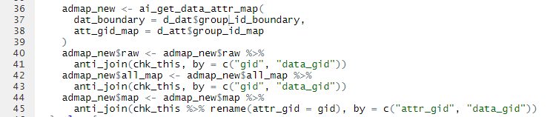

ai_get_data_attr_map_details

major minor classification

name change suggested ai_get_data_attr_map_details done

ai_data_gid_join

nearby gids first

ai_get_data_attr_map_main <- function(d_dat, d_att) {

# start with simple attr data map

admap0 <- ai_get_data_attr_map(

dat_boundary = get_group_id_boundary(d_dat),

att_gid_map = d_att

)

# split attr gid relative to data_gid

rel_chk <- ai_relative_data_split_attr(basic_map = admap0, d_att = d_att)

if (rel_chk$done) {

d_att <- rel_chk$d_att

admap0 <- rel_chk$admap

}

# dimension analysis done here (major minor classification)

# phase 1

admap1_major_minor <- admap0$all_map %>%

filter(direction_group != "corner") %>%

ai_get_dimention_analysis_details(d_dat, d_att)

# @Dev

# why comapting required?

admap1_major_compact <- admap1_major_minor$map %>%

filter(attr_group == "major") %>%

group_by(data_gid, direction_group) %>%

filter(dist == min(dist)) %>%

ungroup()

admap1_major_compact <- admap1_major_compact %>%

# @Dev this filter seems redundant

# filter(direction_group != "corner") %>%

unique() %>%

select(-attr_group)

# dimension analysis done here (major minor classification)

# phase 2

admap1 <- admap1_major_compact %>%

ai_get_dimention_analysis_details(d_dat, d_att)

##########################

# @Dev why do we need two phase??

# really reaquired ? if so why two why not iterative ?? Check it..

if(!identical(admap1_major_minor, admap1)){

cat("you need to see it now!!\n")

browser()

# this is the situation

}

##########################

# @Dev

# d_dat does not change

list(admap = admap1, d_dat = d_dat, d_att = d_att)

}

Analyze Cells

#' Analyze Cells

#'

#' @description After [`Value Attribute Classification`][value_attribute_classify()] done on a [`cell_df`][cell_df-class] next task to do is

#' analyze it's contents for data block detection, attribute orientation identification etc. The function `analyze_cells` (and also `analyse_cells`)

#' does the same for you.

#'

#' **Note**:

#' \if{html}{If you are not sure about what package functions actually do or how they work together,

#' please start with \href{../doc/tidycells-intro.html}{\code{vignette("tidycells-intro")}}.}

#' \if{latex}{If you are not sure about what package functions actually do or how they work together,

#' please start with \code{vignette("tidycells-intro")}.}

#'

#' @param d A [`cell_df`][cell_df-class] after [`Value Attribute Classification`][value_attribute_classify()] done

#' @param silent logical scalar indicating whether to raise a warning if heuristic detection fails. (Default TRUE).

#'

#' @details it returns detailed analysis of the data structure including data block detection, attribute orientation detection etc.

#' The argument `silent` is set to `TRUE` by default, as the warning will be given whenever the [`cell_analysis`][cell_analysis-class] is printed.

#'

#' After this step one may like to do :

#' * [`compose_cells`][compose_cells()]

#'

#' If in an interactive session, following additional functions can be helpful for interactive visualizations:

#' * [`visual_data_block_inspection`][visual_data_block_inspection()]

#' * [`visual_orientation_modification`][visual_orientation_modification()]

#' * [`visual_traceback`][visual_traceback()]

#'

#' @return Detailed analysis of the cell data structure.

#' Which will be a [`cell_analysis`][cell_analysis-class] class object.

#'

#' @seealso [`compose_cells`][compose_cells()], [`collate_columns`][collate_columns()]

#' @export

#' @examples

#' d <- structure(c(

#' "block 1", "", "C", "D", "", "block 2", "", "C",

#' "D", "", "A", "1", "2", "", "", "A", "10", "20", "", "B", "3",

#' "4", "", "", "B", "30", "40"

#' ), .Dim = c(9L, 3L))

#' d <- as.data.frame(d)

#' cd <- as_cell_df(d) %>% numeric_values_classifier()

#'

#' # see it

#' cd %>% plot(adaptive_txt_size = FALSE)

#' ca <- analyze_cells(cd)

#'

#' # look at the plot for detected directions

#' plot(ca)

analyze_cells <- function(d, silent = TRUE) {

analyze_cells_raw(d = d, silent = silent)

}

analyze_cells_raw <- function(d, silent = TRUE) {

if (!is_cell_df(d)) {

abort("A Cell DF expected")

}

if (!hasName(d, "type")) {

abort(paste("The type column not found.",

"(You may like to do 'Value Attribute Classification'.",

"Check basic_classifier, sample_based_classifier, numeric_values_classifier for details.",

sep = "\n"

))

}

val <- validate_cells(d)

if (!val) {

abort(attr(val, "msg") %>% paste0(collapse = "\n"))

}

# remove empty cells

d_orig <- d

d <- d %>% filter(type != "empty")

# the term 'data' and 'value' are interchangeably used going forward

data_cells <- d %>%

filter(type == "value") %>%

as_rc_df()

attr_cells <- d %>%

filter(type == "attribute") %>%

as_rc_df()

if (nrow(data_cells) == 0) {

abort("No `value` cells found")

}

if (nrow(attr_cells) == 0) {

abort("No `attribute` cells found")

}

d_dat <- get_group_id(data_cells, gid_tag = "d")

d_att <- get_group_id(attr_cells, gid_tag = "a")

#@Dev

# this function name may be changed

step1 <- ai_get_data_attr_map_main(d_dat, d_att)

d_att <- step1$d_att

admap1 <- step1$admap

# data_gid join (if possible)

if (length(unique(d_dat$gid)) > 1) {

d_dat_potential_joins <- ai_data_gid_join(

d_dat, d_att,

data_attr_map = admap1,

full_data = d %>% as_tibble()

)

if (d_dat_potential_joins$done) {

# @Dev need to fix

# this means results has been invalidated

d_dat <- d_dat0

# revert back to original form

d_att <- d_att_orig

step2 <- ai_get_data_attr_map_main(d_dat, d_att, crude_join = FALSE)

d_dat <- step2$d_dat

d_att <- step2$d_att

admap1 <- step2$admap

}

}

# join attr based on block merges (potentially possible)

rel_chk <- ai_relative_data_join_attr(admap_main = admap1, d_att = d_att)

if (rel_chk$done) {

d_att <- rel_chk$d_att %>% map(unique)

admap1 <- rel_chk$admap

}

# now time for corners (potential) / minor / less strong mappings

# information blocks are introduced from here

# @Dev check and delink functions

# d_dat$group_id_extended_boundary <- extend_data_block(d_dat$group_id_boundary, admap1$map, d_att)

info_block <- ai_get_information_blocks(admap1, d_dat, d_att)

admap1 <- info_block$map

d_inf <- info_block$d_inf

unmapped_attr_gids <- d_att$gid %>% unique() %>%

setdiff(admap1$attr_gid) %>%

# @Dev

# following may not be perfect as it discards the <missed_block_connections> $ <attr_gid> without seeeing

# <data_gid> <- this is stale now (for this we may opt for <row, col> sample in <missed_block_connections>)

# for now solving purpose but may be dropped later

#

setdiff(common_knowledge("missed_block_connections")$attr_gid)

if(length(unmapped_attr_gids)>0){

# attach unmapped_attr_gids to info_blocks

# fr: for rest attr_ids (this actually mean <unmapped_attr_gids> and can include corners and non-corners also)

admap_fr0 <- ai_get_data_attr_map(

dat_boundary = get_group_id_boundary(d_inf),

att_gid_map = d_att %>% filter(gid %in% unmapped_attr_gids),

attr_to_near_data = TRUE,

leave_inside = TRUE

)

unmapped_attr_gids <-

admap1$map$attr_gid %>%

c(admap_fc0$map$attr_gid) %>%

setdiff(d_att$group_id_boundary$gid, .) %>%

setdiff(d_att$missed_blocks$gid)

admap_fc1 <- admap_fc0$map %>%

ai_get_dimention_analysis_details(d_dat, d_att, major_direction_relax = FALSE)

# try to attach rest attr_gid if any to nearest data_gid [on data_gid boundary]

if (length(unmapped_attr_gids) > 0) {

admap_other0 <- ai_get_data_attr_map(

dat_boundary = d_dat$group_id_boundary,

att_gid_map = d_att$group_id_map %>% filter(gid %in% unmapped_attr_gids),

attr_to_near_data = TRUE

)

unmapped_attr_gids <-

unmapped_attr_gids %>%

setdiff(admap_other0$map$attr_gid)

admap_other1 <- admap_other0$map %>%

ai_get_dimention_analysis_details(d_dat, d_att, major_direction_relax = FALSE)

admap_fc1 <- merge_admaps(admap_fc1, admap_other1)

}

}

# last stage of analysis

# this is not required

# d_dat$group_id_whole_boundary <- extend_data_block(d_dat$group_id_extended_boundary, admap_fc1$map, d_att)

admap2 <- merge_admaps(admap1, admap_fc1)

# join attr based on block merges possible (one more time)

rel_chk <- ai_relative_data_join_attr(admap_main = admap2, d_att = d_att)

if (rel_chk$done) {

d_att <- rel_chk$d_att %>% map(unique)

admap2 <- rel_chk$admap

}

cmp <- compact_gid_maps(d_att, admap2)

d_att <- cmp$gid_map

admap2 <- cmp$admap

admap3 <- admap2$map %>%

select(-attr_group) %>%

ai_get_dimention_analysis_details(d_dat, d_att)

if (!identical(admap3$map, admap2$map)) {

# I think this can be iterated

# KFL

admap3_pass <- admap3$map %>%

rename(md = dist) %>%

group_by(data_gid, direction_group, attr_group) %>%

mutate(m_dist = min(md)) %>%

ungroup() %>%

filter(md == m_dist) %>%

select(-md) %>%

rename(dist = m_dist)

admap <- admap3_pass %>%

select(-attr_group) %>%

ai_get_dimention_analysis_details(d_dat, d_att)

} else {

admap <- admap3

}

# once admap is done

d_dat$group_id_extended_boundary <- NULL

d_dat$group_id_whole_boundary <- extend_data_block(d_dat$group_id_boundary, admap$map, d_att)

# str-detection done

this_cells <- get_cells_from_admap(admap, d_dat, d_att)

# natural gid for easier understanding

gid_ngid <- d_dat$group_id_map %>%

distinct(gid) %>%

mutate(natural_gid = gid %>% as.factor() %>% as.numeric())

# attach natural gid

this_cells <- this_cells %>%

left_join(gid_ngid, by = "gid")

admap$raw_map <- admap$raw_map %>%

mutate(gid = data_gid) %>%

left_join(gid_ngid, by = "gid")

admap$map <- admap$map %>%

mutate(gid = data_gid) %>%

left_join(gid_ngid, by = "gid") %>%

select(-gid)

d_dat$group_id_whole_boundary <- d_dat$group_id_whole_boundary %>%

left_join(gid_ngid, by = "gid")

# attach directions to it

admap$raw_map <- ai_attach_direction(admap$raw_map)

df_details <- get_definiteness_details(admap$raw_map,

all_attr_gids = d_att$group_id_boundary$gid %>%

setdiff(d_att$missed_blocks$gid)

)

definiteness_checks <- get_definiteness_checks(df_details, silent = silent)

obj <- list(

cells = this_cells,

sections = d_dat$group_id_whole_boundary,

details = list(

attr_details = d_att,

data_details = d_dat,

data_attr_map_raw = admap$raw_map,

definiteness_checks = definiteness_checks

),

cell_df = d_orig

)

# attach cell_df_analysis class

class(obj) <- cell_df_analysis_class

obj

}

ai_attach_direction <- function(d_att_dat_map_raw) {

# asp: attr split

d_att_dat_map_raw_asp <- d_att_dat_map_raw %>%

# kept for tracking

mutate(direction_basic = direction) %>%

mutate(attr_gid_split = ifelse(direction_group == "NS" & attr_group == "major", row_a,

ifelse(direction_group == "WE" & attr_group == "major", col_a, 0)

))

d_att_dat_map_raw_asp <- d_att_dat_map_raw_asp %>%

mutate(attr_gid_split = ifelse(direction_group == "corner", col_a, attr_gid_split))

d_att_dat_map_raw_asp %>%

group_by(data_gid, attr_gid, direction, attr_gid_split) %>%

group_split() %>%

map_df(~ .x %>% mutate(direction = get_direction(.x)))

}

ai_attr_gid_micro_splits