1. Pre-processing
   1. Checks
      1. Check a cell DF + other tests
      2. Validate cell DF
   2. Delete <Empty>
2. Data Cell and Attribute Cell Separation

**Definitive function**

1. get_group_id
2. get_direction_df

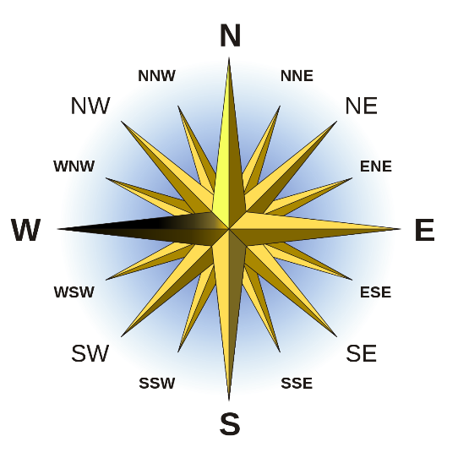

**Ai function**

1. ai_get_data_attr_map_main
   1. ai_get_data_attr_map
      1. get_direction_df (this I think can be linked to intra block dist)
   2. ~~if crude_join~~ (this is problematic) (delinked)
      1. ~~ai_crude_data_block_joins~~
   3. ai_relative_data_split_attr (main place to work)
   4. ~~ai_get_data_attr_map_details~~ renamed to ai_get_dimention_analysis_details
2. ai_data_gid_join
   1. is_attachable
   2. ~~get_links_df~~ (this seems unnecessarily complicated) removed as gid_map_link_tune introduced.
   3. get_group_id_join_gids

**ai_get_data_attr_map**

ai_get_data_attr_map <- function(dat_boundary,

att_gid_map,

attr_to_near_data = FALSE, leave_inside = FALSE)

Need to fix (can be kept without if block)

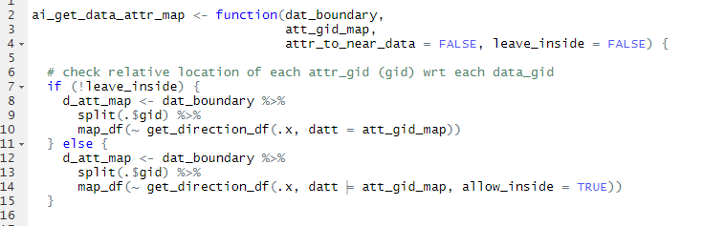

d_att_map has all maps wrt each data boundary

d_gid_att_map gets md min dist between each attr_gid and data_gid and direction group

d_gid_att_map_min_d attach each data_gid to nearest attr_gid for all directions.

map -> mapping (data_gid to nearest attr_gid + attr_gid to nearest data_gid if attr_to_near_data)

all_map -> all other mapping

raw -> attr gid’s cell level information

lo <- list(map = d_gid_att_map_min_d, all_map = d_gid_att_map, raw = d_att_map)

md need to change - done

leave inside ???

ai_relative_data_split_attr

This may not be required

(Changed)

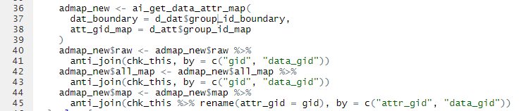

ai_get_data_attr_map_details

major minor classification

name change suggested ai_get_data_attr_map_details done

ai_data_gid_join

nearby gids first