09012019NPKNotesonProbeKernelFromDiskAveraging

The relevant functions are average_disk_shape_testing

and getAveragedDiskShape

These functions are both in the Matlab 4DSTEM repo.

When simply using cross-correlation (no subpixel detection) and aligning the disks on top of each other via the cross-correlation-detected middle, the following probe kernel was obtained:

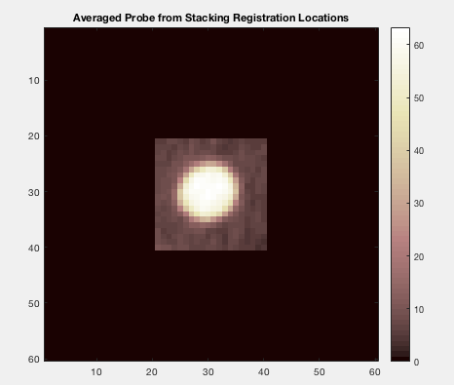

When using cross-correlation again to align the images, the following averaged probe was obtained:

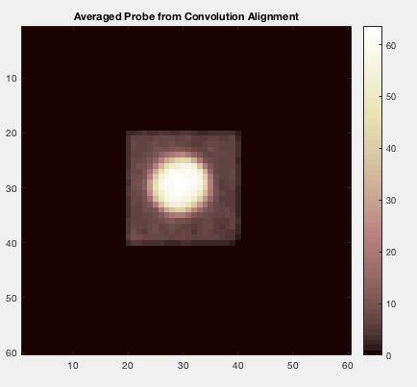

This one looks a little rounder than simply stacking them on top of each other.

Sizes look comparable in both cases, though. Note that in this implementation of the convolution alignments, the increments computed from the convolution map are added in the indexing of the new shifted image. I think this should be write, but the plotting gave me a doubt. If we use subtraction instead, we get the following:

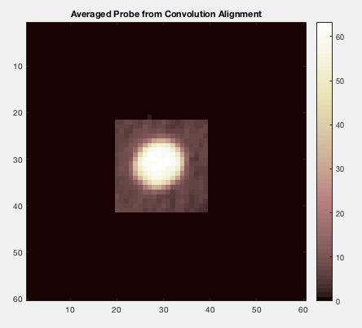

This one appears to have exacerbated the asymmetry in the disk rather than correcting for it, so I do believe that adding the increment is the way to go as I thought. We also got out of this round the four randomized disks for comparison.

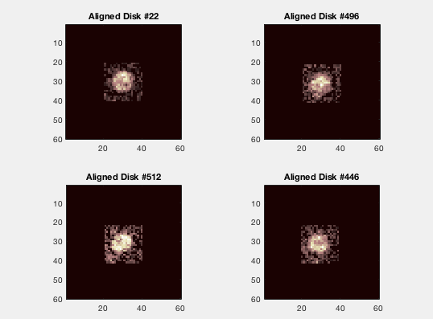

By eye, I think that the averaged probes are reasonable in size, indicating that the averaging process is not causing artificial broadening of the kernel as I had feared might happen.