PART 1: PRACTICE QUESTIONS

A. UNDERSTANDING UNIX/LINUX COMMANDS

1. ls – list files in a directory

ls -la - write out all directory entries in long format

-l – write out in long format

-a – write out all directory entries, including those with names starting with ‘.’ (period)

1. pwd – print working directory
2. cd – change directory
3. cat – concatenate and print the content of files
4. cp – copy one or more files to another directory
5. mv – move or rename directories or files
6. who – print all usernames currently logged in
7. whoami – print the current user id and name
8. ps – list the processes running

ps -la – list the running processes in long format and including those with names starting with period

1. more – display output one screen at a time; unable to scroll back in screens
2. less - display output one screen at a time; able to scroll back in screens and has much more functionality than ‘more’ command
3. head – output beginning of a file
4. tail - output ending of a file
5. fg - starts a suspended process running in the foreground
6. rm – deletes a file
7. mkdir – creates a new directory with the given name
8. rmdir – removes a directory with the given name
9. date – outputs the current date/time
10. sudo – execute a single command as a super user
11. apt-get – search for and install a software package
12. chmod – change the access permissions of a file or a group of files
13. echo – outputs a message or a value
14. find – search for files by name within a given directory
15. free – display memory usage
16. diff – display differences between two files
17. grep – search a file for a given string or expression
18. passwd – change your password
19. wc – output number of chars, lines, words in a file
20. man – help manual
21. sort – sort text files
22. cmp – compare two files
23. bg – run a process in the background
24. file – determine file type
25. time – measure program running time
26. kill – kill a process with a specific PID
27. link – create a link to a file
28. uname – print the system information
29. df – display free disk space
30. du – estimate file space usage
31. chown – change file owner or group
32. chgrp – change group ownership
33. adduser – adds a user
34. addgroup – adds a group
35. deluser – deletes a user
36. delgroup – deletes a group
37. touch – update the last-modified time of a user
38. top – display what processes are consuming the most CPU/memory and output system CPU/memory stats
39. cut – divide a file into several parts
40. sed – stream editor; find and/or replace based on regular expressions
41. uptime – show the time the system is up

B. PERFORMING FILE OPERATIONS USING UNIX I/O SYSTEM CALLS

C. BASH SHELL PROGRAMMING

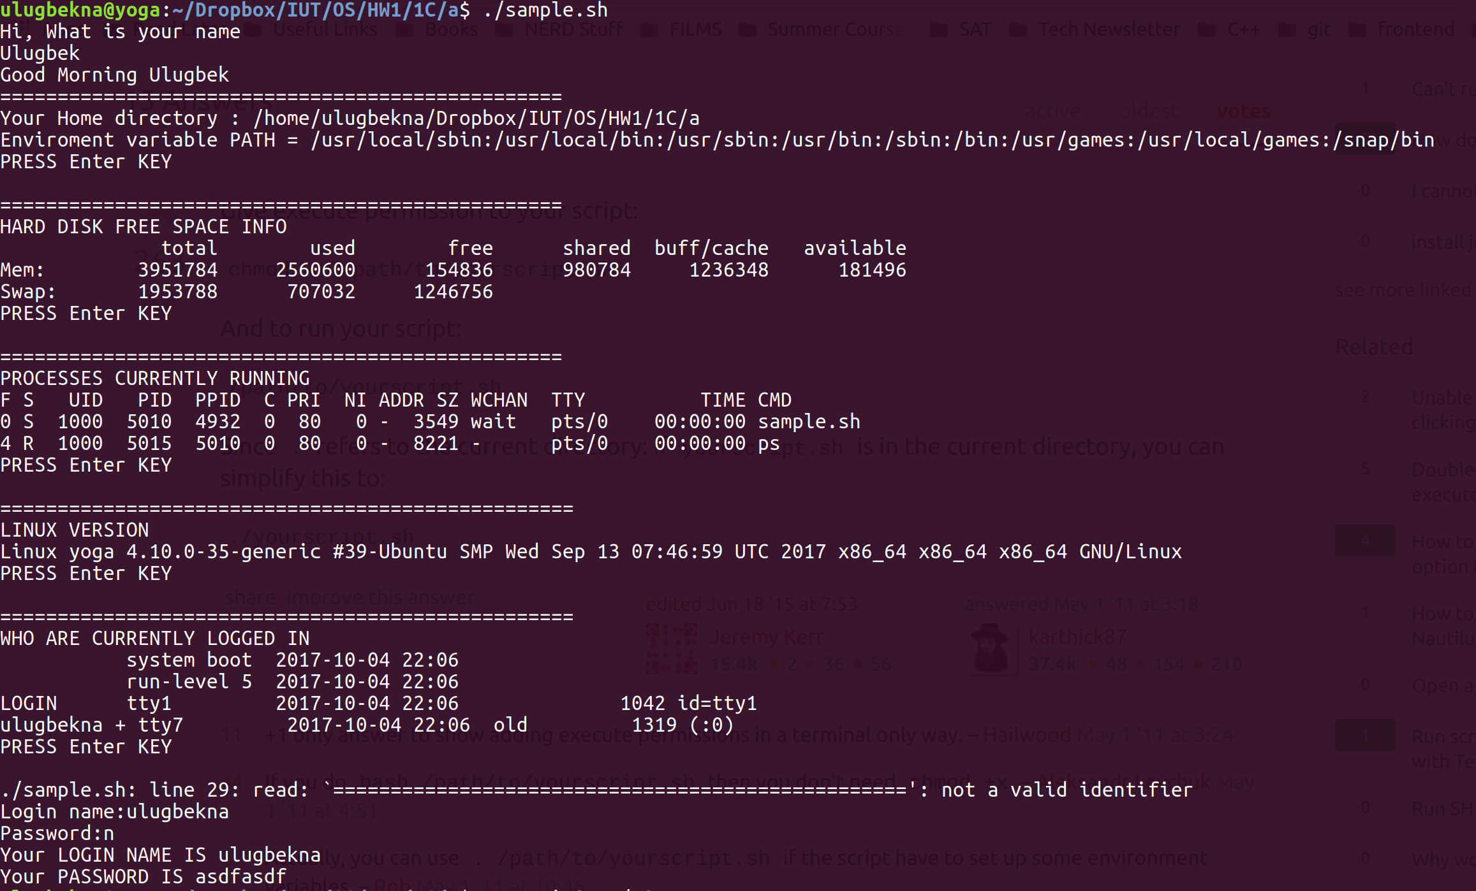

a) Sample Shell Script

Input: name, login, password

Output: home directory, environment variable PATH, hard disk space info, processes running, linux version, currently logged in user, login, password.

b) File – line, word, byte count

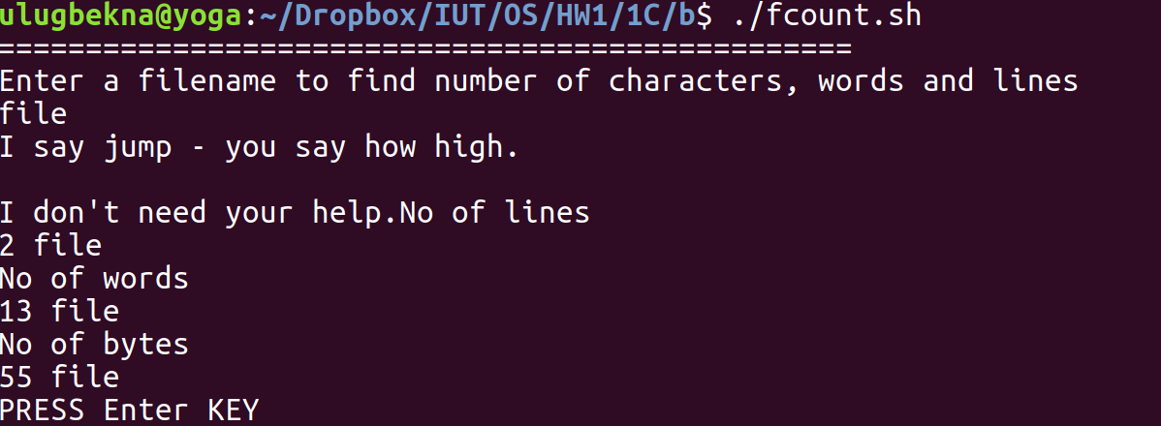

Input: file name

Output: number of lines, words, and bytes in the file

REFERENCES:

1. ‘ls’ command

<http://pubs.opengroup.org/onlinepubs/009695399/utilities/ls.html>

1. bash commands

<https://courses.cs.washington.edu/courses/cse390a/15au/bash.html>

1. [bash commands list](https://ss64.com/bash/)

<https://ss64.com/bash/>