# RINEX VERIFICATION – Help

This script will compare RINEX processed data and TRINAV/SPN logged data to produce difference plots for Lat and Lon, in metres.

The user selects TRINAV/SPN in Navigation System. The NAVIGATION logged file will be recorded in TRINAV/SPN. The RINEX file will be recorded in FUGRO/VERIPOS systems and will be processed before entering in this script.

The names of the GPS systems have to match those of the headers of the file logged in TRINAV/SPN

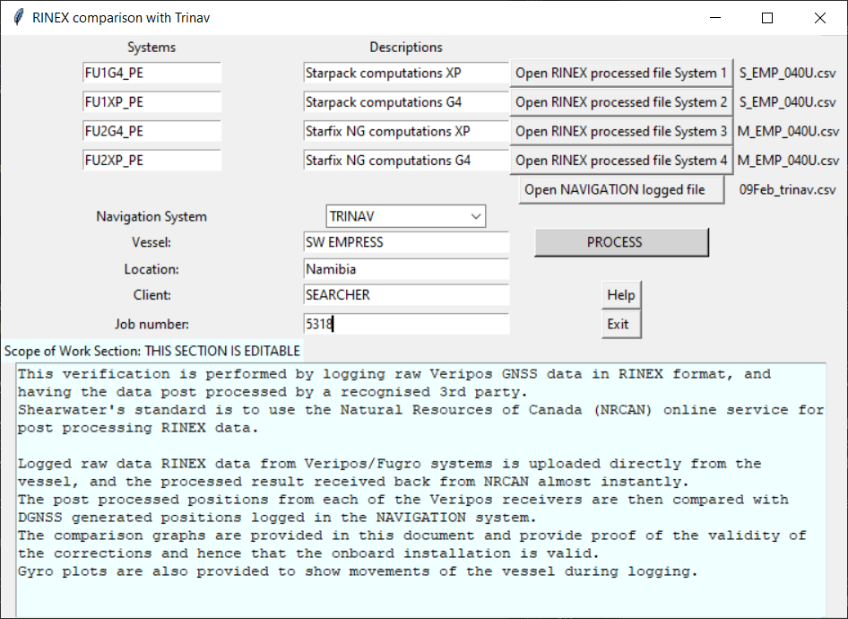

GPS system

Navigation Logged

Rinex processed

1. Log RINEX data from LD-6 / Verify PC, Fugro, etc.
   1. If needed convert the data to RINEX 2.1 format from Veripos or Fugro. Follow Veripos/Fugro work instructions, using conversion software provided by them.
   2. Submit the .??O files to <https://webapp.geod.nrcan.gc.ca/geod/tools-outils/ppp.php?locale=en>
      1. log in or make an account if you do not have one.
      2. Navigate to the “Geodetic tools and data” page, then to the CSRS-PPP page.
      3. Select “Kinematic” and “ITRF”.
      4. Load your RINEX files as instructed.
      5. Await email with results and download.
   3. Use the .csv files processed by Canadian PPP site as input to the RINEX Comparison program



1. Log TRINAV
   1. **Please ensure that the data set does not cross over midnight.**
   2. line in RT while logging the RINEX data. From QCPR :

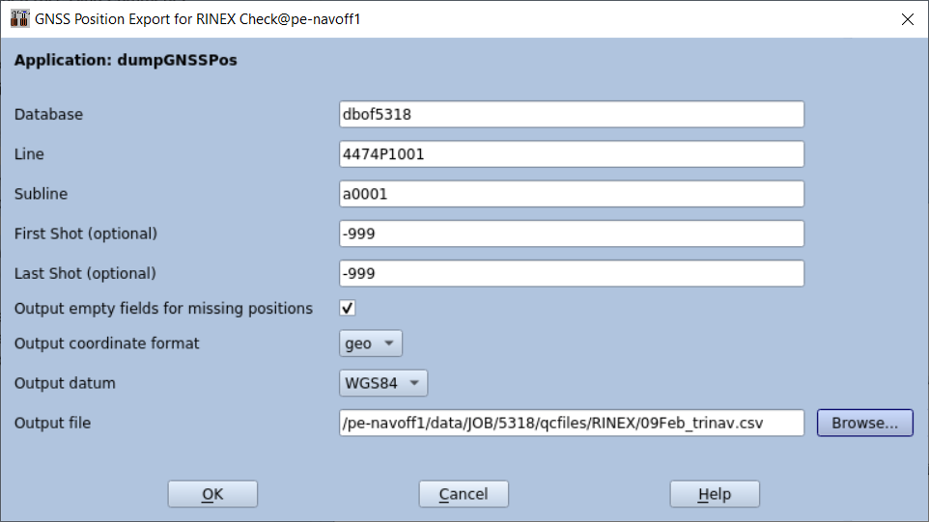

1. Log SPN
   1. **Please ensure that the data set does not cross over midnight.**
   2. If Using SPN, log as follows:

* All antenna offsets need to be set to be zero in both the SPN and the GNSS configurations. In SPN Survey Control create a user output as shown in the screen shots below.
* SPN outputs GPS time from the Raw DGPS Observations. The GPS time field is “Seconds of Week” with the week being the “GPS Week mod 1024”.
* The duration has been set to 2 hours logging time at 1s output rate to match the logging of the GNSS RINEX files.
* The output positions must be RAW.

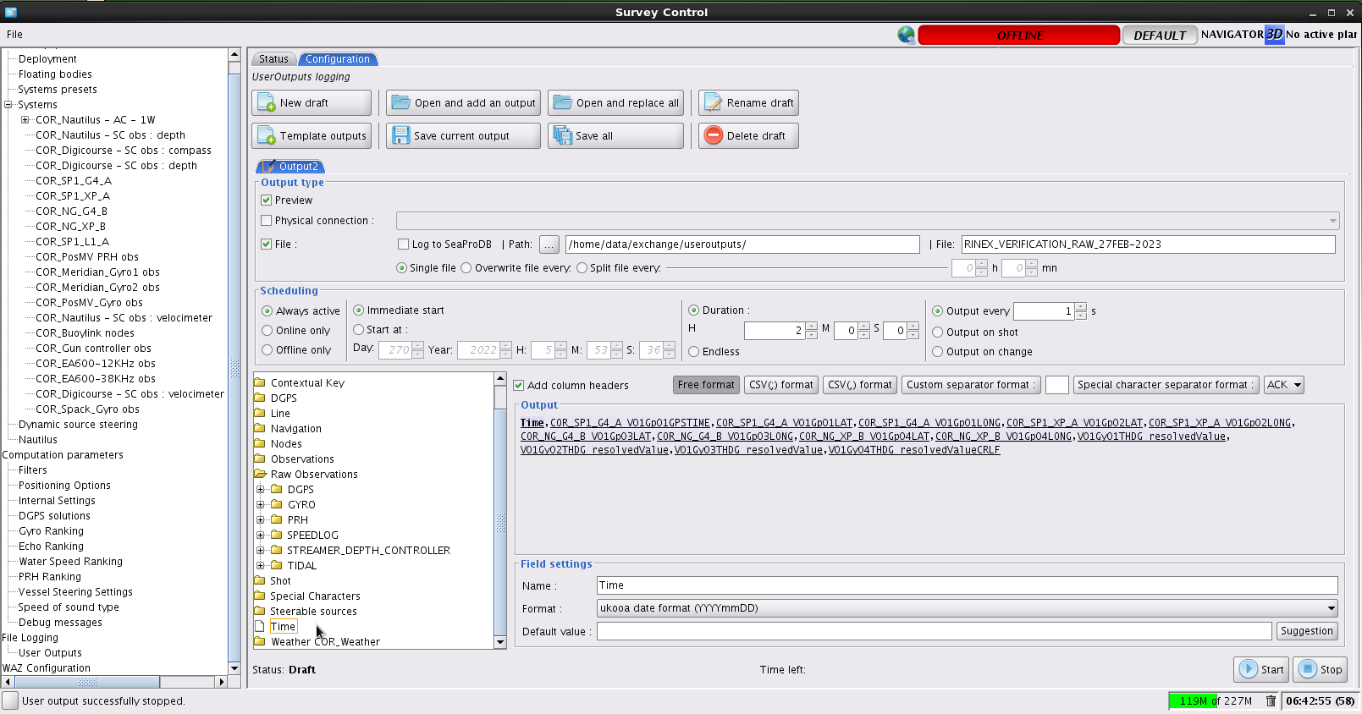

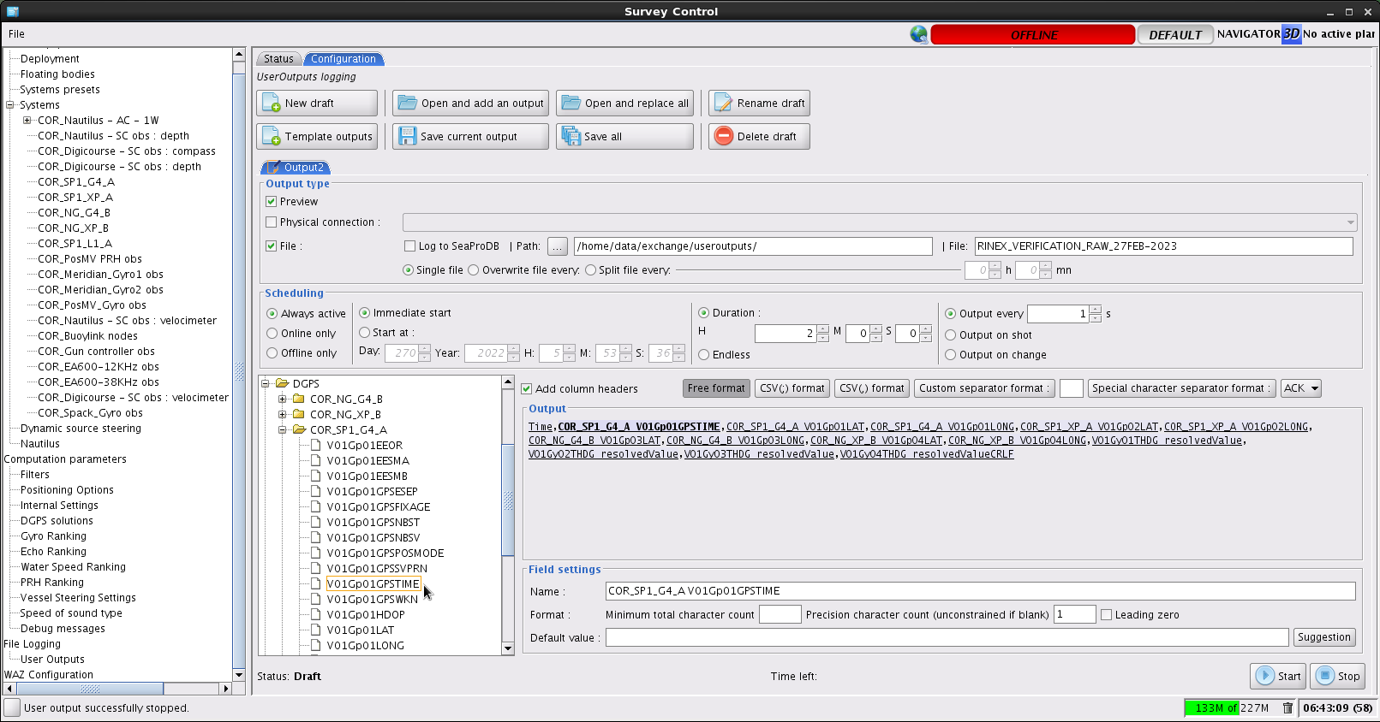

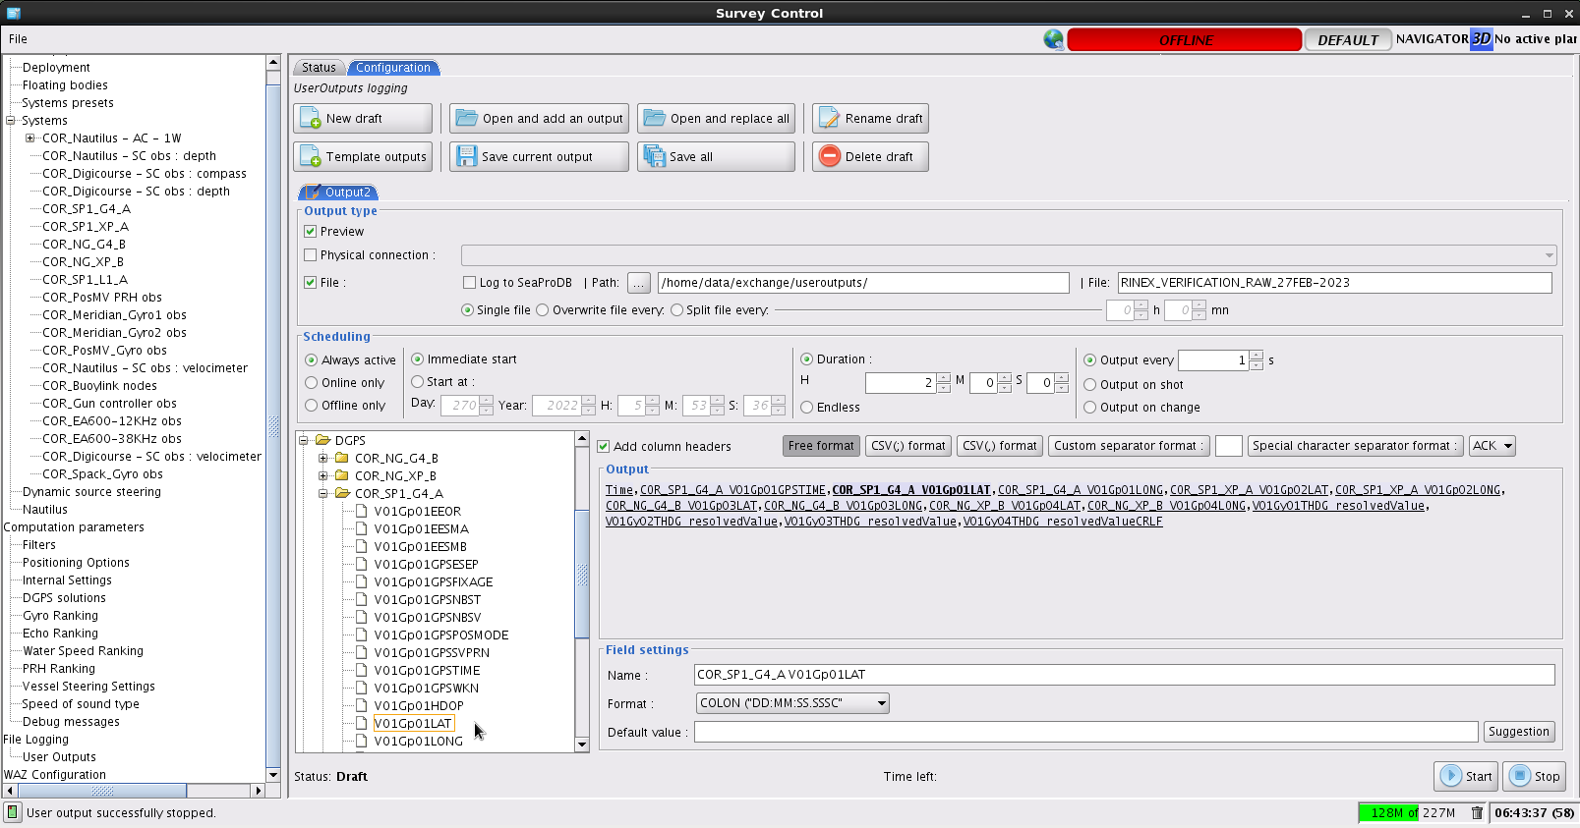

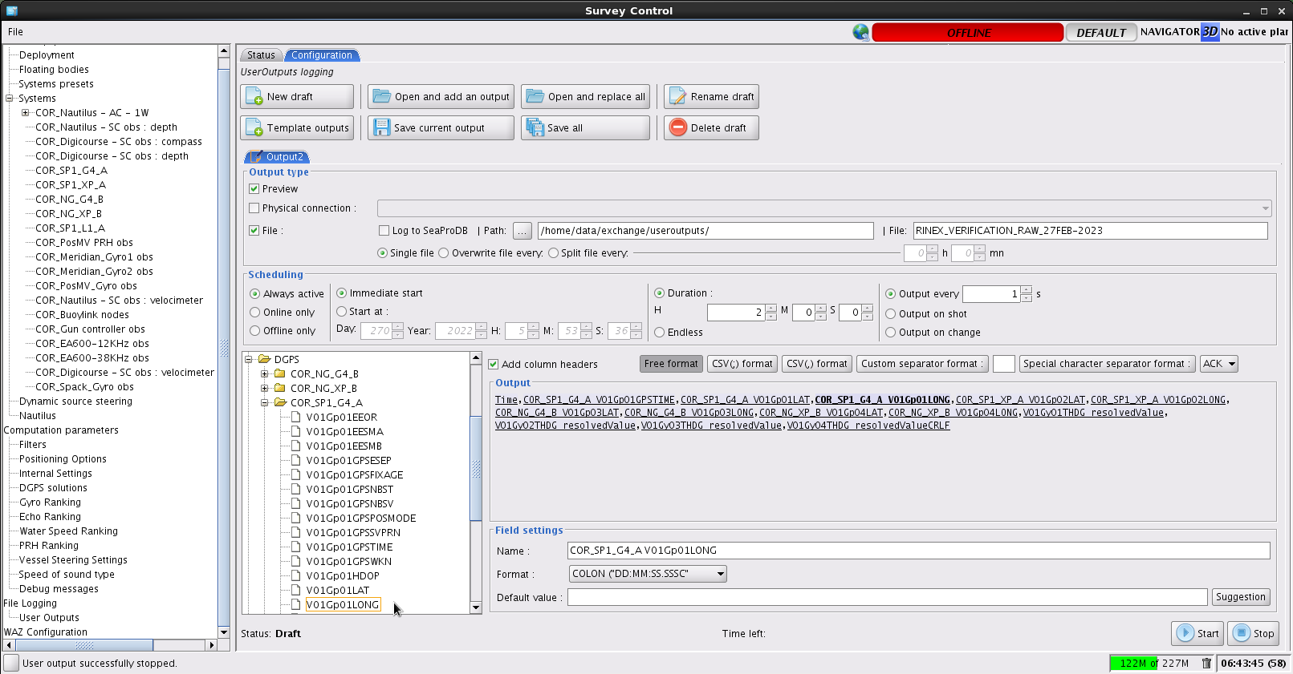

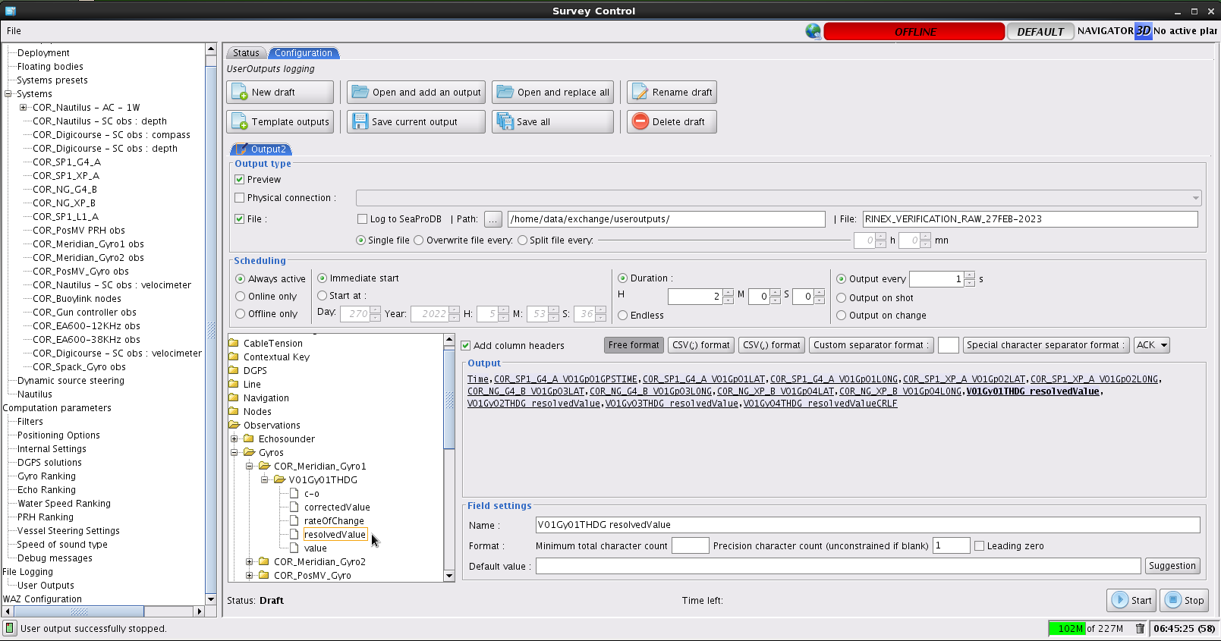

1. Check/Modify Comments : *Scope of Work* section. This is output to the report. The default comments can be modified.
2. Check Results : PDF report with time tag suffix is produced on the same directory where the .exe file is located

------Bugs, suggestions, testing datasets, etc, please submit feedback or a ticket referencing SWConnect_Content-7291937 - RINEX Verification -------