GIU Food Truck Order System

Software Requirements Specification (SRS)

1. Introduction
1.1 Purpose
The GIU Food-truck System is a comprehensive web-based application designed to enable the members of the GIU community to reserve menu items from specific food-trucks on campus for pick-up within a given time window, thus alleviating the problem with long-waiting times for food and beverage items during peak periods in between classes. This system enables seamless menu browsing, order placement, and order management for food-truck customers as well as providing a similarly intuitive, efficient, and scalable solution for food service providers.
1.2 Intended Audience
- GIU students, faculty, and staff (patrons)
- Food-truck service providers (shop owners)
- System administrators
- Project stakeholders and TAs
1.3 Scope
This SRS covers the requirements for the GIU Food-truck System web application, including customer and shop interfaces, order management, and basic administration. It does not include payment processing, external authentication, or integration with third-party systems at this stage.
1.4 Overview
The document outlines the product vision, high-level architecture, functional and non-functional requirements, interface requirements, constraints, and future scope.

2. Product Vision and Scope
2.1 Vision
To streamline food ordering and pickup on campus, reducing wait times and improving the experience for both customers and food-truck operators.
2.2 Scope
The system will:
- Allow users to register, log in, and select their role (customer or shop)
- Enable customers to browse menus, add items to a cart, and schedule pickup times
- Allow shops to manage menus, view incoming orders, and update order statuses
- Provide real-time order status updates and notifications
The system will NOT:
- Process online payments (future scope)
- Integrate with external authentication or credit card services (future scope)
- Support delivery (pickup only)

3. High-Level Architecture
- Frontend: React.js (SPA), HTML5, CSS3
- Backend: Node.js with Express.js (RESTful API)
- Database: MongoDB (Mongoose ODM)
- Authentication: JWT-based (local, no external providers)
- Hosting: To be determined (local for development)
- APIs: RESTful endpoints for all major operations
Architecture Diagram: [Browser/React] <-> [Node.js/Express API] <-> [Postgres]

4. Functional Requirements
4.1 User Stories
Food-truck Patron (Customer)
- As a customer, I want to register and log in so I can place orders.
- As a customer, I want to browse food-truck menus and see item details.
- As a customer, I want to add items (with extras) to my cart.
- As a customer, I want to select a pickup time within allowed hours.
- As a customer, I want to view my order history and status.
Food-truck Service Provider (Shop)
- As a shop, I want to register and log in to manage my food-truck.
- As a shop, I want to add, edit, or remove menu items and set preparation times.
- As a shop, I want to view incoming orders, see customer pickup times, and update order statuses (pending, preparing, ready, completed, cancelled).
- As a shop, I want to be notified when it’s time to start preparing an order.
Administrator
- As an admin, I want to view all users and orders for monitoring and support.
4.2 Use Case Diagram
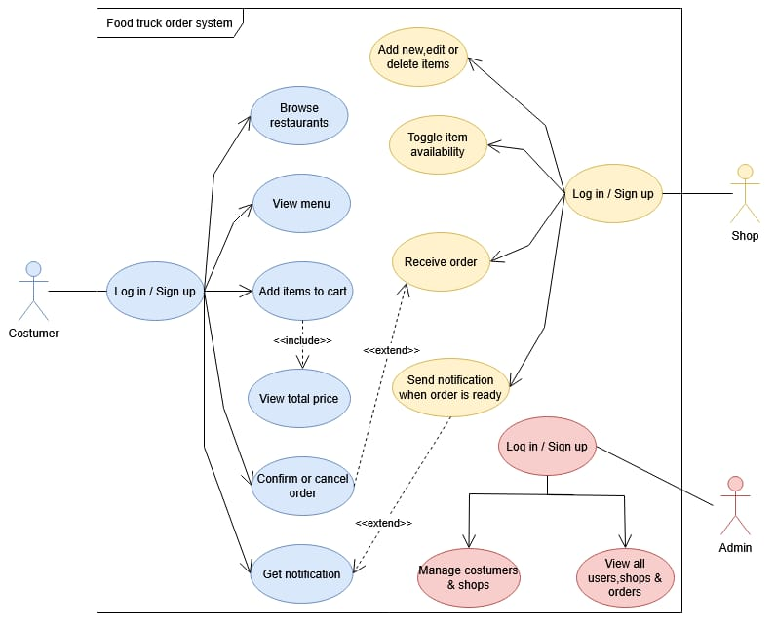
<<include>>

5. Non-Functional Requirements
- Performance: Page load times under three seconds.
- Scalability: Support at least 500 simultaneous users.
- Security: JWT authentication, input validation, rate limiting.
- Reliability: Automated daily database backups, disaster recovery plan.
- Usability: Responsive design for mobile and desktop.
- Operating Hours: System available 24/7; food-truck order windows configurable by shop.

6. Interface Requirements
- Internal: RESTful API between frontend and backend.
- External: No integration with payment gateways, external authentication, or third-party systems at this stage.
- Possible Extensions: Integration with payment gateways, SMS/email notification services, and university authentication in the future.

7. Constraints
- Only GIU community members may register as customers.
- Only authorized food-truck operators may register as shops.
- Pickup times must be within shop-defined operating hours.
- No online payment or external authentication in this version.
8. Future Scope of the Project
- Online payment integration (credit/debit cards, mobile wallets)
- University SSO authentication
- Real-time chat between customer and shop
- Advanced analytics for shop owners
- Integration with campus map for food-truck locations
- Push notifications (mobile/web)
- Support for delivery orders
- Notifications when orders is being prepared and when it is ready.

9. ERD diagram
View menu --- category ---
Place order --- time ---- note

