Bronson Edralin

EE468

Project 1 Ubuntu

10/10/14

# Descriptions

* **apt-get**: This is a command-line tool which acts as a great package handling utility. You can install, upgrade and uninstall packages with ease.
* **sudo**: This allows a permitted user to execute a command as the superuser or another user, as specified by the security policy. You can change the user privileges by typing “sudo visudo” on the command line. You will need sudo to get root privileges as well.
* **fakeroot**: fakeroot provides a fake root environment by means of LD_PRELOAD and SYSV IPC (or TCP) trickery. Before building packages with fakeroot, you must build the fakeroot package first. This is useful when you want to build a package without altering your root or system files for the whole OS. This reminds me of virtualenv.
* **dkpg**: This is software at base of Debian package management system. dpkg is used to install, remove, and provide information about .deb packages. dpkg itself is a low or higher level tool such as APT that is used to fetch packages from remote locations or deal with complex package relations.
* **dmesg**: This command is used to write the kernel messages in Linux and other Unix-like operating systems to standard output (which by default is the display screen). This was used to print the message buffer of the kernel.

# Directions

## Compile without Modify

Update apt-get

* sudo apt-get update

Build Environment (install packages needed for building kernel)

* sudo apt-get build-dep linux-image-$(uname –r)

Get source code

* sudo apt-get source linux-image-$(uname –r)

Building kernel (compiling)

* cd ~/linux-3.13.0/
* sudo fakeroot debian/rules clean
* sudo fakeroot debian/rules binary-headers binary-generic

## Compile with Modifications

Create Makefile in linux-3.13.0/testing

* cd ~/linux-3.13.0/
* mkdir testing
* cd testing
* vi alohaworld.c
  + /* Adding alohaworld system call */

#include <linux/kernel.h> /* Contains often used prototypes */

#include <linux/linkage.h> /* Has the macro asmlinkage */

asmlinkage int sys_alohaworld(void) {

printk(KERN_EMERG “Aloha World!\n”);

return 0;

}

* *Notes:*
  + ***asmlinkage****: Lets compiler know that parameters are passed through kernel stack, i.e., the stack that is in the linux kernel*
  + ***printk****: is used to print out kernel log messages. These messages are stored in /var/log/syslog*
  + ***KERN_EMERG****: is used for logging emergency messages; these usually happen before a crash. The Kernel has 8 different types of log levels, a few others are- KERN_DEBUG, KERN_ALERT, KERN_ERR*
* vi Makefile
  + obj-y:=alohaworld.o

Modify System Call Tables

* cd ~/linux-3.13.0/arch/x86/syscalls
* vi syscall_64.tbl
  + 314 common alohaworld sys_alohaworld

Update syscalls.h

* cd ~/linux-3.13.0/include/linux
* vi syscalls.h
  + asmlinkage int sys_alohaworld(void);
    - *(after “endif” and after last “asmlinkage”)*

Update Makefile

* cd ~/linux-3.13.0/
* vi Makefile
  + core-y+=kernel/mm/fs/ipc/security/crypto/block/ testing/

Compile kernel

* cd ~/linux-3.13.0/
* sudo fakeroot debian/rules clean
* sudo fakeroot debian/rules binary-headers binary-generic

Installing and rebooting the new kernel

* sudo dpkg –i linux*3.13.0-37*.deb
* sudo reboot

Testing System Call

* cd ~/
* vi test_kernel.c
  + #include <sys/syscall.h>

#include <unistd.h>

#include <stdio.h>

/* or whatever you set it in syscall_xx.tbl */

#define __NR_alohaworld 314

int alohaworld() {

return (int) syscall (__NR_alohaworld);

}

main() {

printf(“The return code from the alohaworld system call is %d\n”, alohaworld() );

}

* gcc test_kernel.c
* ./a.out
* cd /var/log
* cat syslog | grep Aloha
* cd ~/linux-3.13.0/
* cat /var/log/syslog | grep Aloha > proj1-step2
* dmesg
* dmesg | grep Aloha > proj1-step2-dmesg

# Results

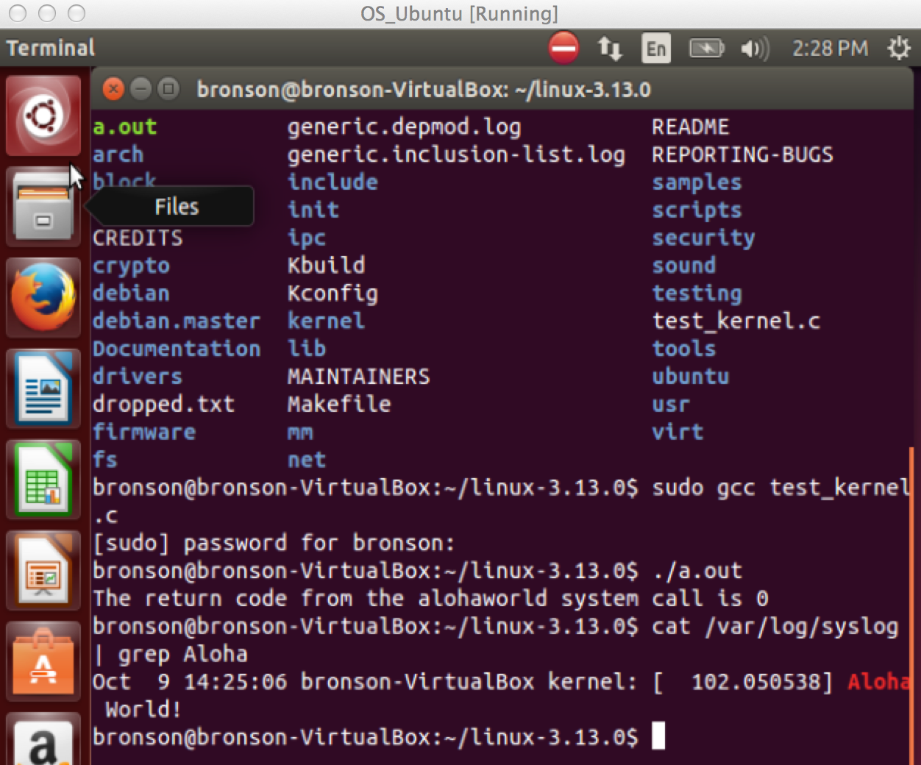After typing *“cat /var/log/syslog | grep Aloha”*

After typing *“cat /var/log/syslog | grep Aloha > proj1-step2”*

* Oct 9 14:25:06 bronson-VirtualBox kernel: [ 102.050538] Aloha World!

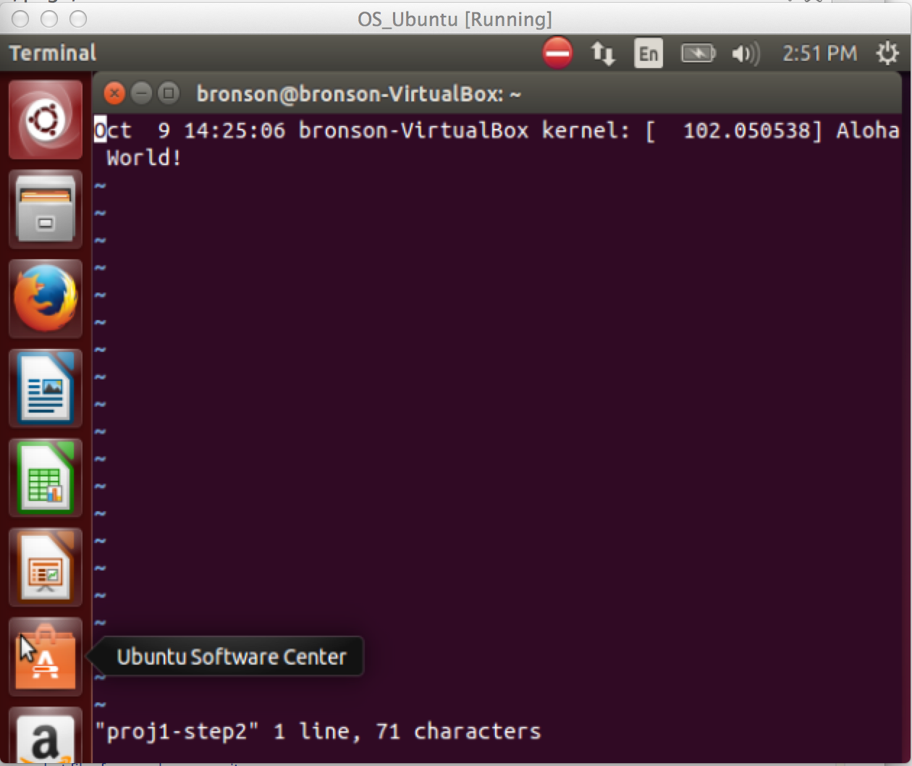

After typing “dmesg | grep Aloha > proj1-step2-dmesg”

* [ 102.050538] Aloha World!

