**micro-TCA DAQ Upgrade Meeting – 9/9/2014**

**- First Meeting**

**Resources:**

[http://www.phys.hawaii.edu/~idlab/taskAndSchedule/STURM/XRM\_Readout\_Upgrade.pdf](http://www.phys.hawaii.edu/~idlab/taskAndSchedule/STURM/XRM_Readout_Upgrade.pdf" \t "_blank)

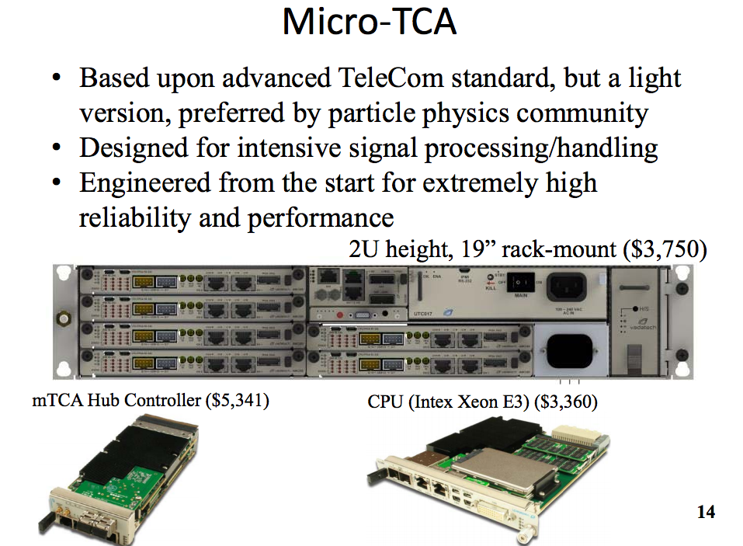

The following is slide 14 from XRM\_Readout\_Upgrade.pdf

CPU(Intel Xeon E3)

Transmission Protocol (Setup)

HI nuon beamline

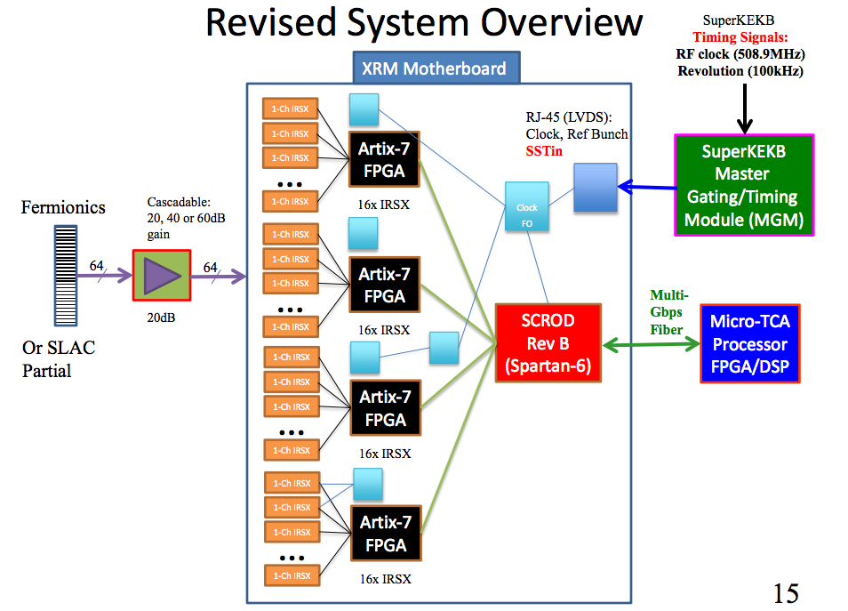

The following is slide 15 from XRM\_Readout\_Upgrade.pdf

**Steps**:

1. Configure OS
2. Set up Link
3. Transfer Protocol
4. Establish Event Transfer

**Problem**:

* We don’t have a high data-rate
* Need very high throughput

**Micro TCA system**

* PCI link
  + Learn how to configure and see how fast can go
* Connect up to 6 computers

**October Deadline (Transmit one at time)**

* Jussi designing hardware at the moment
* Ring in KEK is 3km long (same particle comes every us), 5 Hz